What is the First Day of the Week?

Whether the Gregorian calendar shows Sunday or Monday as the first day of the week depends on where you live.

Do more countries start the week on Sunday or Monday? What about people?

The file `first-day-of-week.csv` shows the first day of the week for each territory. The file `population.csv` shows the population in the year 2020 for each territory in millions.

**Overview of the data frames**

first_day_of-week.csv

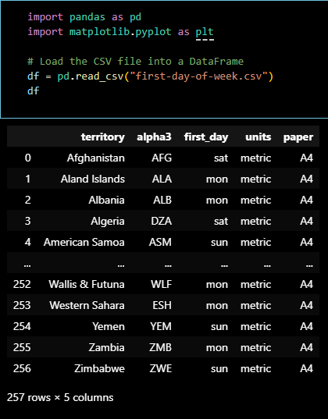

population.csv

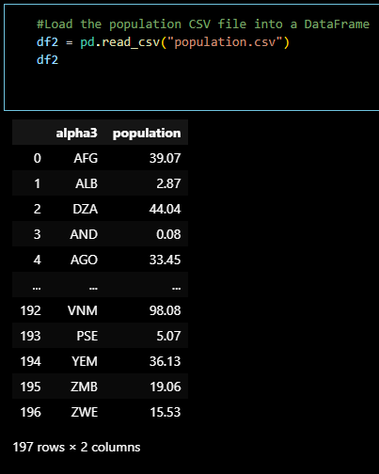

To answer the project’s question, we have to merge the ‘first_day_of-week.csv’ and ‘population’ so that we can have the number of people per country.

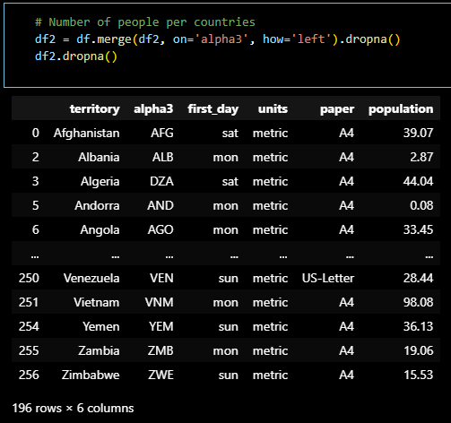

Once we got our merged data frame, we now have to gather countries that has “sun” or “mon” as their first day. We have to use a simple query in order to get this.

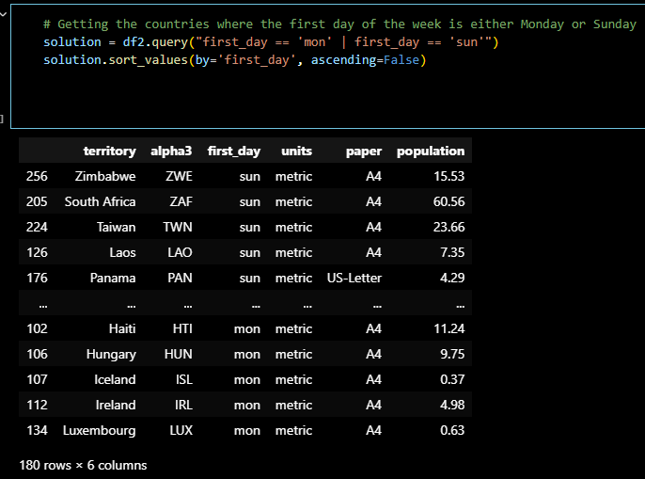

The final step will be calculations of the total population by the first day of the week. We also added a countries_count for the cleaned answer to the question. 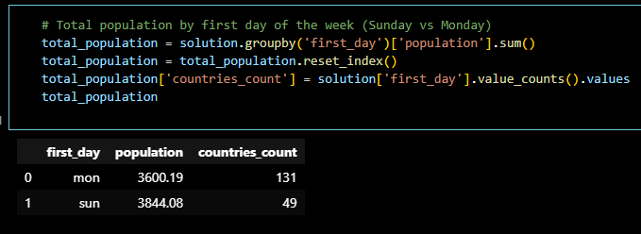

Do more countries start the week on Sunday or Monday? What about people?

If we only looked at the number of countries, we can directly infer that Monday is the most common first day of the week. However, there’s still an argument to be discussed, how many people does each country has?

We still need a supporting evidence for this claim. Therefore, we used the ‘population’ data frame to identify if our hypothesis is correct. It turns out that even though there are few countries starts their first day on Sunday, their population is still more than countries that starts on Monday. A plausible explanation is that these countries might have religious calendars or practices that they usually follow.

They do not follow the Gregorian Calendar which are commonly used throughout the world, that is why it might feel different if whenever we visit these countries.