Ex. No. 1 | Design A Website Using HTML5
Date of Exercise
GitHub Host Link

Aim
To design and develop a simple yet structured HTML5-based website using various essential tags and features that demonstrate a clear understanding of semantic elements and formatting techniques.
Description
This exercise involves creating a basic website consisting of a single web page structured using HTML5. Students are expected to showcase proper usage of fundamental HTML tags and implement different types of content, including headings, images, tables, lists, hyperlinks, and comments. The webpage should visually represent the application theme (e.g., tourism, food delivery, hospital, personal blog) of the student, while effectively applying background and text colors for good design aesthetics.
Procedure:
1. Create an HTML file named index.html.
2. Define the basic HTML document structure using html, head and body elements.
3.Add the SpeedX Bike Showroom heading and navigation bar.
4.Create a hero section with background images and showroom information.
5. Add sections displaying popular bikes, their images and prices.
6. Create bike categories, a bike list, buying process and showroom facilities.
7. Add a test ride registration form with suitable input fields.
8. Apply CSS styling for colours, fonts, borders, spacing and layouts.
9. Use CSS pseudo-classes and selectors to add interactive effects.
10. Add media queries to make the webpage responsive.
11. Save the required images in the project folder and run the webpage using a browser.

Program
<!DOCTYPE html>
<html lang="en">

<head>

<meta charset="UTF-8">
<meta name="viewport" content="width=device-width, initial-scale=1.0">

<title>SpeedX Bike Showroom</title>

<style>

*{
margin:0;
padding:0;
box-sizing:border-box;
}

body{
font-family:Arial;
background:#080808;
color:white;
}

header{
background:#111;
text-align:center;
padding:30px;
border-radius:0 0 30px 30px;
}

header h1{
font-size:65px;
color:#ff3b30;
}

header h2{
font-size:30px;
color:#ffb000;
}

header p{
font-size:22px;
}

nav{
background:#151515;
padding:15px;
}

nav ul{
display:flex;
justify-content:center;
list-style:none;
}

nav li{
padding:10px 20px;
border-radius:10px;
}

nav a{
color:#ffb000;
text-decoration:none;
font-size:22px;
}

nav li:hover{
background:#ff3b30;
}

.hero{
text-align:center;
padding:60px 30px;
margin:20px;
border-radius:25px;

background-image:
url("img_flwr.gif"),
url("paper.gif");

background-position:
right bottom,
left top;

background-repeat:
no-repeat,
repeat;

background-size:
120px 120px,
cover;
}

.hero p{
font-size:25px;
}

.offer{
background:#151515;
color:#ffb000;
padding:10px;
font-size:23px;
border-radius:15px;
}

.showroom{
text-align:center;
padding:40px;
}

.showroom img{
width:70%;
max-width:750px;
border:20px solid transparent;
border-image:url("border.png") 30 round;
border-radius:20px;
}

.container{
padding:20px;
text-align:center;
}

h2{
font-size:45px;
color:#ff3b30;
margin:35px 0 20px;
}

.cards{
display:flex;
justify-content:center;
gap:30px;
}

.card{
background:#151515;
padding:20px;
width:45%;
border-radius:25px;
border:2px solid #ff3b30;
}

.card img{
width:100%;
border-radius:15px;
}

.card h3{
font-size:28px;
color:#ffb000;
margin:15px;
}

.card p{
font-size:20px;
}

table{
margin:auto;
font-size:22px;
background:#151515;
border-collapse:collapse;
border-radius:15px;
overflow:hidden;
}

th{
background:#ff3b30;
padding:15px 30px;
}

td{
padding:15px 30px;
border:1px solid #ff3b30;
}

td:last-child{
color:#ffb000;
}

table tr:nth-child(odd){
background-color:#222;
}

table tr:nth-child(even){
background-color:#151515;
}

table tr:hover{
background-color:#ffd966;
color:black;
}

.categories{
display:flex;
justify-content:center;
gap:30px;
}

.category{
background:#151515;
padding:20px;
width:40%;
border-radius:20px;
}

.category h3{
color:#ffb000;
font-size:27px;
}

ol,ul{
display:inline-block;
text-align:left;
font-size:22px;
line-height:1.8;
}

.bike-list{
margin:30px auto;
width:400px;
background:#151515;
padding:20px;
border-radius:20px;
}

.itemName{
display:block;
padding:15px;
margin:5px;
color:#ffb000;
font-size:22px;
cursor:pointer;
border-radius:10px;
}

.itemImg{
opacity:0.2;
transition:opacity 0.3s ease;
margin-bottom:10px;
}

.itemImg img{
width:100px;
border-radius:10px;
}

.itemName:hover + .itemImg{
opacity:1;
}

.contact-form{
background:#151515;
width:70%;
max-width:600px;
margin:30px auto;
padding:30px;
border-radius:25px;
}

.contact-form label{
display:block;
text-align:left;
margin-top:15px;
font-size:20px;
}

.contact-form input{
width:100%;
padding:12px;
margin-top:5px;
border:2px solid #555;
border-radius:10px;
font-size:18px;
}

.contact-form input:focus{
border:3px solid red;
background-color:#e9ffe9;
outline:none;
}

.contact-form input:required{
border-color:#ffb000;
}

.contact-form input:valid{
border-color:limegreen;
}

.contact-form input:invalid{
border-color:red;
}

.contact-form button{
margin-top:20px;
padding:12px 30px;
font-size:20px;
background:#ff3b30;
color:white;
border:none;
border-radius:12px;
cursor:pointer;
}

.contact-form button:hover{
background:#ffb000;
color:black;
}

footer{
background:#151515;
text-align:center;
padding:30px;
margin-top:30px;
border-radius:30px 30px 0 0;
}

footer h2{
margin:0 0 15px;
}

footer p{
font-size:20px;
}

footer a{
color:#ffb000;
}

@media screen and (max-width:768px){

nav ul{
flex-direction:column;
text-align:center;
}

.cards,.categories{
flex-direction:column;
align-items:center;
}

.card,.category{
width:80%;
}

.contact-form{
width:85%;
}

}

@media screen and (max-width:480px){

header h1{
font-size:40px;
}

header h2{
font-size:23px;
}

h2{
font-size:35px;
}

.showroom img{
width:95%;
}

.card,.category{
width:95%;
}

table{
font-size:16px;
}

th,td{
padding:10px;
}

.hero{
padding:40px 15px;
}

.hero p{
font-size:20px;
}

}

</style>

</head>

<body>

<header>

<h1>SPEEDX</h1>

<h2>BIKE SHOWROOM</h2>

<p>Ride Beyond Limits.</p>

</header>

<nav>

<ul>

<li><a href="#bikes">Popular Bikes</a></li>

<li><a href="#categories">Categories</a></li>

<li><a href="#process">Buying Process</a></li>

<li><a href="#contact">Contact</a></li>

<li><a href="https://www.yamaha-motor-india.com/" target="_blank">Yamaha</a></li>

</ul>

</nav>

<section class="hero">

<p>Welcome to <b style="color:#ff3b30;">SpeedX Bike Showroom</b>. We offer sports bikes, cruisers and scooters at affordable prices.</p>

</section>

<marquee class="offer">~ NEW ARRIVALS ~ BEST OFFERS ~ BOOK YOUR TEST RIDE TODAY ~</marquee>

<div class="showroom">

<a href="showroom.jpg">

<img src="showroom.jpg" alt="Bike Showroom">

</a>

</div>

<div class="container">

<h2 id="bikes">Popular Bikes</h2>

<div class="cards">

<div class="card">

<img src="bike1.jpg" alt="Bike 1">

<h3>Sports Bike</h3>

<p>Powerful bikes designed for speed and performance.</p>

</div>

<div class="card">

<img src="bike2.jpg" alt="Bike 2">

<h3>Cruiser Bike</h3>

<p>Comfortable bikes designed for long rides.</p>

</div>

</div>

<h2>Bike Price List</h2>

<table>

<tr>

<th>Bike</th>

<th>Price</th>

</tr>

<tr>

<td>Yamaha R15</td>

<td>₹1,85,000</td>

</tr>

<tr>

<td>Royal Enfield Classic 350</td>

<td>₹2,05,000</td>

</tr>

<tr>

<td>Honda Activa</td>

<td>₹82,000</td>

</tr>

</table>

<h2 id="categories">Bike Categories</h2>

<div class="categories">

<div class="category">

<h3>Sports Bike</h3>

<p>High-speed performance bikes.</p>

</div>

<div class="category">

<h3>Cruiser Bike</h3>

<p>Comfortable bikes for long rides.</p>

</div>

</div>

<h2>Explore Our Bikes</h2>

<div class="bike-list">

<span class="itemName">Yamaha R15</span>

<div class="itemImg">

<img src="item1.jpg" alt="Yamaha R15">

</div>

<span class="itemName">Royal Enfield Classic 350</span>

<div class="itemImg">

<img src="bike2.jpg" alt="Royal Enfield">

</div>

<span class="itemName">Honda Activa</span>

<div class="itemImg">

<img src="img_flower.jpg" alt="Honda Activa">

</div>

</div>

<h2 id="process">Buying Process</h2>

<ol>

<li>Select Your Bike</li>

<li>Submit Documents</li>

<li>Make Payment</li>

<li>Take Delivery</li>

</ol>

<h2>Facilities</h2>

<ul>

<li>Easy Finance</li>

<li>Insurance</li>

<li>Free Service</li>

<li>Test Ride</li>

</ul>

<h2>Book a Test Ride</h2>

<form class="contact-form">

<label for="name">Name:</label>

<input type="text" id="name" name="name" placeholder="Enter your name" required>

<label for="email">Email:</label>

<input type="email" id="email" name="email" placeholder="name@example.com" required>

<label for="phone">Phone:</label>

<input type="tel" id="phone" name="phone" placeholder="Enter phone number" required>

<button type="submit">Book Test Ride</button>

</form>

</div>

<footer id="contact">

<h2>Contact Us</h2>

<p><a href="mailto:sales@speedxbikes.com">sales@speedxbikes.com</a></p>

<p><a href="tel:+911234567890">+91 1234567890</a></p>

<p>©2026 SpeedX Bike Showroom</p>

</footer>

</body>

</html>

Output
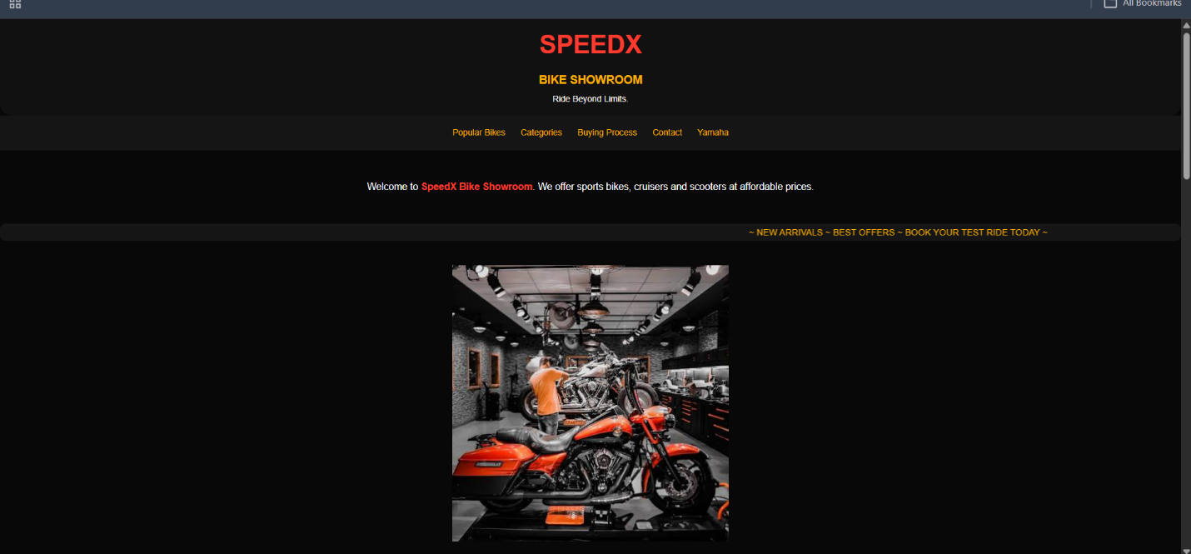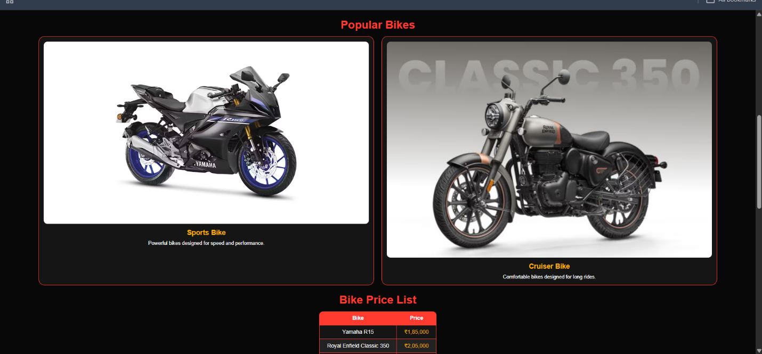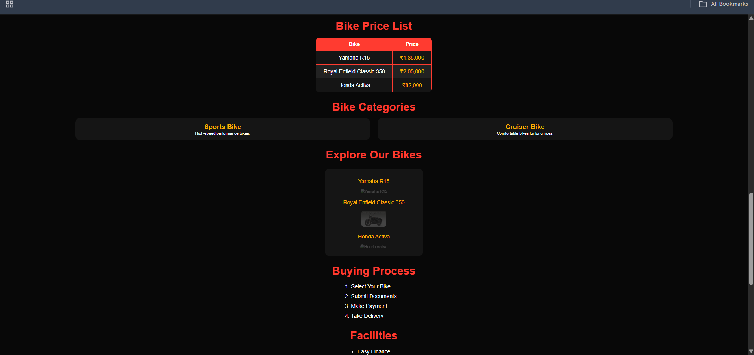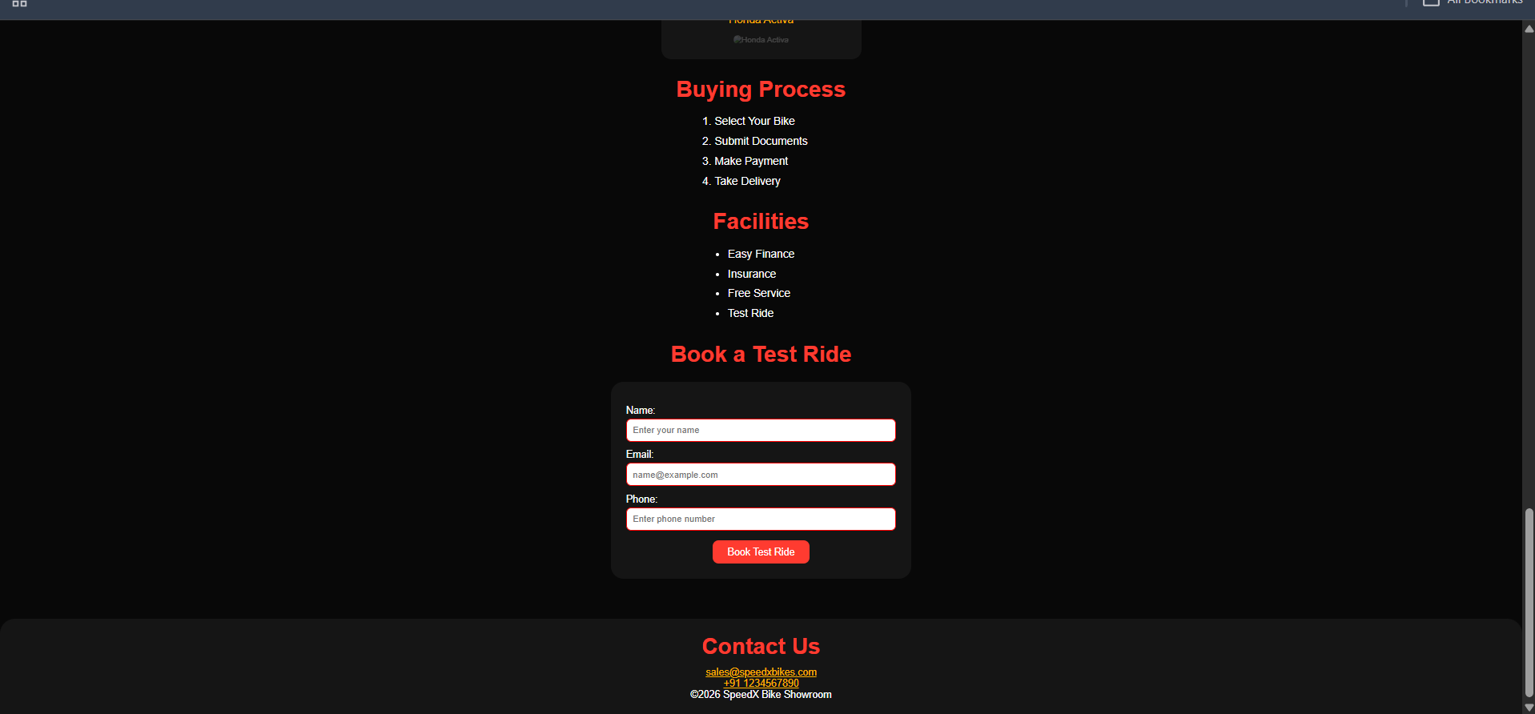

Result
Thus, the SpeedX Bike Showroom website was successfully designed and developed using HTML and CSS. The webpage includes bike details, pricing tables, navigation, interactive styling, a test ride form and responsive layouts.

