Ex. No. 10 | Working with MongoDB using Shell Commands
Date of Exercise
GitHub Host Link

Aim
To demonstrate database creation, document insertion, querying, updating, indexing, and deletion in MongoDB using MongoDB Shell (mongosh) commands.
Description
MongoDB is a NoSQL document-oriented database that stores data in flexible BSON documents. This experiment demonstrates database and collection management, CRUD operations, querying, indexing, and deletion using mongosh.
Procedure:
1. Open MongoDB Shell (mongosh) and connect to the local MongoDB server.
2. List the existing databases using show dbs.
3. Create or switch to the universityDB database using use universityDB.
4. Create a collection named students.
5. Insert single and multiple student documents using insertOne() and insertMany().
6. Retrieve documents using find(), findOne(), and countDocuments().
7. Perform conditional queries using comparison and logical operators.
8. Update documents using $set, $push, and $inc.
9. Create a unique index on the student_id field and display the indexes.
10. Delete selected documents using deleteOne() and deleteMany().
11. Drop the collection and database using drop() and dropDatabase().

Program & Output
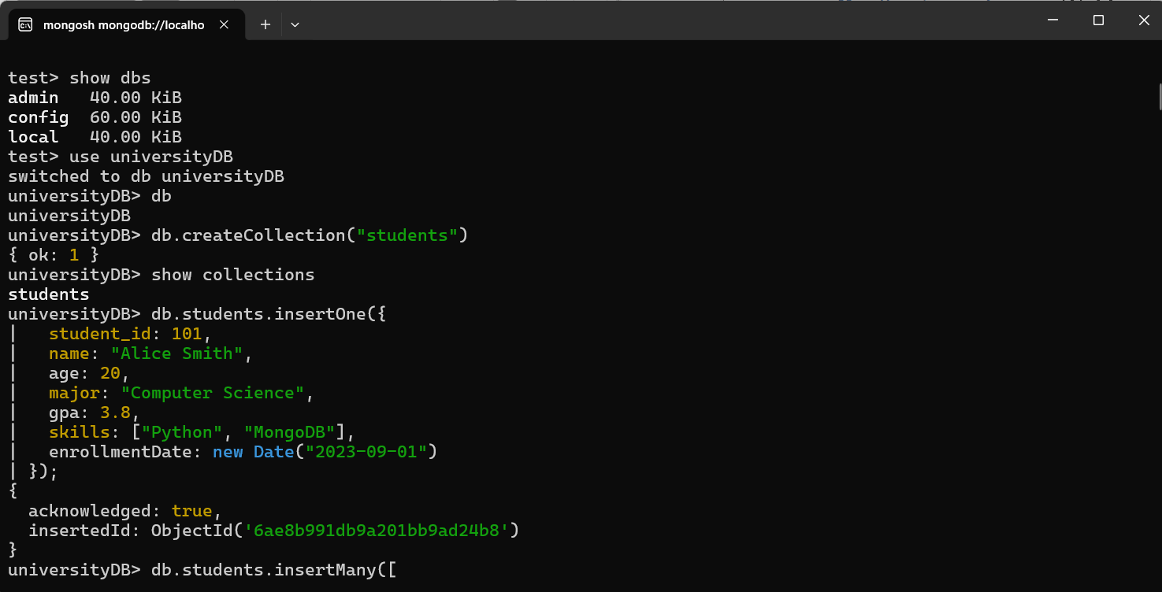
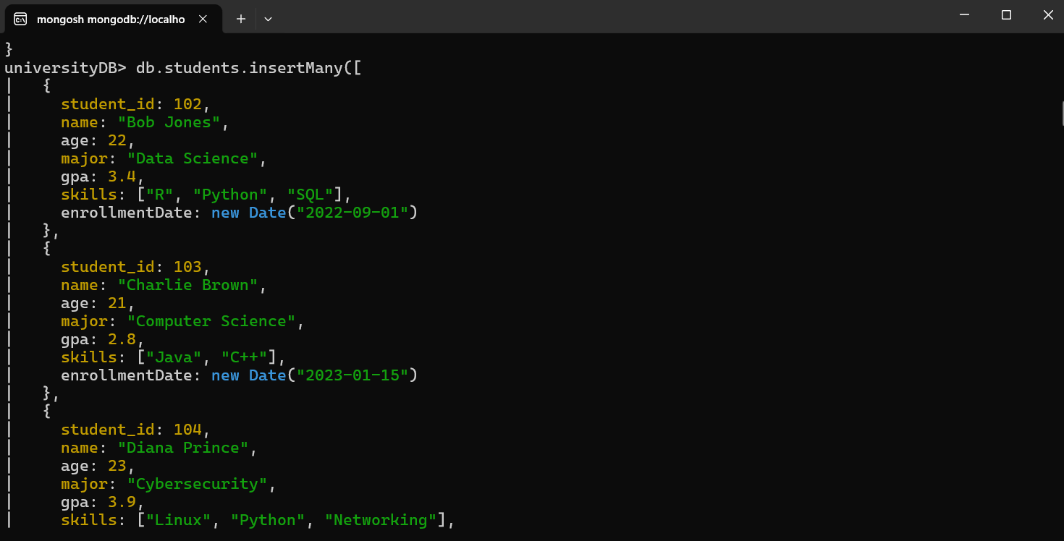
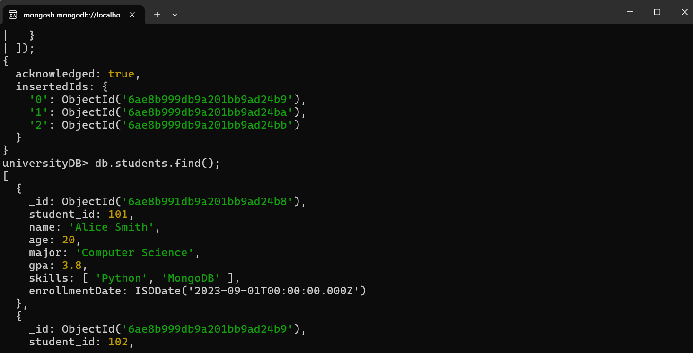
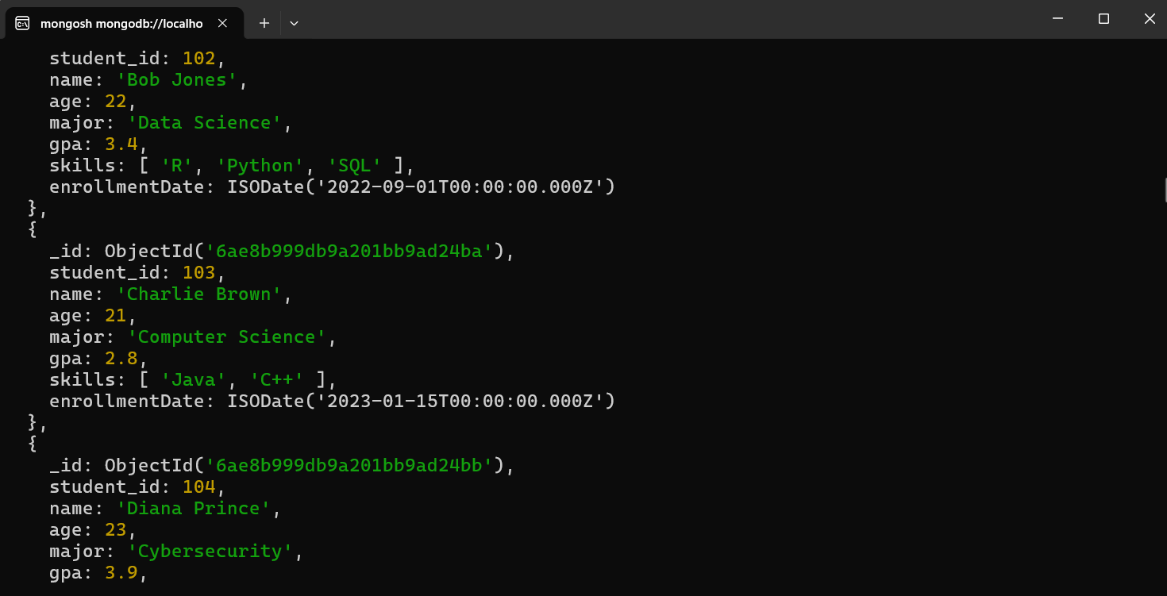
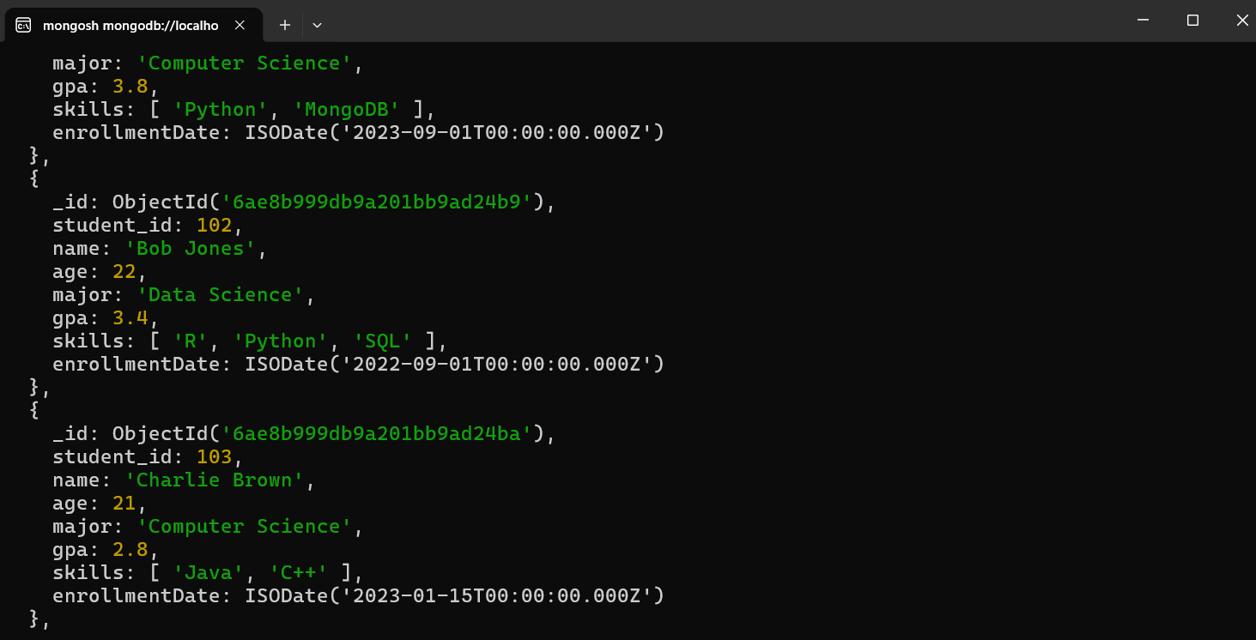
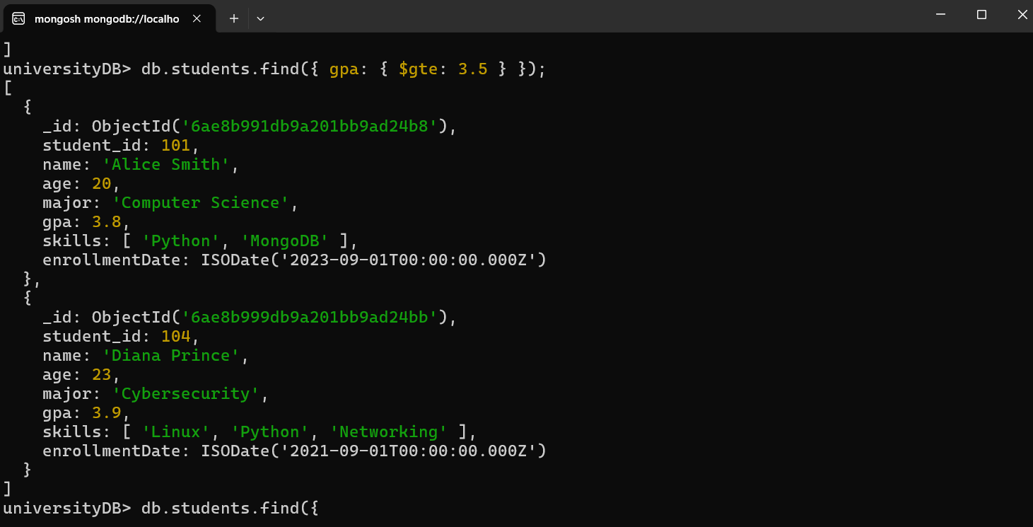
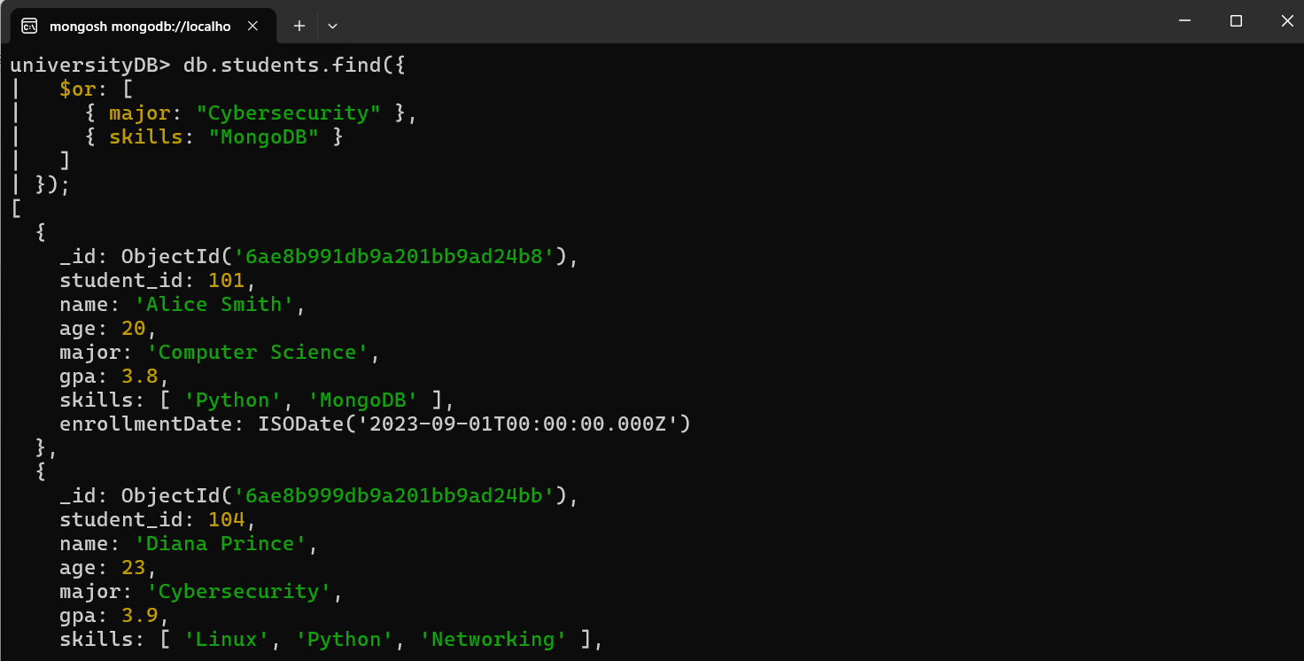
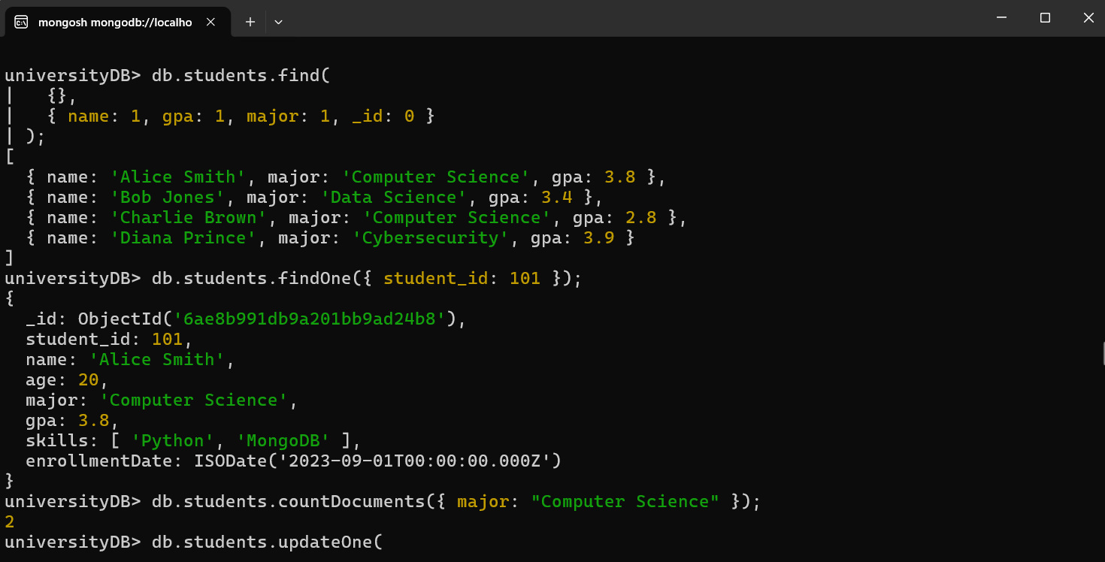
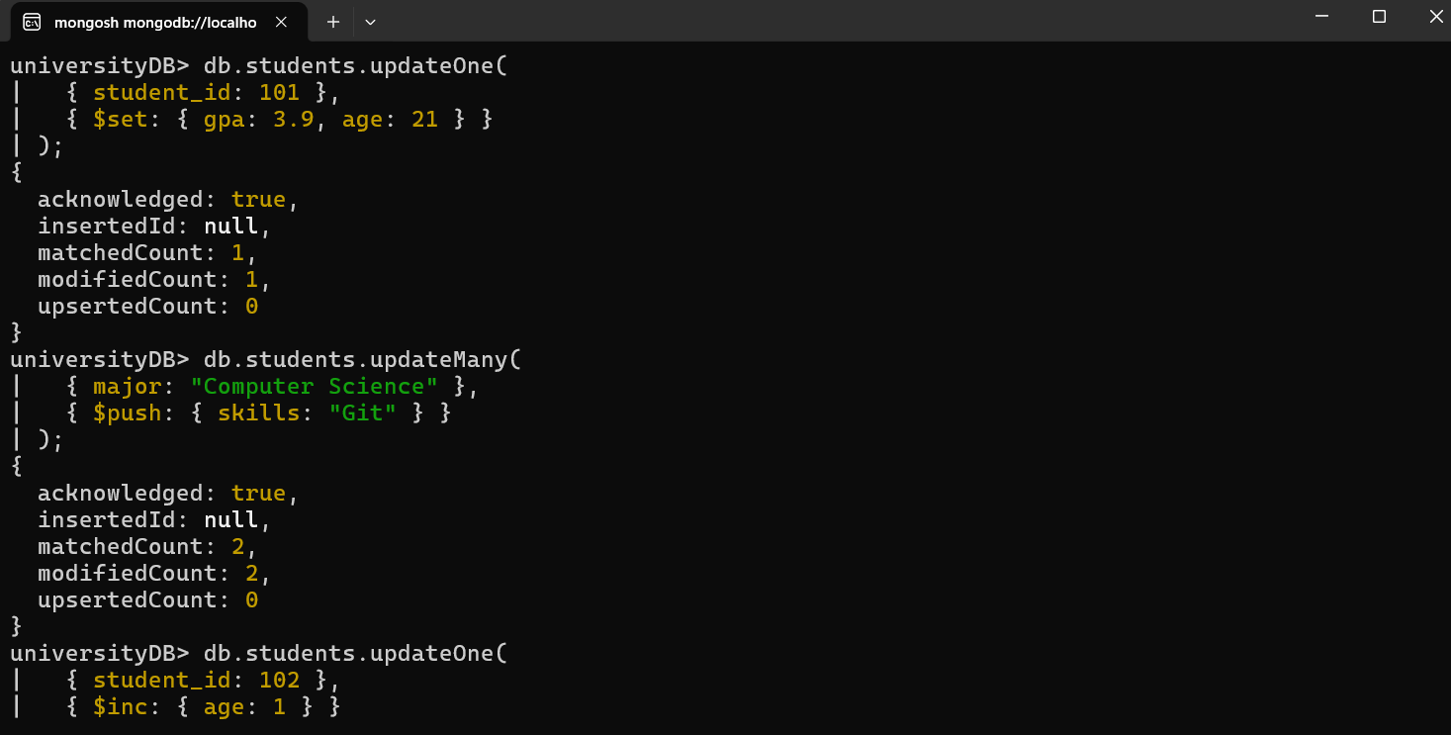
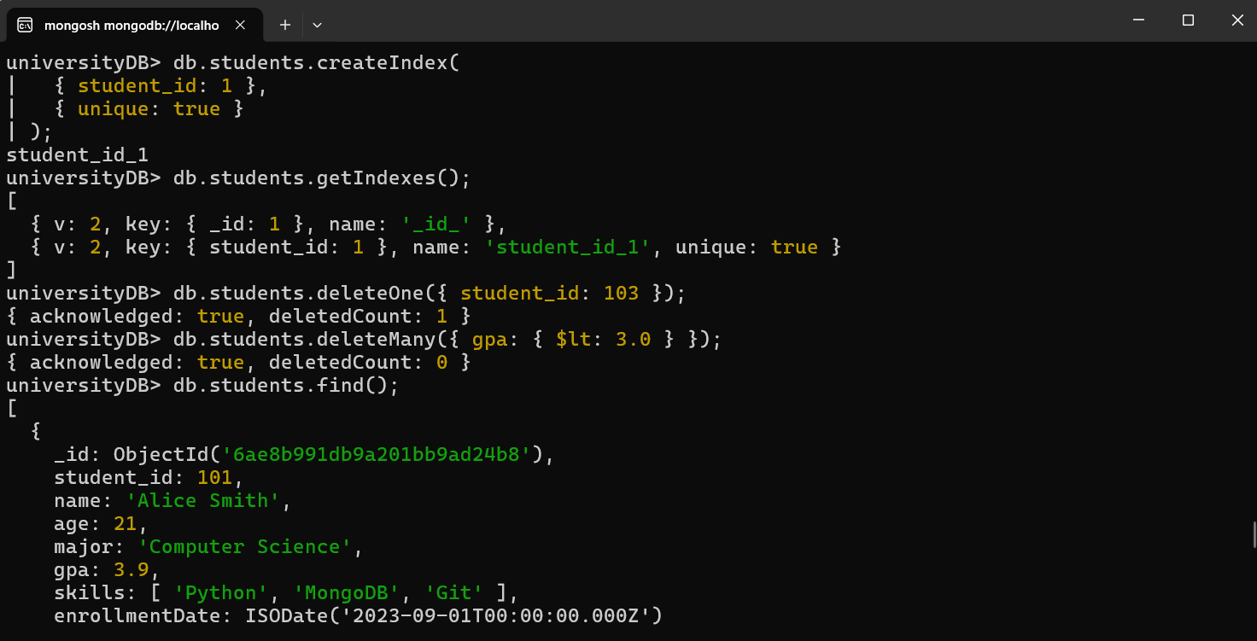
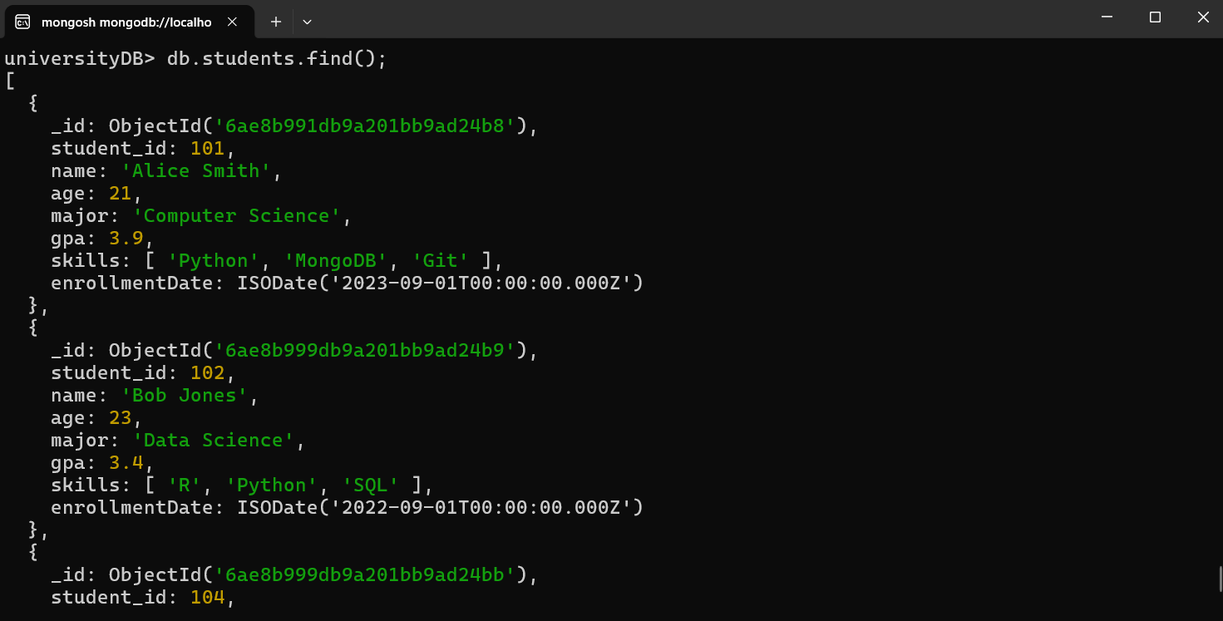
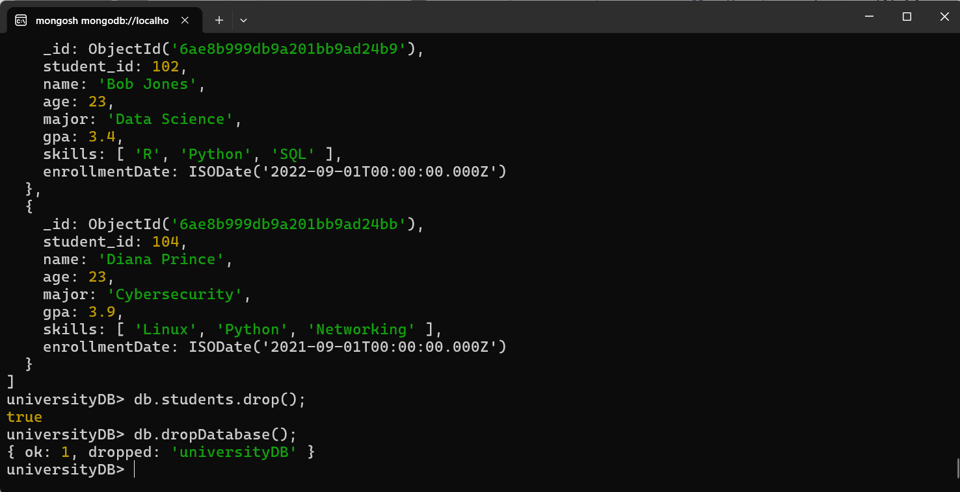

Result
Successfully performed database creation, document insertion, querying, updating, indexing, and deletion using MongoDB Shell (mongosh) commands.

