Ex. No. 2
Date of Exercise
GitHub Host Link

Aim
To design a bike showroom registration form using HTML form elements and different input types.
Description
The SpeedX Bike Showroom registration form is created using HTML form elements such as text fields, password fields, radio buttons, checkboxes, dropdown lists, date pickers, range sliders and colour pickers.
Procedure:
1. Create an HTML file named index.html.
2. Define the basic HTML document structure.
3. Add a heading for the SpeedX Bike Showroom registration form.
4. Create input fields for name, email, password, age and date of birth.
5. Add radio buttons to select the bike type.
6. Add checkboxes to select additional services.
7. Include a dropdown list to select the bike brand.
8. Add a datalist for city selection.
9. Include a range slider and colour picker.
10. Add a submit button and run the webpage in a browser.

Program
<!DOCTYPE html>
<html>
<head>
<title>Bike Showroom Form</title>
</head>

<body bgcolor="beige" text="black">

<center>

<h2 style="font-size:50px;">Bike Showroom Registration Form</h2>

<form action="#" method="post">

<label for="name" style="font-size:28px;">Customer Name:</label><br>
<input type="text" id="name" name="name" placeholder="Enter your name" required style="font-size:22px; width:350px; height:35px;"><br><br>

<label for="email" style="font-size:28px;">Email:</label><br>
<input type="email" id="email" name="email" placeholder="Enter your email" required style="font-size:22px; width:350px; height:35px;"><br><br>

<label for="password" style="font-size:28px;">Password:</label><br>
<input type="password" id="password" name="password" required style="font-size:22px; width:350px; height:35px;"><br><br>

<label for="age" style="font-size:28px;">Age:</label><br>
<input type="number" id="age" name="age" min="18" max="60" style="font-size:22px; width:150px; height:35px;"><br><br>

<label for="visit" style="font-size:28px;">Preferred Visit Date:</label><br>
<input type="date" id="visit" name="visit" style="font-size:22px; height:35px;"><br><br>

<label style="font-size:28px;">Bike Type:</label><br>
<input type="radio" name="bike"> <span style="font-size:24px;">Sports</span>
<input type="radio" name="bike"> <span style="font-size:24px;">Cruiser</span><br><br>

<label style="font-size:28px;">Services:</label><br>
<input type="checkbox"> <span style="font-size:24px;">Finance</span>
<input type="checkbox"> <span style="font-size:24px;">Insurance</span>
<input type="checkbox"> <span style="font-size:24px;">Service</span><br><br>

<label for="brand" style="font-size:28px;">Bike Brand:</label><br>
<select id="brand" style="font-size:22px; width:200px; height:35px;">
<option>Yamaha</option>
<option>Honda</option>
<option>Royal Enfield</option>
</select><br><br>

<label for="city" style="font-size:28px;">City:</label><br>
<input list="cities" style="font-size:22px; width:250px; height:35px;">
<datalist id="cities">
<option value="Chennai">
<option value="Coimbatore">
<option value="Madurai">
</datalist><br><br>

<label for="rating" style="font-size:28px;">Budget:</label><br>
<input type="range" id="rating" min="1" max="10"><br><br>

<label for="color" style="font-size:28px;">Bike Color:</label><br>
<input type="color" id="color"><br><br>

<button type="submit" style="font-size:25px; padding:10px 30px;">
Register
</button>

</form>

</center>

</body>
</html>
Output
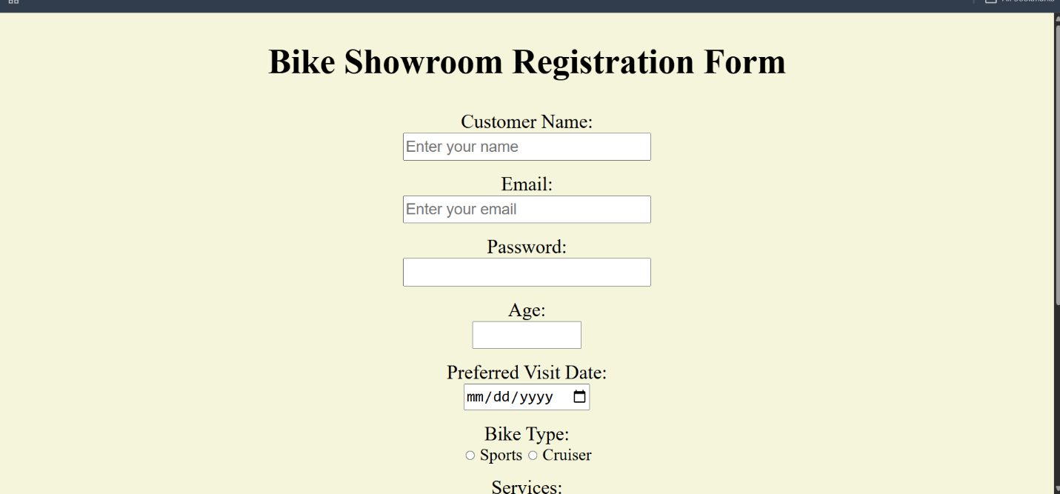

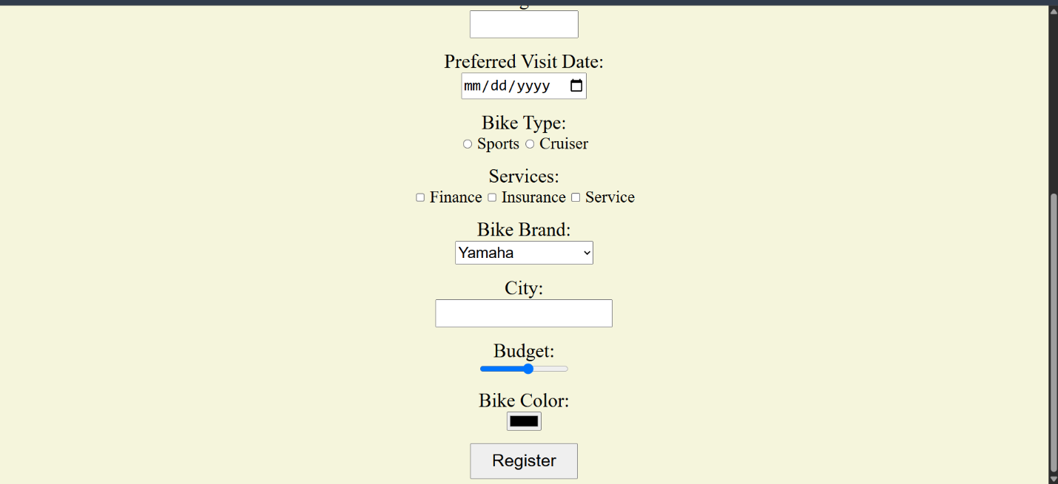

Result
Thus, the SpeedX Bike Showroom registration form was successfully created using HTML form elements and different input types.

