Ex. No. 3 | Responsive Webpage
Date of Exercise
GitHub Host Link

Aim
To design and develop a responsive SpeedX Bike Showroom website using HTML and CSS that adapts to different screen sizes.
Description
The SpeedX Bike Showroom webpage uses HTML and CSS layouts, including Flexbox and media queries, to organise and display bike information. Responsive styling is applied to ensure the webpage adjusts to desktop, tablet and mobile screens.
Procedure:
1. Create an HTML file named webpage.html.
2. Define the basic HTML document structure.
3. Add the SpeedX Bike Showroom header and navigation bar.
4. Create a main container with a sidebar and content section.
5. Add bike cards with images and descriptions.
6. Use CSS Flexbox to arrange the sidebar and bike cards.
7. Apply colours, fonts, margins, padding and borders.
8. Add media queries for different screen sizes.
9. Adjust the layout for tablets and mobile devices.
10. Run the webpage using Live Server and test its responsiveness.

Program
```html
<!DOCTYPE html>
<html lang="en">

<head>

<meta charset="UTF-8">

<meta name="viewport" content="width=device-width, initial-scale=1.0">

<title>SpeedX Bike Showroom - Responsive Website</title>

<style>

*{
margin:0;
padding:0;
box-sizing:border-box;
}

body{
font-family:Arial;
background:#080808;
color:white;
}

header{
background:#111;
text-align:center;
padding:30px;
border-radius:0 0 30px 30px;
}

header h1{
font-size:60px;
color:#ff3b30;
}

header h2{
font-size:30px;
color:#ffb000;
}

header p{
font-size:22px;
}

nav{
background:#151515;
padding:15px;
}

nav ul{
display:flex;
justify-content:center;
list-style:none;
}

nav li{
padding:10px 20px;
border-radius:10px;
}

nav a{
color:#ffb000;
text-decoration:none;
font-size:22px;
}

nav li:hover{
background:#ff3b30;
}

.hero{
background:#222;
text-align:center;
padding:50px;
margin:20px;
border-radius:25px;
}

.hero h2{
color:#ff3b30;
font-size:40px;
}

.hero p{
font-size:23px;
margin-top:15px;
}

.container{
display:flex;
padding:20px;
gap:25px;
}

.sidebar{
width:25%;
background:#151515;
padding:25px;
border-radius:20px;
height:fit-content;
}

.sidebar h2{
color:#ff3b30;
margin-bottom:15px;
}

.sidebar ul{
list-style:none;
}

.sidebar li{
padding:12px;
border-bottom:1px solid #555;
font-size:20px;
color:#ffb000;
}

/* Main Content */

.content{
width:75%;
}

.content h2{
color:#ff3b30;
font-size:35px;
margin-bottom:15px;
}

.content p{
font-size:20px;
line-height:1.6;
}

.cards{
display:flex;
gap:25px;
margin-top:25px;
}

.card{
flex:1;
background:#151515;
padding:20px;
border:2px solid #ff3b30;
border-radius:20px;
text-align:center;
}

.card img{
width:100%;
height:auto;
border-radius:15px;
}

.card h3{
color:#ffb000;
font-size:27px;
margin:15px;
}

.card p{
font-size:18px;
}

button{
background:#ff3b30;
color:white;
padding:12px 25px;
border:none;
border-radius:10px;
margin-top:15px;
font-size:18px;
cursor:pointer;
}

button:hover{
background:#ffb000;
color:black;
}

footer{
background:#151515;
text-align:center;
padding:30px;
margin-top:20px;
border-radius:30px 30px 0 0;
}

footer h2{
color:#ff3b30;
margin-bottom:10px;
}

footer p{
font-size:20px;
}

@media screen and (max-width:992px){

.container{
flex-direction:column;
}

.sidebar,
.content{
width:100%;
}

.cards{
flex-wrap:wrap;
}

.card{
width:45%;
}

}

@media screen and (max-width:768px){

nav ul{
flex-direction:column;
text-align:center;
}

.container{
flex-direction:column;
}

.sidebar,
.content{
width:100%;
}

.cards{
flex-direction:column;
}

.card{
width:100%;
}

.hero{
padding:30px;
}

}

@media screen and (max-width:480px){

header h1{
font-size:40px;
}

header h2{
font-size:23px;
}

.hero h2{
font-size:28px;
}

.hero p{
font-size:18px;
}

.content h2{
font-size:28px;
}

.card h3{
font-size:23px;
}

button{
width:100%;
}

}

</style>

</head>

<body>

<header>

<h1>SPEEDX</h1>

<h2>BIKE SHOWROOM</h2>

<p>Ride Beyond Limits.</p>

</header>

<nav>

<ul>

<li><a href="#">Home</a></li>

<li><a href="#">Sports Bikes</a></li>

<li><a href="#">Cruisers</a></li>

<li><a href="#">Offers</a></li>

<li><a href="#">Contact</a></li>

</ul>

</nav>

<section class="hero">

<h2>Welcome to SpeedX Bike Showroom</h2>

<p>
Explore our collection of sports bikes, cruisers and scooters.
Find your perfect ride at the best prices.
</p>

</section>

<div class="container">

<div class="sidebar">

<h2>Bike Categories</h2>

<ul>

<li>Sports Bikes</li>

<li>Cruiser Bikes</li>

<li>Street Bikes</li>

<li>Electric Bikes</li>

<li>Scooters</li>

<li>Adventure Bikes</li>

</ul>

</div>

<div class="content">

<h2>Popular Bikes</h2>

<p>
SpeedX offers a wide range of bikes designed for performance,
comfort and style. Choose from our popular models and experience
the thrill of riding.
</p>

<div class="cards">

<div class="card">

<img src="bike1.jpg" alt="Yamaha R15">

<h3>Yamaha R15</h3>

<p>
A powerful sports bike designed for speed and performance.
</p>

<button>View Details</button>

</div>

<div class="card">

<img src="bike2.jpg" alt="Royal Enfield Classic 350">

<h3>Classic 350</h3>

<p>
A stylish cruiser bike designed for comfortable long rides.
</p>

<button>View Details</button>

</div>

</div>

</div>

</div>

<footer>

<h2>Contact SpeedX</h2>

<p>sales@speedxbikes.com</p>

<p>+91 1234567890</p>

<p>© 2026 SpeedX Bike Showroom</p>

</footer>

</body>

</html>

Output
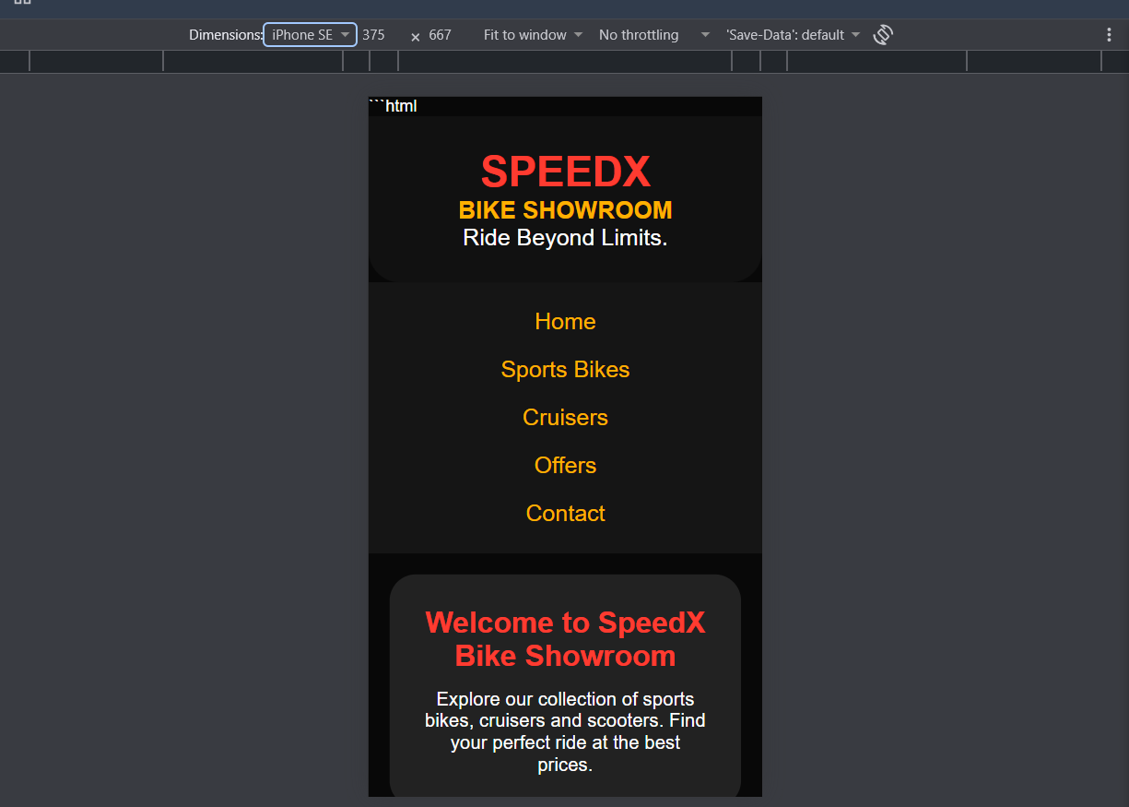
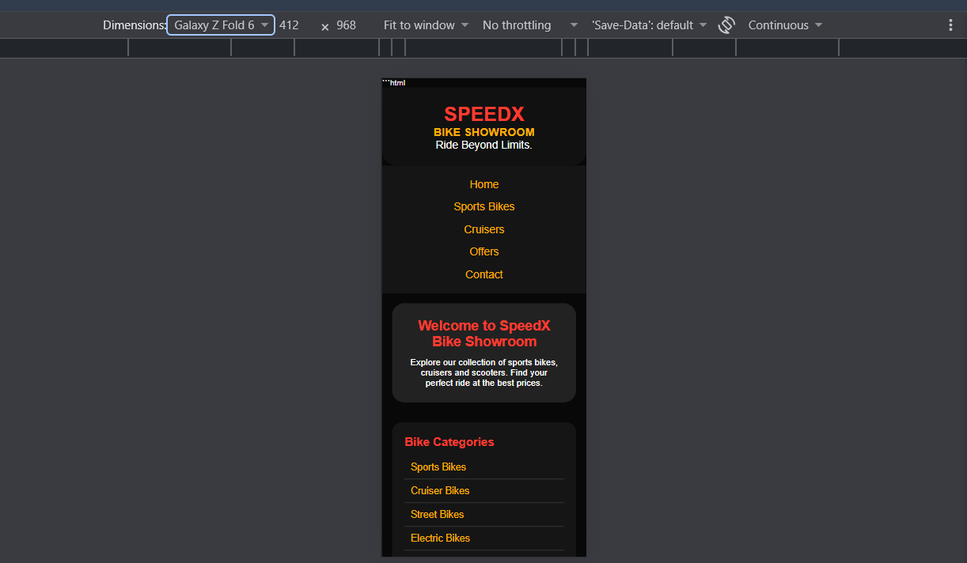
Result
Thus, the SpeedX Bike Showroom registration form was successfully created using HTML form elements and different input types.

