Ex. No. 4 | Webpage Design Using Advanced CSS3
Date of Exercise
GitHub Host Link

Aim
To design a SpeedX Bike Showroom webpage using advanced CSS3 features and selectors.
Description
The webpage demonstrates CSS3 features such as border-radius, border-image, multiple backgrounds, pseudo-classes, adjacent sibling selectors and nth-child() selectors to create interactive styling effects.
Procedure:
1. Create an HTML file named webpage.html.
2. Define the basic HTML document structure.
3. Add the SpeedX Bike Showroom heading and navigation bar.
4. Create sections for showroom images, bike details and pricing.
5. Apply border-radius to create rounded corners.
6. Use border-image to style the showroom image border.
7. Apply multiple backgrounds and background sizing to the hero section.
8. Use :focus, :required, :valid and :invalid pseudo-classes in the form.
9. Apply the adjacent sibling selector to display image effects.
10. Use nth-child() selectors to style alternate table rows.
11. Run the webpage in a browser and verify the CSS effects.

Program
```html
<!DOCTYPE html>
<html lang="en">

<head>

<meta charset="UTF-8">

<meta name="viewport" content="width=device-width, initial-scale=1.0">

<title>SpeedX Bike Showroom</title>

<style>

*{
margin:0;
padding:0;
box-sizing:border-box;
}

body{
font-family:Arial;
background:#080808;
color:white;
}

/* Header */

header{
background:#111;
text-align:center;
padding:30px;
border-radius:0 0 30px 30px;
}

header h1{
font-size:65px;
color:#ff3b30;
}

header h2{
font-size:30px;
color:#ffb000;
}

header p{
font-size:22px;
}

/* Navigation */

nav{
background:#151515;
padding:15px;
}

nav ul{
display:flex;
justify-content:center;
list-style:none;
}

nav li{
padding:10px 20px;
border-radius:10px;
}

nav a{
color:#ffb000;
text-decoration:none;
font-size:22px;
}

nav li:hover{
background:#ff3b30;
}

/* Hero - Multiple Backgrounds */

.hero{
text-align:center;
padding:60px 30px;
margin:20px;
border-radius:25px;

background-image:
url("img_flwr.gif"),
url("paper.gif");

background-position:
right bottom,
left top;

background-repeat:
no-repeat,
repeat;

background-size:
120px 120px,
cover;
}

.hero p{
font-size:25px;
}

/* Offer */

.offer{
background:#151515;
color:#ffb000;
padding:10px;
font-size:23px;
border-radius:15px;
}

/* Showroom Image - Border Image */

.showroom{
text-align:center;
padding:40px;
}

.showroom img{
width:70%;
max-width:750px;
border:20px solid transparent;
border-image:url("border.png") 30 round;
border-radius:20px;
}

/* Main Container */

.container{
padding:20px;
text-align:center;
}

/* Headings */

h2{
font-size:45px;
color:#ff3b30;
margin:35px 0 20px;
}

/* Bike Cards */

.cards{
display:flex;
justify-content:center;
gap:30px;
}

.card{
background:#151515;
padding:20px;
width:45%;
border-radius:25px;
border:2px solid #ff3b30;
}

.card img{
width:100%;
border-radius:15px;
}

.card h3{
font-size:28px;
color:#ffb000;
margin:15px;
}

.card p{
font-size:20px;
}

/* Bike Price Table */

table{
margin:auto;
font-size:22px;
background:#151515;
border-collapse:collapse;
border-radius:15px;
overflow:hidden;
}

th{
background:#ff3b30;
padding:15px 30px;
}

td{
padding:15px 30px;
border:1px solid #ff3b30;
}

td:last-child{
color:#ffb000;
}

/* nth-child Selector */

table tr:nth-child(odd){
background-color:#222;
}

table tr:nth-child(even){
background-color:#151515;
}

table tr:hover{
background-color:#ffd966;
color:black;
}

/* Bike Categories */

.categories{
display:flex;
justify-content:center;
gap:30px;
}

.category{
background:#151515;
padding:20px;
width:40%;
border-radius:20px;
}

.category h3{
color:#ffb000;
font-size:27px;
}

/* Bike List - Adjacent Sibling Selector */

.bike-list{
margin:30px auto;
width:400px;
background:#151515;
padding:20px;
border-radius:20px;
}

.itemName{
display:block;
padding:15px;
margin:5px;
color:#ffb000;
font-size:22px;
cursor:pointer;
border-radius:10px;
}

.itemImg{
opacity:0.2;
transition:opacity 0.3s ease;
margin-bottom:10px;
}

.itemImg img{
width:100px;
border-radius:10px;
}

.itemName:hover + .itemImg{
opacity:1;
}

/* Contact Form - Pseudo Classes */

.contact-form{
background:#151515;
width:70%;
max-width:600px;
margin:30px auto;
padding:30px;
border-radius:25px;
}

.contact-form label{
display:block;
text-align:left;
margin-top:15px;
font-size:20px;
}

.contact-form input{
width:100%;
padding:12px;
margin-top:5px;
border:2px solid #555;
border-radius:10px;
font-size:18px;
}

.contact-form input:focus{
border:3px solid red;
background-color:#e9ffe9;
outline:none;
}

.contact-form input:required{
border-color:#ffb000;
}

.contact-form input:valid{
border-color:limegreen;
}

.contact-form input:invalid{
border-color:red;
}

.contact-form button{
margin-top:20px;
padding:12px 30px;
font-size:20px;
background:#ff3b30;
color:white;
border:none;
border-radius:12px;
cursor:pointer;
}

.contact-form button:hover{
background:#ffb000;
color:black;
}

/* Footer */

footer{
background:#151515;
text-align:center;
padding:30px;
margin-top:30px;
border-radius:30px 30px 0 0;
}

footer h2{
margin:0 0 15px;
}

footer p{
font-size:20px;
}

footer a{
color:#ffb000;
}

/* Tablet */

@media screen and (max-width:768px){

nav ul{
flex-direction:column;
text-align:center;
}

.cards,.categories{
flex-direction:column;
align-items:center;
}

.card,.category{
width:80%;
}

.contact-form{
width:85%;
}

}

/* Mobile */

@media screen and (max-width:480px){

header h1{
font-size:40px;
}

header h2{
font-size:23px;
}

h2{
font-size:35px;
}

.showroom img{
width:95%;
}

.card,.category{
width:95%;
}

table{
font-size:16px;
}

th,td{
padding:10px;
}

.hero{
padding:40px 15px;
}

.hero p{
font-size:20px;
}

.bike-list{
width:95%;
}

}

</style>

</head>

<body>

<header>

<h1>SPEEDX</h1>

<h2>BIKE SHOWROOM</h2>

<p>Ride Beyond Limits.</p>

</header>

<nav>

<ul>

<li><a href="#bikes">Popular Bikes</a></li>

<li><a href="#categories">Categories</a></li>

<li><a href="#explore">Explore Bikes</a></li>

<li><a href="#contact">Contact</a></li>

<li><a href="https://www.yamaha-motor-india.com/" target="_blank">Yamaha</a></li>

</ul>

</nav>

<section class="hero">

<p>
Welcome to <b style="color:#ff3b30;">SpeedX Bike Showroom</b>.
We offer sports bikes, cruisers and scooters at affordable prices.
</p>

</section>

<marquee class="offer">
~ NEW ARRIVALS ~ BEST OFFERS ~ BOOK YOUR TEST RIDE TODAY ~
</marquee>

<div class="showroom">

<a href="showroom.jpg">

<img src="showroom.jpg" alt="Bike Showroom">

</a>

</div>

<div class="container">

<h2 id="bikes">Popular Bikes</h2>

<div class="cards">

<div class="card">

<img src="bike1.jpg" alt="Sports Bike">

<h3>Sports Bike</h3>

<p>Powerful bikes designed for speed and performance.</p>

</div>

<div class="card">

<img src="bike2.jpg" alt="Cruiser Bike">

<h3>Cruiser Bike</h3>

<p>Comfortable bikes designed for long rides.</p>

</div>

</div>

<h2>Bike Price List</h2>

<table>

<tr>
<th>Bike</th>
<th>Price</th>
</tr>

<tr>
<td>Yamaha R15</td>
<td>₹1,85,000</td>
</tr>

<tr>
<td>Royal Enfield Classic 350</td>
<td>₹2,05,000</td>
</tr>

<tr>
<td>Honda Activa</td>
<td>₹82,000</td>
</tr>

</table>

<h2 id="categories">Bike Categories</h2>

<div class="categories">

<div class="category">

<h3>Sports Bike</h3>

<p>High-speed performance bikes.</p>

</div>

<div class="category">

<h3>Cruiser Bike</h3>

<p>Comfortable bikes for long rides.</p>

</div>

</div>

<h2 id="explore">Explore Our Bikes</h2>

<div class="bike-list">

<span class="itemName">Yamaha R15</span>

<div class="itemImg">

<img src="item1.jpg" alt="Yamaha R15">

</div>

<span class="itemName">Royal Enfield Classic 350</span>

<div class="itemImg">

<img src="bike2.jpg" alt="Royal Enfield">

</div>

<span class="itemName">Honda Activa</span>

<div class="itemImg">

<img src="img_flower.jpg" alt="Honda Activa">

</div>

</div>

<h2>Book a Test Ride</h2>

<form class="contact-form">

<label for="name">Name:</label>

<input type="text" id="name" name="name" placeholder="Enter your name" required>

<label for="email">Email:</label>

<input type="email" id="email" name="email" placeholder="name@example.com" required>

<label for="phone">Phone:</label>

<input type="tel" id="phone" name="phone" placeholder="Enter phone number" required>

<button type="submit">Book Test Ride</button>

</form>

</div>

<footer id="contact">

<h2>Contact Us</h2>

<p><a href="mailto:sales@speedxbikes.com">sales@speedxbikes.com</a></p>

<p><a href="tel:+911234567890">+91 1234567890</a></p>

<p>©2026 SpeedX Bike Showroom</p>

</footer>

</body>

</html>
```

Output
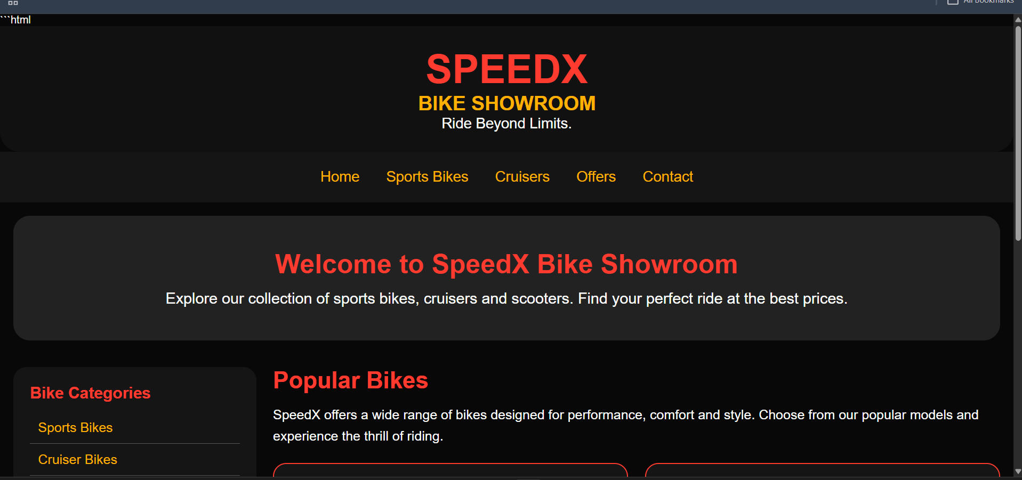
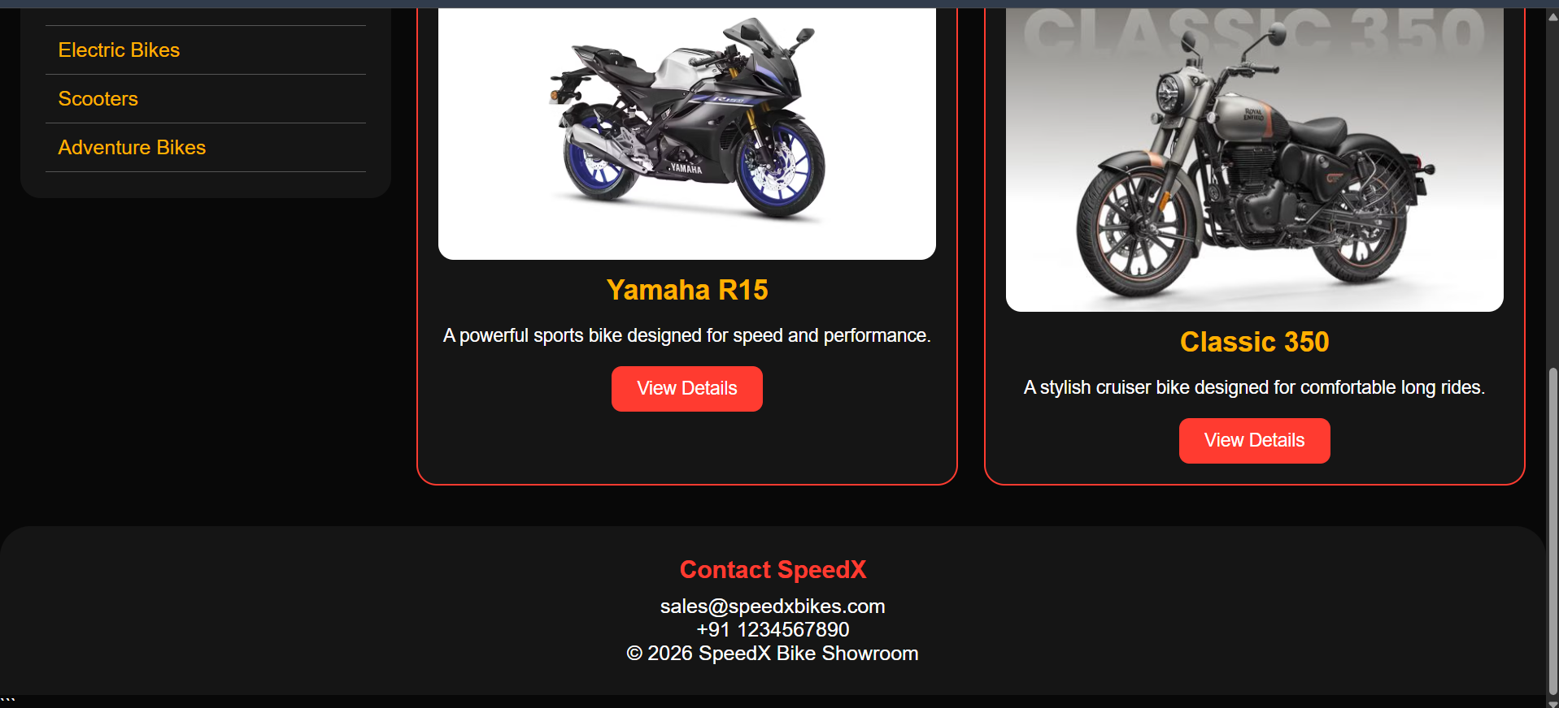

Result
Thus, advanced CSS3 features and selectors were successfully implemented in the SpeedX Bike Showroom webpage.

