Ex. No. 5 | JavaScript Form Validation
Date of Exercise
GitHub Host Link

Aim
To implement form validation using JavaScript functions and conditional statements in the SpeedX Bike Showroom registration form.
Description
The registration form uses JavaScript functions, regular expressions and if-else statements to validate the customer's name, email address and password before submission.
Procedure:
1. Create an HTML file named index.html.
2. Create a JavaScript file named validate.js.
3. Design the SpeedX Bike Showroom registration form using HTML and CSS.
4. Add input fields for name, email and password.
5. Create functions to check empty fields, validate email and check password strength.
6. Use if-else statements to display appropriate validation messages.
7. Use DOM manipulation to display errors.
8. Add a submit event listener to handle form submission.
9. Prevent form submission when the entered details are invalid.
10. Run the webpage and test the form with different inputs.

Program
<!DOCTYPE html>
<html lang="en">

<head>

<meta charset="UTF-8">
<meta name="viewport" content="width=device-width, initial-scale=1.0">

<title>SpeedX Bike Showroom</title>

<style>

*{
margin:0;
padding:0;
box-sizing:border-box;
}

body{
font-family:Arial;
background:#111;
color:white;
}

header{
background:#ff3b30;
padding:20px;
text-align:center;
}

nav{
background:#222;
padding:15px;
text-align:center;
}

nav a{
color:white;
text-decoration:none;
margin:15px;
}

h2{
color:#ffb000;
text-align:center;
margin:25px;
}

.container{
width:400px;
max-width:90%;
margin:30px auto;
background:#222;
padding:25px;
border-radius:10px;
}

label{
display:block;
margin-top:15px;
}

input{
width:100%;
padding:10px;
margin-top:8px;
border:none;
border-radius:5px;
}

button{
width:100%;
padding:12px;
margin-top:20px;
background:#ff3b30;
color:white;
border:none;
border-radius:5px;
cursor:pointer;
}

button:hover{
background:#ffb000;
color:black;
}

.error{
color:#ff3b30;
font-size:13px;
}

footer{
background:#222;
text-align:center;
padding:20px;
margin-top:30px;
}

@media(max-width:500px){

nav a{
display:block;
margin:10px;
}

.container{
width:90%;
}

}

</style>

</head>

<body>

<header>
<h1>SpeedX Bike Showroom</h1>
<p>Ride Your Dream</p>
</header>

<nav>
<a href="#">Home</a>
<a href="#">Bikes</a>
<a href="#">About</a>
<a href="#">Contact</a>
</nav>

<h2>Customer Registration</h2>

<div class="container">

<form id="myForm" novalidate>

<label>Name</label>
<input type="text" id="name">
<span class="error" id="nameError"></span>

<label>Email</label>
<input type="text" id="email">
<span class="error" id="emailError"></span>

<label>Password</label>
<input type="password" id="password">
<span class="error" id="passwordError"></span>

<button type="submit">Register</button>

</form>

</div>

<footer>
<p>© 2026 SpeedX Bike Showroom</p>
</footer>

<script src="validate.js"></script>

</body>

</html>
Output
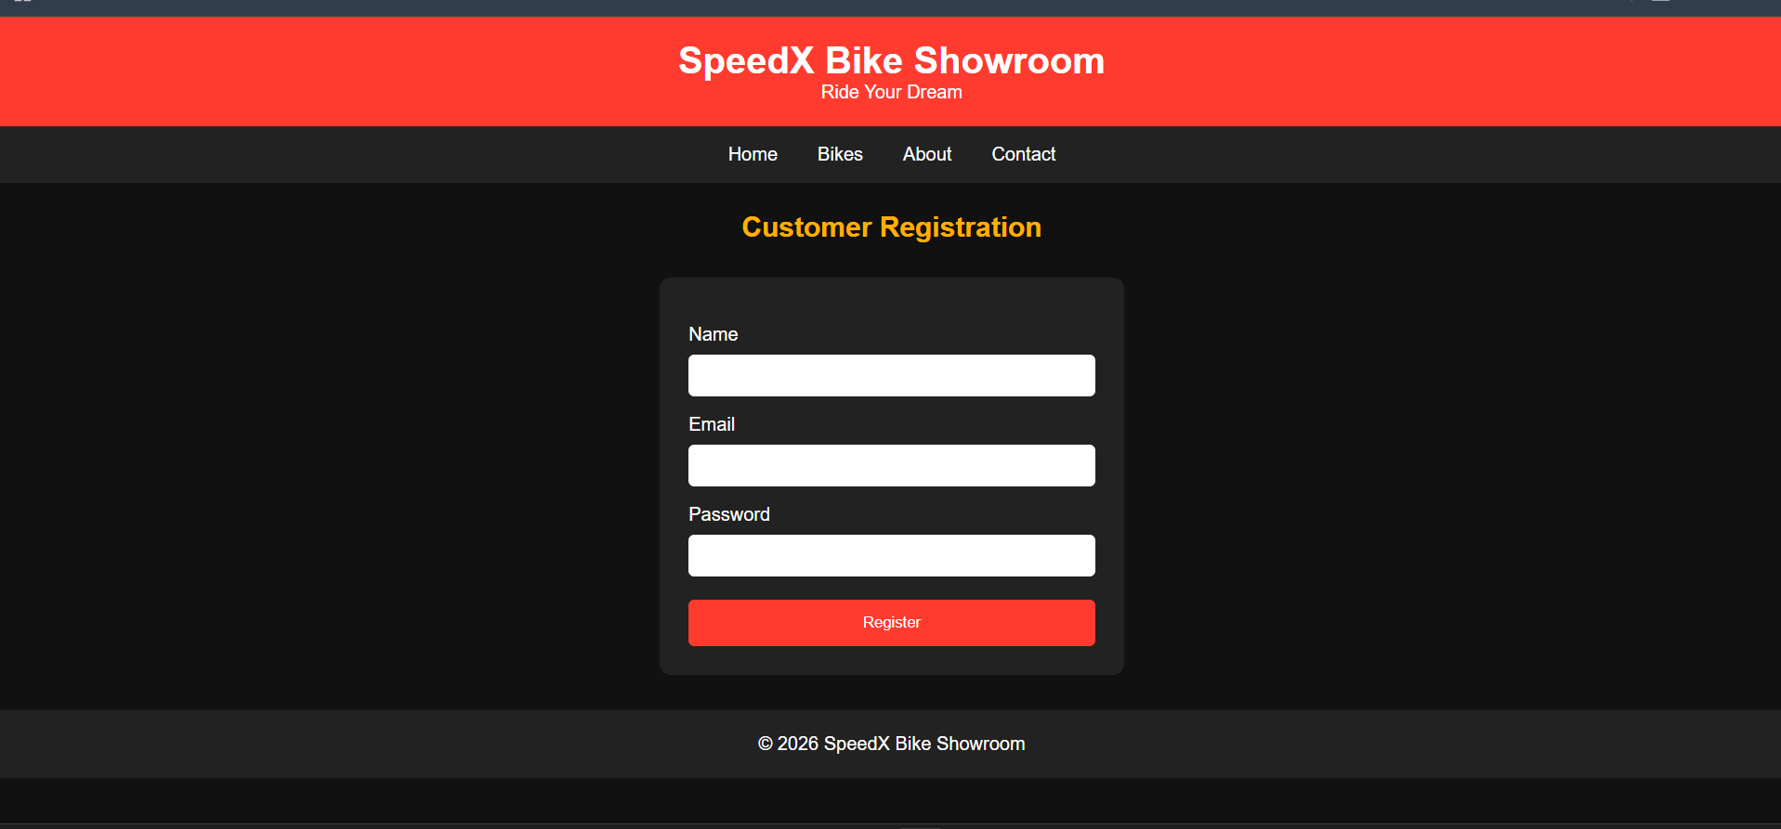

Result
Thus, JavaScript form validation was successfully implemented using functions and conditional statements to verify user inputs before submission.

