Ex. No. 6 | Building a Web App with JavaScript Functions
Date of Exercise
GitHub Host Link

Aim
To develop an interactive task tracker web application using JavaScript functions to add, complete, delete and filter tasks.
Description
The task tracker is developed using JavaScript functions, arrays, objects, callbacks and DOM manipulation. It uses localStorage to save tasks and dynamically updates the task list based on user interactions.
Procedure:
1. Create a project folder named Exp6.
2. Create index.html and app.js files.
3. Design the task tracker interface using HTML and CSS.
4. Create a tasks array to store task details and their completion status.
5. Define createTask() to create new task objects.
6. Implement addTask(), toggleTask() and deleteTask() to manage tasks.
7. Create getVisible() to filter tasks based on their status.
8. Implement renderTasks() to display the task list dynamically.
9. Use localStorage to save and retrieve tasks.
10. Add event listeners to handle task submission and user interactions.
11. Run the application using Live Server and test its functionality.

Program
1. app.js

var tasks = JSON.parse(localStorage.getItem("tasks")) || [];

var filter = "all";

var form = document.getElementById("taskForm");
var input = document.getElementById("taskInput");
var list = document.getElementById("taskList");
var counter = document.getElementById("counter");

function createTask(text){

return {
id: Date.now(),
text: text,
done: false
};

}

function addTask(text){

tasks.push(createTask(text));

saveAndRender();

}

function toggleTask(id){

tasks = tasks.map(t =>
t.id === id ? {...t, done: !t.done} : t
);

saveAndRender();

}

function deleteTask(id){

tasks = tasks.filter(t => t.id !== id);

saveAndRender();

}

function getVisible(){

if(filter === "open"){

return tasks.filter(t => !t.done);

}
else if(filter === "completed"){

return tasks.filter(t => t.done);

}

return tasks;

}

function countOpen(){

return tasks.filter(t => !t.done).length;

}

function taskItem(t){

var li = document.createElement("li");

var span = document.createElement("span");

span.textContent = t.text;

if(t.done){

span.className = "completed";

}

var completeBtn = document.createElement("button");

completeBtn.textContent = t.done ? "Undo" : "Complete";

completeBtn.onclick = function(){

toggleTask(t.id);

};

var deleteBtn = document.createElement("button");

deleteBtn.textContent = "Delete";

deleteBtn.className = "delete";

deleteBtn.onclick = function(){

deleteTask(t.id);

};

li.appendChild(span);
li.appendChild(completeBtn);
li.appendChild(deleteBtn);

return li;

}

function renderTasks(){

list.innerHTML = "";

getVisible().forEach(t => {

list.appendChild(taskItem(t));

});

counter.textContent = countOpen() + " tasks left";

}

function saveAndRender(){

localStorage.setItem("tasks", JSON.stringify(tasks));

renderTasks();

}

function setFilter(value){

filter = value;

renderTasks();

}

function handleSubmit(event){

event.preventDefault();

var text = input.value.trim();

if(text !== ""){

addTask(text);

}

input.value = "";

}

form.addEventListener("submit", handleSubmit);

renderTasks();
2. index.html

<!DOCTYPE html>
<html lang="en">

<head>

<meta charset="UTF-8">
<meta name="viewport" content="width=device-width, initial-scale=1.0">

<title>SpeedX Task Tracker</title>

<style>

*{
margin:0;
padding:0;
box-sizing:border-box;
}

body{
font-family:Arial;
background:#111;
color:white;
}

header{
background:#ff3b30;
padding:20px;
text-align:center;
}

nav{
background:#222;
padding:15px;
text-align:center;
}

nav a{
color:white;
text-decoration:none;
margin:15px;
}

h2{
color:#ffb000;
text-align:center;
margin:25px;
}

.container{
width:500px;
max-width:90%;
margin:30px auto;
background:#222;
padding:25px;
border-radius:10px;
}

form{
display:flex;
gap:10px;
}

input{
flex:1;
padding:12px;
border:none;
border-radius:5px;
}

button{
padding:12px;
background:#ff3b30;
color:white;
border:none;
border-radius:5px;
cursor:pointer;
}

button:hover{
background:#ffb000;
color:black;
}

.filters{
display:flex;
justify-content:center;
gap:10px;
margin:20px 0;
}

ul{
list-style:none;
}

li{
background:#333;
padding:12px;
margin:10px 0;
border-radius:5px;
display:flex;
justify-content:space-between;
align-items:center;
gap:10px;
}

li span{
flex:1;
overflow-wrap:anywhere;
}

.completed{
text-decoration:line-through;
color:#999;
}

.delete{
background:#ff3b30;
}

#counter{
text-align:center;
color:#ffb000;
margin-top:20px;
}

footer{
background:#222;
text-align:center;
padding:20px;
margin-top:30px;
}

@media(max-width:500px){

nav a{
display:block;
margin:10px;
}

form{
flex-direction:column;
}

.filters{
flex-wrap:wrap;
}

}

</style>

</head>

<body>

<header>
<h1>SpeedX Bike Showroom</h1>
<p>Ride Your Dream</p>
</header>

<nav>
<a href="#">Home</a>
<a href="#">Bikes</a>
<a href="#">Services</a>
<a href="#">Contact</a>
</nav>

<h2>Showroom Task Tracker</h2>

<div class="container">

<form id="taskForm">

<input type="text" id="taskInput" placeholder="Enter a task">

<button type="submit">Add Task</button>

</form>

<div class="filters">

<button onclick="setFilter('all')">All</button>
<button onclick="setFilter('open')">Open</button>
<button onclick="setFilter('completed')">Completed</button>

</div>

<ul id="taskList"></ul>

<p id="counter"></p>

</div>

<footer>
<p>© 2026 SpeedX Bike Showroom</p>
</footer>

<script src="app.js"></script>

</body>
</html>
Output
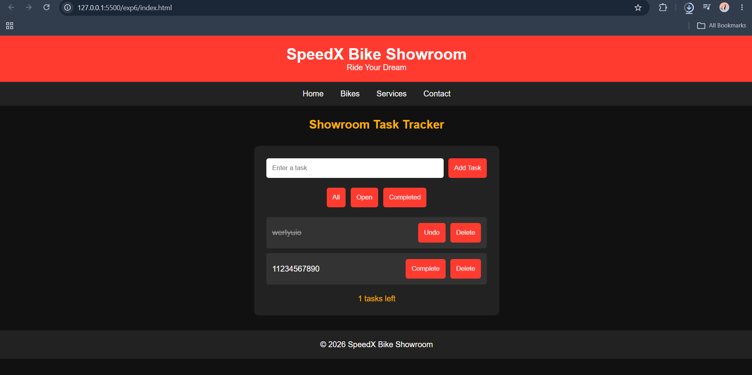
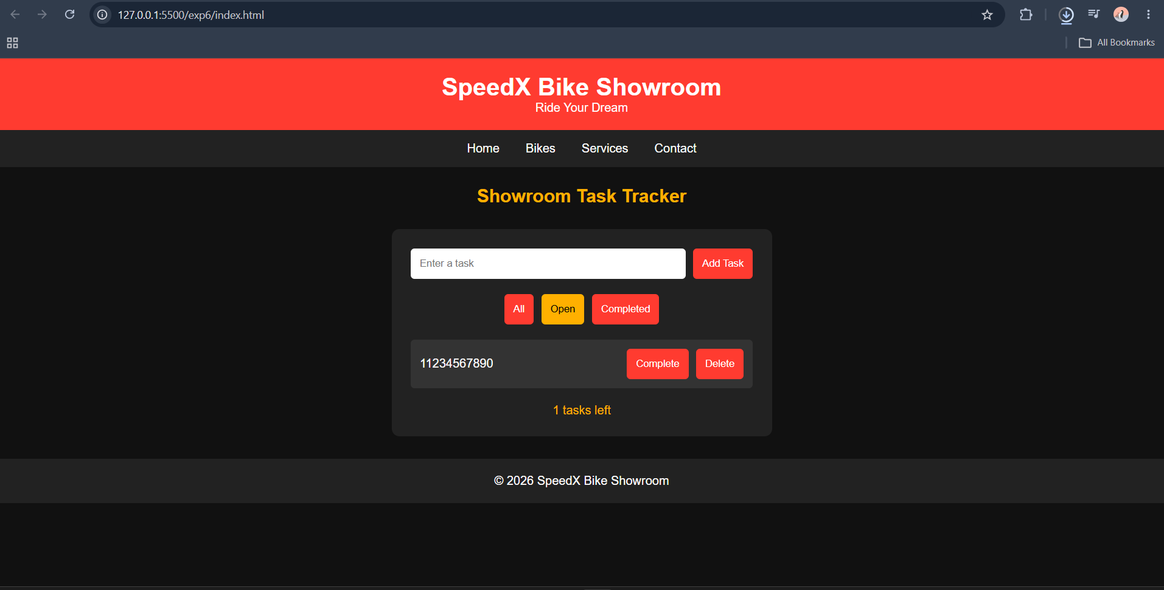
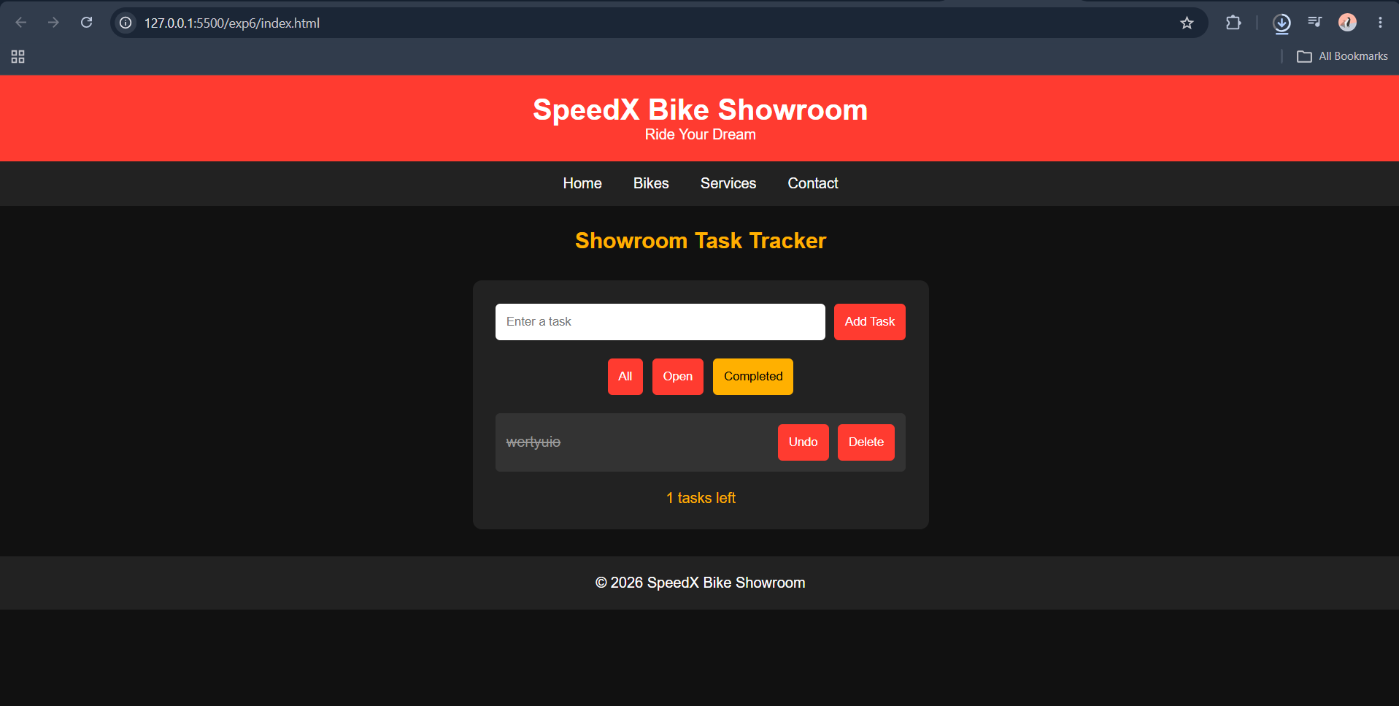

Result
Thus, an interactive task tracker web application was successfully developed using JavaScript functions, callbacks, arrays, DOM manipulation and localStorage.

