Ex. No. 8 | Developing Server Side Application using Node JS
Date of Exercise
GitHub Host Link

Aim
To develop and execute a server-side web application using Node.js to handle HTTP requests, manage routes and send HTML and JSON responses.
Description
The application demonstrates server-side development using Node.js and Express.js. It handles GET and POST requests, processes JSON data, manages routes and returns appropriate HTTP status codes.
Procedure:
1. Create a project folder named Exp8.
2. Open the folder in VS Code.
3. Initialise the project using npm init -y.
4. Create server.js for the native Node.js HTTP server.
5. Import the required http and url modules.
6. Create an HTTP server using http.createServer().
7. Define routes to serve an HTML page and JSON user data.
8. Implement a 404 response for undefined routes.
9. Create app.js for the Express.js server.
10. Install Express using npm install express.
11. Configure JSON middleware using express.json().
12. Define GET and POST routes to retrieve and add items.
13. Start the servers and test the endpoints using a browser or Postman.

Program
1. app.js

const express = require('express');

const app = express();
const PORT = 3000;

// Middleware for JSON data
app.use(express.json());

// Sample item data
let items = [
{ id: 101, name: 'Sports Bike', stock: 12 },
{ id: 102, name: 'Mountain Bike', stock: 5 }
];

// Home page
app.get('/', (req, res) => {
res.send(`
<html>
<head>
<title>SpeedX Bike Showroom</title>
</head>
<body>
<h1>SpeedX Bike Showroom</h1>
<h3>Express Server is Active</h3>
<p>Welcome to SpeedX Bike Showroom.</p>
<a href="/api/items">View Bike Inventory</a>
</body>
</html>
`);
});

// Get all items
app.get('/api/items', (req, res) => {
res.status(200).json({
success: true,
data: items
});
});

// Add a new item
app.post('/api/items', (req, res) => {

const { name, stock } = req.body;

if (!name || stock === undefined) {
return res.status(400).json({
success: false,
message: 'Please provide item name and stock.'
});
}

const newItem = {
id: items.length + 101,
name: name,
stock: Number(stock)
};

items.push(newItem);

res.status(201).json({
success: true,
data: newItem
});
});

// Handle invalid routes
app.use((req, res) => {
res.status(404).json({
success: false,
message: 'Endpoint Not Found'
});
});

// Start server
app.listen(PORT, () => {
console.log('Express server running at http://localhost:' + PORT);
});

2. package.json
{
"name": "exp8",
"version": "1.0.0",
"description": "Node.js Server Side Application",
"main": "server.js",
"scripts": {
"start": "node server.js"
},
"dependencies": {
"express": "^5.1.0"
},
"type": "commonjs"
}

3. server.js

const http = require('http');
const url = require('url');

const PORT = 3000;

// Sample user data
const users = [
{ id: 1, name: 'Alice', role: 'Software Engineer' },
{ id: 2, name: 'Bob', role: 'Systems Architect' }
];

// Create HTTP server
const server = http.createServer((req, res) => {

const path = url.parse(req.url, true).pathname;
const method = req.method;

console.log(method + ' request to ' + path);

// Home page
if (path === '/' && method === 'GET') {

res.writeHead(200, { 'Content-Type': 'text/html' });

res.end(`
<html>
<head>
<title>Node.js Server</title>
</head>
<body>
<h1>SpeedX Bike Showroom</h1>
<h3>Node.js Server is Active</h3>
<p>Welcome to SpeedX Bike Showroom.</p>
<a href="/api/users">View User Data</a>
</body>
</html>
`);
}

// JSON API
else if (path === '/api/users' && method === 'GET') {

res.writeHead(200, { 'Content-Type': 'application/json' });

res.end(JSON.stringify({
success: true,
count: users.length,
data: users
}));
}

// 404 error
else {

res.writeHead(404, { 'Content-Type': 'application/json' });

res.end(JSON.stringify({
success: false,
message: 'Resource Not Found'
}));
}

});

// Start server
server.listen(PORT, () => {
console.log('Server running at http://localhost:' + PORT);
});

Output
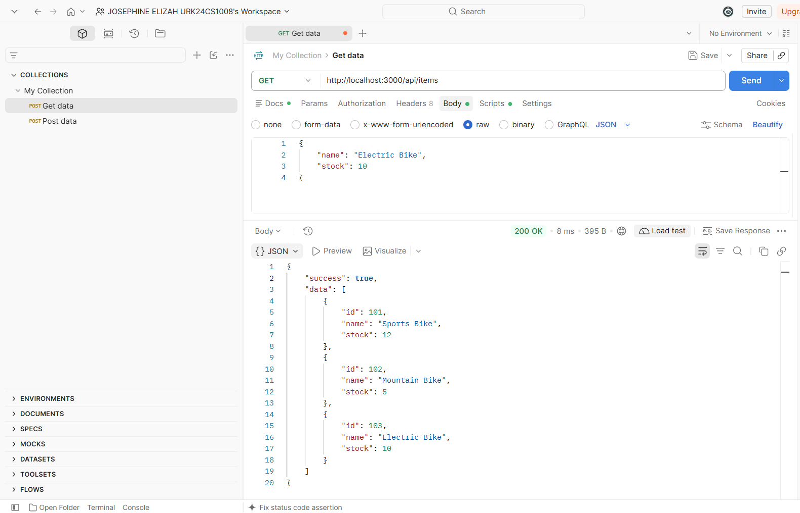

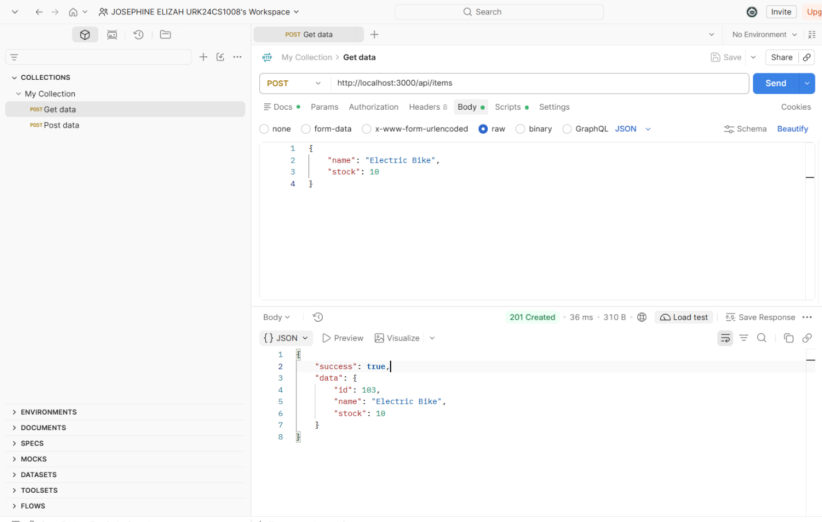

Result
Thus, server-side applications were successfully developed and executed using Node.js and Express.js to handle HTTP requests, process JSON data and manage different routes.

