Ex. No. 9 | Modern User Interface Design using ReactJS
Date of Exercise
GitHub Host Link

Aim
To design and implement a modern, responsive and interactive dashboard using ReactJS with functional components, state management hooks, props and CSS theme switching.
Description
A modern dashboard is developed using ReactJS with reusable components, useState hooks and props. CSS is used to create a responsive layout with interactive task management and light/dark theme switching.
Procedure:
1. Create a React project using Vite.
2. Install the required dependencies.
3. Create App.js and App.css files.
4. Import React, useState and the CSS file.
5. Create reusable components such as Header, StatCard and TaskList.
6. Use props to pass data and functions between components.
7. Implement useState to manage theme, tasks and user input.
8. Add functions to add, complete and delete tasks.
9. Implement light and dark theme switching.
10. Apply CSS styling using Flexbox, Grid and responsive media queries.
11. Run the React application and test its functionality.

Program
1. App.jsx
import { useState } from "react";
import "./App.css";

const Header = ({ theme, toggleTheme, userName }) => {
return (
<header className="app-header">
<h2>ModernUI Dashboard</h2>

<div className="header-actions">
<span>Welcome, <strong>{userName}</strong></span>

<button onClick={toggleTheme}>
{theme === "light" ? "Dark Mode" : "Light Mode"}
</button>
</div>
</header>
);
};

const StatCard = ({ title, value, change, isPositive, icon }) => {
return (
<div className="stat-card">
<div className="stat-header">
<span>{icon}</span>
<span>{title}</span>
</div>

<div className="stat-body">
<h3>{value}</h3>
<span className={isPositive ? "positive" : "negative"}>
{isPositive ? "▲" : "▼"} {change}
</span>
</div>
</div>
);
};

const TaskList = ({ tasks, onToggleTask, onDeleteTask }) => {
return (
<div className="task-container">
<h3>Project Milestones</h3>

<ul className="task-list">
{tasks.length === 0 ? (
<li>No active milestones found.</li>
) : (
tasks.map((task) => (
<li
key={task.id}
className={task.completed ? "completed" : ""}
>
<label>
<input
type="checkbox"
checked={task.completed}
onChange={() => onToggleTask(task.id)}
/>
<span>{task.title}</span>
</label>

<button onClick={() => onDeleteTask(task.id)}>
X
</button>
</li>
))
)}
</ul>
</div>
);
};

export default function App() {
const [theme, setTheme] = useState("light");
const [taskInput, setTaskInput] = useState("");

const [tasks, setTasks] = useState([
{ id: 1, title: "Design Component Wireframes", completed: true },
{ id: 2, title: "Build Responsive Layout System", completed: false },
{ id: 3, title: "Optimize Dark/Light Theme Switching", completed: false }
]);

const toggleTheme = () => {
setTheme((prev) => (prev === "light" ? "dark" : "light"));
};

const handleAddTask = (e) => {
e.preventDefault();

if (!taskInput.trim()) return;

const newTask = {
id: Date.now(),
title: taskInput.trim(),
completed: false
};

setTasks((prev) => [...prev, newTask]);
setTaskInput("");
};

const handleToggleTask = (id) => {
setTasks((prev) =>
prev.map((task) =>
task.id === id
? { ...task, completed: !task.completed }
: task
)
);
};

const handleDeleteTask = (id) => {
setTasks((prev) => prev.filter((task) => task.id !== id));
};

return (
<div className={`app-root ${theme}`}>
<Header
theme={theme}
toggleTheme={toggleTheme}
userName="Alex Vance"
/>

<main className="dashboard-content">
<section className="stats-grid">
<StatCard
title="Total Revenue"
value="$48,250"
change="14.2%"
isPositive={true}
icon="💰"
/>

<StatCard
title="Active Sessions"
value="2,840"
change="8.6%"
isPositive={true}
icon="👥"
/>

<StatCard
title="Bounce Rate"
value="21.4%"
change="2.1%"
isPositive={false}
icon="📊"
/>
</section>

<section className="task-section">
<form className="task-form" onSubmit={handleAddTask}>
<input
type="text"
placeholder="Add a new milestone..."
value={taskInput}
onChange={(e) => setTaskInput(e.target.value)}
/>

<button type="submit">Add Task</button>
</form>

<TaskList
tasks={tasks}
onToggleTask={handleToggleTask}
onDeleteTask={handleDeleteTask}
/>
</section>
</main>
</div>
);
}

2. index.css

* {
box-sizing: border-box;
}

body {
margin: 0;
padding: 0;
}

3. App.css

:root {
--bg-primary: #f8fafc;
--bg-card: #ffffff;
--text-primary: #0f172a;
--text-secondary: #64748b;
--accent-color: #2563eb;
--border-color: #e2e8f0;
}

.app-root.dark {
--bg-primary: #0f172a;
--bg-card: #1e293b;
--text-primary: #f8fafc;
--text-secondary: #94a3b8;
--accent-color: #3b82f6;
--border-color: #334155;
}

.app-root {
min-height: 100vh;
background-color: var(--bg-primary);
color: var(--text-primary);
font-family: system-ui, sans-serif;
transition: 0.3s;
}

.app-header {
display: flex;
justify-content: space-between;
align-items: center;
padding: 1rem 2rem;
background: var(--bg-card);
border-bottom: 1px solid var(--border-color);
}

.header-actions {
display: flex;
align-items: center;
gap: 1rem;
}

button {
cursor: pointer;
}

.header-actions button {
padding: 0.5rem 1rem;
border-radius: 8px;
border: 1px solid var(--border-color);
background: transparent;
color: var(--text-primary);
}

.dashboard-content {
max-width: 1100px;
margin: 2rem auto;
padding: 0 1rem;
}

.stats-grid {
display: grid;
grid-template-columns: repeat(auto-fit, minmax(260px, 1fr));
gap: 1.5rem;
margin-bottom: 2rem;
}

.stat-card {
background: var(--bg-card);
padding: 1.5rem;
border-radius: 12px;
border: 1px solid var(--border-color);
}

.stat-header {
display: flex;
align-items: center;
gap: 0.5rem;
color: var(--text-secondary);
font-size: 0.9rem;
}

.stat-body {
display: flex;
justify-content: space-between;
align-items: baseline;
margin-top: 0.5rem;
}

.positive {
color: #16a34a;
}

.negative {
color: #dc2626;
}

.task-section {
background: var(--bg-card);
padding: 1.5rem;
border-radius: 12px;
border: 1px solid var(--border-color);
}

.task-form {
display: flex;
gap: 0.5rem;
margin-bottom: 1.5rem;
}

.task-form input {
flex: 1;
padding: 0.75rem 1rem;
border-radius: 8px;
border: 1px solid var(--border-color);
background: var(--bg-primary);
color: var(--text-primary);
}

.task-form button {
padding: 0.75rem 1.5rem;
background: var(--accent-color);
color: white;
border: none;
border-radius: 8px;
font-weight: 600;
}

.task-list {
list-style: none;
padding: 0;
margin: 0;
}

.task-list li {
display: flex;
justify-content: space-between;
align-items: center;
padding: 0.75rem 0;
border-bottom: 1px solid var(--border-color);
}

.task-list label {
display: flex;
align-items: center;
gap: 0.5rem;
}

.task-list .completed label {
text-decoration: line-through;
color: var(--text-secondary);
}

.task-list button {
background: none;
border: none;
color: #dc2626;
font-size: 1.1rem;
}

Output
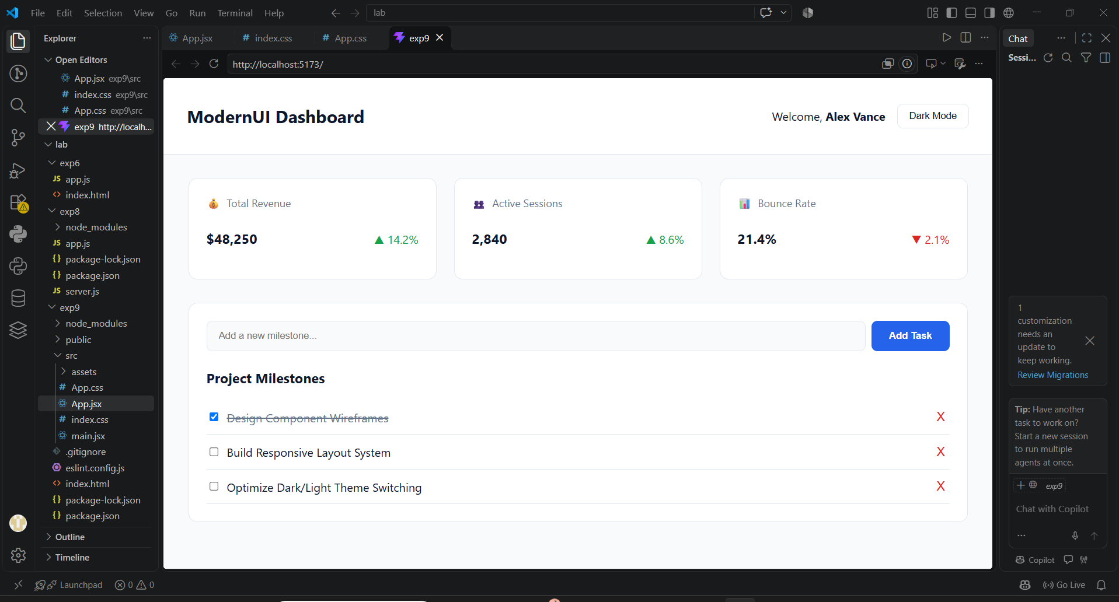
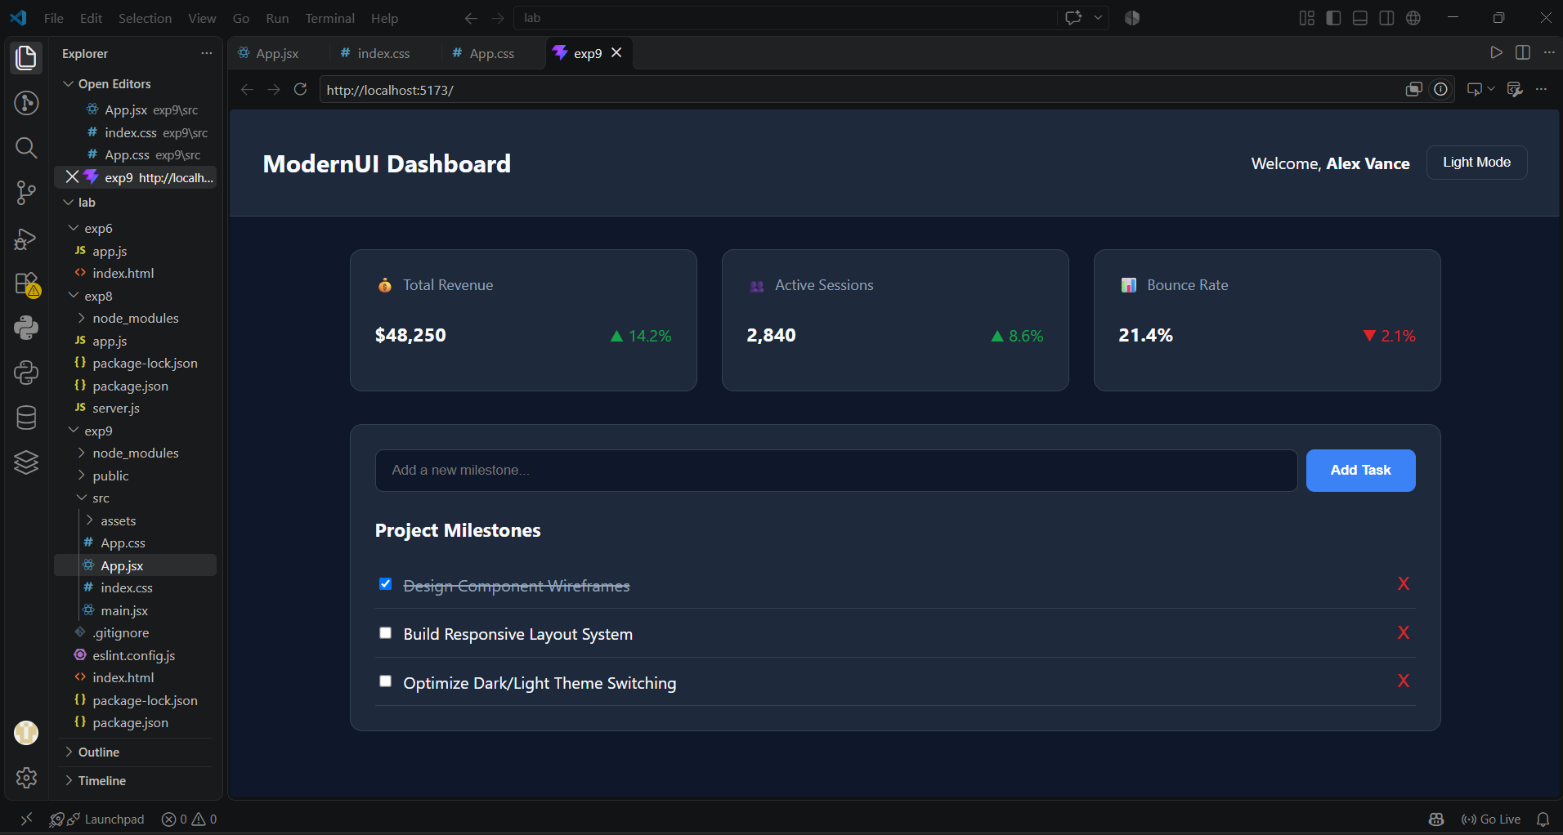
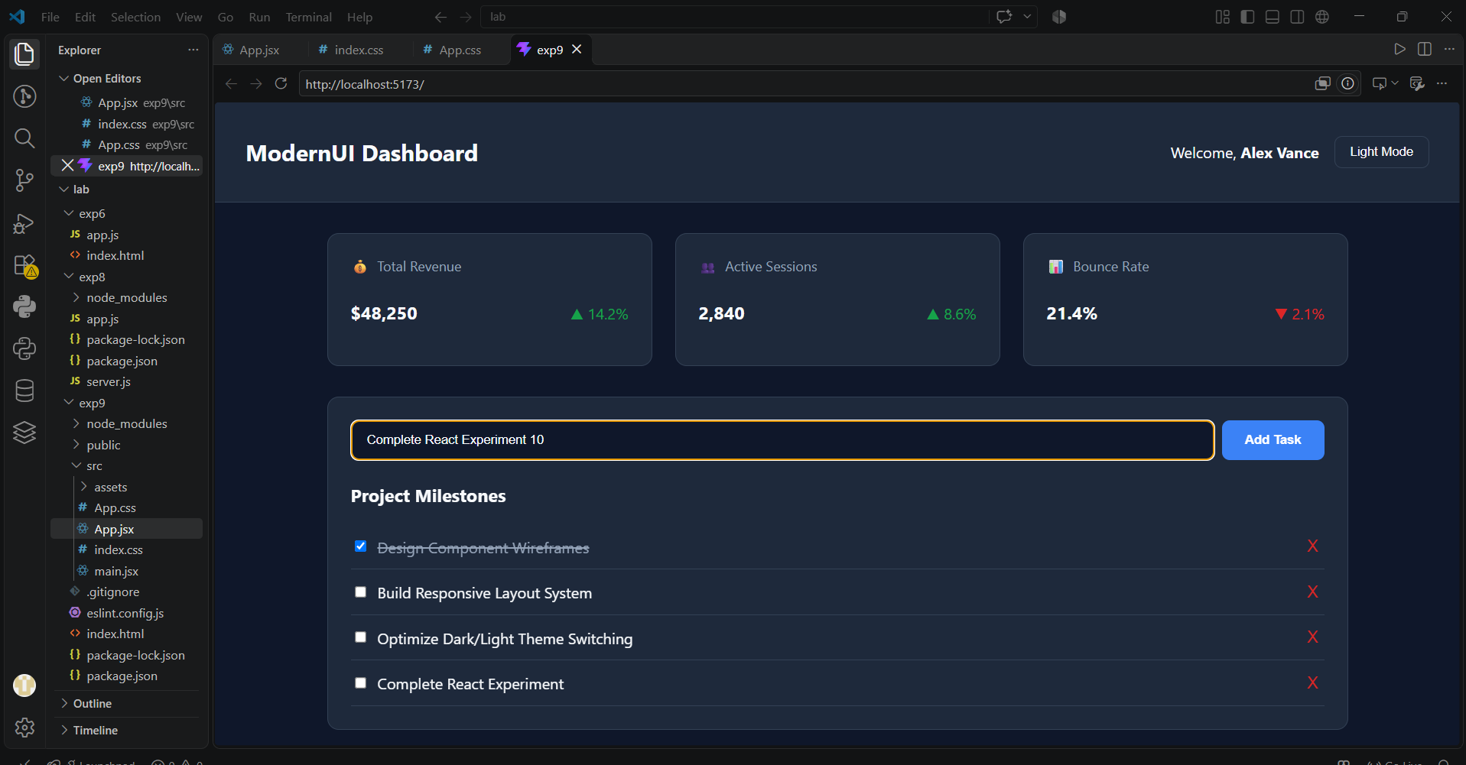
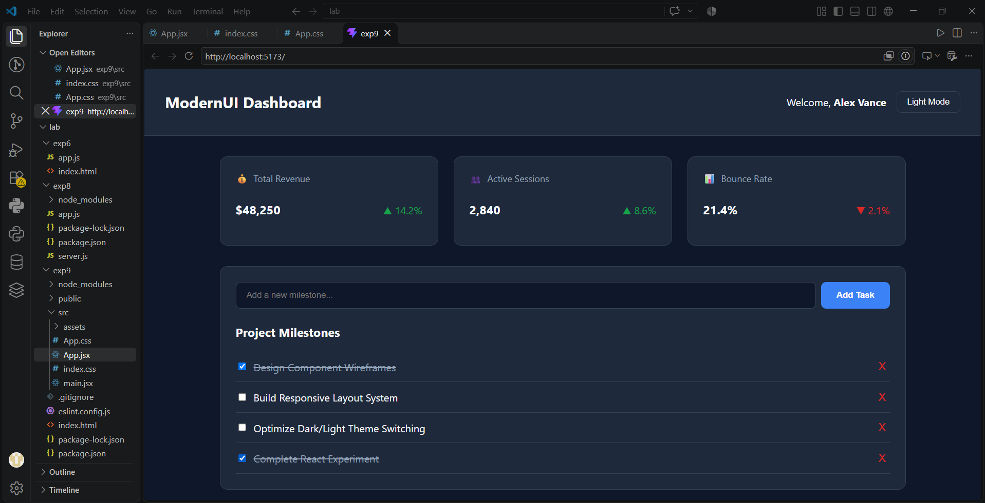
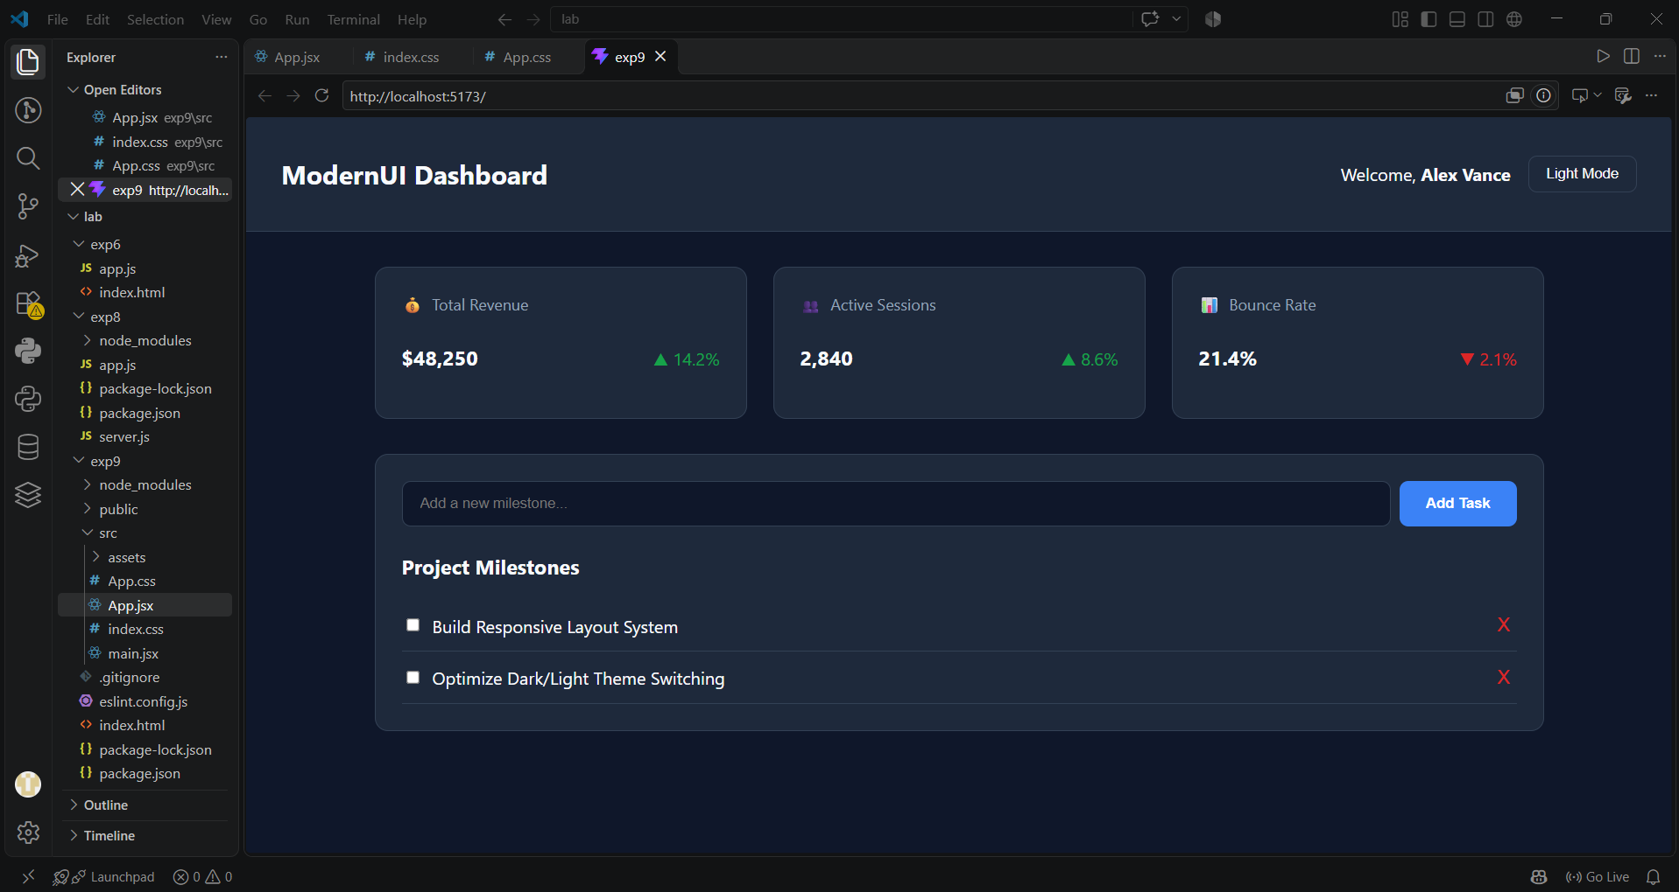

Result
Thus, a modern and responsive dashboard was successfully developed using ReactJS with reusable components, state management, props and CSS theme switching.

