**Docker Kafka container :**

**basecontainer is docker container from fedora/apache image with all tools and java installed**

A) Download confluent and extact tar file in /opt

1.[root@www.mamonir.com josephine]# cd /opt/

2. [root@www.mamonir.com opt]# wget http://packages.confluent.io/archive/5.1/confluent-5.1.2-2.11.tar.gz

3. [root@www.mamonir.com opt]# tar -xzvf confluent-5.1.2-2.11.tar.gz

B) With basecontainer(local image kafka-5.1.2(original fedora/apache))

1.commit and tag the container to save

[root@www.mamonir.com josephine]#docker tag d096f3302872 kafka-5.1.2

(kafka-5.1.2 image base fadora/apache install all necessary tool and java-1.8)

2. run the container with port open 2181 and 9092

[root@www.mamonir.com josephine]# docker run -it -p 2181:2181 -p 9092:9092 --name kafka -h kafka.mamonir.com -v /opt/confluent:/opt kafka-5.1.2 /bin/bash

**Normal kafka workflow:**

**1) start zookeeper**

**2) start kafka**

**3) create a topic**

**4) start producer**

**5) start consumer**

**from putty**

**1. In first putty terminal: connect to container kafka**

a) To see container kafka running

[root@www.mamonir.com josephine]#docker ps

b) if it is running

[root@www.mamonir.com josephine]#docker attach kafka

or [root@www.mamonir.com josephine]#docker start kafka

[root@www.mamonir.com josephine]#docker attach kafka

**2. start zookeeper server:**

a)To start zookeeper-server:

[root@kafka bin]# ./zookeeper-server-start -daemon ../etc/kafka/zookeeper.properties

( if port 0.0.0.0/0.0.0.0:2181 is seen in output press ctrl-c and run below)

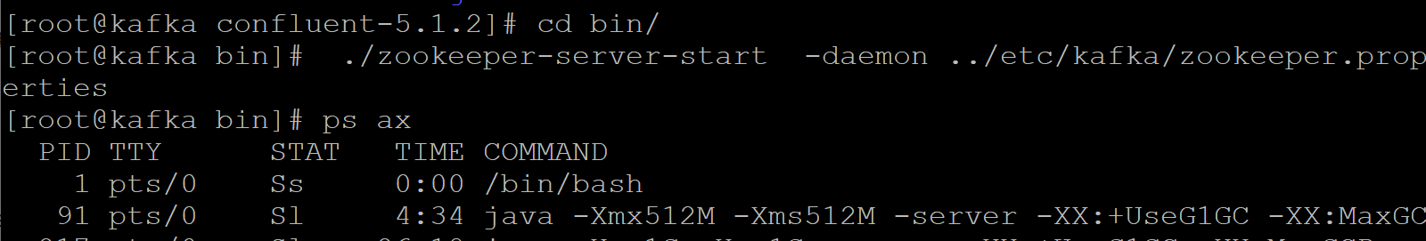

**b) To start zookeeper-daemon:**

[root@kafka bin]# ./zookeeper-server-start -daemon ../etc/kafka/zookeeper.properties

**c) Run netstat command to ensure zookeeper running in 2181**

[root@kafka bin]# netstat -anp|grep 2181

tcp6 0 0 :::2181 :::* LISTEN 15418/java

start kafka server:

cd /opt/confluent-4.1.0/bin

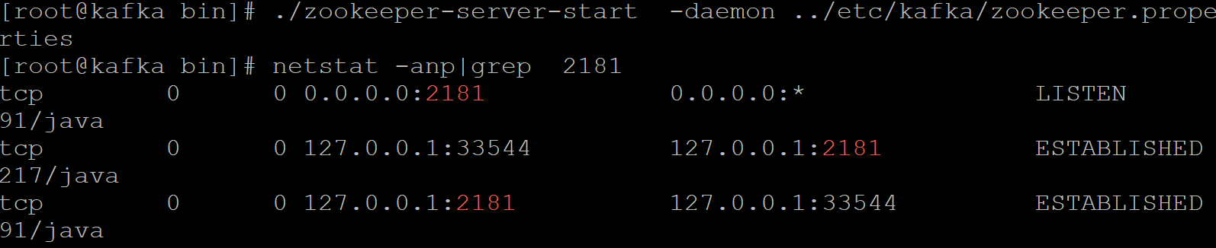

**3. kafka start:**

a) To start kafka-server:

[root@kafka bin]# ./kafka-server-start ../etc/kafka/server.properties

(if socket connections on 0.0.0.0:9092. is seen in output press ctrl-c and run below)



**b) To start kafka-daemon**

[root@kafka bin]# ./kafka-server-start -daemon ../etc/kafka/server.properties

**c) Run netstat command to ensure kafka running in 9092**

[root@kafka bin]# netstat -anp|grep 9092

tcp6 0 0 :::9092 :::* LISTEN 15656/java

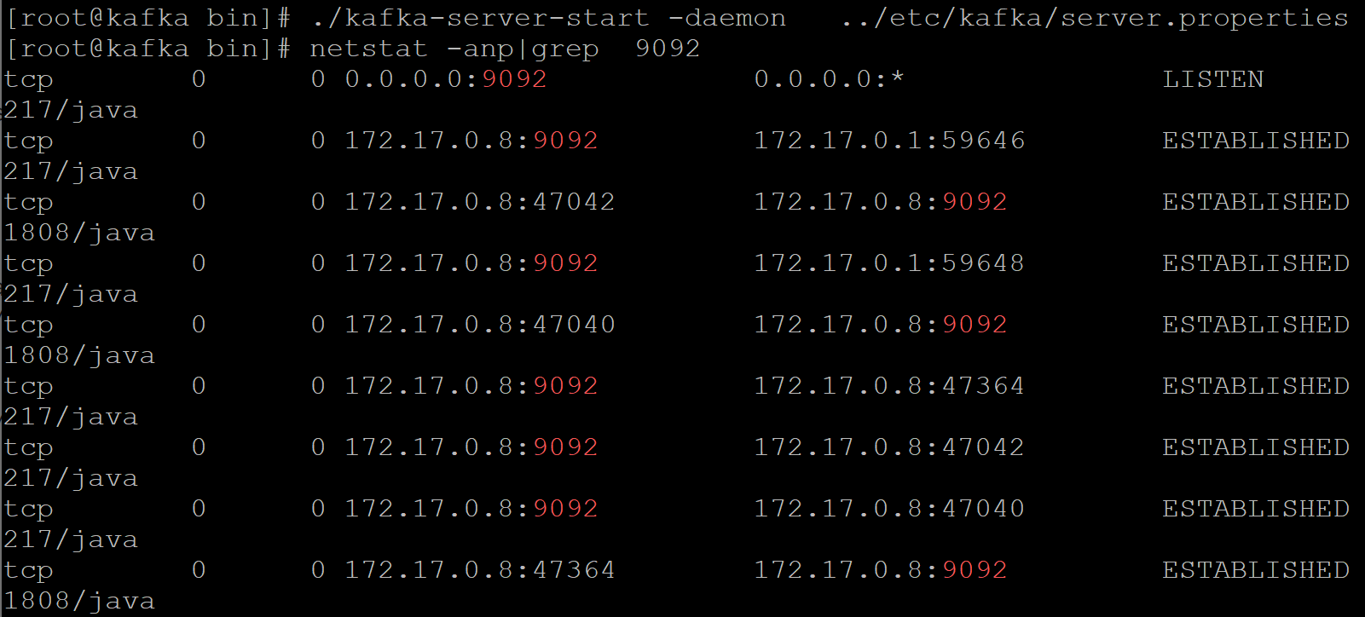

**4) create a topic:**

[root@kafka bin]# ./kafka-topics --create --zookeeper localhost:2181 --replication-factor 1 --partitions 1 --topic poctopic

Created topic "poctopic".



**5) kafka-console-producer**

In second putty terminal:connect to josephine and goto /opt/confluent/confluent-5.1.2/bin

go to /opt/confluent/confluent-5.1.2/bin

1.josephine@www.kshounish.com's password:

Last login: Sun Mar 10 18:42:19 2019 from 76.85.67.68

2.[josephine@www.kshounish.com ~]$ ssh www.mamonir.com

Last login: Sun Mar 10 17:44:24 2019 from 10.0.0.160

3.[josephine@www.mamonir.com ~]$ sudo su

4.[root@www.mamonir.com josephine]# cd /opt

5.[root@www.mamonir.com opt]# ls

confluent containerd customswap lost+found

6.[root@www.mamonir.com opt]# cd confluent/

7.[root@www.mamonir.com confluent]# ls

confluent-5.1.2 confluent-5.1.2-2.11.tar.gz

8.[root@www.mamonir.com confluent]# cd confluent-5.1.2/

9.[root@www.mamonir.com confluent-5.1.2]# cd bin

[root@www.mamonir.com bin]# ./kafka-console-producer --broker-list localhost:9092 --topic poctopic

>

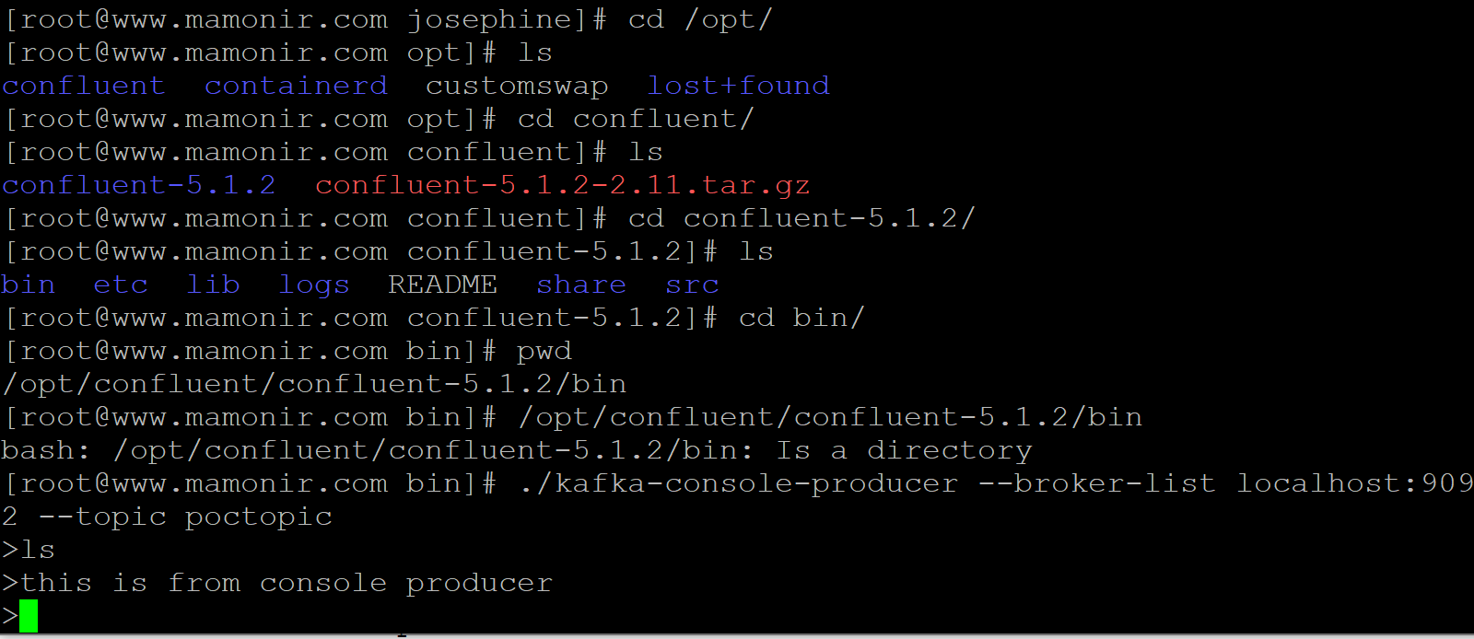

**6) kafka-console-consumer**

In Third putty terminal:connect to josephine and goto /opt/confluent/confluent-5.1.2/bin

steps:

1.josephine@www.kshounish.com's password:

Last login: Sun Mar 10 18:42:19 2019 from 76.85.67.68

2.[josephine@www.kshounish.com ~]$ ssh www.mamonir.com

Last login: Sun Mar 10 17:44:24 2019 from 10.0.0.160

3.[josephine@www.mamonir.com ~]$ sudo su

4.[root@www.mamonir.com josephine]# cd /opt

5.[root@www.mamonir.com opt]# ls

confluent containerd customswap lost+found

6.[root@www.mamonir.com opt]# cd confluent/

7.[root@www.mamonir.com confluent]# ls

confluent-5.1.2 confluent-5.1.2-2.11.tar.gz

8.[root@www.mamonir.com confluent]# cd confluent-5.1.2/

9.[root@www.mamonir.com confluent-5.1.2]# cd bin

[root@www.mamonir.com bin]# ./kafka-console-consumer --bootstrap-server localhost:9092 --topic poctopic --from-beginning

……

you will get masages here

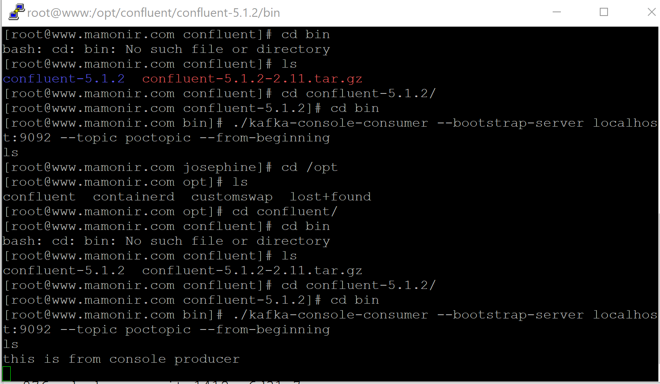

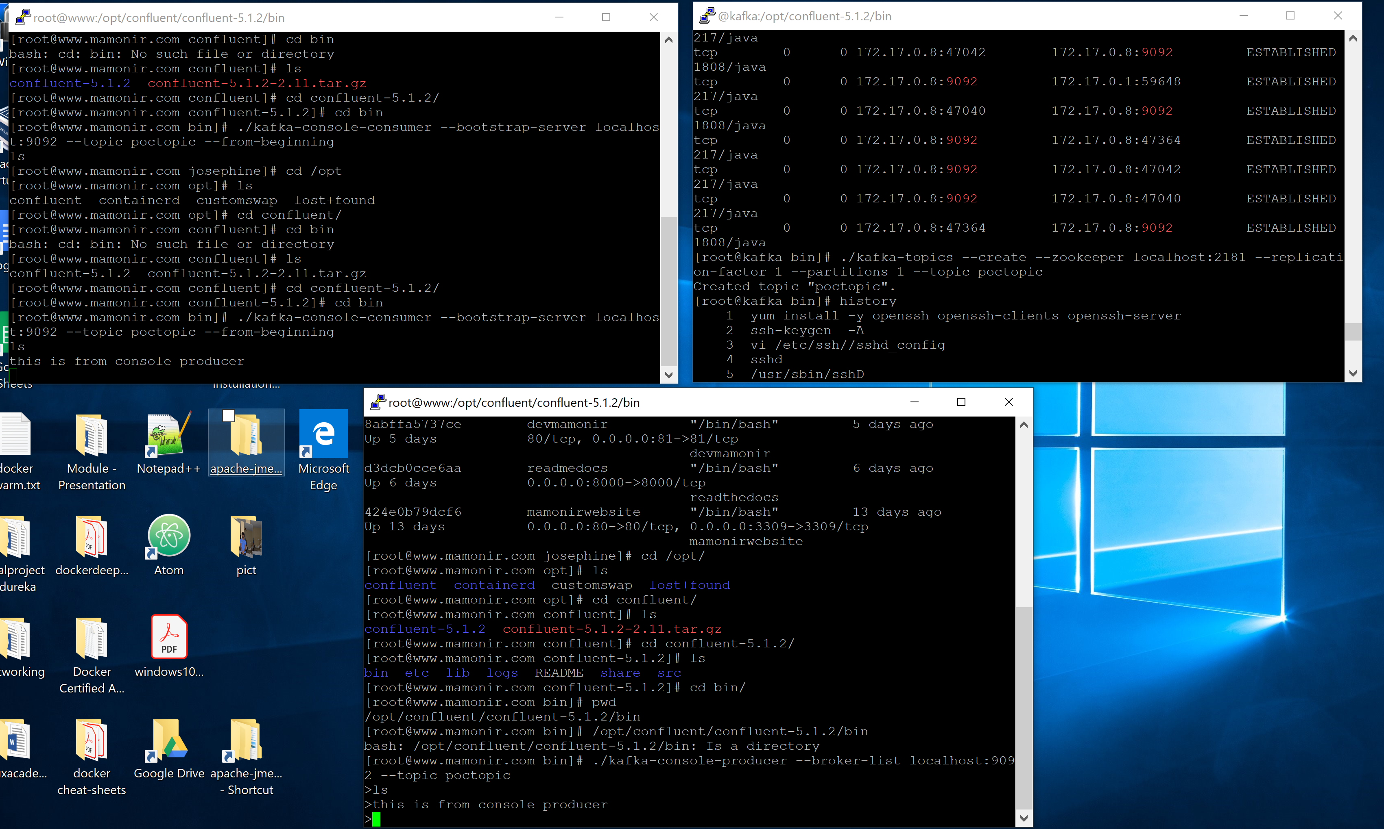

./kafka-console-consumer --bootstrap-server 10.0.0.149:9092 --topic pythontopic