Sample data from <https://my.fastwebengine.com/knowledgebase/130/How-do-I-install-an-SSL-certificate-that-I-have-purchased-for-my-domain.html>

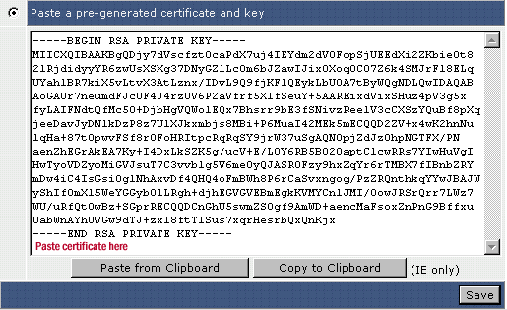

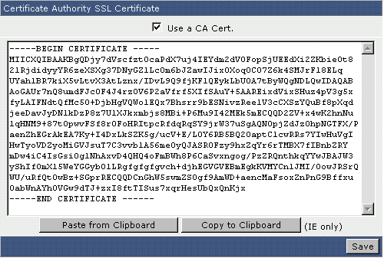

Samples from: <https://www.geocerts.com/blog/understanding-ssl-certificate-authentication-validation>

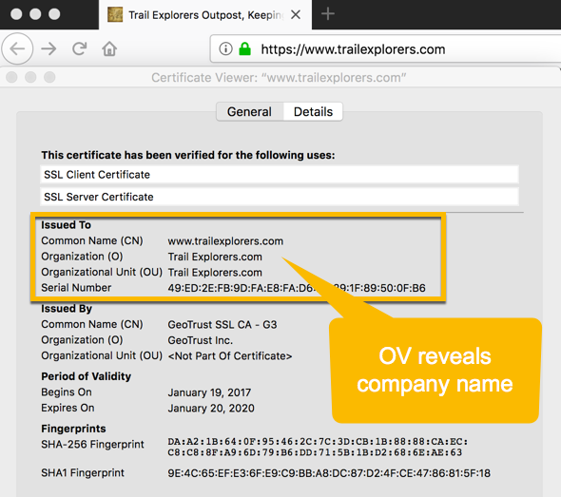

Sample from: <https://www.namecheap.com/support/knowledgebase/article.aspx/786/33/what-is-an-ssl-certificate-and-what-is-it-used-for/>

