Scotland's most picturesque running routes
What 100 routes and 421 reviews say about where runners stop to take photographs
Josephin Shajan
Reboot Data Analyst assessment
Data collected 31 July 2026
Source: AllTrails

In short
I collected 100 trail-running routes across Scotland from AllTrails and scored each one on how picturesque it is. Five things went into the score: how often people photograph the route, what they write about in reviews, AllTrails' own view rating, the star rating, and how much climbing is involved.
Glencoe Lochan comes first, on 78.6 out of 100.
The more useful thing sits underneath the ranking. How highly runners rate a route tells you almost nothing about how much they photograph it. The two correlate at 0.13. What people say about scenery has no relationship to the score they give at all, at -0.03.
Star ratings tell you the run was good. They don't tell you the place was worth looking at.

The measure
AllTrails has no field for how good a route looks, so I built a stand-in. Five signals, each turned into a percentile within the sample, then weighted.
Signal | Weight | What it measures
Photos per review | 25% | Did people stop mid-run to take a picture?
Scenery mention rate | 25% | What runners actually talk about
View-tag score | 20% | AllTrails' own three-level view rating
Adjusted rating | 15% | Star rating, pulled toward the sample average
Elevation gain per km | 15% | Climbing, standing in for viewpoints

The signal doing the most work is photos per review. A star rating tells you somebody finished the run and felt fine about it. A photo tells you they stopped in the middle of it because of what was in front of them.
Dividing by review count matters as much as counting the photos. Raw totals just tell you which routes are near cities. The ratio asks something else: of the people who left a review, how many also uploaded pictures, and how many each?
One thing to be clear about. The denominator is the number of reviews, not the number of visitors, because visitor counts aren't published. A single reviewer can upload several photos, which is why the figure can exceed one.

The ranking
Routes with at least 10 reviews. The eligibility rule is explained under robustness.
# | Route | Index | Rating | Reviews | Photos/review | km | Ascent | Difficulty
1 | Glencoe Lochan: Lochan Trail | 78.6 | 4.7 | 267 | 5.26 | 1.8 | 156 m | Easy
2 | Rhenigidale Post Road | 76.5 | 4.8 | 23 | 3.39 | 12.9 | 867 m | Hard
3 | Ben Lomond Mountain Path | 74.9 | 4.7 | 2,330 | 2.16 | 12.7 | 961 m | Hard
4 | Coire na Creiche and the Fairy Pools | 73.9 | 4.6 | 449 | 11.97 | 8.0 | 352 m | Moderate
5 | Ben Macdui, Stob Coire an t-Sneachda, Cairn Gorm | 70.7 | 4.8 | 671 | 4.66 | 18.0 | 1,027 m | Hard
6 | West Highland Way: Kinlochleven to Fort William | 70.3 | 4.7 | 1,101 | 4.05 | 25.3 | 841 m | Hard
7 | The Hams Track | 70.3 | 4.7 | 21 | 2.76 | 25.4 | — | Hard
8 | Dry Dam Path to St Anthony's Chapel and Arthur's Seat | 69.9 | 4.7 | 2,898 | 2.30 | 3.2 | 197 m | Moderate
9 | West Highland Way: Kingshouse to Kinlochleven | 69.6 | 4.7 | 1,203 | 3.31 | 14.8 | 541 m | Hard
10 | West Highland Way: Tyndrum to Inveroran | 68.7 | 4.8 | 532 | 5.56 | 14.6 | 494 m | Moderate

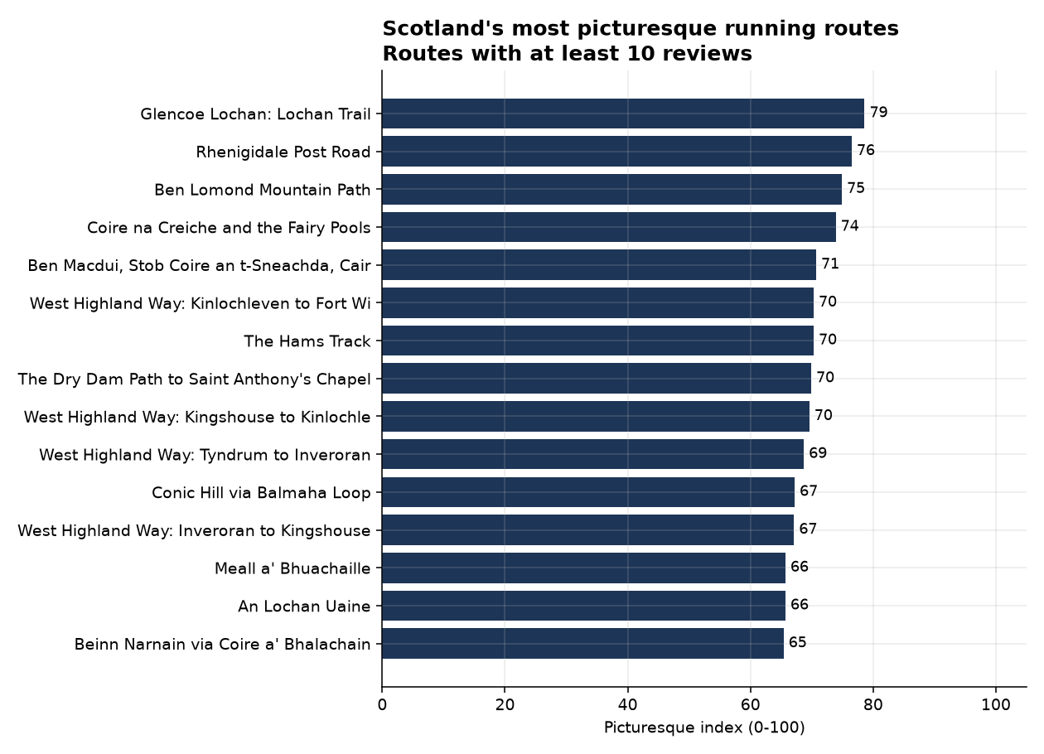
The fifteen highest-scoring eligible routes.
Two things stand out about the shape of that table.
Only one of the top ten is a city route. Arthur's Seat gets there on sheer volume, with 2,898 reviews but 2.30 photos each. Everything else is Glencoe, Skye, the Cairngorms, Harris, Shetland or the West Highland Way.
The top three also have almost nothing in common. Glencoe Lochan is 1.8km with 156m of climb. Ben Lomond is seven times longer with six times the ascent. Rhenigidale has 23 reviews, Ben Lomond has 2,330. Whatever makes a route worth photographing, it isn't size and it isn't fame.

Four findings

1. Enjoying a run and photographing it are different things
Pair | Correlation
Photos per review vs star rating | 0.13
Scenery mention rate vs star rating | -0.03
Scenery mention rate vs photos per review | -0.03

All three are basically nothing.
Star ratings barely separate anything. The median is 4.60 and almost every route sits between 4.5 and 4.8. Photos per review run from under one to nearly twelve.
The Fairy Pools make the point on their own. It has the lowest rating in the top ten at 4.6, which is still a good rating, and the highest photo intensity in the sample at 11.97 photos per review, more than five times the median of 2.18. It doesn't stand out on how much people enjoyed the run. It stands out on how much they photographed it.
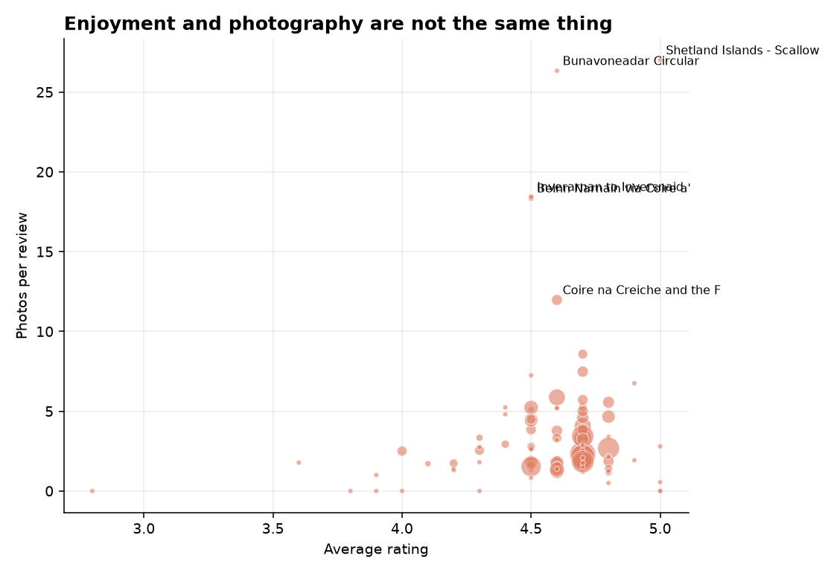
Ratings along the bottom, photos per review up the side. No pattern. Point size is review count.
Potential media angle: the routes runners rate highest aren't the routes they photograph. Works for outdoor and running titles, and it's the reason this index isn't built on ratings.

2. Harder routes get photographed more, but not rated higher
Difficulty | Routes | Mean index | Mean rating | Photos per review
Hard | 33 | 52.6 | 4.51 | 5.32
Moderate | 41 | 52.2 | 4.59 | 2.89
Easy | 26 | 42.2 | 4.58 | 2.35

In this sample, ratings sit within 0.08 of each other across all three bands. Harder routes weren't rated any higher than easy ones.
Photos per review more than double. Hard routes also average ten index points above easy ones while rating slightly lower.
Potential media angle: "the Scottish running routes where you have to earn the view." Everyone assumes it. Now there's a number on it.

3. Scottish runners write about lochs and views
Across 421 reviews, 61.6% mention scenery and only 18.2% mention anything negative like crowding, mud or road noise.
Word | Routes where it leads
views | 81
beautiful | 55
loch | 22
view | 18
stunning | 13
summit | 12
spectacular | 11
forest | 11

"Loch" leading for nearly a quarter of all routes is about as Scottish as a data point gets, and it's the kind of detail that gives a regional story its hook.
Potential media angle: a word-frequency chart travels well on social and gives the story something to look at that isn't a table.

4. The high scorers cluster away from the central belt
Nine of the top ten sit outside Scotland's central belt, spread across Glencoe, Skye, the Cairngorms, Harris, Shetland and the West Highland Way.
There's a caveat though. AllTrails lists about ten routes per regional page, so this sample is spread evenly across regions rather than matching how many routes each region really has. Which routes score highest is a real result. How much of the sample comes from each region is a choice I made.
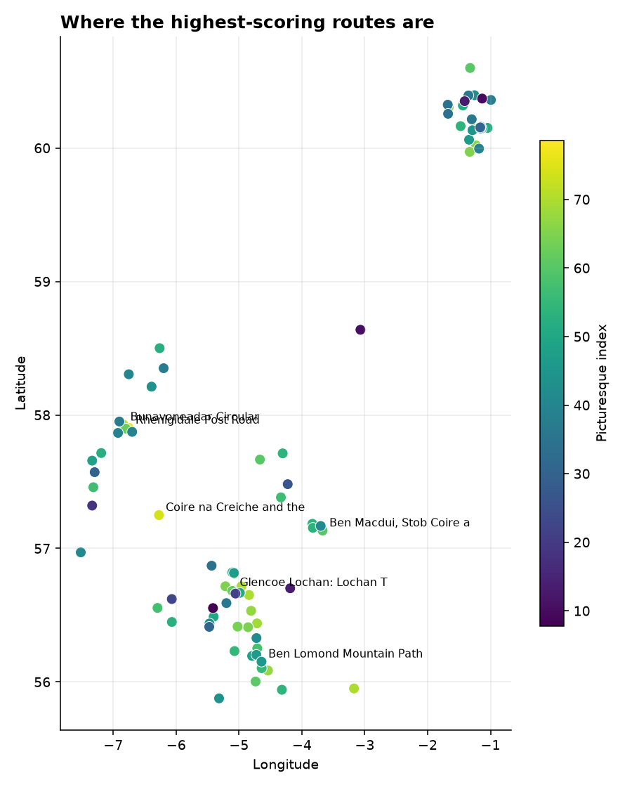
Every route with usable coordinates, coloured by index score.
Potential media angle: regional splits get you local press in every area you can name a route in, which is usually where the links come from.

How much to trust the ranking
I recalculated the score under equal weights and five leave-one-out versions.
Variant | Rank correlation | Top-10 kept
Equal weights | 0.983 | 8/10
Without view-tag score | 0.967 | 9/10
Without elevation gain per km | 0.955 | 6/10
Without adjusted rating | 0.952 | 6/10
Without scenery mention rate | 0.884 | 3/10
Without photos per review | 0.857 | 6/10

The rough order is solid. The exact top ten isn't. Every version correlates above 0.85 with the one I used, so which routes are broadly picturesque doesn't depend on my weightings. But membership of the top ten moves a lot. Take out the scenery mention rate and seven of the ten change.
So what I'd stand behind is "these are among the most picturesque in the sample", not "this one is definitively fourth". Glencoe Lochan holds first place under most weightings. I wouldn't build a headline on the gap between fourth and seventh.
That check also earned its place. An earlier version gave 30% of the weight to the view-tag score, and taking it out changed the ranking by nothing at all. It turned out I'd built it against tags AllTrails doesn't use. A variable that heavy making no difference isn't a stable index. It's a broken one.
82 of the 100 routes have at least 10 reviews and are eligible for the ranking. The other 18 are scored and kept in the dataset, but flagged and excluded from the table and the chart above.

What I'd want before running this as a campaign
- Check it against Scotland's National Scenic Areas. Lining the index up with an official designation would give it outside validation, and a second source makes a campaign much harder to pull apart.
- Go past 100 routes, weighted by region, so the geographic pattern can be separated from my sampling.
- Split by season using photo timestamps. "The Scottish routes that peak in October" is a separate story from the same data.

Caveats
The index is a stand-in I built, not a measurement of beauty. The sensitivity table above is the honest answer to how far the exact order should be trusted.
The sample is 100 routes, so this is the most picturesque of these 100, not of Scotland. Around ten routes per regional page means it isn't proportional to Scotland's route population.
Review text is 421 reviews across 100 routes, being whatever each page showed rather than every review ever left. Word matching can't tell "stunning" from "not stunning at all", though checking a sample by hand suggests it doesn't amount to much at this size. Length is missing for 4 routes and elevation for 7, where the values failed a plausibility check and were set to null rather than kept.
Full detail in the methodology. Collected 31 July 2026, and ratings and photo counts move, so any published figure needs that date on it.

