Methodology
Assessing the most picturesque running routes in Scotland
Josephin Shajan
Reboot Data Analyst assessment
Data collected 31 July 2026
Source: AllTrails

Summary
Aspect | Detail
Source | AllTrails. 100 trail-running routes, taken from six Scottish regional listings.
Collection | Playwright driving a real browser. AllTrails builds its pages in the browser, so a plain HTTP request comes back empty. Pages were saved to disk first and parsed afterwards.
The problem | AllTrails has no field for how good a route looks. I built a five-signal stand-in instead.
Best signal | Photos per review. A rating says the run was good. A photo says someone stopped walking because of the view. The two only correlate at 0.13.
Checks | 22 unit tests on the scoring maths, a sensitivity analysis across seven weightings, plus range, duplicate and location checks written to a QA report.
Main limitation | The rough order holds up under any weighting I tried. The exact top ten does not.

1. How I read the brief
You can't download "picturesque". AllTrails has no column for it and never will. So the first job was picking something measurable to stand in for it, and every other decision follows from that one.
I also took the third requirement at face value. Focus on variables that support the angle. That meant not grabbing everything on the page and sorting it out later. I went in with a short list of things that plausibly relate to how a route looks and ignored the rest.
The other thing I kept in mind was what this data is for. A campaign needs a number that holds up when a journalist rings and asks how you worked it out. So I wanted a scoring method I could explain in one sentence, and I wanted every step saved to disk so any figure in the report could be traced back to a row.

2. Collection

Why a browser and not requests
I tried requests and Beautiful Soup first because it's the cheapest thing to try. It doesn't work. AllTrails builds its pages in the browser, so what comes back is an empty shell with no trail data in it at all.
So the collector drives a real Chrome window through Playwright. The page builds itself properly, and a saved browser profile means any verification step only has to be cleared once instead of on every run.

How the 100 routes were selected
Every route came from an AllTrails trail-running listing, at URLs of the form alltrails.com/scotland/<region>/trail-running. That listing is the activity filter, so a route is in the sample because AllTrails classifies it as a running route. Some of them are also popular hiking routes, which is normal on AllTrails and not a misclassification.
AllTrails groups these by council area and lists about ten per page, so reaching 100 meant working across regions rather than scrolling one national page.
The rule was: work down a list of Scottish regional pages in order, take every unique route link on each, and stop at 100. Six pages got me there. Two others didn't exist and returned 404s, and the remaining 29 on the list weren't needed.
Regional listing | New routes
Scotland (national) | 12
Highlands | 20
Highland | 0 (all duplicates of Highlands)
Highland / Inverness | no page
Argyll and Bute | 27
Shetland | 24
Orkney | no page
Na h-Eileanan an Iar (Western Isles) | 27
Total | 110, capped at 100

This is a coverage-based sample, not a random or population-proportional one. I chose it deliberately: the national list is sorted by popularity, so the first hundred routes would have been almost all Edinburgh and Glasgow. Going region by region gave the Highlands, the islands and the Borders a floor.
The cost of that choice is in the limitations. Ten per region is a decision I made, not a representative sample.

Save the pages first, parse them later
Every page gets written to disk as raw HTML before anything is pulled out of it. Parsing then runs against those files.
This is the decision I'd defend hardest. My first parser was wrong. Badly wrong. It only looked at the top level of the JSON-LD block, and AllTrails wraps everything inside a WebPage object, so length, elevation, rating and coordinates all came back empty.
Because the pages were already saved, fixing it took one function and two seconds. If I hadn't saved them, every parser fix would have meant another 100 requests, another half hour, and another run-in with their rate limiter.
It also means the collection can be checked. The saved HTML shows what the site actually returned on 31 July, so nobody has to take my numbers on trust.

Three ways in
- JSON-LD, read recursively. Name, rating, review count, coordinates, region, and the text of the reviews on the page.
- The page's own JSON. Length, elevation gain, difficulty, photo count.
- Visible text as a backstop.
The second one needs care. A trail page also carries data about nearby trails, so grabbing the first number that matches would hang a neighbour's stats on the wrong route. elevationGain only appears once per page, inside the route's own stats block, so I use that as the anchor and read length backwards from it.

Being reasonable about it
- 5 to 9 seconds between page loads, chosen at random. I started at 2.5 to 5 and widened it after an early run tripped a rate limiter.
- One request per page, run sequentially. No concurrency, no retries in a loop.
- Stopped at 100 routes as the brief asked.

What went wrong
Four separate problems, and every one of them produced the same symptom: a run that collected nothing. A wrong URL, a locale prefix I hadn't allowed for, a rate limiter, and an HTTP 403 against the automated browser.
Since they look identical but need completely different fixes, I wrote a --check mode that loads one page and says which of the four you're looking at. The 403 went away once I attached to a Chrome window I'd opened normally. Nothing in the code breaks an access control. If the site had kept refusing, I'd have written that up and used a different source.

3. What I collected
Variable | Why
Route name | Identification
Route URL and slug | Traceability, so any figure can be checked against the source page
Average rating | Basic quality check
Review count | Used for confidence, not as a score
Photo count | The most useful thing on the page, for reasons below
Feature tags | AllTrails' own labels
Review text | What people actually say, rather than what the tags claim
Length (km) | Context, and needed to work out elevation gain per km
Elevation gain (m) | Climbing usually means a view at the top
Route type | Secondary breakdown
Difficulty | Breakdown
Latitude and longitude | Spread across the country, and a check the route is in Scotland
Region and locality | Geographic grouping
Collection date | Everything here is a snapshot of 31 July 2026

I left out surface, dog policy, parking and accessibility. All real fields. None of them tell you anything about how a place looks.

4. The index
Signal | Weight | What it measures
Photos per review | 25% | Photos divided by review count
Scenery mention rate | 25% | Share of reviews using scenery words
View-tag score | 20% | AllTrails' own three-level view rating
Adjusted rating | 15% | Star rating, pulled toward the sample average
Elevation gain per km | 15% | Steepness, standing in for viewpoints

Written out in full, for a route *i*:
Index(i) = 100 x [ 0.25 x P(photos per review)
+ 0.25 x P(scenery mention rate)
+ 0.20 x P(view-tag score)
+ 0.15 x P(adjusted rating)
+ 0.15 x P(elevation gain per km) ]
P(x) is the percentile rank of that route's value within the 100-route sample, from 0 to 1. Ties get the average rank. Where a signal is missing, it drops out and the remaining weights are rescaled to still sum to 1.

The one that matters
Photos per review. A rating tells you somebody finished the run and felt good about it. A photo tells you they stopped in the middle of it because of what was in front of them.
Dividing by review count matters as much as counting the photos. Raw totals just tell you which routes are near cities. The ratio asks a different question: of the people who left a review, how many also uploaded pictures, and how many each?
To be precise about the denominator: it's the number of reviews, not visitors, because AllTrails doesn't publish visitor counts. One reviewer can upload several photos, which is why the figure often exceeds one.
The data backs the choice up. Photos per review and star rating correlate at 0.13. Scenery mention rate and star rating at -0.03. They aren't measuring the same thing, which is exactly why ranking on ratings would have answered a different question to the one asked.
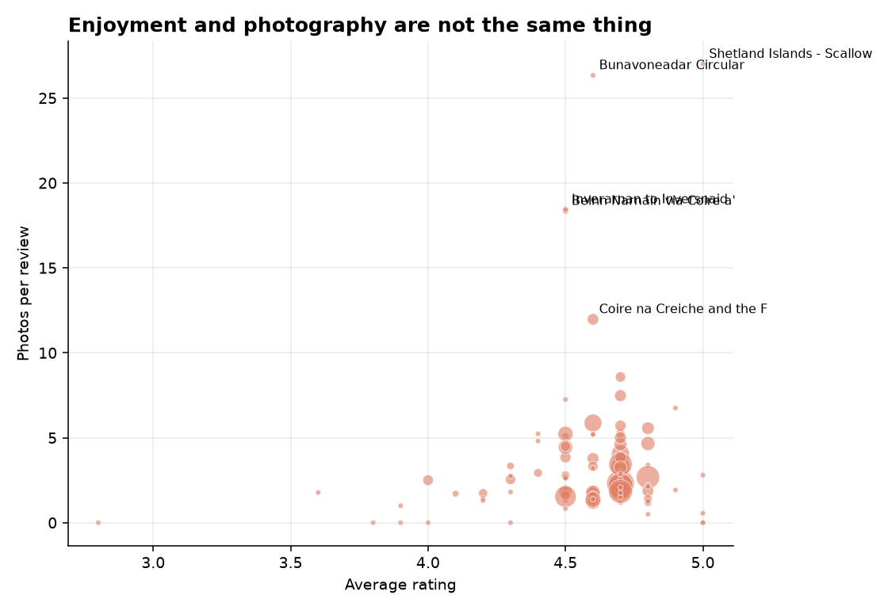
Every point is a route, sized by review count. If ratings told you how good a route looks, this would slope upwards. It doesn't.

Percentiles rather than scaling to the maximum
Each signal becomes a percentile within the sample before it gets weighted. If I'd scaled everything against the highest value, one heavily photographed route would squash the rest towards zero. The Fairy Pools sit at 11.97 photos per review against a median of 2.18, so that's a real risk here.
Percentiles are also easier to explain. "Top 5% for photos per review" needs no translating for anyone.

Pulling thin ratings toward the average
A 5.0 from four people shouldn't beat a 4.7 from nine hundred.
adjusted = (v x R + m x C) / (v + m)
R is the route's rating, v its review count, C the sample average, and m a prior weight set to 25 reviews.
I picked 25 as a moderate figure: high enough that a handful of reviews gets pulled a long way toward the mean, low enough that a route with a few hundred reviews is left almost untouched. It isn't derived from anything, and moving it between roughly 15 and 40 barely changes the ranking.
Note that this is a different number to the 10-review eligibility floor below. The 25 controls *how much* a thin rating gets discounted. The 10 decides whether a route appears in the headline table at all.

The view-tag signal, and why I changed its weight
I assumed AllTrails tagged routes by terrain. Waterfall, lake, forest, that sort of thing. I gave the signal 30% of the weight on that basis.
Then I looked at what the sample actually contained. The tags are condition and amenity labels pulled from reviews: great-views on 86 routes, not-crowded on 85, easy-to-park on 72, dog-friendly on 64. My original list barely matched anything, which meant the heaviest signal in the index was doing nothing at all.
The sensitivity check is what found it. Taking the view-tag score out changed the ranking by nothing whatsoever. That isn't a stable index. That's a variable that was never working.
The rebuilt version uses the only scenery information the tags actually carry, which is a three-level view rating, with a small deduction for tags describing something that spoils it. I dropped the weight from 30% to 20% because a three-level rating doesn't deserve more. The freed-up weight went to scenery mentions and elevation rather than photos, since the sensitivity check already showed the ranking leaning fairly hard on photos.

Gaps
I didn't fill any in. If a route is missing a signal, that signal gets dropped for that route and the remaining weights are rescaled to still add up to one. Each row records how many signals it actually used.
Routes with no reviews get a missing photo intensity rather than a division by zero, and are scored on whatever else is available.

The 10-review floor
Routes with fewer than 10 reviews get scored but are kept out of the headline ranking and the top-15 chart. 82 of the 100 clear it. The rest stay in the dataset, flagged.
What that caught. Bunavoneadar Circular scores 73.0, which would put it fifth in Scotland. It has three reviews, and between them those three carry 26.33 photos per review, twelve times the sample median. Without the floor, a national ranking would have been part-decided by three people.

5. Review language
Every review is lowercased and split into words on anything that isn't a letter or apostrophe, then checked against a scenery list and a negative list. The measure per route is the share of reviews containing at least one scenery word, not a count of total matches.
Both lists live in the configuration block at the top of alltrails_scotland.py as SCENERY_LEXICON and DETRACTOR_LEXICON, so the analysis can be reproduced exactly.
They're short on purpose. "Nice" and "great" describe the run. "Stunning" and "viewpoint" describe the view. Across 421 reviews, 61.6% mention scenery and 18.2% mention something negative. The gap between those two is what tells me the lists are picking up something real and not just measuring how much people write.

6. Checks
- Range checks. Length, elevation, rating, review and photo counts all tested against sensible bounds. Four length values and seven elevation values failed and were set to null rather than kept. All of it logged in qa_report.md.
- Duplicates. Removed by URL slug first, then by name and rounded coordinates. That second pass matters here, because working across regional pages means a route near a boundary can turn up twice.
- Location. Coordinates checked against a box covering Scotland and the islands. Anything outside gets its coordinates nulled but the route kept. Every route came off a Scotland-only listing page, so a bad coordinate is a parsing error, not a foreign route. An earlier version deleted those rows and lost 99 of 100 routes to what was really a parser bug. A filter that removes the whole sample is telling you about your code, not your data.
- Units. AllTrails gives metres in its JSON and miles and feet in the page a UK visitor sees. Both end up in one function so there's a single place to check.
- Completeness. In qa_report.md. Worth reading before the findings.
- Tests. --test runs 22 checks on the shrinkage, the percentile ranking, the view-tag score, the review features, the rescaling when a signal is missing, and the unit conversion. The numbers in those tests are made up and exist only to prove the functions do what I say. None of them touch the collected data.
- Sensitivity. The ranking gets recalculated under equal weights and five leave-one-out variants, then compared by rank correlation and top-ten overlap. This is the check that found the dead view-tag variable.
Output files: routes_clean.csv, routes_scored.csv, six summary_*.csv tables, qa_report.md and auto_findings.md, which holds every figure quoted in the report.

7. Limitations
The index is a stand-in, and it's mine. Five signals and a set of weights is a reasonable construction. It isn't a measurement of beauty.
The rough order is steadier than the exact one. Every weighting I tried correlates above 0.85 with the one I chose, so which routes are broadly picturesque doesn't hinge on my decisions. Top-ten membership does move though. Dropping the scenery mention rate changes seven of the ten. The claim I'd stand behind is "among the most picturesque in this sample", not "fourth, definitively".
The sample is coverage-based, not proportional. Around ten routes per regional page means it doesn't reflect how many routes each region really has. Which routes score highest is a real result. How much of the sample comes from each region is a choice I made.
Popularity bias is reduced but not gone. Using ratios helps and working across regions helps more, but routes near cities still pick up more of everything.
The review text is partial. 421 reviews across 100 routes, being whatever each page showed, not every review ever left. Recent reviews also lean towards recent seasons.
Word matching can't read context. "Not scenic at all" counts as a scenery mention. I checked a sample by hand and it doesn't look like much at this size, but a sentiment model would be the fix, not a longer word list.
It's a snapshot. Collected 31 July 2026. Ratings and photo counts move, so any published figure needs that date on it.

8. What I'd do with more time
- Check the index against Scotland's National Scenic Areas. That would give the stand-in some outside validation, and a second source makes a campaign much harder to pull apart.
- Swap word matching for a sentiment model, so "not scenic" stops counting as praise.
- Pull full elevation profiles instead of total gain, to tell one long climb to a viewpoint apart from the same ascent spread thinly over 20km.
- Look at when photos were taken, for a seasonal angle.
- Go past 100 routes and weight the sample by how many routes each region really has.

9. In closing
The thing I'd take away from this is that the obvious variable was the wrong one. Star ratings are right there on every page, they're easy to sort by, and they would have produced a ranking in about ten minutes. They also correlate with photography at 0.13, which means a ratings-based list would have answered a question nobody asked.
Photos per review took longer to justify and needed a ratio rather than a raw count to be worth anything. But it measures something closer to what "picturesque" actually means, and the gap between the two is the finding the report leads on.
What this method gives you is a defensible ordering of 100 routes and a clear account of where it's soft. What it doesn't give you is a definitive number four. I've tried to be plain about which is which, because a campaign built on the first will survive a journalist's questions and one built on the second won't.

