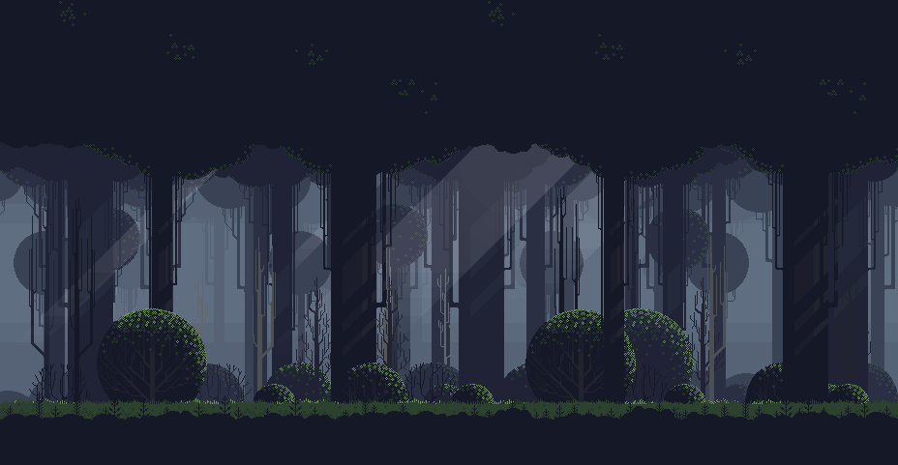

Title of the Game

Cherish Magpayo and Joseph Izon

Description of the Game

Skrrt bRRt Zoom is a simple 1 v 1 2D Pixel-Bit Platformer game developed by Cherish Magpayo and Joseph Izon for their Final Project in their CSCI 22 class. The game is similar to the concept of a battle royale but with only two players pitted against each other. You and your opponent pose as witches / sorcerers who have suddenly lost their powers and in order to regain their magic touch, they must reign victorious in the 1 v 1 situation they are placed in by the ruling powers. The game is staged in a far away land of which no one could locate and thus usually dubbed “The Forest” with towering trees and gigantic bushes that cover most of the sunlight.

An Explanation of the Game

The game is similar in style to famous platformers such as Super Mario and Terraria but with a simpler mechanic of having to collect coins in order to rack up points against the other player. As simple as it sounds, the winner who first reaches the indicated number of points wins. However, each player would have to compete with each other as there is a limited amount of coins that will spawn within the map and thus it will be a game of who could collect the coins first and who could collect the most coins in the end.

how to play the game

To be able to start the game, two players are required to step into the game for the game’s server to start running. Once both players have stepped into the game, they will spawn in “The Forest” and the game will immediately begin at the spawn of the first coin. Players may move using the dedicated arrow keys which all correspond to the direction it indicates, the left-arrow key (🡨) makes the player run left, the right-arrow key (🡪) makes the player run right, and the up-arrow key (↑) will allow the player to jump and reach the platforms in the forest. Simply hovering over the coins will allow the player to collect it and stack their points until the designated number of points is reached. Coins will be scattered all throughout the map and thus will be a game of who can collect the coins faster.

Sample Screenshots