UNITED REPUBLIC OF TANZANIA
MINISTRY OF INDUSTRY AND TRADE

MIT Monitoring & Evaluation System
USER MANUAL
─────────────────────────────
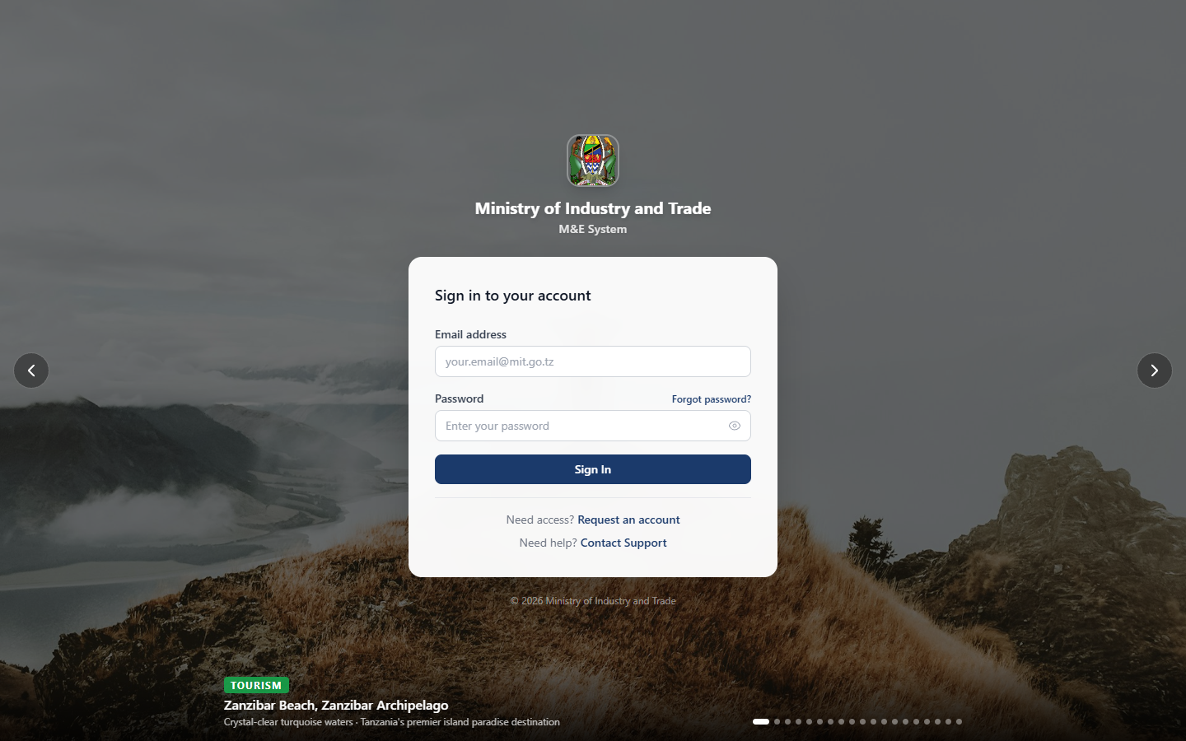

───────────────────────────────
Version 1.0
April 2026

TABLE OF CONTENTS
1.0 System Overview 1
Strategic Objectives Tracked 2
2.0 User Roles & Permissions 3
Role Summary Table 3
Role Descriptions 3
3.0 Login Window 4
3.1 Accessing the System 4
3.2 Logging In 4
3.3 Forgot Password 5
3.4 Register a New Account 5
3.5 Changing Your Password 5
3.6 Session & Security 5
4.0 Dashboard 6
What You See 6
5.0 Results Framework 7
5.1 Viewing the Framework 7
5.2 Framework Hierarchy 7
5.3 Framework Versions (Admin/Super Admin) 8
6.0 Indicators 8
6.1 Viewing Indicators 8
6.2 Indicator Detail Page 9
6.3 Creating a New Indicator (M&E Officer or Super Admin) 9
6.4 Formula Types 10
7.0 Data Entry 11
7.1 Submitting Data 11
7.2 Submission Statuses 12
7.3 Editing a Submission 12
7.4 Viewing Your Submissions 12
8.0 Approval Queue 13
8.1 Approving a Submission 13
8.2 Rejecting a Submission 13
8.3 Bulk Actions 14
9. 0 Industry Statistics 14
9.1 Entering Industry Statistics 14
10.0. Projects 15
10.1 Viewing Projects 15
10.2 Project Detail Page 16
10.3 Creating a New Project (M&E Officer and above) 17
10.4 Updating Project Progress 17
10.5 Project Statuses 17
11.0 Activity Workplan 18
11.1 Viewing the Workplan 18
11.2 Updating an Activity (M&E Officer and above) 19
11.3 Managing Milestones 19
11.4 Workplan Statuses 19
12.0 Budget 20
12.1 Budget Overview 20
12.2 Budget Plans 20
12.3 Recording Expenditures 21
13.0 Reports 21
13.1 Generating a Report 21
13.2 Exporting Reports 22
14.0. Analytics 23
14.1 Available Charts 23
14.2 Filtering Analytics 23
15. Documents 24
15.1 Browsing Documents 24
15.2 Uploading a Document (M&E Officer and above) 24
15.3 Document Categories 24
16.0. Administration 25
16.1 Managing Users 25
16.2 Managing Institutions 26
16.3 MIT Organisational Structure 27
16.4 Reporting Calendar 27
16.5 Period Locks 28
16.6 API Integrations 28
16.7 Framework Versions 29
17.0. Contact Support & Helpdesk 29
17.1 Contact Support (Without Logging In) 29
17.2 Helpdesk (After Logging In) 30
17.3 Ticket Priority Levels 31
18.0. Troubleshooting 32

1.0 System Overview
The MIT Monitoring & Evaluation (M&E) System is a web-based platform used by the Ministry of Industry and Trade (MIT) and its 13 institutions to:
- Track performance against the MIT Strategic Plan 2026/27-2030/31
- Collect and approve indicator data from institutions
- Monitor project implementation and activity workplans
- Manage budgets and expenditures
- Generate reports and analytical insights
- Store and share official documents
Institutions in the System
Institution | Full Name
MIT-HQ | Ministry of Industry and Trade (Headquarters)
BRELA | Business Registrations and Licensing Agency
CAMARTEC | Centre for Agricultural Mechanization and Rural Technology
CBE | College of Business Education
FCC | Fair Competition Commission
FCT | Fair Competition Tribunal
NDC | National Development Corporation
SIDO | Small Industries Development Organisation
TBS | Tanzania Bureau of Standards
TEMDO | Tanzania Engineering and Manufacturing Design Organisation
TIRDO | Tanzania Industrial Research and Development Organisation
TANTRADE | Tanzania Trade Development Authority
WMA | Weights and Measures Agency
WRRB | Warehouse Receipts Regulatory Board

Strategic Objectives Tracked
Code | Objective
A | HIV/AIDS and NCDs (Crosscutting)
B | Anti-Corruption Strategy (Crosscutting)
C | Industrial Performance Improved and Sustained
D | Business Environment Improved
E | Trade and Market Competitiveness Enhanced
F | Institutional Capacity Strengthened
X | Environment and Ecosystems (Crosscutting)
Y | Multi-sectoral Nutrition (Crosscutting)

2.0 User Roles & Permissions
The system has five user roles. Each user is assigned one role by an administrator.

Role Summary Table
Feature | Viewer | Data Collector | M&E Officer | Admin | Super Admin
View dashboard | ✓ | ✓ | ✓ | ✓ | ✓
View indicators | ✓ | ✓ | ✓ | ✓ | ✓
Submit data |  | ✓ | ✓ | ✓ | ✓
Approve data |  |  | ✓ | ✓ | ✓
Manage indicators |  |  | ✓ | ✓ | ✓
Manage projects |  |  | ✓ | ✓ | ✓
Manage workplan |  |  | ✓ | ✓ | ✓
Manage budget |  |  | ✓ | ✓ | ✓
Generate reports | ✓ | ✓ | ✓ | ✓ | ✓
Manage users |  |  |  | ✓ | ✓
Manage institutions |  |  |  |  | ✓
System configuration |  |  |  |  | ✓

Role Descriptions
- Viewer
Read-only access. Can view the dashboard, indicators, framework, reports, and documents. Cannot submit or modify any data.
- Data Collector
Assigned to an institution. Can submit indicator data and track submission status. Cannot approve or reject submissions.
- M&E Officer
Can manage the full data cycle and create indicators, submit data, approve or reject submissions, manage projects, workplan, and budget for their institution.
- Admin
Institution-level administrator. All M&E Officer permissions and managing users within their institution.
- Super Admin
Full system access. Can manage all institutions, all users, system configuration, framework versions, period locks, and reporting calendar.

3.0 Login Window
Figure 1: MIT M&E System Login Page featuring the Tanzania national tourism attraction, slideshow background, and secure sign-in form

3.1 Accessing the System
Open a web browser and navigate to: https://172.20.10.3:5443
NOTE: Note: The system uses a self-signed SSL certificate for internal network use.
NOTE: On first access, your browser will show a security warning. This is expected.
NOTE: Click Advanced → Proceed to [address] to add a browser exception and continue.
NOTE: You only need to do this once per browser.

3.2 Logging In
- Enter your Email Address and Password
- Click Sign In
- You will be redirected to the Dashboard upon successful login

Default credentials (demo):
- Super Admin: admin@mit.go.tz Password: Admin@1234
- Institution Admin (e.g. BRELA): admin@brela.go.tz: Password: Passw0rd@MIT

3.3 Forgot Password
- Click Forgot password? on the login page
- Enter your registered email address
- Click Send Reset Link
- Check your email for a password reset link
- Click the link and enter your new password

3.4 Register a New Account
- Click Request an account on the login page
- Fill in your full name, email, institution, and role
- Submit the request
- An administrator will review and activate your account

3.5 Changing Your Password
Once logged in:
- Click Change Password at the bottom of the left sidebar
- Enter your current password
- Enter and confirm your new password
- Click Update Password

3.6 Session & Security
- Your session automatically expires after 15 minutes of inactivity
- A countdown timer is visible at the bottom of the screen and it turns red when less than 2 minutes remain
- Click anywhere or interact with the page to reset the timer
- You will see a warning message before being logged out
- You will be redirected to the login page when the session expires and your saved data is not lost

Dashboard
The Dashboard is the first page you see after logging in. It provides a high-level summary of system-wide performance.
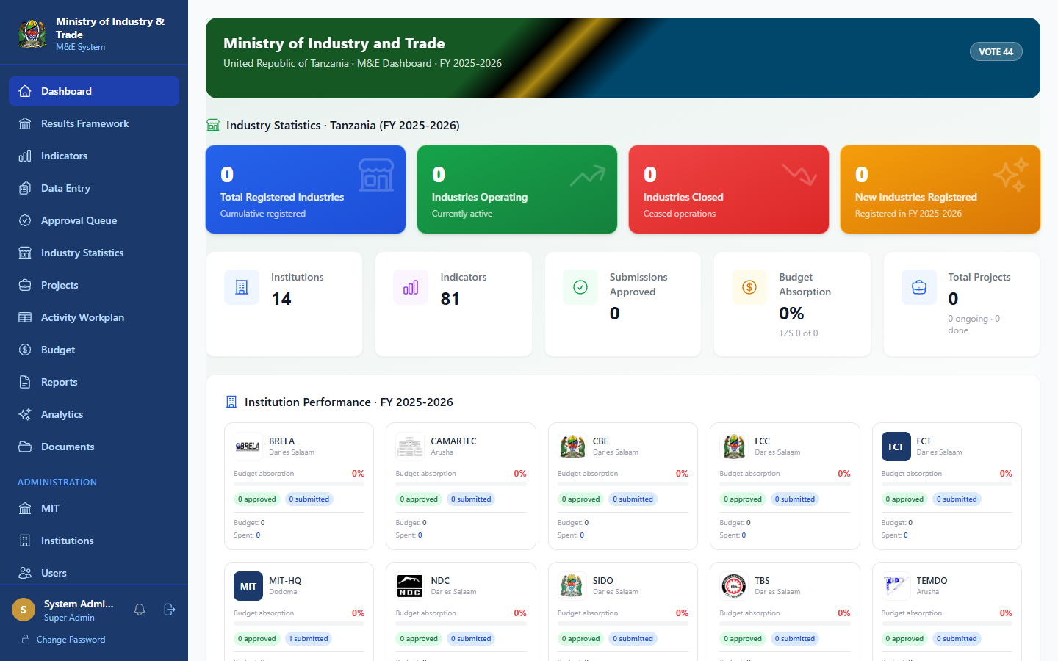
Figure 3: Dashboard a system-wide KPI cards, institution performance summary, and recent activity

What You See
Summary Cards (top row)
- Total Indicators
- Indicators On Track / At Risk / Behind
- Overall Achievement Percentage
- Pending Approvals (if you are an M&E Officer or Admin)
Charts
- Achievement by Strategic Objective bar chart showing performance per objective
- Submission Status breakdown of submitted, pending, and approved data
- Recent Activity latest data submissions and approvals
Quick Links
- Quick access to Data Entry, Approval Queue, and Reports
NOTE: Data displayed is scoped to your institution. Super Admin and M&E Officers see system-wide data.

Results Framework
Navigation: Results Framework (sidebar)
The Results Framework page shows the full logical hierarchy of the MIT Strategic Plan:
Strategic Objective → Outcome → Output → Activity → Indicator
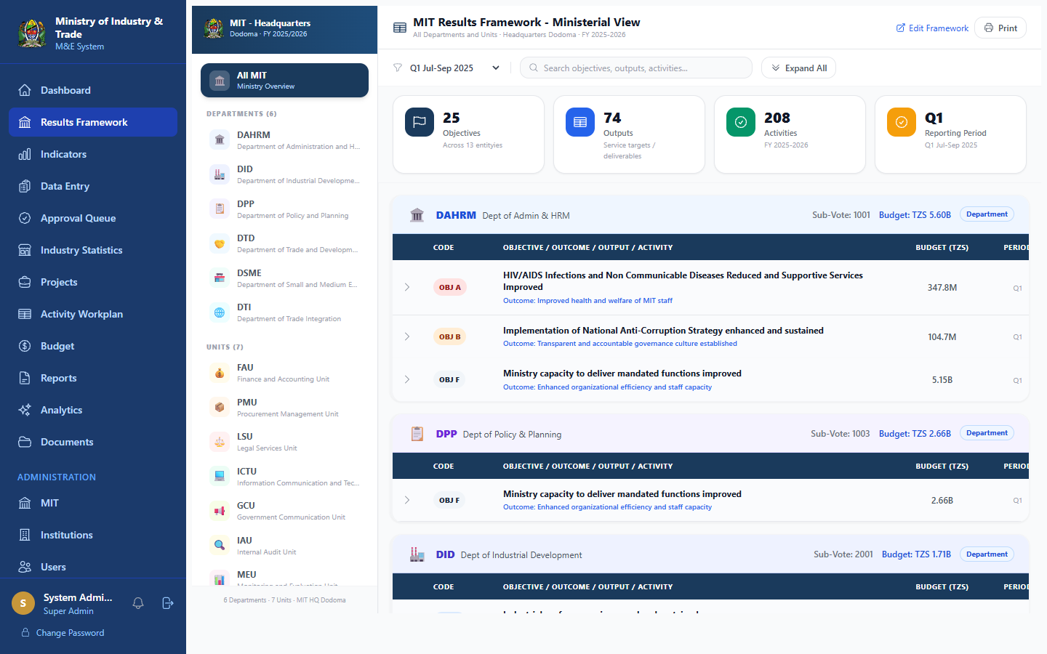Figure 4: Results Framework (Ministerial View) with Strategic Objectives, Outcomes, Outputs, and Activities hierarchy

5.1 Viewing the Framework
- Click Results Framework in the sidebar
- The Ministerial view shows all Strategic Objectives
- Click on an Objective to expand its Outcomes
- Click on an Outcome to see its Outputs
- Click on an Output to see its Activities and linked Indicators

5.2 Framework Hierarchy
Level | Description | Example
Strategic Objective | Top-level goal | Industrial Performance Improved
Outcome | Expected result | Increased industrial output
Output | Deliverable | Number of industries supported
Activity | Action taken | Conduct industrial surveys
Indicator | Measurement | % increase in industrial production

5.3 Framework Versions (Admin/Super Admin)
The system maintains versions of the Results Framework to track changes over time.
- Go to Administration → FW Versions in the sidebar
- View all published versions
- Compare versions to see what changed between periods

6.0 Indicators
Navigation: Indicators (sidebar)
Indicators are the measurable metrics used to track progress against the Results Framework.

6.1 Viewing Indicators
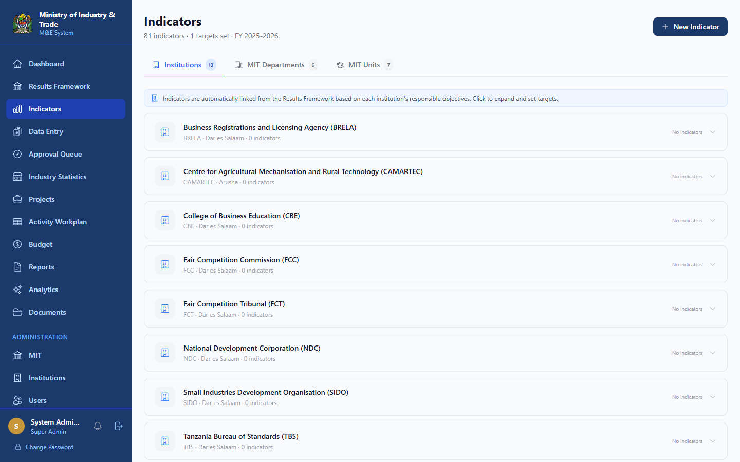
Figure 5: Indicators List searchable and filterable list of all performance indicators
- Click Indicators in the sidebar
- Use the search bar to find an indicator by name or code
- Filter by Strategic Objective, Status, or Reporting Frequency
- Click on any indicator to open its detail page

6.2 Indicator Detail Page
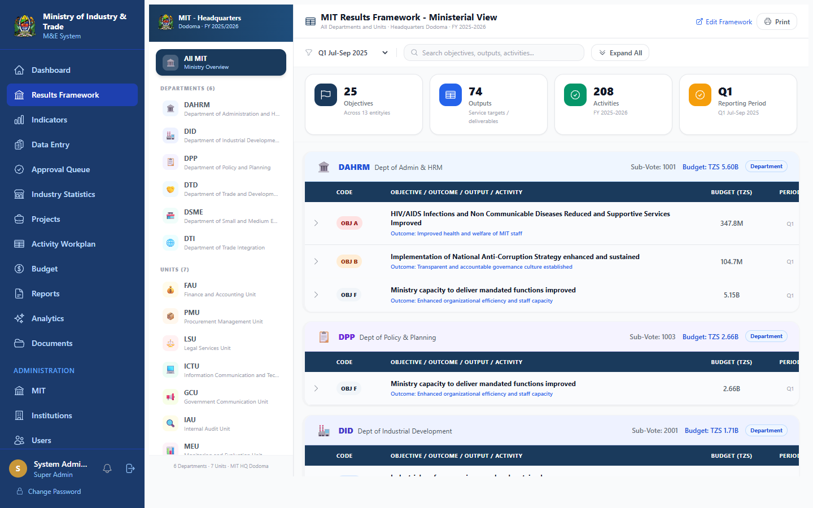
Figure 6: Indicator Detail Page shows targets vs actuals chart, disaggregation, and responsible institutions
Each indicator detail page shows:
- Definition: what the indicator measures
- Disaggregation: how data is broken down (by gender, region, etc.)
- Targets: annual and quarterly targets per fiscal year
- Actuals: submitted and approved data values
- Achievement Chart: visual trend of performance over time
- Responsible Institutions: which institutions report on this indicator

6.3 Creating a New Indicator (M&E Officer or Super Admin)
- Click Indicators in the sidebar
- Click the + New Indicator button (top right)
- Fill in:
- Name: full indicator name
- Code: short reference code
- Definition: clear description of what is being measured
- Unit of Measure: e.g. Number, Percentage, TZS
- Reporting Frequency: Quarterly or Annual
- Formula Type: how achievement is calculated
- Output: link to the Results Framework Output
- Responsible Institutions: which institutions report on it
- Set Targets for the current fiscal year (annual and by quarter)
- Click Save Indicator

6.4 Formula Types
Formula | Description
Achievement % | (Actual ÷ Target) × 100
Cumulative Total | Sum of all period actuals
Proportion % | Part ÷ Whole × 100
Complement % | 100 minus the proportion
Multi-input | Combined formula using multiple values
Manual | Score entered directly by M&E Officer

7.0 Data Entry
Navigation: Data Entry (sidebar)
Data Entry is where institutions submit their indicator performance data for each reporting period.

7.1 Submitting Data
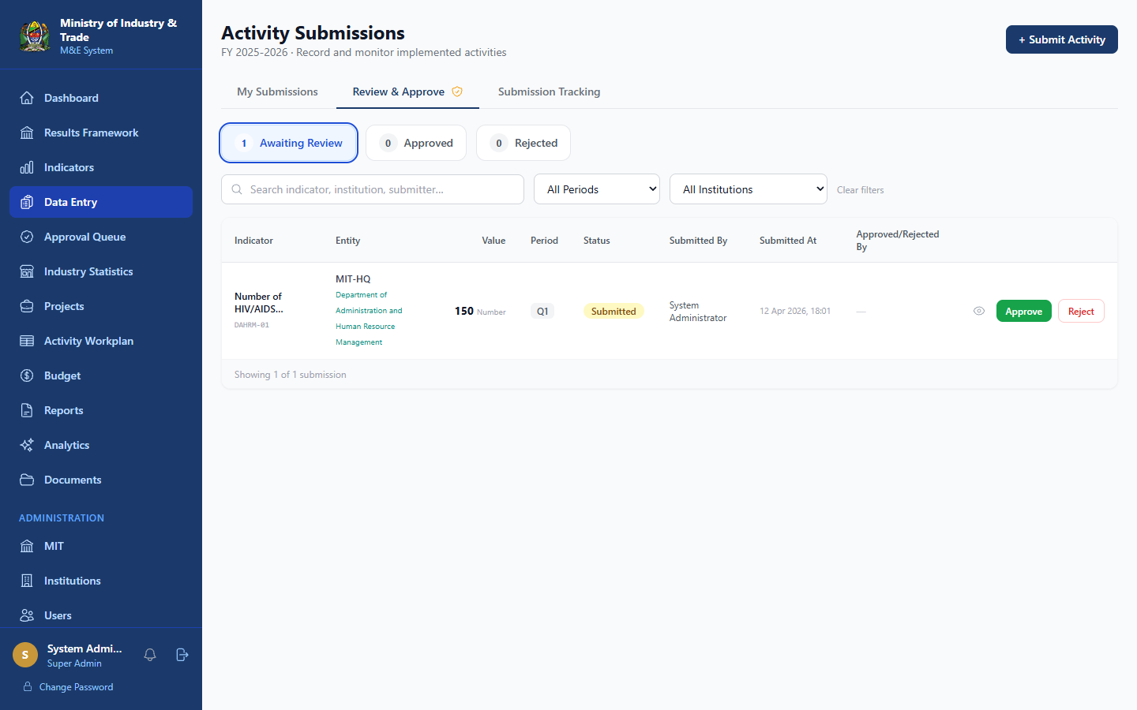
Figure 7: Data Entry Page for indicator submission list with period and status filters
- Click Data Entry in the sidebar
- Click + Submit Data
- Select the Fiscal Year and Reporting Period (Q1, Q2, Q3, Q4, or Annual)
- Select the Indicator you are reporting on
- Enter the Actual Value achieved
- Add any relevant Notes or Comments
- Attach supporting files if required
- Click Submit
NOTE: Note: You can only submit data for indicators assigned to your institution. Periods that are locked by the administrator cannot receive new submissions.

7.2 Submission Statuses
Status | Meaning
Draft | Saved but not yet submitted
Submitted | Sent for supervisor review
Pending Supervisor | Awaiting supervisor approval
Pending M&E | Awaiting M&E Officer review
Approved | Accepted and finalised
Rejected | Returned for correction

7.3 Editing a Submission
- You can edit a submission while it is in Draft or Rejected status
- Once submitted, contact your M&E Officer to reject it back for correction
- Approved submissions cannot be edited (audit trail is preserved)

7.4 Viewing Your Submissions
- Click Data Entry in the sidebar
- The list shows all submissions by your institution
- Filter by period, status, or indicator
- Click any row to view full details and comments

8.0 Approval Queue
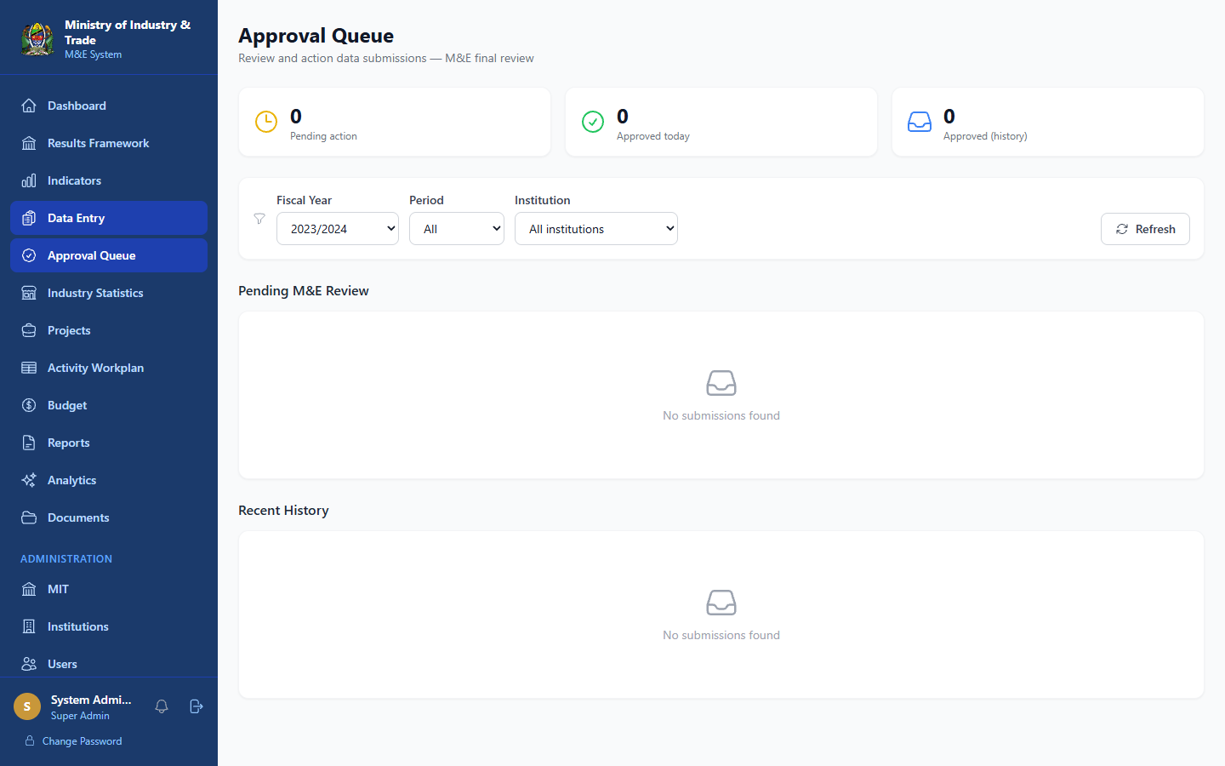
Figure 8: Approval Queue for pending submissions awaiting M&E Officer review
Navigation: Approval Queue (sidebar)
Available to: M&E Officers, Admins, Super Admin
The Approval Queue shows all data submissions waiting for review.

8.1 Approving a Submission
- Click Approval Queue in the sidebar
- You will see all pending submissions for your institution
- Click a submission to open it
- Review the submitted value, notes, and attachments
- Click Approve to accept the data
- The submission status changes to Approved and is locked

8.2 Rejecting a Submission
- Open the submission from the Approval Queue
- Click Reject
- Enter a reason for rejection in the comment box
- Click Confirm Rejection
- The submitter will be notified and can correct and resubmit

8.3 Bulk Actions
- Use the checkboxes to select multiple submissions
- Click Bulk Approve to approve all selected submissions at once

9. 0 Industry Statistics
Navigation: Data Entry → Industry Statistics (sidebar)
Available to: M&E Officers, Admins, Super Admin
This section captures aggregate industry-level statistics for the MIT dashboard.
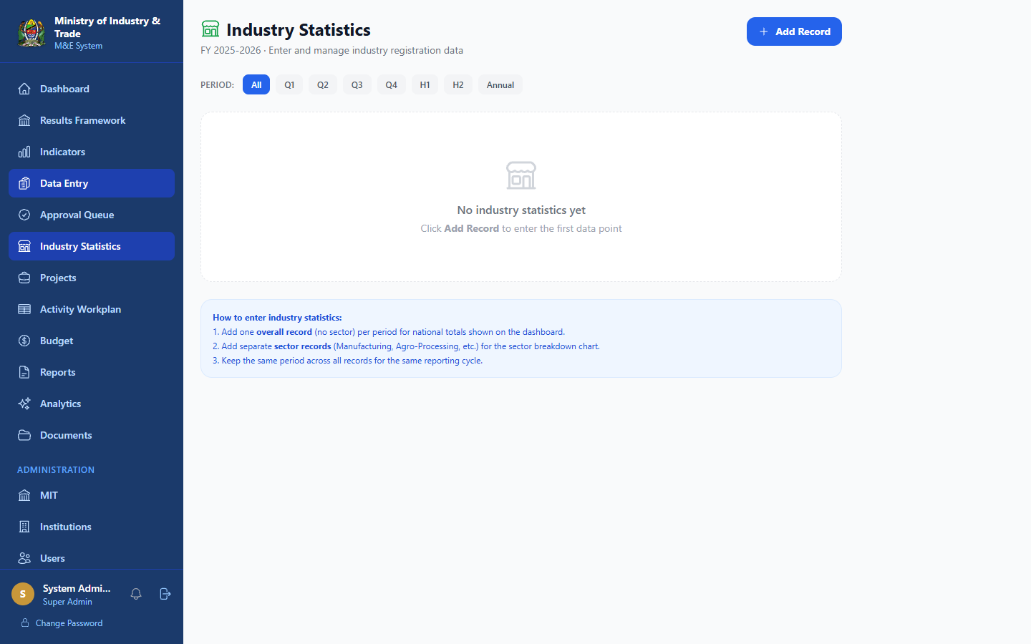
Figure 9: Industry Statistics aggregate national industry data entry form

9.1 Entering Industry Statistics
- Click Industry Statistics in the sidebar
- Select the Fiscal Year and Quarter
- Enter values for each statistical indicator (e.g. number of registered businesses, export value, employment figures)
- Click Save


Figure 9: Industry Statistics aggregate national industry data entry form

10.0. Projects
Navigation: Projects (sidebar)
The Projects module tracks implementation of development projects across MIT and its institutions.

10.1 Viewing Projects
- Click Projects in the sidebar
- Browse the project list filter by status, institution, or fiscal year
- Click any project to view its details
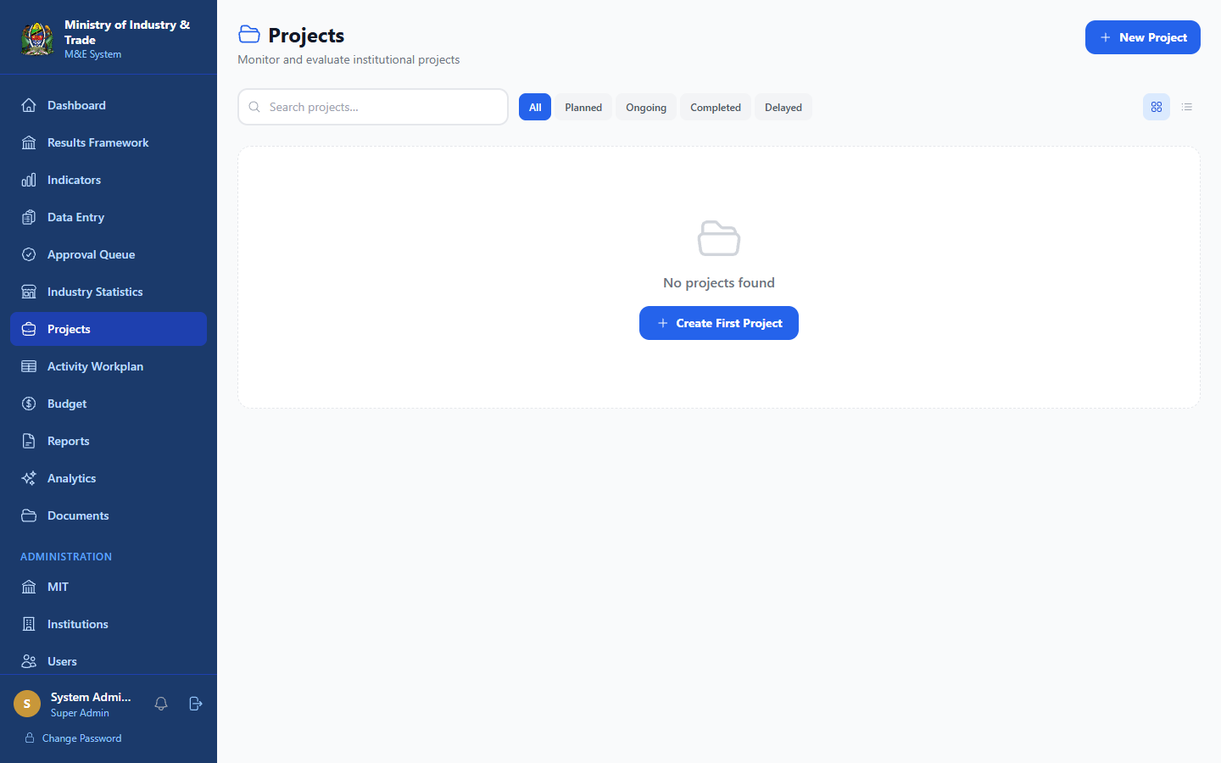
Figure 10: Projects List all projects with status, budget, and institution filters

10.2 Project Detail Page
Each project shows:
- Overview: name, description, budget, start/end dates, status
- Milestones: key deliverables with due dates and completion status
- Activities: specific tasks under each milestone
- Expenditure: actual spending against the project budget
- Progress: overall completion percentage
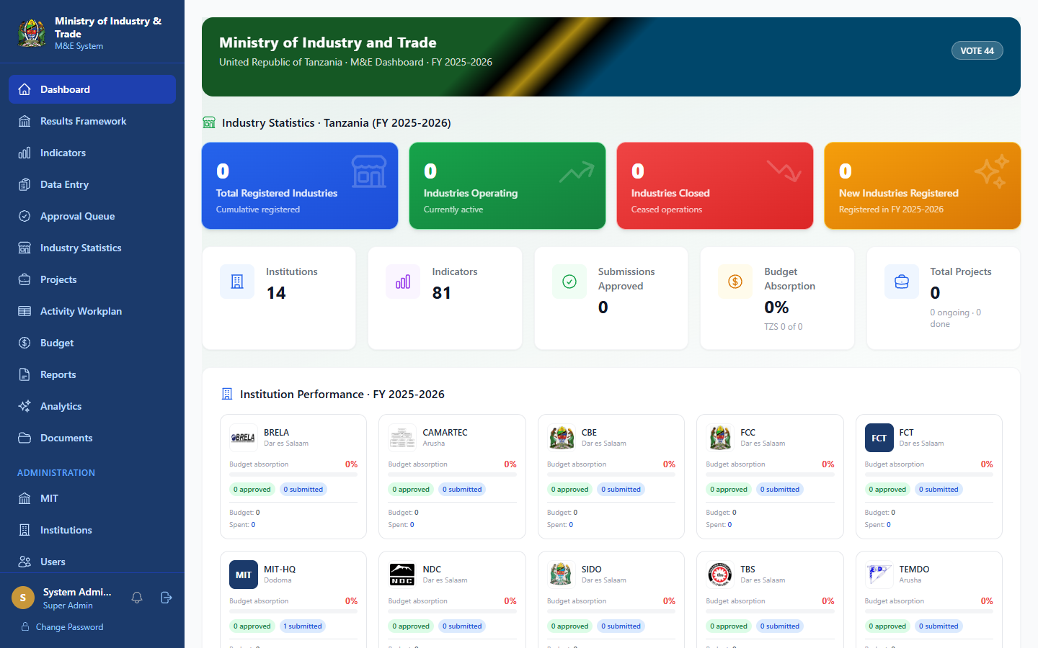
Figure 11: Project Detail milestones, activities, expenditure, and overall progress

10.3 Creating a New Project (M&E Officer and above)
- Click Projects → + New Project
- Fill in:
- Project name and description
- Responsible institution
- Start and end dates
- Total budget (TZS)
- Funding source
- Status (Planned, Ongoing, Completed, Delayed, Cancelled)
- Add Milestones key deliverables with due dates
- Add Activities under each milestone
- Click Save Project

10.4 Updating Project Progress
- Open the project
- Click Edit to update the status, completion percentage, or add remarks
- Update individual milestones as they are completed
- Click Save

10.5 Project Statuses
Status | Meaning
Planned | Not yet started
Ongoing | Implementation in progress
Completed | All milestones achieved
Delayed | Behind schedule
Cancelled | Project has been cancelled

11.0 Activity Workplan
Navigation: Activity Workplan (sidebar)
The Activity Workplan tracks the implementation schedule and progress of activities in the Results Framework.

11.1 Viewing the Workplan

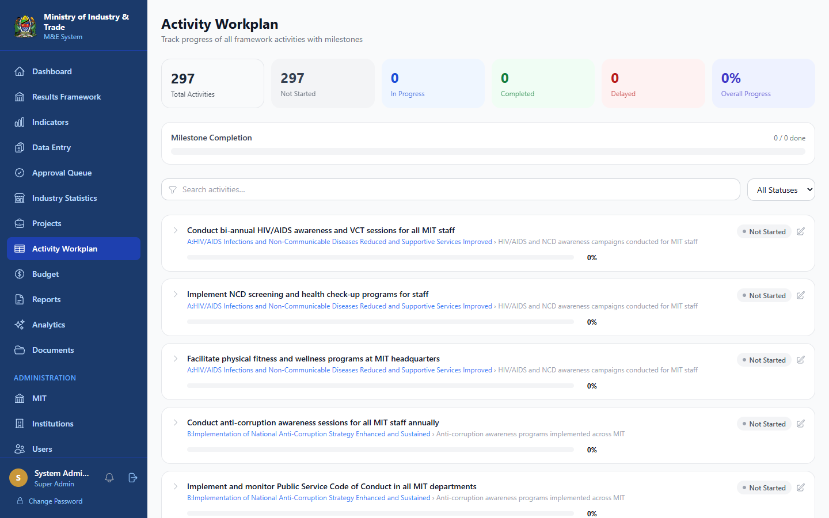
Figure 12: Activity Workplan summary stats and expandable activity cards with milestone tracking
- Click Activity Workplan in the sidebar
- Summary cards show total activities, completion counts, and overall progress
- Use filters to narrow by status or search by activity name
- Each Activity Card shows:
- Activity name and linked Output/Objective
- Start and end dates
- Progress percentage
- Workplan status
- Milestone list

11.2 Updating an Activity (M&E Officer and above)
- Click the activity card to expand it
- Click Edit
- Update:
- Start Date / End Date
- Progress: % overall completion (0-100)
- Status: Not Started, In Progress, Completed, Delayed, On Hold
- Remarks: notes on progress or challenges
- Click Save

11.3 Managing Milestones
- Expand an activity card
- Click + Add Milestone to create a new milestone
- Enter the milestone name and due date
- Click any milestone row to cycle its status (Not Started → Ongoing → Completed → Delayed)
- Hover over a milestone and click the trash icon to delete it (Admin only)

11.4 Workplan Statuses
Status | Description
Not Started | Activity has not begun
In Progress | Activity is underway
Completed | Activity fully achieved
Delayed | Behind planned schedule
On Hold | Temporarily paused

NOTE: Overdue indicator: Activities past their end date that are not completed are highlighted in red.

12.0 Budget
Navigation: Budget (sidebar)
The Budget module tracks financial plans and actual expenditures for each institution.

12.1 Budget Overview
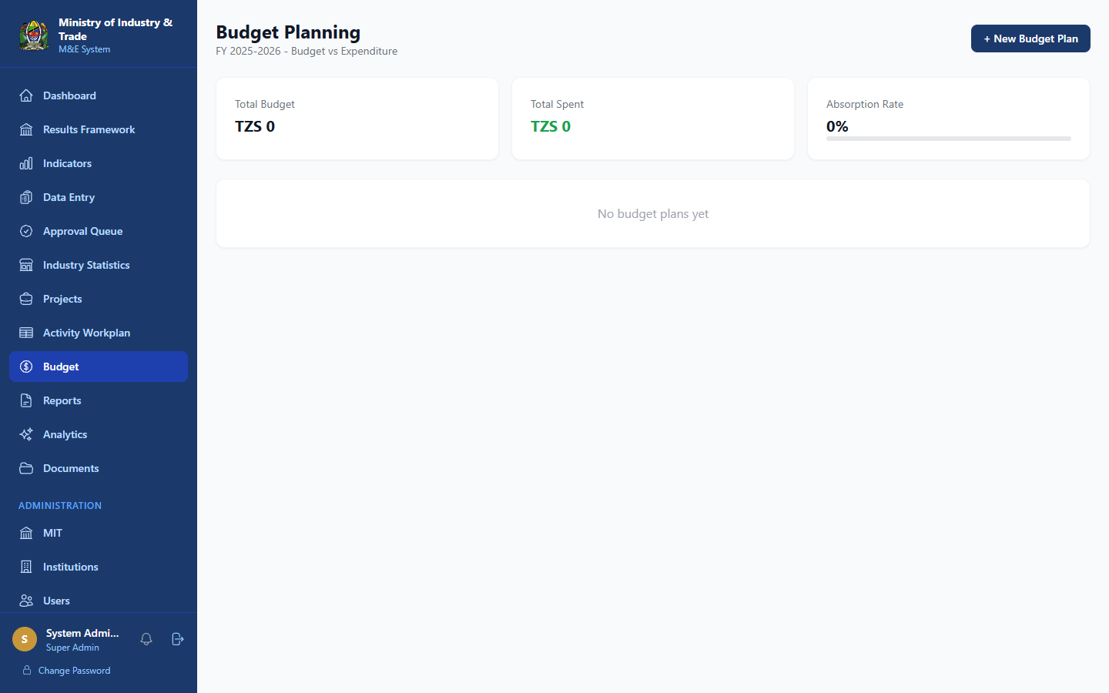
Figure 13: Budget Overview total budget, expenditure to date, and utilisation chart
- Click Budget in the sidebar
- The overview shows:
- Total approved budget
- Total expenditure to date
- Remaining balance
- Budget utilisation chart by quarter

12.2 Budget Plans
- Click Budget → Budget Plan
- View the planned budget breakdown by activity, quarter, and funding source
- Click + New Budget Plan (M&E Officer and above) to create a plan
- Fill in activity, amount, funding source, and quarter
- Click Save

12.3 Recording Expenditures
- Click Budget → Expenditures
- Click + Record Expenditure
- Fill in:
- Activity reference
- Amount spent (TZS)
- Quarter
- Description and supporting reference number
- Click Save

13.0 Reports
Navigation: Reports (sidebar)
The Reports module allows you to generate formatted performance reports.

13.1 Generating a Report
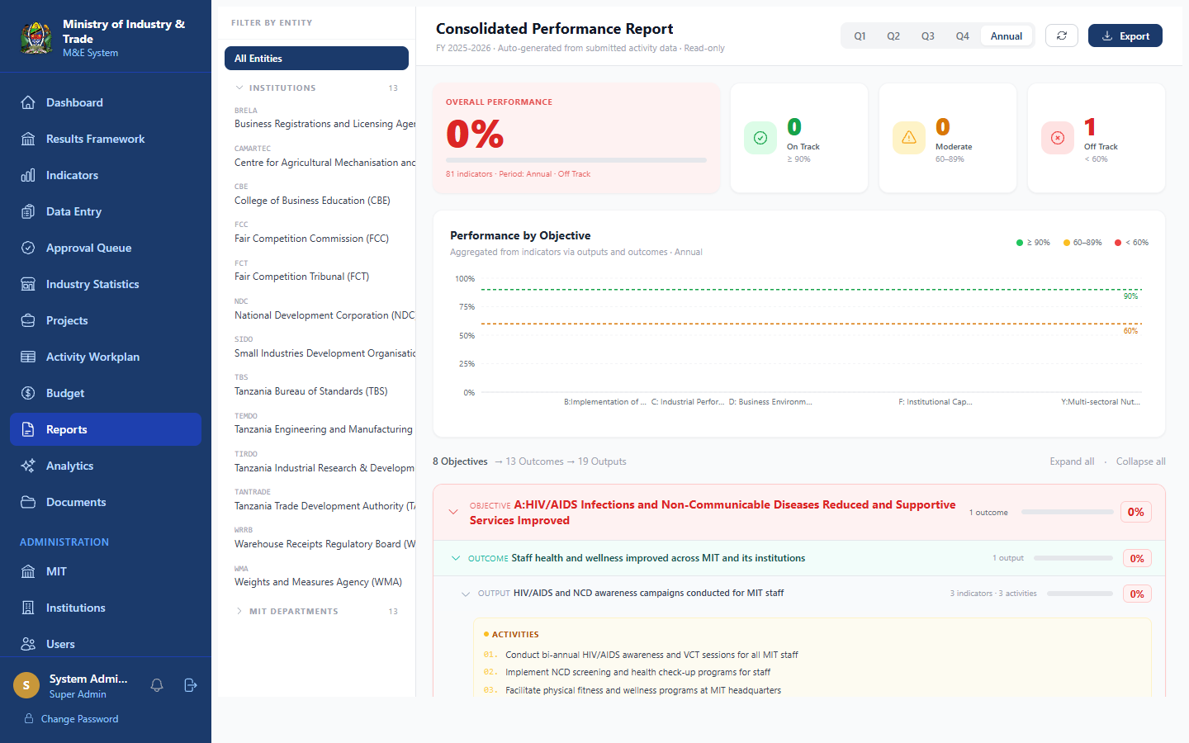
Figure 14: Reports Page- report type selection, period filter, and export options
- Click Reports in the sidebar
- Select the Report Type:
- Performance Report: achievement against targets by indicator
- Submission Summary: status of all data submissions
- Budget Report: budget utilisation summary
- Project Status Report: overview of all projects
- Select the Fiscal Year and Reporting Period
- Select the Institution(s) to include (Super Admin can select all)
- Click Generate Report

13.2 Exporting Reports
- Click Export PDF to download a PDF version
- Click Export Excel to download a spreadsheet
- Reports include charts, tables, and summary narratives

14.0. Analytics
Navigation: Analytics (sidebar)
The Analytics page provides advanced visual analysis of system-wide performance data.

14.1 Available Charts
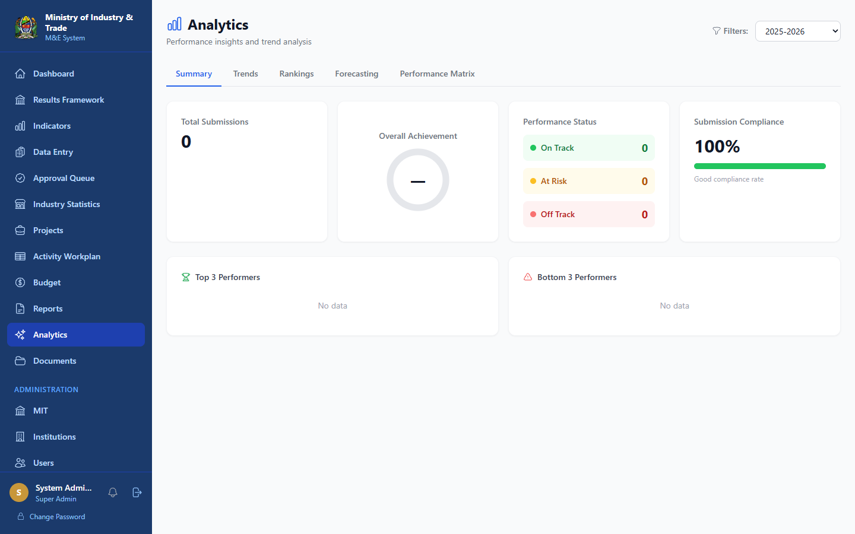
Figure 15: Analytics Page - interactive charts for trend analysis and institution comparison
- Achievement by Objective: bar chart of performance per strategic objective
- Trend Analysis: indicator performance over multiple periods
- Institution Comparison: side-by-side performance of all institutions
- Submission Heatmap: data submission activity by institution and period
- Budget vs. Expenditure: financial utilisation trends

14.2 Filtering Analytics
Use the filter panel to narrow data by:
- Fiscal Year
- Reporting Period
- Strategic Objective
- Institution
- Indicator

15. Documents
Navigation: Documents (sidebar)
The Documents module is a central repository for official files shared across MIT and its institutions.

15.1 Browsing Documents
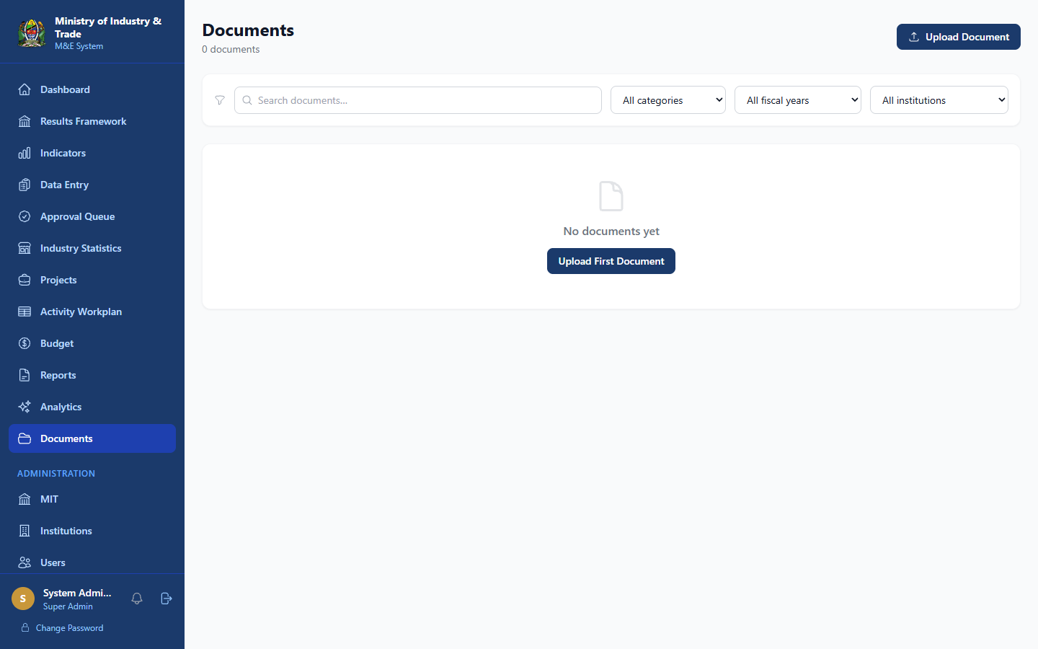
Figure 16: Documents Repository - categorised document library with search
- Click Documents in the sidebar
- Browse by category or use the search bar
- Click a document to preview or download it

15.2 Uploading a Document (M&E Officer and above)
- Click + Upload Document
- Select the file from your computer (PDF, Word, Excel, PNG supported)
- Fill in:
- Document title
- Category (Policy, Report, Template, Guideline, Other)
- Description (optional)
- Click Upload

15.3 Document Categories
Category | Examples
Policy | Ministry policies, circulars
Report | Quarterly and annual performance reports
Template | Data collection forms, reporting templates
Guideline | M&E manuals, indicator guides

16.0. Administration
Administration features are only visible to users with Admin or Super Admin roles.

16.1 Managing Users
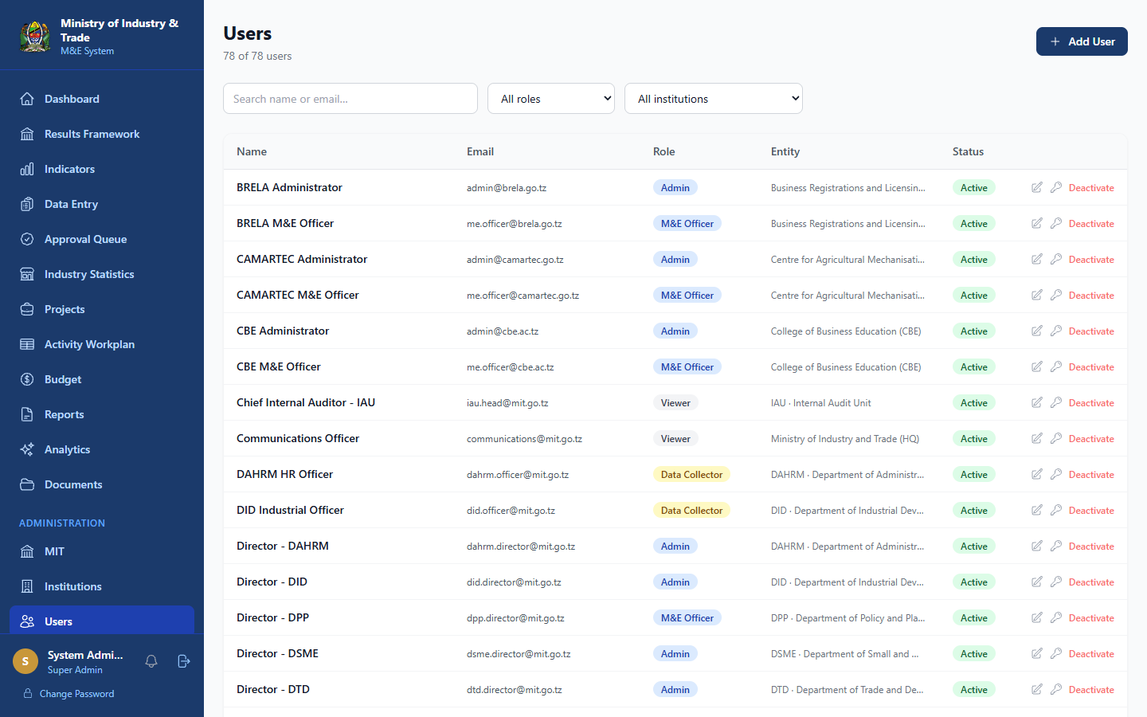
Figure 17: User Management - list of all system users with role, institution, and status
Navigation: Administration → Users
Creating a New User
- Click Administration → Users
- Click + New User
- Fill in:
- Full name
- Email address
- Role (Viewer, Data Collector, M&E Officer, Admin)
- Institution
- Department (for MIT-HQ staff)
- Click Create User
- A welcome email with a temporary password is sent to the user
Editing a User
- Find the user in the list
- Click the Edit (pencil) icon
- Update name, role, or institution as needed
- Click Save
Deactivating a User
- Find the user in the list
- Click the Deactivate toggle
- The user will no longer be able to log in

16.2 Managing Institutions
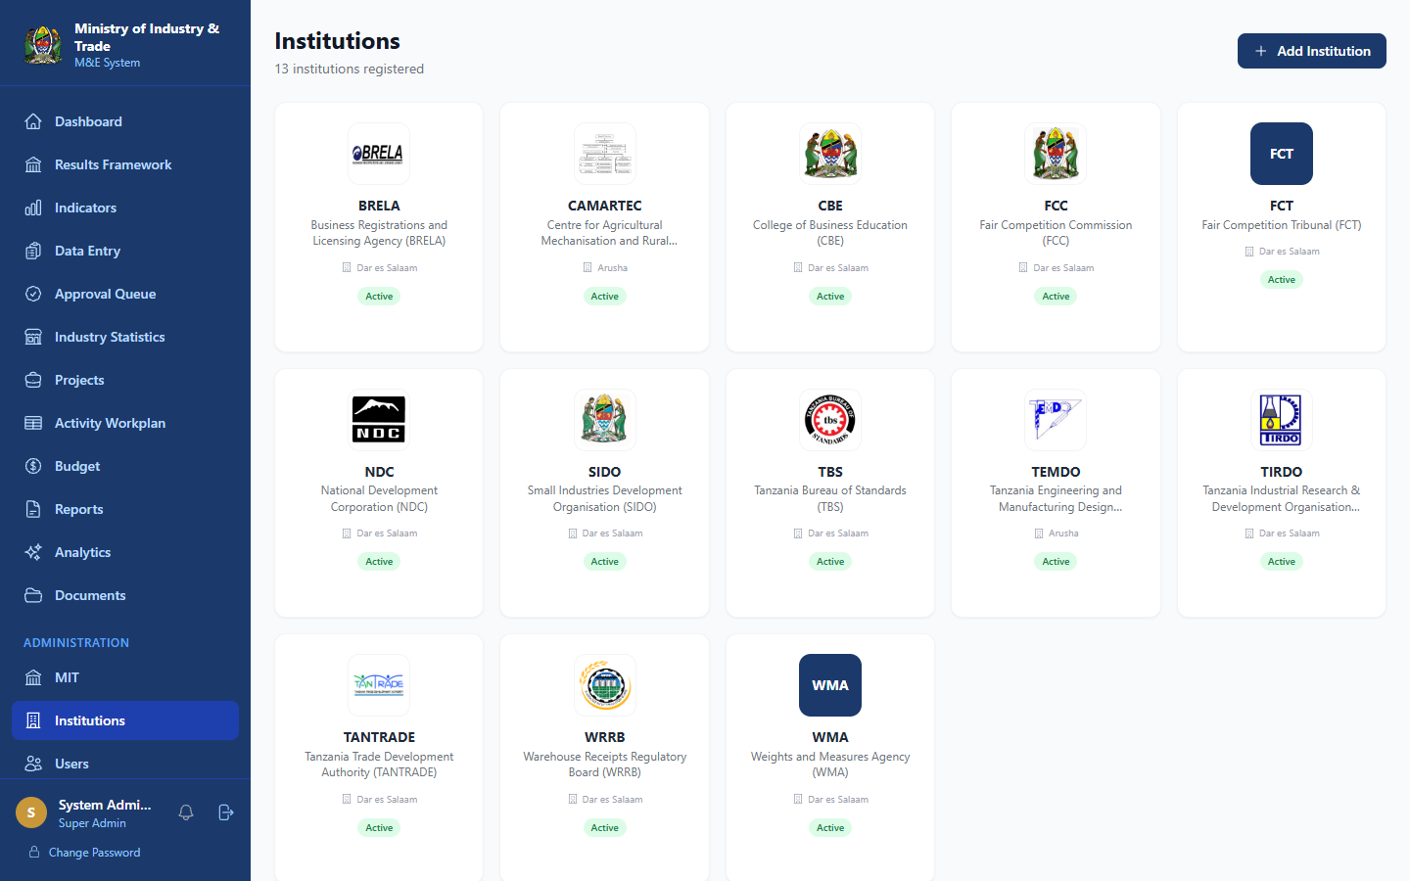
Figure 18: Institutions Management- MIT-HQ and 13 affiliated agencies
Navigation: Administration → Institutions
Available to: Super Admin only
- Click Administration → Institutions
- View all institutions and MIT-HQ + 13 with their details
- Click an institution to edit its name, code, logo, or contact details
- Click + New Institution to add a new agency

16.3 MIT Organisational Structure
Navigation: Administration → MIT
This section manages the internal structure of MIT-HQ:
- Departments
- Units within departments
- Staff assignments
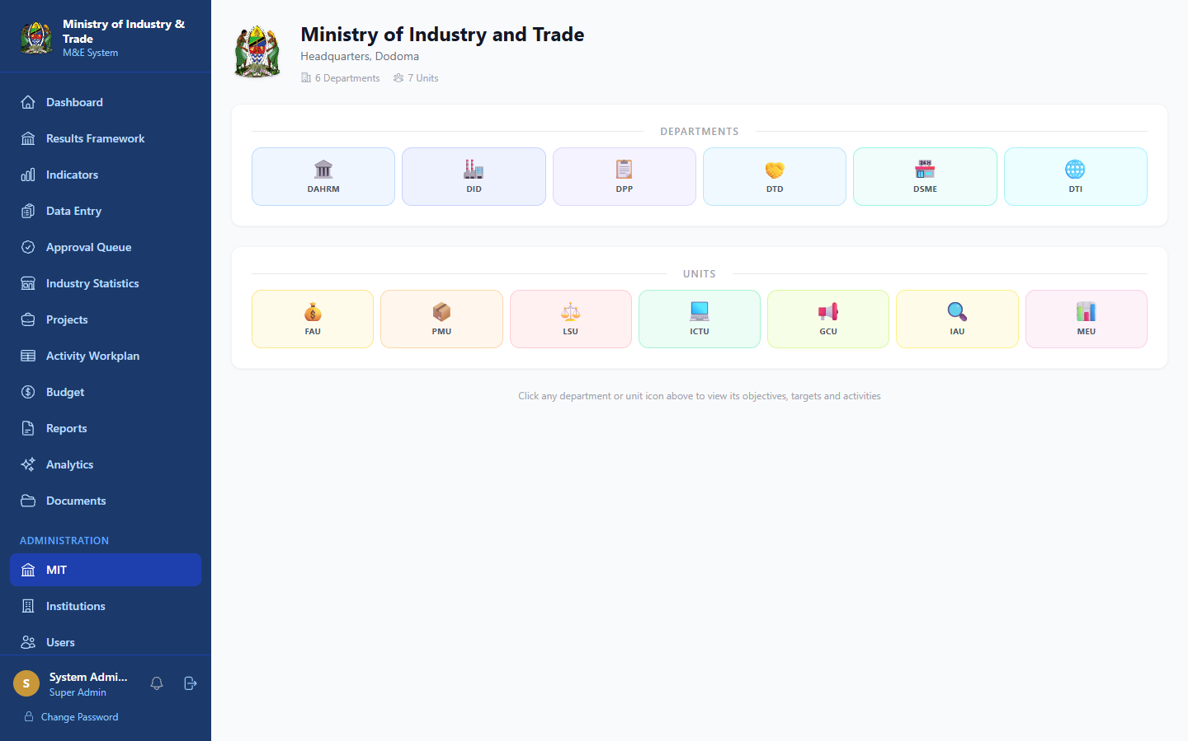
Figure 19: MIT Structure departments and units within MIT Headquarters

16.4 Reporting Calendar
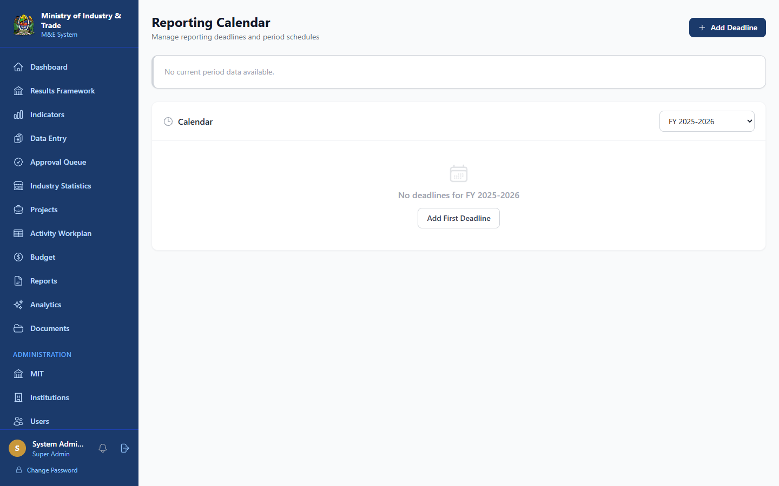
Figure 20: Reporting Calendar - fiscal year periods with open/close dates

16.5 Period Locks
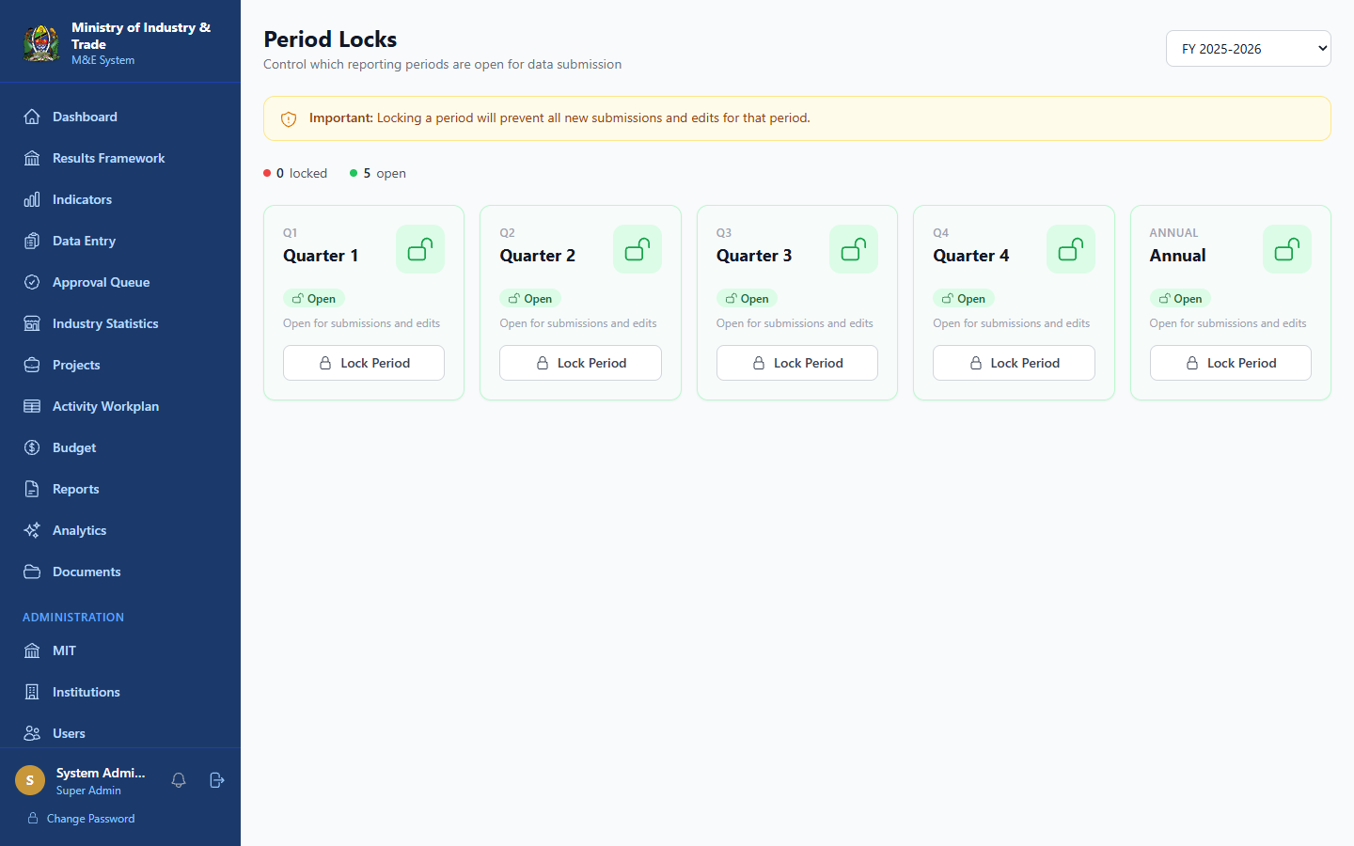
Figure 21: Period Locks- locked and unlocked reporting periods per fiscal year
Navigation: Administration → Period Locks
Available to: Admin, M&E Officer, Super Admin
Period Locks prevent new submissions for a reporting period that has been closed.
Locking a Period
- Click Administration → Period Locks
- Select the Fiscal Year and Period
- Click Lock Period
- No new submissions can be made for that period after locking
Unlocking a Period
- Find the locked period in the list
- Click Unlock
- Submissions can be made again
NOTE: Warning: Unlocking a period should only be done to correct errors and should be re-locked promptly.

16.6 API Integrations
Navigation: Administration → Integrations
The Integrations module allows institutions to connect external systems via API keys.
- Click Administration → Integrations
- Click Generate API Key to create a new key for an institution
- Share the key securely with the institution's technical team
- Monitor API sync logs to track data exchanges

16.7 Framework Versions
Navigation: Administration → FW Versions
- Click FW Versions in the sidebar
- View all saved versions of the Results Framework
- Click a version to compare it against the current framework
- Click + Save Version to snapshot the current framework

17.0. Contact Support & Helpdesk
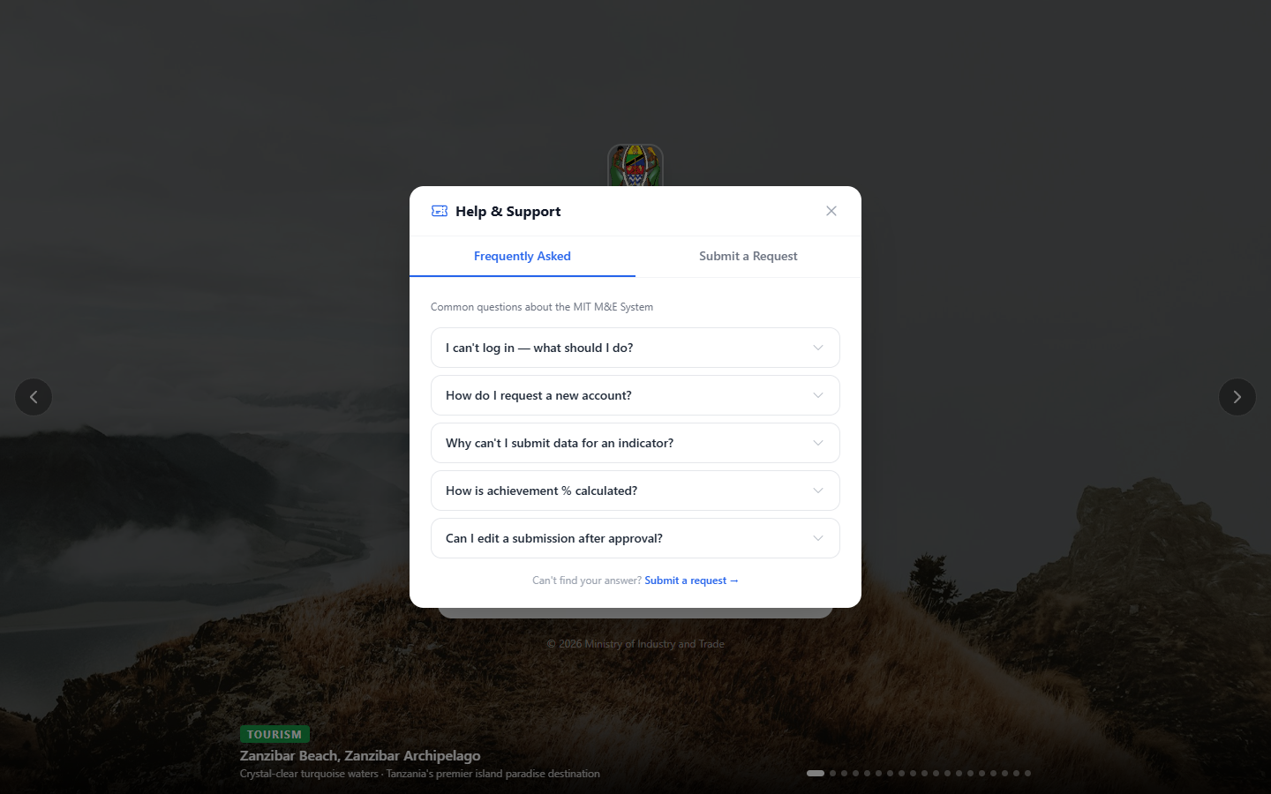
Figure 2: Contact Support Panel-FAQ tab and ticket submission form accessible without logging in

17.1 Contact Support (Without Logging In)

Figure 2: Contact Support Panel - FAQ tab and ticket submission form accessible without logging in
If you cannot log in or need help before accessing the system:
- Go to the login page
- Click Contact Support (below the login form)
- A support panel opens with two tabs:
Frequently Asked Questions tab
Browse common questions and answers about:
- Login issues
- Account requests
- Data submission problems
- Report generation
- Password resets
Submit a Request tab
- Enter your Name and Email
- Select the Category of your issue
- Enter a Subject and detailed Description
- Click Submit Request
- You will receive a ticket number for tracking

17.2 Helpdesk (After Logging In)
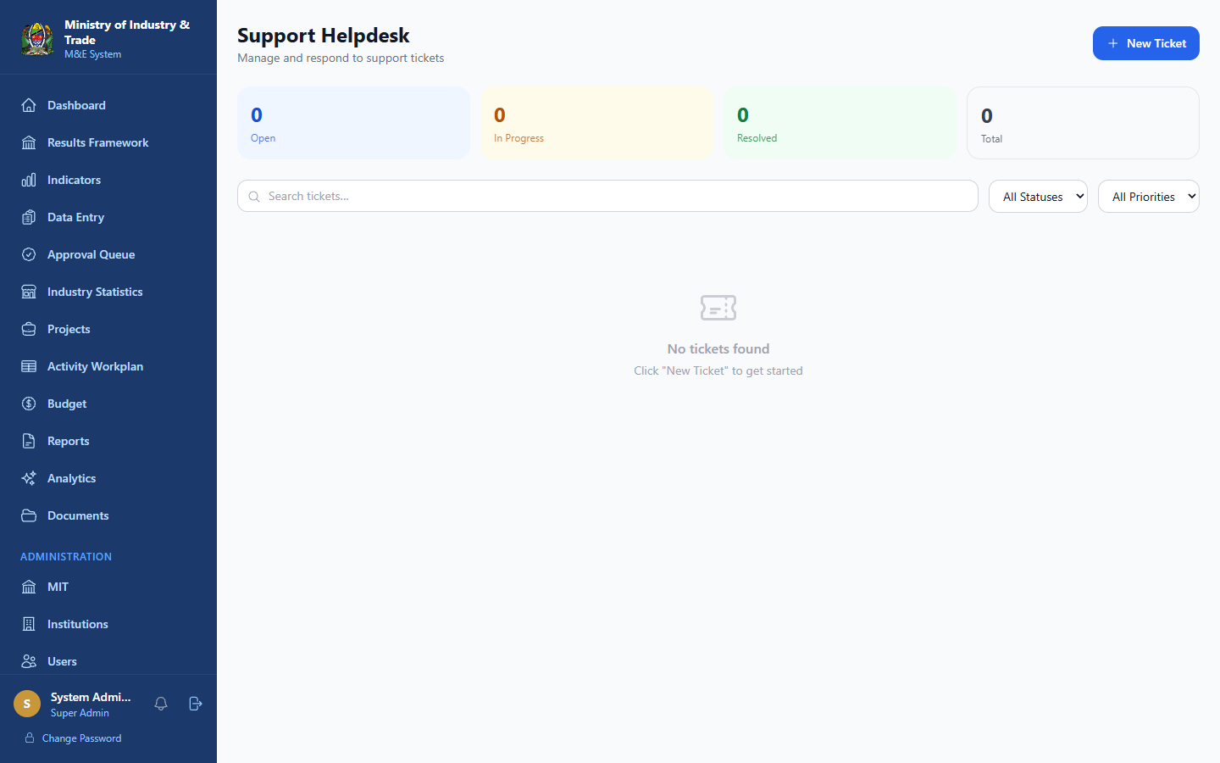
Figure 22: Helpdesk- ticket list with status/priority filters and admin stats panel
Once logged in, you can manage your support tickets:
- Navigate to https://[server]:5443/helpdesk (or ask your admin for access)
- Click + New Ticket to submit a request
- Fill in the subject, description, category, and priority
- Click Submit Ticket

Ticket Statuses
Status | Meaning
Open | Ticket received, awaiting response
In Progress | Support team is working on it
Resolved | Issue has been resolved
Closed | Ticket is closed - no further replies

Replying to a Ticket
- Click on a ticket to open it
- Read the conversation thread
- Type your reply in the text box at the bottom
- Click Send

17.3 Ticket Priority Levels
Priority | Use For
Low | General questions, minor issues
Medium | Standard problems affecting your work
High | Significant issue affecting multiple users
Urgent | System down, data loss, security concern

18.0. Troubleshooting
I cannot log in
- Check that your email and password are correct (passwords are case-sensitive)
- Click Forgot password? to reset your password
- If your account is locked after multiple failed attempts, wait 5 minutes and try again
- Contact your institution administrator if the issue persists
The page shows a security warning
The system uses a self-signed SSL certificate for internal network use. Your browser will show a security warning on first access this is expected for systems hosted within a government intranet.
- In Chrome/Edge: Click Advanced → Proceed to [address] (unsafe)
- In Firefox: Click Advanced → Accept the Risk and Continue
- This only needs to be done once per browser per device
- When the system is deployed on a public government server, a trusted SSL certificate will be installed and this warning will no longer appear
My session expired
Your session expires after 15 minutes of inactivity. Log in again — your work in the system is saved.
I cannot submit data
Possible reasons:
- The reporting period is locked — contact your M&E Officer or Admin
- The indicator is not assigned to your institution — contact your M&E Officer
- Your role does not have Data Collector or higher permissions
I cannot find my submission
- Check the Data Entry page and filter by All Statuses
- Approved submissions may have been archived — check the approved filter
The system is slow or unresponsive
- Check your internet/WiFi connection
- Refresh the page (F5)
- Clear your browser cache (Ctrl+Shift+Delete)
- If the problem persists, contact support
I get "Access Denied" on a page
Your user role does not have permission to access that page. Contact your administrator to request elevated access if needed.
Charts or data are not loading
- Ensure you are connected to the same network as the server
- Try refreshing the page
- Check the notification bell (top of sidebar) for any system alerts

Appendix A: Keyboard Shortcuts
Shortcut | Action
F5 | Refresh page
Ctrl + F | Search within a page
Escape | Close a modal/popup
Tab | Move between form fields

Appendix B: Glossary
Term | Definition
Actual | The measured value achieved for an indicator in a reporting period
Baseline | The starting value of an indicator before the strategic plan begins
Data Collector | A user responsible for submitting indicator data for their institution
Fiscal Year | Tanzania government fiscal year (July–June, e.g. 2025/2026)
Indicator | A measurable metric used to track progress toward a strategic objective
M&E | Monitoring and Evaluation
Outcome | The medium-term result expected from a set of outputs
Output | A direct deliverable produced by activities
Period Lock | A system control that prevents new submissions for a closed reporting period
Reporting Period | Q1 (Jul–Sep), Q2 (Oct–Dec), Q3 (Jan–Mar), Q4 (Apr–Jun), or Annual
Results Framework | The structured hierarchy linking activities to strategic objectives
Strategic Objective | A high-level goal in the MIT Strategic Plan 2026/27–2030/31
Target | The planned value an indicator should reach in a given period

Appendix C: System Information
Item | Detail
System Name | MIT M&E System
Version | 1.0
Developer | ICT Unit, Ministry of Industry and Trade
Database | PostgreSQL 16
Technology | Node.js + React 18
Access | HTTPS (port 5443)
Support Email | helpdesk@mit.go.tz

Ministry of Industry and Trade - M&E System User Manual v1.0
For technical support, use the Contact Support button on the login page or submit a ticket through the Helpdesk.

