The Future of Prior Authorization with Agentic AI
Panel discussion — screen-by-screen walkthrough
Prior Authorization panel · Recorded date not stated in source · Duration 57:29
Presenters | Gabriel Skelton (host) — Head of AI Solutions, Openbots · Zia Buddha — CEO & Founder, Openbots · Ronaldo Deb Banerjee (“Ronaldo” / on-screen “Rano”) — Associate Director, Healthcare Automation, Openbots · Jonathan Leon — Senior Healthcare Process Architect, Accelerate
Organizations | Openbots (openbots.ai); Accelerate
Format | Live panel webinar · 425+ healthcare leaders attending · audience Q&A via on-screen chat
Topic | Automating prior authorization (PA) across the healthcare revenue cycle with agentic AI
Source video | 720p (1280×720), 30 fps, 57:29
Goal | Faithful screen-by-screen record of the panel discussion
About this document
This is a faithful record of a live panel webinar. Every screenshot is a real frame captured directly from the recording (the full 1280×720 frame — no crop was needed). The mm:ss on each step is the exact moment in the video. Narration quotes are the speakers’ own words, matched to each moment using the timestamped transcript; light [bracketed] clarifications fix obvious auto-caption slips. On-screen text (links, emails, audience comments) is read directly off the frames. The complete verbatim transcript is included as an appendix.
Note: this session is discussion-first. It runs the whole time in a fixed four-person video-call gallery (Gabriel Skelton and Jonathan Leon on top; Zia and Rano below) with a growing panel of audience chat comments on the right — there is no slide deck or product demo in the recording. The screenshots therefore document the panel and the on-screen chat rather than a changing user interface.
The discussion — at a glance
- 1. Opening & the problem — why prior authorization matters (16 min/PA; ~37% of denials)
- 2. Meet the panel — introductions, and what “agentic AI” means
- 3. The current state — where PA breaks down today
- 4. Automation & agentic AI — unifying EMRs and payer portals
- 5. Downstream revenue risk — cancellations & no-shows
- 6. Human-in-the-loop — when agentic AI escalates to a person
- 7. The ROI case — how CFOs should evaluate it
- 8. Documentation & denials — bottlenecks, monitoring, and trends
- 9. Speed — from ~16 minutes to under 3
- 10. Why PA is ideal for AI — high impact, high friction, high automation potential
- 11. What to automate next — across the revenue cycle
- 12. Q&A and close — clinical-note extraction, referrals, wrap-up

Section 1 — Opening & the problem
Host Gabriel Skelton opens the panel and frames why prior authorization matters.

1.1 Panel opens — the prior-authorization problem 00:12
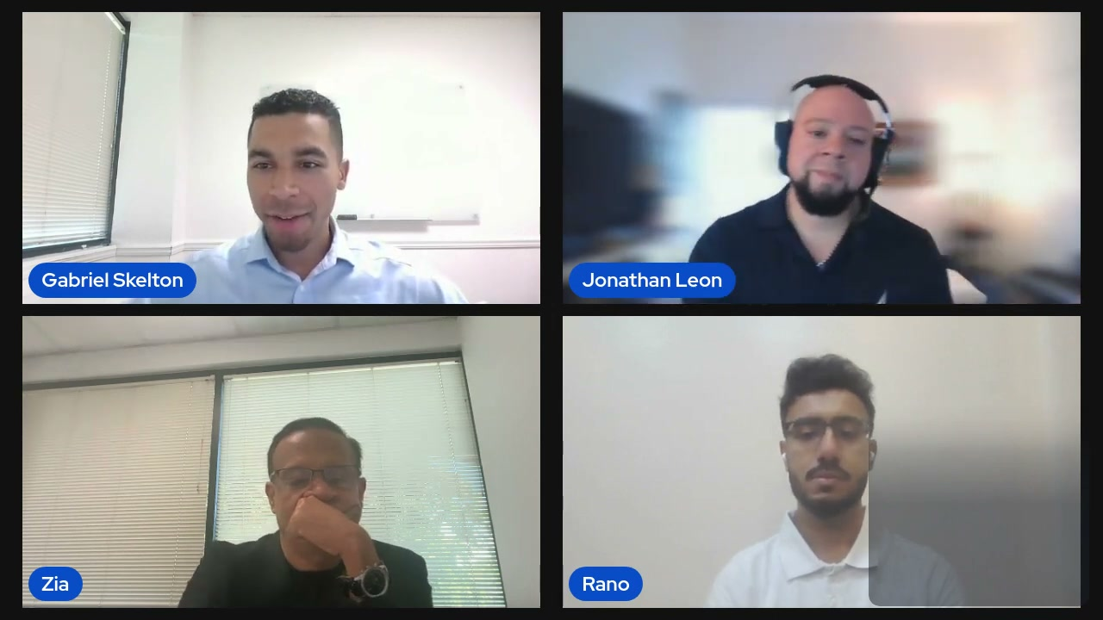
What's on screen
- Four-person video gallery: Gabriel Skelton (host, top-left), Jonathan Leon (top-right), Zia (bottom-left), Rano / Ronaldo (bottom-right). Rano’s tile carries the presenter’s small self-view.
- No slides or screen-share — the entire session runs in this webinar layout.
- Host notes the scale of the audience: 425+ healthcare leaders attending.
- Framing statistics: ~16 minutes to manually process one PA on average; ~37% of denials tied to prior-authorization, registration and eligibility manual errors.
Narration (Gabriel Skelton): “Today it currently takes 16 minutes to manually process one [prior] authorization on average… 37% of denials are directly tied to [prior] authorization, registration, and eligibility manual errors. So doing this solely manually is not the way forward.”

Section 2 — Meet the panel & what “agentic AI” means
Introductions, then the host defines agentic automation.

2.1 Panel introductions & “automation with reasoning” 04:30
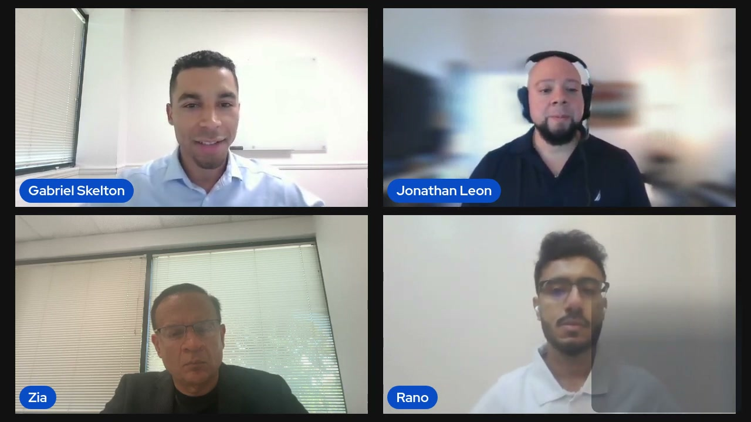
What's on screen
- Each panelist is introduced: Zia Buddha (CEO & founder, Openbots), Ronaldo Deb Banerjee (Associate Director of Healthcare Automation, Openbots), Jonathan Leon (Senior Healthcare Process Architect, Accelerate), and host Gabriel Skelton (Head of AI Solutions, Openbots).
- Openbots is described as a platform to help providers run their revenue cycles autonomously — referral management, eligibility verification, claims, denials and prior auth.
- Host defines “agentic automation” as automation plus reasoning, enabled by large language models.
- A Google form is mentioned for attendees who want to learn more (its link is shown on screen later).
Narration (Gabriel Skelton): “Really all it is is automation with reasoning. The fundamental difference that large language models have enabled is reasoning for automation. That’s a game changer for [prior] authorization.”

Section 3 — The current state: where PA breaks down
Ronaldo, Jonathan and Zia describe today’s fragmented, manual reality.

3.1 Current state — time lost across portals & EMRs 07:00
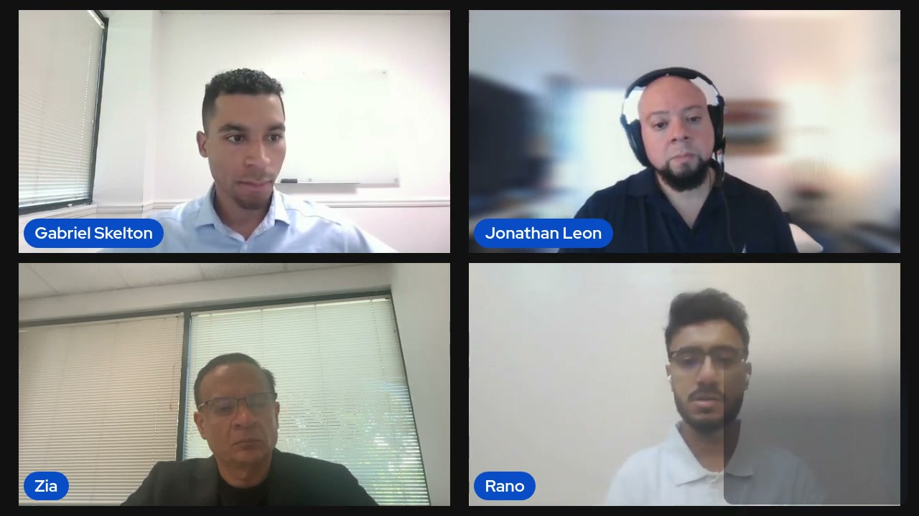
What's on screen
- Ronaldo answers the first question on the current state of PA technology.
- Cites an American Medical Association stat: ~40% of PA submission time is spent navigating between payer portals, EMRs and clearing houses, and tracking status.
- Each payer has different rule sets — what United Healthcare requires differs from Aetna, for medications, procedures and drugs.
- Much of the work is repetitive and low-value — exactly what automation can handle today.
Narration (Ronaldo): “Nearly 40% of the prior authorization request submissions time is spent on navigating between payer portals, EMRs, entering information from the patient chart into the clearing houses or the payer portals… and tracking down the status of the prior authorization request.”

3.2 What goes wrong operationally 09:30
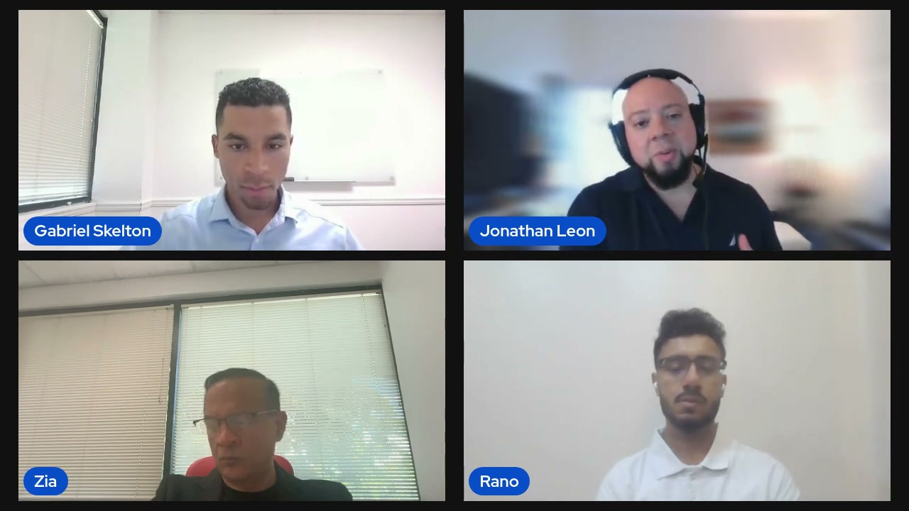
What's on screen
- Jonathan breaks the failure points into three: (1) manual data capture (member ID vs subscriber ID, misspellings, “fat fingers”); (2) communication breakdown between schedulers, authorization specialists and clinical teams; (3) payer complexity and variability that changes without notice.
- Denials context: ~24% tied to registration/eligibility and ~13% directly to prior auth — a little under 40% of denials on the front end.
- A clean initial submission matters, because there is no reliable indicator of when a payer will respond.
Narration (Jonathan Leon): “A lot of manual collection of information is provided from person to person and then it’s documented into an EMR/EHR system… misspellings, incorrect numbers, fat fingers happens all the time.”

3.3 Is it a clinical or a financial issue? 12:15
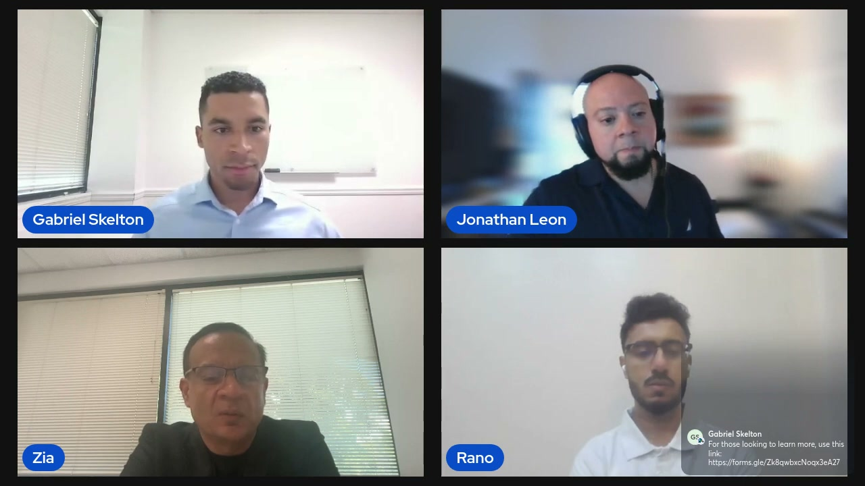
What's on screen
- Zia answers whether PA problems are clinical or financial: primarily clinical, with downstream financial impact.
- Delayed treatment → disease progression, complications, hospitalizations; repeat PAs affect continuity of care; higher long-term costs for payers/systems and higher patient out-of-pocket.
- On-screen chat now shows the host’s “learn more” Google-form link in the comment panel (bottom-right).
Narration (Zia Buddha): “I think it’s a clinical issue with eventually… impact obviously on patient well-being, as well as… [it] becomes a financial issue.”

Section 4 — How automation & agentic AI unify the workflow
Ronaldo explains UI/API automation across EMRs and payer portals, and where agentic AI adds reasoning.

4.1 Automation unifies EMRs & payer portals 13:12
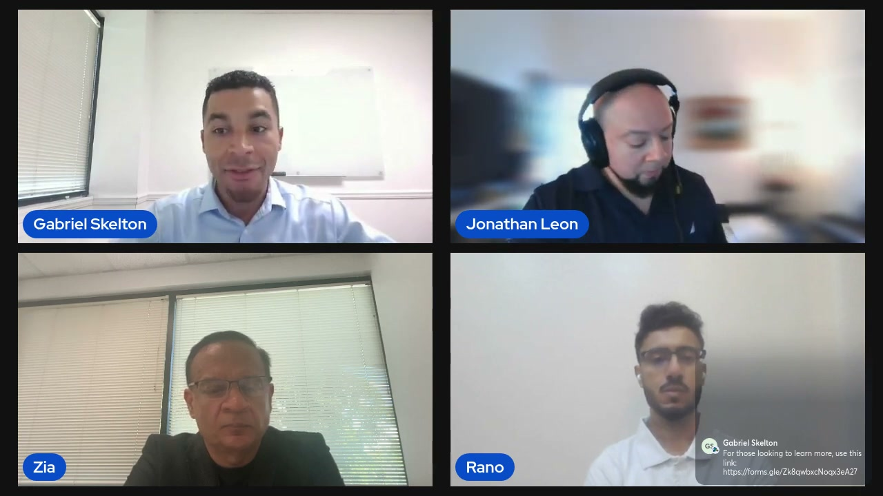
What's on screen
- Ronaldo: bots integrate with EMRs via API, or via UI automation — a bot with its own credentials — to identify the primary payer and collect recent records.
- The bot then logs into payer portals (e.g., United Healthcare) or clearing houses (e.g., Availity, OneHealthPort) to run eligibility checks and submit the required information.
- First audience comment appears on screen: Gabriel Skelton posts “For those looking to learn more, use this link: https://forms.gle/Zk8qwbxcNoqx3eA27”.
Narration (Ronaldo): “You have an automation bot with its own set of credentials to log into an EMR. It can very quickly go into the patient’s chart… every single thing that you do in an EMR is just like a streamlined workflow for an automation bot.”

4.2 Where agentic AI adds reasoning — and the first pinned comment 15:30
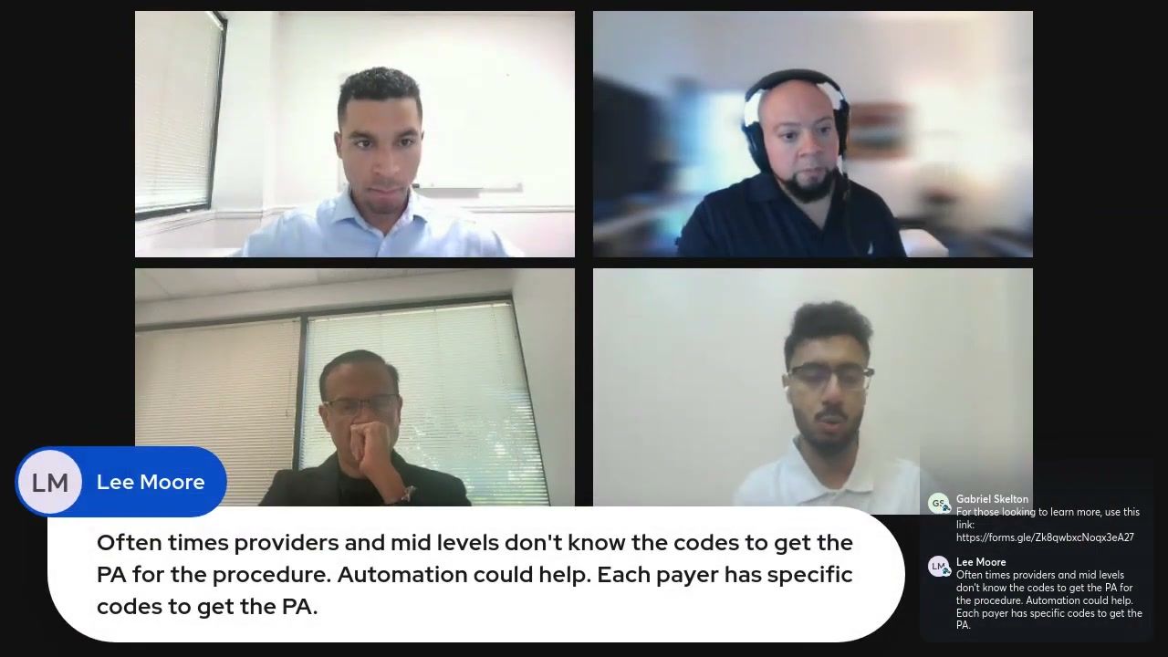
What's on screen
- Ronaldo: agentic AI adds reasoning — e.g., knowing from historical context baked into the LLM that a given drug/procedure has previously been denied by a payer, so the agent escalates preemptively instead of blindly submitting, heading off the denial.
- On screen, an audience comment from Lee Moore is pinned as a large bubble: “Often times providers and mid levels don’t know the codes to get the PA for the procedure. Automation could help. Each payer has specific codes to get the PA.”
- The chat panel (right) still shows the host’s forms.gle link.
Narration (Ronaldo): “This kind of knowledge can easily be baked in to an AI agent so that the AI agent… instead of it submitting the prior documents, it can escalate that situation preemptively to a… prior authorization team member.”

Section 5 — Downstream revenue risk: cancellations & no-shows
Jonathan on how PA delays drive cancellations and no-shows; the audience weighs in.

5.1 Cancellations & no-shows 19:00
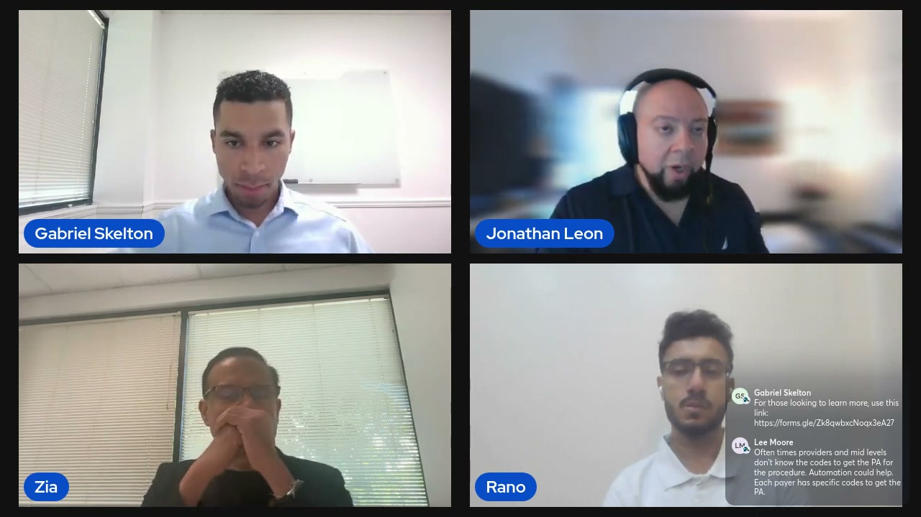
What's on screen
- Jonathan: on average ~15–25% of scheduled appointments are canceled or no-showed because of prior-auth issues; hospitals created dedicated worklists for these patients.
- Impact: negative patient experience, administrative rework, initial authorizations that lapse and need re-auth, and reserved capacity lost on no-shows.
- Highest-volume PA segments: radiology, oncology, cardiology, ortho — but the priority is getting the PA before (or shortly after) the appointment regardless of segment.
Narration (Jonathan Leon): “On average it’s about 15 to 25% of… scheduled appointments… are canceled or no-showed because of… prior [auth] issues.”

5.2 Audience comment highlighted — get the PA before the visit 22:34
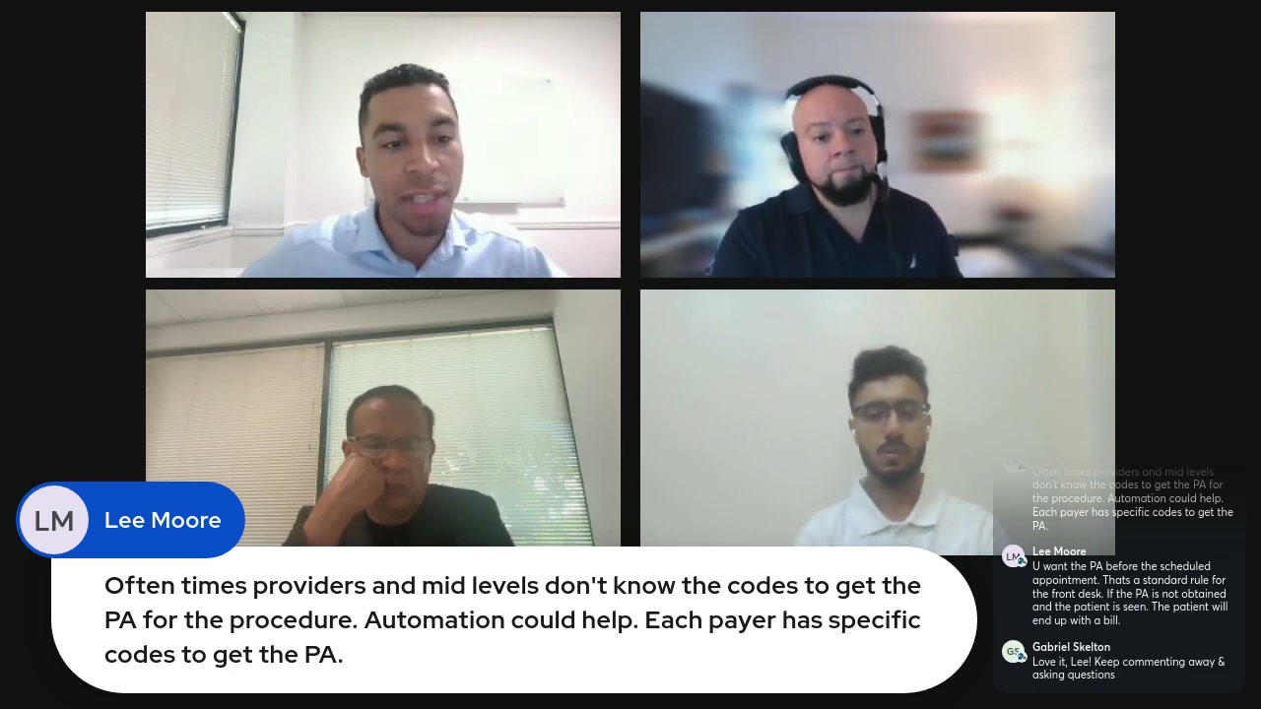
What's on screen
- The host highlights Lee Moore’s comments on screen. The pinned bubble still shows the “codes” comment.
- Chat panel adds — Lee Moore: “U want the PA before the scheduled appointment. Thats a standard rule for the front desk. If the PA is not obtained and the patient is seen. The patient will end up with a bill.” and Gabriel Skelton: “Love it, Lee! Keep commenting away & asking questions”.
- Gabriel echoes the point: without the PA, the patient can be left with a large bill and the provider may not get paid.
Narration (Gabriel Skelton): “If the PA is not obtained and the patient is seen, the patient can easily end up with a bill… it’s not the ideal way for the provider that may not get paid or for the patient who’s [got] a huge bill.”

Section 6 — When agentic AI escalates to a human
Ronaldo gives concrete triggers for handing a PA to a person.

6.1 Escalation triggers 25:00
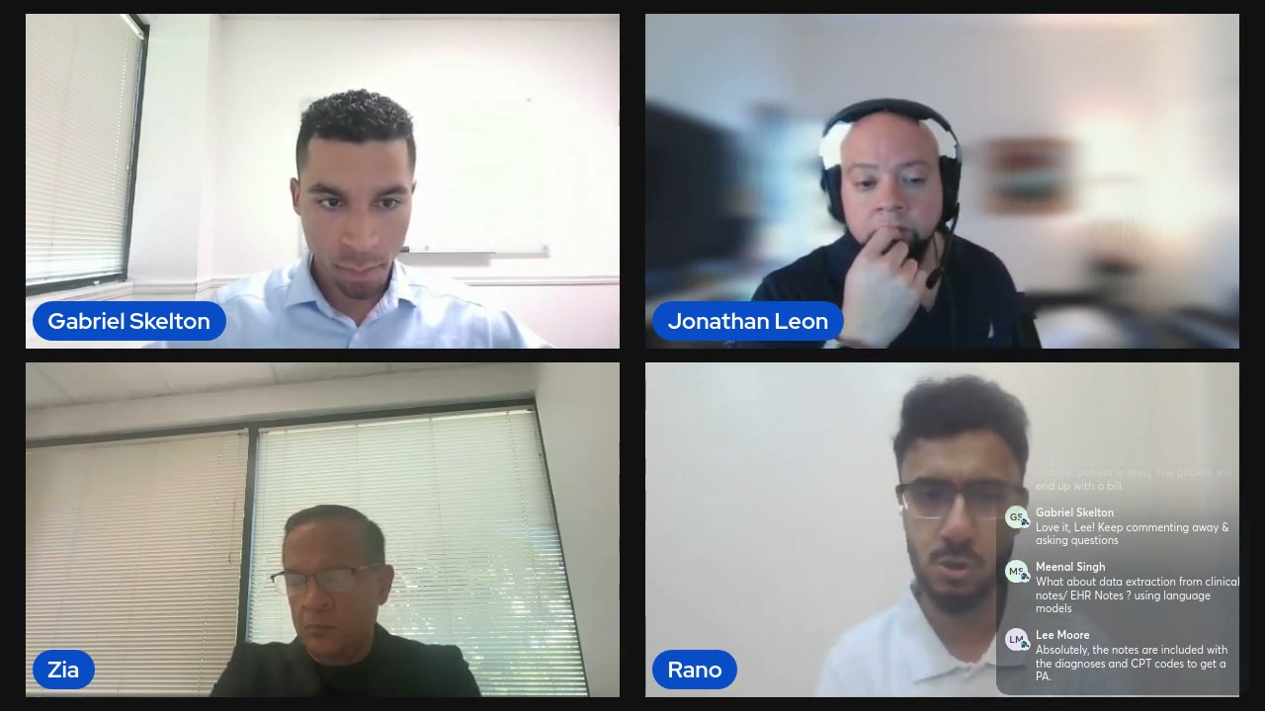
What's on screen
- Ronaldo’s escalation examples: (1) an insurance-eligibility mismatch between the EMR and the payer; (2) a high-cost drug beyond a payer’s cost threshold that historically won’t be approved; (3) oncology/radiology cases where the payer historically requires extra documentation or a peer-to-peer review.
- A rule-based bot can’t make these judgment calls — an AI agent hands them to the right PA team member.
- Chat: Meenal Singh asks “What about data extraction from clinical notes / EHR Notes ? using language models”; Lee Moore replies “Absolutely, the notes are included with the diagnoses and CPT codes to get a PA.”
Narration (Ronaldo): “An AI agent can be deployed… to flag those situations where it can straight away tell the care team that… a [payer] like United Healthcare won’t allow this particular approval for this drug… an automation bot coded in rule-based logic won’t be able to do that.”

Section 7 — The ROI case for CFOs
Zia frames ROI quantitatively and qualitatively; Gabriel on monitoring & audit.

7.1 ROI buckets for CFOs 28:30
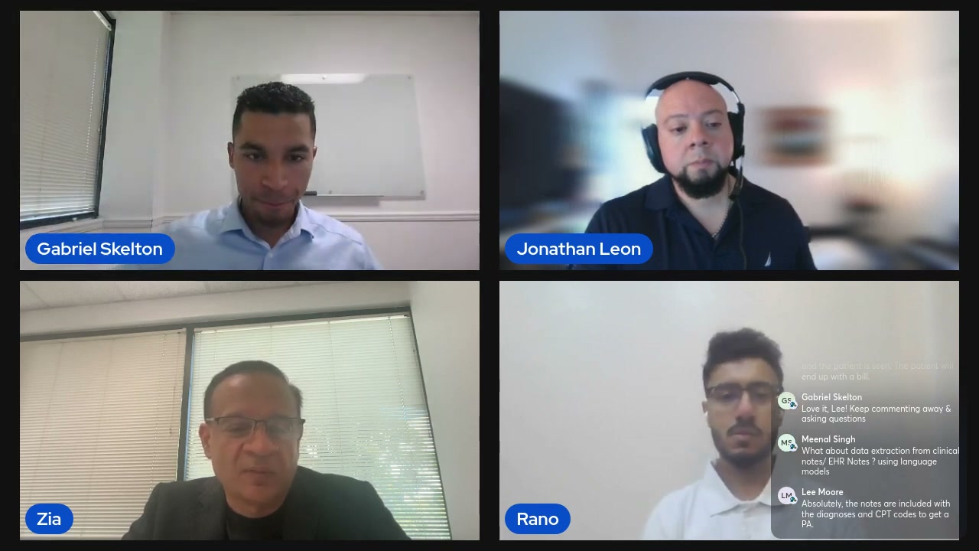
What's on screen
- Zia: ROI is both quantitative and qualitative — FTE savings (reducing a 10–30-person PA team by 5–10×), faster and accurate submissions that reduce/prevent denials, faster patient throughput and accelerated revenue collection.
- Also: better patient care/retention, better compliance & audit-risk management (machines track and log everything), and scalability as providers grow or acquire.
- Most EHRs don’t orchestrate or manage the PA process — the gap a platform like Openbots fills.
Narration (Zia Buddha): “It’s not just the FTE savings or denial prevention… you have to look at things quantitatively and… qualitatively — operational efficiency, revenue integrity and… patient throughput.”

7.2 Surviving vs. monitoring — the audit advantage 31:00
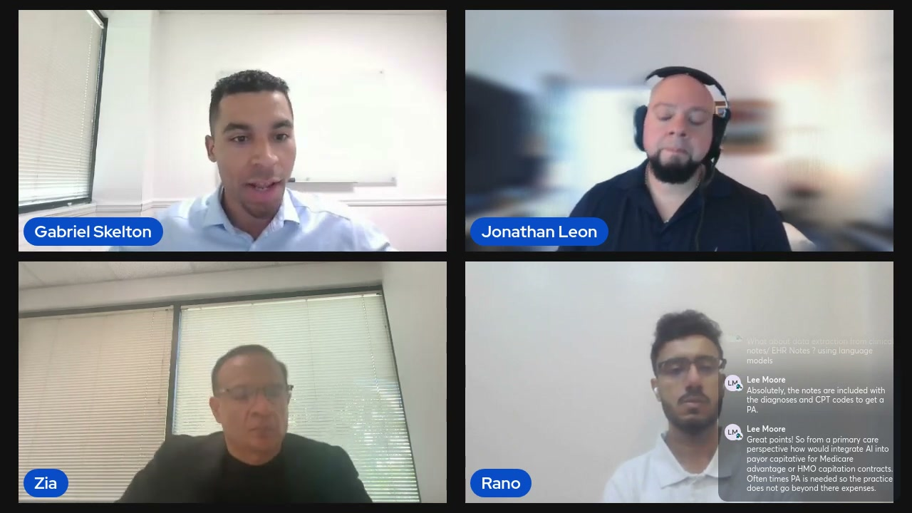
What's on screen
- Gabriel: smaller providers run combined billing teams (claims + PA + eligibility); larger systems have dedicated PA teams — but both are often “just surviving,” keeping up with volume.
- Doing everything manually makes it hard to focus on metrics, orchestration and auditing.
- Automating the low-IQ manual work lets teams monitor the automation and reach denial resolution far faster using the audit trail.
Narration (Gabriel Skelton): “When you’re just… trying to keep up with the volume and doing everything manually, it gets very difficult… to focus on metrics and orchestration of the process and actually auditing things.”

Section 8 — Documentation bottlenecks & denials
Jonathan on medical-necessity docs and status monitoring; then market trends.

8.1 Documentation & status-monitoring bottlenecks 34:00
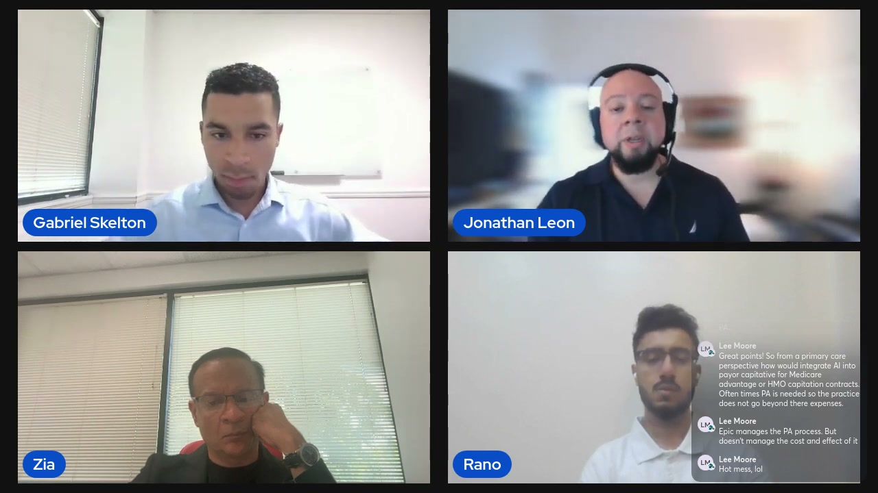
What's on screen
- Jonathan: gathering medical-necessity documentation (H&Ps, labs, results) is time-consuming and often needs a clinical person to judge what’s relevant.
- After submission there’s no easy response signal — someone must continuously monitor each payer portal, per patient; that doesn’t scale.
- A little automation lets a team of 10 perform like a team of 12–15+.
- Chat: Lee Moore on primary-care AI for Medicare Advantage / HMO capitation, “Epic manages the PA process. But doesn’t manage the cost and effect of it”, and “Hot mess, lol”.
Narration (Jonathan Leon): “Someone now needs to continuously monitor that site for that patient to see if a response of an approval or denial has been obtained… and that’s just one patient. So imagine that at scale.”

8.2 Trends — Blackberry→iPhone; in-house vs outsourced 37:00
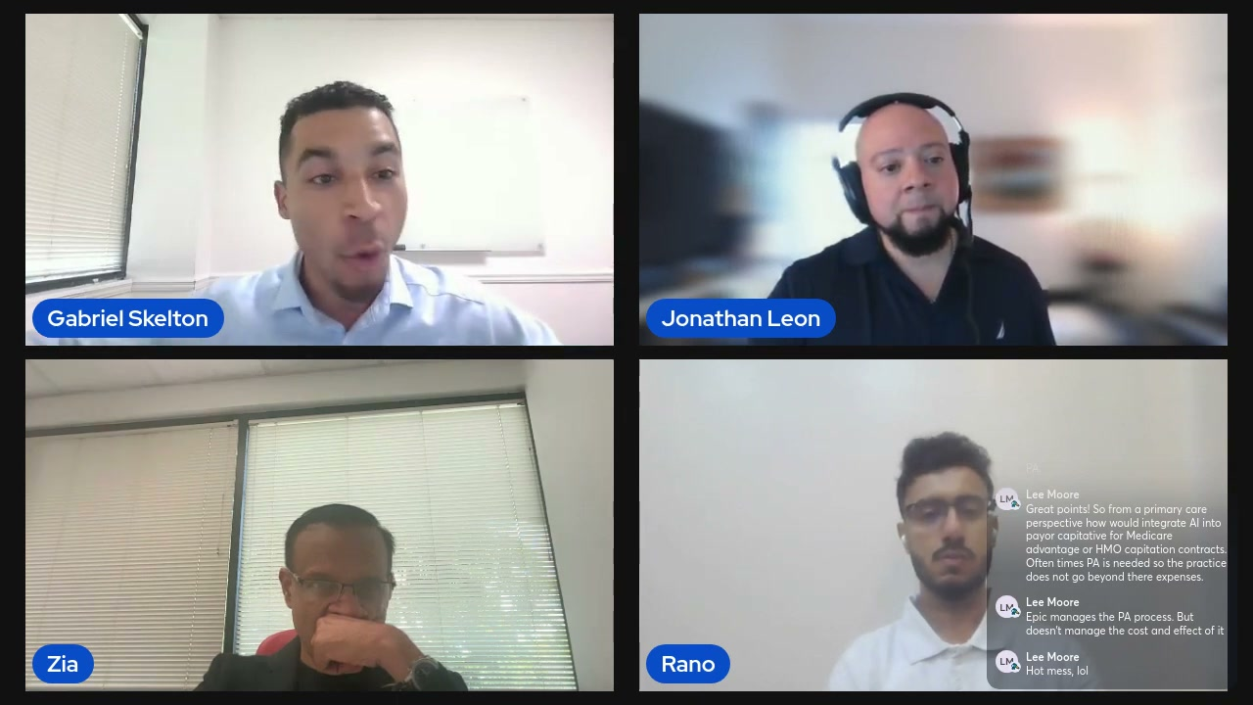
What's on screen
- Gabriel: revenue-cycle leaders increasingly need automation expertise; moving from manual to automated is “like going from the Blackberry to an iPhone.”
- Back-end rules-based work (payment posting, claim-status reviews) is often outsourced; prior authorization is usually kept in-house because speed, accuracy, turnaround and control matter.
- Keeping PA in-house bloats cost when expert staff spend time on data entry and repeatedly checking portals.
Narration (Gabriel Skelton): “It’s almost like going from the Blackberry to an iPhone. It’s so different… you’re completely changing the process, but it’s what’s happening.”

Section 9 — Speed: from ~16 minutes to under 3
Ronaldo’s framework: detection, submission, tracking.

9.1 Detection, submission, tracking 39:30
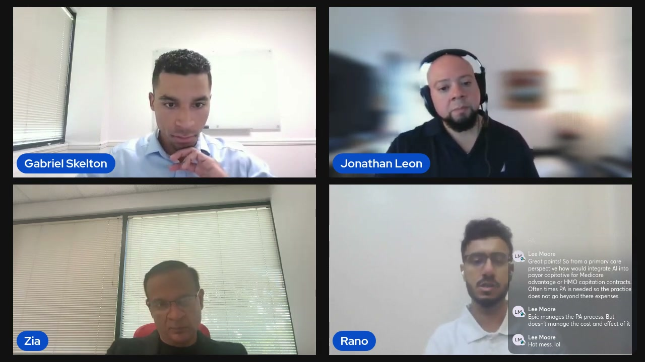
What's on screen
- Ronaldo: an AI agent should have three “powers” — detection (does this drug/procedure need a PA? flag it to the care team), submission (log into payer portals and submit the required evidential documents), and tracking (return to portals for non-happy-path cases).
- The agent already has context on typical approval windows (24–72 hours vs seven business days), so it can follow up, resubmit, or escalate to a peer-to-peer when needed — instead of “bugging the payer.”
- Stat cited: a manual PA taking ~15 minutes can be done by an agent/automation in ~3 minutes.
Narration (Ronaldo): “An AI agent categorically should have three powers… a power of detection, a power of submission and a power of tracking.”

Section 10 — Why PA is the ideal starting point for AI
Zia on why prior auth is the perfect first use case.

10.1 High impact, high friction, high automation potential 44:30
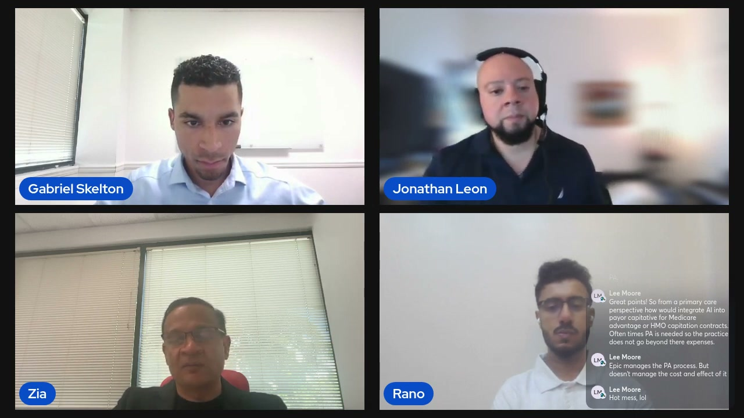
What's on screen
- Zia: at HIMSS, ViVE and Becker’s this year, ~6 of 10 booth conversations were about prior authorization.
- PA is structured-but-fragmented: semi-standardized data (codes, clinical docs, payer rules) across fax / phone / portal workflows — complex enough to need intelligence, not so unstructured that it’s beyond today’s AI.
- Ideal for LLM + RPA: LLMs add reasoning (read charts, match criteria, autofill faster than humans), plus audit trails and easily-measured binary (approved/denied) ROI.
- Nobody — payers, providers or patients — likes the PA process, so it’s a win-win to simplify.
Narration (Zia Buddha): “We think prior authorization… is ideal for AI because it’s high impact, it’s high friction and it’s got high potential for automation.”

Section 11 — What to automate next across the revenue cycle
The panel names the next targets, then the underlying data challenge.

11.1 Next targets — repeat PAs, payment posting, denials, case management 49:30
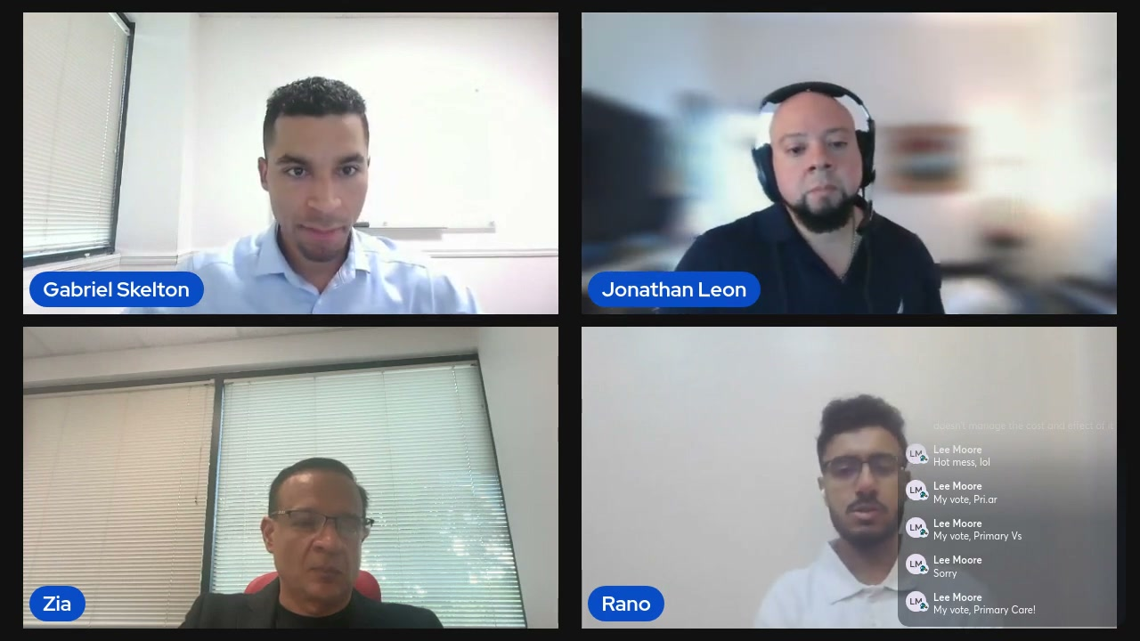
What's on screen
- Zia: repeat / secondary PAs (e.g., extending a hospital stay) and the process intelligence/insights automation yields.
- Ronaldo: payment posting (with intelligent document processing reading EOBs) and denials — major revenue-loss areas, especially for thin-margin providers; payment posting “should be on top of the list.”
- Jonathan: case management — AI medical-record summarization to keep authorizations approved during a stay and free case managers to handle more patients.
Narration (Ronaldo): “In 2025 we still see payment posting being a manual process… you simply don’t need a payment poster or a team of payment posting… payment posting should be… on top of the list.”

11.2 The data challenge — 70–80% is unstructured 52:50
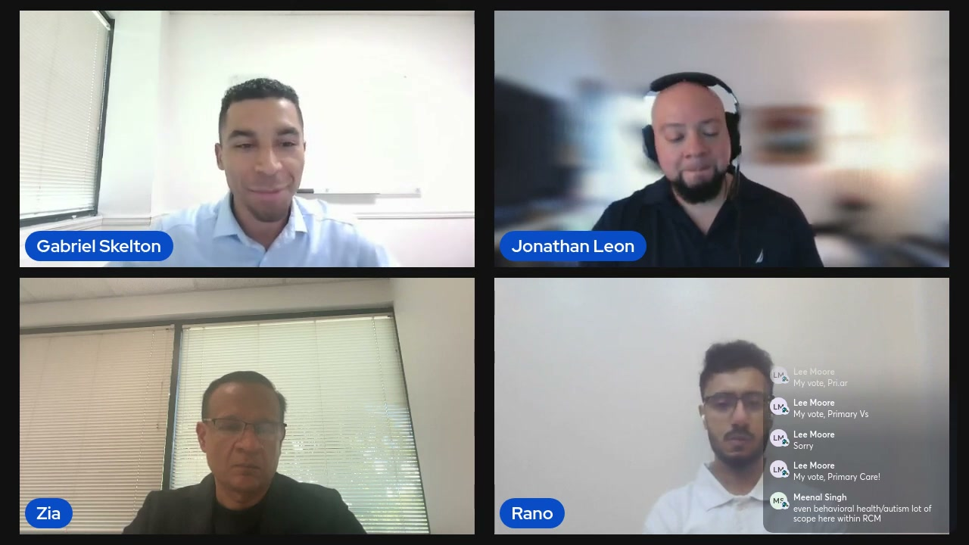
What's on screen
- Gabriel: 70–80% of healthcare data is unstructured, so more advanced technology is needed to process it.
- Providers are at a crossroads — those who stay manual vs those who focus on innovating within their revenue cycles.
Narration (Gabriel Skelton): “70 to 80% of healthcare data is unstructured. So you need… a little bit more advanced technology to process all of that.”

Section 12 — Q&A and close
Audience Q&A on LLMs for clinical notes and referrals, then the wrap-up.

12.1 Q&A — LLMs on clinical notes & referral management 54:30
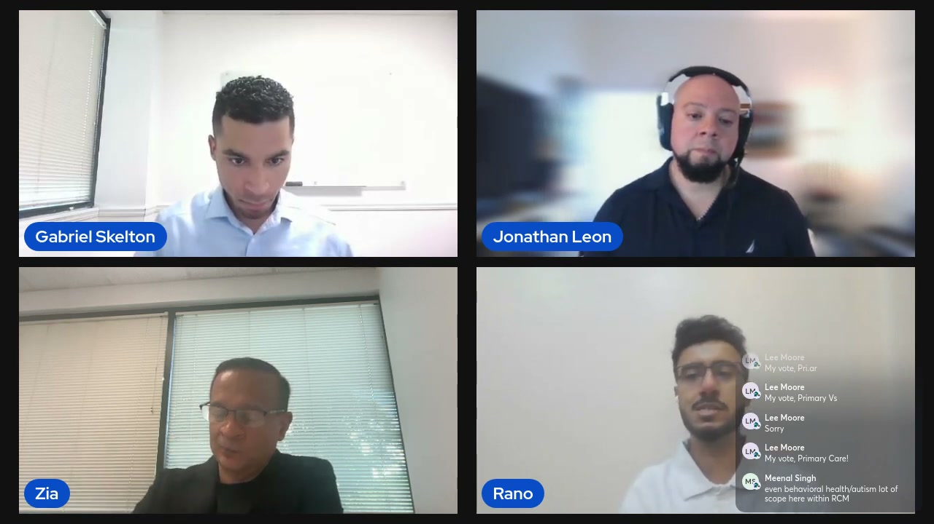
What's on screen
- Ronaldo answers Meenal Singh’s question. Openbots’ intelligent document processing (IDP) tool (LLM-embedded for 2.5+ years) summarizes medical records — e.g., surfacing one detail on page 35 of a 40–50-page fax so clinical staff don’t read every line.
- Prime use cases: summarizing medical records, automating referral management (still ~70% fax-driven — identifying the primary payer, checking whether the patient exists, creating the chart), and extracting data from EOBs.
- Chat shows audience “votes” from Lee Moore and Meenal Singh’s note that behavioral health / autism is also in scope for RCM.
Narration (Ronaldo): “One of the main components that we offer is an intelligent document processing tool… summarizing the medical records… some of which could be 40 to 50 pages long.”

12.2 Closing recap & where to learn more 57:00
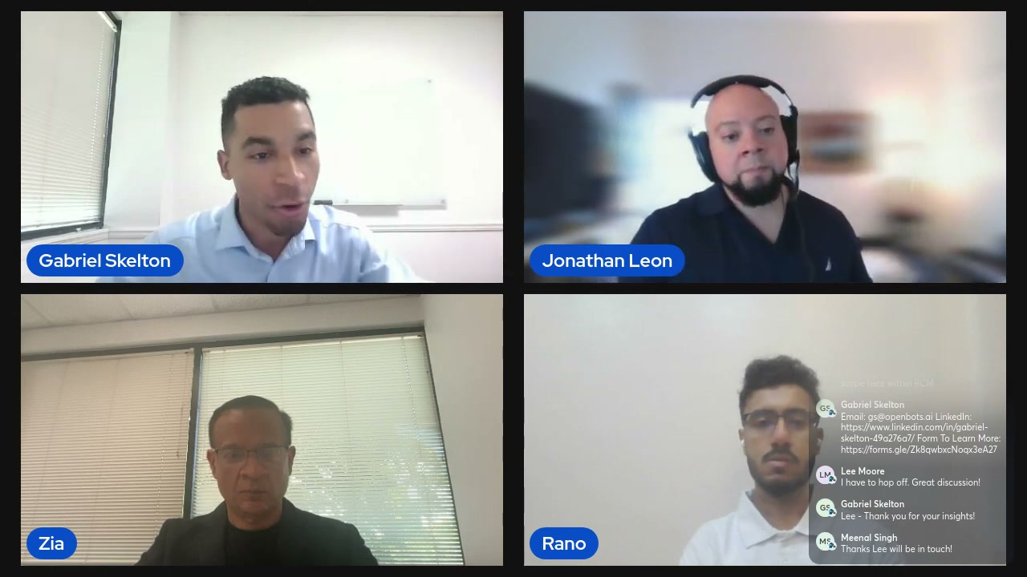
What's on screen
- Gabriel recaps: prior authorization is a burning, #1 most time-consuming problem across the revenue cycle; denials are at record highs (~12% average at the end of 2023, many higher); automation is needed for scalability, speed, and to prevent staff burnout.
- On-screen contact posted in chat: Email gs@openbots.ai · LinkedIn linkedin.com/in/gabriel-skelton-49a276a7/ · Form https://forms.gle/Zk8qwbxcNoqx3eA27 · website openbots.ai.
- Closing audience chat: Lee Moore “I have to hop off. Great discussion!”; Gabriel Skelton “Lee - Thank you for your insights!”; Meenal Singh “Thanks Lee will be in touch!”.
Narration (Gabriel Skelton): “Prior [auth] is the number one… single most time consuming task across the revenue [cycle]… you need to incorporate things like automation for scalability, for speed, and to really help your staff not… be burnt out.”

Notes for automation
Rules and human-in-the-loop points the panel actually raised, distilled for anyone building PA automation:
- PA is structured-but-fragmented: semi-standardized data (codes, clinical docs, payer rules) across fax / phone / portal channels — a fit for LLM + RPA rather than rule-based bots alone.
- Give the agent three capabilities: detection (does it need a PA?), submission (payer portal + evidential documents), and tracking (status, resubmit, and knowing typical 24–72h vs 7-business-day windows).
- Keep humans in the loop: escalate on insurance-eligibility mismatches, high-cost drugs beyond payer thresholds, and oncology/radiology or peer-to-peer cases.
- Prevent denials preemptively using payer-specific historical context (which orders that payer has denied before), not just static rules.
- Measure value both ways: FTE savings (5–10× on a PA team), denial prevention, faster throughput/revenue, compliance & audit trails, and scalability for growth/acquisitions.
- Automation adds orchestration and auditability that most EHRs lack — everything is tracked and logged.
- Natural expansion beyond PA: repeat/secondary PAs, payment posting, denials, and case-management / medical-record summarization.
End of walkthrough. 20 screenshots, all captured and verified from the recording.

Appendix — Full transcript (verbatim, timestamped)
The complete transcript exactly as captioned, with its original timestamps. Only blank filler lines from the source file were removed; every spoken caption line is preserved verbatim. (Auto-caption quirks, including occasional “:60” seconds and mis-hearings such as “priorization” for “prior authorization,” are left unchanged.)
00:10 Thank you everyone for joining our panel
00:12 on the future of prior authorization
00:16 with a Gentic AI. I am pleased to see
00:19 over
00:21 425 healthc care leaders join today and
00:24 we're going to speak about one of the
00:26 hottest topics in healthc care
00:28 operations right now which is prior
00:31 authorization some know it as
00:33 pre-chartification pre-registration the
00:36 point is that health care as a whole is
00:39 almost 20% of the US GDP and we're going
00:43 to talk about healthcare technology all
00:44 day in bottom line for healthcare orgs
00:47 and efficiency for rep cycle teams. But
00:50 as we all know, the number one reason
00:53 we're all here today is because it
00:54 impacts patient care. So this really
00:57 matters. And today it currently takes 16
01:00 minutes to manually process one
01:04 priorization on average. It currently at
01:06 37% of denials are directly tied to
01:11 priorization, registration, and
01:13 eligibility manual errors. So doing this
01:16 solely manually is not the way forward.
01:19 So let's get into what we can actually
01:21 do about it. So the agenda for today,
01:24 I'll do some intros of the people here
01:26 today. Excited to have you all. Then
01:28 we'll get into the current state of
01:30 priorization. what's really going right
01:32 and wrong, the cause of delays and
01:36 denials and what how this actually uh is
01:38 attributed to denials, communicating the
01:41 ROI and the impact around prioritization
01:44 and what it means for other pieces of
01:48 the revenue cycle when it's done
01:49 correctly versus incorrectly. Then we'll
01:52 cap it off with a Q&A. Without further
01:55 ado, let me introduce Zia Buddha. He is
01:59 the CEO and founder of Openbots. Zia is
02:02 a serial investor, an entrepreneur in
02:05 the automation and healthcare technology
02:08 space and he has a very big vision of
02:10 making healthc care revenue cycle
02:13 management as autonomous and streamlined
02:15 as possible. Z, any words? Good
02:18 afternoon. Thanks, Gabe. Gabe and a very
02:19 nice uh very nice of you to have me
02:21 here. Um, I'm very excited to be here.
02:24 Um prior authorization is actually the
02:27 number one thing that we uh are solving
02:30 for. So uh this is a very exciting
02:33 panel. Uh it's a very exciting
02:34 discussion for me. So thanks for having
02:36 me.
02:38 Absolutely. Uh nice to have you. And
02:40 next we have Ronaldo Deb Banerjee. He
02:43 goes by Ronaldo. He is the associate
02:45 director of healthcare automation here
02:47 at Openbots. Ronaldo any words?
02:51 Thank you Gabe for having me and it's
02:53 lovely to see Jonathan Zia and you too
02:56 Gabe. Yeah I'm very excited like Zia
02:59 mentioned it's like one of the big
03:01 problems across revenue cycle that we
03:03 are trying to tackle with agentic AI and
03:06 I'm quite excited to speak about this
03:08 topic today.
03:10 Excellent. Excellent. And next we have
03:12 Jonathan Leon. He is a senior healthc
03:16 care process architect at Accelerate.
03:19 He's a former systems analyst at
03:22 Nicholas Children's Health System. Uh he
03:24 has experience at Baptist Health, but
03:26 really he combines a deep expertise
03:28 across revenue cycle management and
03:30 healthcare automation that really helps
03:32 your clients, I'm sure. And he works at
03:34 Accelerate. Accelerate is one of the
03:35 leading automation implementation
03:38 companies within the healthcare
03:40 industry, specifically focused on
03:42 healthcare providers. Jonathan, any
03:44 words? Appreciate that intro. Very nice,
03:47 sir. Um, no, it's always great to
03:48 collaborate. I really enjoy sharing um
03:52 what it is that we can do to those in
03:53 the healthcare space. Um, just with my
03:56 experience being actually working on the
03:58 provider side, our tool set was limited,
04:01 but now being outside and working with
04:03 companies such like ours, uh, I'm
04:05 excited that, you know, there are other
04:07 tools that these organizations might not
04:09 be aware of that can really impact and
04:12 improve the way they're operating. So,
04:14 it's always great to be able to share
04:15 this information with uh with those in
04:17 the space and let them know that there
04:19 is a brighter side of things. So, thanks
04:21 for having
04:23 me. Excellent. Absolutely. And myself,
04:26 my name is Gabriel Skelson. I am the
04:28 head of artificial intelligence
04:31 solutions here at Openbots. Openbots is
04:33 a platform designed to help health care
04:37 providers run their rev cycles
04:39 autonomously. We have a deep focus on
04:41 automating referral management,
04:43 eligibility verification, claims
04:44 processing, denials, pry roth and all
04:47 with a gentic automation. I think it's
04:49 important also to to define a gentic
04:52 automation as we're all here and hearing
04:53 about it. Really all it is is automation
04:56 with reasoning. The fundamental
04:58 difference that large language models
05:00 have enabled is reasoning for
05:02 automation. That's a gamecher for
05:06 priorization. whether you're submitting
05:08 the prior roth and then monitoring the
05:09 prior roth and automating all of that.
05:11 There are higher IQ tasks that are not
05:13 possible as well. For example, you can
05:15 have an AI agent actually sift through
05:17 clinical notes and documentation
05:19 accurately, swiftly to streamline
05:22 things. So for anyone who wants to learn
05:24 a bit more about that, we'll put a
05:26 Google form in the chat. You could drop
05:28 your name and your email and we'll we'll
05:30 we'll get to you there. All right. And
05:31 then we'll cap off with the Q&A. So
05:33 let's get into the first question Ronald
05:34 for
05:35 you. RCM teams are are operating in a
05:38 very siloed way where the majority of
05:42 low IQ processes are still manually
05:44 executed by subject matter experts and
05:47 people who have very strong expertise in
05:50 the industry taking a lot of time here
05:52 and currently 94% of physicians agree
05:55 that manually processing prior os cause
05:58 delays. So the question to you is tell
05:60 us a little more about the current state
06:01 of technology in priorization. Why has
06:04 it taken so long to fix and what's going
06:05 on today?
06:07 Yeah, I think a surprising stat that I
06:10 was seeing Gabe from American Medical
06:12 Association that mentioned that nearly
06:15 40% of the prior authorization request
06:20 submissions time is spent on navigating
06:23 between payer portals, EMRs, entering
06:27 information from the patient chart into
06:30 the clearing houses or the payer portals
06:32 and kind of tracking down the status of
06:35 the prior authorization request. on
06:37 different peer portals. Once again, it
06:39 clearly shows that a lot of time that is
06:43 spent on is kind of like repetitive but
06:47 more importantly low value in nature
06:49 which simply automation can do in
06:50 today's world. Now why hasn't this
06:54 landscape changed in the last few years
06:57 or even a decade? I think there are a
06:59 lot of nuances if you think about a
07:02 payer from a payer standpoint. What
07:05 specific rules United Healthcare follows
07:08 is not going to be the same for what
07:09 Etna follows. So there are different
07:11 rule sets. There are different
07:13 guidelines that appear has to kind of
07:16 follow for not just medications but also
07:19 the procedures and the drugs which is
07:21 going to be ordered by the provider
07:23 groups. But more importantly, one of the
07:26 things that we have seen is that you
07:29 know it it's literally the time this
07:32 prior authorization teams spend on the
07:36 payer portals or on the EMRS which is
07:39 literally staggering. I mean you log
07:42 into a EHR as a as a as a prior
07:46 authorization team member to find the
07:48 right patient. You go into the
07:50 demographics. You find the insurance
07:52 information. You then try to go into a
07:55 clearing house like a validity or a peer
07:57 portal like United Healthcare. You run
07:60 those eligibility checks. You then try
08:02 to submit all the sufficient documents
08:05 that United Healthcare is requesting for
08:07 for the authorization that you're submit
08:09 for the for the order that you're
08:11 submitting. It is quite a back and
08:14 forth. It is something that which should
08:16 be solved. and and and once again I
08:19 think I think that's another area which
08:22 we as a team at open bots we are trying
08:24 to solve by bringing in agentic AI.
08:29 I love it. Uh very interesting points
08:31 and and even Jonathan what's interesting
08:33 is that it's actually very hard to get
08:36 data around prior authorization because
08:39 it's done so manually and there such
08:42 little monitoring around it.
08:43 As of today, I believe 24% of denials
08:46 are directly attributed to registration
08:48 eligibility. There's no third 13% can be
08:51 directly tied to prior off making a
08:53 little over a little under 40% of
08:55 denials really on the front end directly
08:58 tied to prior off and in and
08:59 registration eligibility. So tell us a
09:01 little more like what's going wrong
09:02 operationally. What's the state
09:04 currently there?
09:06 I mean so I guess kind of what we were
09:07 just saying even Ronald was saying like
09:08 that it's a lot of manual processing
09:10 that takes place. I mean at the very
09:12 beginning it's an exchange of
09:13 information between the patient and the
09:14 organization the provider's office what
09:16 what have you. Um just for their
09:18 demographic information their insurance
09:20 information I mean the verbiage even at
09:22 times isn't always the same. It's like
09:24 your member ID your subscriber ID this
09:26 and that. So a lot of manual collection
09:28 of information is provided from person
09:30 to person and then it's documented into
09:32 an EMR ehr system.
09:35 mis misspellings, incorrect numbers, fat
09:37 fingers happens all the time, um without
09:40 even notice. Uh from there, uh just kind
09:42 of like we said, it's from one system to
09:44 another. It's logging into other systems
09:45 and know so it's a lot of data capture
09:47 um I would say is the very beginning
09:49 pain point and then from there we can
09:51 move over to communication. So we have
09:54 all that uh entered in normally but the
09:57 you know the scheduler would probably be
09:58 the first person doing all this data
09:60 collection but it's going to be probably
10:02 someone with an authorization unit or an
10:03 authorization specialist would be the
10:05 one to really go through that process of
10:07 obtaining the prior off. Um at times
10:09 they might need to refer to a clinical
10:10 team member to obtain some more
10:12 documentation some more you know
10:14 justification to really satisfy why a
10:16 procedure a study a medication is
10:19 required. So then another set of
10:21 communication between two other team
10:22 members. Um so between all those
10:26 different interactions personto person
10:27 and then really trying to get everything
10:30 documented in one place a slew of errors
10:32 can happen. Um so I would say that's you
10:35 know communication breakdown is probably
10:36 the second challenge. Uh and then
10:38 thirdly like we touched upon is just on
10:39 the the um the payer side. Um there's so
10:43 much complexity and variability that can
10:45 happen. um things can change at any
10:47 given time without really true notice.
10:50 So what someone on the off side might
10:52 know one day can completely change the
10:54 next day. So then there's that research
10:56 to ensure that you know does this
10:59 procedure medication study require a
11:01 prior O. Um if so what sort of
11:04 documentation is needed to satisfy um or
11:07 to help make the decision? um just uh
11:11 just yeah really understanding the
11:12 guidelines really doing all that
11:13 research to ensure that that initial
11:16 submission of that prior off is done
11:18 cleanly because if not it's going to be
11:20 a lot of back and forth uh which even
11:22 there there's there is no true indicator
11:25 as to when a response is provided so
11:27 yeah data capture communication
11:29 breakdowns complexity and variability
11:33 no absolutely and I mean I think I think
11:35 there's a stat about 33% of patients
11:38 abandon treatment when there are prior
11:41 offro issues and delays and we talked
11:43 about how I think it's like almost like
11:45 90 94% of physicians say that it delays
11:48 care basically everybody so Zia I'll
11:50 kick it to you I mean it the issues that
11:53 Jonathan and Ronald are talking about
11:54 like is this a clinical issue or a
11:56 financial issue like what's going on
11:58 here well I think it's a clinical issue
12:01 with eventually uh impact obviously on
12:04 patient well-being as well as um becomes
12:07 a financial issue So if you have uh
12:10 delayed treatment which uh prior
12:12 authorization process generally leads to
12:15 you can have disease progression you can
12:17 have complications and you can have
12:19 hospitalizations um in addition some
12:22 procedures you know require repeat prior
12:24 authorization so that uh can affect
12:27 continuity of care. So um so it's you
12:30 know and and eventually you all of that
12:32 turns into a financial impact because it
12:35 increases the long-term costs for payers
12:37 and the health care systems and uh
12:39 patients may also face you know higher
12:42 out of pocket cost. So um so you know
12:45 one leads to the other but again if we
12:47 go back to the original mission of you
12:49 know patient well-being and patient care
12:52 uh primarily if we don't do that right
12:54 the financial implications you know will
12:56 will always be there and and they are
12:59 they are huge in case of prior
13:00 authorization
13:05 well said and I think today I mean
13:07 what's happening is that I think Ronald
13:08 you alluded to this providers are
13:10 logging into four five six seven
13:12 different systems. There's so much
13:14 swivel screen just to submit and manage
13:16 pyro. Talk a little bit more around if
13:18 you don't mind about how automation kind
13:21 of unifies this and even like things
13:22 like turnaround time. Like right now,
13:24 one of the best metrics we have for our
13:26 clients is compare the turnaround time
13:28 you have manually processing a prior off
13:31 to what it is after automating. That's a
13:34 a great metric. And also it's not just
13:37 about automating like the submission of
13:38 a prior off like what if that data is
13:40 incomplete or incorrect. You need to
13:42 make sure that they that there's a check
13:44 there before the
13:49 authentic to make sure you have as much
13:52 efficiency and accuracy as possible. But
13:53 you can talk a little more about that
13:54 Ronald. Yeah, absolutely. I think I
13:57 think there is a combination of
13:59 automation and agentic AI that comes
14:01 into play if you're looking to automate
14:03 prior authorization. U I think you
14:06 touched about the provider or the care
14:09 team logging into four to six different
14:11 systems. Let's start with the first one,
14:13 the EMR. You know, I think automation
14:16 bots these days can simply be integrated
14:19 with EMRs using API or you can log into
14:23 a EMR with a approach called user
14:26 interface automation which simply means
14:28 you have an automation bot with its own
14:30 set of credentials to log into an EMR.
14:34 It can very quickly go into the
14:36 patient's chart. It can essentially
14:38 identify who is the primary medical
14:40 payer. It can simply go into the
14:43 patient's chart and collect all the
14:45 recent medical records. I mean, every
14:48 single thing that you do in an EMR is
14:51 just like a streamline workflow for an
14:54 automation bot to perform within an EMR.
14:57 Now, let's go to the other type of
15:00 systems that we are going to interact
15:02 with. It is either going to be a direct
15:05 payer portal like UC or it is going to
15:08 be a clearing house like a or one health
15:11 portal. Once again if you if you want to
15:14 use automation to log into a if you want
15:20 an automation bot to access United
15:23 Healthcare with a set of username and
15:25 password and one healthcare ID, it can
15:28 simply do that. It can essentially go
15:30 into the interface of the payer. It can
15:35 identify what the payer form looks like.
15:38 It can understand what sort of
15:40 information it needs to submit to that
15:43 particular payer in order to satisfy, if
15:46 I may use the word satisfy, the demands
15:48 that the insurance company's making
15:50 before it can approve whether they're
15:52 going to give an approval to the drug or
15:54 or or the medication or the procedure.
15:56 Now you know essentially you are kind of
15:59 submitting all the data that you need to
16:02 submit after going through the patient's
16:05 charts. The area where you would need
16:08 agentic AI is perhaps identifying what
16:11 the insurance company wants. You know in
16:14 many scenarios the insurance company is
16:16 not straight away going to approve a
16:18 drug or or or or a procedure or a
16:21 medication that you have requested for.
16:23 Agent DKI comes into play in my opinion
16:27 when a common drug or a medication or a
16:33 procedure that is requested by the
16:35 provider is already available in LLM's
16:39 large language models that this kind of
16:42 orders of a medication of a procedure
16:46 has been previously denied by this
16:48 particular insurance company. This kind
16:51 of knowledge can easily be baked in to
16:53 an AI agent so that the AI agent instead
16:57 of you know without brains going into
17:00 the payer portal or clearing house
17:02 instead of it submitting the prior
17:05 documents, it can escalate that
17:07 situation preemptively to a particular
17:10 prior authorization team member and
17:12 request the team member saying that if
17:15 you want to submit the order for this
17:17 particular drug then according to the
17:19 historic ical scenarios, you always had
17:22 to submit some proper documentation or
17:25 you had to justify the need to use this
17:28 drug. And and and once again, this ties
17:31 you back to the denial solving case
17:33 because you are straight away saving the
17:35 denials in the first place instead of,
17:37 you know, just waiting for the insurance
17:39 company to come back to you after seven
17:41 business days and tell you that, hey, we
17:42 won't approve this particular medication
17:44 because that simply doesn't matches with
17:46 our guidelines.
17:50 Well said because there's there's
17:51 distinct payer rules for every payer.
17:54 But what you're saying basically is that
17:56 it's bringing organization and structure
17:59 to the process of submitting and
18:02 monitoring prior authorizations
18:03 especially because you can start getting
18:04 more predictability on how it happens.
18:07 So Jonathan, question for you. I mean
18:09 the question is how often do you see
18:11 prior off delays causing cancellations
18:14 and no-shows? tell us a little more
18:16 about the downstream revenue risks and
18:18 and a comment there is I mean of course
18:20 it changes for every segment of health
18:22 care like some of the segments that have
18:24 the highest volume of priorities are
18:27 radiology oncology cardiology
18:30 ortho and it changes but at the same
18:33 time regardless of segment it's crucial
18:35 to make sure you get the priority either
18:37 before the appointment happens or
18:39 shortly after
18:42 um yeah so with this one percentage-wise
18:45 I I don't know a number off top of my
18:46 head. I'll be honest. I had to do a
18:48 little googling myself on this, but it's
18:49 it said on average it's about 15 to 25%
18:52 of of um of um I guess scheduled
18:56 appointments kind of are canceled or no
18:58 showed because of uh prior issues. From
19:01 my experience working at the hospitals,
19:03 I do know it was such a large concern
19:05 that dedicated worklists had to be
19:07 created for those canceled and no-show
19:10 patients. Um because it's something that
19:13 the organization wanted to reassure that
19:15 the patient does get you know
19:17 rescheduled does reappear for that
19:20 service because if not then there is a
19:22 financial loss to the organization and
19:24 on the the most important part the
19:26 patient themselves. they're not even
19:27 getting that type of care and they're
19:29 probably having to find other means of
19:30 going about that. Um, so I would say
19:34 yeah, prior is is a big issue with
19:36 regards to that. Um, and then as an
19:38 organization, the main the customer is
19:41 obviously the patient. You want to give
19:43 them the smoothest the best experience
19:44 you can, but with something related to
19:46 this, it puts a bad taste in their
19:47 mouth. You know, from a regular person
19:50 who's not really in the field, they just
19:52 know they have insurance. So, for the
19:53 most part, they feel they're covered. So
19:55 when they present all that information,
19:56 they're making their appointment for
19:58 services, medications, whatnot, they
20:01 don't want to really know about the
20:02 behind the scenes of what the problems
20:04 are. They just feel let's go ahead and
20:06 get this taken care of. So now that
20:08 there is that delay or there are issues
20:10 and most likely they will be contacted
20:12 about it. It it it just gives again it
20:14 it gives that negative experience and
20:16 then now starts giving a bad look to
20:18 that organization. Uh therefore that you
20:21 know if the the the issue can't be
20:23 resolved within time then it's going to
20:24 lead to a cancellation. Um which that
20:27 cancellation is an administrative burden
20:29 now on the organization because it's
20:31 going to have to be rework that would
20:33 have to be done to reschedule the
20:34 patient. Depending on how long of a time
20:37 frame it would take to reschedule that
20:38 patient. The initial prior off might
20:40 have lapsed. So then it's going to have
20:42 to be a new authorization process again
20:45 submitting the documentation and all
20:46 that which hopefully what was already
20:48 collected is fine but if things change
20:50 on the payer side it's now new
20:52 guidelines new requirements new research
20:54 to determine what else is needed to
20:56 satisfy the the need there. So um it
20:59 it's a big issue um affecting both
21:02 patient and the organization or or
21:05 office and the the the amount of rework
21:07 or the time dedicated to it can
21:10 definitely um have large um impactful
21:12 revenue risks from the no-show
21:14 standpoint. I think that's even worse
21:15 because it means that everything was
21:17 like was was let's say everything was
21:19 lined up. Now, a patient no shows for
21:21 whatever reason, but now that's that's
21:23 um resources that were dedicated and
21:25 reserved for that specific appointment
21:27 or time frame. Um that now is lost. So,
21:31 the organization loses out in the
21:32 revenue there where they could have fit
21:34 someone else in. Now, it's just time
21:36 wasted there. It's still administrative
21:38 rework because they'd have to reach out
21:39 to the patient, try to get them
21:41 rescheduled. And again, given how long
21:43 it's going to take to reschedule them,
21:45 it might have to be another pre-off
21:46 process. So, it's it's a large it's a
21:49 large issue. And if automation can get a
21:50 hand in there, it'll alleviate so much
21:52 burden from the teams to really kind of
21:54 keep up with the workload that's that's
21:56 presently in front of them.
21:59 Very well said. I mean, I I 100% agree.
22:01 The the level of administrative burden,
22:04 the rework, how initial odds may have
22:06 actually lapsed because it could be a
22:08 few months and now you got to get
22:10 reauthorized basically because you maybe
22:12 you were authorized in March, but then
22:14 your insurance is up in in May. So,
22:16 absolutely, it's it's a huge thing. Um,
22:19 and question for you, Ronald. Before we
22:21 do, I actually I want to highlight a
22:22 couple of the comments that Lee has
22:23 shared. Um, I'll put it here. So, he
22:25 mentioned oftentimes providers and mid
22:28 levels don't know the codes to get the
22:30 prior authorization for the procedure.
22:32 Automation could help. Each payer has
22:34 specific codes to get the PA. And next,
22:36 he mentioned you want the authorization
22:38 before the appointment is scheduled.
22:41 That's a standard rule for the front
22:43 desk. And if the PA is not obtained and
22:45 the patient is seen, the patient can
22:47 easily end up with a bill which
22:49 definitely happens in a lot of segments
22:50 of health care and it's not the ideal
22:52 way for the provider that may not get
22:53 paid or for the patient who's a huge
22:55 bill that they have to now uh interface
22:57 with. So next question for you Ronald.
22:60 So it goes along with Lee's comments is
23:02 specifically how does a Gentic AI decide
23:05 when to escalate a prior off manually
23:08 versus just processing auto
23:10 automatically? What happens? Because the
23:11 reality is you can't just automate it
23:13 and have no people. You need people for
23:14 this, right? People are crucial. They're
23:16 the most important piece of this. But
23:17 how does that change? Tell us a little
23:18 more about that, Ronald.
23:21 Yeah, I think I I just want to, you
23:23 know, kind of continue with the same
23:25 question that is uh asked in the comment
23:28 section. Let me give you a few examples
23:30 where agentic AI can escalate the
23:33 process and which obviously an
23:35 automation bot cannot do. You think if
23:38 you think about prior authorization, you
23:40 have to first think about even insurance
23:42 eligibility. You need to understand that
23:44 the patient has the right insurance
23:47 plan. It has the right coverage for for
23:49 the for the for the insurance payer he
23:52 is paying.
23:53 Now you know a aentic AI process would
23:58 be like this. It can easily go into the
24:00 patient's chart. It can identify who the
24:04 primary medical payer is. He it can
24:07 essentially look into the insurance
24:09 information and it can immediately do an
24:12 eligibility check by going to that
24:14 particular specific pair and notify the
24:18 care team whether there is a mismatch in
24:21 the insurance information based on what
24:24 is reflected in the EMR and it's a very
24:27 very simple process but this can have
24:30 massive consequences you simply cannot
24:33 go into billing and other pieces is
24:36 without identifying whether the patient
24:38 has the right insurance coverage or not.
24:41 The second piece where I think agentic
24:43 AI would play a huge role and it's
24:45 already kind of taking shape is think
24:49 about this. If you are ordering for a
24:52 high cost drug from United
24:54 Healthcare and United Healthcare has a
24:60 threshold on the cost it can absorb for
25:03 giving a drug, then an AI agent can be
25:07 deployed in those scenarios to flag
25:09 those situations where it can straight
25:11 away tell the care team that right now
25:14 you are trying to order a high cost drug
25:18 but historically speaking speaking and
25:19 logically speaking a pair let's say like
25:22 United Healthcare won't allow you this
25:26 particular approval for this drug
25:28 because that is going beyond the limits
25:31 or the capacity to which they can absorb
25:32 the cost. Once again an automation bot
25:35 coded in rulebased logic won't be able
25:38 to do that. And finally, like Jonathan
25:41 was
25:42 saying, you know, an AI agent has some
25:45 context to the payer specific rules and
25:48 guidelines. It also has the context on
25:52 the commonly used drugs and medications
25:55 and
25:56 procedures and particularly in the field
25:58 of oncology and orthopedic groups where
26:01 you know prior authorization is a very
26:03 very not only timesensitive process but
26:06 a very cautious process if I may use the
26:09 word cautious here. You know, during an
26:12 oncology or radiology approval process,
26:15 when you do a prior authorization, it is
26:17 super important to know that the
26:20 medication or the treatment you're
26:22 requesting for historically has been
26:24 approved by the payer or not. Because if
26:26 it isn't the case then at the end of the
26:29 day the insurance company is going to
26:31 come back to you after 3 days and simply
26:34 request you for either additional
26:37 documentation or in certain situations
26:39 it can request you for a peer-to-peer
26:41 intervention which means they want to
26:42 talk to a doctor who is requesting this
26:45 particular medication in the first
26:46 place. Now if you use an AI agents in
26:50 all these three scenarios it can
26:52 escalate it. it can hand this off to a
26:55 right particular member in the prior
26:57 authorization team who can simply work
26:59 on the clinicals and be better prepared
27:03 to kind of justify the reason for
27:06 ordering those PAs in the first place
27:08 instead of just sitting back and seeing
27:10 what's going to happen in in the next 10
27:12 to 15 days.
27:15 Absolutely. And your point is basically
27:17 technology is getting advanced and even
27:20 though as advances it's getting and much
27:22 more that automation can do some of the
27:24 problems are the exact same that have
27:26 existed for a long time that have not
27:29 been solved. So a question for you Zia
27:32 for CFOs evaluating ROI is prior off
27:36 automationable FTE savings denial
27:38 prevention or something broader tell us
27:40 a little more about how CFOs should
27:42 approach this.
27:44 Yeah. So I think for I think for CFOs
27:46 and for that matter for even for CEOs I
27:48 think it's uh um it's not just the FT
27:52 savings or denial prevention. I think
27:54 it's like anything else there is you
27:56 know you have to look at things
27:57 quantitatively and you have to look at
27:58 things qualitatively right um you know
28:02 so you have to look at things like
28:03 operational efficiency revenue integrity
28:05 and you know patient throughput. So if
28:07 we look at you know just a high level if
28:08 we do a breakdown of the ROI in
28:11 different buckets um yes FTE savings
28:14 that would be the number one sort of
28:16 quantitative you know measure you know
28:18 for example if you have 10 people or 20
28:20 people or 30 people working on the prior
28:22 authorization function and if you can
28:24 reduce that down to uh you know by by
28:27 let's say by a factor of 10 or by a
28:30 factor of five even I mean that's you
28:31 know it's it's it's substantial savings
28:33 so that's that's that's a simple math Um
28:36 you also have to you know if if you
28:39 think about uh when the machine is doing
28:41 a prior authorization submission and um
28:44 again there's a there's a happy path
28:46 prior authorization which is the simple
28:48 prior authorization request and then
28:49 there is the medium and there's a
28:51 complex prior authorization request and
28:53 let's say if the machine takes over you
28:55 know a whole bunch of it in the very
28:57 first round and takes over the rest of
28:59 it over a period of time you have prior
29:02 authorizations there that are being
29:04 submitted faster they're accurate and um
29:08 you know they reduce um andor prevent
29:11 denials right so that's again a
29:13 quantitative and qualitative benefit um
29:16 and if you you know then you also have
29:18 again if you look at it from a patient
29:20 standpoint it's faster and successful
29:22 patient throughput right and and that
29:25 results in uh an accelerated revenue
29:27 collection for um you know for for for
29:30 the provider and now let's take a look
29:32 at some of the other benefits I mean you
29:33 have you know better patient care
29:35 patient retention you have you manage
29:38 the compliance and audit risks much
29:40 better and there is a reason for that
29:42 and the reason for that is that machines
29:44 track and log everything so whatever
29:46 automation and AI is doing it's tracking
29:48 and logging right so it's it's it's it's
29:51 providing a complete orchestration of
29:53 the process that does not exist in an
29:56 EHR system most EHR systems do not have
29:60 any orchestration or do not manage the
30:02 prior authorization process Right. Uh
30:05 this is again this is where companies
30:06 like open bots come into play because
30:08 that's what we offer and you know and
30:10 and lastly if uh you know if you look at
30:13 all of those combined I think the
30:15 scalability of the operation many
30:17 providers that we talked to um you know
30:19 they are expanding their operations they
30:21 are either bringing in additional
30:23 practices or you know doing you know
30:26 through through acquisitions or or just
30:28 you know organic expansion of their uh
30:30 uh of their practices and and and
30:33 scalability. ility is a much you know
30:35 much bigger benefit uh from this. So
30:37 it's the benefits for CFOs and CEOs are
30:40 both qualitative and quantitative
30:43 quantitative. I mean that's that's the
30:44 beauty of automation and AI.
30:47 Well said. It's fascinating that for
30:50 smaller healthcare providers, they may
30:52 have combined billing teams that are
30:55 doing claims and prior authorizations to
30:57 doing eligibility and pri doing a lot of
30:59 different functions versus some of the
31:01 larger systems have dedicated teams just
31:04 to prioritization. In both examples
31:07 though, honestly, we've seen that
31:09 they're just surviving. They're just
31:11 trying to keep up with the volume. like
31:12 the and when you're just surviving when
31:14 you're just trying to keep up with the
31:15 volume and doing everything manually, it
31:17 gets very difficult as he mentioned to
31:20 focus on metrics and orchestration of
31:23 the process and actually auditing
31:24 things. Whereas when you automate a lot
31:27 of that work that is low IQ and manual,
31:30 you can make sure that not only the
31:32 automation is running, you know exactly
31:34 what the automation is doing. So if
31:36 there's a break or there's an error,
31:38 there's a denial and you don't fully
31:39 understand why, you can get to the
31:41 resolution much faster by taking
31:44 advantage of that audit piece, which is
31:46 huge. You have to monitor it. You can't
31:48 just automate and execute and survive on
31:50 a day-to-day
31:51 basis. That leads very well into the
31:54 next question. And I saw another
31:55 question in the comments we'll address
31:56 in a second, but Jonathan, what do you
31:59 feel like what documentation
32:02 uh or steps slow teams down the most?
32:05 and where do these gaps typically lead
32:07 to denials when it comes to the front
32:09 end of eligibility prior a tell us a
32:11 little bit more about that given your
32:12 experience
32:15 uh so really documentation standpoint
32:17 there's the medical necessity you know
32:19 um just gathering that type of
32:21 documentation is time consuming so being
32:23 able to to track that down to see if it
32:26 if it's existing in the current system
32:27 if not it needs to be obtained um from
32:30 the source so either the history and
32:32 physicals any kind of labs test results.
32:35 All that type of documentation that
32:37 needs to be collected to really provide
32:39 that justification is one of the the key
32:41 pain points. And at times it can't be
32:43 obtained by just let's say an O
32:45 specialist. It's going to have to go to
32:46 a clinically driven type person, a
32:48 clinical team that really understands
32:50 the information and knows which is
32:52 valuable to you know when submitting the
32:54 prior off. Um I'd say also even just uh
32:58 like we've kind of been touching on the
32:59 the different steps of going in from one
33:01 system to another. Um but let's just say
33:03 once it's even submitted there is no
33:06 true um response or easy response of
33:08 knowing when the provider uh sorry the
33:11 payer has provided an answer. So someone
33:13 now needs to continuously monitor that
33:15 site for that patient to see if a
33:17 response of an approval or denial has
33:19 been obtained. Um given the workload
33:22 there that's something that's now has to
33:24 be at the top of someone's mind to be
33:26 sure to continuously check for that. And
33:28 that's just one patient. So imagine that
33:30 at scale it's it's it's such um a huge
33:34 pain point which automation can easily
33:36 assist with something like that. Uh for
33:38 denial types I mean of course without
33:40 missing um without proper documentation
33:43 there'll be some kind of a medical
33:44 necessity denial or um just yeah just
33:48 maybe even a request for additional
33:50 documentation is what's going to have to
33:51 be obtained. So that's now here we work
33:54 going back to the case back to see what
33:56 was submitted reaching back out to
33:58 clinical teams to say okay we need
33:59 additional supporting information. So
34:03 um all these um kind of just what we
34:05 said are just um major roadblockers for
34:07 the teams. Um and I want to kind of
34:10 touch a little upon a little bit upon
34:11 what Zia said um or even what what
34:13 everyone's been kind of saying here that
34:15 team of let's say of 10 that's just kind
34:17 of focused on a particular portion of
34:20 the prior process. Even if you just left
34:23 them alone and you included a small
34:25 amount of automation or agents within
34:28 that process, that 10, that team of 10
34:30 can now work like a team of 12, 15 or
34:33 even more. All depends on how much
34:35 automation you include into that team.
34:38 You've just upscale the performance of
34:39 what that team can accomplish in a given
34:41 day. So instead of just breathing, they
34:44 can actually get their heads much
34:45 further above water and handle a a more
34:48 throughput amount of information in a
34:49 given day.
34:51 So like we've been saying there's huge
34:53 opportunities even for just the clicks
34:55 and navigations from site to site to uh
34:58 collecting information and kind of
34:59 preparing the packet that can all be
35:01 done with all this type of technology.
35:03 Um as well as doing the the
35:05 investigations as someone's mentioned
35:06 yes not everyone knows what codes
35:08 require prior ros or not an agent or you
35:12 know automation can actually go out to
35:14 the site perform a CPT code search um
35:17 bring back the results there pass it on
35:19 to the agent. And so now the agent has
35:20 that contextual information to say okay
35:23 given this code and given this
35:25 information I now know what the next
35:27 steps are and they can go ahead and take
35:28 those next steps. So it's really helping
35:31 you know working alongside people making
35:33 the days much easier reducing you know
35:35 increasing efficiency reducing errors
35:37 and just you know to me overall giving
35:39 the the the teams breathing room and I
35:42 guess the one last thing I'd say on that
35:44 um within this organization or this
35:45 industry it is a service industry right
35:47 the patients don't really need to know
35:49 what's going on behind the scenes they
35:50 don't need to be involved in all this
35:52 back and forth and all that you know
35:54 kind of like something that Disney does
35:55 you don't really know how all these
35:58 different areas of the parks get um get
35:60 kind of filled with inventory and all
36:02 that. They have a tunnel network below
36:04 the parks where all the teams and all
36:06 that can move, you know. So, that's
36:07 really the behind the scenes. So, that's
36:10 something that I I feel like providers
36:11 also are trying to do as well, right?
36:13 They want to make sure that all these
36:14 back-end processes, all this work behind
36:16 the scenes takes place efficiently
36:19 without really involving the patient and
36:20 kind of can really muddying that
36:22 experience. So, with technology like
36:24 this, you can really get closer to that
36:26 feel where everything can happen. the
36:28 patient can have their great experience,
36:30 you know, get a good feeling for the
36:32 organization that they're working with
36:34 because of the efficiency that's now
36:35 happening behind the scenes.
36:39 Well, very well said, Jonathan. I mean,
36:41 there's a trend right now, I think, in
36:42 in CFOs and heads of revenue cycle and
36:46 and directors of patient access and
36:48 really just revenue cycle leaders in
36:50 needing to know more about automation.
36:52 It's not just about understanding,
36:53 having the expertise. I've personally
36:56 been so impressed by subject matter
36:59 experts who are forward thinking of them
37:01 say, "Hey, how can we do this
37:02 differently?" Because it's not it's like
37:04 it's almost like going from the
37:05 Blackberry to an iPhone. It's so
37:07 different. It's like you're you're just
37:08 completely changing the process, but it
37:11 it's what's happening, right? But even
37:13 like a what you mentioned like a happy
37:14 path, whether you submit a prior and it
37:16 gets approved in two hours or two weeks,
37:19 where's the monitoring behind it? Like
37:20 who who is monitoring this? And it's
37:22 people. So automation obviously can't
37:24 take bathroom breaks or sleep. It just
37:26 it just empowers people to do better
37:28 work. And I mean some of the trends you
37:31 see across things like payment posting
37:33 and claim status reviews in the back end
37:37 of the revenue cycle is extremely
37:38 rules-based. It's extremely structured
37:41 and that's why it's often outsourced
37:43 which is in a lot of ways okay it's good
37:45 because you could lower your costs and
37:47 all of that. However, when it comes to
37:49 prior authorization, it's almost always
37:53 in-house or maybe a portion of it is
37:55 outsourced, but usually it's in-house
37:57 because healthcare providers want
37:59 control over it and speed matters,
38:02 accuracy matters, turnaround time
38:04 matters. So, you typically trust your
38:06 in-house staff the most to do it. That's
38:08 excellent. But that does mean your costs
38:11 are bloated there because your people
38:13 that understand your operations best are
38:16 spending time doing data entry work are
38:19 spending time checking portals over and
38:22 over again. As Ronald mentioned that
38:23 stat the amount of time that's being
38:26 spent on patient portals. So Ronald
38:29 question to you. We talked about how it
38:31 takes 15 16 minutes to process one prior
38:34 authorization on average manually.
38:37 tell us a bit more about like how do you
38:39 get that under three under four minutes
38:41 even under two minutes like how does
38:43 that happen?
38:45 Yeah, I think if you think about an AI
38:48 agent and automation, processing and
38:50 prior authorization instead of a human
38:53 doing it, then an AI agent categorically
38:56 should have three powers if I may say a
39:00 power of detection, a power of
39:02 submission and a power of tracking. With
39:05 Jonathan was saying, what is the power
39:07 of detection? An AI agent should be able
39:10 to understand that the medication or the
39:13 drug or the procedure that you're
39:15 requesting whether it requires a prior
39:18 authorization or not and then once again
39:20 flag that over to the care team. The
39:23 power of submission is essentially going
39:26 into the payer portals and submitting
39:28 all the necessary evidential documents
39:31 that the payer wants. And the power of
39:34 tracking is essentially AI agents going
39:39 back to the payer portals during the
39:42 scenarios when it is not a happy path to
39:45 Z's point. You need to understand
39:48 whether a payer has denied the prior
39:52 authorization that you have requested
39:54 for it or it has approved it. Now AI
39:57 agents in particular do understand
40:01 because it has the context whether a
40:04 common drug for a particular pair can be
40:07 approved and if it is approved whether
40:09 the time frame would be 24 to 72 hours
40:12 or it is going to be seven business
40:13 days. An AI agent has this context
40:15 already behind the scenes. So instead of
40:18 bugging the payer, instead of bugging
40:20 the provider and instead of specifically
40:24 letting a prior authorization team
40:26 member go into the portal to check the
40:29 status, an AI agent can essentially
40:32 identify whether the prior authorization
40:34 request is of urgent type or whether
40:37 prior authorization request is a simple
40:39 medication request and it can
40:41 essentially go and track the status from
40:43 the payer portal. If it's a denied prior
40:47 authorization, it can essentially follow
40:48 up on that. It can essentially resubmit
40:51 the documents. But at some point where
40:55 it needs to escalate to a scenario where
40:57 a peer-to-peer intervention is required,
41:00 it can also think about this particular
41:03 scenario that this is not a situation
41:05 which an AI agent can handle. It
41:07 understands that and then it can hand
41:09 off that particular process for a
41:11 peer-to-peer intervention. So if you
41:14 think about all the step that I said an
41:17 AI agent is just like a GPD right when
41:19 you ask a even subjective question a GPT
41:22 doesn't take five minutes to answer that
41:23 question back because it's already
41:25 embedded with the type of context within
41:27 the within the model. So you you don't
41:29 expect a GPT to wait for 5 minutes. But
41:32 even if you think about a very
41:34 experienced prior authorization team
41:36 member submitting a prior oath, he or
41:39 she will have to take the time to go
41:41 through the clinical notes. He or she
41:43 have to log into a pair portal like a
41:45 vality or United Healthcare. He or she
41:48 needs to do the back and forth between
41:49 the different systems. So there is no
41:52 way or in no shape or form they can
41:55 process these prior authorizations
41:57 faster than an AI agent. And even
41:59 research or stats back this up by saying
42:02 that if you are looking at automating
42:05 prior authorization manual I mean if
42:07 you're looking at processing prior
42:09 manually and it's taking 15 minutes
42:11 quite simply an AI agent or automation
42:14 can do it in three minutes at max. So
42:16 you have a lot of efficiency gains on
42:18 that particular process.
42:21 Excellent Ronaldo. I think your point of
42:23 two is that on the front end in the
42:25 middle there's there are so many
42:27 unsolved problems. Everyone recognizes
42:30 that this is a problem and there's such
42:32 few focus on actually solving it. So I
42:34 think uh I'm going to get into one of my
42:36 favorite questions. But to simplify what
42:38 we're talking about here is simply
42:39 automating the work on payer portals,
42:42 right? automating the work within EHR
42:44 systems, automating the review of
42:46 clinical notes and documentation when
42:48 you need to resubmit a prior off for
42:50 example. That's what we're talking about
42:51 here. So Zia, question for you. Why
42:55 across the revenue cycle, why is prior
42:58 authorization one of the most ideal
43:00 starting points for AI in healthcare
43:03 operations and what does that unlock
43:06 next across the the revenue cycle?
43:10 Hey, so um yeah, so we actually went to
43:13 uh three health conferences this year.
43:15 Uh we went to uh HIMS, we went to Vive,
43:19 and we went to Beckers and uh we had a
43:21 booth and um I would say six out of 10
43:25 people that were stopping at the booth
43:27 or six out of 10 conversations that we
43:29 were having were around prior
43:32 authorization. So it it seemed like that
43:34 was the the one of the biggest pain
43:36 points uh you know that that that exists
43:39 um in in the provider space. So and and
43:42 why is that? So um we think that you
43:45 know we think prior authorization
43:48 um is ideal for AI because it's high
43:53 impact, it's high friction and it's got
43:56 high potential for automation. Um so
43:59 let's see why right so so first it's
44:02 it's it's the process itself is somewhat
44:05 structured but it's fragmented okay two
44:08 two sort of uh uh contradicting terms
44:12 but um let's analyze that a little bit
44:14 you know a little bit more deeper so
44:16 because you have prior authorization you
44:18 have you're dealing with
44:19 semi-standardized data right you're
44:20 dealing with codes you're dealing with
44:22 clinical documentation you're dealing
44:23 with pay rules and you're dealing with
44:27 workflows that are highly fragmented
44:29 because you can have a fax data coming
44:31 in from fax, you can have phone calls,
44:33 you you may have to go to portals. So um
44:36 so semi-standardized data across a very
44:38 highly fragmented workflow. So we think
44:42 so it's complex enough to require
44:45 intelligence but not so unstructured
44:47 that it's beyond today's AI capabilities
44:50 and the AI capabilities that exist
44:53 literally you know uh post 2022 2023
44:56 after the LLM revolutions uh are pretty
44:59 much game changers for this right um
45:02 because you can now read the charts you
45:04 can ma you can have match criteria you
45:06 can autofill forms faster than the
45:08 humans uh this is an ideal use case for
45:11 an LLM plus an RPA rules-based
45:14 automation type of a scenario. With RPA,
45:16 you were limited to what you could
45:17 achieve, right? With LLMs, you can
45:20 actually do the reasoning and you can
45:23 get much more um uh you know, you can
45:26 get much more out of an automation that
45:28 you deploy. Um you know the other thing
45:31 again
45:32 it's with AI uh and automation as I kind
45:35 of mentioned before because we
45:37 everything is logged everything is track
45:40 track um you have audit trails but you
45:42 also you know you also can uh take a
45:45 look at your measure your ROI with a
45:47 with an outcome like you can with a
45:49 binary outcome you can have an approved
45:50 or a denied outcome and then you can see
45:53 uh the overall throughput by applying AI
45:55 so it's very it's relatively easy to see
45:58 the ROI um you know with a with a system
46:01 that not just only orchestrates the
46:03 process uh but also you know also gives
46:06 you all the all all the insights into
46:09 the process right um so and and lastly
46:13 as I said in the beginning it's uh we
46:15 think it's um it's it is a painful
46:18 process to demand change
46:21 um we think you know based on our
46:23 conversations that most um I guess we
46:26 can say for the patients also but pairs
46:28 and providers nobody likes prior
46:30 authorization uh process the way it is
46:33 uh it is a pain and anything um that you
46:37 can do to simplify that process I think
46:40 it's it's it's a win-win and you know we
46:42 look at it from a standpoint of we want
46:44 the providers to have control over the
46:47 process we want the process to be
46:49 efficient we want a high throughput and
46:52 we want accountability from the process
46:54 and you can achieve all of that with AI
46:56 and that's why this is a perfect use
46:58 case for AI.
47:03 What you're mentioning basically is that
47:04 like those that avoid technology like
47:07 those healthy providers, they're going
47:08 to stay the same. They're going to stay
47:10 inefficient, bloated, and ultimately
47:12 there will be patients that have
47:14 negative experience or don't get the
47:15 care they they
47:17 require. I have one more question and
47:19 then we'll get into Q&A that again
47:20 relates to this. But going forward,
47:23 let's say a provider does automate as
47:26 much as they can within priorization and
47:29 this is open to everybody. What is the
47:31 next area in your opinion across the
47:34 revenue cycle on the front end or the
47:36 back end that deserves more attention
47:38 from automation but doesn't always get
47:40 it? Like what else is also super
47:41 important to automate?
47:47 Yeah, I would say uh one of the things
47:49 uh it might not it may not be just for
47:51 automations but um I think one of the
47:54 other things that you get by deploying
47:56 automation and AI is you actually get
47:58 some intelligence that you can gather
48:01 from within a process and you can
48:03 analyze that intelligence um and it can
48:06 actually yield quite a you know quite a
48:08 few uh insights that can affect the
48:10 overall process that you're executing.
48:12 So I think that's one of the benefits of
48:14 you know uh applying AI to RCM. Um you
48:18 know the other things that come to mind
48:20 is you also have you know in for example
48:23 one of the things that I mentioned about
48:24 prior authorization is the the repeat
48:26 prior authorizations right um it's not
48:29 just the initial prior authorizations. I
48:30 mean if you have an hospital stay that
48:32 needs to be extended you need a you know
48:34 you need a you need a secondary prior
48:35 authorization. So I think that's another
48:38 that's another area where um you know
48:40 where u uh deployment of automation and
48:43 AI can can can yield more benefits. And
48:45 there there there's many others. I' I'd
48:47 leave the room to other others for uh to
48:50 chime in as well. Rao uh Jonathan.
48:54 Yeah, I think I think you know in in
48:56 2025 we still see payment posting being
48:59 a manual process and you know it will
49:02 it's simply it's mindboggling that when
49:05 you have a set of rules to look through
49:07 when you have intelligent document
49:09 processing tools to find information
49:11 from
49:13 EOBS you simply don't need a payment
49:16 poster or a team of payment posting to
49:19 go through those checks and balances and
49:22 deposit amounts and then essentially
49:24 validate and reconcile payments within
49:26 within a clearing house. I think payment
49:29 posting should be a process that has to
49:32 be on top of the list if you're looking
49:33 at
49:34 automation. I think the other area
49:37 besides payment posting and prior
49:38 authorization which should be talked
49:41 about is denials. I know we have talked
49:43 about prior authorization which is
49:45 essentially one of the main reasons for
49:47 denials to pop up you know with
49:49 percentage hikes every single year. But
49:52 I think revenue loss is a huge thing
49:56 particularly in the world of healthcare
49:57 providers where the profit margin is is
50:01 way too less compared to what you see
50:03 from a payer standpoint. So if we can
50:07 find a way to use agentic AI, use LLMs
50:12 or whatever the technology is, but we
50:14 can address denials, I think that's
50:16 going to be a gamecher for healthcare
50:18 providers who are particularly working
50:20 with very small margins. Yeah, it's a
50:23 great point, Rana, because payment
50:24 posting is a um very big chunk of
50:28 payment posting and and and and those
50:30 type of processes are actually handled
50:33 by offshore BO type of operations and
50:35 there's thousands and thousands of
50:37 people working in those type of things.
50:39 And um you know we think that the time
50:41 has come that a lot of that uh work um
50:46 can simply be handled by automation and
50:49 AI
50:50 um and and and it can be brought in
50:53 inhouse
50:54 uh with more control and oversight. So
50:57 great point R.
51:01 I guess I'll go down the revenue cycle
51:03 line and um I will go to like case
51:06 management. Um I know that team. So,
51:08 let's say the patient's been scheduled,
51:10 they're admitted, they're now in the
51:12 hospital, they're receiving care. Um,
51:14 but a team like case management needs to
51:16 continue to monitor them to uh document
51:19 how the the patient is um uh I guess,
51:23 you know, how their care is coming along
51:25 and they're still tied to a payer to
51:28 provide additional clinical information
51:31 um to to to continue to to make sure the
51:34 O is still approved. Um, so where I'm
51:36 going is maybe an agent or AI to assist
51:39 with the medical record summarization.
51:42 As the the longer the patient stays, the
51:44 more documentation is entered in and all
51:46 that needs to then be reviewed by
51:48 someone clinically driven to be able to
51:50 summarize that and provide the context
51:53 of what's going on to to payers. So with
51:57 an agent um that would be able to
51:59 collect and view all that information,
52:01 provide a meaningful summary so that a
52:03 person doesn't have to dedicate so much
52:05 time to that. They're now just on the
52:06 reviewing end of what was the output of
52:09 the AI. Um I think that would be a huge
52:11 timesaver. Uh still ensure that an
52:15 authorization is secured. Uh free up
52:17 time uh for those case managers to
52:19 actually work through a lot more
52:21 patients in a given day. And again, now
52:24 you've just kind of went down the step
52:25 from, you know, the next department or
52:27 kind of revenue cycle area in line. So,
52:30 um, yeah, if we're going to start from
52:31 the front, let's just keep going down
52:32 the line and, uh, keep a keep a clean
52:35 flow of information going through.
52:38 Wow. Well said, Zano and Jonathan. Um,
52:42 very well said. I think it it it it
52:44 relates to the fact that 70 to 80% of
52:47 healthcare data is unstructured. So you
52:50 need more a little bit more advanced
52:51 technology to process all of that which
52:53 is kind of where we're at today. We're
52:54 at that crossroads where there's going
52:55 to be a very big shift of providers who
52:58 stay doing things manually and providers
52:59 who really focus on how can they
53:01 innovate within their revenue cycles.
53:03 Let's move on to Q&A. We have a couple
53:05 questions here that we can get into. And
53:07 before we do, those that want to learn
53:08 more, I mean, feel free to check out
53:10 OpenBoss.ai. Feel free to message me or
53:13 Ronaldo directly on LinkedIn or even my
53:15 email is
53:16 gsopenboss.ai for the Q&A. So one
53:19 question that we received was this might
53:21 be good for you Ronaldo if you'd like to
53:23 answer it. What about data extraction
53:26 from clinical notes, EHR notes using
53:29 language models? Tell us a little bit
53:31 more about that.
53:33 Okay, that's an excellent question. It's
53:35 I think just to set up the context here.
53:37 Open bots is a is a automation and AI
53:41 platform and one of the main components
53:43 that we offer is an intelligent document
53:46 processing tool. Now talking about
53:49 language models something that we have
53:51 embedded with our document processing
53:53 tool more than like two and a half years
53:55 back is is a tool that is applied in
53:59 many different scenarios. I think one of
54:01 the things that Jonathan said uh kind of
54:03 takes me back to a use case that we were
54:06 solving which is summarizing the medical
54:08 records and making sure that the
54:10 clinical team is not spending time going
54:13 through all the faxes that comes in some
54:15 of which could be 40 to 50 pages long
54:18 and it's it's it's like it's like a
54:20 waste of time if I may say this word for
54:22 a clinical staff to identify whether the
54:25 patient has some kind of psychiatric
54:28 disorders which is reflected on page 35
54:31 from the long list of 40page document.
54:34 So you know we are using our language
54:36 models in many different areas in many
54:38 different
54:40 shapes but I think one of the main
54:42 things that we do is obviously scanning
54:45 through all the faxes looking for key
54:47 information and making
54:50 it you know I think summarizing it in a
54:53 way which is much more ingestable for
54:55 for a care team to look at rather than
54:58 kind of you know spending time on every
55:02 single line of a large document. The
55:04 other prime use case for the document
55:08 processing tool that we have is in fact
55:10 automating the referrals process. You
55:12 know, surprisingly patient referral
55:15 management which can be considered as
55:18 the front line of revenue cycle
55:20 management is is a huge process and and
55:25 every single provider group needs to
55:27 handle this. Obviously we know in in in
55:30 today's world there are different EHRs
55:32 who has a very electronic and integrated
55:35 referral management system but we still
55:37 see 70% of the healthcare providers we
55:40 talk to still gets a lot of faxes from
55:43 different groups and they really need to
55:45 go through those faxes they need to
55:47 identify who the primary uh you know
55:50 medical pair of the patient is but more
55:52 importantly is this patient even
55:54 existing on our database or not and if
55:56 it's not if it's a patient who is not a
55:58 part of our database. Then we then need
55:60 to essentially create the patient's
56:02 chart first before even before we can
56:05 create an order or we can do any kind of
56:08 appointment scheduling. So we do have a
56:11 document processing tool uh baked with
56:14 language models. The use cases are many
56:17 but I would say referral process
56:19 management, summarizing, medical records
56:21 or even extraction of data from EOBS
56:25 seems to be the prime use cases of where
56:27 this tool is getting applied.
56:31 Absolutely. We're almost basically up on
56:33 time. So thank you everyone for joining.
56:35 Just to recap, we discussed a lot about
56:37 how listen everyone is aware and agrees
56:39 that priorization is a burning problem
56:41 across the cycle. um denials are are the
56:45 highest they've ever been. I believe the
56:46 average as of the end of 2023 was 12% on
56:50 average and many are actually higher
56:52 than that. It's taking way too long. I
56:54 think prior is the number one uh single
56:58 most time consuming task across the
57:01 revenue compared to everything else. And
57:03 I mean there's just so many so much
57:04 silver screening, so much going on and
57:06 you you need to incorporate things like
57:07 automation for scalability, for speed,
57:10 and to really help your staff not go and
57:13 be burnt out. Thank you all for your
57:15 time today. If you want to learn more,
57:16 you can see my email in the chat,
57:18 LinkedIn us, reach out to us, go to our
57:19 website, openbots.ai. Looking forward to
57:22 continue connecting and making waves and
57:23 disrupting the healthcare provider uh
57:26 technology space. Thank you all. Thank
57:28 you. Thank you. Take

