CMS-0057-F Explained
The prior-authorization rule health plans must build by 2027 — screen-by-screen walkthrough
Technical explainer · Da Vinci CRD / DTR / PAS · Recorded date not stated in source · Duration 43:03
Presenter | Medblocks (FHIR training / consulting) — individual presenter not named on screen
Format | Screen-share tutorial: browser walkthrough of the specs + an Excalidraw whiteboard, with the presenter as a webcam picture-in-picture
Topic | Implementing the CMS-0057-F prior-authorization APIs — HL7 Da Vinci CRD, DTR and PAS on FHIR + CDS Hooks
Audience | Developers / architects at health plans and their vendors (advanced; assumes FHIR basics)
Source video | 1080p (1920×1080), 30 fps, 43:03
Goal | Faithful screen-by-screen record of the tutorial as a reference for building CRD/DTR/PAS
About this document
Every screenshot is a real frame captured directly from the recording (the full 1920×1080 frame — no crop; the presenter’s webcam sits in the bottom-left corner). The mm:ss on each step is the exact moment in the video. On-screen facts (URLs, version numbers, JSON fields, regulation citations) are read directly off the frames, and narration quotes are the presenter’s own words matched to each moment using the timestamped transcript (light [bracketed] fixes correct obvious auto-caption slips). Because the source page text can be dense, open the matching file in screenshots-session-1\ to read a screen at full resolution. The complete verbatim transcript is included as an appendix.
Note: this is a fast, back-and-forth tutorial — the presenter jumps between the CMS rule, the HL7 specs and a hand-drawn whiteboard. Steps are therefore grouped by topic for readability rather than in strict clock order, but each keeps its real video timestamp (so, for example, the two Inferno test-kit screens in Section 8 are labelled 04:16 (the kit’s landing page) and 40:16 (the suite being run), where they were actually shown).
The tutorial — at a glance
- 1. The rule — CMS-0057-F, its four APIs, and the January 1, 2027 deadline
- 2. Who must build it — payers, providers and their vendors — and why it’s radical
- 3. The new flow — CRD → DTR → PAS, a real-time loop on CDS Hooks
- 4. CDS Hooks — the foundation: cards, hooks and order-select
- 5. CRD in depth — scenarios, discovery, and the request anatomy
- 6. CRD responses — the end-to-end sequence and the Burden-Reduction family
- 7. Architecture — composing multiple vendors safely
- 8. Wrap-up — how to implement and test

Section 1 — The rule: CMS-0057-F and its APIs
What the rule is, the four APIs it mandates, the provider criteria, and the compliance dates.

1.1 The CMS Interoperability & Prior Authorization Final Rule 00:06
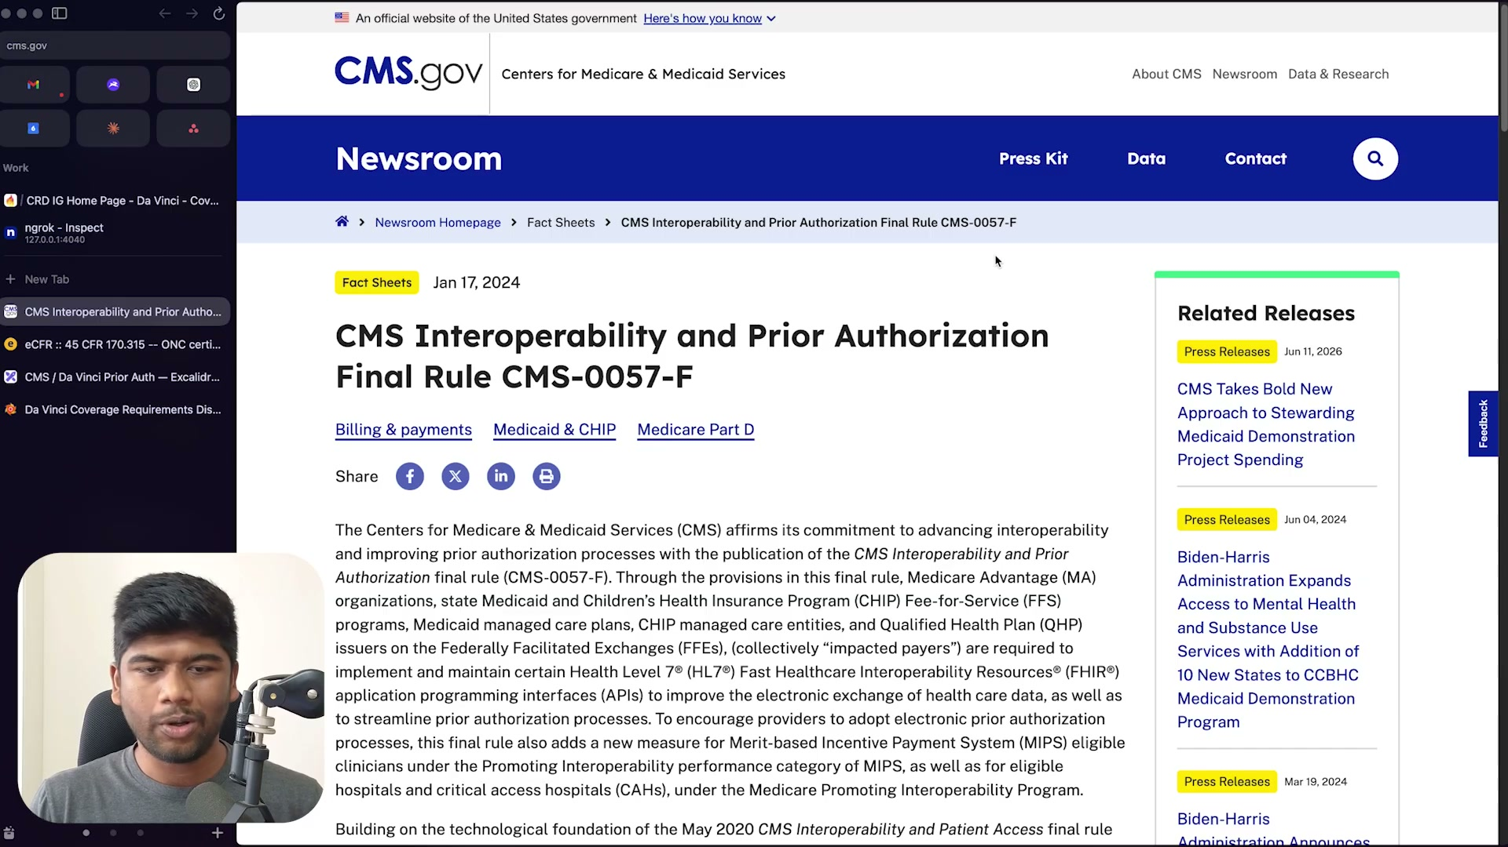
What's on screen
- Browser on CMS.gov Newsroom → Fact Sheet “CMS Interoperability and Prior Authorization Final Rule CMS-0057-F” (Jan 17, 2024).
- Impacted payers: Medicare Advantage (MA), state Medicaid & CHIP fee-for-service, Medicaid/CHIP managed care, and QHP issuers on the Federally Facilitated Exchanges (FFEs).
- They must implement and maintain HL7 FHIR APIs to improve data exchange and streamline prior authorization; the rule also adds a new MIPS measure.
- The whole video is a screen-share; the presenter appears as a webcam in the bottom-left.
Narration: “We are going to talk about the CMS interoperability prior [authorization] initiative… also known as the CMS 0057-F, and this actually includes a lot more than just prior authorization. It includes a bunch of APIs.”

1.2 The four APIs — and the January 1, 2027 deadline 00:18
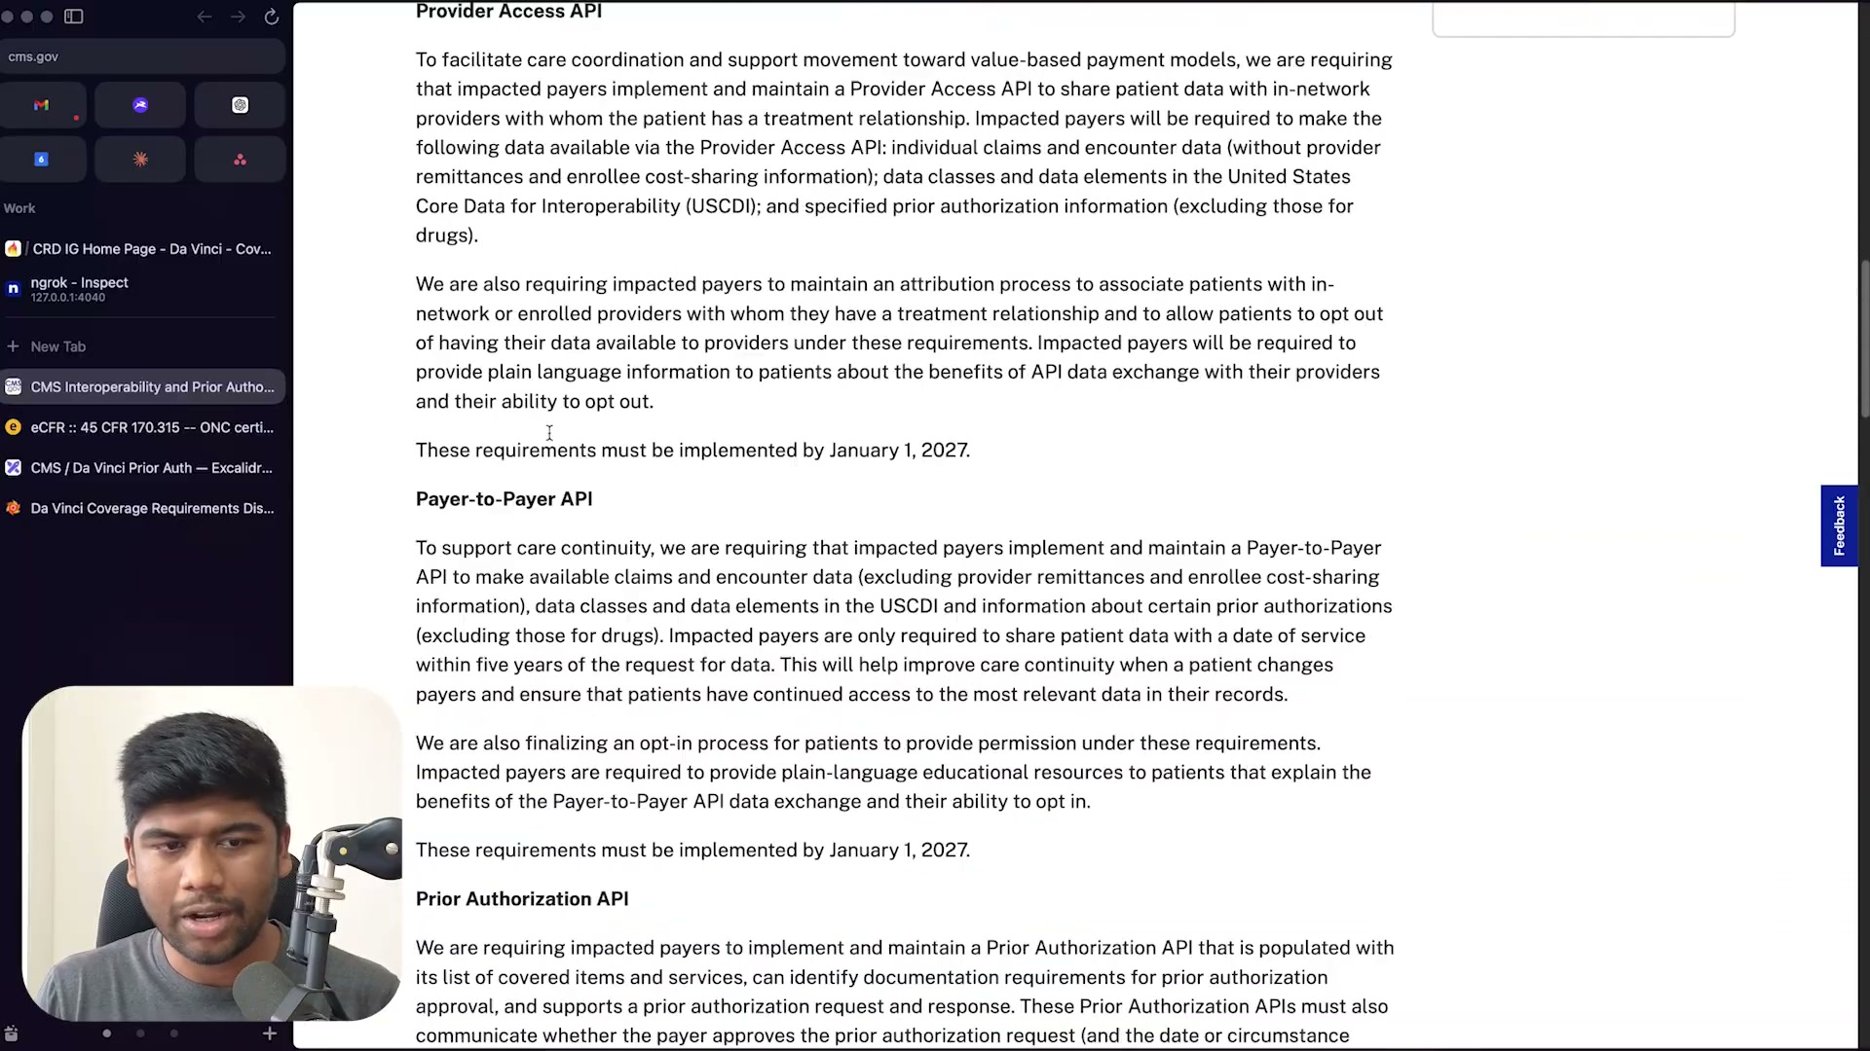
What's on screen
- CMS rule text: the Patient Access API, Provider Access API, Payer-to-Payer API, and the Prior Authorization API.
- Provider Access and Payer-to-Payer APIs must be implemented by January 1, 2027.
- The Prior Authorization API is the biggest change: it must expose covered items/services, identify documentation requirements, support a PA request and response, and communicate approval/denial.
- Applies to everyone serving under Medicare Advantage, CHIP, and fee-for-service.
Narration: “The biggest change that’s going to come up in 2027 is going to be the prior authorization APIs, and everyone who basically serves under Medicare Advantage, the CHIP program, fee-for-service — all of these people will need to now support this by January 1st 2027.”

1.3 The three provider APIs — CRD, DTR, PAS 03:02
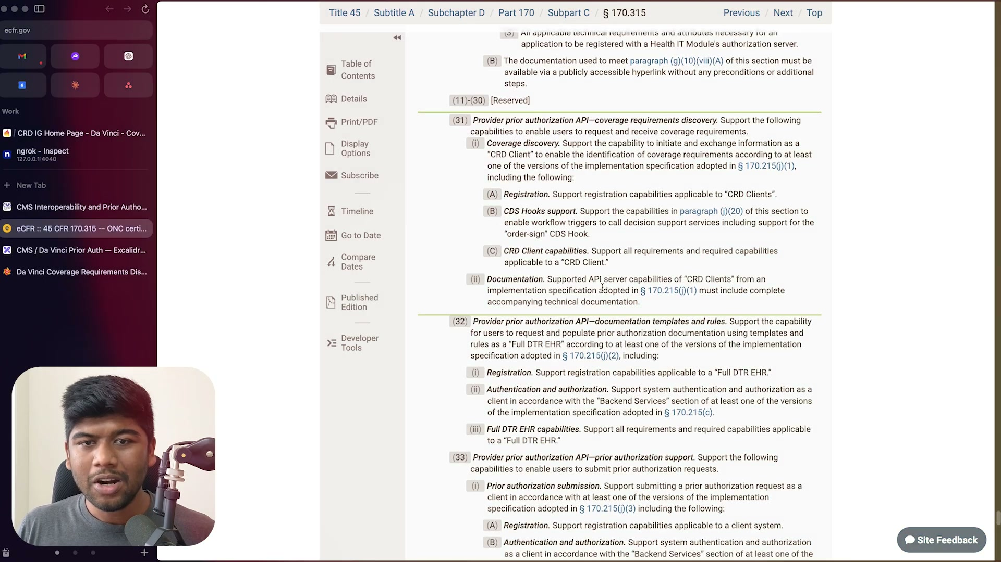
What's on screen
- eCFR 45 CFR 170.315 (the ONC / HTI certification criteria), sitting just below (g)(10) / “G10” (the standardized FHIR APIs).
- (g)(31) Provider prior authorization API — coverage requirements discovery (CRD): a “CRD Client”, CDS Hooks support, and the order-sign hook.
- (g)(32) Provider prior authorization API — documentation templates and rules (DTR): a “Full DTR EHR”.
- (g)(33) Provider prior authorization API — prior authorization support (PAS): prior authorization submission.
Narration: “This is right below G10… 31 and 32 and 33 — all of these are provider prior authorizations: coverage requirements discovery, documentation templates and rules (DTR), and prior authorizations, or PAS.”

1.4 The spec — Da Vinci Coverage Requirements Discovery (CRD) IG 03:32
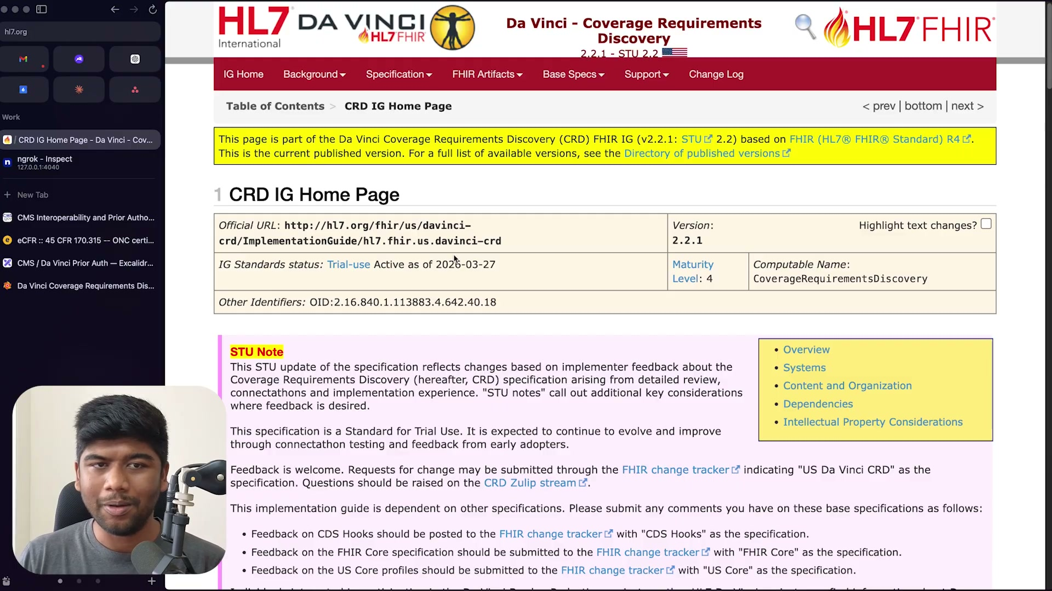
What's on screen
- HL7 Da Vinci “Coverage Requirements Discovery” Implementation Guide, version 2.2.1 (STU 2.2), based on FHIR R4.
- Official URL hl7.org/fhir/us/davinci-crd; Maturity Level 4; computable name CoverageRequirementsDiscovery.
- CMS technically mandates CRD 2.0.1, but the presenter recommends implementing 2.2.1 (what EHRs actually use).
Narration: “CRD that is mandated by CMS right now is technically the 2.0.1 version, but what is actually [used] for EHRs is 2.2.1… that’s what I recommend anybody implementing CRD/DTR/PAS to do.”

1.5 The MIPS electronic prior-authorization measure & deadlines 03:46
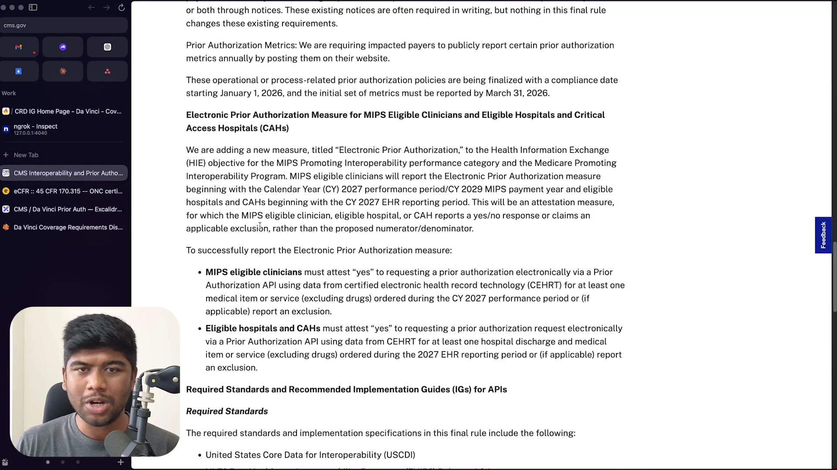
What's on screen
- Back on the CMS rule: impacted payers must publicly report PA metrics annually; operational PA policies have a compliance date of January 1, 2026, with the initial metrics reported by March 31, 2026.
- A new “Electronic Prior Authorization” MIPS measure: MIPS eligible clinicians (CY2027 performance period) and eligible hospitals/CAHs (2027 EHR reporting period) attest “yes” to at least one electronic PA via a Prior Authorization API using certified EHR technology (CEHRT), excluding drugs.
- This is how CMS effectively pushes providers (not just payers) toward electronic prior auth.
Narration: “Any MIPS eligible clinician needs to attest to ‘yes,’ saying that they have actually done at least one electronic prior authorization — and they do need a certified health IT product for that.”

Section 2 — Who must build it, and why it’s radical
The scope of covered parties, and how far this departs from today’s prior-auth reality.

2.1 Payers, providers — and the vendors behind them 05:00
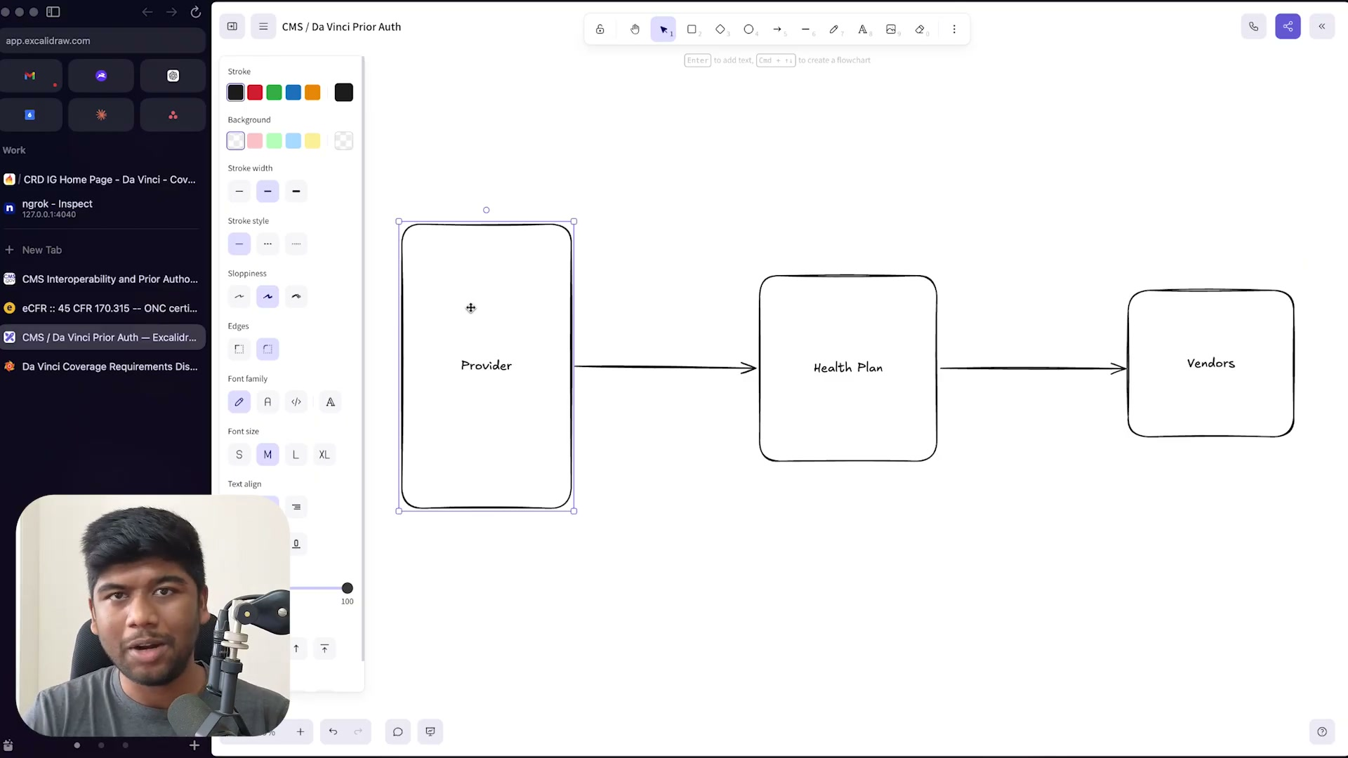
What's on screen
- Whiteboard (Excalidraw): Provider → Health Plan → Vendors.
- The deadline is on health plans, but plans subcontract to vendors / business associates who actually execute the APIs — so the scope of who is covered is broad.
- The old way: phone calls, faxes, the X12 278 transaction, per-payer portals, and hundreds of forms a day — the burden CMS wants to cut.
- CMS is compressing PA decision time to 72 hours (with proposed rules for 48 hours) and making X12 278 optional for FHIR implementers (“enforcement discretion”).
Narration: “This is one of the most radical transformations in terms of prior authorization and the clinical workflow since the original HIPAA ruling for portability… they are bringing that [decision time] down to 72 hours, and there are proposed rules to bring it down even further to 48 hours.”

Section 3 — The new flow: CRD → DTR → PAS
The core idea — a real-time feedback loop inside the EHR, built on CDS Hooks.

3.1 The core idea — a real-time CDS Hooks feedback loop 09:46
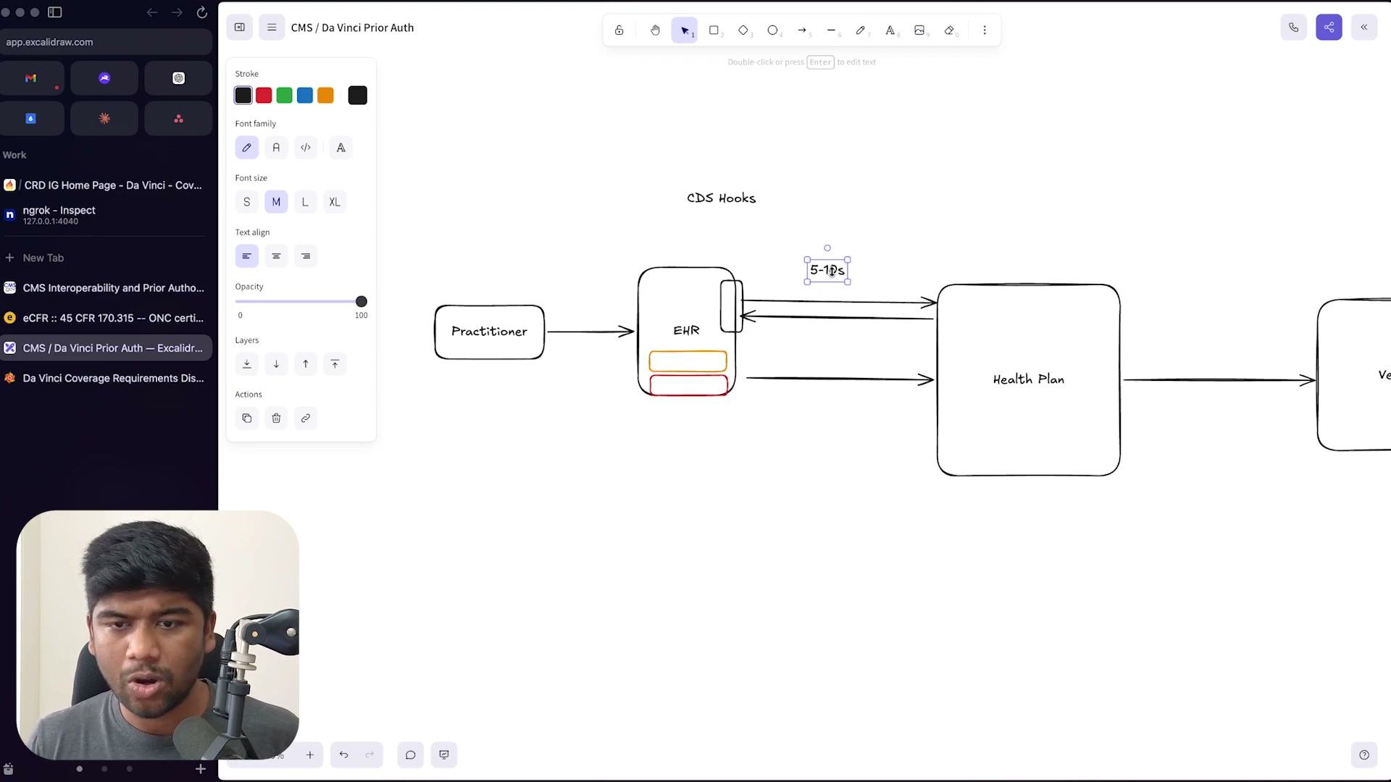
What's on screen
- Whiteboard: Practitioner → EHR (CDS Hooks) ⇄ Health Plan, labelled “5-10s”.
- Da Vinci CRD/DTR/PAS are built on CDS Hooks, which live inside the EHR and interject in the practitioner’s workflow (e.g., “consider a different drug”, “not eligible for this procedure”).
- The EHR calls the payer’s CDS service and gets cards back in 5–10 seconds — a loop that previously took days or weeks.
Narration: “This happens in like 5 to 10 seconds… this is a loop that did not exist before. Previously this feedback came like after days… right now we have one really fast channel which is able to do this in like 5 to 10 seconds.”

3.2 The full flow — CRD, DTR and PAS 13:32
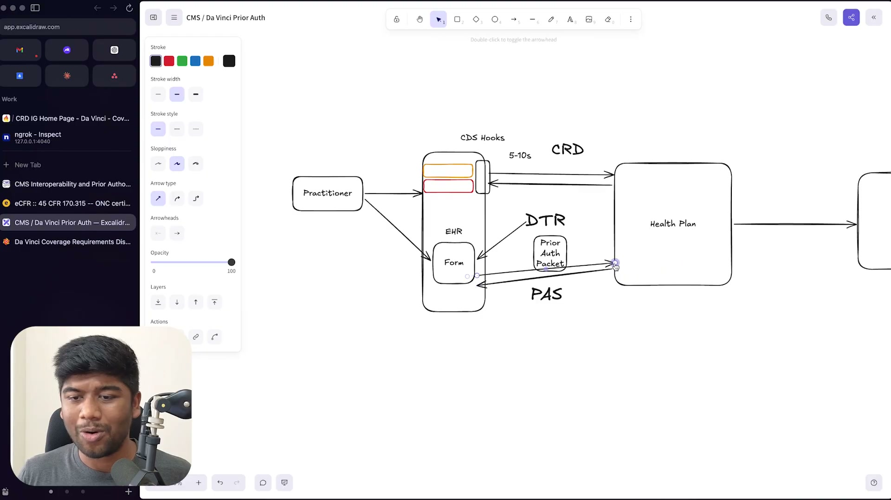
What's on screen
- Whiteboard overview: Practitioner → EHR. CRD returns cards (5–10s); DTR returns a questionnaire / Form embedded in the EHR; the EHR builds a “Prior Auth Packet” and sends it to the Health Plan via PAS.
- CRD = Coverage Requirements Discovery. DTR = Documentation Templates & Rules (form filled inside the EHR, many fields auto-filled). PAS = Prior Authorization Support (packet submission; status can be checked or pushed via FHIR Subscriptions).
- These are the three profiles the rest of the video works through in detail.
Narration: “Once this form is filled, the EHR basically generates a prior [auth] packet… this is called PAS or prior authorization support. And these are all three different profiles in the spec.”

Section 4 — CDS Hooks: the foundation
What CDS Hooks are, the cards they return, the available hooks, and order-select.

4.1 CDS Hooks — cards returned into the workflow 15:15
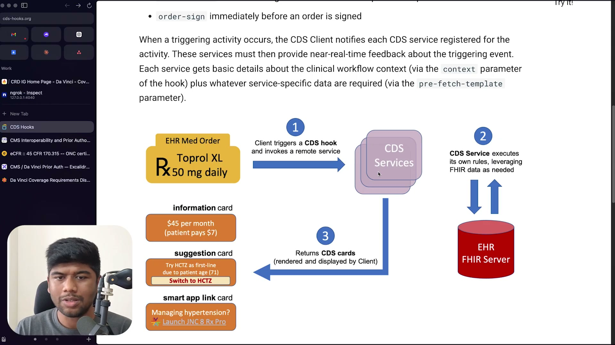
What's on screen
- cds-hooks.org “how it works” diagram: an EHR med order (Rx Toprol XL 50 mg daily) → (1) the client triggers a CDS hook and invokes a remote service → CDS Services → (2) the CDS Service executes its own rules, leveraging FHIR data from the EHR FHIR Server → (3) returns CDS cards.
- Card types shown: an information card ($45/month, patient pays $7), a suggestion card (Try HCTZ as first-line due to patient age; “Switch to HCTZ”), and a smart app link card (“Managing hypertension? Launch JNC 8 Rx Pro”).
- Each service gets context via the hook’s context parameter plus data via prefetch.
Narration: “When a triggering activity occurs, the CDS Client notifies each CDS service registered for the activity. These services must then provide near-real-time feedback… via the context parameter plus whatever service-specific data are required via the prefetch.”

4.2 The order-select hook 19:32
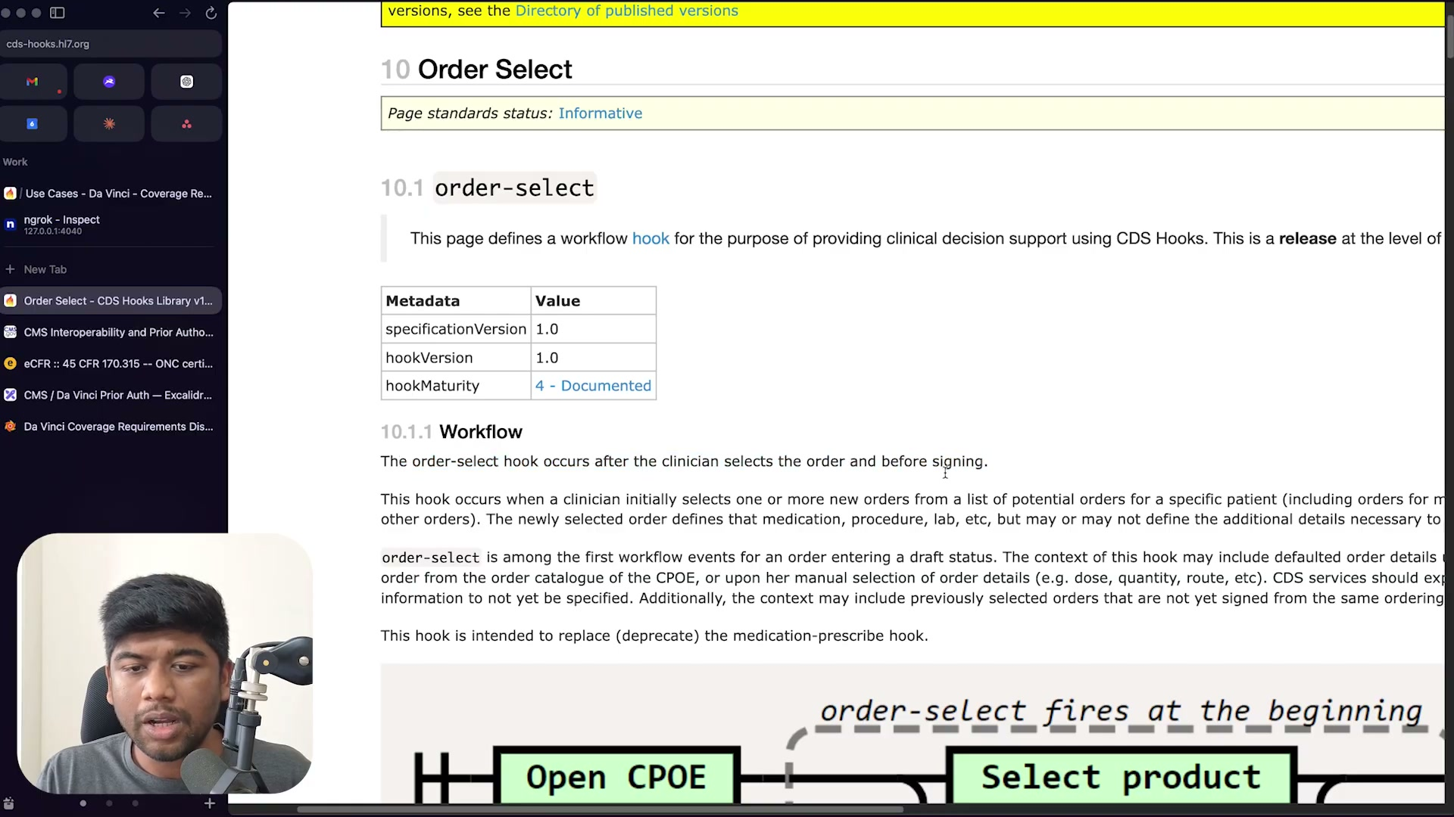
What's on screen
- cds-hooks.hl7.org “Order Select” spec: the order-select hook (specificationVersion 1.0, hookMaturity 4 - Documented).
- “The order-select hook occurs after the clinician selects the order and before signing”; it’s among the first workflow events for an order entering draft status, and it replaces (deprecates) medication-prescribe.
- Diagram “order-select fires at the beginning”: Open CPOE → Select product. order-sign fires immediately before an order is signed.
- order-select and order-sign are the most mature hooks for CRD.
Narration: “The order-select hook occurs after the clinician selects the order and before signing… if you consider order-sign, order-select, order-dispatch and appointment-book, you’re pretty much covered.”

4.3 The available CDS Hooks 27:30
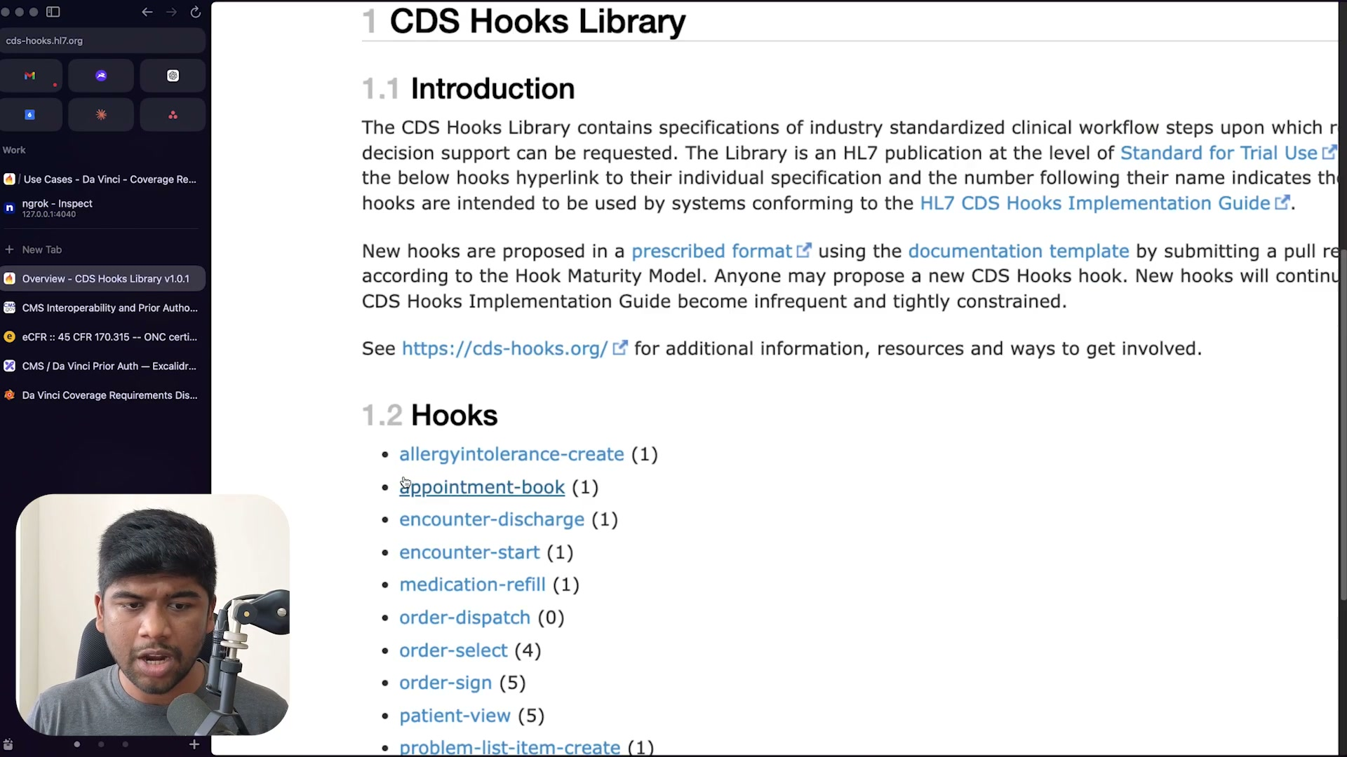
What's on screen
- cds-hooks.hl7.org “CDS Hooks Library” — the standardized clinical-workflow hooks: allergyintolerance-create, appointment-book, encounter-discharge, encounter-start, medication-refill, order-dispatch, order-select (4), order-sign (5), patient-view (5), problem-list-item-create, …
- The number after each name is the hook’s maturity; new hooks follow the Hook Maturity Model.
- patient-view fires when the chart is opened; order-select/order-sign are the important ones for CRD.
Narration: “How do you know all the different hooks? You go to the hook specification… patient-view is literally when you click on the patient chart and open up the patient. order-sign, order-select will be super important in CRD.”

Section 5 — Coverage Requirements Discovery (CRD) in depth
Worked scenarios, the discovery step, and the anatomy of a CDS-hook request.

5.1 CRD “success” scenarios 16:46
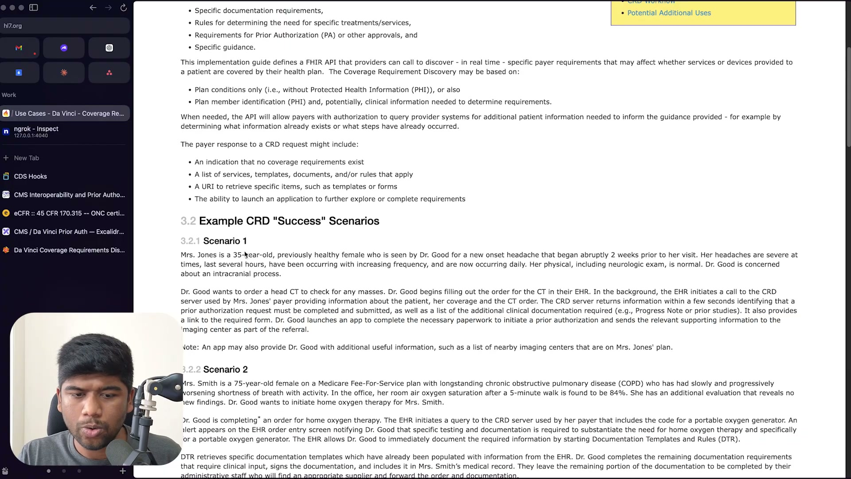
What's on screen
- Da Vinci CRD IG §3.2 “Example CRD Success Scenarios”.
- Scenario 1 — Mrs. Jones (35, new headache): Dr. Good orders a head CT; in the background the EHR calls the CRD server; within seconds it identifies that a prior authorization is required, lists additional clinical documentation (e.g., progress note / prior studies), and provides a link to the required form; DTR handles the form.
- A CRD request can return: no coverage requirements; a list of services/templates/documents/rules; a URI to retrieve items; or the ability to launch an app.
Narration: “In the background, the EHR initiates a call to the CRD server used by Mrs. Jones’ payer… The CRD server returns information within a few seconds identifying that a prior authorization request must be completed and submitted, as well as a list of the additional clinical documentation required.”

5.2 Discovery — registering a payer’s CDS services 21:16
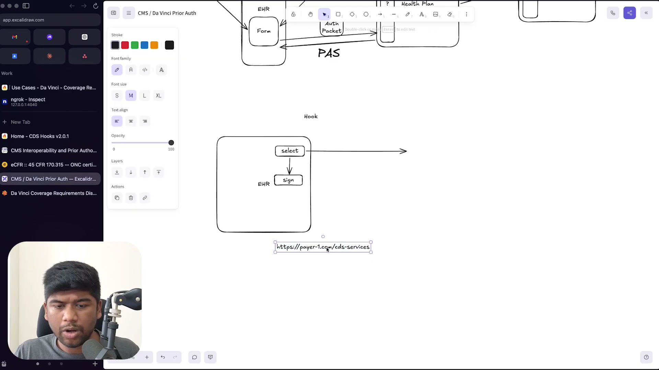
What's on screen
- Whiteboard: the EHR must first know a payer’s CDS-services base URL, e.g., https://payer-1.com/cds-services.
- Discovery is a GET to that endpoint (authenticated with a JWT bearer token); the CDS service responds with all the hooks it supports (e.g., order-select, order-sign) so the EHR can register them.
- Discovery can run ahead of time (e.g., every couple of hours) — it doesn’t have to happen at hook time.
Narration: “Firstly the EHR needs to register the fact that this payer has a particular endpoint… the CDS service responds back to the EHR saying what all it supports… this discovery call can happen earlier, it doesn’t need to happen when this hook is happening.”

5.3 Calling a CDS service — the request anatomy 25:46
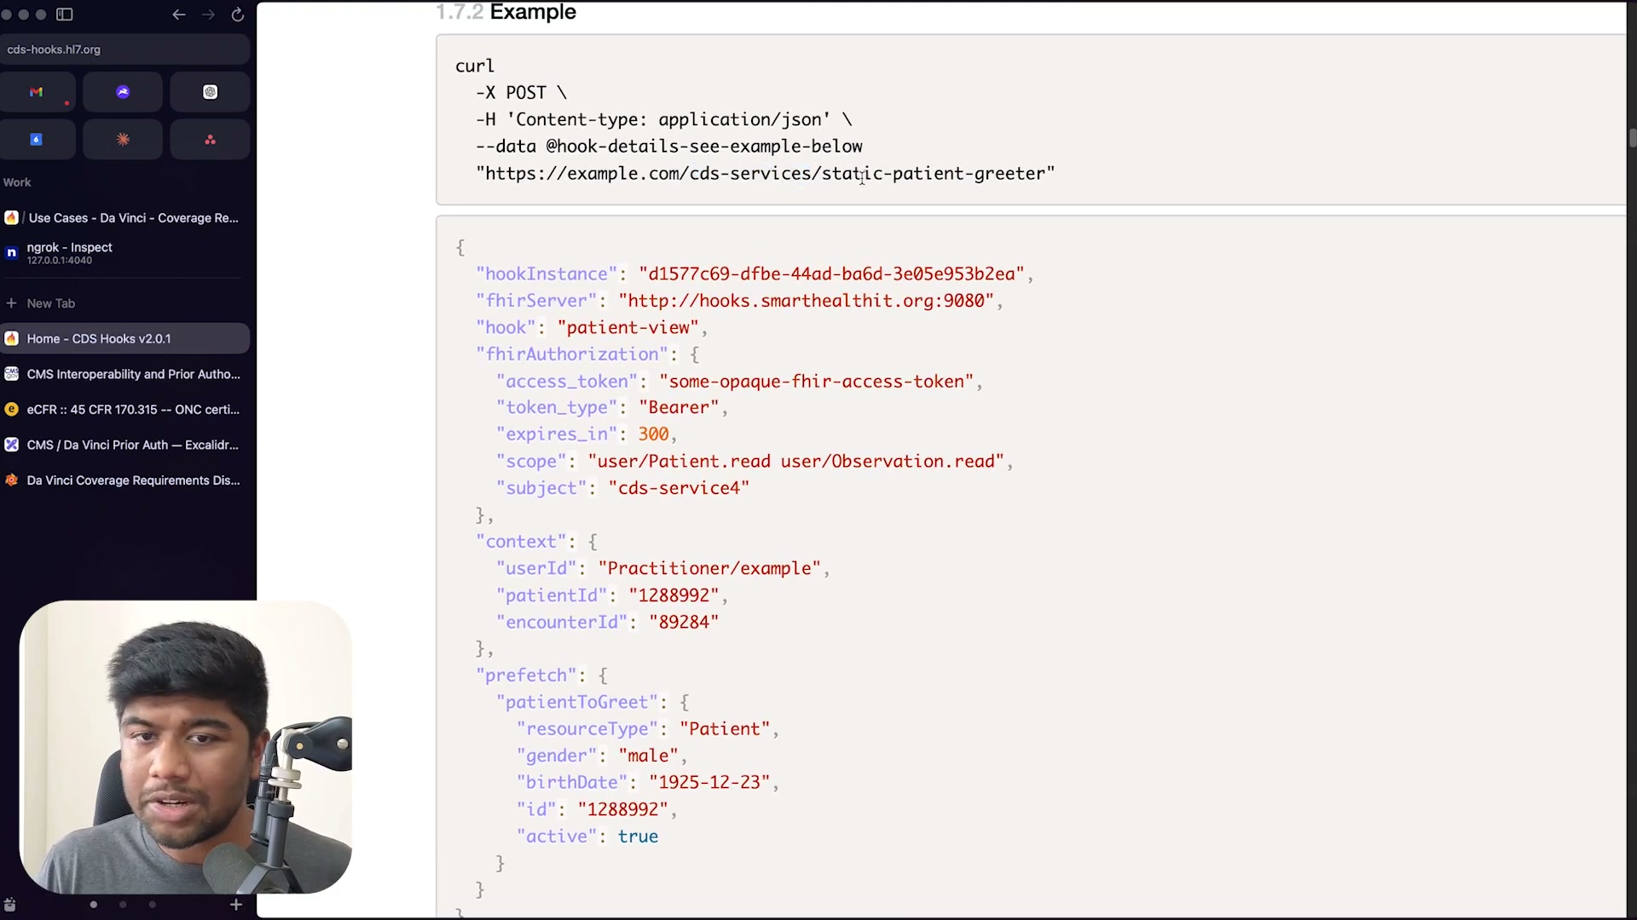
What's on screen
- cds-hooks.hl7.org §1.7.2 Example: a POST to /cds-services/static-patient-greeter.
- Request JSON fields: hookInstance (a UUID), fhirServer (the EHR’s FHIR base URL), hook (e.g., “patient-view”), fhirAuthorization (access_token, token_type “Bearer”, expires_in 300, scope, subject), context (userId, patientId, encounterId), and prefetch (e.g., patientToGreet — the pre-resolved Patient resource).
- Prefetch lets the EHR send required data up front so the service can respond fast.
Narration: “It also provides the URL to the FHIR server… and an authentication token… if you can use prefetch — in this case they did use prefetch, they’ve asked the server to provide the patient to greet in advance — so when the hook comes in… it already includes all of the prefetch information.”

5.4 The hook context — selections and draft orders 29:02
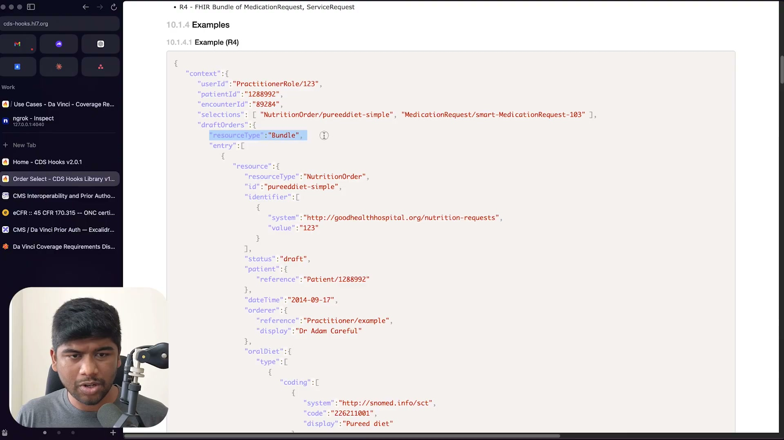
What's on screen
- CDS Hooks order-select example (R4): context with userId (PractitionerRole/123), patientId, encounterId, selections [NutritionOrder/pureeddiet-simple, MedicationRequest/smart-MedicationRequest-103], and draftOrders (a FHIR Bundle of the in-progress orders).
- selections reference FHIR resources inside the draftOrders bundle.
- draft orders are only available in the order-select hook — asking for them in, say, a patient-view hook makes no sense.
Narration: “Asking for draft orders as a prefetch in a patient-view hook doesn’t make any sense. So this is only available in the order-select hook… you are allowed to use this.”

Section 6 — CRD responses & the end-to-end sequence
What the payer returns, the CRD→DTR sequence, the Burden-Reduction family, and the workflow figure.

6.1 The CRD → DTR sequence 33:02
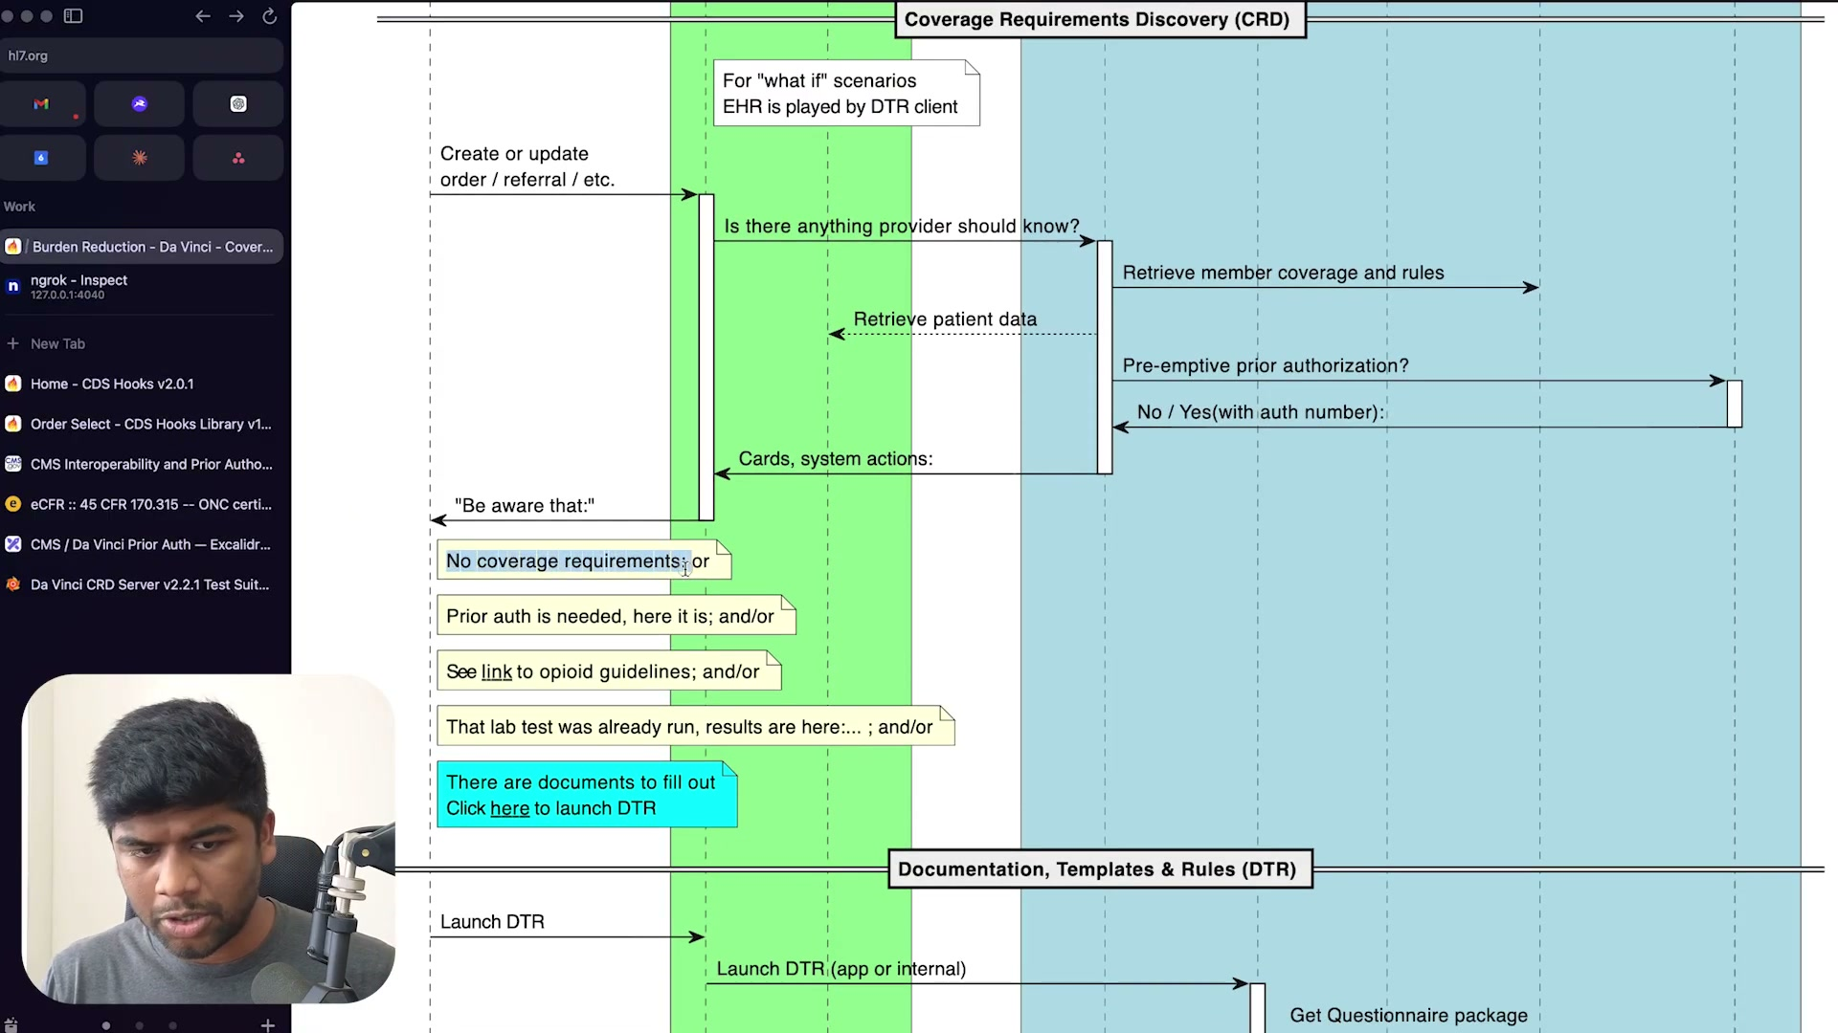
What's on screen
- Da Vinci CRD sequence diagram (swimlanes: Coverage Requirements Discovery in green, Documentation Templates & Rules in blue).
- Flow: Create/update order/referral → “Is there anything the provider should know?” → the CRD server retrieves member coverage & rules, may retrieve patient data, and checks pre-emptive prior authorization (No / Yes with auth number) → returns cards / system actions (“Be aware that:”).
- Possible cards: no coverage requirements; prior auth is needed (here it is); see link to opioid guidelines; that lab test was already run (results here); or “there are documents to fill out — click here to launch DTR”.
- For “what if” scenarios the EHR is played by the DTR client; launching DTR fetches a Questionnaire package.
Narration: “This particular thing needs prior authorization… so you can return… is it covered, is prior required, and if prior is required then it can also include links and other documentation for what needs to be provided.”

6.2 The Da Vinci “Burden Reduction” family 34:46
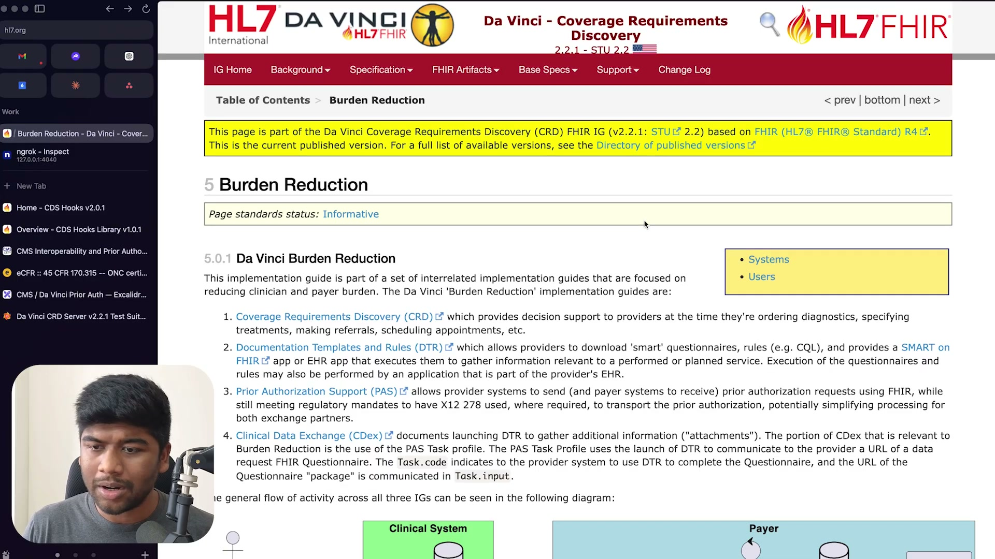
What's on screen
- Da Vinci CRD IG §5 “Burden Reduction” — four interrelated implementation guides:
- 1) CRD — decision support at ordering time. 2) DTR — download ‘smart’ questionnaires and rules (e.g., CQL) via a SMART-on-FHIR or EHR app. 3) PAS — send/receive prior authorization using FHIR, while still meeting the X12 278 mandate where required. 4) CDex — launch DTR to gather attachments (the PAS Task profile).
- Together they reduce clinician and payer burden.
Narration: “The Da Vinci Burden Reduction implementation guides are: Coverage Requirements Discovery… Documentation Templates and Rules… Prior Authorization Support… allows provider systems to send and payer systems to receive prior authorization requests using FHIR, while still meeting regulatory mandates to have X12 278 used where required.”

6.3 The high-level CRD workflow 41:16
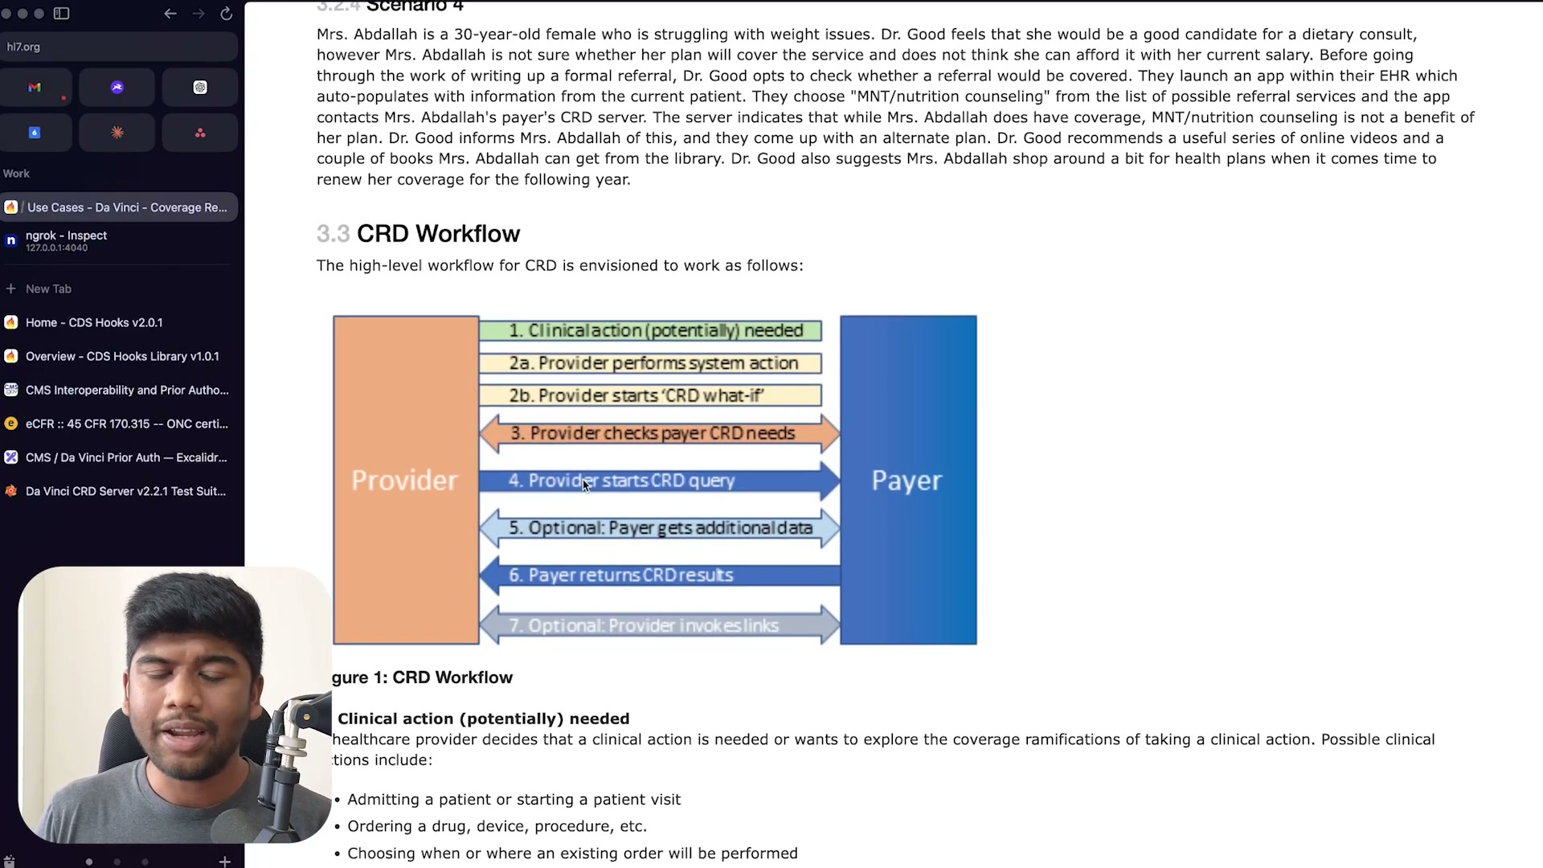
What's on screen
- Da Vinci CRD IG §3.3 “CRD Workflow” (Figure 1, Provider ↔ Payer): 1. Clinical action (potentially) needed; 2a. Provider performs system action; 2b. Provider starts ‘CRD what-if’; 3. Provider checks payer CRD needs; 4. Provider starts CRD query; 5. Optional: Payer gets additional data; 6. Payer returns CRD results; 7. Optional: Provider invokes links.
- “what-if” (no-op) hooks let a provider test what would happen without actually placing an order — the payer must treat these differently (no real authorization number, no stateful change).
Narration: “CRD also supports one other kind of hook which is the no-op or what-if scenarios… a provider might just place an order just to check ‘is this true’… and then you don’t need to actually make any stateful changes in your system.”

Section 7 — Architecture for health plans and their vendors
How to compose multiple vendors safely — proxying, tokens, and prefetch namespacing.

7.1 Composing multiple vendors — proxy, tokens & prefetch namespacing 40:02
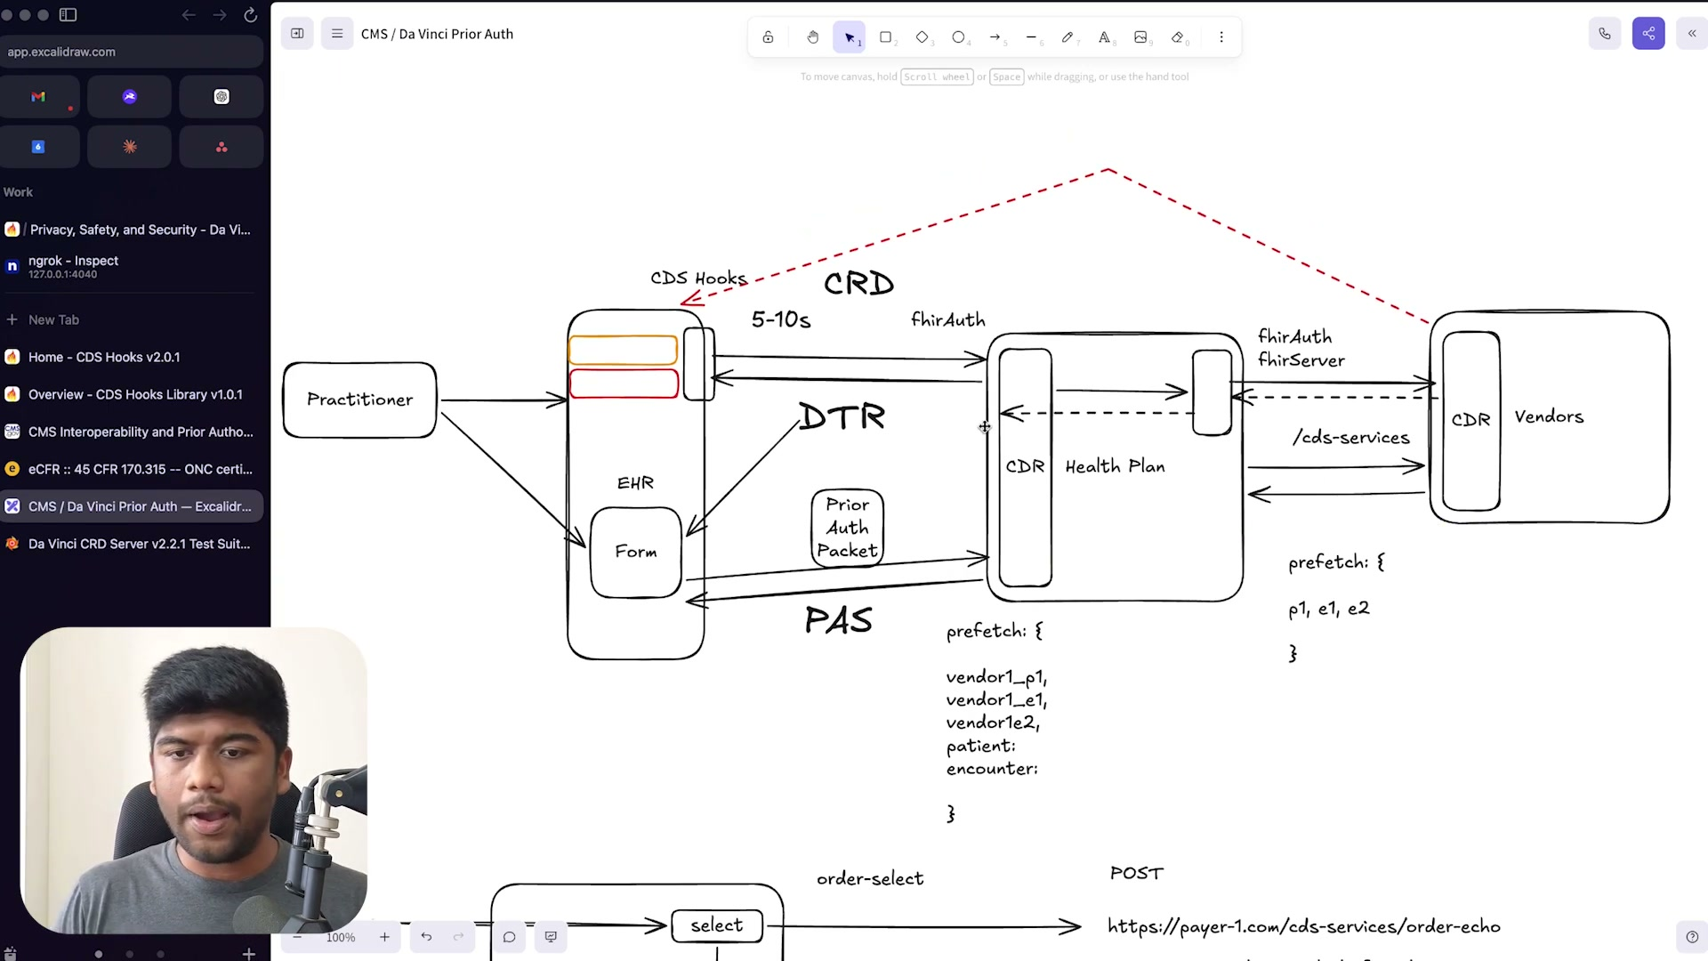
What's on screen
- Whiteboard architecture: EHR (CDS Hooks / CRD / DTR / PAS, Form, Prior Auth Packet) ⇄ Health Plan (its own FHIR server / CDR, fhirAuth) ⇄ Vendors.
- The APIs are composable: have every vendor implement the same CRD spec; the health plan builds a facade / proxy that aggregates discovery and routes hooks.
- Privacy/security: do NOT forward the EHR’s fhirAuthorization token to vendors (the red dashed “do not” line). Instead the health plan hosts its own FHIR server and forwards requests back to the EHR.
- Prefetch namespacing: prefix each vendor’s prefetch keys (e.g., vendor1_p1, vendor1_e1, vendor1e2) so they can be split out and forwarded.
Narration: “Just have all of your vendors implement the spec exactly as it is… access tokens provided as part of CRD calls should not be forwarded to systems that are not managed by the same organization… instead just provide them with a FHIR server that the health plan can host, and forward all the requests back to the EHR.”

Section 8 — Wrap-up
How to implement and how to prove you’re compliant.

8.1 Testing compliance — the Inferno CRD Test Kit 04:16
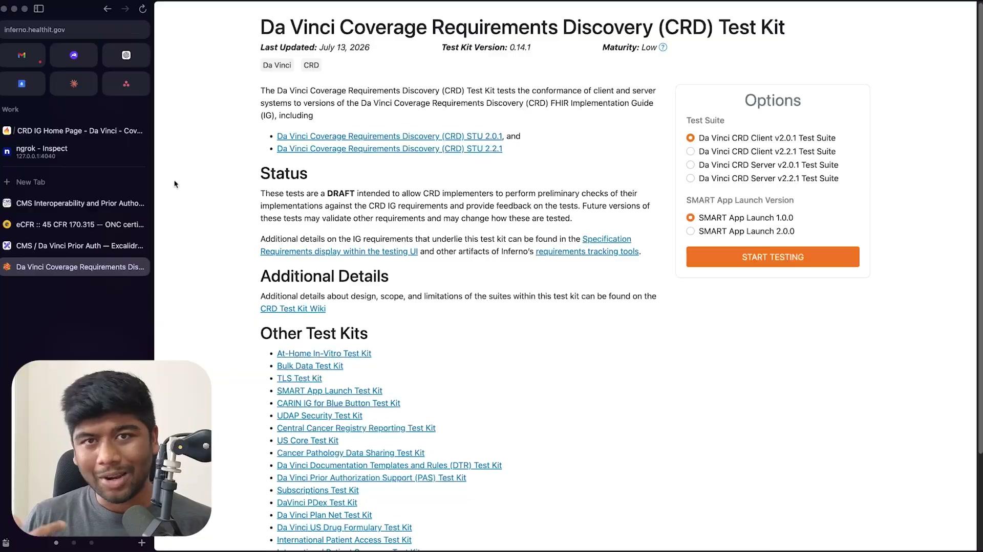
What's on screen
- Inferno (inferno.healthit.gov) — the “Da Vinci Coverage Requirements Discovery (CRD) Test Kit” (Test Kit Version 0.14.1; maturity: Low).
- It tests the conformance of client and server systems to the CRD IG — both STU 2.0.1 and STU 2.2.1.
- The Options panel picks a Test Suite (Da Vinci CRD Client v2.0.1 / v2.2.1; Da Vinci CRD Server v2.0.1 / v2.2.1) and a SMART App Launch version (1.0.0 / 2.0.0), then “START TESTING”.
- Sibling test kits exist for DTR and PAS — the presenter’s recommended way to prove compliance (alongside the CDS Hooks sandbox).
Narration: “…we are going to try and build out a solution that actually passes all of the tests that the Inferno testing kit will throw at us, and we are going to cover CRD, DTR and PAS.”

8.2 The test suite in action — Da Vinci CRD Server v2.2.1 40:16
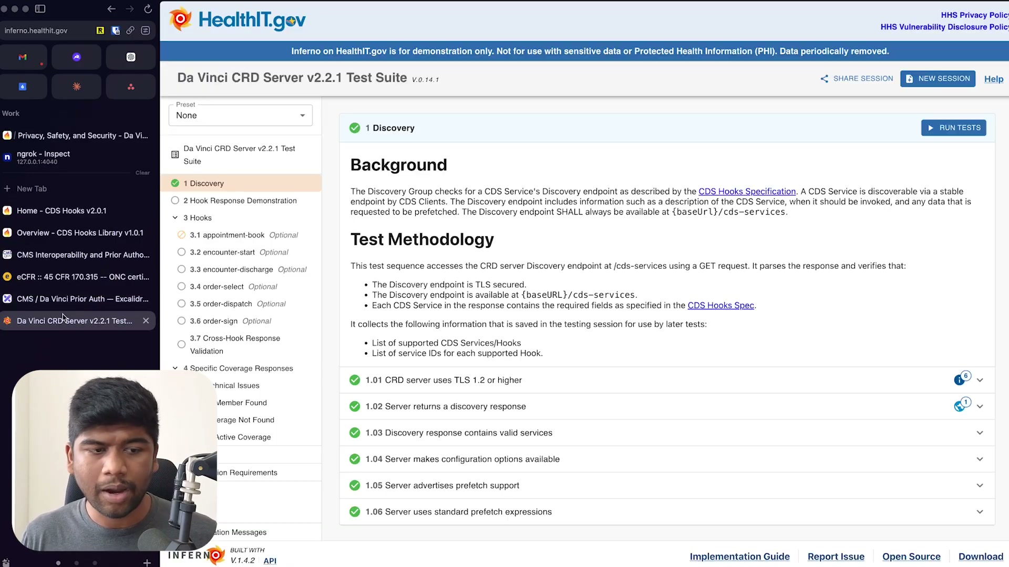
What's on screen
- The same Inferno kit, now running: “Da Vinci CRD Server v2.2.1 Test Suite” (V.0.14.1) on HealthIT.gov — banner: “Inferno on HealthIT.gov is for demonstration only. Not for use with … Protected Health Information (PHI).”
- Left-hand test tree: 1 Discovery · 2 Hook Response Demonstration · 3 Hooks (3.1 appointment-book … 3.7 Cross-Hook Response Validation, all Optional) · 4 Specific Coverage Responses.
- The “1 Discovery” group is open: its Background notes the Discovery endpoint must be available at {baseUrl}/cds-services; the Test Methodology parses a GET response.
- Discovery checks 1.01–1.06 all pass (green ✓): TLS 1.2+, returns a discovery response, valid services, configuration options available, advertises prefetch support, standard prefetch expressions.
Narration: “…just have everybody implement the exact same CMS spec and have them do the checking by … going to Inferno, and maybe even testing it on the CDS Hooks sandbox, and you will have a much easier time.”

8.3 How to implement and wrap-up 42:46
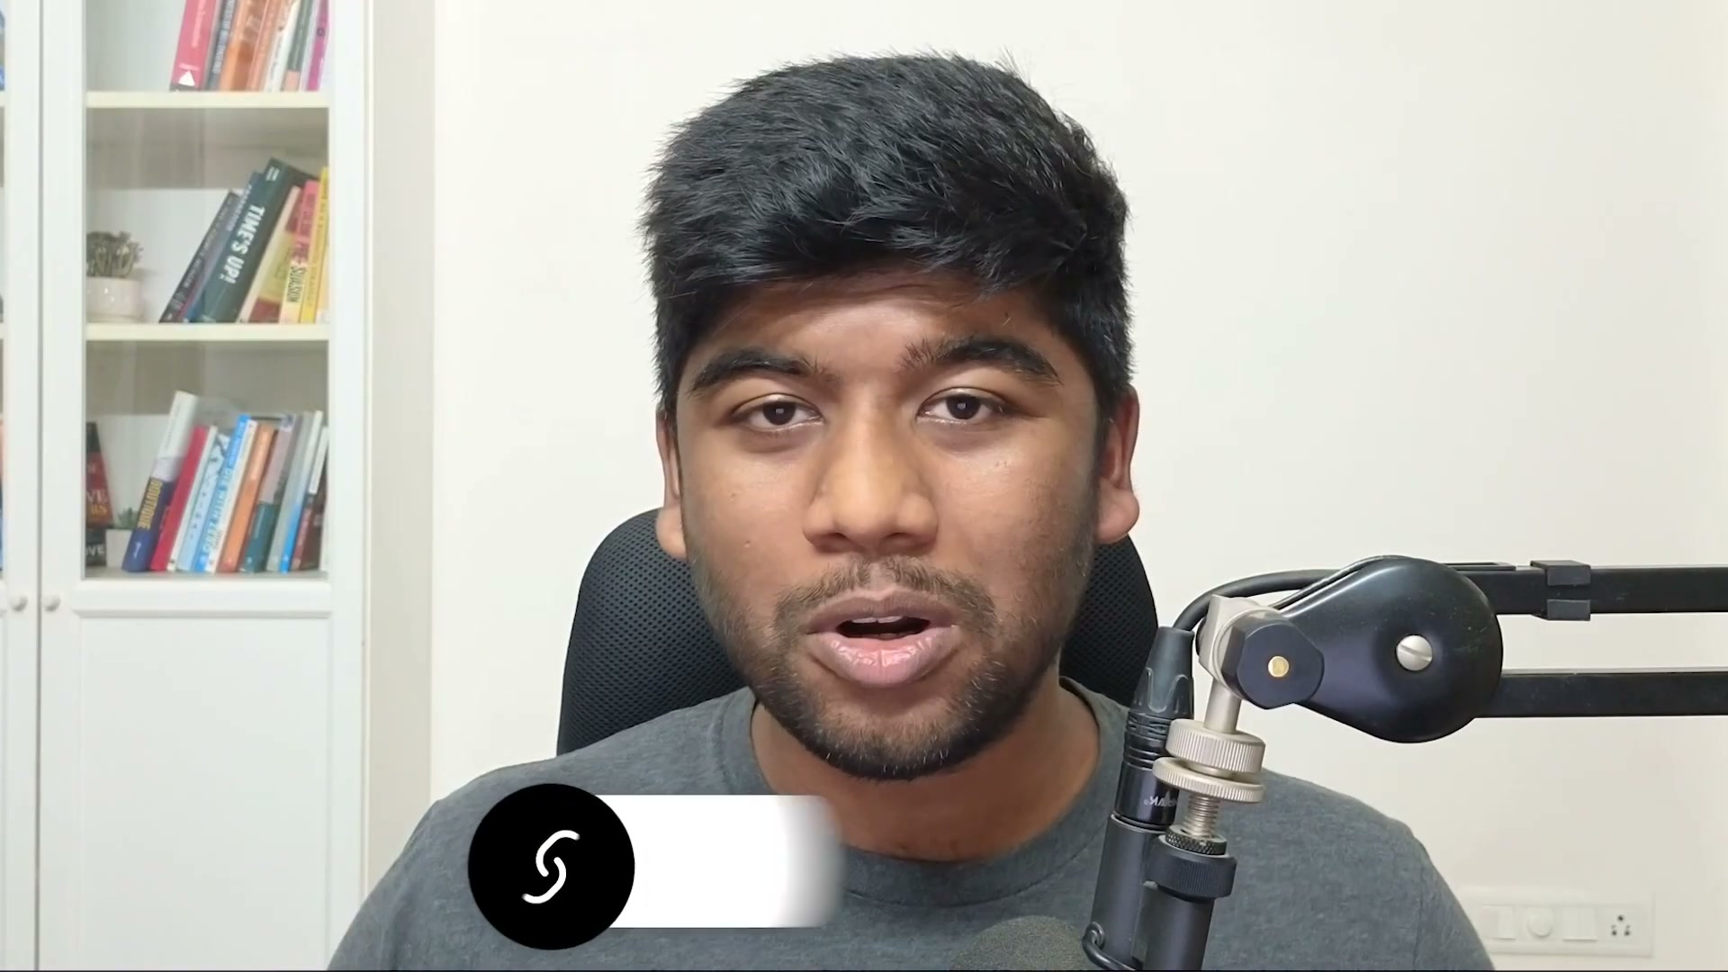
What's on screen
- The presenter returns on camera to close.
- Recap: implement the spec as-is (don’t invent your own APIs or auth schemes); test against the Inferno CRD test suite (and the CDS Hooks sandbox); let the health plan build a proxy to compose multiple vendors.
- He offers help implementing CRD/DTR/PAS and invites questions in the comments.
Narration: “Just implement the spec as it is, do not make any changes, and the health plan can build a proxy to compose multiple other vendors… reach out to me if you’re interested in working with us or if you just want more information on how to implement CRD/DTR or PAS in your systems.”

Notes for implementation
The concrete build guidance the tutorial actually gives, distilled:
- CMS-0057-F requires impacted payers (Medicare Advantage; Medicaid/CHIP FFS & managed care; FFE QHPs) to stand up FHIR APIs; the Prior Authorization API is the big one, due January 1, 2027.
- Build the three provider APIs as a set: CRD (g)(31), DTR (g)(32), PAS (g)(33) — part of the Da Vinci ‘Burden Reduction’ family (with CDex).
- CRD/DTR/PAS are built on CDS Hooks: real-time (5–10s) cards returned into the practitioner’s EHR workflow, replacing days/weeks of back-and-forth.
- Implement CRD 2.2.1 (CMS mandates 2.0.1, but EHRs use 2.2.1).
- Use order-select and order-sign as the primary hooks; support the no-op / ‘what-if’ variant (no stateful change, no real authorization number).
- Master the request anatomy: discovery (GET, JWT) to the payer’s /cds-services base URL, then POST with hook / hookInstance / fhirServer / fhirAuthorization / context / prefetch; use prefetch to respond fast.
- Do NOT forward the EHR’s fhirAuthorization token to downstream vendors; the health plan should host its own FHIR server and proxy/aggregate; namespace each vendor’s prefetch keys.
- Have every vendor implement the exact same spec and verify against the Inferno CRD test suite and the CDS Hooks sandbox.
- CMS is compressing PA decision time to 72 hours (proposed 48h) and making the X12 278 transaction optional for FHIR implementers (enforcement discretion).
End of walkthrough. 22 screenshots, all captured and verified from the recording.

Appendix — Full transcript (verbatim, timestamped)
The complete transcript exactly as captioned, with its original timestamps. Only blank filler lines from the source file were removed; every spoken caption line is preserved verbatim (auto-caption quirks, including occasional “:60” seconds and mis-hearings, are left unchanged).
00:00 So we are going to talk about the CMS
00:03 interoperability prior initiative. So
00:06 again this is also known as the CMS
00:09 0057F
00:11 and this actually includes uh a lot more
00:13 than just prior authorization. It
00:15 includes a bunch of APIs. There is the
00:17 patient access API provider access
00:19 payer-to-payer APIs. But I think the
00:21 biggest change that's going to come up
00:23 in 2027 uh is going to be the prior
00:26 authorization APIs and everyone who
00:29 basically serves under uh Medicare
00:32 advantage uh the chip program fee for
00:35 service all of these people will need to
00:38 now support this by um January 1st 2027
00:42 and they have uh put that date on the
00:45 wall for everyone to see. Uh now the
00:47 thing is this is mostly for health
00:50 plans. Uh this deadline is for health
00:52 plans serving under any of these
00:54 programs but the thing is usually what
00:56 happens is you have health plan or you
00:60 have a payer and they would have another
01:03 uh vendor or they have another business
01:05 uh associate who is like helping them
01:07 actually execute some of these plans. So
01:10 these uh could be like other vendors. So
01:13 now the thing is the scope of what all
01:17 or like who all are covered is quite
01:19 broad and I think this is one of the
01:21 most radical transformations in terms of
01:25 like prior authorization and the
01:26 clinical workflow since like the
01:29 original HIPPA ruling for portability
01:31 came on. So you have a provider and the
01:35 thing is they are also enforcing this on
01:37 the provider. So now they're not
01:39 directly telling providers okay you are
01:41 going to do this but the CMS has uh
01:44 other ways to do this where you know
01:46 they have this uh improving prior
01:49 authorization MIP score where they have
01:51 an electronic prior authorization
01:53 measure. So by uh the calendar year 2027
01:57 which again like even in October of this
01:59 year uh people will need to start
02:02 thinking about this where any MIPS
02:04 eligible clinician needs to attest to
02:08 yes saying that they have actually done
02:10 u at least one electronic prior
02:13 authorization and they do need a
02:15 certified health IT uh product for that
02:18 and just in in time uh we have HDI4 and
02:22 they have actually passed this in the
02:24 regulation along again like this is
02:26 right below uh G10. So this is for the
02:29 standardized fire APIs that again made a
02:31 lot of new things possible and everybody
02:33 was like implementing this and we see
02:35 that people are going after um you know
02:38 EHRs that are not compliant. We even see
02:42 like the federal government going after
02:43 a few EHRs that are blocking uh
02:46 information by not exposing fire APIs.
02:48 This is right under that. This is like
02:49 31 and 32 and 33. All of these are
02:53 provider prior authorizations, coverage
02:55 requirements discovery and this is like
02:57 documentation templates and rules or DTR
02:60 and this is prior authorizations about
03:01 PAS. We probably have this as a
03:04 miniourse on our website as well. So
03:06 this will have all of the um written
03:09 content that comes along with this. So
03:11 look out for that and if you're
03:12 interested like just uh sign up for
03:14 that. Just go to the website and you can
03:15 grab that. Now, we'll talk about all of
03:18 these three in as much detail as we can
03:20 throughout uh these videos. Uh we'll
03:23 also be taking a look at how you can
03:26 test yourself against um compliance like
03:29 are you actually compliant. We'll also
03:30 be taking a look at the Davinci spec uh
03:34 and the fire spec in as much detail as
03:37 possible. So by the end of this uh whole
03:41 video, it's going to be quite long uh
03:43 but we are going to try and build out uh
03:45 a solution that actually passes all of
03:48 the tests that the inferno testing kit
03:51 will throw at us and we are going to
03:53 cover CRD, DTR and PAS. So again this
03:58 video is going to be quite advanced. Uh
04:00 so if you are just getting started with
04:02 fire, then we have a fire fundamentals
04:04 course. uh I recommend that you check
04:06 that out first and then come back here
04:09 because we are going to be dealing with
04:11 quite a lot of advanced APIs and like
04:13 how exactly to implement this properly.
04:16 So again we are working with a bunch of
04:18 health plans and I'm seeing time and
04:20 time again that they sort of get it.
04:23 They sort of look at the uh spec and
04:25 they're like oh okay that's all we got
04:26 to do but no like this is fundamentally
04:30 different from your usual prior
04:32 authorization work. So usually what
04:35 happens is you have um the provider and
04:38 like somebody at the provider maybe they
04:41 they call on the phone and they keep
04:43 this thing in their minds on like okay
04:45 these kind of CPT codes for this sort of
04:47 a health plan needs prior authorization.
04:50 So they'll call them and then they'll
04:51 like check whether they can send them
04:53 facts later and then they'll send the
04:54 facts and then it'll take forever to
04:56 come back and then uh you decide whether
04:59 or not you can treat that patient with
05:01 that particular uh drug or service. The
05:03 thing here is CMS is actually cracking
05:05 down overall on uh how much time it
05:09 takes for prior authorization as a
05:11 whole. So again they are bringing that
05:13 down to 72 hours and I think um there
05:17 are proposed rules again to bring it
05:19 down even further to 48 hours. And the
05:22 other thing is uh they are making this
05:26 whole X12 to 78 prior authorization APIs
05:30 optional for providers implementing uh
05:33 the newer fire standards. So again this
05:35 is the older uh standards that were
05:39 available in the HIPPA regulation and
05:41 the HIPPA basically mandated that if you
05:43 are a covered entity you need to
05:44 implement uh the X12 prior authorization
05:48 um format in order for you to send prior
05:51 authorization to uh a payer and get
05:53 details back. They call this enforcement
05:56 uh discretion. So basically they can
05:58 choose to enforce it if they want to.
06:01 basically saying like for people who
06:03 have done fire uh only implementation we
06:07 are not going to come after you and we
06:08 are not going to say that you're not
06:10 complying with HIPPA just because you
06:12 didn't implement X12. So this is again
06:15 all of these are major changes and the
06:18 biggest thing here is that usually what
06:21 happens is that the provider has an EHR
06:24 system and this EHR system sort of like
06:27 sends out this uh request to a health
06:29 plan through X12 and then they get like
06:32 a response after a few days back saying
06:34 like okay this is approved or not. But
06:37 this process only started after someone
06:40 even knew that a particular um procedure
06:44 needed prior authorization. How do you
06:46 discover that? What do you do uh if
06:47 that's not the case? And there was a lot
06:50 of back and forth uh to get that
06:52 information out. And a lot of times uh
06:56 they didn't even support these X12
06:58 messages and they had to like a provider
07:00 had to go specially into a particular
07:03 portal that the health plan has for them
07:06 to fill out a form for a particular uh
07:09 procedure and they had to do this for
07:10 like hundreds of patients every day and
07:13 it gets really tiring uh for the
07:15 provider as well. So this is what burden
07:18 reduction is all about where you know
07:19 can we reduce the amount of forms that
07:21 somebody has to fill to get something
07:24 done. So that's basically what this is
07:25 all about and the Davinci uh APIs and
07:29 the whole uh CRDTR and PAS APIs that we
07:33 are going to talk about the fundamental
07:35 thing that they change is it is based on
07:38 CDS hooks. Now CDS hooks is not just any
07:43 other API it is inside the EHR. So
07:46 serious hooks happens sort of when uh a
07:49 provider is I think I'll just get rid of
07:51 this big provider. Let's just talk about
07:53 the EHR uh for now. So the EHR has a way
07:58 to sort of get in the way of a
08:02 practitioner's workflow and it can tell
08:04 things like oh this particular um you
08:07 know you're giving this particular
08:09 patient this particular drug maybe
08:10 consider something else or maybe uh oh
08:13 this patient is not eligible for this
08:15 particular procedure do something else
08:17 and all of that shows up in the context
08:19 of that provider's workflow. So again
08:22 you have um like a practitioner here
08:25 who's accessing the EHR and the EHR
08:29 makes all of these API calls through
08:32 their uh the CDS hooks endpoint. So this
08:35 is the whole CRD and we'll like we'll
08:37 talk about this more in detail and this
08:39 returns things back to the practitioner
08:42 and this happens in like 5 to 10 seconds
08:45 like you can um you can have a card show
08:48 up to a practitioner and you have like a
08:50 bunch of different cards and some of
08:52 them can be you know like critical
08:54 alerts or you can have um okay like
08:57 warning or maybe like change this drug.
08:59 You can have a bunch of things. This
09:01 goes back as feedback to the provider.
09:04 Right now, this didn't exist before.
09:07 Now, you can you have this feedback loop
09:09 where a practitioner is doing something
09:11 in the HR and you are like talking to
09:13 the health plan in real time like 5 to
09:16 10 seconds and you're giving them back
09:17 some suggestion. They're looking at the
09:19 suggestion and they're taking action
09:20 back on the HR. And this is a loop that
09:24 did not exist before. Previously this
09:27 feedback came like after days right and
09:30 even right now they are like making it
09:33 72 hours but this used to happen like
09:36 this used to take weeks sometimes and
09:38 right now the whole process we have one
09:41 really fast channel which is able to do
09:44 this in like 5 to 10 seconds. Now this
09:46 is called CRD and this is like coverage
09:50 uh requirements discovery and we'll talk
09:53 a lot more about this in detail. Now
09:55 this is through again this is a CDS hook
09:57 specification. This is the first thing
09:59 that you need to understand. Uh the
10:01 second thing is that there is a way for
10:04 the health plan to return a particular
10:07 form back to the EHR in a particular
10:11 format that is standardized through fire
10:13 and the practitioner can uh fill out
10:16 this form within the EHR. So that is
10:18 actually DTR or documentation uh
10:22 templates and rules like I think the
10:24 name is really bad but the second thing
10:26 is DTR where again this sort of like the
10:29 end of CRD we'll look at how it
10:30 transitions to DTR but DTR lives mostly
10:34 within the EHR. So what uh an EHR can
10:36 now do is it can offer again like let's
10:41 the practitioner starts the workflow
10:43 here and uh you have all of these cards
10:45 coming up. This is part of our CRD. Uh
10:48 now DTR is basically you can provide
10:51 like a long form and you know I'm just
10:55 going to call this form and you can
10:58 embed this form within the EHR. Right
11:01 now this again did not exist before. So
11:06 the payer again through DTR is able to
11:09 give this response back inside and again
11:12 a practitioner can come in and they can
11:14 fill out this form in their own time.
11:16 They can come on uh do that. They don't
11:18 need to now open up a completely
11:20 separate portal just to fill out this
11:22 one form for one health plan for one
11:24 patient. they have a process now within
11:27 the EHR where they can like do all of
11:29 this and that is the major uh burden
11:31 reduction and again there are a lot of
11:33 uh rules around uh how you can make this
11:36 questionnaire uh easy for someone to
11:38 fill maybe like a lot of fields are
11:40 autofilled by default and the
11:41 practitioner only has to provide uh
11:43 answers to what the health plan really
11:45 needs uh and again you in this whole
11:49 discovery process as well as DTR the
11:52 health plan has full access to the EHR's
11:55 um fire server and they can actually
11:57 query data about the patient and they
11:59 can um make informed choices on what
12:03 they want to provide back to the
12:05 provider to fill. Now once this is
12:07 filled now again uh this is where the
12:11 final prior authorization uh packet
12:13 comes in. So once this form is filled
12:15 the EHR basically generates uh like a
12:19 prior packet just going to call it prior
12:22 packet but this prior packet is what is
12:25 sent back again through the EHR to the
12:29 health plan. Now this is called PAS or
12:33 prior authorization support basically uh
12:36 and these are all three different
12:38 profiles in um you know in the spec. We
12:42 are going to look at each one in detail.
12:43 Uh now once you have sent the prior
12:46 authorization u packet then you can also
12:48 like the EHR can obviously check on its
12:52 status. You can query back asking like
12:54 hey is this approved or not and uh there
12:57 is another channel that they've
12:59 established through fire subscriptions
13:00 as well where you have uh the health
13:04 plan notify the EHR once something is
13:07 ready. So it doesn't need to like keep
13:09 polling back and forth. it can just uh
13:12 go and do it when it's ready. Right? So,
13:15 I'm just going to get rid of this. This
13:16 is basically the same prior packet and
13:19 from the form you get this packet and
13:21 it's being sent. I think it's easier if
13:23 I just put this arrow from the form. So,
13:26 hopefully again this is the introduction
13:28 to what all of this is. Uh now there is
13:31 a lot more. We will go into the details
13:34 of each and every uh spec here. uh now
13:37 one thing to understand is again a
13:39 health plan is not just one entity they
13:41 have uh multiple other vendors that they
13:44 are handling so I'm going to talk from
13:47 that perspective as well because I do
13:50 see that a lot of health plans
13:51 subcontract and they're struggling to
13:53 understand how they are going to handle
13:55 all of these APIs now a health plan
13:57 itself might just buy a product or they
13:59 might like have something that's able to
14:01 handle all of these APIs but then they
14:04 are now struggling uh to understand like
14:05 okay now how do I send this to this uh
14:08 vendor or like this vendor is now
14:10 struggling to understand like what
14:12 should they implement here like what
14:13 does this look like? Uh now I'll try to
14:16 answer all of this uh throughout this
14:18 video. And again if you're not technical
14:22 enough to understand what all of these
14:25 mean. Uh first check out the basics of
14:27 fire and like there is the fundamental
14:30 scores available. So like come back once
14:32 you have uh that background. I also have
14:34 a few videos on CDS hooks specifically.
14:37 So if you want to check that out again
14:40 like you can look at that and then come
14:42 back. So we'll first talk about CRD. Now
14:45 CRD stands for coverage requirements
14:47 discovery and it is one of the main
14:50 pillars of uh the whole prior
14:52 authorization uh flow. Now there is a
14:56 lot of different things here and like
14:57 they put a dependencies to a lot of
14:59 other fire packages but one thing that
15:01 you really need to understand before
15:03 understanding CRD is CDS hooks. Now CDS
15:06 hooks is another specification where
15:08 within an EHR someone can do something
15:10 and that triggers this hook and then uh
15:13 the CDS service you know this is another
15:16 uh rest API that you can host this
15:19 response with a bunch of different
15:21 actions. So one action could just be
15:23 like showing an information card.
15:24 Another could be suggesting something.
15:26 Another could even be like automatically
15:28 changing uh a particular resource in the
15:31 context of that EHR so that it knows
15:33 more about that resource. So we we will
15:35 look at that. But the CDS service it's
15:38 important to understand that it has
15:40 access to the EHR's fire server. So it's
15:43 not just something where you know they
15:45 are sending you something and you are
15:46 just taking that and making decisions.
15:48 No, the CDS service has a way to go back
15:52 to the HR, fetch more information or
15:55 even tell it up front that I need all of
15:59 this information to be sent when you're
16:00 sending this request. So that makes it
16:03 really different from what was happening
16:05 uh before where like you know you just
16:07 send a prior authorization request.
16:09 There is a lot of back and forth that
16:11 can happen before a CDS response is
16:14 sent. Uh but usually like you know needs
16:16 to happen
16:17 like within 5 seconds. That's like a
16:19 good rule. In an ideal case if you have
16:21 it ced like you can do it even within uh
16:23 a second like we've done this within a
16:25 second for a lot of cases. Okay. Now
16:27 let's try and actually read the
16:29 implementation guide and understand what
16:30 they're all about. Uh you can just keep
16:32 clicking on next and they tell you like
16:34 all of the different links that you need
16:36 to understand. I don't recommend you go
16:37 through everything. Uh you can just
16:39 follow like what I'm doing right now.
16:41 The first thing to understand are the
16:43 scenarios and the business needs. I
16:44 think they have explained a few
16:46 scenarios quite well. Uh so I'll just
16:49 read this uh for you like just so you
16:51 understand what this is all about. So
16:53 Mrs. Jones is a 35-year-old uh
16:55 previously healthy female who is seen by
16:57 Dr. Good for a new onset headache that
16:59 began abruptly 2 weeks prior to her
17:00 visit. Her headaches are severe at times
17:04 several uh plus several hours and has
17:06 been occurring blah blah blah. Okay,
17:07 this is all like stuff that a medical
17:09 student would tell a doctor. Now, Dr.
17:11 Good is concerned about an intraranial u
17:14 process. Okay, Dr. Good wants to order a
17:17 head CT to check for any mass. All
17:19 right. So, Dr. Good begins filling out
17:22 the order for the CT in the EHR. Now, in
17:25 the background, the EHR initiates a call
17:27 to the CRD server used by Mrs. Jones
17:31 payer providing information about the
17:33 patient, her coverage, and the CT order.
17:35 Now this is really where the CDS hook
17:37 specification comes into play and I'll
17:39 try to uh walk through what this will
17:42 look like for this particular scenario.
17:44 The CR server returns information within
17:47 a few seconds identifying that a prior
17:48 authorization request must be completed
17:50 and submitted as well as a list of
17:53 additional clinical documents required.
17:55 Example progress note uh or like prior
17:58 studies. It also provides a link uh to
18:01 the required form. Now Dr. good launches
18:03 an app to complete the necessary
18:05 paperwork to initiate a prior
18:06 authorization and sends the relevant
18:08 supporting information to the imaging
18:10 center as part of the referral. Now they
18:13 say app in a lot of places but actually
18:15 in the more uh recent version of CR they
18:18 just like they're saying just send back
18:20 the questionnaire back into the HR and
18:22 DTR will handle all of that. So uh I
18:25 will walk through this use case again.
18:28 So the first thing that you need to know
18:29 is okay let's come back here we have uh
18:33 the EHR now it's starting the flow when
18:36 something happens okay like what is this
18:39 like this is a hook in the CDS hook
18:42 specification now this hook can be one
18:45 of many things now if you look at the
18:47 CDS hook specification and click on hook
18:50 you will get a bunch of different stuff
18:52 so here you have a hook for allergy
18:54 intolerance create like appointment book
18:57 um order select order sign and I think
18:60 uh order sign and order select are the
19:02 most mature ones. Uh these are the
19:03 maturity uh rating of like how widely
19:06 they are used. Patient view is literally
19:08 when you click on the patient chart and
19:10 open up the patient. Auto sign, auto
19:12 select will be super important in CRD.
19:15 Another thing that might also be pretty
19:17 important is appointment book. Uh now I
19:19 think if you if you consider like auto
19:21 sign, order select, order dispatch and
19:23 appointment book, you're pretty much
19:24 covered. uh but let's take a look at
19:26 like what this means right so order
19:29 select now order select hook occurs
19:32 after a clinician selects the order and
19:35 before signing so it's a very specific
19:37 point in the EHR workflow right so
19:41 inside the EHR workflow the clinician is
19:43 doing a bunch of things right they are
19:45 like selecting that order first it's
19:47 from a bunch of drop- down stuff and
19:49 after they select they'll like basically
19:52 sign this order right so When they are
19:55 doing all of this, the EHR then triggers
19:58 this hook to this external service and
20:02 then it comes back with results and then
20:04 it shows stuff back to the practitioner
20:06 and that's how CDS hooks works. Now um
20:09 let's understand the anatomy of a CDS
20:12 hook like what does this look like? Now
20:14 for order select you see that okay there
20:16 is a they've given this context field
20:18 and they are providing user ID patient
20:19 ID and counter ID selections and draft
20:21 orders and they say these are required
20:23 then counter ID is optional now before
20:26 we understand this context you need to
20:29 understand what um a CDS hook even looks
20:32 like right so let's go back uh let's go
20:36 to the specification here this again is
20:38 the full specification of CDS hooks uh
20:41 and CS hooks again like uses only JSON
20:44 Although the rest of fire uses like XML
20:45 and JSON here. It's okay if your service
20:48 just supports uh JSON. So let's look at
20:50 the anatomy of the CDS hook. The first
20:53 thing that happens is discovery, right?
20:56 So the EHR
20:58 first needs to have the base URL of a
21:03 particular CDS hook service. So for
21:05 example, let's say https payer1.com/
21:11 cds services. So once you have this
21:16 particular endpoint registered uh the
21:18 ehr sort of decides that it has this
21:22 particular endpoint for payer one. Now
21:25 it might have a patient here. So let's
21:27 say patient x uh patient x might have
21:31 some sort of a coverage with payer one.
21:33 Let's assume that this has two pairs.
21:35 Pair one and pair two. Now the EHR can
21:38 decide, oh, you know what? I think pair
21:40 one is the primary pair for this
21:41 patient. So I am going to first call
21:45 this particular uh endpoint. This is the
21:47 discovery step. Now in the discovery
21:50 step, a few important things happen.
21:52 Okay. So this is discovery. The CDS uh
21:55 service responds back to the HR saying
21:59 what all it supports. Okay. Uh now if
22:01 you look at this example uh for this
22:03 it'll just make a get request and again
22:05 all of this is authenticated. So the EHR
22:08 will uh provide a JWT bearer token uh
22:12 for this for authentication usually. Um
22:14 so it'll include a JWT token and we'll
22:16 look at like how you can authenticate on
22:18 that as well. uh but this has to happen
22:22 first like firstly the EHR needs to
22:25 register the fact that this payer has a
22:28 particular endpoint and this uh patient
22:32 has this particular uh payer and when
22:34 this patient uh is you know when the
22:37 provider is doing something for this
22:38 patient we now need to make this call
22:41 now this discovery call can happen
22:43 earlier it doesn't need to happen when
22:45 this hook is happening this can happen
22:46 like at a earlier step or like be uh
22:49 every 2 hours or so it can like run this
22:51 discovery. But what does discovery
22:54 return, right? So as a part of discovery
22:58 you have uh all of the different hooks
23:01 that this particular uh service
23:04 supports. So for example here what um
23:07 this is saying is that this particular
23:09 uh endpoint in this case like
23:11 payer1.com/cdius
23:13 serviceservices it supports patient view
23:16 it supports order select it supports
23:18 order sign now based on this the ehr
23:21 registers all of these so it knows that
23:24 oh okay let's so let's say payer one
23:27 only supports two things like order
23:30 select and order sign right and it has
23:33 returned all this in that JSON response
23:35 back to the EHR and again like this will
23:37 go back uh in the discovery flow. So
23:40 once it knows that uh order select and
23:43 order signed are in indeed like
23:45 supported then when the actual thing is
23:49 happening like this is being triggered
23:51 uh by our practitioner. So when our
23:54 practitioner is actually selecting
23:57 something from a drop-down then this
23:59 hook triggers. Now this hook is
24:01 literally going to be the auto select
24:02 hook. And where does this go? It again
24:04 the URL is provided in the discovery
24:07 itself. So for example here this hook is
24:09 for order select and the ID is order
24:12 echo. So all that uh the EHR needs to do
24:16 is it'll actually make an API call again
24:19 to payer one. So that is the base URL of
24:21 the CDS services. It'll just add that ID
24:24 right. So in this case you have order
24:26 echo. So what will happen is it'll just
24:28 make an API call to order echo. Now this
24:31 will be a post request and it will also
24:33 include a bunch of other things. Now
24:36 what are these other things can be uh
24:39 determined by your discovery uh call. So
24:42 that is what a prefetch is. Now a
24:43 prefetch uh is essentially the CDS
24:48 server telling the EHR that hey you know
24:51 what for this particular service I may
24:54 need a little bit more context so why
24:56 don't you give me all of these details
24:58 up front. Okay. So it's telling for
25:01 example here it's saying that oh I need
25:02 this thing called patient. This is just
25:04 a key. This can be anything. This could
25:05 be like patient one, patient two,
25:06 whatever you want to do. So here it's
25:08 like patient to greet. And you're saying
25:10 that oh I want this particular resource.
25:12 Now this is in the same format as a
25:15 usual get request to the fire server. So
25:18 in this case you have patient and then
25:20 slash context dot patient ID. Now where
25:24 does this context come from? that is
25:26 where the hook definition uh really
25:28 matters. Okay. So uh in this case it's a
25:31 patient view. So again let's try try and
25:34 look at the anatomy of this hook. So
25:36 when a HTTP um call is being made and
25:39 again this is an example of a post
25:41 request being made to a server. So in
25:44 this case it's CDS services/static
25:47 patient greeter. Why static patient
25:49 greeter? Because we have this as the ID
25:51 here. Now it makes an API call to this
25:55 particular thing and this is the format
25:57 of that particular um API call it's
26:00 making. Basically all it includes here
26:03 is uh a bunch of important details. The
26:05 first thing is the hook instance. This
26:07 is just a random UU ID that it generates
26:09 so that we can track this this thing
26:11 later. It also provides the URL to the
26:14 fire server. So the EHR is telling
26:17 basically that hey this is my fire
26:18 server. You can access it here. uh and
26:20 it also provides an authentication token
26:23 to the fire server saying that oh okay
26:25 like you can use this bearer token to go
26:27 back and call the fire server if you
26:29 want although I don't recommend people
26:31 doing this as a general rule because
26:33 like CDS hooks you need to um respond
26:36 back as soon as possible so if you can
26:38 use prefetch and in this case they did
26:41 use prefetch they've asked the server to
26:43 provide the patient to greet in advance
26:45 so when they provided u when the hook
26:48 comes in as a post request to this
26:50 thing. It already includes all of the
26:53 prefetch information here. So for
26:54 example, here it says prefetch that's a
26:56 whole field and it provides uh this
26:60 whole patient agreed and the patient
27:01 agre is literally the get request of
27:03 whatever they've asked for here. So in
27:05 this case it was just patient/ the
27:08 context and then the patient ID. Now
27:11 this is some URL templating going on
27:13 here. Now you can understand what all
27:15 different contexts are available by
27:17 looking at the hook definition. So in
27:19 this case we have a context and it says
27:21 user ID, patient ID and encounter ID.
27:24 Now this is specific for the patient
27:26 view hook. Now how do you know all the
27:28 different hooks? You go to the hook
27:29 specification again and here you'll
27:32 click on patient view and then here
27:33 it'll tell you that oh user ID is
27:35 required. Patient ID is required.
27:37 Encounter ID is required. What do these
27:39 mean? User ID is the ID of the current
27:41 user must be in the format resource
27:44 type/ ID. So you're going to have like
27:46 practitioner ro123 or practitioner/abc.
27:50 All of this is valid. You'll also have
27:51 the patient ID like which patient are we
27:54 opening up like it's a patient uh view
27:56 hook. So you need to have this and you
27:58 can also have an encounter ID optionally
28:00 if the patient is uh currently having an
28:03 open encounter that you are like working
28:05 under. Now this same context is what we
28:08 need to use when asking for the prefetch
28:10 request. So when they say um you know
28:13 the bracket bracket and the whole
28:15 context dot patient ID in the prefetch
28:18 uh we are using the same uh
28:20 specification like we are using the this
28:23 context.patient ID. So this
28:25 context.patient ID what we mean by
28:27 context here is nothing but this
28:30 context.patient ID like whatever is
28:32 available in that hooks context you can
28:34 get it back. So in in this case, let's
28:36 take a look again at order select. And
28:39 in order select, you have a bunch of
28:41 other details. So you have the user ID,
28:43 the patient ID, the uh encounter ID, but
28:45 you also have selections. So what does
28:47 this mean? Uh the fire ID of the newly
28:49 selected orders. The selection field
28:51 references fire resources in the draft
28:53 orders bundle. For example, medication
28:56 request/103.
28:57 So let's look at an example. you have a
28:59 draft orders uh in the context and you
29:02 have this resource type of bundle and
29:04 under this you have uh a nutrition order
29:08 being placed for this patient. Now you
29:11 can only access this if this is actually
29:14 provided um in that hook. So for example
29:18 asking for draft orders as a prefetch in
29:21 a patient view hook doesn't make any
29:23 sense. So this is only available in the
29:26 order select hook. So you need to
29:28 basically like you are allowed to use
29:30 this. So using all of this again uh this
29:34 is the format in which you will get the
29:36 hook but along with that you can also
29:38 ask it for a few things. So in the
29:41 discovery you can not only say that we
29:43 support all of this you can also include
29:46 prefetch for each of these. So for
29:49 example here for order select I might
29:51 say I want to prefetch um coverage uh
29:54 and I also want to prefetch the
29:56 practitioner a little bit more like I
29:58 want to understand their NPI ID and so
30:00 on. Uh maybe for order sign I also want
30:02 to get both like coverage but I also
30:05 want like the location where it happened
30:07 right like I want to like prefetch all
30:08 of this. So when uh the actual order
30:12 select is coming in what is happening
30:14 here is it'll give you all of the
30:16 context that we talked about. So you'll
30:18 get like you know the patient ID, the
30:20 user ID, the uh draft orders, you'll get
30:24 all of this but along with that you'll
30:26 also get um prefetch and you know that
30:28 will give you the details that you asked
30:31 for. So this makes it really easy for
30:34 the uh service downstream to process
30:37 this and then return something. So we
30:39 have a lot of that as well documented
30:42 under the CRD. So again there are a
30:44 bunch of other scenarios but let's just
30:46 look at like what we are expected to
30:49 return right so in this case uh they
30:52 said that okay this particular thing
30:54 needs prior authorization right so they
30:57 returned the link to that prior
30:58 authorization so you can return mostly
31:01 in our situation it's a bunch of
31:03 different things so it is number one is
31:06 this approved is this okay can we do
31:08 this right first is like prior o
31:11 required the second thing is is this
31:14 actually I should say this is number
31:16 two. The first is is it covered is this
31:19 particular procedure or something
31:20 covered by our plan uh by the patient.
31:23 The second is is prior required and if
31:25 prior is required then it can also
31:28 include links and other documentation
31:31 for what needs to be provided back so
31:33 that they can finish the prior
31:35 authorization request. So again like
31:37 documents for prior. Now along with this
31:41 there's a bunch of other things that you
31:42 can do as well that like you can suggest
31:45 um you know alternative
31:47 uh therapy right you know you you can
31:49 suggest additional therapy you can
31:51 suggest alternatives uh you can do a
31:53 bunch of this as well uh you can also um
31:56 update the coverage of the patient so
31:60 for example they let's say the EHR has
32:02 an outdated coverage uh you can say that
32:05 okay like I want to update that and
32:07 let's say the EHR doesn't have certain
32:08 questionnaires you can come I can say I
32:10 want to update that. So the basic thing
32:12 here is like okay are they covered is
32:13 prior required is if documentation is
32:16 required for this prior what is the
32:17 questionnaire that this EHR has to fill
32:20 so that they can uh do that in DTR and
32:22 send it through pass. So this this is
32:24 basically the gist of what the response
32:28 looks like. Now we will go through each
32:29 and every uh possible hook and each and
32:32 every possible response in more detail.
32:34 We'll look at all the possibilities uh
32:36 that exist in the CRD space. Now this is
32:39 a good diagram that represents uh the
32:42 overall flow. Now this is for CR they
32:44 also have it for DTR and they have it
32:45 for pass. Now this is all one single
32:48 thing. Now for CR specifically we again
32:50 saw in uh here that okay like we could
32:53 do covered prior required documents for
32:56 you can do a bunch of actions right and
32:58 that is what uh they are representing
33:00 here. So there is uh there is no
33:02 coverage requirements or prior is
33:04 required or see these links or just
33:06 inform them of something. the lab test
33:08 was already run and the results are here
33:10 uh or you know even the okay these
33:12 documents need to be filled out uh and
33:14 launch DTR using this particular
33:16 questioner. So all of this is the return
33:20 uh actions that you know uh payer can
33:23 return back to the EHR and the EHR has
33:25 all of these different uh hooks that we
33:28 already talked about. Now the question I
33:29 get asked a lot is like hey Sedat uh we
33:31 are a health plan and you know we have
33:33 these other vendors and we need to sort
33:35 of like implement our own system but
33:37 also like delegate certain things to
33:39 other vendors. How do we do this? What
33:41 should these people implement and what
33:43 should we implement? Uh now the answer
33:45 from my perspective is these APIs the
33:49 whole CDS hooks APIs are quite
33:51 composable. So for example, what I mean
33:53 by that is if you ask them to
33:55 independently implement uh CRD just as
33:59 if they were directly connecting with an
34:01 EHR, you could uh build a quick client
34:04 here that almost like proxies through
34:07 you and it's possible for them to just
34:10 uh look at the whole Inferno testing
34:13 suite and again like Inferno has a bunch
34:14 of different testing methodology for
34:16 CRD. it's easy to just have your uh
34:20 business partners also implement exactly
34:22 the same CRD spec. One thing to note is
34:25 the version of CRD and again uh CRD that
34:29 is mandated by CMS right now is
34:33 technically the 2.0.1 version. Uh but
34:37 what is actually for um EHRs is 2.2.1.
34:42 So I do think most people will implement
34:45 2.2.1 2.1 and that's what I recommend
34:47 anybody implementing uh CRDTRPS to do uh
34:51 just use the 2.21 2.1 version and what
34:55 uh I mean by composing is so for example
34:57 let's say you get a discovery request
35:01 from a vendor right like so they
35:02 implement their own CRD implementation
35:05 just like you would your own right like
35:07 you have your own version of the CRD and
35:10 you are uh building a facade here now
35:14 this you could proxy to them if you know
35:17 that this particular vendor needs to
35:19 handle a particular uh plan or like you
35:21 a certain set of codes they are
35:23 responsible for. Under the privacy
35:25 security uh section here of CRD, they do
35:29 explicitly say that uh again access
35:32 tokens provided as part of CDR calls
35:34 should not be forwarded to systems that
35:37 are not managed by the same organization
35:39 or have business associated agreements
35:41 that allow centralized audit of access.
35:43 Possible alternatives to token sharing
35:45 include routing all requests for
35:46 information through the initial endpoint
35:48 system. And again this looks uh
35:51 complicated but all that they are
35:53 talking about here is if you uh see here
35:56 before whenever you get a hook this also
36:01 includes your authorization. So this
36:04 fire authorization is meant for this
36:06 particular EHR URL. And this is
36:10 something that they're asking
36:11 specifically not to forward to another
36:14 vendor. And this is one of the things
36:15 that we'll see. you could just proxy it
36:17 through your own thing and you could um
36:20 you don't need to forward those same
36:21 tokens. So what the health plan here
36:24 sort of has to do is let's say you are
36:26 getting a CRD request you know you have
36:29 uh the fire authorization coming in you
36:32 do not forward this asis to your vendors
36:36 but then you keep your own version of
36:39 fire right you provide your own fire
36:43 server and you do all of this and then
36:45 when the CRD this this vendor doesn't
36:48 know anything about the HR's fire server
36:50 so you know they don't even I don't
36:52 think it even makes sense for it to
36:53 forward the server because a lot of
36:55 times this is inside an internal network
36:56 and they may not be able to access the
36:60 endpoint of the EHR anyway. So instead
37:03 of having them go straight here, I I I
37:07 don't think this makes a lot of sense
37:09 like do not do this. That's why I'm like
37:11 putting this do not do this. instead
37:13 just provide them with a fire server
37:15 that the health plan can host and
37:18 forward all the requests that come from
37:20 this back to
37:23 um the EHR, right? So you could have
37:26 this and then they could then forward it
37:28 back to the EHR using the same
37:29 mechanisms. So this is pretty
37:31 straightforward. There is another thing
37:33 that you need to know which is also
37:35 discovery. So now when an EHR asks you
37:38 for okay let me know all of the
37:40 different uh hooks that you support and
37:42 let me know what all you can do uh you
37:45 don't as a health plan want to show them
37:48 10 different hooks for uh order select
37:51 right instead you unify all of the uh
37:54 different hooks that they are
37:55 advertising. So you do need to do this
37:57 uh discovery flow where like you are
37:60 making a call for discovery and you
38:04 aggregate all of this and then you have
38:07 your own version of CDS services that
38:10 you are able to u provide your EHR
38:13 vendor and how does uh prefetch work
38:16 here now again each of them might have a
38:18 prefetch so for example let's say uh
38:20 they have a prefetch say like uh patient
38:25 one uh encounter one, encounter two or
38:30 whatever, right? Like they have a bunch
38:31 of different prefetch requirements. All
38:33 you need to do is make sure you
38:35 namespace this and then send it back to
38:37 the EHR uh when they are asking for a
38:40 prefetch and then you can basically add
38:44 all of this and you know you can rename
38:46 this if you want and you can add your
38:48 own requirements. So you can have like
38:50 your own patient, you can have your own
38:52 encounter and if you're pretty smart
38:53 about this router, you can uh sort of
38:57 like resolve these resources yourself.
38:59 But most of the time I've seen a lot of
39:00 health plans just like forward these
39:02 prefixes as it is. Uh so they'll have
39:05 these namespaced prefetches. So again,
39:07 let's say this is vendor uh one. So
39:09 they'll call this like vendor one P1 and
39:13 vendor one E2. vendor one uh E2 again
39:18 like let's let's say all of this and
39:19 then these are the health plan's own uh
39:21 prefetch and once they get this and when
39:24 they are like actually sending the hook
39:26 uh again like when the hook is getting
39:28 triggered they can like now route it
39:29 smartly and then they actually make the
39:31 hook they include exactly whatever they
39:34 asked um for so in this case they might
39:37 have asked for P1 E1 and E2 they just
39:39 strip this vendor prefix and then they
39:41 are able to send it as it is so this is
39:43 again like completely valid uh again
39:45 like it doesn't need to be like this.
39:46 Could be an underscore prefix. It could
39:47 be whatever. But just prefix it with
39:50 whatever uh needs to be sent and then
39:52 they can send it with that prefetch to
39:54 your um other you know sub businesses so
39:58 that they can handle it. So my
39:59 recommendation here is again not for um
40:03 you to implement something completely
40:05 new to not come up with your own
40:07 authentication schemes and your own APIs
40:10 to do this. You can just have everybody
40:12 implement the exact same CMS spec and
40:16 have them uh do the checking by like
40:19 going to uh Inferno and maybe even
40:22 testing it on the CDS hooks sandbox and
40:25 you will have a much easier time uh
40:28 going through all of this than if you
40:30 make your own APIs for each vendors and
40:33 again like this will become a mess. Uh
40:35 so don't do that. Just have all of your
40:36 vendors implement the spec exactly as it
40:39 is. And there are pretty good techniques
40:41 to compose them if you have multiple
40:44 vendors and then send it uh across. So
40:46 you don't need to have something new
40:48 here. So I something that I kept getting
40:50 asked and like they wanted to resolve
40:52 that here. Uh another thing is uh there
40:55 are all of these hooks available. So we
40:57 talked about um the hooks available on
40:60 CDS hooks. Now the uh CRD also supports
41:06 one other kind of hook which is the no
41:09 op uh or like what if scenarios. So
41:11 basically a provider doesn't need to
41:14 actually place an order for something.
41:16 They can just test what will happen if I
41:18 place this order and I want to see what
41:20 comes out of it. So there is a way in
41:22 the EHR to just test that and a lot of
41:24 EHRs are implementing that
41:26 functionality. So a provider might just
41:29 place an order just to check uh is this
41:31 true and the payer uh needs to treat
41:35 this slightly differently because you
41:37 don't want to provide for example a
41:39 prior ro uh number or like a
41:41 authorization number and so on. You just
41:43 want to treat it like okay they're just
41:45 checking this and there is a way to
41:46 determine like what that hooks look
41:48 looks like. We'll go into that later.
41:50 And if that is the case then you don't
41:53 need to actually make any stateful
41:55 changes in your system. you can just
41:57 return telling that oh okay if that's
41:58 the case then this is what we will
42:00 return uh it's either covered or not
42:02 covered or like this is the
42:04 documentation that we might need. Uh so
42:05 that's one slight difference from the
42:08 standard uh CDS hook spec where you know
42:10 there is no whatif scenario it's just
42:12 like they're actually doing something
42:13 and it triggers something. Uh in here
42:16 you also have this what if that you need
42:17 to think about. uh now yeah so that I
42:19 hope that covers all of this
42:21 composibility and architecture of like
42:23 what do I do as a health plan what do I
42:25 do as a uh you know a vendor to a health
42:27 plan like what should we really worry
42:29 about uh I think just implement the spec
42:32 as it is uh do not make any changes and
42:35 the health plan can build a proxy to
42:38 compose multiple other vendors and I'm
42:41 seeing a lot of other products doing
42:42 that as well so I think that will be the
42:45 norm reach out to me if you are
42:47 interested in like working with us or if
42:49 you just want more information on how to
42:52 implement CRDDT or or PIS in your
42:54 systems, I we'll be happy to help. And
42:57 uh yeah, like let me know down in the
42:59 comments below if this helped you in any
43:00 way. And uh yeah, see you in the next

