MedGemma
Google’s open models for Health AI development — screen-by-screen walkthrough
Google for Startups · Startup School: HealthTech (Session 1 of 5) · Recorded September 23, 2026 · Duration 53:43
Speaker | Daniel Golden (“Dan”) — Software Engineering Manager, Google Research; research lead for MedGemma (on-screen title slide: “Software Engineer, Google Research”)
Host | Joe Shonkwiler — Venture Capital Partnerships, HCLS | Google Cloud (leads Google Cloud’s healthcare & life-science startup team)
Format | Live webinar: slide presentation (~00:00–21:40) + startup-program segment + audience Q&A (~25:00–52:20)
Topic | MedGemma and the HAI-DEF (Health AI Developer Foundations) open models for building healthcare AI
Source video | 1080p (1920×1080), 30 fps, 53:43
Goal | Faithful screen-by-screen record of the presentation and Q&A
About this document
Every screenshot is a real frame captured directly from the recording (the full 1920×1080 frame — no crop; the presenter’s webcam sits as a small picture-in-picture over the slide’s margin). The mm:ss on each step is the exact moment in the video. On-screen facts (slide text, model names, URLs, figures) are read directly off the frames; narration quotes are the speakers’ own words matched to each moment using the timestamped transcript, with light [bracketed] fixes for obvious auto-caption slips (e.g. the transcript’s “Medgema” / “highdev” are the on-screen “MedGemma” / “HAI-DEF”, and the host’s name is spelled “Shonkwiler” per his on-screen lower-third). The complete verbatim transcript is included as an appendix.
Note: the ~28-minute Q&A (Section 11) is a fixed two-webcam discussion with no new slides, so it is captured as one representative frame with the questions and Dan’s answers summarised as bullets; every word is preserved in the transcript appendix. A brief connection drop occurs around 49:22–49:46.
The session — at a glance
- 1. Welcome — the Startup School: HealthTech series, and the speakers
- 2. Health AI at Google — the mission and the HAI-DEF program
- 3. MedGemma — the open model and its collection
- 4. MedGemma in action — chest-X-ray and CT examples
- 5. The developer workflow — define → pick → baseline → adapt → scale, plus the enabling tools
- 6. Gemini vs MedGemma — when to choose which
- 7. Documentation — model cards and technical reports
- 8. Demo apps — four reference applications
- 9. Real-world adoption — sovereign AI and health-tech startups
- 10. Startup programs — the Digital Hub and Cloud Program (Joe)
- 11. Q&A — HIPAA, languages, video, routing, quantization, FDA
- 12. Close — wrap-up and what’s next

Section 1 — Welcome & introductions
The opening, the host, and the speaker.

1.1 Opening title card 00:03
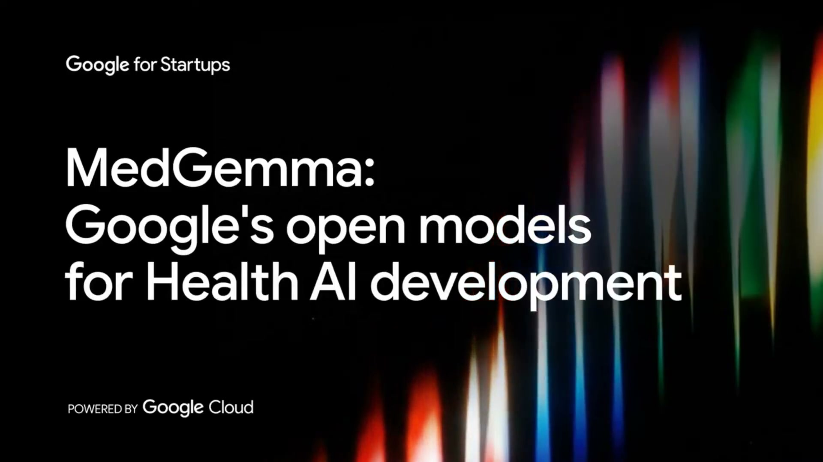
What's on screen
- Opening card: “MedGemma: Google’s open models for Health AI development”, POWERED BY Google Cloud, under the “Google for Startups” brand.
- This is Session 1 of a five-part “Startup School: HealthTech” webinar series.

1.2 Host welcome — Joe Shonkwiler 00:11
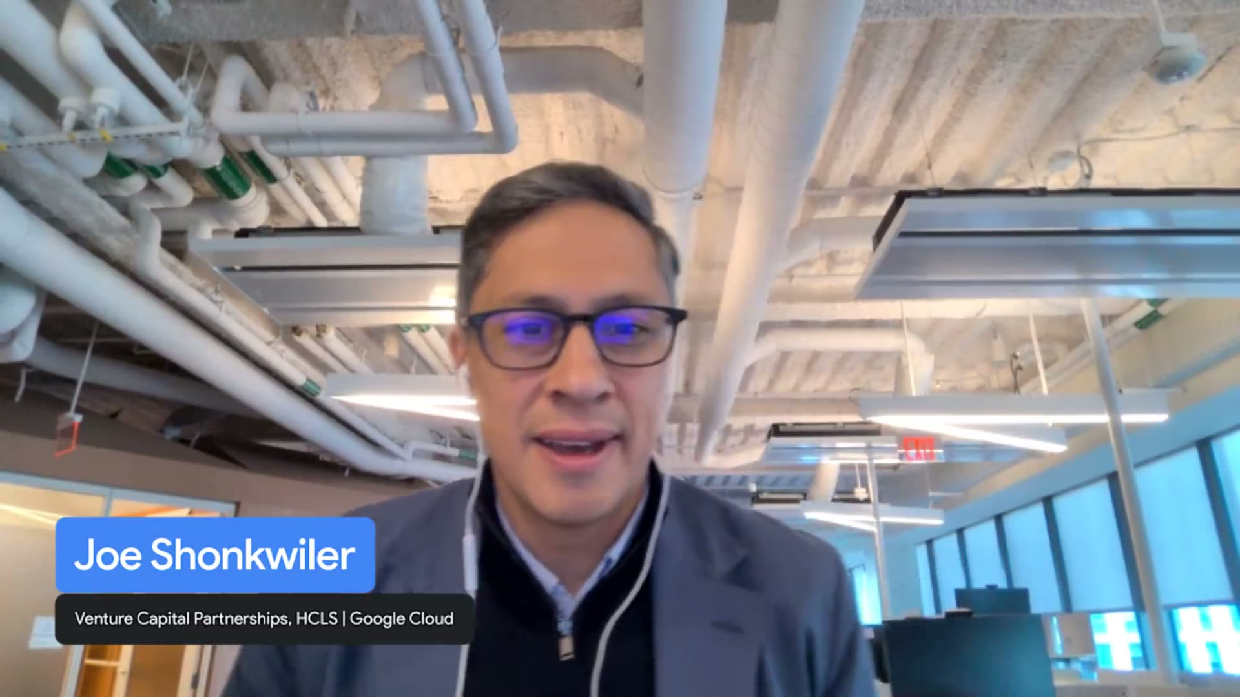
What's on screen
- Host on camera with a lower-third: “Joe Shonkwiler — Venture Capital Partnerships, HCLS | Google Cloud.”
- He leads Google Cloud’s healthcare & life-science startup team and kicks off the five-part series.
- Housekeeping: use the chat to network and drop questions; Google Cloud experts are on standby; top questions will be taken at the end for a Q&A.
- He hands over to the speaker, Dan.
Narration (Joe Shonkwiler): “My name is Joe [Shonkwiler] and I lead Google’s healthcare and life science… startup team here at Google Cloud. I’m thrilled to kick off this five-part series called Startup School focusing on health technology.”

1.3 Speaker title slide — Daniel Golden 01:53

What's on screen
- Title slide: “Startup School: HealthTech — Google’s open models for health AI development.”
- Speaker: Daniel Golden, Software Engineer, Google Research. Dated September 23, 2026.
- Dan introduces himself as a software engineering manager in Google Research and the research lead for MedGemma.
Narration (Dan): “My name is Dan. I’m a software engineering manager in Google Research… and today I’m going to be talking about Google’s open models for health AI development, and specifically MedGemma, of which I’m the research lead.”

Section 2 — Health AI at Google & HAI-DEF
The mission, the program, and the growing model catalog.

2.1 The Google Health AI mission 02:10
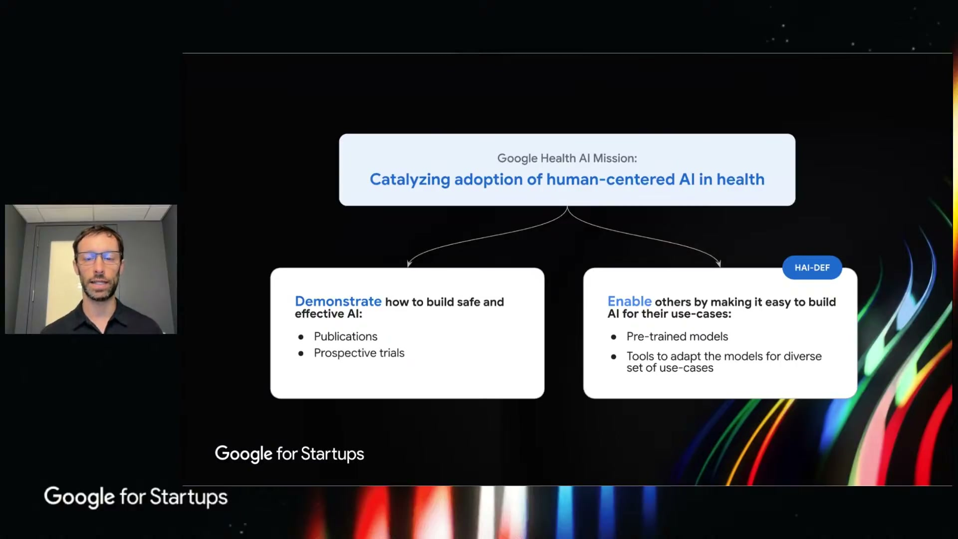
What's on screen
- “Google Health AI Mission: Catalyzing adoption of human-centered AI in health.”
- Two branches: Demonstrate how to build safe and effective AI (Publications, Prospective trials); and Enable others to build AI for their use-cases (Pre-trained models, Tools to adapt the models) — tagged HAI-DEF.
Narration (Dan): “Our… program within Google Research has been focused on the principle of catalyzing the adoption of human-centered AI in healthcare.”

2.2 What is HAI-DEF? 02:50
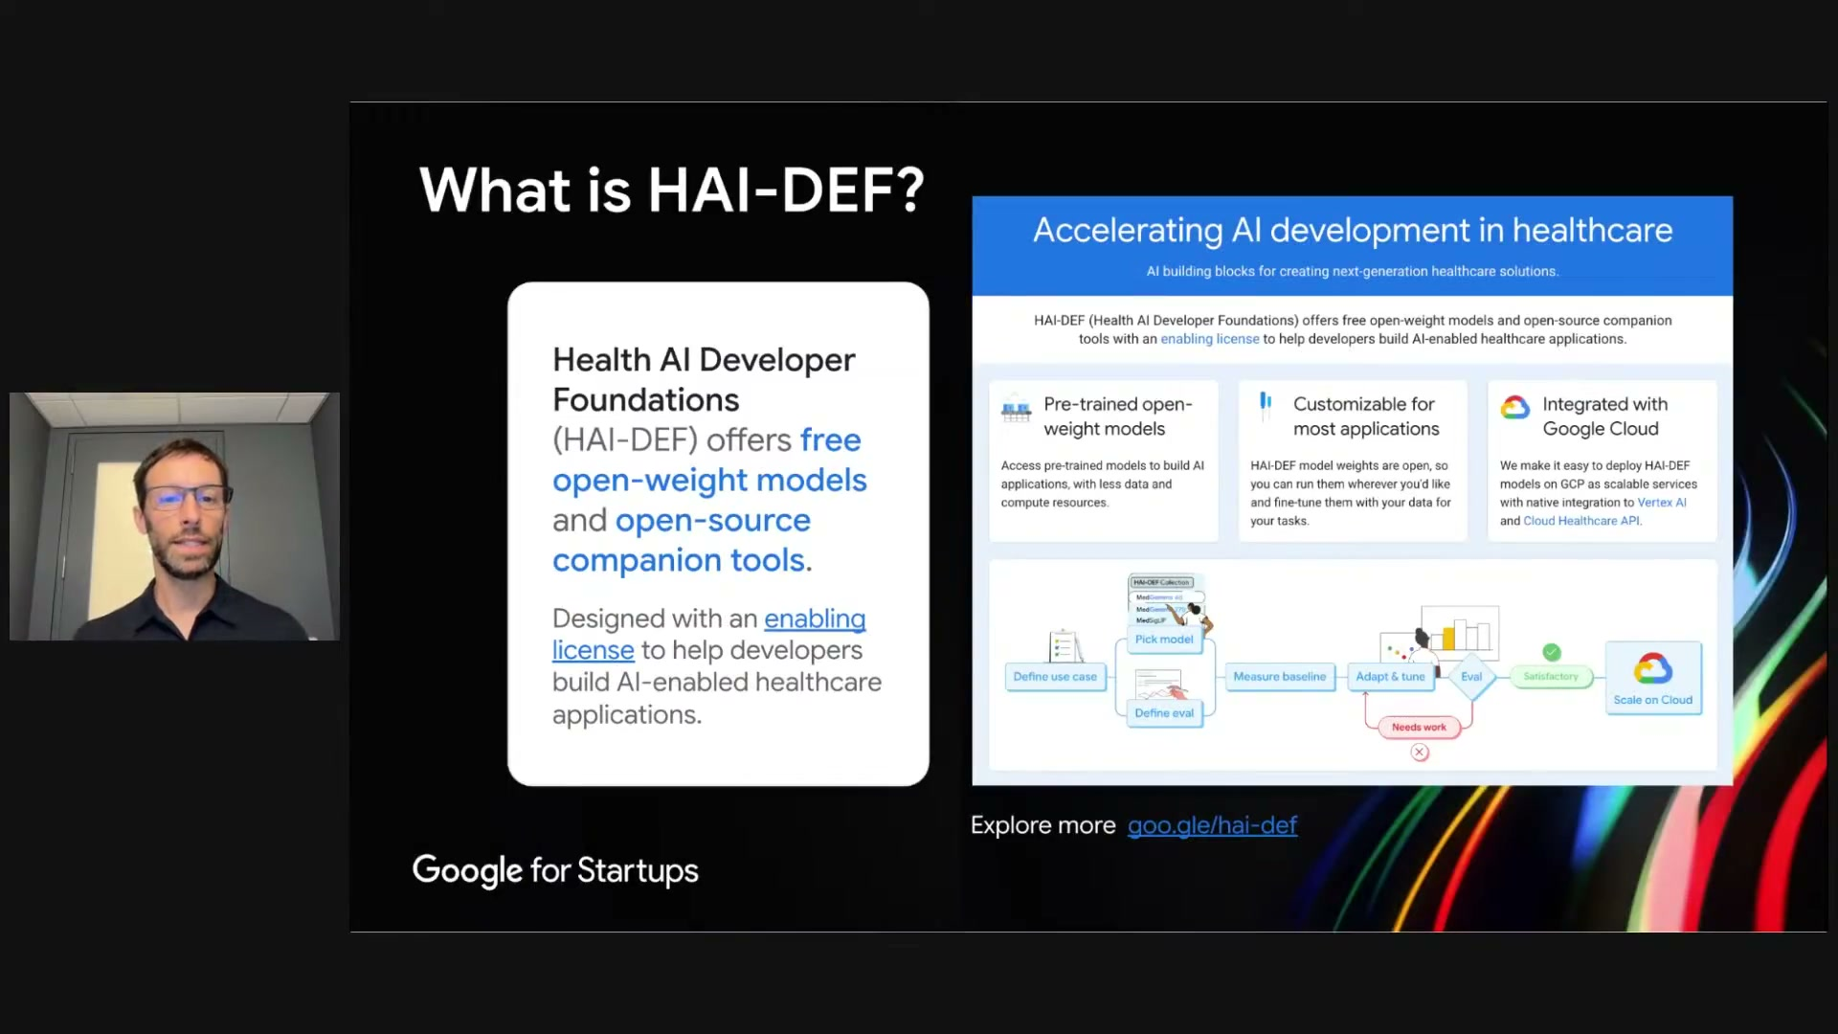
What's on screen
- Health AI Developer Foundations (HAI-DEF) offers free open-weight models and open-source companion tools, under an enabling license, to help developers build AI-enabled healthcare applications.
- Panel “Accelerating AI development in healthcare”: Pre-trained open-weight models; Customizable for most applications; Integrated with Google Cloud (Vertex AI and Cloud Healthcare API).
- Main site: goo.gle/hai-def.
Narration (Dan): “All of the tools we release have an enabling license that allows them to be used completely free and without any obligation to Google… these tools can be adopted and owned by the users and developers.”

2.3 The philosophy of HAI-DEF 03:32
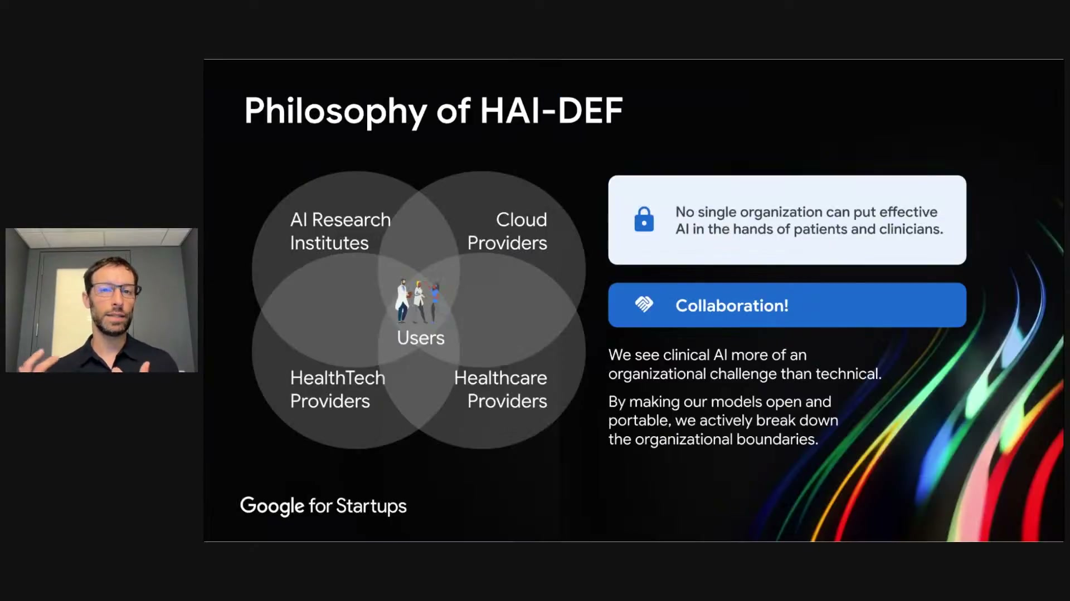
What's on screen
- Venn diagram with Users at the centre of AI Research Institutes, Cloud Providers, HealthTech Providers and Healthcare Providers.
- “No single organization can put effective AI in the hands of patients and clinicians” → Collaboration.
- “We see clinical AI more of an organizational challenge than technical. By making our models open and portable, we actively break down the organizational boundaries.”
Narration (Dan): “There isn’t one organization that’s really able to do everything… we are enabling… these users to all come together to build effective applications for healthcare.”

2.4 The growing catalog at a glance 04:18
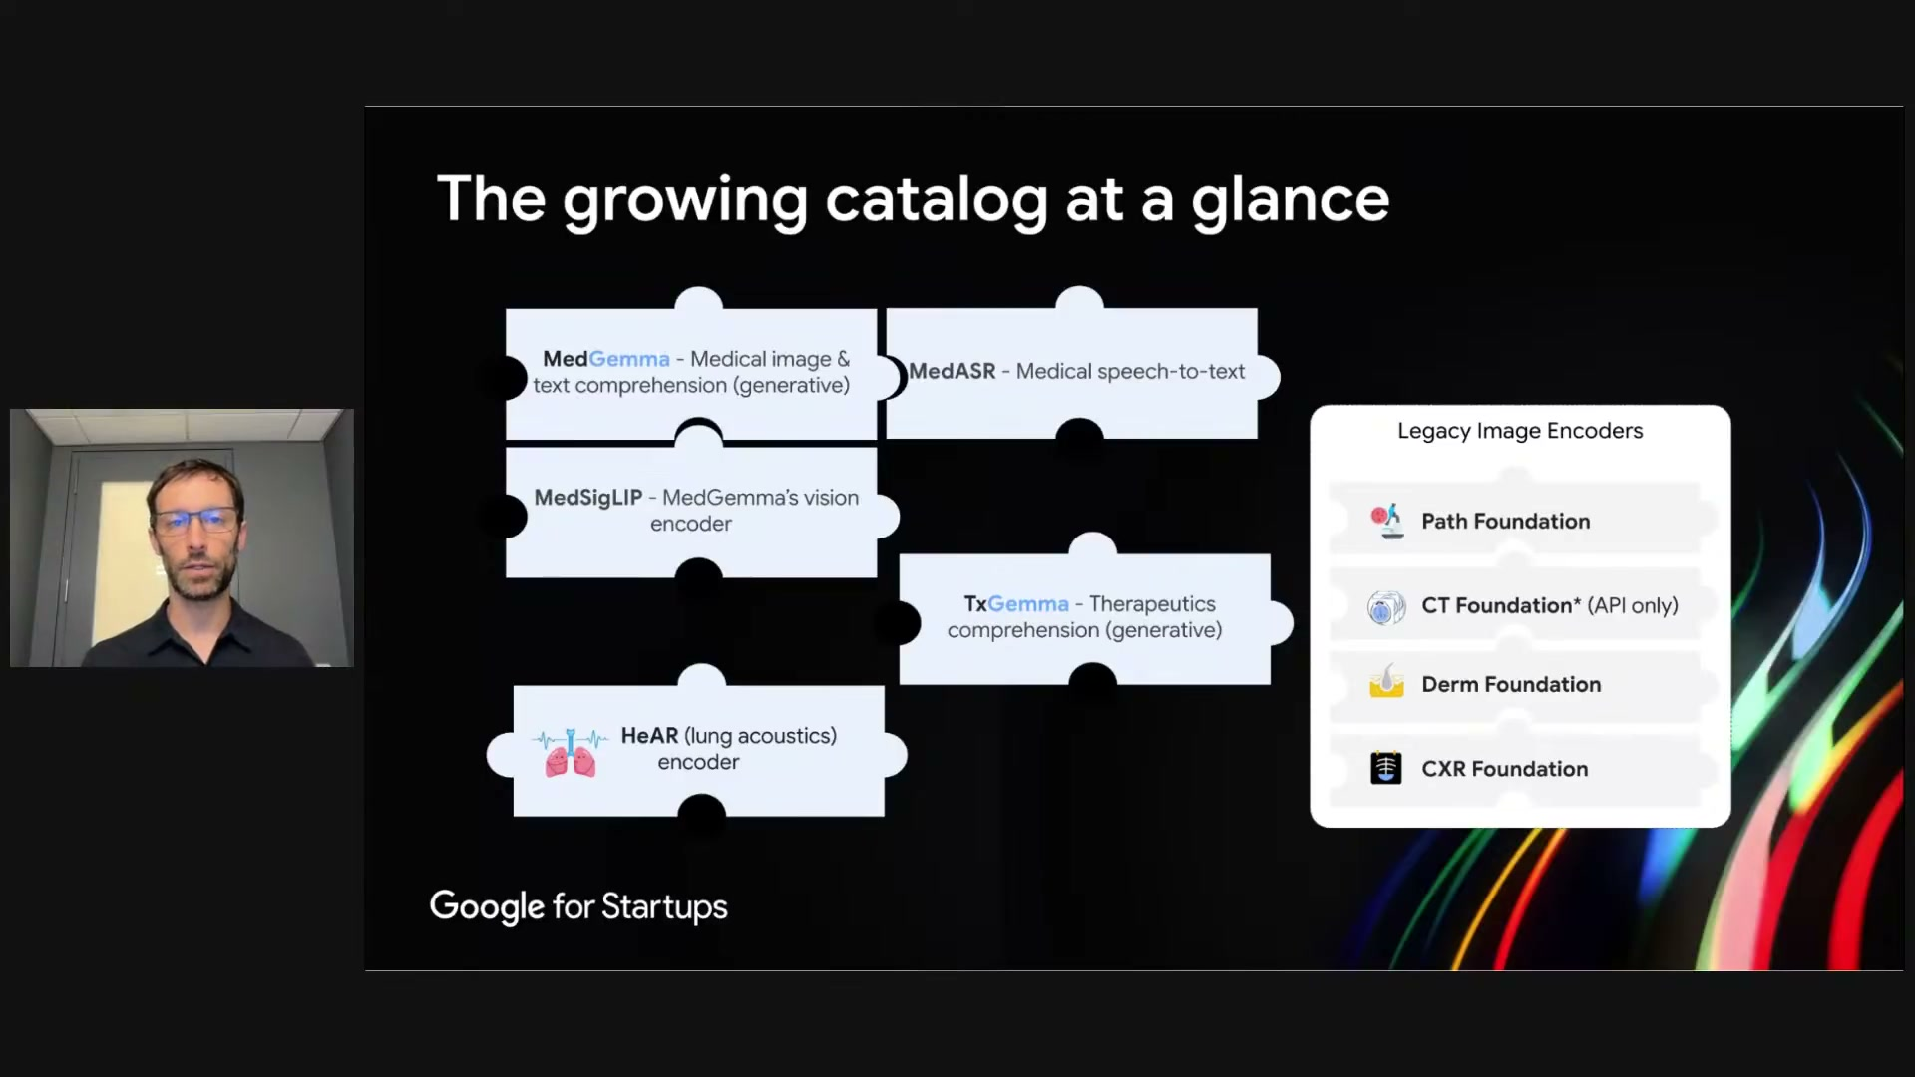
What's on screen
- Jigsaw of HAI-DEF models: MedGemma (medical image & text comprehension, generative); MedASR (medical speech-to-text); MedSigLIP (MedGemma’s vision encoder); TxGemma (therapeutics comprehension, generative); HeAR (lung-acoustics encoder).
- Plus Legacy Image Encoders: Path Foundation, CT Foundation (API only), Derm Foundation, CXR Foundation.
Narration (Dan): “We also have several other models that are more specialized… MedASR… MedSigLIP… TxGemma… and the HeAR model, which is a bio-acoustics model… for lung sounds, coughs, sneezes.”

Section 3 — MedGemma
The model and how the collection is organised.

3.1 MedGemma 05:02
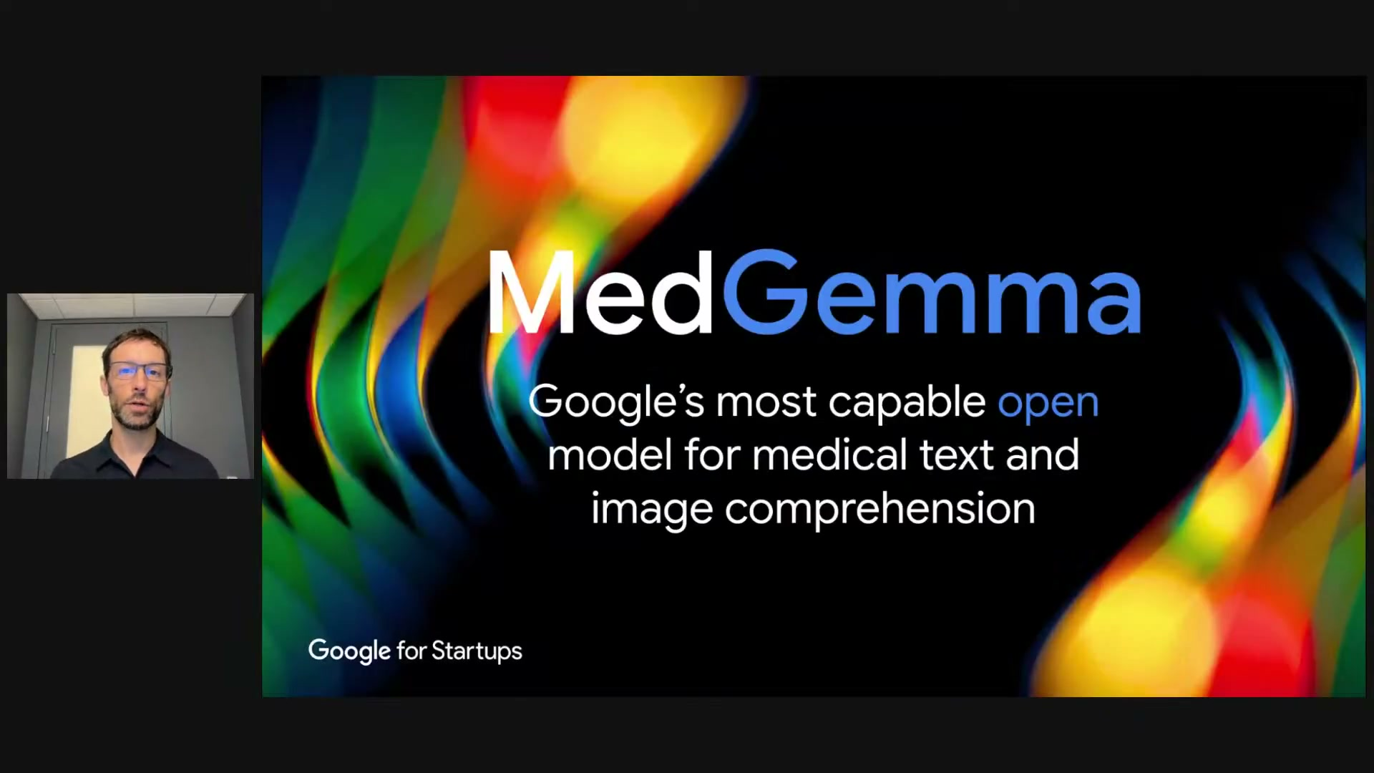
What's on screen
- Section title slide: “MedGemma — Google’s most capable open model for medical text and image comprehension.”
- MedGemma is built on Google’s open general-purpose model, Gemma.
Narration (Dan): “MedGemma is built on Google’s open general-purpose model Gemma, and it’s Google’s most capable open model for medical text and image comprehension.”

3.2 The MedGemma collection (model picker) 05:45
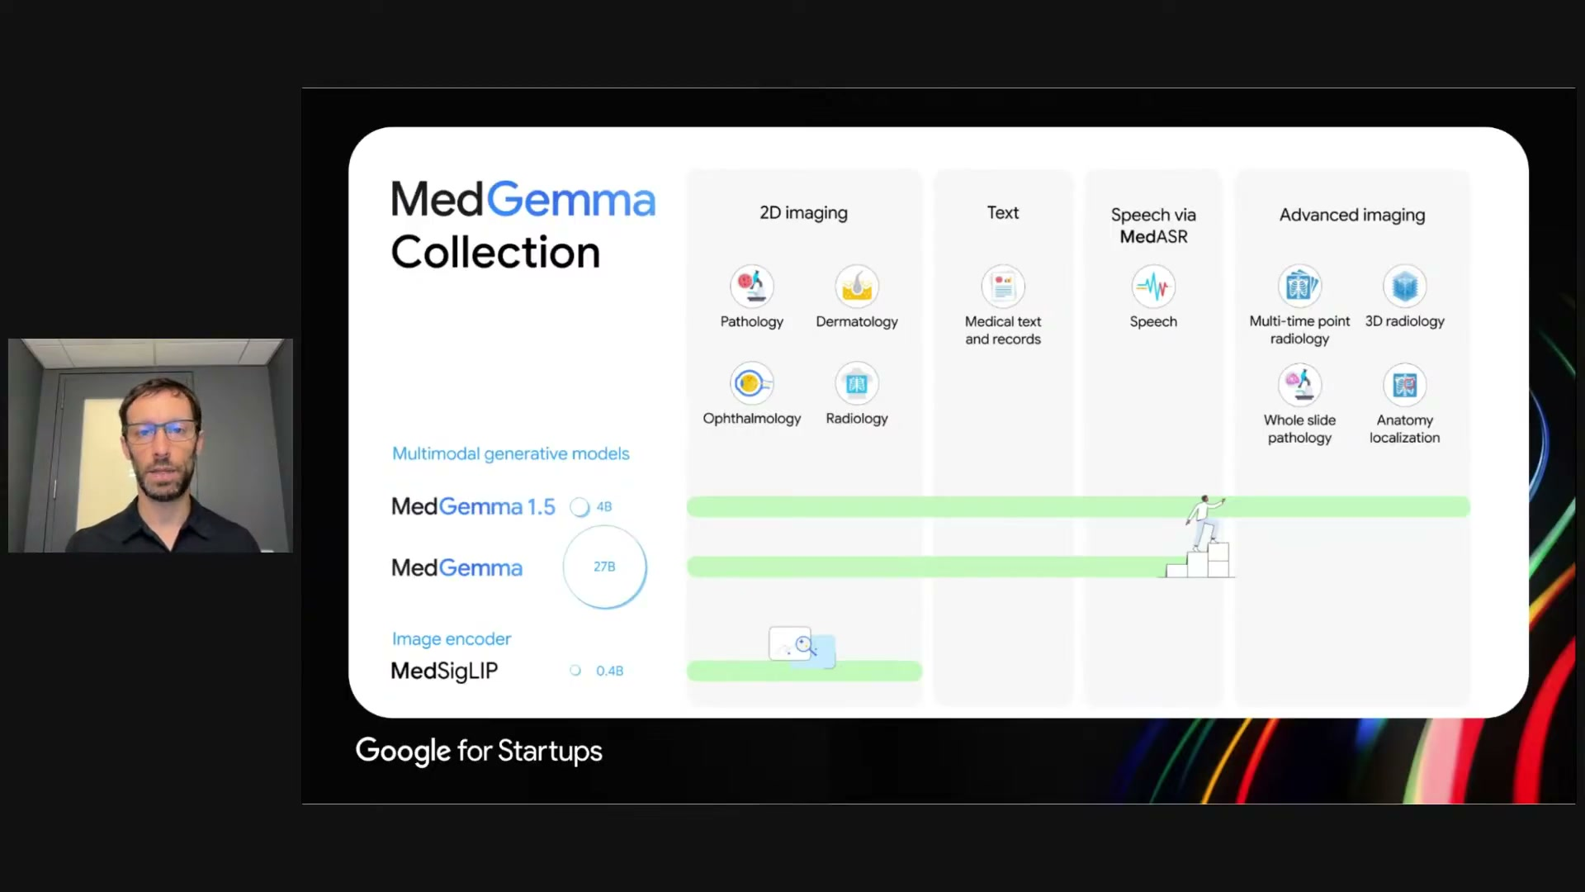
What's on screen
- Capability columns: 2D imaging (Pathology, Dermatology, Ophthalmology, Radiology); Text (medical text and records); Speech via MedASR; Advanced imaging (Multi-time-point radiology, 3D radiology, Whole-slide pathology, Anatomy localization).
- Models: MedGemma 1.5 (4B), MedGemma (27B) — multimodal generative; MedSigLIP (0.4B) — image encoder.
- Guidance: MedGemma 1.5 4B is small/efficient with advanced-imaging optimizations; the 27B MedGemma is best for text (more expensive to run); MedSigLIP is for classification/retrieval and is not generative.
Narration (Dan): “The MedGemma 1.5… 4 billion parameter model is small, efficient and has these additional… optimizations for advanced imaging… the original MedGemma is really the best choice for text… and finally MedSigLIP is optimized… for classification or image retrieval, but it’s not a generative model.”

Section 4 — MedGemma in action
Two out-of-the-box examples — and why fine-tuning matters.

4.1 Chest-X-ray comparison 07:40
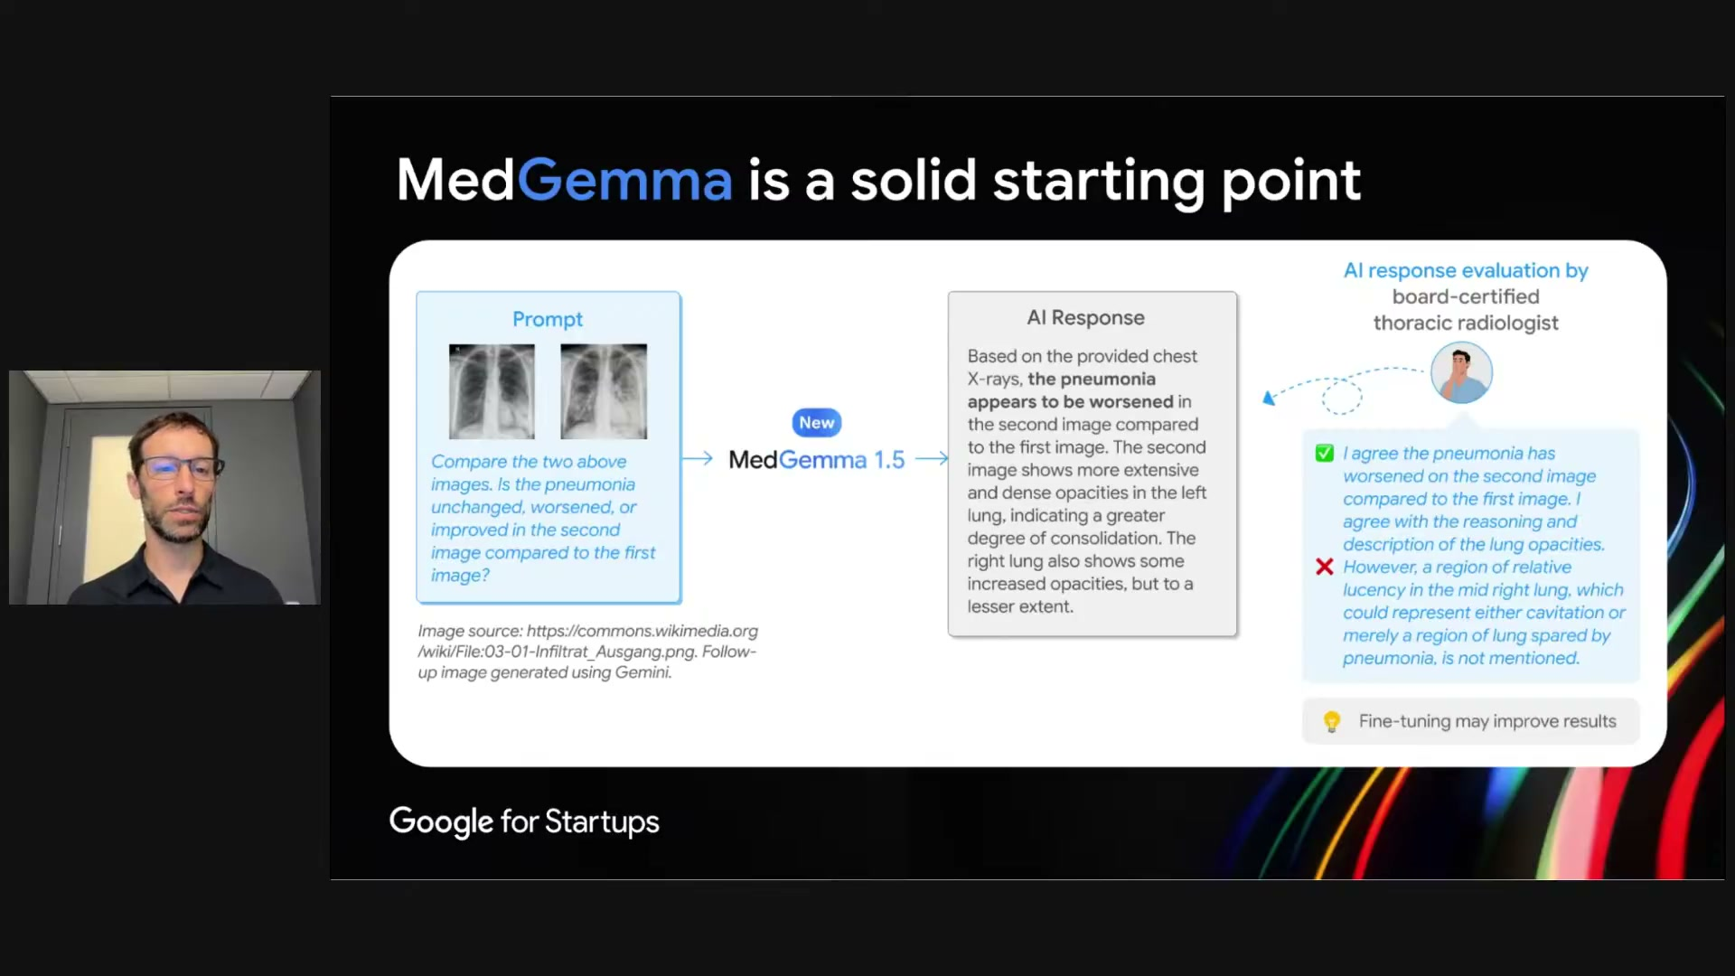
What's on screen
- “MedGemma is a solid starting point.” A longitudinal pair of chest X-rays. Prompt: “Compare the two above images. Is the pneumonia unchanged, worsened, or improved in the second image compared to the first?”
- MedGemma 1.5 answer: the pneumonia “appears to be worsened”, with more extensive, dense opacities in the left lung.
- A board-certified thoracic radiologist agreed the pneumonia worsened (✅) but noted a region of relative lucency in the mid-right lung, not mentioned by the model (❌). “Fine-tuning may improve results.”
Narration (Dan): “It noted that the pneumonia appears to have worsened… we reviewed that response… with a board-certified thoracic radiologist who agreed… we consider MedGemma to be a good starting point… but it’s not intended to be used for clinical diagnosis or management out of the box.”

4.2 Volumetric CT — liver 09:00
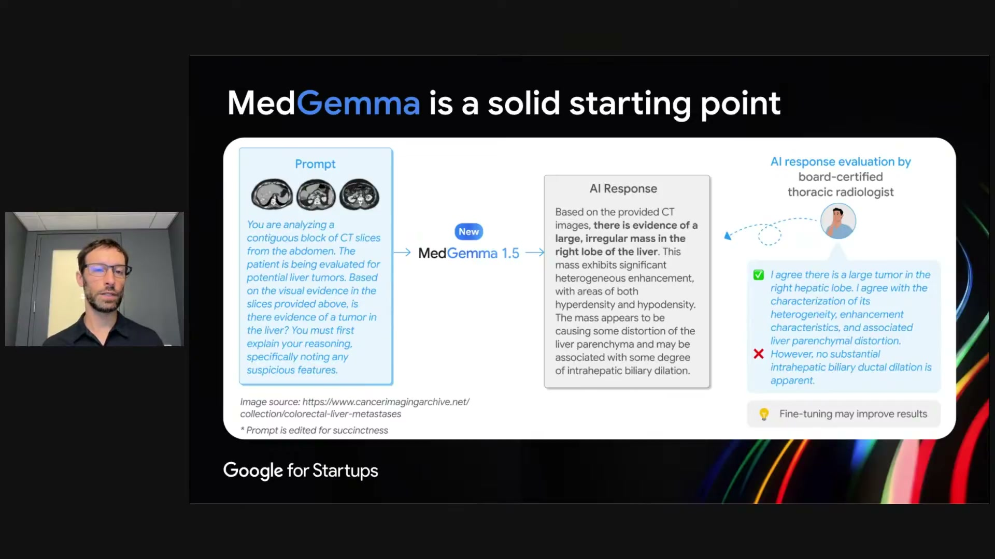
What's on screen
- A CT volume (three slices shown; the full volume is provided). Prompt: analyzing a contiguous block of CT slices; the patient is being evaluated for liver tumors — is there evidence of a tumor?
- MedGemma 1.5 answer: “evidence of a large, irregular mass in the right lobe of the liver” with heterogeneous enhancement.
- The radiologist agreed there is a large tumor in the right hepatic lobe (✅) but found one finding (intrahepatic biliary ductal dilation) to be spurious (❌) — again a solid starting point, not for out-of-the-box use.
Narration (Dan): “The model says there is evidence of a large, irregular mass in the right lobe of the liver… [the radiologist] however noted that one of the findings by MedGemma appeared to be spurious… highlighting that MedGemma is a solid starting point but is not intended to be used out of the box.”

Section 5 — The developer workflow & enabling tools
How Google expects developers to build with MedGemma.

5.1 Extensible foundation models, not finished products 09:55
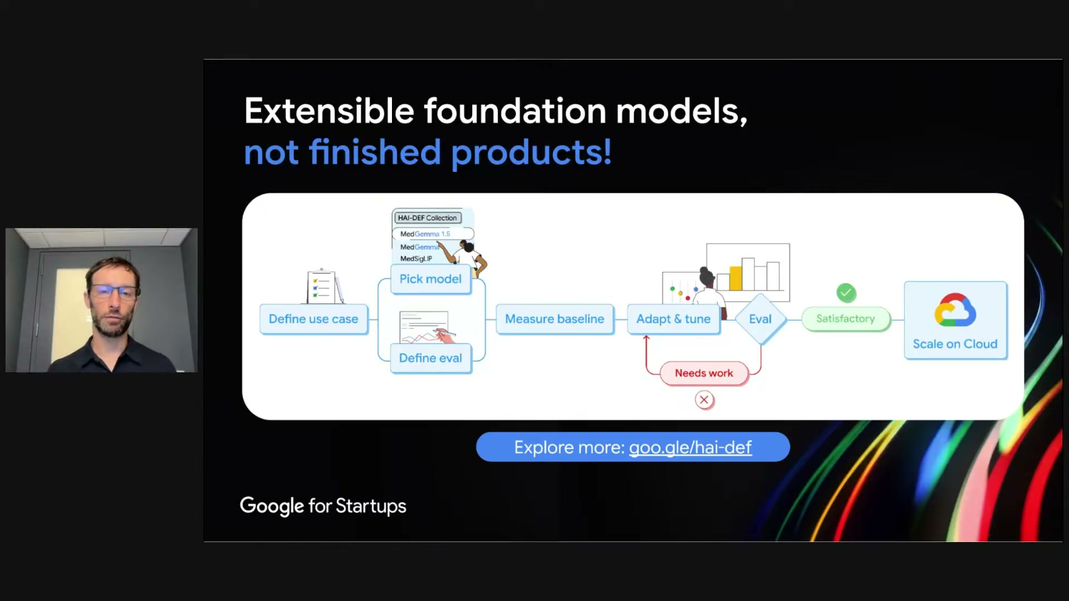
What's on screen
- Workflow: Define use case + Define eval → Pick model (from the HAI-DEF Collection: MedGemma 1.5, MedGemma, MedSigLIP) → Measure baseline → Adapt & tune ⇄ Eval (Needs work → loop back; Satisfactory →) → Scale on Cloud.
- Developers spend most of their time in the adapt/tune/eval loop; Google Cloud partners make it easy to scale to live inference. Explore more: goo.gle/hai-def.
Narration (Dan): “This is the quintessential workflow we expect developers to be following… define a use case, then identify the right model… define the appropriate evaluation… measure baseline performance… and critically they’ll spend most of their time in this adaptation and tuning loop with evaluation.”

5.2 We enable you, so you DIY 11:00
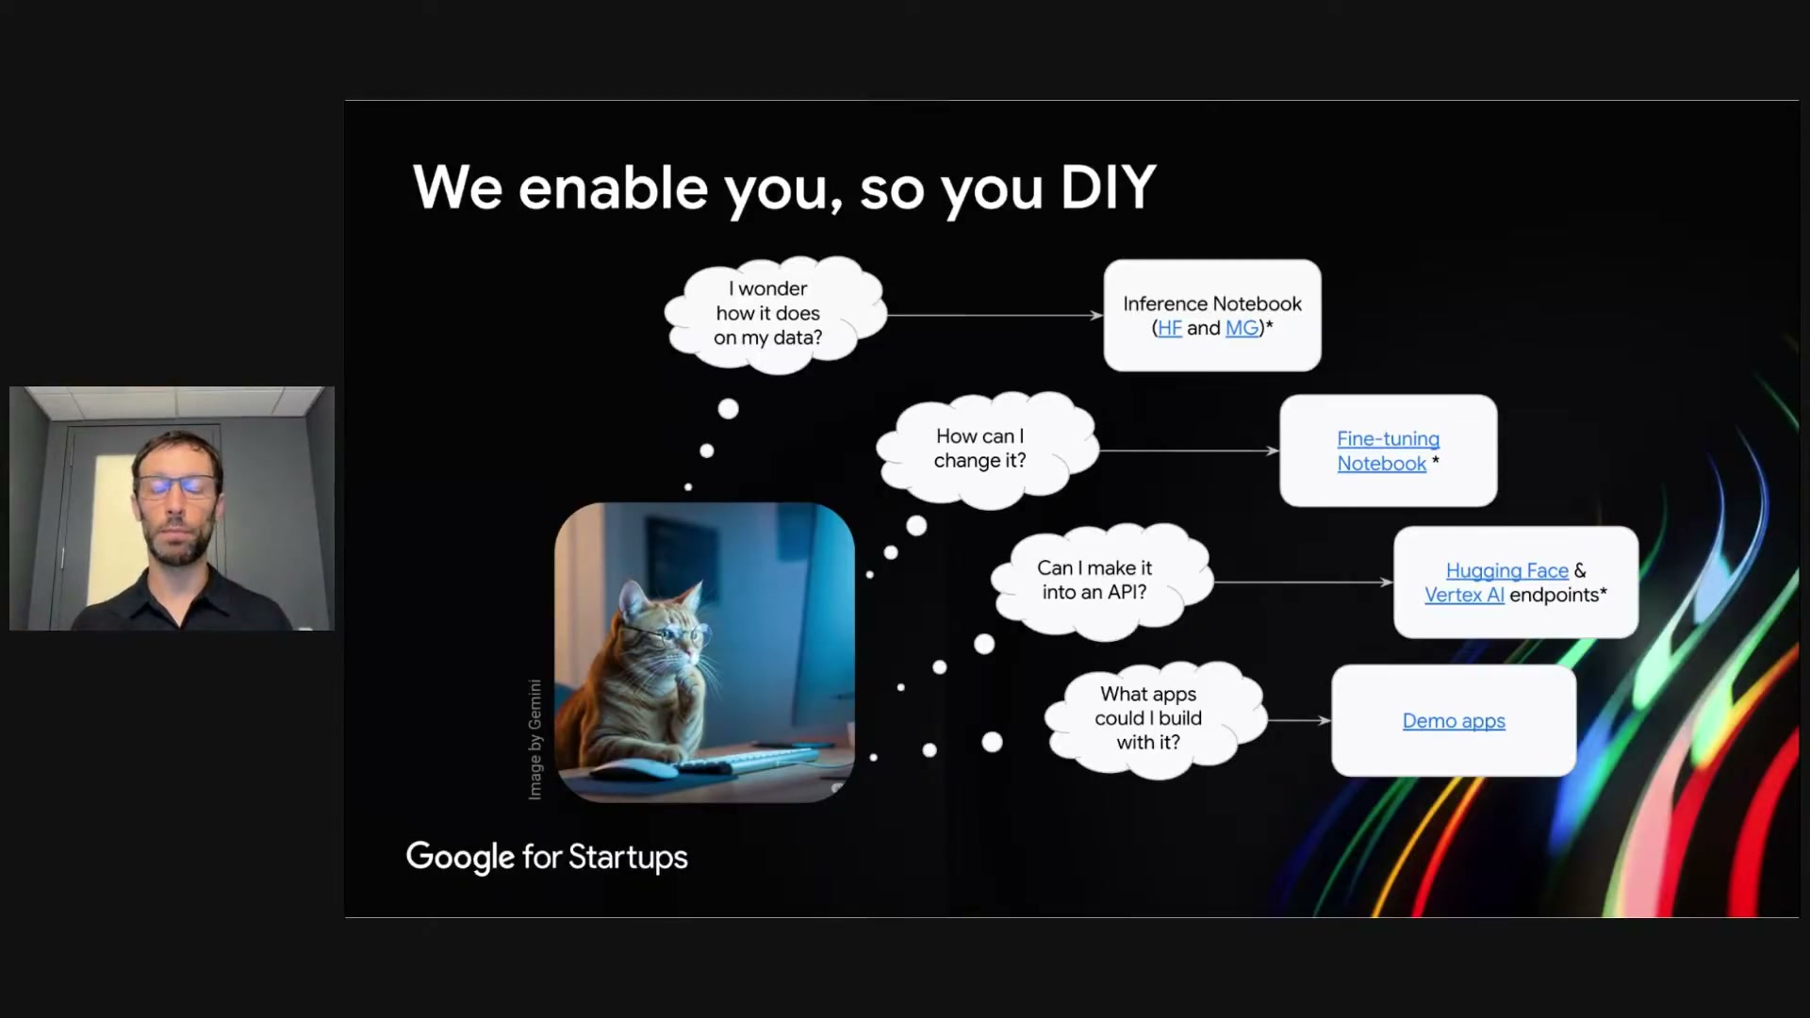
What's on screen
- Thought-bubble map of common questions → the tool that answers each:
- “I wonder how it does on my data?” → Inference Notebook (Hugging Face and Model Garden).
- “How can I change it?” → Fine-tuning Notebook. “Can I make it into an API?” → Hugging Face & Vertex AI endpoints. “What apps could I build with it?” → Demo apps.
Narration (Dan): “For questions users may have like ‘I wonder how this model does on my data’… we provide example notebooks on both Hugging Face and Model Garden for how to run the model and then evaluate results on your own data.”

Section 6 — Gemini vs MedGemma
When to reach for the closed model vs the open one.

6.1 Choosing the right model 12:30
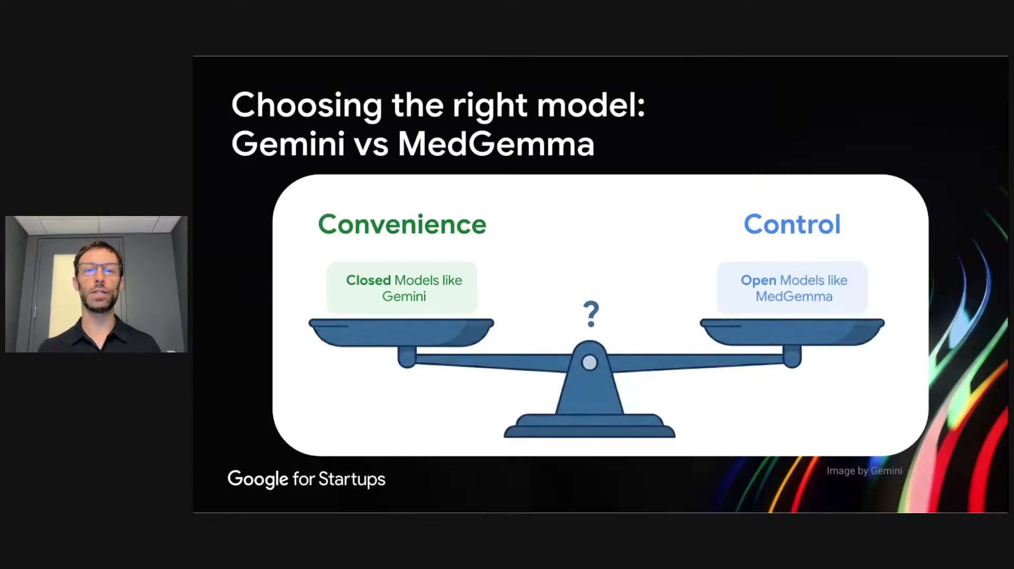
What's on screen
- A balance scale: Convenience (Closed Models like Gemini) vs Control (Open Models like MedGemma).
- Default guidance: if Gemini works for your use case, it is usually preferred for its convenience and often-improved performance (worth comparing).
Narration (Dan): “The bottom line in most cases is: if Gemini works for your use case, Gemini is probably preferred due to its convenience and potential improved performance.”

6.2 MedGemma vs Gemini 13:45
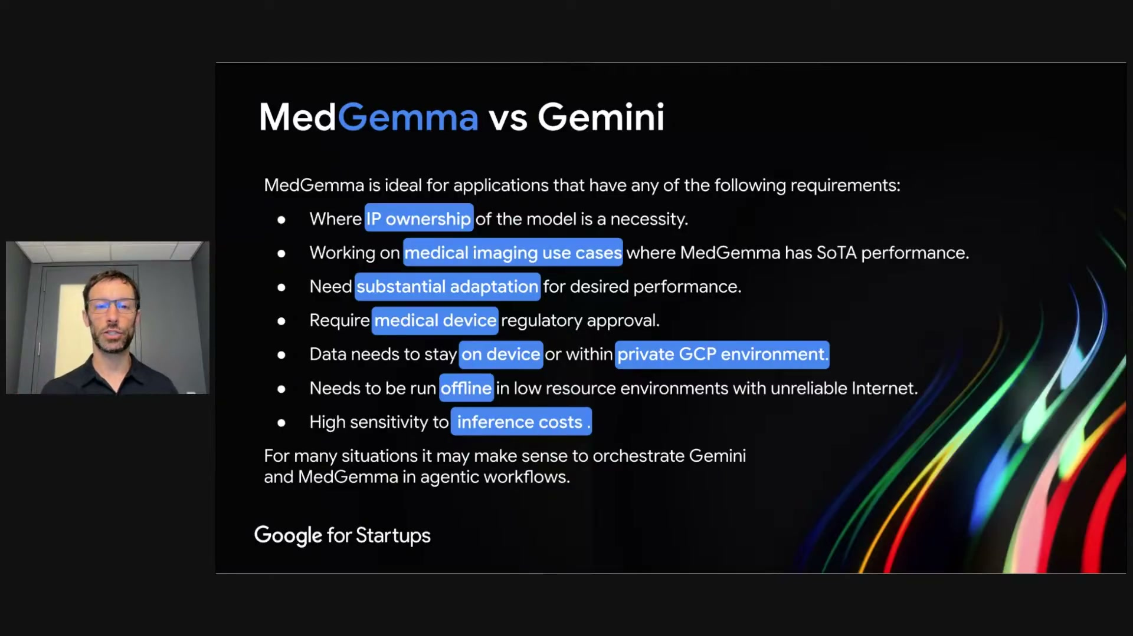
What's on screen
- MedGemma is ideal when: IP ownership of the model is a necessity; working on medical-imaging use cases (MedGemma has SoTA performance); substantial adaptation is needed; medical-device regulatory approval is required; data must stay on-device or within a private GCP environment; it must run offline in low-resource settings; or there is high sensitivity to inference costs.
- “For many situations it may make sense to orchestrate Gemini and MedGemma in agentic workflows.”
Narration (Dan): “If you need full control over the models — which is true for a lot of the users we talk to, because they are in sovereign nations… or they want to own all the IP… or they want to work offline — then MedGemma provides essentially the only experience that would work for them.”

Section 7 — Documentation
Where to learn what MedGemma was trained and tested on.

7.1 Model cards 14:55
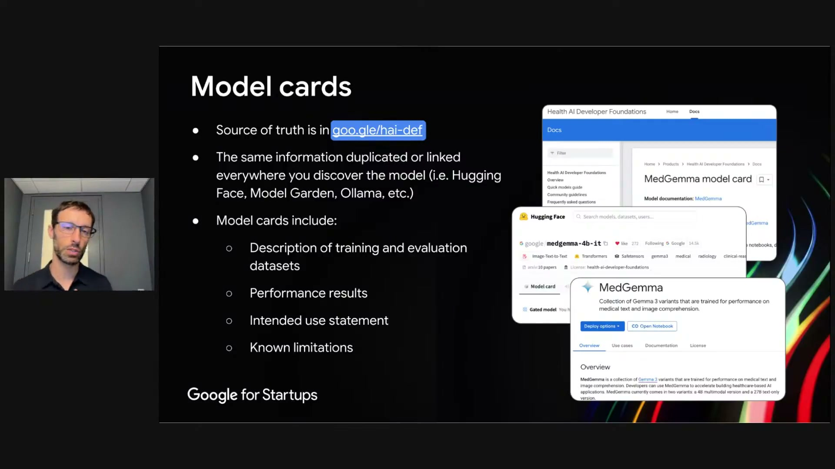
What's on screen
- Source of truth is goo.gle/hai-def; the same information is linked everywhere you discover the model (Hugging Face, Model Garden, Ollama, etc.).
- Model cards include: description of training and evaluation datasets; performance results; the intended-use statement; and known limitations.
- Emphasis: the intended use is to adapt the model, not to use it out of the box.
Narration (Dan): “You’ll find our model cards that detail how the model was trained and also how it was evaluated… and very critically our intended-use statement… we intend for this model to be adapted by the users, not to be used out of the box.”

7.2 Technical reports 15:38
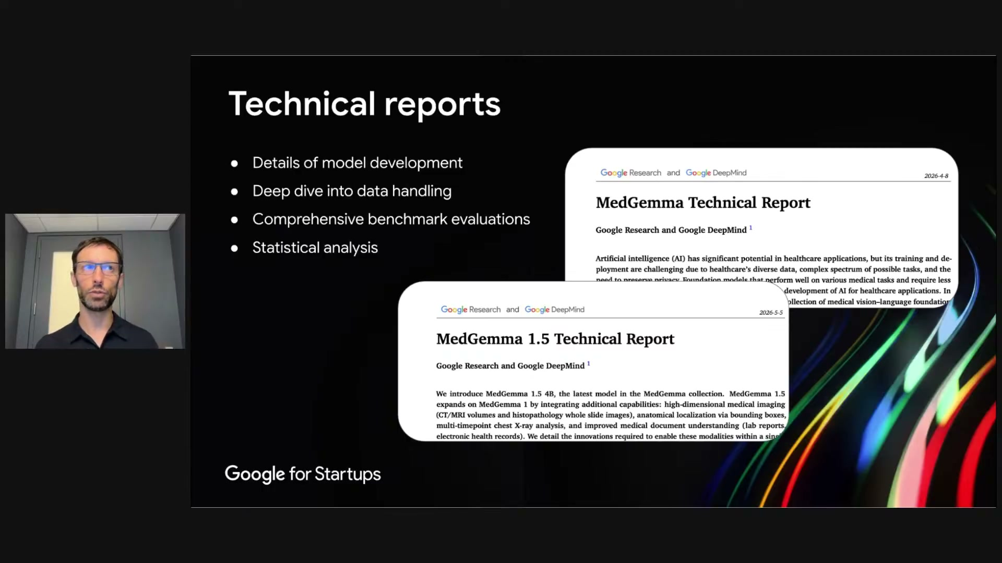
What's on screen
- Two technical reports on arXiv from Google Research and Google DeepMind: the MedGemma Technical Report and the MedGemma 1.5 Technical Report.
- They cover details of model development, a deep dive into data handling, comprehensive benchmark evaluations, and statistical analysis.
Narration (Dan): “We’ve provided technical reports on arXiv for both the original MedGemma… as well as MedGemma 1.5… they go into much more detail about how the models were developed and how they were evaluated.”

Section 8 — Demo applications
Reference apps that show how to orchestrate MedGemma.

8.1 Inspire product development with demo apps 17:30
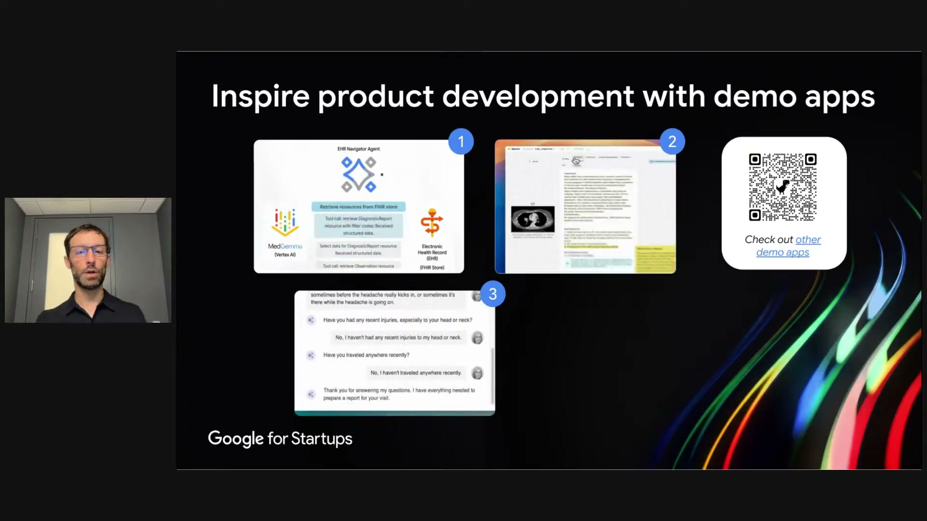
What's on screen
- Four demo apps (available on Hugging Face; scan the QR for “other demo apps”):
- (1) EHR Navigator Agent — MedGemma (on Vertex AI) retrieves resources from a FHIR store / electronic health record. (2) Understanding a radiology report — a consumer-facing explainer. (3) Adaptive patient intake — an adaptive pre-visit questionnaire. (4) Radiology training — quizzes a user on findings in an image.
- These are demos (with mocks), not full products — review the code and reuse pieces rather than copy-pasting whole apps.
Narration (Dan): “The first demo application shows how MedGemma can be used to interact with electronic health records through FHIR… another… understanding a radiology report… a third… simulates the previsit intake… and finally… radiology… general clinical training applications.”

Section 9 — Real-world adoption
Third parties already building on HAI-DEF.

9.1 HAI-DEF Showcase 18:47
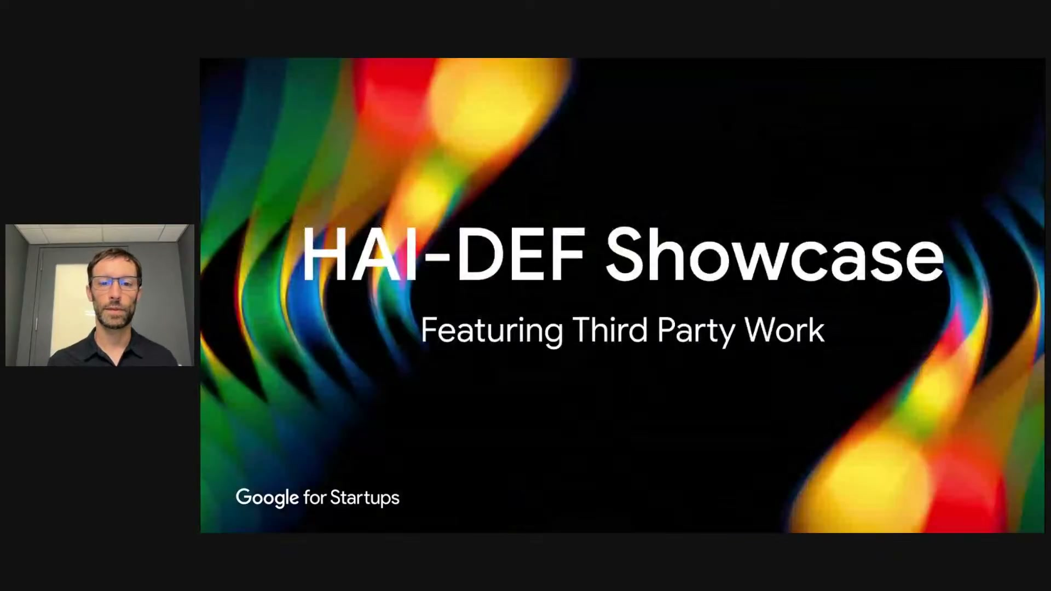
What's on screen
- Section title slide: “HAI-DEF Showcase — Featuring Third Party Work.”
- The whole point of HAI-DEF is for third parties to build medical applications; many have since the 2025 release.
Narration (Dan): “We have a lot of third parties… the whole point of HAI-DEF is for third parties to use it and build medical applications to solve the particular healthcare problems they’re focusing on.”

9.2 Success stories: sovereign AI 19:15
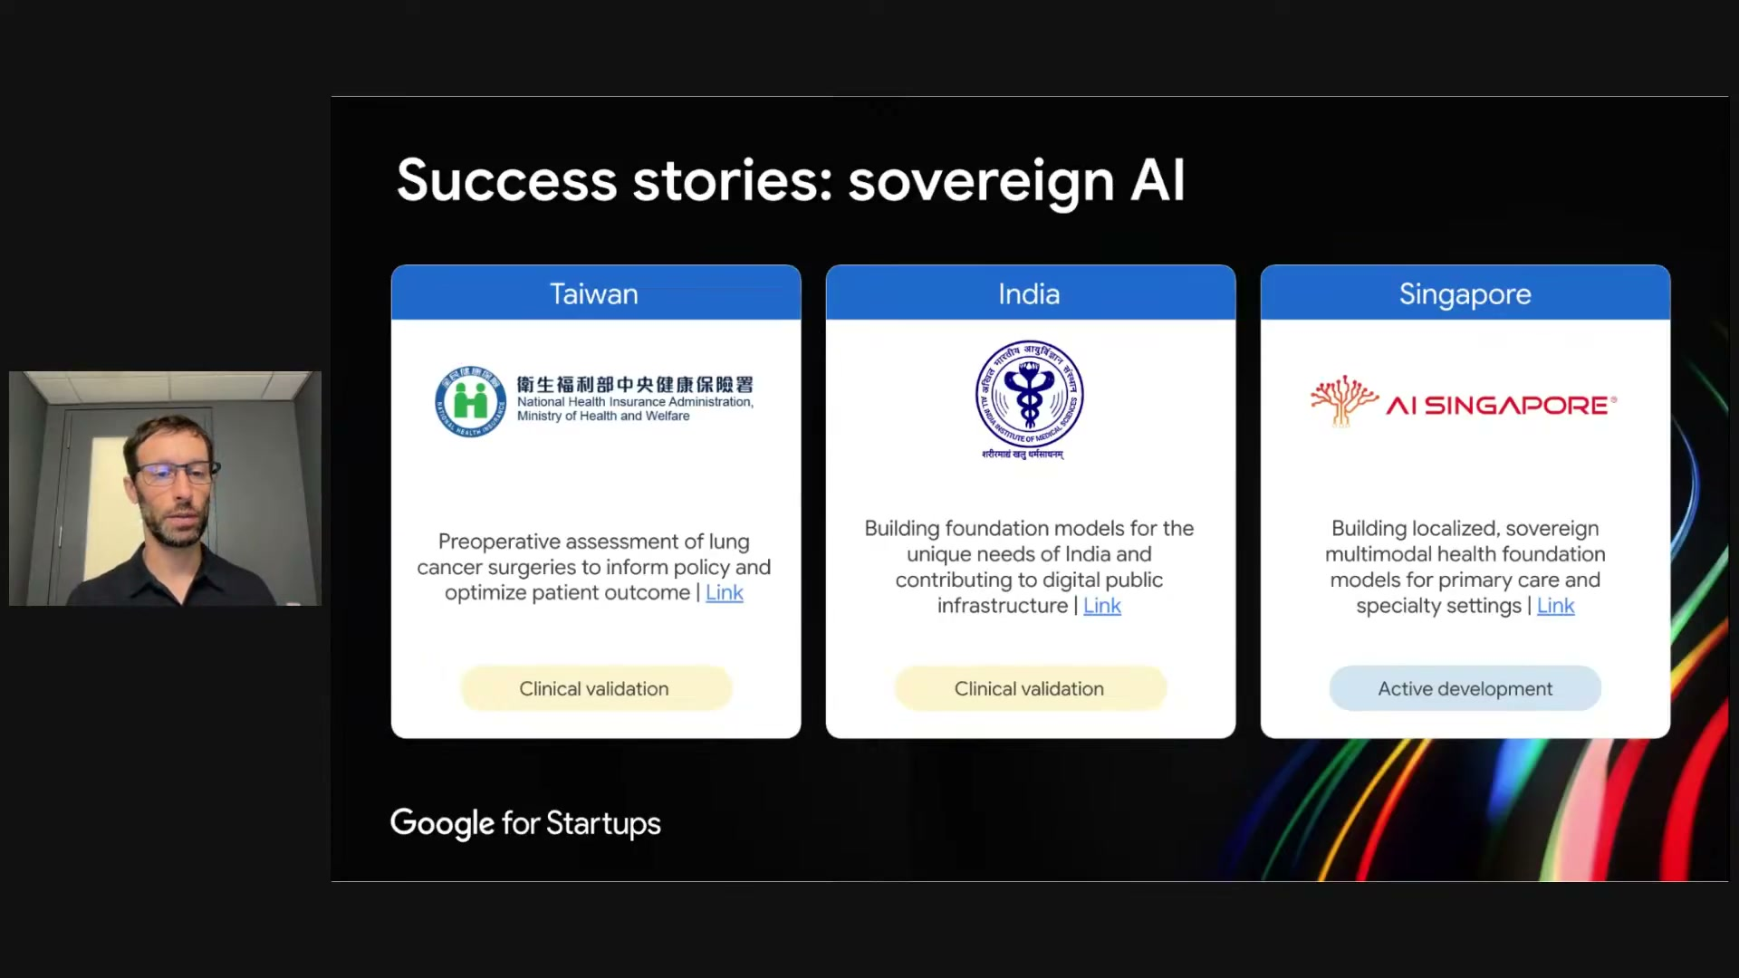
What's on screen
- Taiwan — National Health Insurance Administration (Ministry of Health and Welfare): pre-operative assessment of lung-cancer surgeries to inform policy and optimize patient outcomes (Clinical validation).
- India — (AIIMS): building foundation models for India’s unique needs and contributing to digital public infrastructure (Clinical validation).
- Singapore — AI SINGAPORE: building localized, sovereign, multimodal health foundation models for primary care and specialty settings (Active development).
Narration (Dan): “The Ministry of Health of Taiwan has used MedGemma to do a pre-operative assessment of lung-cancer surgery candidates… the Ministry of Health of India is working… to build foundation models for India… Singapore is also using MedGemma to build localized, sovereign, multimodal foundation models for primary care.”

9.3 Success stories: health-tech startups 20:15
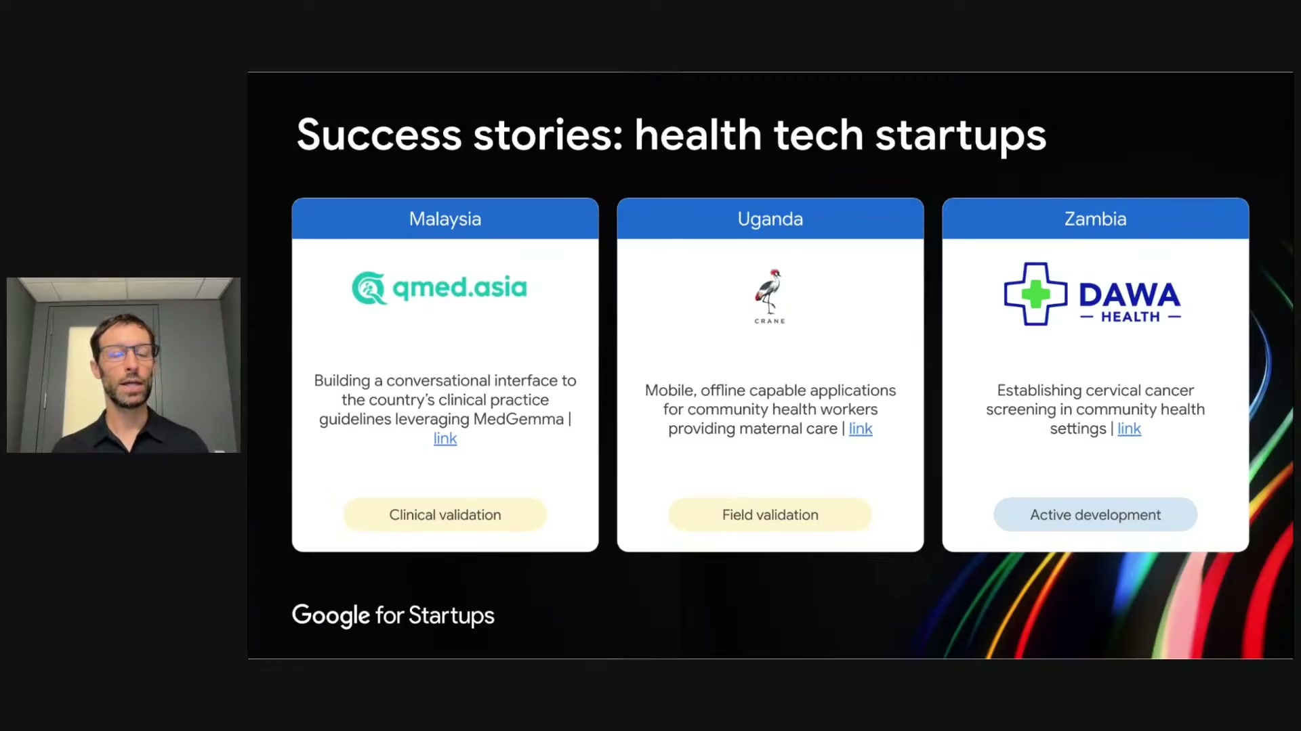
What's on screen
- Malaysia — qmed.asia: a conversational interface to the country’s clinical-practice guidelines, leveraging MedGemma (via retrieval-augmented generation) (Clinical validation).
- Uganda — CRANE: mobile, offline-capable applications for community health workers providing maternal care (Field validation).
- Zambia — DAWA HEALTH: establishing cervical-cancer screening in community health settings (Active development).
- In every case MedGemma is used as a foundation model, then adapted and evaluated — not used out of the box.
Narration (Dan): “In Malaysia, QMED Asia has built a conversational interface… using MedGemma via retrieval-augmented generation. In Uganda, Crane AI has used MedGemma for mobile applications to support maternal health… and in Zambia, Dawa Health has used MedGemma… for cervical-cancer screening.”

9.4 Public showcase 21:03
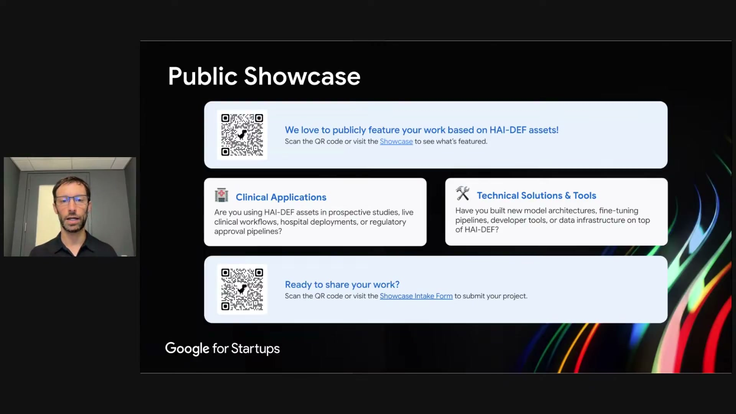
What's on screen
- “We love to publicly feature your work based on HAI-DEF assets!” (scan the QR or visit the Showcase).
- Two categories: Clinical Applications (prospective studies, live clinical workflows, hospital deployments, regulatory-approval pipelines) and Technical Solutions & Tools (model architectures, fine-tuning pipelines, developer tools, data infrastructure).
- “Ready to share your work?” — a Showcase Intake Form to submit a project.
Narration (Dan): “We have a public showcase online… with in-depth case studies from different users of MedGemma… if anyone in this audience ever develops something with MedGemma, we would love to feature your work on the showcase.”

9.5 Thank you — resources 21:32
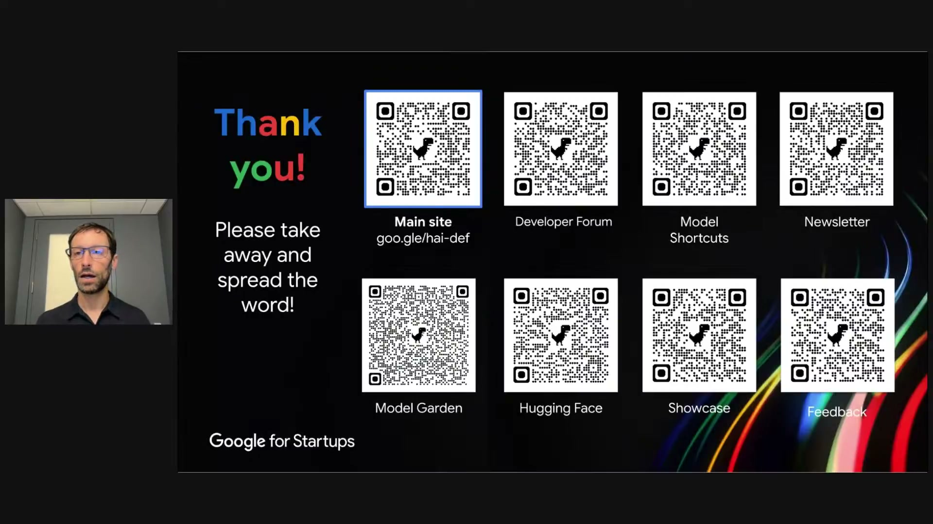
What's on screen
- “Thank you! Please take away and spread the word!”
- QR codes: Main site (goo.gle/hai-def), Developer Forum, Model Shortcuts, Newsletter, Model Garden, Hugging Face, Showcase, Feedback.
Narration (Dan): “Those are all the slides I wanted to share. Here’s a lot of QR codes for people who like QR codes, and I really appreciate your attention.”

Section 10 — Startup programs (Joe)
While Dan reviews questions, Joe highlights Google’s startup offerings.

10.1 Here to help founders progress 21:44
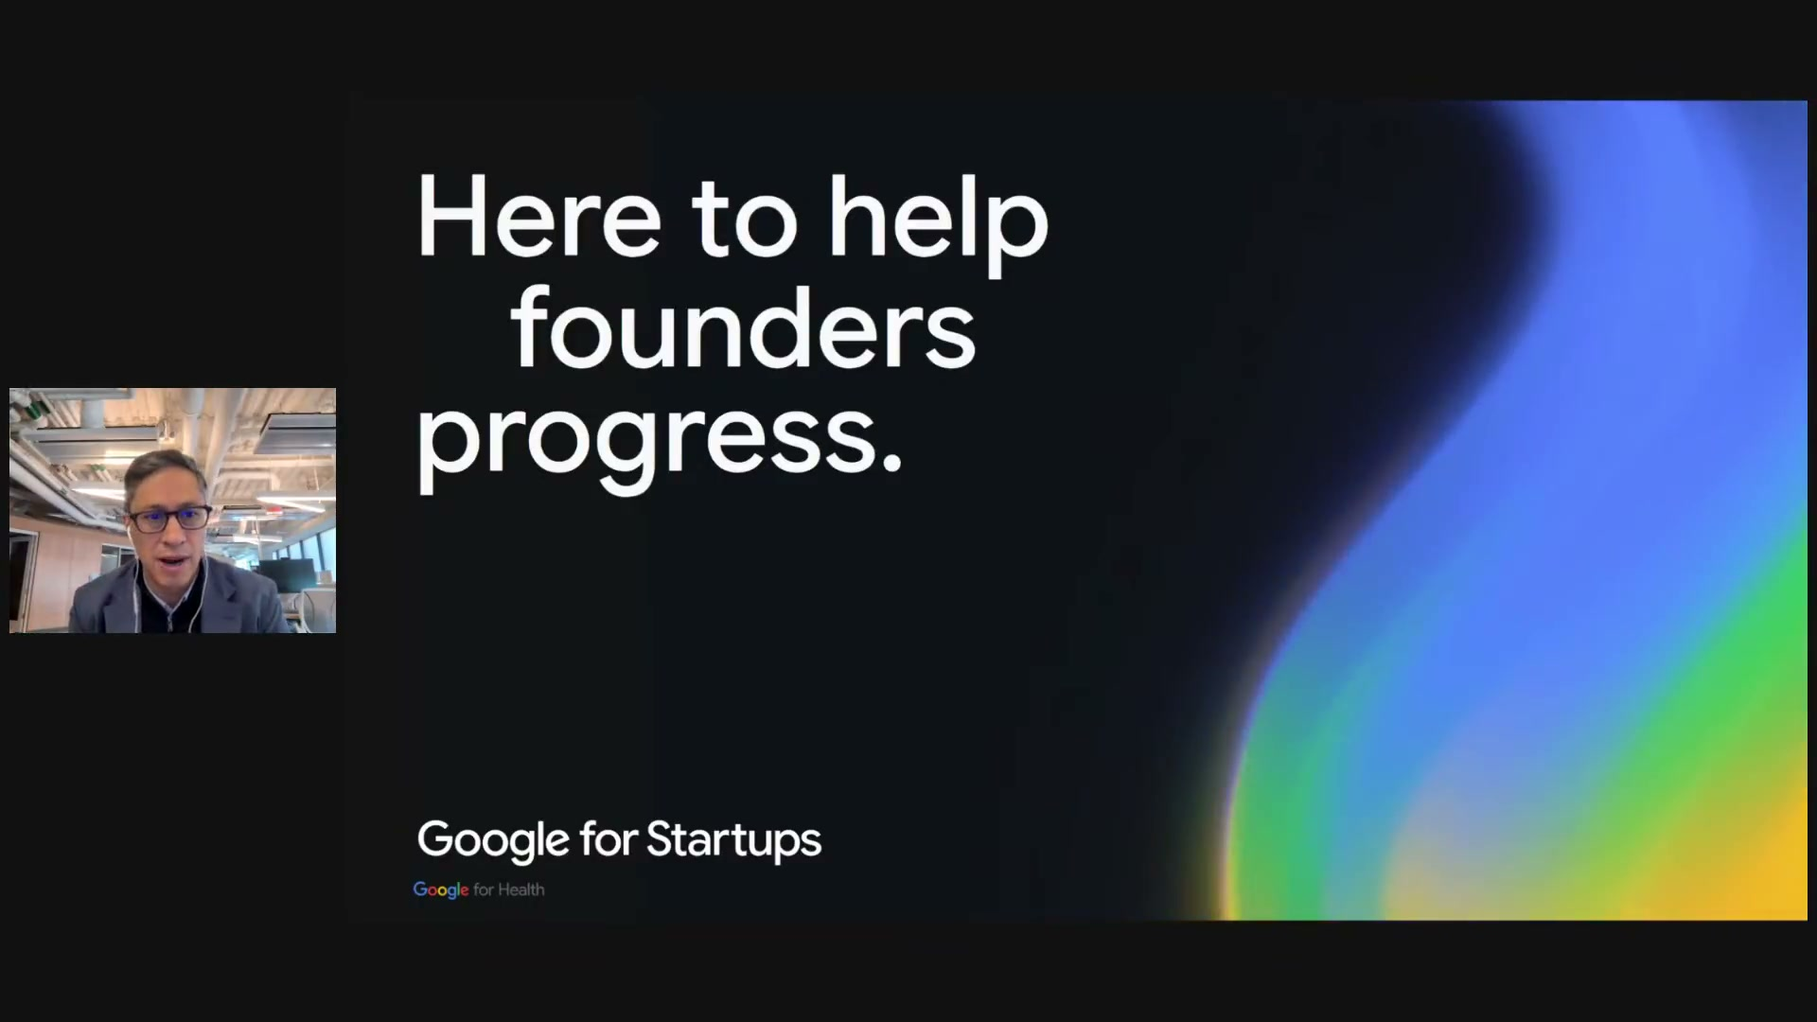
What's on screen
- Section-title card for Joe’s segment: “Here to help founders progress.” on a black background with the Google rainbow swoosh.
- Branding: “Google for Startups” and “Google for Health.” Joe’s webcam sits in the bottom-left.
- Host Joe Shonkwiler takes back over to cover Google’s startup offerings while Dan’s team curates the audience questions.
Narration (Joe Shonkwiler): “Thanks so much, Dan… that was fantastic — particularly the walkthrough on the technical frameworks and architectural insights you shared. What really stood out to me… is that [building] these complex healthcare and life-sciences production systems isn’t just about choosing a particular algorithm or model… it’s about architecting for scale, taking governance into account, and the long-term defensibility right from that prototype stage.”

10.2 Startups Digital Hub 22:40
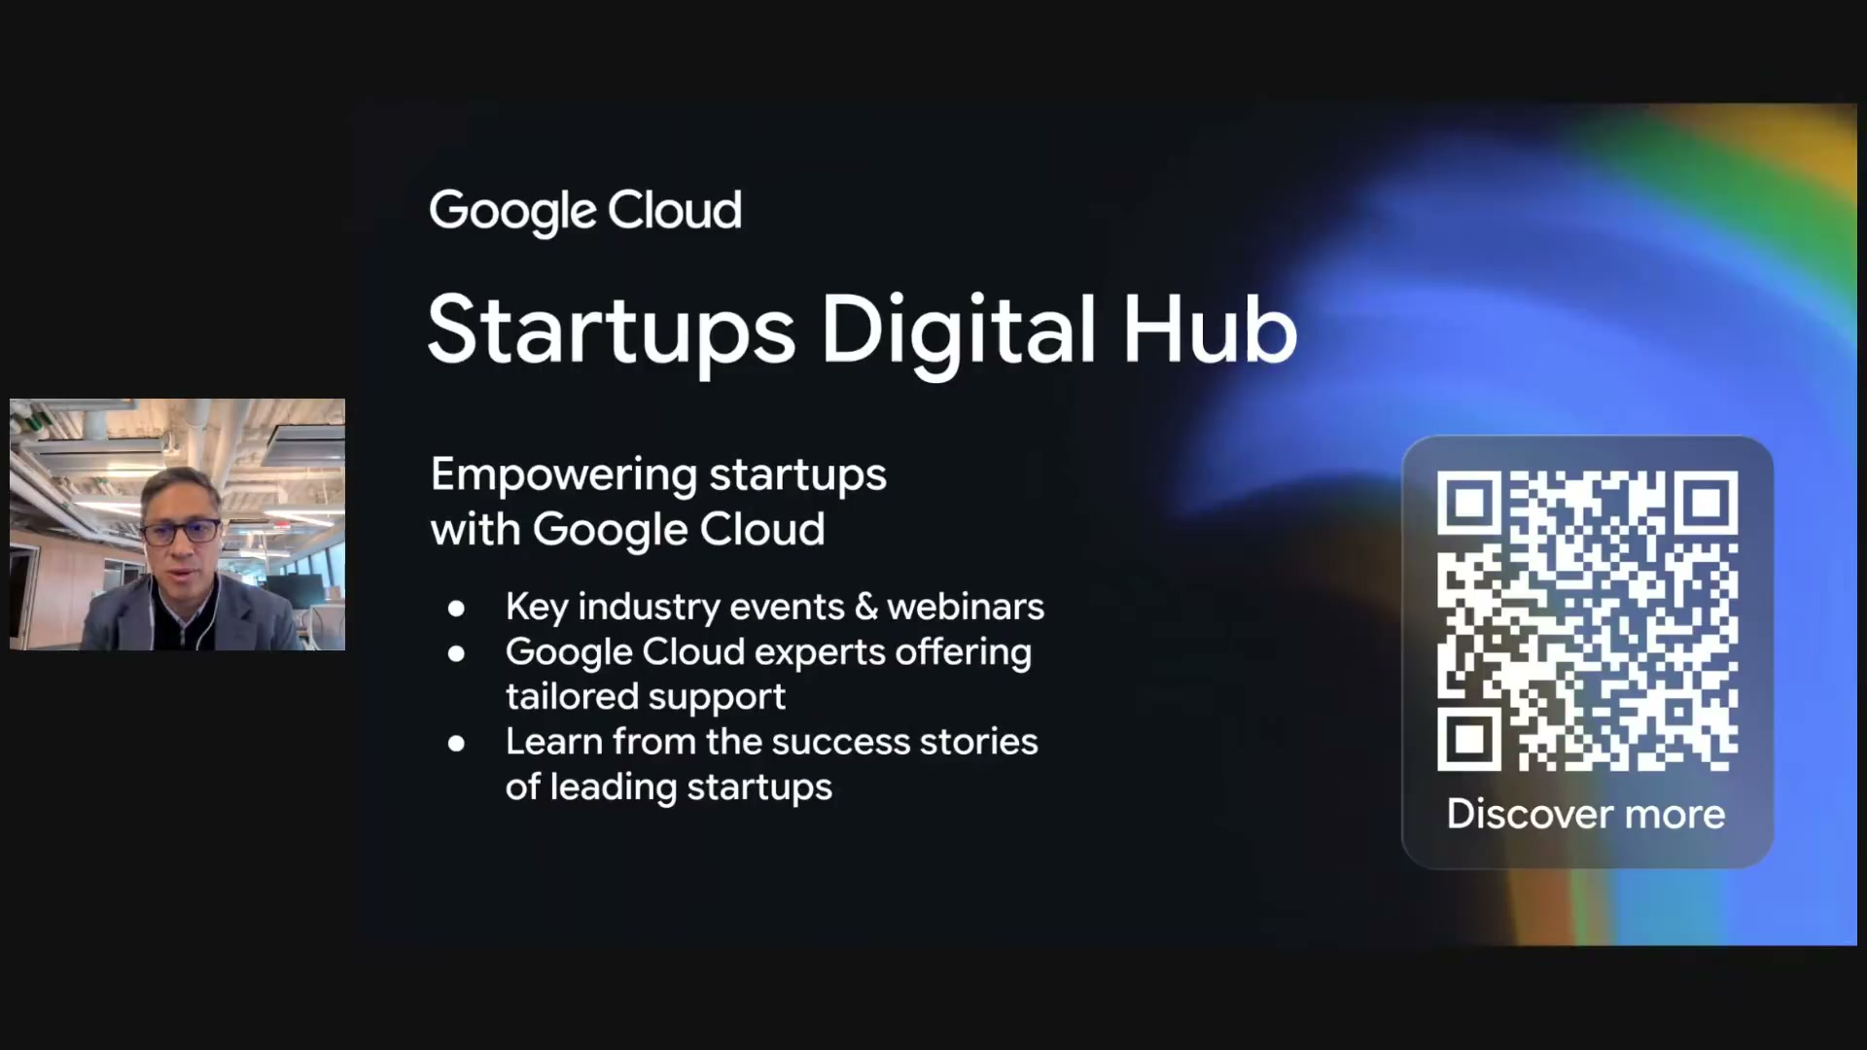
What's on screen
- “Google Cloud — Startups Digital Hub: Empowering startups with Google Cloud.”
- A one-stop hub: key industry events & webinars; Google Cloud experts offering tailored support; learn from the success stories of leading startups. Scan “Discover more.”
Narration (Joe Shonkwiler): “Please make sure to bookmark the startup’s digital hub… you can think of this as your one-stop shop — a central hub for technical webinars… hands-on architectural workshops, startup programs.”

10.3 The Google for Startups Cloud Program 23:50
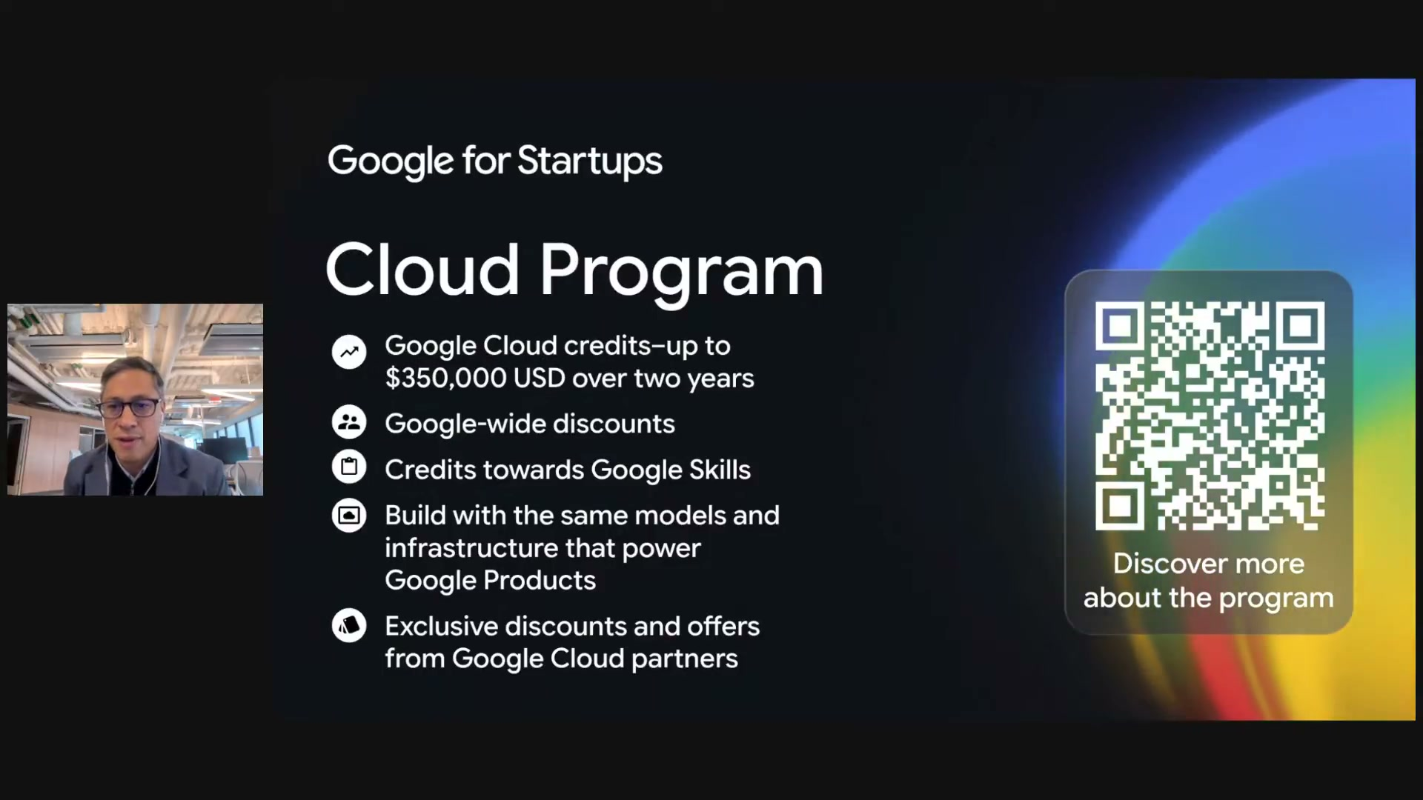
What's on screen
- “Google for Startups — Cloud Program”: Google Cloud credits up to $350,000 USD over two years; Google-wide discounts; credits towards Google Skills; build with the same models and infrastructure that power Google products; exclusive discounts and offers from Google Cloud partners.
- Scan “Discover more about the program.”
Narration (Joe Shonkwiler): “For founders looking to protect their runway while building on our top-tier infrastructure, we have the Google for Startups cloud program… eligible startups can access up to $350,000 US dollars in Google Cloud credits.”

10.4 Perk up! — partner offers 24:35
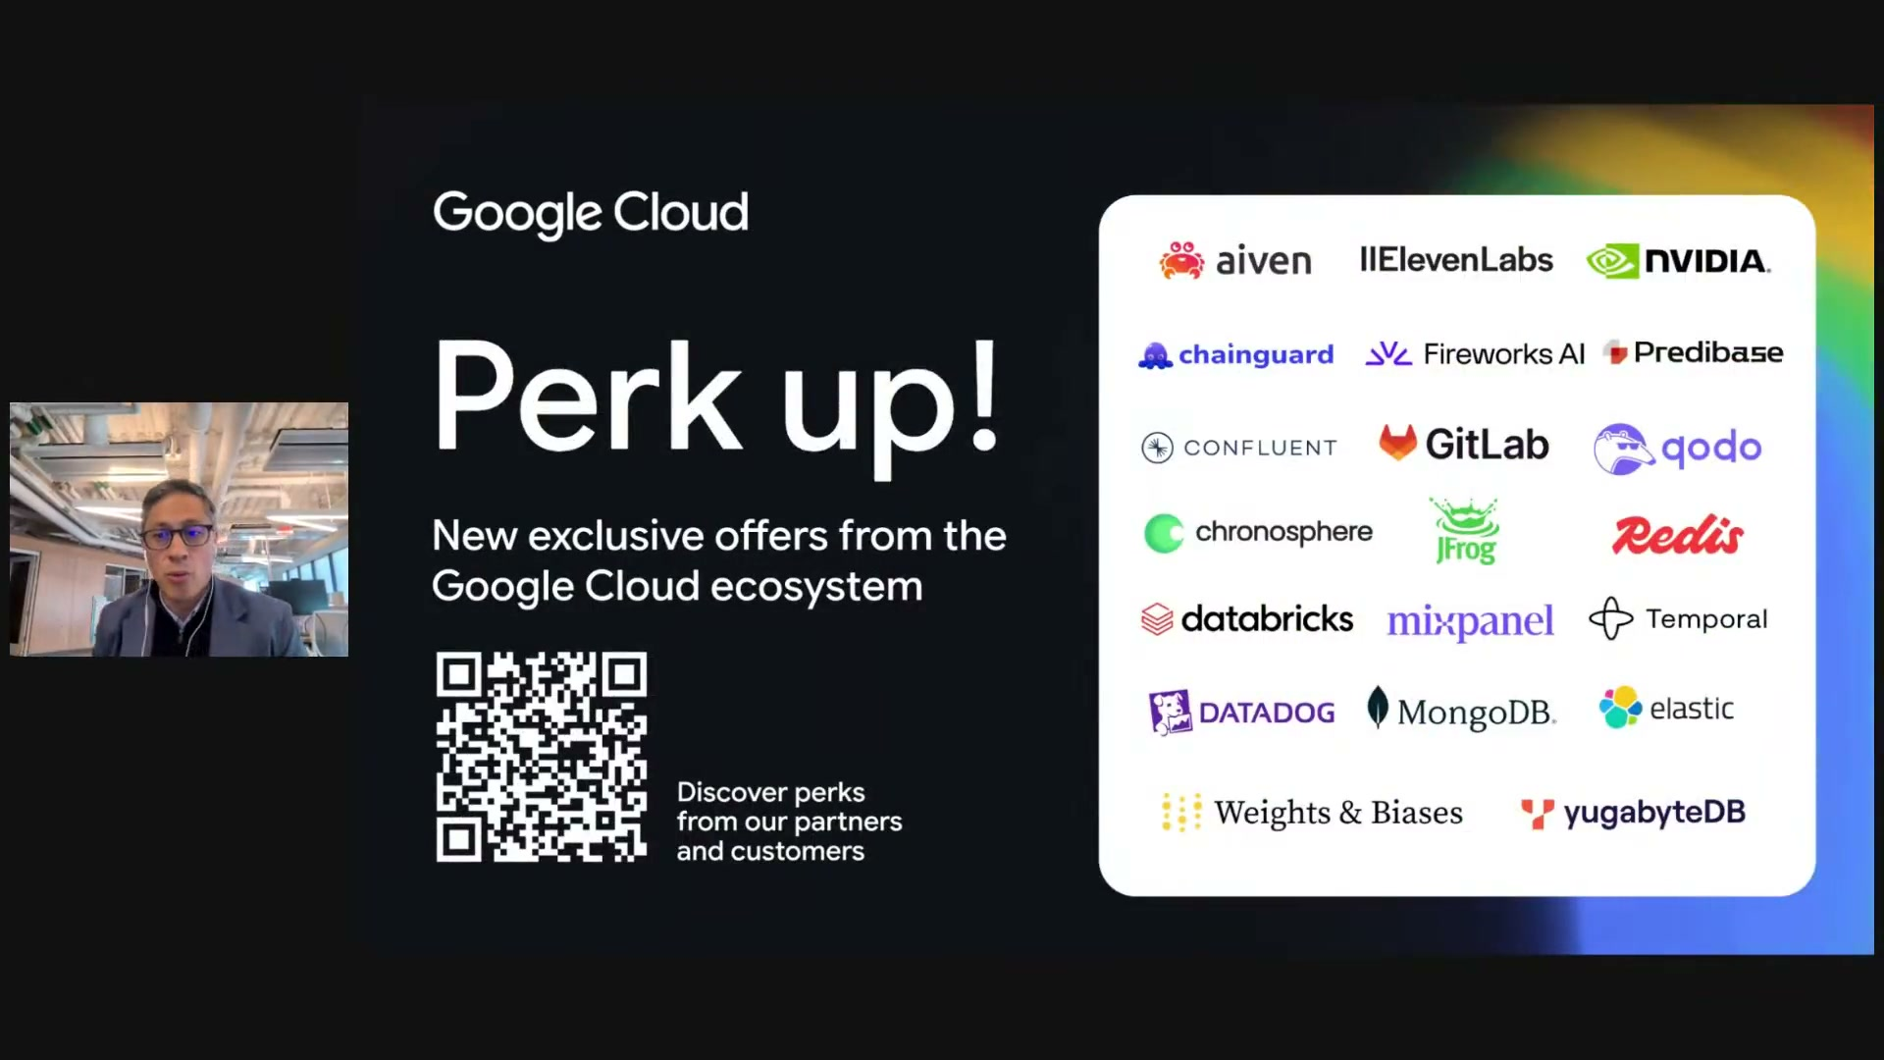
What's on screen
- “Google Cloud — Perk up! New exclusive offers from the Google Cloud ecosystem.”
- Partner logos: Aiven, ElevenLabs, NVIDIA, Chainguard, Fireworks AI, Predibase, Confluent, GitLab, Qodo, Chronosphere, JFrog, Redis, Databricks, Mixpanel, Temporal, Datadog, MongoDB, Elastic, Weights & Biases, YugabyteDB. Scan to discover perks.
Narration (Joe Shonkwiler): “Exclusive perks really are available for you and your team as you join that program and continue to build at scale.”

Section 11 — Audience Q&A
A two-webcam discussion (no new slides). The questions and Dan’s answers, in order:

11.1 Q&A with Dan Golden 27:00
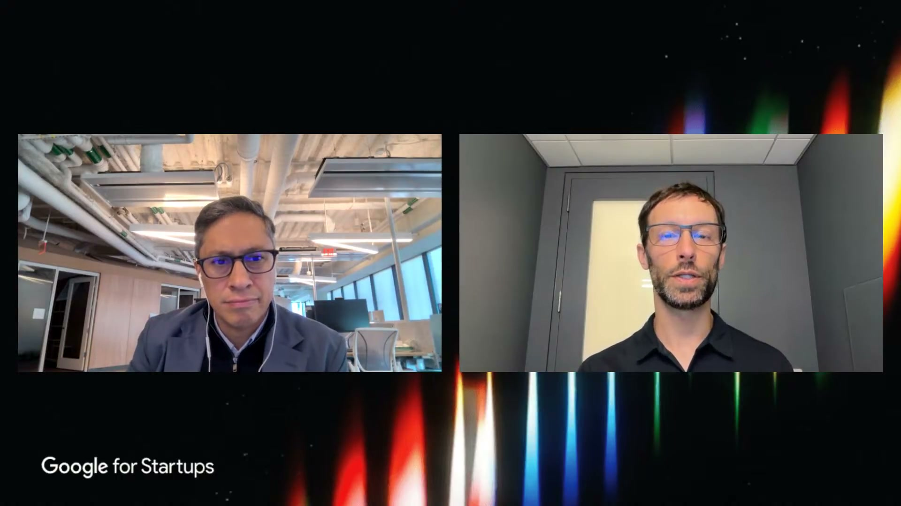
What's on screen
- NHS: Google has published mammography-screening research with the NHS, but has not yet integrated MedGemma into NHS systems.
- HIPAA / PHI: open models are downloaded binaries (not an API) — deploy on-premise (no data leaves the hospital) or on HIPAA-compliant Google Cloud; systems are HIPAA-compliant, models are not.
- Updates: a next MedGemma / “Gemma 4” is actively in progress; they hope to announce something this year.
- Non-English (e.g. Indonesian, Spanish): English-heavy data is a real limitation — fine-tune on local-language medical data aligned to the intended use (LoRA/QLoRA or full fine-tuning); medical concepts are in the model, mainly the language layer needs tuning; more tools are coming.
- Medical video: RGB visible-light video is closer to base Gemma’s domain than X-rays — light tuning already gives good results; better surgical-video support is planned.
- Gemini + MedGemma: route medical imaging to MedGemma and use Gemini as the general/front-end model; or keep PHI only on MedGemma in your own infrastructure (Gemini can also be HIPAA-compliant) — orchestration specifics go to your cloud customer engineer.
- Quantization / edge: no first-party quantization-aware-training checkpoint yet (~5% drop, recoverable by fine-tuning); third parties (e.g. Unsloth) offer quantized versions; the next release aims to add QAT + first-party quantized models and a smaller Gemma-based model.
- FDA / validation: no official advice — the FDA has the first and last word; build to be safe and effective within the intended use; keep MedGemma on-prem for PHI and send only de-identified data onward.
- In / out of distribution: trained on chest X-ray, histopathology and dermatology (good starting point); not surgical video, wearables or PET (may not beat base Gemma) — check the model cards / tech reports.
- Clinical trials: much overlaps with clinical tasks (reading radiology, assessing symptoms) where MedGemma helps; it is optimized for clinical medicine, not scientific research/discovery.
- Regulatory example: still early for generative AI — but partners have clearance for earlier (non-generative) models, e.g. Nexus AI (South Africa) for chest-X-ray classification.
Narration (Dan): “One of the big advantages of open models like MedGemma is that they are binary models that you download and deploy in the system that works best for you… you can deploy this locally, on-premise in the hospital, in which case no data ever leaves the hospital.”

Section 12 — Close
The wrap-up and what’s next.

12.1 Closing & what’s next 52:25
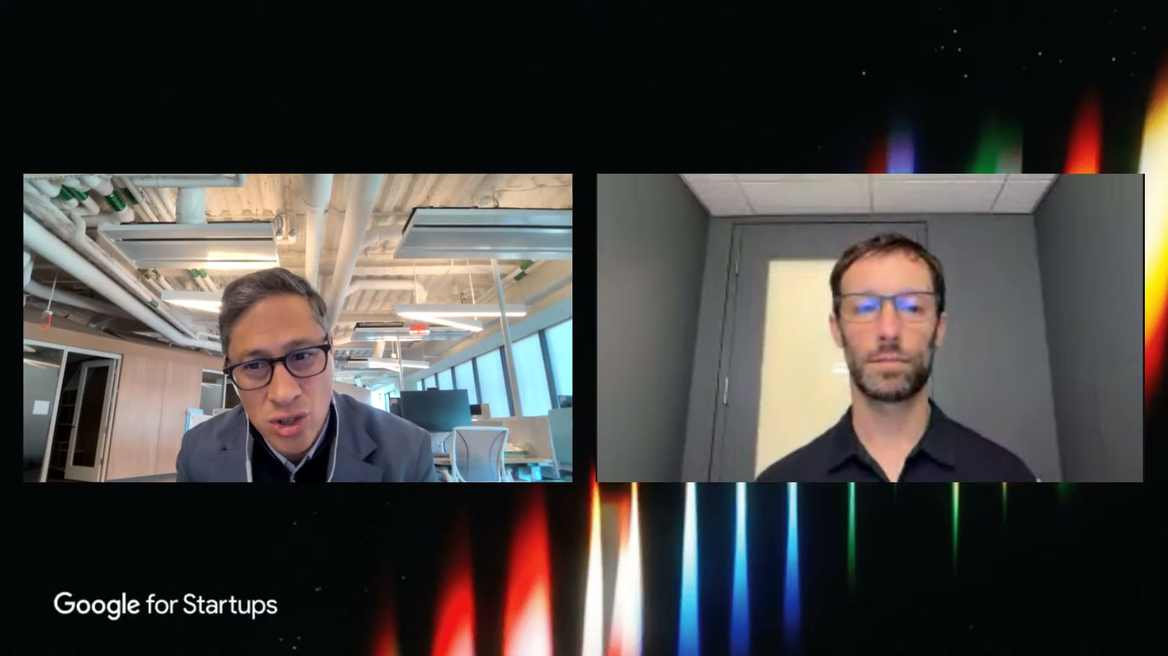
What's on screen
- Joe thanks Dan for showing how to adapt open foundation models responsibly for clinical workflows, and thanks the audience for the questions.
- A quick survey is requested; and Session 2 follows in ~30 minutes: “token economics — how to beat the cost curve” with founder advocate David White.
Narration (Joe Shonkwiler): “A huge thank you to Dan Golden for walking us through MedGemma… how to adapt these open foundation models responsibly for clinical workflows… in about 30 minutes, session two on token economics… with David White.”

Key takeaways
The substance of the talk, distilled:
- MedGemma is Google’s open model for medical text & image comprehension, built on Gemma and part of HAI-DEF (free open-weight models + tools under an enabling license).
- It is a foundation model / starting point — intended to be fine-tuned, adapted and evaluated per use case, not used out of the box for clinical diagnosis or management.
- The collection: MedGemma 1.5 (4B, efficient + advanced imaging), MedGemma (27B, best for text), MedSigLIP (0.4B image encoder), plus MedASR, TxGemma and HeAR.
- Choose Gemini for convenience/performance when it works; choose MedGemma for control — IP ownership, medical-imaging SoTA, heavy adaptation, medical devices, on-device/offline/sovereign use, or inference-cost control. Often orchestrate the two together.
- Enabling tools: inference & fine-tuning notebooks (Hugging Face, Model Garden), API deployment (Hugging Face, Vertex AI), demo apps — then scale on Google Cloud.
- Privacy: open models are downloaded binaries deployable on-premise or on HIPAA-compliant infrastructure, so patient data can stay in the hospital.
- Proven globally: sovereign-AI programs (Taiwan, India, Singapore) and startups (Malaysia, Uganda, Zambia) — always adapted and evaluated, not used out of the box.
- Resources: go.gle/hai-def (model cards, intended use), the arXiv technical reports (MedGemma and MedGemma 1.5), and the demo apps on Hugging Face.
End of walkthrough. 29 screenshots, all captured and verified from the recording.

Appendix — Full transcript (verbatim, timestamped)
The complete transcript exactly as captioned, with its original timestamps. Only blank filler lines from the source file were removed; every spoken caption line is preserved verbatim (auto-caption quirks and mis-hearings are left unchanged).
00:02 [music]
00:05 Audio Jungle.
00:09 >> Hi everybody. Thanks for joining us
00:10 today. Uh my name is Joe Shankweiler and
00:13 I lead uh Google's healthcare and life
00:15 science uh startup team here at Google
00:18 Cloud. Uh I'm thrilled to kick off this
00:20 five-part series called Startup School
00:23 focusing on health technology. Over the
00:25 next several sessions, we're bringing
00:26 together builders, technical
00:27 specialists, venture investors, a whole
00:30 range of folks that are going to be
00:32 relevant to this space. Um, uh, we've
00:36 starting today with a really important
00:37 session on Google's open health AI
00:41 development or high def. Developing AI
00:43 in healthcare carries a unique demand
00:45 around data safety, clinical nuance,
00:47 model alignment, and open models are
00:50 fundamentally changing how fast startups
00:52 can grow and move. And I'm we're
00:54 thrilled today to be joined by Dan
00:56 Golden from the Google research team to
00:59 explore the Med Gemma ecosystem,
01:01 fine-tuning techniques for medical tasks
01:04 and responsible deployment practices.
01:06 And before I hand it over to Dan, just a
01:08 quick housekeeping note. Um, use the
01:10 chat feature directly below the webinar
01:12 window to introduce yourself, network
01:15 with fellow founders, and drop in your
01:16 questions throughout the talk. We have a
01:19 team of Google Cloud experts um, live on
01:22 standby to chat right now to answer any
01:23 of those technical questions that arise.
01:26 And we'll also be pulling in the top
01:27 questions at the end for a Q&A with Dan
01:30 to dig into some of these areas. Um, so
01:33 that's the housekeeping section and and
01:34 without further ado, Dan, uh, over to
01:36 you.
01:38 >> All right. Thanks so much, Joe. All
01:39 right, thank you everyone for joining.
01:41 Uh, my name is Dan. I'm a software
01:42 engineering manager in Google research
01:44 at Google. And today I'm going to be
01:46 talking about Google's open models for
01:49 health AI development and specifically
01:51 Medgema of which I'm the research lead.
01:55 So a little bit of background about
01:57 health AI at Google before we get into
01:58 the models themselves. For a long time
02:01 now, uh, our our program within Google
02:05 research has been focused on the
02:06 principle of catalyzing the adoption of
02:09 human- centered AI in healthcare. For a
02:12 long time, we've done this via
02:13 demonstrations. These are our own
02:15 internal studies, often with with
02:17 collaborators and partners to show the
02:19 possibilities of using AI in clinical
02:22 research and healthcare. More recently,
02:25 we've been focused on supporting the
02:27 community directly by building tools and
02:31 uh foundation models to help them
02:33 develop health AI applications. And
02:35 that's the principle behind the highdev
02:37 program which stands for health AI
02:39 developer foundations where we are
02:41 releasing pre-trained models and
02:43 supporting tools to enable thirdparty
02:45 developers to build healthcare
02:47 applications.
02:49 The idea behind high def is that we have
02:52 both the models and the tools enabling
02:55 people via both uh these foundational
02:58 elements and then also instructing them
03:00 how to use them most effectively. There
03:02 are instructions as well as frameworks
03:04 and and tools for that. The important
03:07 aspect of this also is that all of the
03:09 tools we release have an enabling
03:11 license that allows them to be used
03:13 completely free and without any
03:15 obligation to Google. So they can be
03:17 built into applications, they can be
03:18 used offline. There is no required
03:21 payments per inference run or anything
03:23 like that. These tools can be kind of
03:26 adopted and owned by the users and
03:28 developers.
03:31 The principle behind this program is
03:34 that within healthc care development and
03:36 health AI development and the
03:38 development of products for patients and
03:39 clinicians, there isn't one organization
03:42 that's really able to do everything.
03:43 There are AI research institutes like
03:46 Google cloud providers like Google by uh
03:49 Google cloud health care providers those
03:51 actually providing the services and
03:53 health tech providers who are creating
03:54 medical products and no one of these uh
03:57 individual institutions can do
03:58 everything. So we are enabling uh via
04:02 the the elements that we have the most
04:04 leverage in in the developing AI
04:06 applications to allow these users to all
04:09 come together to build effective
04:10 applications for healthcare.
04:14 Within healthi developer foundations we
04:16 have the medgeema family of models which
04:18 I'll be talking in more detail about
04:20 later in the webinar. But we also have
04:22 several other models that are more
04:24 specialized for specific applications
04:26 including Med ASR which is optimized for
04:28 medical speech to text. Meds Sigip which
04:31 is an image encoder optimized for
04:33 classification or retrieval of medical
04:35 images. TXGMema which is optimized for
04:38 therapeutics, comprehension and question
04:40 answering and the hear model which is a
04:42 bio acoustics model meant for
04:44 interpreting and creating embeddings for
04:46 lung sounds, coughs, sneezes, coughs,
04:49 sneezes and so on which can be used to
04:51 help with diagnostics for uh lung
04:54 diseases. We also have a few legacy
04:56 image encoders on the right side of the
04:58 screen that I won't be talking about.
05:01 So I want to focus the rest of the talk
05:03 on medgeemma. Medgema is built on
05:07 Google's open uh general purpose model
05:10 Gemma and it's Google's most capable
05:12 open model for medical text and image
05:14 comprehension.
05:18 The Medgema collection consists of
05:20 several different models each with
05:21 different uh applications and strengths.
05:25 So uh on the left side of the screen
05:27 you'll see three different models. Medma
05:28 1.5 which is available in a 4 billion
05:31 parameter version. than the original
05:33 MedeMema which is available in a 27
05:36 billion parameter version and also a
05:38 smaller version that is essentially
05:39 superseded by MedGema 1.5. So we focus
05:42 on the 27b version of that as well as
05:44 the medigip image encoder which is 400
05:47 million parameters or 0.4 billion. All
05:50 of these different models are really
05:52 useful for interpreting two-dimensional
05:55 medical imaging and in particular
05:57 hystopathology, dermatology,
05:59 opthalmology, retinal fundus images and
06:01 radiology. And then the LLM versions of
06:04 the models, the medgeema models are also
06:06 really useful for medical text and
06:08 medical records. They can be prompted
06:11 via speech by leveraging med ASR to
06:14 convert speech to text. And then in
06:16 particular, MEGMA 1.5, our more recent
06:19 model, is uh optimized also for advanced
06:22 medical imaging, including
06:24 multi-timepoint radiology, so multiple
06:26 images of a patient over time,
06:28 threedimensional radiology like uh CT
06:31 and MRI scans, whole slide pathology,
06:34 that is interpreting an entire slide, a
06:36 gig gigapixel slide uh all at once, as
06:39 well as anatomical localization, in
06:41 particular in chest X-rays.
06:43 So one way to interpret this uh
06:46 portfolio of models is that the medgema
06:50 1.5 model the 4 billion parameter model
06:52 is small efficient and has these
06:54 additional uh elements of optimization
06:56 for advanced imaging and the original
06:59 medgeema is really the best choice for
07:01 text as long as you have the resources
07:02 to run it. It's a bit more expensive to
07:04 do so. And then finally mediglip is
07:06 optimized again for classification or
07:08 image retrieval but it's not a
07:10 generative model.
07:14 So just to give an example of how
07:16 Medgema can be used as a solid starting
07:19 point and what its capabilities are,
07:21 this is one example of out of the box
07:23 usage of Medgema interpreting a pair of
07:25 chest X-rays. Uh this is a longitudinal
07:28 pair that I alluded to before. So uh
07:30 it's interpretation of a current X-ray
07:32 in the context of an earlier X-ray of
07:35 the same patient. So in this case the
07:37 two x-rays are provided to medema and
07:39 the prompt is to compare the two above
07:41 images and is the pneumonia unchanged
07:45 worsened or improved in the second image
07:46 compared to the first image. I won't
07:49 read the full AI response but the main
07:51 point is that it noted that the
07:52 pneumonia appears to have worsened in
07:54 this case and then we also reviewed that
07:57 response as well as the original images
07:59 with a board-certified thoracic
08:00 radiologist who agreed that the
08:02 pneumonia is worsened. So it got the
08:04 broad strokes of the question correct
08:06 but then also noted that there is a
08:08 region of relative lucency in the
08:09 midright lung uh we're um reading off
08:12 the right side here that could res
08:14 represents either cavitation or merely a
08:16 region of lungs spared by pneumonia.
08:18 [snorts] So the interpretation by the
08:21 radiologist indicates that in a broad
08:23 stroke it it gets the question correct
08:25 but there's still room for improvement
08:28 and as we note in the lower right down
08:29 here fine-tuning may improve results
08:31 which is an important point where we
08:33 consider MedGema to be a good starting
08:35 point for medical modeling but it's not
08:37 intended to be used for clinical
08:39 diagnosis or management out of the box.
08:41 It's meant to be fine-tuned and adapted
08:43 by thirdparty users when building their
08:45 own medical AI applications and then
08:47 evaluated in their particular use cases.
08:51 I'll give this one additional example.
08:52 This is a a a capability that we also
08:55 added in Medgema 1.5 of analyzing
08:57 volutric CT images where given a CT
09:01 volume here just we're showing three
09:03 slices of a CT volume but the entire
09:04 volume is provided and the tool is asked
09:07 to analyze this contiguous block of CT
09:09 slices and given that the patient is
09:12 being evaluated for liver tumors are
09:14 there any evidence of tumors in the
09:15 liver again the model says there is
09:17 evidence of a larger regular mass in the
09:19 right lobe of the liver and gives
09:20 additional context we also had this
09:22 reviewed by board-certified thoracic
09:24 radiologist who agreed with the
09:26 assessment however noted that one of the
09:28 findings by MedeMema appeared to be
09:30 spurious. There wasn't this secondary
09:32 finding that Medma indicated again
09:34 highlighting that Medma is a solid
09:36 starting point but is not intended to be
09:38 used out of the box. It's intended to be
09:40 adapted by users.
09:44 So this is the uh quintessential
09:46 workflow that we expect developers to be
09:48 following when using Medma for their
09:50 applications. They'll initially be
09:52 defining a use case, then identifying
09:54 the right model for their use case via
09:56 that model picker graphic that I showed
09:58 earlier. They'll also, and this is
09:60 critical, define the appropriate
10:01 evaluation for their use case. Something
10:03 that is evaluating their systems
10:05 intended use and in the context of the
10:07 patient population that they'll be
10:09 working with. They'll measure baseline
10:11 performance with the the medgeema model
10:13 or whatever the model is they choose to
10:14 start with. And then critically they'll
10:16 spend most of their time in this adapt
10:18 adaptation and tuning loop with
10:20 evaluation making modifications, running
10:23 new experiments, maybe modifying their
10:25 data until they achieve a result that
10:26 they find meets the needs of their
10:29 application. And at that point, we make
10:31 it very easy with our cloud partners to
10:34 scale the application to run it live on
10:36 Google Cloud. Uh so that you don't need
10:38 to worry about managing all of that
10:40 inference and infrastructure yourself.
10:46 So as I mentioned before besides
10:48 actually providing the models with these
10:49 base capabilities we do a lot to provide
10:53 enabling tools to help people use the
10:55 models and deploy the models. So for
10:57 questions that users may have like I
10:59 wonder how this model does on my data
11:03 results but every individual
11:06 application's data is going to be
11:07 somewhat different. It could be a
11:09 different kind of data. It could just be
11:10 a different patient population. So we
11:12 provide uh example notebooks on both
11:15 hugging face and uh on model garden for
11:19 how to actually run the model and then
11:21 evaluate results on your own data. You
11:24 may ask how can I change the model and
11:25 adapt it for my use case if my initial
11:27 evaluation is not satisfactory. So we
11:29 provide example notebooks for how to
11:31 fine-tune the model using Google cloud.
11:34 uh once you've actually tuned the model
11:36 and want to deploy it or even if you
11:37 want to deploy it uh to evaluate it, we
11:40 provide example uh use cases for how to
11:43 turn it into an API and deploy it via
11:45 both hugging face and vertex AI. And
11:48 then we also provide a few example demo
11:50 applications to just give you uh both
11:53 some inspiration for what you can build
11:54 with the model but also to show uh we we
11:57 provide the code for those demo
11:59 applications. So you can actually see
12:00 the inner workings of how one might
12:02 orchestrate medema into a larger
12:05 application
12:06 and those are also available by our
12:08 hugging face collection.
12:12 So uh a question that we very often are
12:15 asked is what is the practical
12:17 difference between Gemini and Medgema?
12:19 Why would I choose one over the other?
12:22 And in general, Gemini will provide
12:24 greater convenience and in many cases
12:26 but not all improved performance. Uh the
12:29 convenience because there is no need to
12:32 uh host the model for example. Uh there
12:34 are APIs for fine-tuning it and so on.
12:36 So uh and then I'll also say that uh for
12:39 control medgeemma provides u a more rich
12:43 experience. So the bottom line here in
12:45 most cases is if gemini works for your
12:48 use case gemini is probably preferred
12:51 due to its convenience and potential uh
12:53 improved performance although the
12:54 performance is worth comparing. If
12:56 however you need full control over the
12:57 models which is true for a lot of the
12:59 users we talk to because they are in
13:02 sovereign nations and don't want to have
13:03 this dependence on infrastructure based
13:05 in the US or they want to own all the IP
13:08 uh of what they're doing in a very clear
13:11 way and so on or they want to work
13:13 offline where these closed models like
13:15 Gemini are not available then Medma
13:18 provides essentially the only experience
13:20 that would work for them. So it kind of
13:22 meets the those types of users where
13:24 they are.
13:26 to go into a little bit more detail
13:27 here. Compared to Gemini, Medgema will
13:30 provide a superior or a preferred
13:32 experience in a few different cases
13:34 where IP ownership of the model is
13:36 necessary where you're working on
13:38 medical imaging use cases where Medjma
13:40 has been specifically tuned and uh
13:42 generally achieve state-of-the-art
13:43 performance where you need to
13:45 substantially adapt the models beyond
13:47 what's possible via existing Gemini
13:49 tuning APIs or you want to create a
13:51 medical device. This is uh totally
13:53 within the bounds of the license for
13:55 Medgema. You can create a medical device
13:57 based on Medgema. If you need the
13:60 devices uh sorry the your data to stay
14:02 on device or in a private TCP
14:04 environment or you need to run offline
14:06 uh Medma provides that opportunity via
14:08 its openness. And then finally Medgema
14:12 allows you to take full control over the
14:14 inference pipeline rather rather than
14:16 relying on an API. So for example, if
14:18 you're running uh an inference system
14:21 maybe on an edge device for example and
14:24 you want to have full control over those
14:25 costs that's possible with open models
14:28 not as straightforward with closed
14:29 models like Gemini again in many cases
14:32 Gemini will be a preferred choice for
14:34 medical applications but when it's not
14:36 possible Medma is there to fill that
14:38 gap.
14:41 We provide many different resources so
14:43 you can learn more about Medjema, its
14:45 strengths, um what we've tested it on
14:48 and get a feel for whether your
14:50 application is in or out of distribution
14:52 for what we've optimized it for. Our
14:54 main site is this one over here,
14:56 go.glehide.
14:59 Um and on that site, you'll find our
15:01 model cards that detail both the how the
15:04 model was trained and also how it was
15:05 evaluated and the training data that was
15:07 used in the model. Uh and also very
15:11 critically our intended use statement
15:12 which is you know intended use is not
15:15 super exciting but it's an emphasis that
15:18 we intend for this model to be adapted
15:19 by the users not to be used out of the
15:21 box and that's where you're going to
15:23 find the best performance with the
15:24 models.
15:27 Beyond the model cards which are fairly
15:29 straightforward basic information, we
15:32 also have provided technical reports on
15:34 archive for both the original Medma
15:37 model developed and released in mid 2025
15:40 as well as MedGema 1.5 which was
15:43 released earlier this year. Tech reports
15:45 are available for both of those and they
15:47 go into much more detail about how the
15:49 models were developed and how they were
15:51 evaluated so you can get a better feel
15:53 for how they may work in your use case.
15:59 Beyond the uh the tools we provide and
16:02 infrastructure as well as these uh the
16:05 technical documentation, we also provide
16:08 demo applications which I which I
16:09 mentioned before that show you how you
16:12 can orchestrate Medma into a larger
16:14 application.
16:15 So the uh first app this these are all
16:19 available on you can use this QR code.
16:20 They're also available in our hugging
16:22 face collection. The first demo
16:23 application shows how Medgema can be
16:26 used to interact with electronic health
16:28 records through fire. So with a a broad
16:32 query about some information about a
16:34 patient, Medma can be orchestrated to
16:37 access the medical record uh through
16:39 fire or through other uh systems, get
16:42 information and return it to answer that
16:43 query.
16:46 Another demo we provide is this one for
16:50 understanding a radiology report. So uh
16:54 given an existing radiology report
16:56 provided by the radiologist Gemma can be
16:59 used uh in in a consumerf facing
17:01 application to explain the meaning
17:03 behind the different aspects in the
17:05 radiology report.
17:08 A third one simulates the pre-in
17:11 previsit intake that a patient may go
17:14 through before having a visit with their
17:17 provider. So this is an intake form
17:19 where traditionally this is done um uh
17:21 on a written piece of paper. More
17:23 recently it's a set of maybe 10 or 20
17:26 questions that the patient will fill out
17:28 electronically.
17:30 This demo shows how one can make an
17:32 adaptive patient intake process where uh
17:35 questions are asked using medema as the
17:37 the the thinking basis behind which
17:40 questions are relevant and it will adapt
17:43 and ask relevant questions for the
17:46 patients symptoms medical history and so
17:48 on as well as providing a basic uh
17:52 report about the patient that the
17:53 provider can then review prior to the
17:56 visit. So we have a demo showing that
17:58 process. And then finally we have one
18:00 that is focused on radiology similarly
18:03 to demo two where the uh user can
18:07 provide radiology image and then they
18:10 are quizzed on different aspects and and
18:12 findings within the radiology image
18:14 highlighting how a tool like MedGema can
18:16 be used for general clinical training
18:19 applications.
18:20 All of these are just demos. They're not
18:22 full applications meant to just show
18:24 some of the possibilities of what you
18:26 can do with Medgema. And of course, you
18:27 can view these on high on hugging face.
18:30 You can review the code and then take
18:32 inspiration and maybe even take pieces
18:34 of the code although generally not the
18:35 full applications with have mock the
18:38 applications have mocks and so on. So
18:39 you wouldn't necessarily copy paste the
18:40 code but you can take pieces of the code
18:42 and potentially use them in your own
18:44 application.
18:48 uh we have a lot of third parties that
18:52 have the whole point of high def is for
18:54 third parties to use it and build
18:55 medical applications to to solve their
18:58 particular healthcare problems they're
18:59 focusing on and we have many third
19:01 parties that have done this already
19:02 since our initial release in 2025.
19:06 The Ministry of Health of Taiwan has
19:09 used Medgema to uh do a pre-operative
19:13 assessment of lung cancer surgery
19:15 candidates patients to both uh optimize
19:19 patient outcomes and then also in
19:20 aggregate to inform public policy about
19:23 how these patients are treated and and
19:25 the optimal treatments for the patients.
19:28 The Ministry of Health of India is
19:31 working with different organizations
19:33 within India to build foundation models
19:35 for India optimized both for the Indian
19:38 languages as well as for clinical
19:40 guidelines and best practices within
19:43 India.
19:44 Ministry of Health of Singapore is also
19:47 using Medma to build localized sovereign
19:50 multimodal foundation models for primary
19:53 care sort of general triage and simple
19:55 use cases as well as in specialty
19:57 settings and these are in different uh
19:60 area um different steps in clinical
20:03 validation or active development.
20:07 In addition, many different health tech
20:08 startups, especially outside the US,
20:10 have used MedeMema for various different
20:12 applications. In Malaysia, QMED Asia has
20:15 built a conversational interface to uh
20:18 be a front end to their clinical
20:20 guidelines using Medma to interpret uh
20:23 the guidelines via retrieval augmented
20:26 generation. Uh within Uganda, Crane AI
20:30 has used MedeMema for mobile
20:32 applications to support maternal health
20:35 uh via community health workers. And in
20:37 Zambia, Dawa Health has used Medma via
20:40 its multimodal capabilities for cervical
20:43 cancer screening.
20:45 And I'll just reemphasize that in all
20:46 these cases, Medma is used as a
20:49 foundation model, then adapted and
20:51 evaluated on these specific use cases,
20:53 not used out of the box.
20:56 We have a public showcase uh online uh
20:59 you can go to that high def site that I
21:00 mentioned earlier go.glehide
21:03 and see the showcase where we have
21:05 in-depth case studies from different
21:07 users of Medgema to show what their
21:09 experience has been and how they've used
21:11 it as well as uh details about which
21:15 different infrastructure they use what
21:17 cloud services were relevant to them and
21:18 so on. Uh if anyone in this audience
21:21 ever develops something with Medgema, we
21:23 would love to feature your work on the
21:25 showcase. So please do get in touch with
21:27 us or if you've already used it, of
21:29 course, get in touch.
21:32 Uh those are all the slides I wanted to
21:33 share. Here's a lot of QR codes for
21:35 people who like QR codes and I really
21:37 appreciate your attention and I'll turn
21:39 it back over to Joe.
21:42 >> Wonderful.
21:44 Thanks so much, Dan. Thank you. Uh that
21:46 was that was fantastic. particularly the
21:48 the walkthrough on the technical
21:49 frameworks and architectural insights
21:52 that you shared that was really
21:53 invaluable. Um what really stood out to
21:55 me from today's talk is that turning
21:58 these complex healthcare and life
21:60 science breakthroughs into reliable
22:02 production systems isn't just about
22:04 choosing a particular algorithm or model
22:06 in the process. It's about architecting
22:09 for scale, taking governance into
22:11 account and the long-term defensibility
22:14 right from that prototype stage. Um, our
22:17 team, I should say, has been actively
22:19 curating your questions. Thanks
22:20 everybody for engaging throughout the
22:22 talk. While Dan steps away for just a
22:24 second to review some of those
22:26 questions, take a B. Um, I'm going to do
22:28 uh just highlight a couple things that I
22:30 think are worth mentioning regarding our
22:32 uh our programs for working with
22:34 startups in particular.
22:36 Um so you know to stay connected with
22:40 everything that's happening across the
22:42 whole ecosystem um please make sure to
22:45 bookmark the startup's digital hub as a
22:48 follow-up here. You see the QR code
22:49 there you can think of this as like your
22:51 one-stop shop a central hub for
22:53 technical webinars things like this uh
22:56 hands-on architectural workshops startup
22:58 programs
22:60 um you know really anything and
23:02 everything. this is your this is the
23:03 place that you go. Um through that hub
23:06 you're going to tap directly into key
23:07 industry events and webinars um focused
23:10 on emerging technology frontier markets
23:12 not just healthcare but sort of
23:14 generally um direct engagement with
23:16 Google cloud technical experts that's
23:18 one of the most common things that I get
23:19 asked on the BD side is how do you get
23:21 in touch with with the folks that really
23:23 know this technology inside and out um
23:26 and that's how you get this the support
23:28 for your own architectures and work and
23:30 then real world case studies. So
23:32 particularly in healthcare but across
23:33 these industries, it's not just diagrams
23:36 and and slides, but actually how do you
23:38 deliver and build these things in real
23:40 time. So case studies showing you the
23:42 exact blueprints and success stories of
23:44 leading startups showing how they've
23:47 built for scale.
23:49 And then then finally here the cloud
23:51 program itself. So for founders looking
23:53 to protect their runway while building
23:56 um on our top tier infrastructure, we
23:58 have the Google for startups cloud
23:60 program. eligible startups, and there
24:02 are some some nuances to this that
24:03 you'll see, um can access up to $350,000
24:07 of US dollars um in Google Cloud
24:09 credits. Um there are companywide
24:11 discounts um across Google, direct
24:14 access to build with the exact same
24:16 models and infrastructure that power
24:18 Google's core products. Um and uh um
24:22 exclusive partner discounts and perks
24:24 along the way. So you can apply directly
24:26 o online and reach out to our team to
24:29 explore your eligibility for these
24:31 programs
24:34 and remember that with that Google for
24:36 startups cloud program you get access
24:38 not only to cloud credits but also the
24:40 vast network of our partners um
24:43 exclusive perks really are available for
24:45 you and your team as you join that
24:47 program and and continue to build at
24:49 scale. Um, so thanks for for for uh uh
24:53 indulging there in that part and be sure
24:55 to bookmark those sites. Um, I'm going
24:58 to bring Dan back on now just to um go
25:01 through a couple of the questions um
25:03 that we um that we talked about. So Dan,
25:06 thanks. Welcome back. Um, one one
25:09 question we had was are there any real
25:12 world examples of uh Medma being used or
25:15 embedded into the NHS um and existing
25:19 software? So MS uh uh things like that.
25:23 >> Yeah, we we as I mentioned before we
25:26 have a lot of collaborations with with
25:29 governments outside the US. We have had
25:32 other research that we've done in
25:34 collaboration with NHS. We've had uh
25:36 some research on mimography screening
25:38 that was published earlier this year
25:40 with the NHS. We have not to date
25:43 engaged with the NHS on integration of
25:46 medema into their systems yet. Uh, of
25:48 course, if there's anyone from the NHS
25:50 who's interested in that, we would love
25:51 to talk to them, but the NHS is one that
25:53 we have not yet engaged with to my
25:55 knowledge.
25:56 >> And we didn't talk about it this time,
25:58 but I, you know, I spent my own career
25:60 in in clinical medicine. I was a surgeon
26:02 many years ago before making the jump
26:03 over to the technology side. And I know
26:06 HIPPA and patient protection, protection
26:08 of P, PHI, and patient data is really
26:11 crucial. What are some of the HIPPA
26:13 guard rails um that you take into
26:15 account when building with this? And
26:16 then like is there a documentation on
26:19 that? Um because I know that folks
26:20 always want to make sure that they're
26:21 they're covered all around.
26:23 >> Yeah, that's a great question. I one of
26:26 the big advantages when it comes to
26:28 patient privacy and I agree patient
26:30 privacy is a very very important concern
26:31 and something we have to really be very
26:34 cautious of and intentional about when
26:35 building medical applications. One of
26:37 the big advantages of open models like
26:39 Medgema is that they are uh these are
26:42 binary models that you download and you
26:44 deploy in the system that works best for
26:46 you. These are not API based models. So,
26:49 Medma is not an API to which you will
26:52 send data and then have some concerns or
26:54 questions about HIPPA. It is is
26:56 something you download and then you can
26:57 deploy on your own infrastructure. So
26:59 you can deploy this locally within on
27:02 premise in the hospital in which case no
27:04 data ever leaves the hospital or you can
27:06 work with Google Google cloud's many
27:08 HIPPA compliant services virtual
27:11 machines and the like and feel
27:13 comfortable comfortable by virtue of
27:15 those guarantees that if you deploy
27:17 Medma there it will also be HIPPA
27:18 compliant. So med that system not medma
27:22 models don't get h compliant systems are
27:24 hypoaco compliant or not and so this
27:27 flexibility allows you to deploy medema
27:30 into the hippaco compliant environment
27:32 of your choice and uh kind of reduces
27:36 that risk of sending data to the model
27:39 where you're not sure where it's going
27:40 because you have the full control.
27:43 >> Um and one other question we had was
27:44 about updates. Is there going to be a um
27:47 a an update similar to that we see
27:49 across Gemini? Is there a Gemma 4 um
27:51 update coming from May?
27:53 >> That's a it's a great question. It's one
27:54 of our most popular questions. Uh
27:56 absolutely. It is something we're
27:57 actively working on and we hope to be
28:01 able to announce something this year.
28:03 >> Okay, great. Stay tuned. Stay tuned. Um
28:07 a specific question here on the Medgema
28:09 4B. Um we have a team from an Indonesian
28:12 clinical documentation startup. um that
28:15 the the base is multilingual and the
28:17 grammar was fluent when they built with
28:19 this. Um but some of the medical
28:21 vocabulary felt slightly off. They were,
28:24 you know, asking for one result, they
28:25 got another that was very different. Um
28:28 the question is medically tuning the
28:30 language. It seems really Englishheavy.
28:32 Um and is there any of the domain tuning
28:36 to um non-English settings? Like how do
28:39 you think about language particularly as
28:40 it relates to medical language here?
28:42 >> Yeah, it's a great question. It's it is
28:44 um an unfortunate limitation of a lot of
28:47 AI development these days that the
28:49 majority of available data is in English
28:52 and especially because we have a lot of
28:55 partners who partners and users who use
28:59 MedGema outside the US we definitely
29:01 recognize this as a limitation. So I'll
29:04 say two things there which is for the
29:06 current generation of models we have
29:09 seen users have success fine-tuning the
29:12 models on medical data sets in their
29:14 local languages and allowing it to be
29:16 adapted there because the fundamental
29:18 medical concepts are built into the
29:20 model and it's really just this language
29:22 layer which is not a literal layer but
29:24 you know conceptually layer within the
29:27 model that needs to be tuned. So tuning
29:29 on local language data, we've seen
29:32 people have good results with that. With
29:34 that said, we definitely recognize that
29:36 users who are using Medma in languages
29:39 other than English could use some
29:41 additional support assistance tools and
29:42 so on. So we're actively working on
29:44 developing uh those kinds of tools,
29:47 thinking about it, ideulating about it
29:48 uh that will help users adapt MedGema,
29:52 both current and future versions to
29:54 different languages. Um, so if if you
29:56 have ideas on how to do that or if you
29:57 have feedback on how uh it's not working
30:00 right now, we'd love to hear more from
30:02 you and work with you on that.
30:03 >> That's great. Um, sort of a similar vein
30:07 about um the way multimodal data comes
30:10 in. Um, there's a team here working with
30:12 medical video data sets. Um, and is
30:16 there a way to leverage the Gemma family
30:18 of models best in that kind of setting?
30:21 >> Yeah. Uh so one sort of um distinction
30:26 between medical video versus other types
30:28 of medical imaging like radiology is
30:30 that these are RGB sort of visible light
30:34 images typically and that means that the
30:37 domain of medical video tends to be a
30:39 little bit closer to the domain that the
30:41 original Gemma and Gemini models were
30:43 trained on compared to X-rays for
30:45 example which are quite different
30:46 because they're high bit depth data
30:49 they're different uh dimensions
30:51 and so on. So what that means is uh the
30:55 even though we have not tuned medema
30:58 specifically on medical video and that
30:60 could include surgical videos for
31:01 example or even videos of um individuals
31:04 undergoing uh physical exams for example
31:07 in a primary care setting. We expect
31:09 that with some light tuning you can
31:12 probably achieve pretty good results uh
31:14 where
31:16 just because the the RGB nature of the
31:18 images is similar and that tuning can
31:20 involve uh different frames of the video
31:23 being passed in uh together into the
31:25 prompt. With that said there uh there
31:29 are some things we're working on related
31:31 to surgical video especially that we
31:33 hope to release in future versions of
31:34 Medma. So we expect that future versions
31:37 will provide even uh better foundations
31:40 for medical video especially surgical
31:42 video but I think you can find you can
31:44 get pretty good results even today with
31:46 the current models uh with some
31:48 fine-tuning on the domain of interest.
31:50 >> That's great. Um this is this next one I
31:53 I I love because I think it it touches
31:55 on so many elements of how folks are
31:57 currently using uh Medma but also
31:59 Gemini. So, so there's a group that
32:01 already has Gemini running uh within the
32:04 production healthcare workflow that they
32:06 have and they want to add Medge Gemma,
32:08 but they don't want it to replace Gemini
32:11 in the process. They want to use the
32:12 right model at the right time for the
32:14 right task, which is which is great. um
32:16 what architecture um is currently
32:19 recommended for integrating MedGeemma
32:21 alongside Gemini on Google Cloud and
32:24 that includes model routing, deployment,
32:26 data and PHI boundaries, evaluation,
32:29 clinical safety, the whole range. Um,
32:32 and the goal here is that so that
32:35 Medgema can handle the specialized
32:37 medical reasoning or multimodal
32:40 workloads while Gemini continues
32:42 handling the general AI work and patient
32:46 facing workflows. Is there like how
32:48 should they be thinking about that and
32:49 what are the best ways to sort of tee
32:51 that up?
32:52 >> Yeah, for that kind of application it
32:54 depends on uh specifically why you're
32:57 considering adding medema. So there's
32:59 probably I would say two big reasons.
33:01 Number one is for the specific use cases
33:04 that where Medge Gemma may provide a
33:06 better result than Gemini and for that I
33:08 think um clinical medical imaging is the
33:11 main one that comes to mind uh like
33:13 radiology in general probably Gemini
33:16 will provide a better result for medical
33:18 text um so if you're using MedMe as a
33:22 tool probably clinical radiology or some
33:25 other kind of um specific medical
33:27 imaging would be the the reason another
33:29 reason you might orchestrate them
33:30 together is to provide a layer of
33:33 abstraction where uh in infrastructure
33:35 you control any personal health
33:38 information is seen only by medgeemma
33:41 through your infrastructure in a way you
33:43 can control in with full HIPPA
33:44 compliance and then you can send then
33:48 the deidentified data maybe that's an
33:49 output of medgema to Gemini with that
33:52 said I want to emphasize that um with
33:54 the right orchestration Gemini can also
33:56 be hipaco compliant so from a strictly
33:58 legal perspective you can use Gemini for
34:01 that end to end, but some organizations
34:03 may just have greater comfort knowing
34:04 that they have full control of the data
34:06 for for privacy. So, how you actually
34:09 orchestrate them together really depends
34:12 on the use case and why you're using it.
34:14 In general, I would say if it's the
34:16 first case where you're using it as a
34:18 tool for medical imaging, say, then the
34:22 Gemini would provide a front end and
34:24 then it can farm out to Medjema as a
34:28 tool when a medical image is provided. I
34:30 unfortunately I I can only speak in the
34:32 abstract for that because we're mostly
34:34 in the business of providing the the
34:36 foundation models and so on. we are not
34:38 as involved in the actual orchestration
34:40 of applications but your you know cloud
34:42 service provider and your your contact
34:44 at cloud can can give you more
34:46 information and provide and connect you
34:47 to customer engineers for how to
34:49 orchestrate things together.
34:50 >> Um the first one about uh providing an
34:54 abstraction layer for personal health
34:56 information that gets more complicated I
34:58 probably it's probably better for me not
34:59 to pontificate about that because I
35:01 don't know how useful it would be.
35:02 Suffice [snorts] to say, talk to your um
35:05 customer engineer and cloud
35:07 representative for feedback, but you can
35:08 also get in touch with us either through
35:10 our forum. Uh we have a forum linked
35:12 through our website or we have a
35:14 feedback forum or your customer engineer
35:16 can contact us for more information. So,
35:18 I think that's the best way to get that
35:19 information.
35:20 >> Great. Yeah, makes total sense. Um this
35:23 is this is another good one. These are
35:24 great questions. very nuanced and
35:26 clearly folks are digging into these
35:28 models and and really you know seeing
35:31 pressing the limits if you will. Um so
35:34 what are the current recommendations for
35:36 best practice for quantizing and running
35:38 lightweight variants of Medgema locally
35:41 on lowcost edge hardware? This is in a a
35:44 rural healthcare setting. Um and before
35:47 then syncing telemetry back to Google
35:49 Cloud or Vertex AI or other or other
35:52 areas of connectivity. what's the what's
35:53 the best practice recommendation there?
35:55 >> Okay, there I think there are two two
35:56 questions in there about actual
35:58 deployments on edge hardware and then
36:00 telemetry.
36:02 uh I I'll focus on the first one to
36:04 start which is um so for for
36:07 quantization we for for the existing
36:10 medgema checkpoints especially medgeema
36:12 1.5 which is our latest smaller model 4B
36:15 we don't provide a quantization aware
36:18 training checkpoint which means that
36:20 after quantization there will be some
36:21 reduction in performance but we found in
36:23 our experiments depending on the
36:24 benchmark it's on the order of 5%. you
36:27 know, maybe you'd prefer 0% of course,
36:28 but 5% is not too bad and especially
36:30 after fine-tuning, you can probably
36:31 recover that performance. So, we don't
36:35 have official quantized checkpoints for
36:38 Med Gemma, but I know some third
36:40 parties, especially Unsloth, for
36:41 example, have provided quantized
36:44 versions of those models. So, that would
36:45 [snorts] be your best bet for an
36:46 off-the-shelf quantized version of the
36:48 model. With that said, for the next
36:51 version of Magma again, which I we
36:53 hoping to release this year, we are
36:56 hoping to release quantization aware
36:58 training versions. So that will uh
37:01 result in improved performance after
37:02 quantization as well as our own
37:05 firstparty quantized versions of the
37:07 models and instructions for how to
37:09 quantize on your own. If for example,
37:11 you take the original full precision
37:12 models, fine-tune and then quantize, we
37:14 can provide instructions for that. So,
37:16 we're we're hoping to provide that and
37:18 and essenti essentially address this
37:21 feedback about how to best quantize and
37:24 deploy on mobile or on um local machines
37:27 like laptops with our next release. And
37:30 also we hope in the future uh I do hope
37:33 this year again no promises about any of
37:35 this lots of lots of things can happen
37:37 but we hope to release a smaller model
37:39 based on Gemma 2 uh Gemma 4 2b uh so
37:44 that would be even more amendable to
37:47 deployment on smaller mobile devices.
37:50 Um, suffice to say, you have some
37:52 options now via third party quantized
37:54 versions of the models and this is
37:56 feedback we've heard a lot. So, we're
37:57 working on improving the experience for
37:59 the next uh versions of our models.
38:01 >> Wonderful.
38:02 >> Yeah, sorry. Go ahead.
38:03 >> I didn't answer the second part of the
38:04 question. Uh, it is probably one that I
38:06 may not be able to answer, but if if you
38:08 don't mind repeating it quickly, Joe, I
38:09 can see if I can address it at all.
38:11 >> Yeah, it was a question about um syncing
38:14 telemetry back to the cloud or Vert.ex X
38:16 AI when so when you're at a so they're
38:19 working on an edge on an edge hardware
38:21 and then sort of syncing back once they
38:23 have connectivity again.
38:24 >> Okay, that one is probably outside of
38:26 our area of expertise. So I would talk
38:27 to your uh cloud representative for
38:29 suggestions on that.
38:30 >> Got it. Um so here's another specific
38:33 use case. Um folks that are somebody's
38:36 using Gemini right now um to work with
38:40 uh non-verbal and neurode divergent um
38:42 folks um living with dementia PTSD.
38:45 they're already using Gemini in that
38:47 process.
38:48 >> Um the question is if they fine-tune
38:50 Medma inside of their own architecture
38:53 and later build a medical device on top
38:55 of it, what are our and you can speak
38:57 abstractly about this. I don't want you
38:59 to I'm not asking you to to talk
39:00 specifically about their case, but what
39:02 do we recommend right now for validation
39:05 and FDA submission in that setting? um
39:08 if you're embedding Medge Gemma and then
39:11 um the a follow-up question is that they
39:14 want to know if they can keep Med Gemma
39:15 on premise for patient data while using
39:18 Gemini or Vert.Ex AI for the rest of
39:20 their platform with that sort of back to
39:23 that hybrid setup which you may have
39:25 touched on.
39:26 >> Yeah, this I'll answer in reverse order.
39:28 So yes, Mema can be uh kept on premise
39:32 and it can handle sensitive things uh
39:34 and then only say the identified
39:36 information can be sent externally. So
39:38 you you'd have your application split up
39:39 like that. So definitely that's a use
39:41 case that I think would be very useful
39:43 and would encourage for the first part
39:45 um about how one like what are major
39:48 considerations for FDA clearance and and
39:52 so on. Um it's it's not something that
39:56 we do not have uh official advice we
39:58 provide as part of our team for that. I
39:60 think the you know FDA has both the
40:02 first and the last word on what's
40:04 required for clearance. things are
40:05 always evolving. Um, and any kind of
40:08 specific advice I give you would
40:10 probably go out of date and could turn
40:11 out to be wrong. Um, just based on my
40:14 experience now, speaking as a citizen,
40:16 not as the Med Gemma team or Google or
40:19 so on, one of the most important things
40:21 you'll need to do besides like tracking
40:24 how you develop the product and and
40:25 documentation and so on, is how you
40:27 evaluate it. And
40:29 um I won't go off on a on a like tangent
40:32 about FDA, but they they want to see
40:34 that your application is safe and
40:35 effective for its intended use and it's
40:36 not likely to be used outside of its
40:38 intended use. So if you kind of keep
40:40 those principles in mind, that will
40:42 guide you towards what you actually need
40:44 to do to ensure that your your system is
40:46 safe and effective. But I think I'll
40:48 just stop my speech there because it's a
40:50 little bit out of my wheelhouse.
40:52 >> Yeah, understood. And I think you know
40:54 it's a it's a common question that we
40:55 get on the regulatory side which makes
40:57 total sense and it sounds like we're um
41:00 there's no definitive way and a lot of
41:02 it is sort of a balance between what
41:03 you're building how you're building it
41:04 how you're handling your own data and
41:06 and model structures etc.
41:08 >> Um a question here about um how we've
41:12 talked a lot about radiology which is
41:14 sort of a a classic use case for a lot
41:16 of this and I think um you focused on
41:18 this just for example purposes but what
41:21 about other medical results? So
41:22 biochemistry, pathology, we talked about
41:25 the imaging piece, um wearables. Um what
41:29 is how do the open weight models and
41:31 high defaf like treat those and what
41:33 what's the testing look like there?
41:35 >> Yeah, it's a great question. For for the
41:37 specifics, I'd refer you to our
41:39 technical reports that are on archive
41:41 and and probably focus on the
41:44 I guess depends on which model you're
41:46 using, but start with the more recent
41:47 tech report on Medjma 1.5. We detail
41:51 fully all the data sets that are used to
41:53 train the model. So you can generally
41:55 assume that anything that is used to
41:58 train the model is closer to in
41:59 distribution. We're going to perform
42:00 better out of the box. You will require
42:02 less training data and adaptation for
42:04 your use case. Whereas data sets that
42:06 are not used to train the model um you
42:09 probably would not get better results
42:11 with Medgema than you would with the
42:13 base Gemma for example. So I'll give
42:15 some concrete examples. We did extensive
42:17 training with chest X-rays, with
42:19 hystopathology data, both uh individual
42:22 slices and pole slides, with um
42:26 dermatology data and so on. For those
42:29 use cases, you'll find the mede is a
42:31 really good starting point and is likely
42:33 to be the best starting point among open
42:34 models. We did not yet for the released
42:38 models uh fine-tune on say surgical
42:41 videos or wearable signals like heart
42:45 rate pulse oxymmetry and so on or some
42:49 other kinds of radiology positron
42:51 emission tomography and others. So if
42:54 your use case involves those you may not
42:56 necessarily um get a better experience
42:59 with medema than you would with Gemma.
43:01 Uh I don't think it's worth going into
43:04 details of everything that's in and out
43:05 of scope, but just check out those tech
43:06 reports with or the model cards which
43:08 have full details of what we trained on
43:10 and that'll tell you where the models
43:12 provide the best starting point.
43:14 >> And and in general, just as a another
43:16 side note, like that's sort of the
43:18 one-stop shop for for a lot of these
43:20 questions, right? In terms of as much
43:22 data as they can get about the the
43:24 models themselves and how to utilize
43:25 them. Is that right?
43:26 >> Yeah, I'd start with the model cards,
43:27 which are easier reading. It's very
43:29 straightforward. Um but the the uh tech
43:32 reports are also have this data in a
43:35 table very easily delineated as well. So
43:37 probably start with the model cards and
43:39 if you want more information go for the
43:40 tech reports.
43:41 >> Got it. Um another sort of language
43:43 question and I think you you referenced
43:45 this before um in in some of the
43:47 opportunities and potential limitations
43:50 but specifically um out of the box use
43:53 with Spanish as a language. Um is there
43:56 any divergence there? Are there
43:58 recommended prompting strategies to
43:60 ensure accurate medical reasoning? Um,
44:02 consistent Spanish outputs and with like
44:05 and and how does pre-training
44:07 fine-tuning play into that? Just to
44:09 reiterate that because I also get the
44:10 language question quite a bit from
44:13 >> um you the term out of the box is
44:16 slightly triggering to me. So I'll
44:17 address that first which is again the
44:18 intended use for Medgema is to be used
44:21 uh adapted and then evaluated by users
44:23 when they're building their medical
44:24 applications. So it's not intended to be
44:26 used out of the box for any application
44:28 and kind of general clinical reasoning
44:30 or question answering on Spanish is no
44:32 exception. So
44:35 we this is essentially that this sort of
44:37 thing um uh out of the box performance
44:39 on other languages is not something
44:41 we've extensively evaluated but we have
44:43 heard from partners that with
44:45 fine-tuning on data that's in their
44:48 language that is aligned with their
44:51 intended use. So if their intended use
44:52 is as kind of a medical triage chatbot
44:56 then they would have examples of
44:57 question like medical questions that
44:59 that consumers might ask for example and
45:01 then the appropriate responses in their
45:03 language. Um if you have that and you
45:05 fine-tune on that uh you can do it
45:07 simply with with Laura Qura or you can
45:10 do more complex full fine-tuning
45:12 depending on the on the use case. Uh
45:14 we've found that users have gotten good
45:16 results in that use case. So I do not I
45:19 wouldn't give a prompting strategy to
45:21 get the model to work well on Spanish.
45:23 Not only because out of the box use case
45:26 uh is not really is not what we're
45:28 encouraging but also because I think
45:30 you'll get much better results with
45:31 fine-tuning and it would behoove anyone
45:34 building an application to have
45:37 collected some data both to use for
45:39 evaluation of course because you need to
45:40 know how well it works but also take a
45:42 subset of that data and use it for
45:43 training or tuning.
45:45 >> Makes sense. um any specific use cases
45:49 around clinical trial workflows um
45:51 accelerating trials
45:53 anything to to highlight or places to
45:56 point people for case studies in that
45:58 area.
46:00 >> Um I think maybe the one I I don't think
46:04 that the use cases are I mean there are
46:07 different use cases but a lot of the
46:08 things that one needs to do are
46:10 fundamentally similar to standard
46:11 clinical use cases which is what we've
46:13 optimized for. There can be reading
46:15 radiology reports. Um there can be um
46:19 assessing symptoms and that kind of
46:20 thing. So I think there's a lot of
46:22 overlap with clinical medicine which is
46:24 what we've we've optimized it for. The
46:26 one thing I will say is that the um the
46:32 way essentially for the use case you you
46:34 still want to tune it. Um but then also
46:39 the models have been optimized for
46:43 clinical medicine. They have not been
46:45 optimized as much for scientific
46:47 research and discovery. And so what that
46:50 practically means is when there are
46:51 clinical aspects of the study like I
46:54 mentioned before reading radiology or
46:56 radiology images as an example the
46:58 models can be used very well for that.
46:60 Again fine-tuning will get you the best
47:02 results. If it is more about
47:05 interpreting novel findings from the
47:08 clinical trial and what are the
47:09 implications the model hasn't really
47:10 been tuned on that I don't expect it
47:12 necessarily to do better than the base
47:14 gema models.
47:15 >> Got it. So it's a question of the way
47:18 you're using it in that study. Not
47:21 necessarily sort of a blanket study
47:23 approach or trial approach in and of
47:25 itself. That makes yeah that makes
47:27 sense. And it seems to be sort of a
47:28 theme running through this, right? Like
47:30 this is sort of built to customize,
47:31 built to fine-tune, just as you said.
47:33 And so take it with that spirit. This is
47:36 not um and could you just give like a a
47:40 quick head-to-head in some of these
47:42 scenarios with something like Gemini? We
47:44 talked about it before, but I think
47:45 reiterating that where like the key
47:48 difference for something like that is if
47:50 you're trying to do task X, then maybe
47:52 Gemini is a better approach or or one of
47:54 those type of models versus something
47:56 that you're fine-tuning and and
47:57 reworking yourself.
47:59 >> Yeah. I um I think it in general if if
48:04 the operational elements of Gemini work
48:08 for you, you can work online. You're
48:10 willing to pay per inference call like
48:12 you know per token or whatever and um
48:16 you are okay the model will get better
48:19 over time which is an advantage in most
48:20 cases but in some cases you really don't
48:22 want it to change. So as long as you're
48:23 okay with the model changing over time
48:25 you know the old Gemini will get
48:27 deprecated over time and so on. If
48:28 you're okay with those aspects, I would
48:31 usually start with Gemini and then
48:33 practically I would uh com for for use
48:37 cases where Gemma or MedeMema may have a
48:39 better experience. I would just do an
48:41 evaluation. You should have evaluation
48:43 data and just compare them side by side
48:45 on your use case. Um Medma will again
48:49 will be most useful when you cannot
48:51 accept some of those aspects of Gemini
48:53 or where the actual performance is
48:55 better. So for the aspects you should
48:57 know that in advance it needs to run
48:58 offline or um you need you want to build
49:00 a medical device then magma is your
49:02 choice. If it's something where you're
49:05 not sure, um, you want to do it, you
49:07 want to do chest X-ray report generation
49:09 pro.
49:22 >> Oh,
49:24 >> sorry. I think I lost connection for a
49:25 moment. Did you hear that?
49:26 >> I think I can I can hear you. I can hear
49:28 you. You were talking about we lost you
49:29 at at chest X-ray report generation. I
49:31 think I'm back, but maybe Joe has lost
49:33 connection.
49:34 >> Can you hear me?
49:42 >> Okay. I think maybe Joe and I lost
49:43 connection, but I see I'm back and Joe's
49:46 back.
49:46 >> Yeah.
49:47 >> Sorry about that.
49:48 >> No, no problem.
49:50 >> Um, so can you can you hear me?
49:52 >> Yep.
49:52 >> Dan.
49:53 >> Yeah. Yep.
49:54 >> Yeah. Um so um we we um you cut out
49:58 right as you were saying if you're doing
49:59 report generation for chest X-rays
50:01 versus you know the alternative use case
50:03 there just to close that out.
50:06 >> Okay. In that case if you were going to
50:08 uh do something like chest X-rays where
50:09 medma may have an edge I would strongly
50:11 encourage just doing a sidebyside
50:12 comparison between
50:14 >> great and then last question here. Um
50:16 these were great questions from the from
50:18 the audience. Thanks for thanks for
50:20 putting those in. Um, is there like
50:22 what's your best example of um, MedeMema
50:28 feeding into a regulatory use case? So
50:30 something that's FDA approved or
50:32 European regulatory um, approved. Um, is
50:35 there like a gold standard that you
50:37 point to? Not that people would, you
50:38 know, use it exactly, but just sort of
50:40 like, hey, this is how it's worked in
50:42 that scenario.
50:43 >> Yeah, in in AI time scales, we're pretty
50:47 late in this process. We launched more
50:49 than a year ago and that's like you know
50:51 10 generations of AI in FDA time scales.
50:54 We're quite early in this process. Um I
50:56 think and regulatory people will know
50:58 that that often takes um you know years
51:02 or so. So we do not have any great
51:07 examples that we know of yet of uh
51:10 individuals getting FDA FDA or
51:13 regulatory clearance for their devices.
51:16 Um we have
51:19 we have uh partners who have gotten
51:22 clearance for earlier generations of
51:25 these models. Not not the generative
51:27 aspects I don't think. I have to get
51:29 back to you on that. Um but for um chest
51:31 X-ray interpretation in the context of
51:33 classification. We have partners who
51:35 have gotten regulatory clearance for
51:37 that. The um specifically Nexus AI which
51:40 is based in South Africa has gotten
51:42 clearance for that. I think we're still
51:44 early in generative AI use cases being
51:46 used for regulatory applications, but it
51:48 is a great question and something we're
51:50 always also keeping an eye on and when
51:53 we have examples that we think really
51:55 kind of best exemplify that, we'll
51:57 definitely share them on our site.
51:59 Definitely appreciate the question and
51:60 also it's it's tough to be a pioneer. I
52:03 recognize that. But I think there is
52:04 also a huge opportunity to using these
52:06 tools for regulated medical devices. So
52:09 please don't let the lack of precedent
52:11 be a deterrent. It's a big opportunity.
52:13 >> Maybe maybe one of the folks who joined
52:14 for this call is going to be that like
52:17 you know another one of those those use
52:18 cases. So um thank you thanks um that's
52:22 that's the end of the first session. Uh
52:24 I want to have a huge thank you to Dan
52:26 Golden uh for walking us through Medge
52:28 Gemma showing us how to adapt these open
52:30 open foundation models responsibly for
52:33 clinical workflows as we talked about.
52:36 Um thank you to the audience for the
52:38 fantastic and thoughtful questions. Um
52:40 the chat was really um additive and and
52:43 complimentary to what we worked on here.
52:45 Um just one one quick housekeeping note
52:47 before you log off. Uh please take a
52:49 moment to fill out the quick survey uh
52:51 in the window directly to the right of
52:53 your webinar screen. Your feedback
52:55 really helps uh shape how we do these
52:58 moving forward. Um this was the first in
53:00 this series, but we're gonna we're
53:02 actually going to do session two right
53:04 on the back of it. Um so um in about 30
53:06 minutes session two on token economics
53:10 um uh this is focused on how to beat the
53:12 cost curve with David White who's one of
53:14 our founder advocates. We're going to
53:16 dive into how to rein inference spend
53:18 how to keep your infrastructure lean um
53:21 even as user demand scales. So please
53:23 tune in for that and uh I'll be there
53:25 and we hope to see many of you there
53:27 too. Thanks again for joining and we
53:29 will see you at the next session. Thanks
53:31 again Dan.

