Content/Pages

Home

Chapter intro
The Indian Society for Technical Education is a national, professional, non-profit Society registered under the Indian Societies Registration Act of 1860.

Tagline:
hero banner:
highlights/recent events:

About Us

ABOUT ISTE
The Indian Society for Technical Education is a national, professional, non-profit Society registered under the Indian Societies Registration Act of 1860.

OUR OBJECTIVE
To contribute to the development of skilled, innovative and industry-ready engineers and technical professionals who can meet the evolving needs of industries and organizations.

Chapter History
A Legacy Built Over Decades

The Early Years (1999 to Early 2000s) With roots on campus dating back to 1999, ISTE SC CET built an early reputation by winning the ISTE Best Student Chapter Award three years in a row (1999 to 2001).

Growth and Milestones (2000s to 2010s)
Grew into a major platform for students across Kerala and beyond by hosting the national tech fest Aavishkar (2006, 2009) and the State Annual Conference (2007), with more Best Chapter awards following in 2010 and 2013.

Where We Are Today
Still one of CET's most active technical clubs, bringing students together through hands- on workshops, talks, competitions, and peer learning.

Mission
To enable students to explore the world of engineering and understand its scope.

Vision
To introduce several technological advancements that are of great importance to student community.

Team/Office Bearers
Chair -Adhin
Vice chair- Rayan
Secretary-Niharika
Joint Secretary- Mark
Treasurer- Avanthika
Joint Treasurer- Marsuq

Events
- Freshers Orientation & JAM
Welcomed first-year students with an introduction to ISTE SC CET, followed by a fun JAM (Just A Minute) session to build confidence, communication, and interaction skills.

- Panchatantra - Online Treasure Hunt
Conducted an engaging online treasure hunt that challenged participants with puzzles, logical thinking, and teamwork.

- Python Workshop
Organized a hands-on Python programming workshop covering programming fundamentals and practical problem-solving.

- Web Development Workshop
Date: 19th September 2025
Venue: Online
ISTE SC CET, in collaboration with PANTHEON, conducted an online Web Development Workshop covering HTML, CSS, and JavaScript through hands-on sessions. Certificates carrying KTU activity points were provided to participants.

- KiCad Workshop
An introduction using KiCad.
Students got exposure to:
- Schematic capture
- PCB layout
- Basic PCB design workflow
- Practical electronics design

- 3D Printing Workshop
Date: 11 February 2026
Hands-on introduction to:
- Additive manufacturing
- 3D modelling
- 3D printing workflow
- Practical applications of 3D printing
- From a digital model to a physical object
This is the kind of practical exposure that can help you understand how classroom concepts connect with real-world technology

- ISTE State Convention at MBCET
Date: 30th & 31st January 2026
Our students participated in the ISTE State Convention at MBCET, giving them an opportunity to: Interact with students from other colleges Experience a larger technical sessions and activities Represent ISTE SC CET outside connections and gain exposure

- CIRCUIT TECHATHON
Date: 8th September 2026
In collaboration with SPECTRA, ISTE presented an exciting technical challenge for all electronics enthusiasts to put circuit skills to the test. The event was team based with a written test to advance to the circuit designing round.

- PIXELCRAFT
PixelCraft is a 2-hour individual design competition where participants put their creativity and Figma skills to the test. With the theme revealed on the spot, participants must create an original design entirely using Figma, with no pre-made templates. Internet access is allowed only for resources and inspiration, and the final Figma project link along with screenshots/PDF must be submitted before the deadline. A certificate with activity points will be provided.

- Master PCB with Altium
Date: 20 February 2026
Workshop under VERTEX, where the fundamentals of PCB designing using industry-standard tools were taught. From schematic creation to PCB layout, everything explained in a simple and practical way.

Gallery
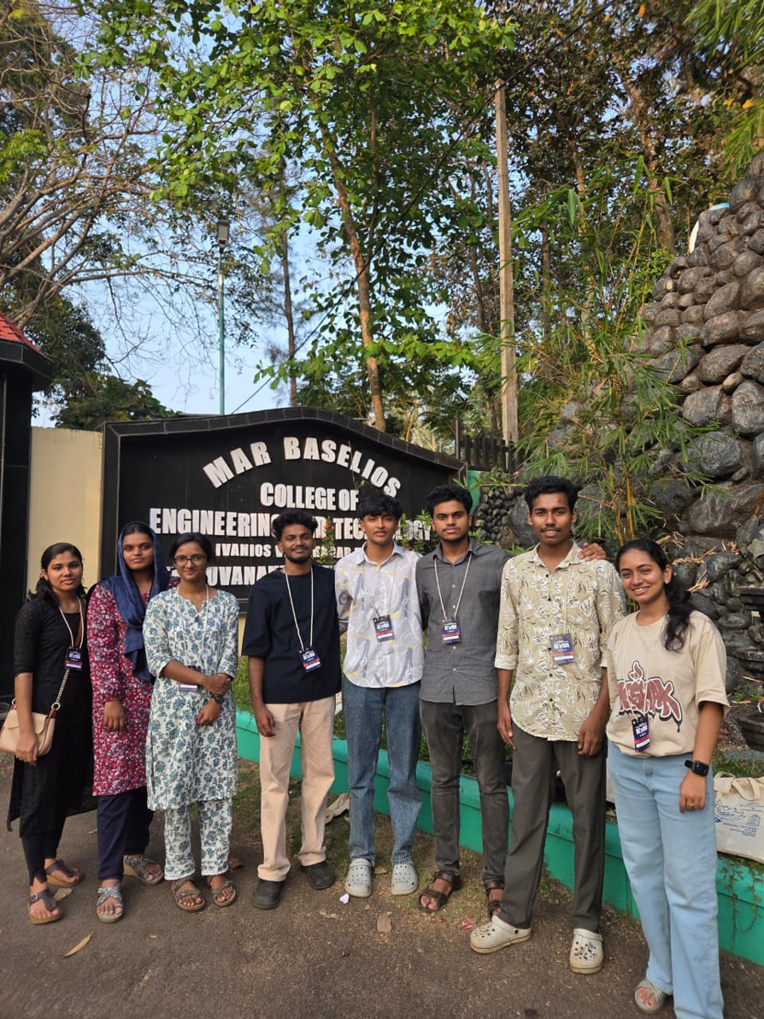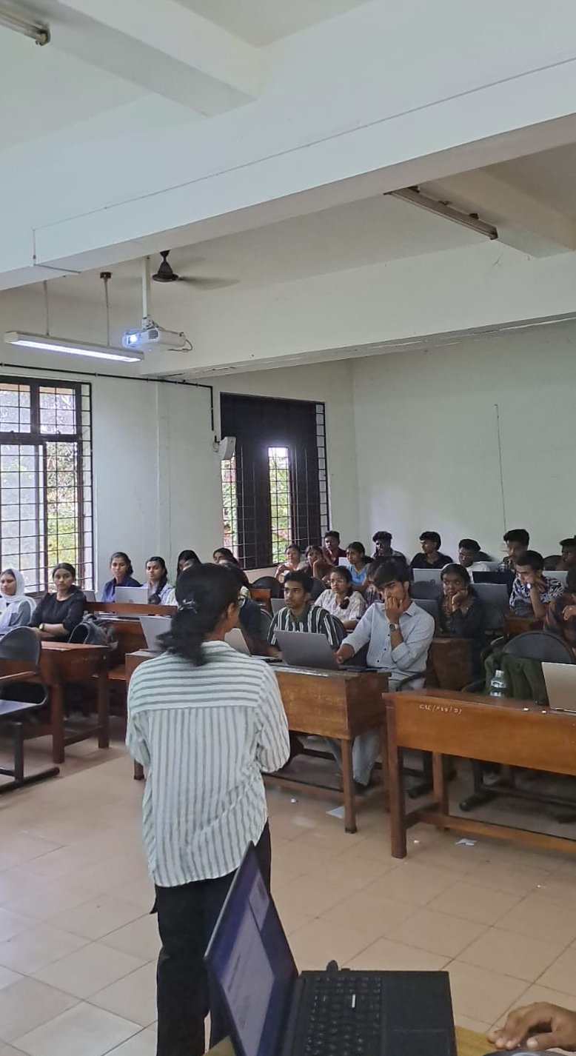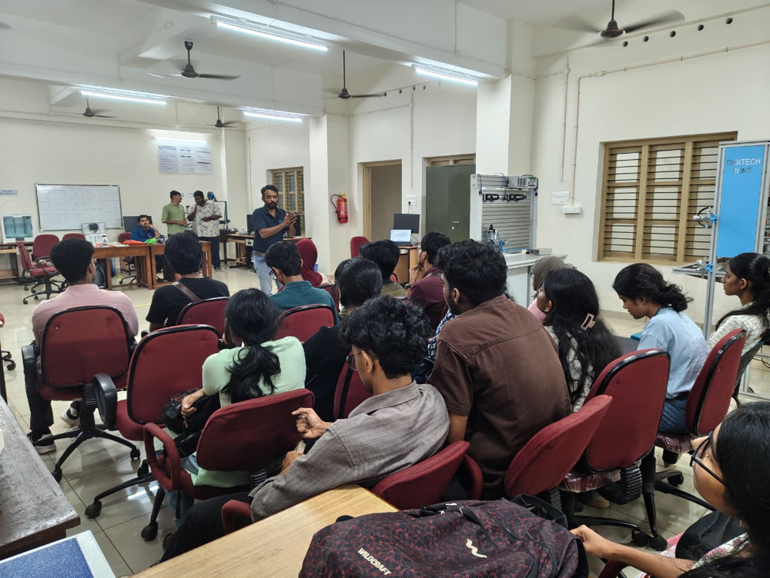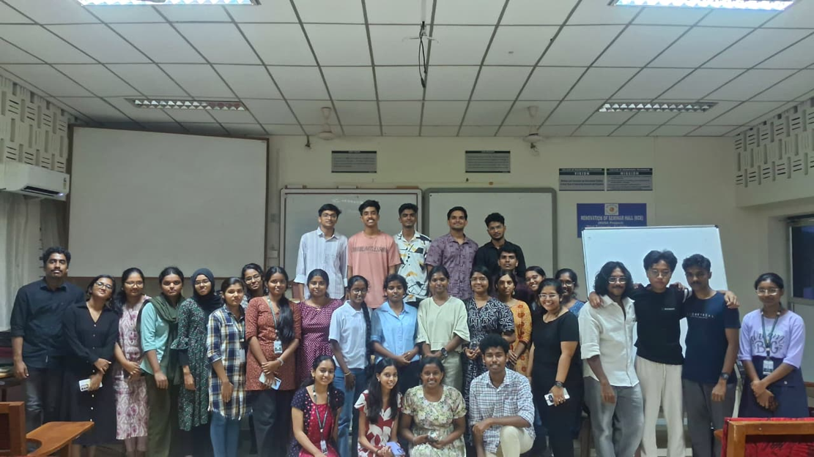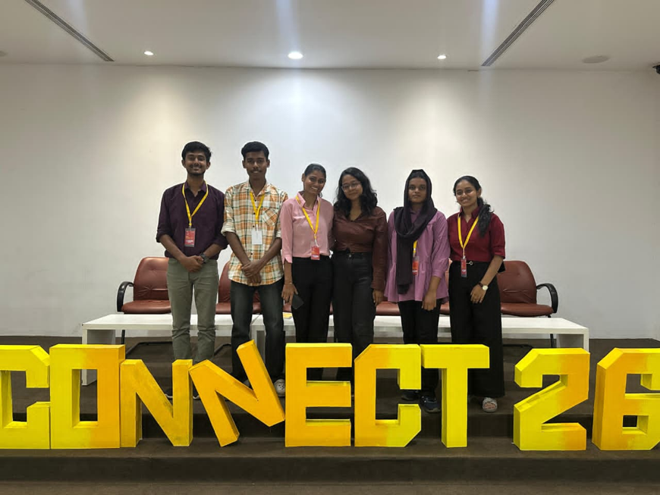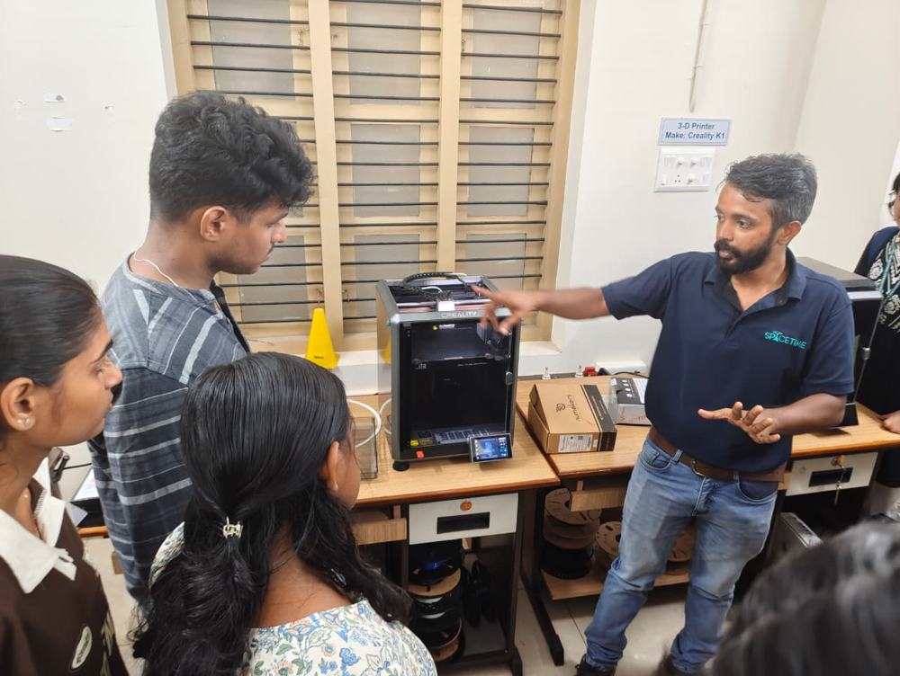

Achievements
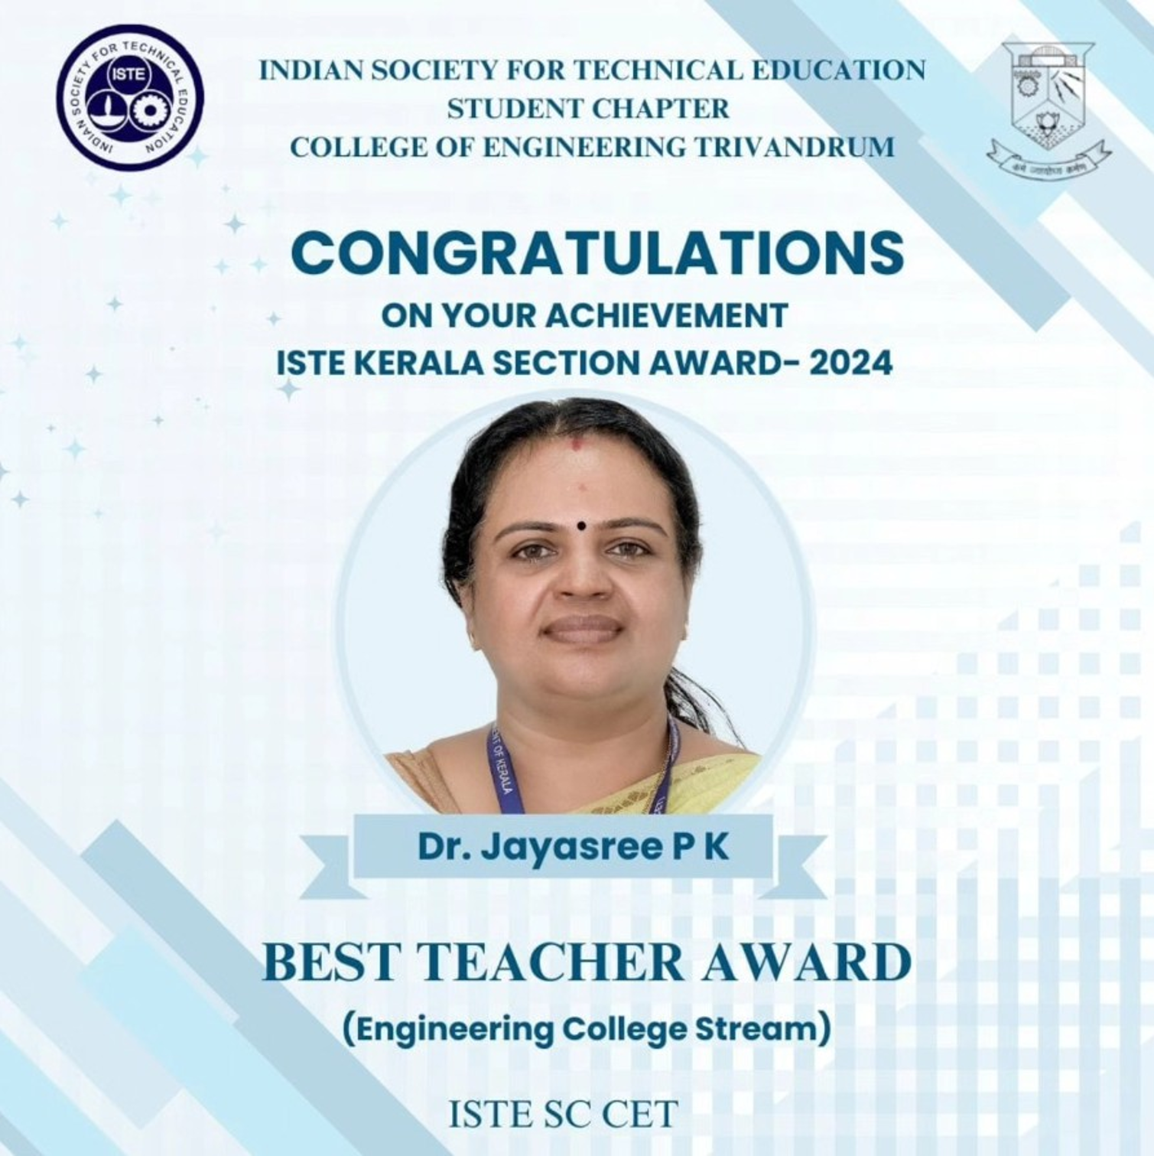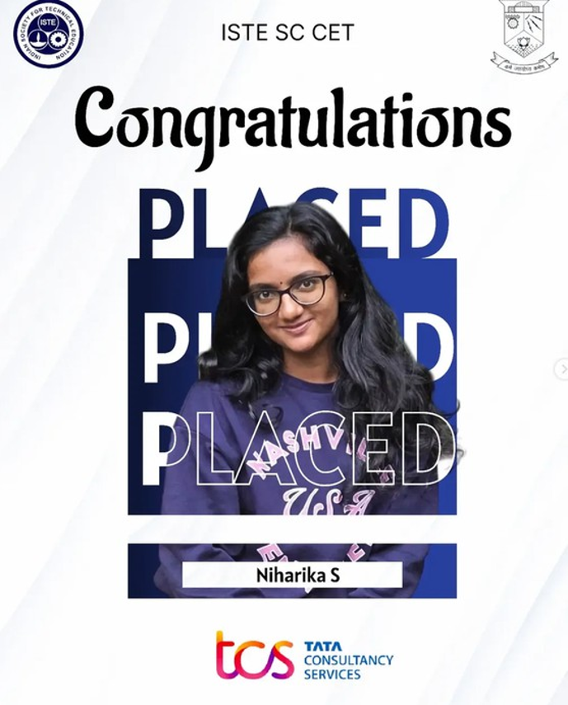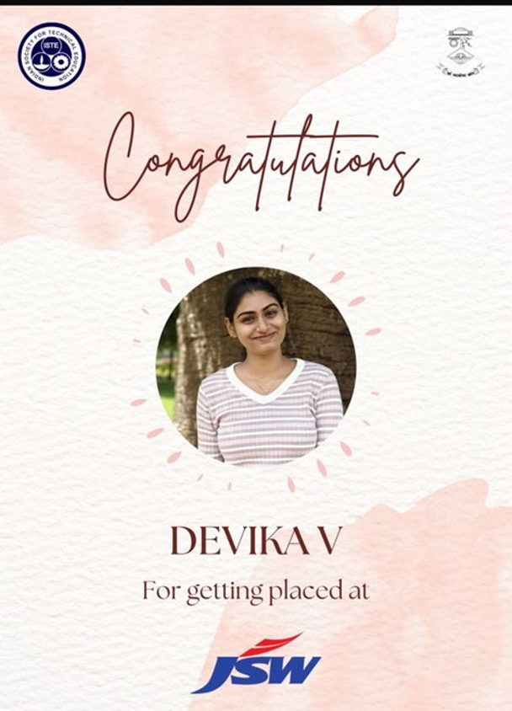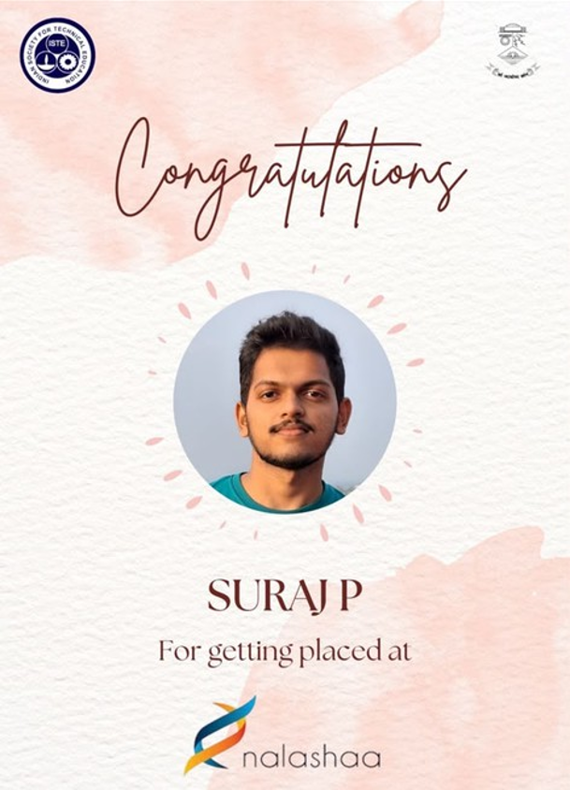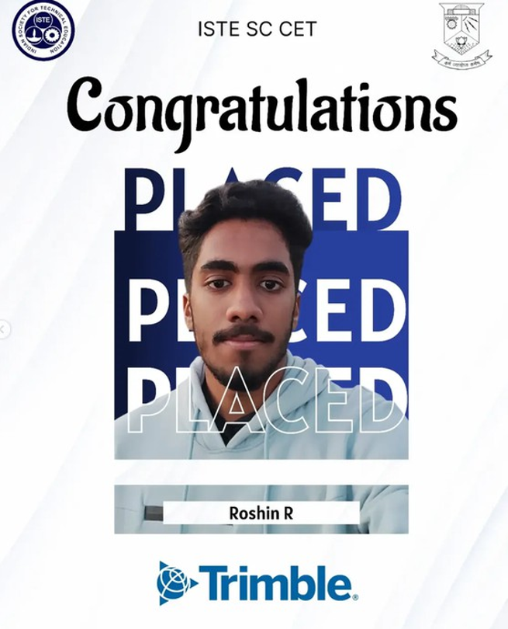
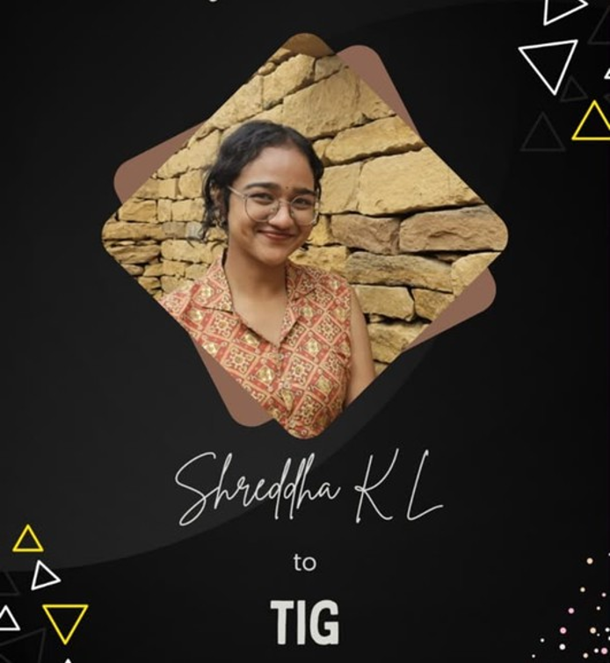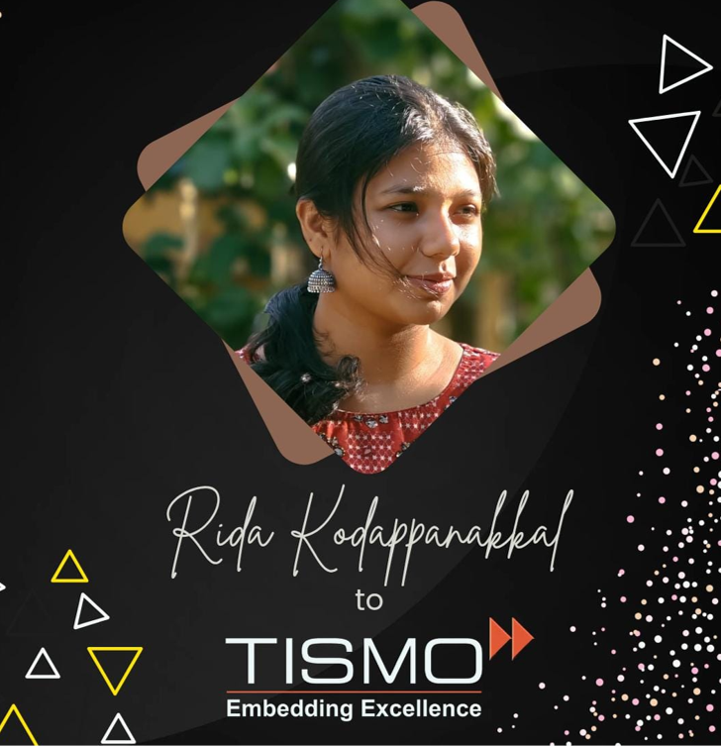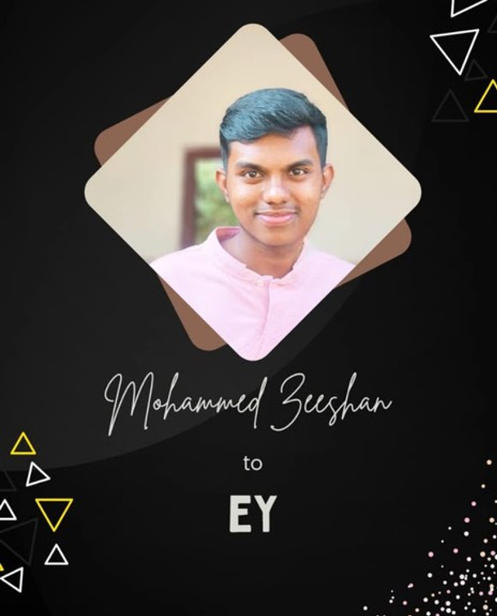
Membership - how to join, benefits, registration form/link

Blog/Newsletter (optional) - technical articles, member write-ups

Resources - study materials, past event slides/recordings

Contact Us
Email: iste@cet.ac.in
Website: iste@cet.ac.in
Instagram: https://www.instagram.com/iste_sc_cet/
LinkedIn: https://www.linkedin.com/company/iste-sc-cet/posts/?feedView=all
WhatsApp community: https://chat.whatsapp.com/GYn2aTp77gnLGBllVCvxHX

