Complete System Documentation Package
Rwanda NBSAP Monitoring Dashboard 2025-2030

Document Reference: NBSAP-DOC-PKG-2026-000
Version: 1.0
Date: 20 June 2026
Prepared by: Joe Karanga
Status: Draft
Classification: Confidential — REMA Internal Use
Contains: Requirements Specification | Business Process Document | Software Requirements Specification | System Architecture Document

Document Control

Version History
Version | Date | Author | Description of Change
0.1 | 01 June 2026 | Joe Karanga | Initial draft structure for all four constituent documents
0.5 | 12 June 2026 | Joe Karanga | Populated content from internal NBSAP system documentation
1.0 | 20 June 2026 | Joe Karanga | First complete draft of the combined documentation package

Document Custodian
Role | Details
Document Owner | REMA — Department of Biodiversity & Landscape Management
Prepared By | Joe Karanga
Organization | Rwanda Environment Management Authority (REMA)
Classification | Confidential — REMA Internal Use
Review Cycle | Reviewed at each major system release or annually, whichever is sooner

How to Use This Document
Audience | Recommended Starting Point
Executives / Approvers | Part 1 (Requirements Specification) Section 1, and the Document Approval section of each Part
Business / Process Owners | Part 2 (Business Process Document) — As-Is/To-Be workflows and approval flows
Developers / QA | Part 3 (Software Requirements Specification) — use cases, validation rules, error handling
Architects / DevOps / ICT Audit | Part 4 (System Architecture Document) — tech stack, database, infrastructure, security

PART 1 OF 4

RS

Requirements Specification Document

Defines the functional and non-functional requirements, business rules, user roles, and data requirements that govern the system.

1. Introduction

1.1 Purpose
This Requirements Specification (RS) document defines the functional and non-functional requirements for the Rwanda NBSAP Monitoring Dashboard, the national digital platform used by the Rwanda Environment Management Authority (REMA) to track progress against Rwanda's 22 National Biodiversity Strategy and Action Plan (NBSAP) 2025-2030 targets. It is the authoritative reference for system capabilities, acceptance criteria, and stakeholder expectations, and is used by REMA management, lead government ministries, system developers, and government ICT auditors to confirm that the delivered system meets agreed requirements before and after deployment.

1.2 Scope
This document covers all modules of the NBSAP Monitoring Dashboard: user authentication and role-based access control; the seven-tool reporting toolkit (T01-T07); the data verification and approval queue; automated national metric computation; the executive dashboard and 22-target progress monitoring; the geographic information system (GIS) map of Rwanda's 30 districts; data export and Convention on Biological Diversity (CBD) reporting; the audit log; risk and compliance management; and user/role administration. It excludes third-party systems that the platform integrates with (GBIF, RBIS, Supabase Cloud) except where their interfaces directly affect NBSAP Dashboard behaviour.

1.3 Definitions & Abbreviations
Term / Acronym | Definition
RS | Requirements Specification — this document, defining what the system must do
FR | Functional Requirement — a capability the system must provide
NFR | Non-Functional Requirement — a quality attribute (performance, security, availability)
BR | Business Rule — a constraint or policy the system must enforce
RBAC | Role-Based Access Control — restricting system actions based on assigned user role
API | Application Programming Interface — a defined interface for system-to-system communication
CRUD | Create, Read, Update, Delete — the four basic data operations
SLA | Service Level Agreement — a committed target for performance or availability
NBSAP | National Biodiversity Strategy and Action Plan 2025-2030 (Rwanda)
KM-GBF | Kunming-Montreal Global Biodiversity Framework — the 2022 international framework of 23 global targets that Rwanda's 22 national targets are mapped to
CBD | Convention on Biological Diversity — the international treaty under which Rwanda reports progress
RLS | Row-Level Security — PostgreSQL feature enforcing data access rules at the database layer
REMA | Rwanda Environment Management Authority — the system owner and lead administering agency
T01-T07 | The seven structured reporting tools covering institutional, ecosystem, protected area, human-wildlife conflict, finance, EIA compliance, and community engagement data

1.4 Document Conventions
Requirements in this document are identified using the naming format [TYPE-XXX] or [TYPE-CATEGORY-XX], where TYPE indicates the requirement class (FR for functional, NFR for non-functional, BR for business rule) and the numeric suffix is a unique sequential identifier within that category, for example FR-AUTH-01 or NFR-SEC-03. Priority is expressed using MoSCoW terms: Must Have, Should Have, Could Have, Won't Have (this release). Every requirement in this document is traceable to a corresponding test case in the project's acceptance test plan.

1.5 Regulatory Context
The system operates within, and is designed to actively support, the following national and international frameworks.
Framework | Relevance
Convention on Biological Diversity (CBD) | Rwanda is a signatory; the system supports National Report preparation and structured data export for CBD submission
Kunming-Montreal Global Biodiversity Framework (2022) | 23 global targets; Rwanda's 22 national NBSAP targets are mapped to these and organised by 4 KM-GBF Goals (A-D)
Rwanda NBSAP 2025-2030 | The system's primary policy instrument; all 22 targets and ~80 indicators are drawn directly from this strategy
Rwanda ICT Policy | The system aligns with national digital government transformation objectives
Rwanda Data Protection Law (2021) | User data handling, retention, and access control comply with national data protection requirements

1.6 Stakeholder Analysis
Stakeholder | Role in System | Key Needs
REMA | System owner, administrator | Full oversight, data verification, user management, CBD reporting
Lead Government Ministries | Data providers (T01-T07 reports) | Structured reporting tools, verification feedback, analytics
District Reporting Officers | Field-level data entry | Simple forms, evidence upload, submission tracking
Policy Monitors | Strategic oversight | Read-only dashboards, national progress summaries
Development Partners | Programme alignment | Analytical views, indicator data access
General Public | Transparency audience | View-only access to dashboards and maps
CBD Secretariat | International reporting body | Structured indicator data in exportable formats

1.7 Stakeholder Interaction Model
CBD Secretariat <--- Export (CSV/PDF/JSON) <--- REMA Administrators
^
Verify & Approve
^
Ministry Reporters ---> Submit Reports (T01-T07)
District Officers ---> Submit Reports (T02-T04)
|
Policy Monitors <--- View Dashboards (read-only)
Dev Partners <--- View Analytics (read-only)
Public <--- View Dashboard & Map (read-only)

2. Functional Requirements
Functional requirements describe the specific behaviours, features, and capabilities the NBSAP Monitoring Dashboard must provide to its users. Each requirement below is uniquely identified, prioritised using MoSCoW, and annotated with implementation notes drawn from the current system design.

2.1 User Authentication & Access
ID | Requirement | Priority | Notes
FR-AUTH-01 | The system shall authenticate users via email and password using JWT tokens issued by Supabase Auth | Must Have | 1-hour access token; auto-refresh
FR-AUTH-02 | Sessions shall auto-refresh without requiring re-login during active use | Must Have | Handled by Supabase client SDK
FR-AUTH-03 | The system shall support a formal role-change request and approval workflow (no self-service OAuth/SSO in current release) | Should Have | Future: institutional SSO via Rwanda e-Gov
FR-AUTH-04 | Administrators shall be able to suspend or permanently deactivate user accounts, with reason and optional auto-reactivation date | Must Have | Audit-logged action
FR-AUTH-05 | All authentication events (login, logout, failed attempt, password reset) shall be recorded in the immutable audit log | Must Have | Append-only audit_log table

2.2 Core Business Functions
ID | Requirement | Priority | Notes
FR-CRUD-01 | The system shall support create, read, update, and delete operations on reports, indicators, targets, and reference data, scoped by role | Must Have | Enforced via RLS
FR-RPT-01 | The system shall provide seven structured reporting tools (T01-T07) covering all NBSAP sectors | Must Have | Institutional, ecosystem, protected area, HWC, finance, EIA, community
FR-RPT-02 | Each report shall support file/evidence attachments (documents, images) stored in secure cloud storage | Must Have | Supabase Storage, access-policy controlled
FR-VRF-01 | All submitted reports shall enter a mandatory verification queue before affecting national metrics | Must Have | No data bypasses the approval gate
FR-AUD-01 | The system shall maintain an immutable, append-only audit log of all significant system actions | Must Have | Records user identity, action, timestamp, affected record
FR-LNG-01 | The current release shall be delivered in English, with the data model designed to accommodate Kinyarwanda and French translations in a future release | Could Have | Multi-language is a roadmap item

2.3 Reporting & Analytics
ID | Requirement | Priority | Notes
FR-DSH-01 | The dashboard shall display 13 automated, real-time KPI metrics summarising national biodiversity status | Must Have | Trigger-computed, no manual entry
FR-EXP-01 | The system shall export data in CSV format for spreadsheet analysis | Must Have | Filterable by tool, district, target, date
FR-EXP-02 | The system shall export formatted PDF reports and structured JSON for system interoperability | Should Have | PDF for distribution, JSON for CBD tooling
FR-DSH-02 | Charts shall visualise indicator trends and the progress of all 22 NBSAP targets, organised by the four KM-GBF Goals | Must Have | Recharts-based visualisations

3. Non-Functional Requirements

3.1 Performance
ID | Requirement | Target / Metric
NFR-PERF-01 | Initial page load time | < 3 seconds on a 4G connection
NFR-PERF-02 | API response time for standard queries | < 500ms (p95)
NFR-PERF-03 | Concurrent user capacity | 500 simultaneous users
NFR-PERF-04 | Database query time for dashboard aggregation | < 200ms (p50), supported by 20+ indexes
NFR-PERF-05 | Evidence file upload time (typical document/image) | < 5 seconds on standard broadband

3.2 Security
ID | Requirement | Standard / Reference
NFR-SEC-01 | All traffic shall be encrypted via HTTPS/TLS | TLS 1.2+, Vercel-managed certificates
NFR-SEC-02 | Data at rest shall be encrypted | AES-256, Supabase managed encryption
NFR-SEC-03 | Passwords shall be hashed, never stored in plaintext | bcrypt via Supabase Auth
NFR-SEC-04 | The system shall undergo periodic security assessment against common web vulnerabilities | OWASP Top 10
NFR-SEC-05 | User sessions shall expire and require refresh after a defined inactivity period | JWT 1-hour access token with auto-refresh
NFR-SEC-06 | All user input shall be validated and sanitised before storage or display | Client-side validation + DB constraints

3.3 Availability & Reliability
ID | Requirement | Target
NFR-AVL-01 | System uptime | 99.5% annually
NFR-AVL-02 | Scheduled maintenance window | Off-peak hours, communicated 48 hours in advance
NFR-AVL-03 | Recovery Time Objective (RTO) | 4 hours
NFR-AVL-04 | Recovery Point Objective (RPO) | 24 hours
NFR-AVL-05 | Database backup frequency | Daily automated backup (Supabase managed)

3.4 Scalability & Maintainability
ID | Requirement | Details
NFR-SCL-01 | The architecture shall support horizontal scaling without code changes | Serverless BaaS (Supabase) + CDN-hosted frontend (Vercel)
NFR-SCL-02 | The system shall accommodate growth in report volume without redesign | 10,000+ report capacity on current tier
NFR-SCL-03 | The codebase shall be maintainable by future development teams | TypeScript throughout; ~15,000+ lines across 50+ components
NFR-SCL-04 | Deployments shall be automated and require no manual server configuration | Git push to main triggers Vercel CI/CD build and deploy

4. Business Rules
Business rules are policy-driven constraints that the system enforces independently of any single feature. They protect data integrity, ensure separation of duties, and uphold REMA's governance requirements for national biodiversity reporting.
ID | Business Rule | Category | Enforcement
BR-01 | A reference record (district, target, indicator) with dependent reports cannot be deleted while dependents exist | Referential Integrity | Database foreign-key constraints
BR-02 | Reports affecting national metrics require approval by an authorised reviewer before they take effect | Approval Threshold | Verification Queue workflow + DB trigger gate
BR-03 | A reviewer cannot approve their own submitted report | Self-Approval Prohibition | Application logic + audit check
BR-04 | Monetary values (budgets, disbursements) shall be recorded and displayed in Rwandan Francs (RWF) with standard thousands formatting | Currency Formatting | Frontend formatting utility
BR-05 | The current release is delivered in English only; all user-facing text shall be sourced from a single language resource for future translation | Language Compliance | Centralised string resources
BR-06 | User accounts inactive for an extended period may be flagged and, if configured, automatically suspended by an administrator action | Account Lifecycle | Admin-initiated suspension with audit log
BR-07 | Submitted reports and audit log entries are retained for the duration of the NBSAP 2025-2030 period at minimum before archival review | Data Archival Age | Retention policy (Section 7.3)
BR-08 | Duplicate report submissions for the same district, tool, and reporting period shall be flagged for reviewer attention | Duplicate Rejection | Validation check at submission + reviewer judgement

5. User Roles & Permissions

5.1 Role Definitions
Role | Description | Typical Users
REMA Administrator | Full system oversight: user management, data verification, audit log access, and system configuration. The only role with unrestricted access. | REMA Department of Biodiversity & Landscape Management staff
Sector Reporter | Submits and can approve structured reports across the seven reporting tools; can export raw data for sectoral analysis. | Lead ministry focal points (Agriculture, Forestry, Mining, Water)
Local Reporter | Submits district-level reports restricted to their own district; cannot approve submissions. | District Reporting Officers, local environment offices
Policy Monitor | Read-only strategic oversight of dashboards, targets, and indicators; no submission or approval rights. | Ministry of Environment oversight personnel, policy analysts
Development Partner | Read-only analytical access to indicator data and programme alignment views for donor coordination. | UNDP, GIZ, World Bank and other NBSAP development partners
Public Viewer | Read-only public access to dashboards and the biodiversity map; no access to reports, audit logs, or user data. | General public, journalists, students, researchers

5.2 Permission Matrix
The matrix below summarises access by feature for the five roles with system access beyond pure public viewing. Development Partner access mirrors the Policy Monitor (read-only analytical) row; Public Viewer is included as the most restricted profile.
Feature / Module | REMA Admin | Sector Reporter | Local Reporter | Policy Monitor | Public Viewer
Create Records | ✓ | ✓ | Own district only | ✗ | ✗
Edit Records | ✓ | Own only | Own only | ✗ | ✗
Delete Records | ✓ | ✗ | ✗ | ✗ | ✗
Approve / Reject | ✓ | ✓ | ✗ | ✗ | ✗
View All Records | ✓ | Limited | Own district only | ✓ | Limited
Generate Reports | ✓ | ✓ | Limited | Read-only | ✗
Manage Users | ✓ | ✗ | ✗ | ✗ | ✗
System Configuration | ✓ | ✗ | ✗ | ✗ | ✗
View Audit Logs | ✓ | ✗ | ✗ | ✗ | ✗

6. System Integrations

6.1 Integration Overview
The NBSAP Monitoring Dashboard integrates with several external systems and services to enrich its biodiversity data, manage authentication, and operate reliably at national scale.
ID | System / Service | Integration Type | Direction | Protocol | Priority
INT-01 | Supabase Auth (email) | Authentication | Bidirectional | HTTPS / JWT | Must Have
INT-02 | Supabase Realtime | Live data push | Outbound (push) | WebSocket (WSS) | Must Have
INT-03 | GBIF API (species data) | Data feed | Inbound | HTTPS REST | Should Have
INT-04 | RBIS (Rwanda Biodiversity Information System) | Data feed | Inbound | HTTPS REST (Bearer token) | Should Have
INT-05 | Supabase Storage | File/evidence storage | Bidirectional | HTTPS (S3-compatible) | Must Have
INT-06 | GIS / GeoJSON map layers | Static reference data | Inbound | HTTPS (CDN static assets) | Must Have
INT-07 | Government CBD reporting tools (future) | Document/Data exchange | Outbound | File export (CSV/PDF/JSON) | Could Have

6.2 Integration Requirements
ID | Requirement
INT-REQ-01 | All external integrations shall use HTTPS; no integration shall transmit data over unencrypted HTTP
INT-REQ-02 | API keys, bearer tokens, and service credentials shall be stored as environment secrets, never committed to source control
INT-REQ-03 | Integration failures shall be logged and, for critical integrations, trigger an operational alert
INT-REQ-04 | Outbound calls to rate-limited external APIs (e.g. GBIF) shall implement client-side rate limiting and retry logic
INT-REQ-05 | Data received from external sources shall be validated before being rendered or stored

7. Data Requirements

7.1 Core Data Entities
Entity | Description | Key Attributes | Relationships
User / Profile | A registered system user with an assigned role | id, email, full_name, role, organisation, status | Has many Reports; has many Audit Log entries
Report (toolkit_reports) | A structured submission under one of the T01-T07 tools | id, tool_type, district_id, form_data (JSONB), status, submitted_by, reviewed_by | Belongs to User (submitter, reviewer); has many Attachments
Attachment | Evidence file linked to a report | id, report_id, file_url, file_type, uploaded_at | Belongs to Report
Audit Log Entry | Immutable record of a significant system action | id, user_id, action, table_name, record_id, timestamp | Belongs to User
Notification | Per-user alert about a relevant system event | id, user_id, type, message, is_read, created_at | Belongs to User
Reference / Lookup (district, target, indicator) | Static or semi-static reference data underpinning reports and dashboards | id, name, code, parent references | Referenced by Reports and Indicators

7.2 Data Quality Requirements
ID | Requirement
DQ-01 | Mandatory fields shall be enforced at both the form layer and the database constraint layer
DQ-02 | Date fields shall be stored and exchanged in ISO 8601 format (YYYY-MM-DD)
DQ-03 | Email fields shall be validated against RFC 5322 syntax and checked for uniqueness on user creation
DQ-04 | Numeric fields (hectares, budgets, counts) shall enforce defined precision (typically 2 decimal places) and valid ranges
DQ-05 | Free-text fields shall enforce a documented maximum length appropriate to the field's purpose
DQ-06 | The system shall flag likely duplicate submissions based on matching district, tool, and reporting period
DQ-07 | Every record shall carry CreatedAt, CreatedBy, UpdatedAt, and UpdatedBy metadata fields

7.3 Data Retention Policy
Data Category | Retention Period | Post-Retention Action
Active reports & indicators | Duration of NBSAP 2025-2030 period (minimum) | Reviewed for archival, not deleted
Audit logs | Indefinite | Retained for regulatory compliance
Authentication logs | 12 months minimum | Reviewed and archived
Database backups | 7 days (free tier) / 30 days (pro tier) | Rolling deletion of oldest backup
Archived/superseded records | Indefinite, in archived state | Retained read-only, excluded from active dashboards

7.4 Data Sources
Source | Type | Frequency | Description
Manual Entry | Structured forms | Quarterly / Ad hoc | T01-T07 reporting toolkit submissions
GBIF API | Automated feed | Real-time | Species occurrence records for Rwanda
RBIS API | Automated feed | Real-time | Rwanda Biodiversity Information System data streams
GeoJSON Files | Static reference | At deployment | District boundaries, protected areas, rivers, lakes

8. Constraints & Assumptions

8.1 Constraints
Constraint | Description
Budget | System designed for minimal operational cost, using free/low-tier cloud services (Supabase, Vercel)
Connectivity | Users in some districts may have limited bandwidth; the system is optimised for low-bandwidth conditions
Browser support | Internet Explorer 11 is not supported; modern browsers required (Chrome 90+, Firefox 88+, Safari 14+, Edge 90+)
Language | The current release is delivered in English only

8.2 Assumptions
Assumption | Rationale
District officers have internet access | Rwanda's national broadband coverage exceeds 95% of urban areas
REMA will designate system administrators | Ongoing user and data management requires institutional commitment
GBIF API will remain publicly accessible | GBIF is a multilateral research infrastructure with long-term funding
Supabase will maintain service availability | Supabase provides managed PostgreSQL with a 99.9% uptime SLA

9. Acceptance Criteria Summary
Category | Criterion
Authentication | Users can register, log in, and maintain sessions without re-authentication
RBAC | Each of the 6 roles can access only their authorised pages and actions
Reporting | All 7 reporting tools (T01-T07) accept, validate, and store submissions
Verification | The approval/rejection workflow operates correctly with automatic metric update
Dashboard | The executive dashboard displays all 13 automated metrics accurately
Map | The interactive map renders all 30 districts with toggleable GeoJSON layers
Export | CSV, PDF, and JSON exports produce correct, complete data
Audit | The audit log records all significant system actions immutably
Performance | The system loads within 3 seconds and supports 500 concurrent users
Security | RLS, HTTPS, CSP headers, and JWT authentication are all operational

10. Document Approval
The undersigned confirm that this Requirements Specification Document has been reviewed and is approved as the authoritative reference for the Rwanda NBSAP Monitoring Dashboard.

Role | Name | Signature | Date
Prepared by | Joe Karanga
Reviewed by
Approved by (REMA)
Approved by (Ministry of Environment)
PART 2 OF 4

BPD

Business Process Document

Maps the end-to-end business process — from field data submission through verification to national CBD-ready reporting.

1. Introduction

1.1 Purpose
This Business Process Document (BPD) describes the business processes automated by the Rwanda NBSAP Monitoring Dashboard. It maps the end-to-end workflow from field data collection through verification to national CBD reporting, identifying process owners, decision points, and system touch-points at each stage. It should be read by REMA process owners, ministry and district reporting staff, and anyone responsible for training users or auditing process compliance.

1.2 Process Overview
Process in Focus
Data Collection, Verification & National Target Reporting — the core end-to-end business process by which Rwanda's biodiversity data moves from field submission to verified national metric to CBD-ready export.

Attribute | Details
Process Owner | REMA Department of Biodiversity & Landscape Management
Start Trigger | Reporting period deadline, or occurrence of a reportable event (e.g. a human-wildlife conflict incident)
End Condition | Report is approved and reflected in national metrics, or rejected and returned for revision
Frequency | Quarterly scheduled reporting, plus ad hoc event-driven submissions
Volume | Target of 50+ reports per quarter across all seven tools and 30 districts
Affected Departments | Lead ministries (Agriculture, Forestry, Mining, Water), District Environment Offices, REMA
Regulatory Reference | Rwanda NBSAP 2025-2030; Kunming-Montreal Global Biodiversity Framework; CBD National Reporting obligations

2. Current Workflow (As-Is)

2.1 Description
Prior to the NBSAP Monitoring Dashboard, biodiversity data collection and national reporting relied on a manual, spreadsheet- and email-based process. District and ministry staff completed reports in offline templates (Excel/Word), routed them through email for review, and REMA staff manually consolidated figures into national summaries. The As-Is process below describes this existing manual workflow.

2.2 As-Is Process Steps
Step # | Activity | Who (Actor) | How (Method) | Time Taken | Pain Points
1 | Receive reporting period notice | District/Ministry Reporter | Email circular from REMA | 1 day | Notices missed or buried in inboxes; no tracking of who received them
2 | Complete report template | District/Ministry Reporter | Offline Excel/Word template | 2-5 days | Inconsistent formats between districts; manual data entry errors
3 | Gather supporting evidence | District/Ministry Reporter | Photographs, scanned documents emailed separately | 1-2 days | Evidence often disconnected from the report it supports
4 | Submit completed report | District/Ministry Reporter | Email attachment to REMA focal point | Same day | No confirmation of receipt; emails lost or misdirected
5 | Review submission | REMA Reviewer | Manual review of spreadsheet against prior submissions | 3-7 days | No standard checklist; quality varies by reviewer; slow turnaround
6 | Consolidate approved data | REMA Reviewer | Manual copy-paste into master tracking spreadsheet | 2-4 days | High risk of transcription error; master file version conflicts
7 | Recalculate national progress | REMA Analyst | Manual spreadsheet formulas re-run after each consolidation | 1-2 days | Formulas break; progress figures go stale between updates
8 | Report to management / CBD | REMA Senior Management | Manually compiled PowerPoint/Word report | 1 week | Labour-intensive; figures often weeks out of date by the time they are presented

2.3 As-Is Process Diagram
+------------------+ +------------------+ +-------------------+
| District/Ministry| --> | Email Template | --> | REMA Manual |
| completes form | | Submission | | Review |
+------------------+ +------------------+ +-------------------+
|
v
+------------------+ +------------------+ +-------------------+
| Management/CBD | <-- | Manual Progress | <-- | Manual Spreadsheet|
| Report (manual) | | Recalculation | | Consolidation |
+------------------+ +------------------+ +-------------------+
Note: This is a simplified text representation. Replace with a formal BPMN diagram (draw.io, Lucidchart, Visio, or Figma) for the final published document.

2.4 As-Is Pain Points Summary
# | Pain Point | Impact | Severity
1 | No standard submission tracking — reporters unsure if reports were received | Missed deadlines; repeated follow-up emails | High
2 | Inconsistent report formats across districts and ministries | Time lost reconciling data before it can be aggregated | High
3 | No mandatory evidence linkage to specific data points | Difficult to verify claims during audit or CBD review | Medium
4 | Manual consolidation introduces transcription errors | National figures sometimes inaccurate or inconsistent | High
5 | No audit trail of who approved or changed a figure | Accountability gaps; difficult to investigate discrepancies | High
6 | Progress figures stale between manual recalculation cycles | Management decisions based on outdated information | Medium
7 | No real-time visibility for non-REMA stakeholders (donors, public) | Reduced transparency; repeated ad hoc information requests | Medium

3. Proposed Workflow (To-Be)

3.1 Description
The NBSAP Monitoring Dashboard digitises the entire reporting lifecycle. Structured online forms replace offline templates, a built-in verification queue replaces ad hoc email review, and database triggers replace manual spreadsheet recalculation. The result is a single source of truth that updates in real time as reports are approved, with a complete and immutable audit trail of every action.

3.2 To-Be Process Steps
Step # | Activity | Who (Actor) | How (System) | Est. Time | Improvement
1 | Reporting period reminder | System | In-app + real-time notification on login | Instant | Guaranteed delivery; tracked read status
2 | Complete structured report (T01-T07) | District/Ministry Reporter | Web form with validation and pre-filled identity/timestamp | 30-60 min | Consistent structure; validation prevents bad data at entry
3 | Attach supporting evidence | District/Ministry Reporter | Direct upload to Supabase Storage, linked to the report record | 5-10 min | Evidence permanently linked to the exact submission
4 | Submit report | District/Ministry Reporter | One-click submit; status set to 'pending' | Instant | Immediate confirmation; full submission history visible to reporter
5 | Review submission | REMA / Sector Reviewer | Verification Queue with side-by-side data and evidence view | < 48 hours | Standardised review screen; SLA-tracked turnaround
6 | Approve or reject | REMA / Sector Reviewer | One-click Approve/Reject with mandatory comment on rejection | Instant | Decision and rationale captured immediately and immutably
7 | Recalculate national progress | System (database trigger) | Automatic trigger-driven metric and target progress update | < 1 second | Always current; zero manual calculation, zero formula errors
8 | Report to management / CBD | REMA Senior Management | Live dashboard plus one-click CSV/PDF/JSON export | Minutes | Always up to date; export-ready in CBD 3-tier indicator structure

3.3 To-Be Process Diagram
+------------------+ +------------------+ +-------------------+
| Reporter submits | --> | Verification | --> | Approve / Reject |
| via web form | | Queue (REMA) | | (with audit log) |
+------------------+ +------------------+ +-------------------+
|
v (on approve)
+------------------+ +------------------+ +-------------------+
| Live Dashboard | <-- | Target Progress | <-- | DB Trigger: |
| + CBD Export | | Auto-Updated | | Metric Calc |
+------------------+ +------------------+ +-------------------+
Note: This is a simplified text representation. Replace with a formal BPMN diagram (draw.io, Lucidchart, Visio, or Figma) for the final published document.

3.4 As-Is vs To-Be Comparison
Dimension | As-Is (Current) | To-Be (Proposed)
Data Entry | Offline spreadsheet/Word templates, inconsistent formats | Structured online forms with built-in validation
Assignment | Ad hoc email distribution, no tracking | Role-based access; system tracks who must report
Approval Process | Informal email review, no SLA | Formal Verification Queue with approve/reject and SLA tracking
Audit Trail | None — changes untracked | Immutable, append-only audit log of every action
Reporting | Manual PowerPoint/Word compiled weekly to monthly | Live executive dashboard, always current
Notifications | Manual email follow-up | Automated in-app and real-time WebSocket notifications
Data Retrieval | Search through email threads and shared drives | Searchable, filterable database with export
Data Quality | Manual checks, transcription errors common | Form validation plus mandatory reviewer verification gate
Scalability | Breaks down as district/ministry count grows | Scales to all 30 districts and unlimited reporters without added manual effort

4. Approval Flows

4.1 Standard Approval Flow
Stage | Action | Actor | System Behaviour | SLA
Submission | Reporter submits completed form | District/Ministry Reporter | Status set to 'pending'; audit log entry created | Instant
Notification | Reviewers alerted to new submission | System | Real-time WebSocket + in-app notification to authorised reviewers | Instant
Review | Reviewer examines data, evidence, and history | Authorised Reviewer | Verification Queue displays full submission context | < 48 hours
Approval | Reviewer approves the submission | Authorised Reviewer | Status -> 'approved'; metrics auto-updated; reporter notified | Instant on decision
Rejection | Reviewer rejects with mandatory reason | Authorised Reviewer | Status -> 'rejected'; reporter notified with reason | Instant on decision
Revision (if rejected) | Reporter revises and resubmits | District/Ministry Reporter | New submission re-enters the queue | Reporter-dependent
Escalation | Submission exceeds SLA without review | System | Escalation notification to REMA Administrator | After 48 hours pending

4.2 Multi-Level Approval Flow
While most NBSAP reports follow the single-stage approval flow above, higher-value or sensitive submissions (e.g. large finance disbursements, EIA compliance escalations) may require multi-level review:
Level | Approver | Threshold / Trigger | Action
Level 1 | Sector Reporter (peer review) | All T05 finance and T06 EIA compliance submissions | Initial data-quality check before escalation
Level 2 | REMA Department Reviewer | Submissions exceeding district-level materiality threshold | Substantive review and approve/reject decision
Level 3 | REMA Senior Management | National-level policy implications or repeated non-compliance | Final determination and corrective action assignment

4.3 Approval Flow Rules
Rule # | Rule Description
AR-01 | A reviewer cannot approve or reject a report they submitted themselves (self-approval prohibition)
AR-02 | No report data affects national metrics until it has passed mandatory approval
AR-03 | Every approval or rejection decision is timestamped and attributed to the deciding reviewer
AR-04 | A rejection requires a written reason; rejections without a reason cannot be submitted
AR-05 | Once a report is approved, its core data fields are locked and cannot be directly edited; corrections require a new submission
AR-06 | A submission left pending beyond the 48-hour SLA automatically triggers an escalation notification

5. Process Landscape
The NBSAP Monitoring Dashboard supports nine core business processes spanning data collection through to international CBD reporting. Sections 2-4 of this document detailed the primary collection-and-approval workflow (BP-01/BP-02); the remaining seven processes are described below.
Process ID | Process Name | Process Owner
BP-01 | Data Collection & Submission | Ministry/District Reporters
BP-02 | Data Verification & Approval | REMA Administrators / Lead Ministry Reviewers
BP-03 | Automated Metric Calculation | System (database triggers)
BP-04 | National Target Progress Monitoring | REMA Senior Management
BP-05 | User Account & Role Management | REMA Administrators
BP-06 | Role Change Request Workflow | System Users / REMA Administrators
BP-07 | Data Export & CBD Reporting | REMA Reporting Officers
BP-08 | Geographic & Biodiversity Data Integration | System (automated APIs)
BP-09 | Risk & Compliance Management | REMA / Policy Monitors

5.1 BP-03: Automated Metric Calculation
Process Owner: System (fully automated, no human intervention). Trigger: a report is approved, or a previously approved report is deleted.
Report approved
|
v
DB trigger fires on status change to 'approved'
|
v
System identifies tool type (T01-T07) and extracts metric
values from form_data JSONB (forest ha, wetland ha, HWC
incidents, budget disbursed, EIA compliance rate, etc.)
|
v
system_metrics table updated; target progress recalculated
using configurable tool_weights (weighted progress = SUM
(tool_progress x tool_weight))
|
v
WebSocket pushes real-time update to all connected browsers

On deletion of an approved report: trigger reverses all
metric contributions and recalculates affected target
progress; audit log records "Metric reversal".

5.2 BP-04: National Target Progress Monitoring
Process Owner: REMA Senior Management / Policy Monitors. The dashboard displays all 22 national targets organised by 4 KM-GBF Goals, with progress bars using a 3-colour status system.
Colour | Threshold | Meaning
Green | ≥ 70% | On track to meet 2030 target
Amber | 40% - 69% | At risk — intervention may be needed
Red | < 40% | Behind schedule — urgent attention required

5.3 BP-05: User Account & Role Management
Process Owner: REMA Administrators. New users register with a default Policy Monitor (read-only) role; an administrator then assigns the appropriate role based on institutional mandate. Ongoing management includes suspending an account (with reason and optional auto-reactivation end date), permanent deactivation, role changes, and login-activity review — every action is audit-logged.

5.4 BP-06: Role Change Request Workflow
Process Owner: requesting user (initiator) / REMA Administrator (approver). A user submits a role change request with a desired role and written justification; the request is created with status 'pending'. An administrator evaluates the justification against institutional need and either approves it — the user's role updates immediately with notification — or rejects it with a recorded reason, also notified to the user. Every decision is audit-logged.

5.5 BP-07: Data Export & CBD Reporting
Process Owner: REMA Reporting Officers. Officers select an export scope (by tool, date range, district, NBSAP target, or full dataset) and a format (CSV for spreadsheet analysis, PDF for distribution, JSON for system interoperability). For CBD reporting specifically, indicator data is mapped to the KM-GBF 3-tier structure: Headline indicators become Tier 1 (internationally comparable), Component indicators become Tier 2 (implementation detail), and Binary indicators become Tier 3 (policy condition assessments).

5.6 BP-08: Geographic & Biodiversity Data Integration
Process Owner: System (fully automated). GBIF species occurrence data is queried for Rwanda (country=RW), rate-limited to 1 request/second, proxied through a Supabase Edge Function to avoid CORS issues, and auto-refreshed on the map every 30-60 seconds. RBIS integration monitors 8 predefined data streams with tracked connection status (connected/disconnected/error) and maintains linkage to specific NBSAP indicators. Static GeoJSON layers provide Rwanda's 30 district boundaries, protected area polygons, river network lines, and lake boundaries.

5.7 BP-09: Risk & Compliance Management
Process Owner: REMA / Policy Monitors. The Risk Register categorises risks by type and severity (High/Medium/Low), with each entry recording description, likelihood, impact, mitigation, and owner; active risks are flagged for dashboard visibility and reviewed periodically. Compliance tracking monitors EIA compliance per district and sector, with compliance scores auto-calculated from T06 submissions, district-level compliance visible on the map, and non-compliance flagged for follow-up.

6. Process Integration Map
The diagram below shows how the nine business processes interact end to end.
BP-01 (Data Collection)
|
v
BP-02 (Verification)
|
+-- Approved --> BP-03 (Auto Metrics) --> BP-04 (Target Monitoring)
| |
| v
| BP-07 (Export & CBD Reporting)
|
+-- Rejected --> Back to BP-01 (Reporter revises & resubmits)

BP-05 (User Management) <--> BP-06 (Role Change Requests)

BP-08 (External Data) --> BP-04 (Target Monitoring - map & RBIS views)

BP-09 (Risk & Compliance) <-- BP-01 (fed by T06 EIA compliance data)

7. Key Performance Indicators (KPIs)
KPI | Target | Measurement Source
Average report verification turnaround | < 48 hours | Verification Queue timestamps
Percentage of districts with 'submitted' status | > 90% | District compliance tracking
Number of reports submitted per quarter | > 50 across all tools | Toolkit report counts
System uptime | 99.5% | Vercel/Supabase monitoring
Audit log completeness | 100% of system actions logged | Audit log table
CBD export readiness | Indicator data exportable in 3-tier structure | Export functionality

8. Process Improvement Opportunities
Opportunity | Current State | Future State | Priority
Automated notifications for overdue reports | Manual follow-up | Scheduled reminders to districts with 'missing' status | High
Multi-language support | English only | Kinyarwanda and French translations | Medium
Mobile application | Responsive web only | Native iOS/Android app for field data collection | Medium
Offline data collection | Online only | Offline-capable forms with sync-when-connected | Medium
Automated CBD report generation | Manual compilation from exports | One-click CBD National Report draft | High

9. Document Approval
The undersigned confirm that this Business Process Document has been reviewed and is approved as an accurate description of the Rwanda NBSAP Monitoring Dashboard's business processes.

Role | Name | Signature | Date
Prepared by | Joe Karanga
Reviewed by
Approved by (REMA)
Approved by (Ministry of Environment)
PART 3 OF 4

SRS

Software Requirements Specification

Details system use cases, behaviours, validation rules, and error handling for developers, testers, and QA.

1. Introduction

1.1 Purpose
This Software Requirements Specification (SRS) defines the technical behaviour of the Rwanda NBSAP Monitoring Dashboard: its use cases, system behaviours, validation rules, and error handling. Where the Requirements Specification (RS) describes what the system must do from a business perspective, this SRS describes precisely how the software behaves, and serves as the definitive technical reference during development, testing, and audit within the software development lifecycle (SDLC).

1.2 Intended Audience
Audience | Use of This Document
Software Developers | Implementation reference for use cases, validation logic, and error handling behaviour
QA / Testers | Source of testable conditions for use case flows, validation rules, and error scenarios
System Architects | Confirms functional behaviour aligns with the System Architecture Document
Project Managers | Tracks technical scope and acceptance criteria against the project plan
Business Stakeholders | Confirms technical behaviour matches business intent from the RS and BPD
Security Auditors | Reference for authentication, session, and error-handling controls (Sections 3 and 5)

2. Use Cases

2.1 Use Case Diagram Overview
The NBSAP Monitoring Dashboard's primary actors are: REMA Administrator, Sector Reporter, Local Reporter, Policy Monitor, Development Partner, Public Viewer, and the System itself (for automated behaviours such as metric calculation and notification dispatch). The four use cases below illustrate the core interactions common to most authenticated roles.

2.2 Use Case Specifications

UC-001: User Login
Use Case ID | UC-001
Use Case Name | User Login
Actor(s) | Any registered user (all roles)
Trigger | User navigates to the application and submits login credentials
Preconditions | User holds a registered account with a known email and password
Postconditions | A valid session (JWT access + refresh token) is established and the user is redirected to the dashboard appropriate to their role
Main Flow | 1. User enters email and password on the login screen  2. System validates credentials against the password hash (Supabase Auth)  3. System checks the account status (active / suspended / deactivated)  4. System creates a session and issues a JWT access token and refresh token  5. System redirects the user to their role-appropriate dashboard
Alternative Flow(s) | 1. Alt Flow A — MFA enabled: after step 2, system prompts for a one-time password (OTP); user enters OTP; system validates OTP before proceeding to step 3
Exception Flow(s) | 1. E1 — Invalid credentials: system displays a generic authentication error, logs the failed attempt, and locks the account after 5 consecutive failures  2. E2 — Inactive/suspended account: system displays an account-status error and redirects the user to an administrator contact page

UC-002: Create New Record (Submit Report)
Use Case ID | UC-002
Use Case Name | Create New Record (Submit Report)
Actor(s) | Sector Reporter, Local Reporter
Trigger | Reporter selects a reporting tool (T01-T07) to begin a new submission
Preconditions | User is authenticated and holds report-submission permission for the selected tool/district
Postconditions | A new report record exists with status 'Draft' or 'Pending Approval', and an audit log entry is created
Main Flow | 1. User opens the structured form for the selected tool (T01-T07)  2. System pre-fills reporter identity and submission timestamp  3. User completes the required and optional fields  4. User uploads supporting evidence attachments  5. User clicks Submit  6. System validates all field-level and business-logic rules  7. System saves the record with status 'Pending Approval'  8. System creates an audit log entry and notifies the assigned approver
Alternative Flow(s) | 1. Alt Flow — Save as Draft: user clicks Save Draft instead of Submit; record is stored with status 'Draft' and is not sent for approval until the user later submits it
Exception Flow(s) | 1. E1 — Validation failure: system highlights the offending fields with specific error messages and does NOT save the record until errors are corrected

UC-003: Approve / Reject Record
Use Case ID | UC-003
Use Case Name | Approve / Reject Record
Actor(s) | REMA Administrator, Sector Reporter (peer reviewer role)
Trigger | A new submission appears in the Verification Queue
Preconditions | User holds approval permission and did not submit the record under review
Postconditions | Report status is updated to 'Approved' or 'Rejected'; if approved, national metrics are recalculated automatically
Main Flow | 1. Reviewer opens the Verification Queue and views the list of pending submissions  2. Reviewer opens a specific record to review its details and attachments  3. Reviewer adds review comments  4. Reviewer clicks Approve or Reject  5. System performs a segregation-of-duties check (reviewer != submitter)  6. System updates the record status accordingly  7. System notifies the submitter and other relevant parties  8. System creates an audit log entry recording the decision and rationale
Alternative Flow(s) | 1. Alt Flow — Escalation: if the record remains pending beyond the 48-hour SLA, system automatically escalates to a REMA Administrator
Exception Flow(s) | 1. E1 — Self-approval attempt: system blocks the action and displays an error indicating the reviewer cannot approve their own submission

UC-004: Generate Report
Use Case ID | UC-004
Use Case Name | Generate Report
Actor(s) | REMA Administrator, Sector Reporter, Policy Monitor (read-only export)
Trigger | User navigates to the Reports module to produce an export
Preconditions | User is authenticated and holds export permission for the requested data scope
Postconditions | A downloadable file (or emailed link) containing the requested data is produced
Main Flow | 1. User navigates to the Reports page  2. User selects a report template or export scope (tool, date range, district, target)  3. User sets filters (date, category, department, status)  4. User selects the output format (PDF or Excel/CSV)  5. User clicks Generate  6. System queries the database for matching records  7. System compiles the export file  8. System returns a download link, or emails the file for larger exports
Alternative Flow(s) | 1. Alt Flow — JSON export: user selects JSON format for system-to-system interoperability (e.g. CBD reporting tools)
Exception Flow(s) | 1. E1 — No data matches filters: system displays an informative message and does not generate an empty file

3. System Behaviours

3.1 Authentication & Session Management
ID | Behaviour
SB-AUTH-01 | JWT access tokens are created on login with a 30-minute to 1-hour expiry window
SB-AUTH-02 | Tokens auto-refresh silently on continued user activity, without forcing re-login
SB-AUTH-03 | An account is locked for 15 minutes after 5 consecutive failed login attempts
SB-AUTH-04 | All active sessions are invalidated immediately when a user changes their password
SB-AUTH-05 | A REMA Administrator can force-expire any user's active session for security purposes

3.2 Notifications
Trigger Event | Notification Type | Recipients | Timing
New report submission | In-app + real-time push | Assigned reviewers | Immediate
Report approved | In-app + real-time push | Submitting reporter | Immediate
Report rejected | In-app + real-time push (with reason) | Submitting reporter | Immediate
Verification SLA breach (48h) | In-app escalation alert | REMA Administrator | On SLA threshold
User account created | In-app welcome notification | New user | Immediate
Password reset requested | Email link | Requesting user | Immediate
Scheduled report ready | In-app + optional email link | Report requester | On generation complete

3.3 Data Autosave & Locking
ID | Behaviour
SB-LOCK-01 | Long-form report drafts auto-save every 2 minutes while being edited
SB-LOCK-02 | A record is locked for editing while one user has it open, to prevent concurrent edit conflicts
SB-LOCK-03 | An editing lock automatically releases after 10 minutes of inactivity
SB-LOCK-04 | Approved records become read-only; corrections require a new linked submission rather than direct edits

4. Validation Rules

4.1 Field-Level Validation
Field Type | Validation Rule | Error Message
Email | Must match RFC 5322 syntax and be unique across user accounts | "Please enter a valid, unused email address."
Password (creation) | Minimum 8 characters, must include upper/lowercase and a number | "Password does not meet complexity requirements."
Date fields | Must be valid ISO 8601 (YYYY-MM-DD); end date must not precede start date | "Please enter a valid date."
Numeric fields | Must fall within the defined valid range and respect 2-decimal precision | "Value is outside the accepted range."
Required text | Must be non-empty and within the field's defined maximum length | "This field is required."
Phone / Mobile | Must conform to E.164 international format | "Please enter a valid phone number, e.g. +250..."
File uploads | Restricted to allowed types (PDF, JPG, PNG, DOCX) and maximum 10 MB | "File type not supported or exceeds 10 MB limit."
Dropdown / lookup | Selected value must exist in the corresponding reference table | "Please select a valid option from the list."

4.2 Business Logic Validation
ID | Validation Rule | Trigger
BLV-01 | End date must be greater than or equal to start date for any reporting period | On form submit
BLV-02 | Sub-item totals must equal the declared header total (e.g. budget line items vs total budget) | On form submit
BLV-03 | Mandatory evidence attachments must be present before a report can be submitted | On form submit
BLV-04 | Duplicate-key warning when district, tool, and reporting period match an existing submission | On form submit
BLV-05 | Self-approval prevention enforced at the routing/approval layer | On approve/reject action
BLV-06 | Approved records cannot be directly edited; they must be revised through a new linked submission | On edit attempt

5. Error Handling

5.1 Error Categories & Handling
Error Category | Examples | User Message | System Behaviour
Validation Error | Missing required field, invalid format | Field-specific inline error | Form blocks submission; no data persisted
Authentication Error | Invalid credentials, expired session | "Please log in again." | Redirect to login; failed attempt logged
Authorisation Error | Role lacks permission for the action | "You do not have permission to perform this action." | Action blocked client- and server-side (RLS)
Not Found (404) | Record deleted or invalid ID in URL | "The requested item could not be found." | Friendly not-found page; no stack trace shown
Server Error (500) | Unexpected backend exception | "Something went wrong. Please try again." | Error logged centrally; generic message to user
Network / Timeout | Connection lost, slow network | "Connection issue — retrying..." | Automatic retry with backoff; offline indicator shown
File Upload Error | Oversized or unsupported file type | "File could not be uploaded — check type and size." | Upload rejected before storage write

5.2 Error Logging Requirements
ID | Requirement
ELOG-01 | Every logged error shall capture timestamp, user ID, error code, affected module, severity, and stack trace
ELOG-02 | Client-side errors shall be captured and forwarded to a centralised error-monitoring service
ELOG-03 | Critical errors shall trigger an alert to the operations/admin team
ELOG-04 | Error logs shall be retained for a minimum of 12 months
ELOG-05 | No sensitive data (passwords, tokens, personally identifiable information) shall ever be written to logs

6. Page & Module Inventory
The application comprises 16 routed pages, each implemented as a lazily-loaded React component with route-level access control enforced by a shared ProtectedRoute wrapper.
Page | Route | Component | Access Level
Dashboard | /dashboard | DashboardPage.tsx | All authenticated users
National Targets | /targets | NationalTargetsPage.tsx | All authenticated users
Indicators | /indicators | IndicatorsPage.tsx | All authenticated users
Map | /map | MapPage.tsx | All authenticated users
Reporting Toolkit | /reporting | ReportingToolkitPage.tsx | Reporters + Admins
Verification Queue | /verification | VerifQueuePage.tsx | Reviewers + Admins
Reports | /reports | ReportsPage.tsx | Analytics-capable roles
RBIS Dashboard | /rbis | BiodiversityDataPage.tsx | All authenticated users
Compliance | /compliance | CompliancePage.tsx | Compliance-capable roles
Risk Register | /risk | RiskPage.tsx | Risk-capable roles
Stakeholders | /stakeholders | StakeholdersPage.tsx | Admins
Data Pipeline | /pipeline | DataPipelinePage.tsx | Admins
User Management | /users | UserManagementPage.tsx | Admins only
Role Requests | /role-requests | RoleRequestsPage.tsx | Admins only
Settings | /settings | SettingsPage.tsx | All authenticated users
Adaptive Management | /adaptive | AdaptiveManagementPage.tsx | Policy roles

7. External Interface Specifications

7.1 GBIF API (Global Biodiversity Information Facility)
Attribute | Value
Base URL | https://api.gbif.org/v1
Protocol | HTTPS REST
Authentication | None (public API)
Rate Limit | 1 request/second (client-side enforced)
Proxy | Supabase Edge Function gbif-proxy
Endpoint Used | GET /occurrence/search — params: country=RW, limit, eventDate, hasCoordinate

7.2 RBIS API (Rwanda Biodiversity Information System)
Attribute | Value
Base URL | https://rbis.ur.ac.rw/api/v1
Protocol | HTTPS REST
Authentication | API Token (Bearer)
Timeout | 10,000 ms
Cache Duration | 300,000 ms (5 minutes)

7.3 Internal Service Interfaces
Service | Responsibility
dataService.ts | Fetch/create/update reports, indicators, targets — core CRUD operations
rbisService.ts | RBIS integration: connection management, metrics, data streams
systemMetricsService.ts | Fetch automated system metrics for the executive dashboard
roleChangeService.ts | Submit/approve/reject role change requests
dataValidationService.ts | Validate report form data before submission
automatedProcessingEngine.ts | Automated batch data-processing workflows
eventBus.ts | In-app event publication and subscription

8. Database Automation
Much of the system's behaviour described in Section 3 is implemented not in application code but as PostgreSQL triggers and functions, ensuring that critical business rules (metric calculation, audit logging, role propagation) cannot be bypassed regardless of which client calls the database.

8.1 Trigger Inventory
Trigger | Fires On | Action
on_report_approved | toolkit_reports.status -> 'approved' | Updates system_metrics with extracted form values
on_report_deleted | toolkit_reports DELETE (if was approved) | Reverses metric contributions
on_weighted_progress | system_metrics UPDATE | Recalculates target progress using tool weights
on_profile_created | auth.users INSERT | Creates matching row in profiles table
on_role_change_approved | role_change_requests.status -> 'approved' | Updates user's role in profiles table
on_notification_created | notifications INSERT | Pushes via Supabase Realtime to connected clients
on_audit_action | Various tables (INSERT/UPDATE/DELETE) | Appends entry to audit_log table

8.2 Database Function Inventory
Function | Purpose
calculate_weighted_progress(target_id) | Computes target progress from tool-weighted metrics
recalculate_all_metrics() | Full recalculation of all 13 system metrics
extract_metric_from_report(report_id) | Extracts metric-relevant values from report JSONB
reverse_metric_contribution(report_id) | Reverses metric impact when an approved report is deleted
get_user_role(user_id) | Returns the user's current role from profiles
check_role_permission(user_id, permission) | Checks if a user has a specific permission
update_district_compliance(district_id) | Recalculates a district's compliance score

9. Testing Strategy
Test Type | Scope | Tools
Unit Tests | Service functions, utility functions, hooks | Vitest
Integration Tests | API service -> Supabase database round-trips | Vitest + Supabase local
Type Checking | Full codebase type safety | TypeScript compiler (tsc --noEmit)
Linting | Code style and potential errors | ESLint

Existing automated test files cover: useEIAComplianceTracking (EIA compliance hook logic), useLiveTargetProgress (live target progress calculation), automatedProcessingEngine (automated processing workflows), batchUpdateProcessor (batch update operations), dataValidationService (data validation rules), and eventBus (event publication and subscription).

10. Document Approval
The undersigned confirm that this Software Requirements Specification has been reviewed and is approved as the authoritative technical reference for the Rwanda NBSAP Monitoring Dashboard.

Role | Name | Signature | Date
Prepared by | Joe Karanga
Reviewed by
Approved by (REMA)
Approved by (Ministry of Environment)
PART 4 OF 4

SAD

System Architecture Document

Describes the technology stack, application, database, and infrastructure architecture underpinning the platform.

1. Architecture Overview

1.1 Purpose
This System Architecture Document (SAD) describes how the Rwanda NBSAP Monitoring Dashboard is built: its technology stack, application architecture, database design, and infrastructure topology. It is intended for system architects, developers, DevOps/infrastructure staff, and government ICT auditors who need to understand, operate, or extend the platform.

1.2 Architectural Principles
Principle | Description
Serverless-first | Eliminates server provisioning and maintenance burden through Backend-as-a-Service (Supabase); pay-per-use cost model
Security by Design | Row-Level Security on every table, JWT authentication, HTTPS everywhere, and security headers applied by default
Automation over Manual | Database triggers compute national metrics automatically; no human-run calculations or spreadsheet formulas
Real-Time Visibility | WebSocket push (Supabase Realtime) ensures all connected dashboards reflect current system state
Global Availability | CDN-distributed frontend (Vercel) loads quickly for users anywhere, including low-bandwidth districts
Cost Efficiency / Open Standards | Built on free/low-tier managed cloud services and open standards (REST, PostgreSQL, GeoJSON) to minimise total cost of ownership for REMA

1.3 Architecture Decision Record
The table below records the major architectural choices made during the system's design, the alternatives considered, and the rationale for the final decision. This is preserved so future maintainers understand why the stack looks the way it does.
Decision | Options Considered | Chosen | Rationale
Backend approach | Custom Node.js API / Django / BaaS | Supabase (BaaS) | No server management; built-in Auth, RLS, Realtime, and Storage out of the box
Frontend framework | React / Vue / Angular | React 18 | Largest ecosystem; strong component reuse; mature TypeScript support
Build tool | Webpack / Vite | Vite | Faster builds; native ES module support; simpler configuration
Database | MySQL / MongoDB / PostgreSQL | PostgreSQL 15 | Row-Level Security support; JSONB for flexible report payloads; proven at scale
Hosting | AWS / Azure / Vercel | Vercel | Git-push deploy; global CDN; generous free tier; optimised for React SPAs
Map library | Google Maps / Mapbox / Leaflet | Leaflet.js | Open source; no API key required; lightweight; mature ecosystem
Chart library | D3.js / Chart.js / Recharts | Recharts (+ Chart.js) | React-native declarative API; responsive; sensible defaults

2. Technology Stack

2.1 Full Stack Summary
Layer | Technology / Tool | Version | Purpose
Frontend Framework | React | 18.2 | Component-based UI framework
Frontend Language | TypeScript | 5.2 | Static type checking across ~15,000+ lines of code
Build Tool | Vite | 5.0.8 | Development server and production bundler
UI Component / Icon Library | Lucide React + FontAwesome Free | 0.263 / 7.2 | Icon system used across all pages
State Management | Zustand + React Context | 4.4.7 | Global state management and auth context
Routing | React Router DOM | 6.21 | Client-side routing with protected routes
Mapping / GIS | Leaflet.js | Latest | Interactive map of districts, protected areas, rivers, lakes
Charts / Visualisation | Chart.js + react-chartjs-2 / Recharts | 4.4.1 / 5.2.0 | Indicator trend and target progress visualisation
Toast Notifications | react-hot-toast | 2.4.1 | In-app user notifications
PDF / Export | jsPDF, pptxgenjs | 4.2.1 / 4.0.1 | Client-side PDF and PowerPoint export
Backend / Database | PostgreSQL (via Supabase) | 15 | Primary relational data store with JSONB and RLS support
Backend-as-a-Service | Supabase | Cloud-managed | Auth, Realtime, Storage, Edge Functions
Authentication | Supabase Auth (GoTrue) | Latest | JWT-based authentication and session management
Realtime / Push | Supabase Realtime | Latest | WebSocket push for live dashboard updates
File Storage | Supabase Storage (S3-compatible) | Latest | Report evidence and attachment storage
Serverless Functions | Supabase Edge Functions (Deno) | Latest | GBIF API proxy to avoid CORS issues
External Species Data | GBIF API | v1 | Global species occurrence data for Rwanda
External Biodiversity Data | RBIS API (rbis.ur.ac.rw) | v1 | Rwanda Biodiversity Information System data streams
Hosting / CDN | Vercel | Cloud | Global CDN frontend hosting with automatic HTTPS
CI/CD | Vercel Build Pipeline + GitHub | Cloud | Git-push-to-deploy automated pipeline
Version Control | Git / GitHub | Latest | Source code management and deployment trigger
Testing | Vitest + @testing-library/react | 4.1.8 / 16.3.2 | Unit and component testing
Linting / Type Safety | ESLint + TypeScript ESLint | 8.55 / 6.14 | Code quality and static analysis

3. Application Architecture

3.1 High-Level Architecture
+---------------------------------------------------------------+
| CLIENT LAYER |
| Browser / Mobile -> React 18 SPA (TypeScript + Vite) -> CDN |
+---------------------------------------------------------------+
| HTTPS
v
+---------------------------------------------------------------+
| GATEWAY LAYER (Vercel Edge / Nginx-equivalent) |
| SSL termination, global load balancing, basic rate limiting |
+---------------------------------------------------------------+
|
v
+---------------------------------------------------------------+
| APPLICATION LAYER (Supabase-managed services) |
| Auth Module | Business Logic (DB functions) | Integration |
| Services (GBIF proxy, RBIS client) |
+---------------------------------------------------------------+
|
v
+---------------------------------------------------------------+
| DATA LAYER |
| PostgreSQL 15 (primary + managed backups) | Supabase Storage |
+---------------------------------------------------------------+
|
v
+---------------------------------------------------------------+
| BACKGROUND SERVICES |
| DB Triggers (metric calc) | Edge Functions | Notification |
| Dispatcher (Realtime) |
+---------------------------------------------------------------+
Note: This is a simplified text representation. Replace with a formal architecture diagram (draw.io, Lucidchart, Visio, or Figma) for the final published document.

3.2 Frontend Architecture
Component | Description
Pages / Routes | 16 lazy-loaded page components (Dashboard, Targets, Indicators, Map, Reporting Toolkit, Verification Queue, Reports, RBIS, Compliance, Risk, Stakeholders, Pipeline, Users, Role Requests, Settings, Adaptive Management)
Component Structure | Organised by domain folders: common/, map/, panels/, rbis/, plus shared ErrorBoundary, ProtectedRoute, and form components
State Management | React Context (AuthContext) for auth/session state; Zustand for cross-page application state
API Communication | Supabase JS client wrapping REST + WebSocket calls; custom service modules (dataService, rbisService) encapsulate query logic
Form Handling | Controlled React forms with client-side validation utilities (utils/validation.ts) before submission
Authentication Flow | JWT access + refresh tokens managed by Supabase Auth client; session state mirrored into AuthContext
Lazy Loading | Every page component is route-based code-split via React.lazy(), reducing initial bundle size
Accessibility | ARIA labels on interactive elements; colour-contrast-conscious green/amber/red status system targeting WCAG 2.1 AA

3.3 Backend Architecture
Component | Description
API Design | Supabase auto-generated RESTful API over PostgreSQL, versioned via Supabase project configuration
Data Access Layer | Service modules (dataService.ts, rbisService.ts, systemMetricsService.ts) act as the application's repository layer over the Supabase client
Business Logic Layer | Implemented primarily as PostgreSQL functions and triggers (10+ functions) so core rules are enforced regardless of client
Validation Layer | dataValidationService.ts performs pre-submission validation; database CHECK constraints provide a second enforcement layer
Middleware Equivalent | Row-Level Security (RLS) policies act as server-side authorisation middleware on every table
Error Handling | errorHandling.ts centralises client-side error normalisation; Supabase error codes mapped to user-facing messages
Background Jobs | Database triggers fire asynchronously on report approval/deletion to update metrics; Realtime channel dispatches notifications
Logging | Audit log table records all significant actions; client errors forwarded to a centralised monitoring service

4. Database Architecture

4.1 Database Overview
Attribute | Details
Engine | PostgreSQL 15 (Supabase managed)
Tables | 18 tables, fully covered by Row-Level Security (25+ policies)
Schema Management | 22 sequentially numbered SQL migration files, version-controlled in the repository
Automation | 7 database triggers and 10+ database functions automate metric calculation and notifications
Backup Strategy | Daily automated backups (Supabase managed); 7-30 day retention depending on tier
Connection Handling | Supabase-managed connection pooling (PgBouncer)

4.2 Core Database Tables
Table Name | Key Columns | Description
profiles | id (FK auth.users), email, full_name, role, organisation, status, created_at | User accounts, roles, and organisational metadata
roles / permission maps | role_key, label, can_submit, can_approve, can_view_audit | RBAC permission definitions per role
nbsap_targets | id, target_number, goal, title, baseline, target_2030, progress | The 22 NBSAP 2025-2030 national targets
toolkit_reports | id, tool_type, district_id, form_data (JSONB), status, submitted_by, reviewed_by, created_at | T01-T07 structured report submissions
report_attachments | id, report_id (FK), file_url, file_type, uploaded_at | Evidence files linked to a report
audit_log | id, user_id, action, table_name, record_id, timestamp | Immutable append-only action history
notifications | id, user_id, type, message, is_read, created_at | Per-user in-app and real-time alerts
indicators / lookup_values | id, name, tier, nbsap_target_id, baseline, current_value, status | ~80 biodiversity indicators and reference lookups
sessions (Supabase Auth managed) | id, user_id, created_at, refreshed_at | Active authentication session tracking

4.3 Data Flow Architecture
READ FLOW:
User -> Frontend -> Supabase JS Client -> Vercel Edge -> Supabase REST API
-> RLS Check -> PostgreSQL Query -> Response -> React Query/Zustand Cache
-> UI Render

WRITE FLOW:
Form Submit -> Frontend Validation -> Supabase Client -> Auth + RLS Check
-> Business Logic (DB Function) -> Transaction -> PostgreSQL Write
-> Audit Log Insert -> Trigger Fires (metric update) -> Commit
-> Realtime Channel (notification) -> Response -> UI Update

FILE UPLOAD FLOW:
File Select -> Frontend Pre-validation (type/size) -> Multipart Upload
-> Supabase Storage Write -> Access Policy Check -> DB Metadata Insert
(report_attachments) -> Signed URL Returned -> UI Confirmation

4.4 Entity-Relationship Diagrams
The complete schema spans 19 production tables plus the Supabase-managed auth.users table. To keep each diagram legible on a portrait page, the schema is presented below as four domain-scoped entity-relationship diagrams. Each table is rendered with its full, unabridged column list and PostgreSQL data type — no column has been omitted or summarised. PK denotes a primary key; FK denotes a foreign key; shaded rows mark key columns. Solid arrows represent enforced foreign-key relationships; dashed arrows represent automated/trigger-driven data flows; dotted arrows represent denormalised text-based linkages (e.g. district name) used for reporting convenience rather than referential integrity. A single consolidated diagram showing all 20 tables together, at full resolution, is provided in Appendix A for formal review and government submission purposes.

4.4.1 Core NBSAP Domain
The heart of the schema: national targets are measured by indicators, evidenced by toolkit reports, and rolled up automatically into system metrics whenever a report is approved.
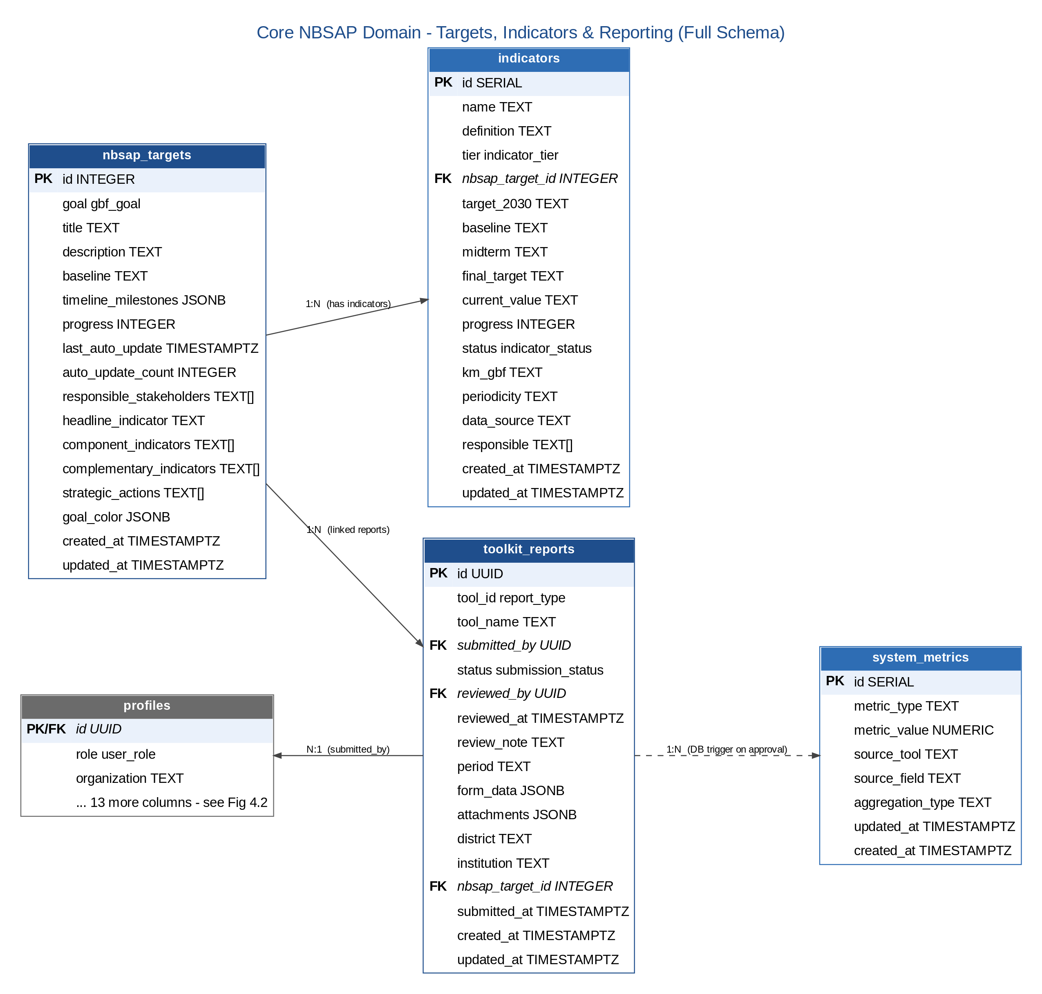
Figure 4.1 — Core NBSAP Domain: Targets, Indicators & Reporting

4.4.2 User Identity & Access Control
Every authenticated user has exactly one profile, which fans out 1:1 into personal settings and notification preferences, and 1:N into notifications, role-change requests, and the immutable audit trail.
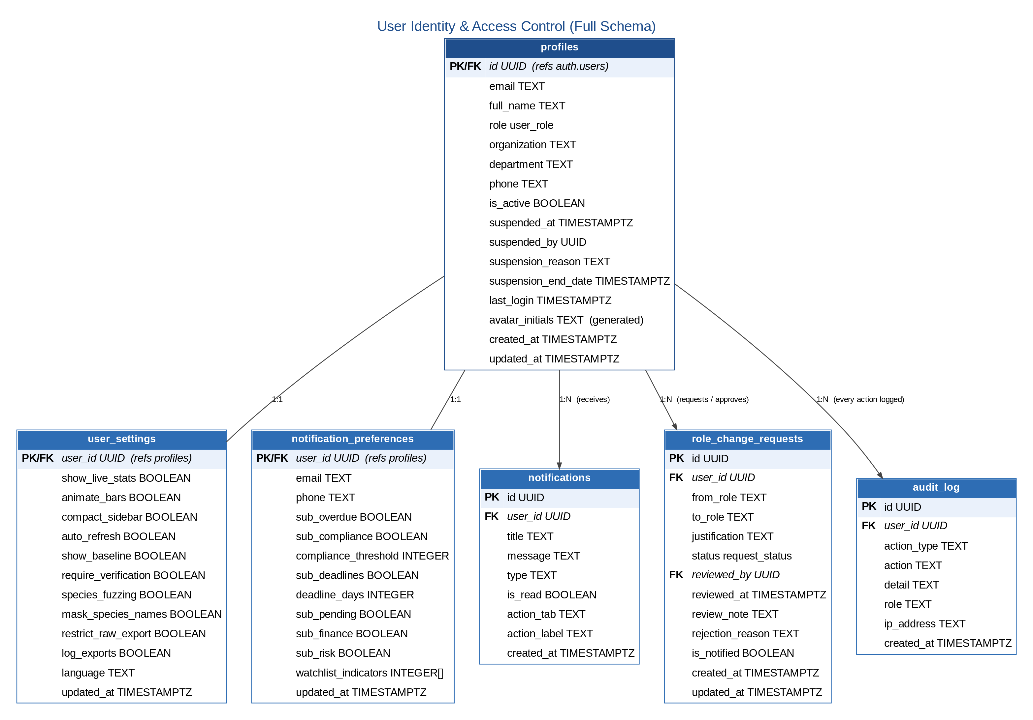
Figure 4.2 — User Identity & Access Control

4.4.3 Reporting & AI Extraction Pipeline
Each submitted toolkit report can carry multiple evidence attachments and triggers exactly one AI document-extraction job, which in turn can generate multiple proposed data updates for human review.
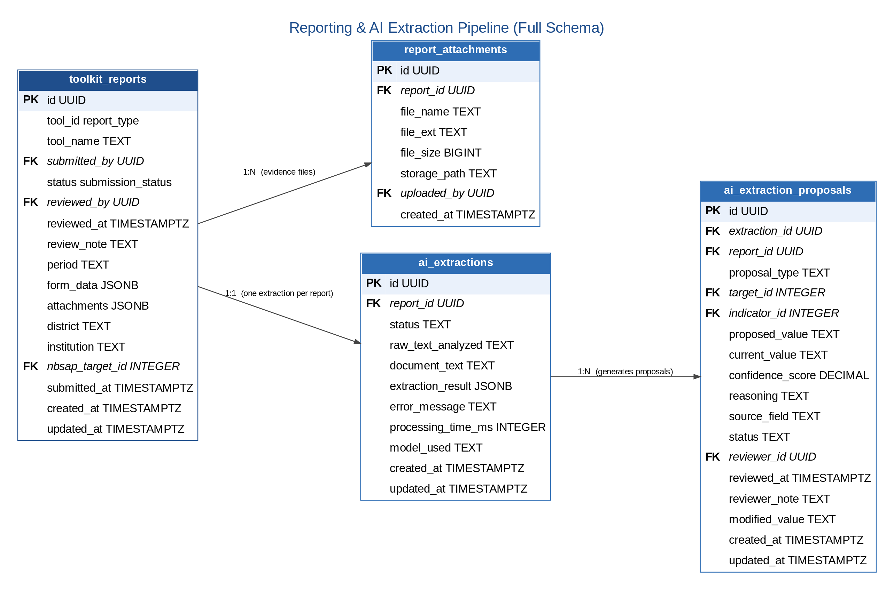
Figure 4.3 — Reporting & AI Extraction Pipeline

4.4.4 Geographic Reference Data
Rwanda's 5 provinces and 30 districts form the geographic backbone referenced (mostly by denormalised district name, for query simplicity) throughout the reporting and compliance tables.
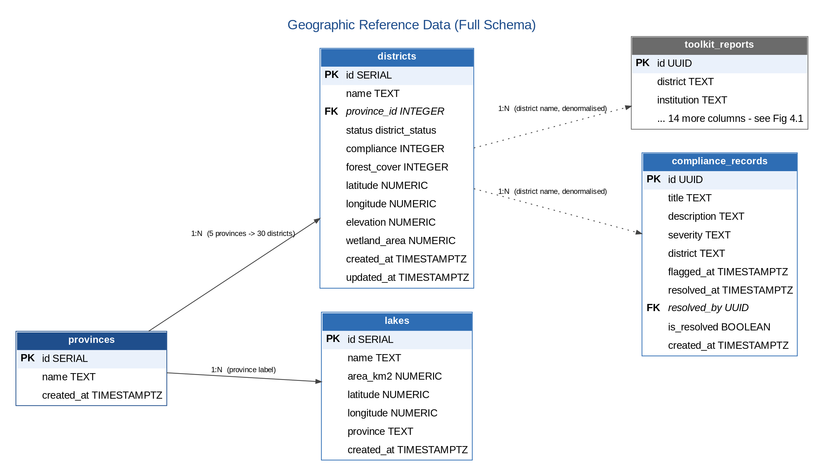
Figure 4.4 — Geographic Reference Data

4.4.5 Key Cardinalities Summary
Relationship | Cardinality | Notes
auth.users -> profiles | 1:1 | Auto-created on signup via database trigger
profiles -> user_settings | 1:1 | Auto-created on signup
profiles -> notification_preferences | 1:1 | Auto-created on signup
provinces -> districts | 1:N | 5 provinces, 30 districts
nbsap_targets -> indicators | 1:N | 1 target -> 2-4 component indicators plus 1 headline indicator
nbsap_targets -> toolkit_reports | 1:N | Each report optionally links to one target
toolkit_reports -> report_attachments | 1:N | Attachment metadata is also mirrored into a JSONB column
toolkit_reports -> ai_extractions | 1:1 | One AI extraction job per submitted report
ai_extractions -> ai_extraction_proposals | 1:N | Multiple proposed field updates per extraction
profiles -> toolkit_reports (submitted) | 1:N | A user can submit many reports over time
profiles -> toolkit_reports (reviewed) | 1:N | A reviewer can approve/reject many reports
profiles -> audit_log | 1:N | Every significant user action is logged

5. Infrastructure Architecture

5.1 Deployment Architecture
Component | Technology | Configuration
Web Server / Edge Proxy | Vercel Edge Network | Automatic SSL, global CDN, 200+ edge locations
Application Hosting | Vercel (static SPA build) | Git-push auto-deploy from main branch
Database | Supabase-managed PostgreSQL 15 | Primary instance with daily automated backup
Realtime Service | Supabase Realtime | WebSocket channel-based push, scoped by RLS
File Storage | Supabase Storage (S3-compatible) | Private buckets with access-policy-controlled URLs
Serverless Functions | Supabase Edge Functions (Deno) | GBIF proxy function, deployed alongside the database project
CDN | Vercel global CDN | Content-hashed static asset caching, 1-year cache headers
CI/CD | Vercel Build Pipeline | npm install -> vite build -> deploy on every git push
Monitoring | Vercel Analytics + Supabase Dashboard | Build/deploy status, query performance, error rates
Version Control | GitHub | Source of truth; webhook triggers the Vercel build

5.2 Security Architecture
Layer | Security Control
Network | Vercel/Supabase managed network perimeter; no self-managed servers to patch or expose
Transport | TLS 1.2+ enforced on all connections; HSTS headers; automatic certificate renewal (Vercel)
Application | JWT authentication, Role-Based Access Control, OWASP Top 10 considerations, Content-Security-Policy headers, X-Frame-Options DENY
Database | Row-Level Security on all 18 tables (25+ policies); AES-256 encryption at rest; least-privilege service roles; no public direct access
File Storage | Private storage buckets, access-policy-controlled signed URLs, file type/size restrictions on upload
Secrets | Environment-variable secrets (Supabase keys, RBIS token) never committed to source control
Audit | Immutable, append-only audit log; every significant action attributed to a user ID and timestamp

5.3 Environment Strategy
Environment | Purpose | Data | Access
Development | Local development and feature testing | Synthetic/sample seed data | Developers only
Staging / UAT | Pre-release validation and stakeholder review | Anonymised or representative test data | QA team and REMA stakeholders
Production | Live national reporting and dashboard use | Real, regulator-protected biodiversity data | REMA operations staff and authenticated end users

5.4 Network Flow Matrix
Flow | Protocol | Source | Destination | Port | Authentication
Browser -> Frontend | HTTPS | End user | Vercel CDN | 443 | None (public)
Browser -> Supabase API | HTTPS | End user | Supabase Cloud | 443 | JWT (anon key + session)
Browser -> Supabase Realtime | WSS | End user | Supabase Cloud | 443 | JWT session
Edge Function -> GBIF | HTTPS | Supabase | api.gbif.org | 443 | None
Browser -> RBIS | HTTPS | End user | rbis.ur.ac.rw | 443 | Bearer token

6. Integration, Availability & Scalability

6.1 External Integration Points
+----------------------+
| NBSAP Dashboard |
| |
| +-----------------+ | +-------------------+
| | Supabase Edge |--+---->| GBIF API |
| | Function (proxy)| | | (species data) |
| +-----------------+ | +-------------------+
| |
| +-----------------+ | +-------------------+
| | RBIS Service |--+---->| RBIS API |
| | (browser client) | | | (biodiversity |
| +-----------------+ | | data streams) |
| | +-------------------+
| +-----------------+ | +-------------------+
| | Map Components |--+---->| Static GeoJSON |
| | (Leaflet) | | | (CDN-served) |
| +-----------------+ | +-------------------+
+----------------------+

6.2 Integration Resilience
Integration | Failure Mode | System Behaviour
GBIF API down | Timeout after 30 seconds | Dashboard shows cached data; map shows last-known occurrence records
RBIS API down | Connection error | Status indicator turns red; manual data entry continues unaffected
Supabase down | Service unavailable | Full system offline; users see a graceful error page
GeoJSON CDN miss | 404 error | Map renders without the affected layer; warning logged to console

6.3 Availability & Backup Strategy
Component | Target SLA | Redundancy / Backup Approach
Vercel CDN | 99.99% | Multi-region edge network
Supabase Database | 99.9% | Managed PostgreSQL with automated daily backups (7-30 day retention)
Supabase Auth | 99.9% | Managed GoTrue service
GBIF API | Best-effort (external) | Graceful degradation; last-fetched data cached client-side
RBIS API | Best-effort (external) | Dashboard remains fully functional without RBIS
Source code | N/A | GitHub repository, every commit preserved indefinitely
Migration files | N/A | Git-versioned SQL files, indefinite retention

6.4 Recovery Procedures
Scenario | Recovery Action | Estimated Time
Frontend deployment issue | Vercel automatic rollback to the previous successful deployment | < 5 minutes
Database corruption | Restore from the most recent Supabase daily backup | 1-4 hours
Credential compromise | Rotate Supabase keys and redeploy with updated environment variables | 30 minutes
Complete infrastructure loss | Re-deploy from GitHub and re-run all 22 migrations on a new Supabase project | 2-4 hours

6.5 Scalability Considerations
Dimension | Current Design | Headroom
Concurrent users | Designed for 500 | Sufficient for the current stakeholder base (~200 active users)
Report storage | 10,000+ reports | Ample for quarterly reporting from 30 districts over a 5-year NBSAP cycle
Database size | Supabase free tier (500MB) | Current usage well under the limit
API calls | Supabase free tier (500K/month) | Current usage well under the limit
File storage | Supabase free tier (1GB) | Adequate for current evidence attachment volume

Should usage grow beyond current capacity, the recommended scaling path is to upgrade Supabase to its Pro tier (database, storage and API call ceilings all expand at a fixed monthly cost), provision an additional regional Supabase project if the system expands beyond Rwanda, and reuse the same backend for a future companion mobile application built with React Native.

6.6 Technology Lifecycle
Technology | Current Status | End-of-Support Risk | Upgrade Path
React 18 | Active (LTS) | Low (2027+) | Move to React 19 once stable
TypeScript 5.2 | Active | Very low | Incremental version upgrades
Vite 5.0 | Active | Low | Non-breaking upgrades to Vite 6+
PostgreSQL 15 | Active (LTS) | Very low (2027+) | Supabase manages database version upgrades
Node.js (build tooling) | Active (LTS) | Moderate | Track Node.js LTS releases
Leaflet.js | Stable | Very low | Actively maintained open-source project

7. Document Approval
The undersigned confirm that this System Architecture Document has been reviewed and is approved as the authoritative technical architecture reference for the Rwanda NBSAP Monitoring Dashboard.

Role | Name | Signature | Date
Prepared by | Joe Karanga
Reviewed by
Approved by (REMA)
Approved by (Ministry of Environment)

Appendix A: Complete System Entity-Relationship Diagram
This appendix consolidates all four domain-scoped diagrams from Section 4.4 into a single, authoritative entity-relationship diagram covering all 20 database tables (19 production tables plus the Supabase-managed auth.users table), each with its full column list, PostgreSQL data type, and primary/foreign key markers. Tables are grouped into five labelled domains — Core NBSAP Domain, Reporting & AI Extraction Pipeline, User Identity & Access Control, Geographic Reference Data, and Standalone Reference/Configuration Tables — matching the structure of the underlying physical schema documented in ERD.md. This page is set in landscape orientation and the source image is rendered at high resolution; reviewers may zoom in within Word (or a PDF export) to inspect any individual column without loss of clarity.
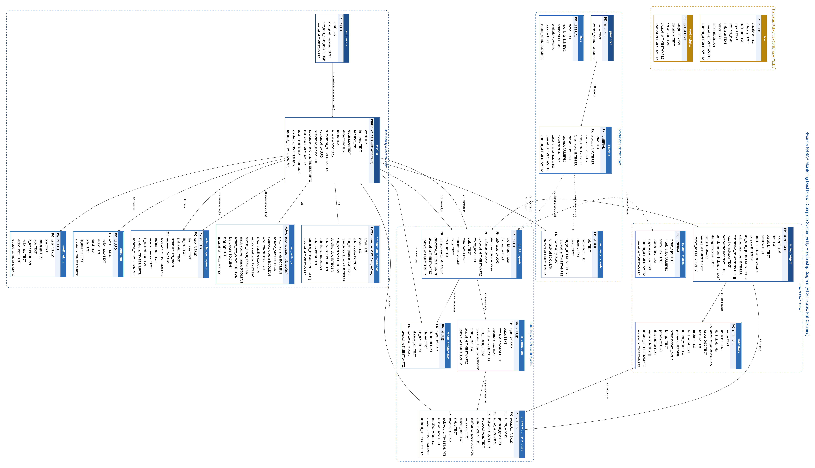
Figure A.1 — Complete System Entity-Relationship Diagram (all 20 tables, full columns, full PostgreSQL types)

A.1 PostgreSQL Enum Type Reference
The following 9 enumerated types constrain the values of specific columns referenced in Figure A.1 and throughout Section 4. Listing them here completes the schema documentation: every custom (non-primitive) type used anywhere in the database is fully defined.
Enum Type | Permitted Values | Used By (table.column)
user_role | policy_monitoring, lead_government_ministry_reporting, local_reporting, dashboard_management, programme_alignment, public_viewer | profiles.role
indicator_status | on-track, at-risk, behind | indicators.status
indicator_tier | headline, component, complementary, binary | indicators.tier
submission_status | pending, approved, rejected | toolkit_reports.status
district_status | submitted, pending, missing | districts.status
report_type | T01, T02, T03, T04, T05, T06, T07 | toolkit_reports.tool_id
risk_level | High, Medium, Low | risks.level
gbf_goal | A, B, C, D | nbsap_targets.goal
request_status | pending, approved, rejected, cancelled, stale | role_change_requests.status

A.2 Table Inventory Summary
20 tables in total: 1 Supabase-managed identity table (auth.users) and 19 application tables, none of which are abbreviated or omitted from Figure A.1 above.
Domain | Tables | Count
Core NBSAP Domain | nbsap_targets, indicators, system_metrics | 3
Reporting & AI Extraction Pipeline | toolkit_reports, report_attachments, ai_extractions, ai_extraction_proposals | 4
User Identity & Access Control | auth_users, profiles, user_settings, notification_preferences, notifications, audit_log, role_change_requests | 7
Geographic Reference Data | provinces, districts, lakes, compliance_records | 4
Standalone Reference / Configuration | risks, tool_weights | 2

Final Sign-Off
This page certifies that all four constituent documents within this Complete System Documentation Package — the Requirements Specification Document, Business Process Document, Software Requirements Specification, and System Architecture Document — have been reviewed together as a single, consistent body of documentation for the Rwanda NBSAP Monitoring Dashboard 2025-2030, and are approved for distribution as Version 1.0 (Draft).

Role | Name | Signature | Date
Prepared by | Joe Karanga
Reviewed by
Approved by (REMA)
Approved by (Ministry of Environment)

— End of Complete System Documentation Package —

