System Architecture Document
Rwanda NBSAP Monitoring Dashboard 2025-2030

Document Reference: NBSAP-SAD-2026-005
Version: 1.0
Date: 20 June 2026
Prepared by: Joe Karanga
Status: Draft
Classification: Confidential — REMA Internal Use

1. Architecture Overview

1.1 Purpose
This System Architecture Document (SAD) describes how the Rwanda NBSAP Monitoring Dashboard is built: its technology stack, application architecture, database design, and infrastructure topology. It is intended for system architects, developers, DevOps/infrastructure staff, and government ICT auditors who need to understand, operate, or extend the platform.

1.2 Architectural Principles
Principle | Description
Serverless-first | Eliminates server provisioning and maintenance burden through Backend-as-a-Service (Supabase); pay-per-use cost model
Security by Design | Row-Level Security on every table, JWT authentication, HTTPS everywhere, and security headers applied by default
Automation over Manual | Database triggers compute national metrics automatically; no human-run calculations or spreadsheet formulas
Real-Time Visibility | WebSocket push (Supabase Realtime) ensures all connected dashboards reflect current system state
Global Availability | CDN-distributed frontend (Vercel) loads quickly for users anywhere, including low-bandwidth districts
Cost Efficiency / Open Standards | Built on free/low-tier managed cloud services and open standards (REST, PostgreSQL, GeoJSON) to minimise total cost of ownership for REMA

1.3 Architecture Decision Record
The table below records the major architectural choices made during the system's design, the alternatives considered, and the rationale for the final decision. This is preserved so future maintainers understand why the stack looks the way it does.
Decision | Options Considered | Chosen | Rationale
Backend approach | Custom Node.js API / Django / BaaS | Supabase (BaaS) | No server management; built-in Auth, RLS, Realtime, and Storage out of the box
Frontend framework | React / Vue / Angular | React 18 | Largest ecosystem; strong component reuse; mature TypeScript support
Build tool | Webpack / Vite | Vite | Faster builds; native ES module support; simpler configuration
Database | MySQL / MongoDB / PostgreSQL | PostgreSQL 15 | Row-Level Security support; JSONB for flexible report payloads; proven at scale
Hosting | AWS / Azure / Vercel | Vercel | Git-push deploy; global CDN; generous free tier; optimised for React SPAs
Map library | Google Maps / Mapbox / Leaflet | Leaflet.js | Open source; no API key required; lightweight; mature ecosystem
Chart library | D3.js / Chart.js / Recharts | Recharts (+ Chart.js) | React-native declarative API; responsive; sensible defaults

2. Technology Stack

2.1 Full Stack Summary
Layer | Technology / Tool | Version | Purpose
Frontend Framework | React | 18.2 | Component-based UI framework
Frontend Language | TypeScript | 5.2 | Static type checking across ~15,000+ lines of code
Build Tool | Vite | 5.0.8 | Development server and production bundler
UI Component / Icon Library | Lucide React + FontAwesome Free | 0.263 / 7.2 | Icon system used across all pages
State Management | Zustand + React Context | 4.4.7 | Global state management and auth context
Routing | React Router DOM | 6.21 | Client-side routing with protected routes
Mapping / GIS | Leaflet.js | Latest | Interactive map of districts, protected areas, rivers, lakes
Charts / Visualisation | Chart.js + react-chartjs-2 / Recharts | 4.4.1 / 5.2.0 | Indicator trend and target progress visualisation
Toast Notifications | react-hot-toast | 2.4.1 | In-app user notifications
PDF / Export | jsPDF, pptxgenjs | 4.2.1 / 4.0.1 | Client-side PDF and PowerPoint export
Backend / Database | PostgreSQL (via Supabase) | 15 | Primary relational data store with JSONB and RLS support
Backend-as-a-Service | Supabase | Cloud-managed | Auth, Realtime, Storage, Edge Functions
Authentication | Supabase Auth (GoTrue) | Latest | JWT-based authentication and session management
Realtime / Push | Supabase Realtime | Latest | WebSocket push for live dashboard updates
File Storage | Supabase Storage (S3-compatible) | Latest | Report evidence and attachment storage
Serverless Functions | Supabase Edge Functions (Deno) | Latest | GBIF API proxy to avoid CORS issues
External Species Data | GBIF API | v1 | Global species occurrence data for Rwanda
External Biodiversity Data | RBIS API (rbis.ur.ac.rw) | v1 | Rwanda Biodiversity Information System data streams
Hosting / CDN | Vercel | Cloud | Global CDN frontend hosting with automatic HTTPS
CI/CD | Vercel Build Pipeline + GitHub | Cloud | Git-push-to-deploy automated pipeline
Version Control | Git / GitHub | Latest | Source code management and deployment trigger
Testing | Vitest + @testing-library/react | 4.1.8 / 16.3.2 | Unit and component testing
Linting / Type Safety | ESLint + TypeScript ESLint | 8.55 / 6.14 | Code quality and static analysis

3. Application Architecture

3.1 High-Level Architecture
+---------------------------------------------------------------+
| CLIENT LAYER |
| Browser / Mobile -> React 18 SPA (TypeScript + Vite) -> CDN |
+---------------------------------------------------------------+
| HTTPS
v
+---------------------------------------------------------------+
| GATEWAY LAYER (Vercel Edge / Nginx-equivalent) |
| SSL termination, global load balancing, basic rate limiting |
+---------------------------------------------------------------+
|
v
+---------------------------------------------------------------+
| APPLICATION LAYER (Supabase-managed services) |
| Auth Module | Business Logic (DB functions) | Integration |
| Services (GBIF proxy, RBIS client) |
+---------------------------------------------------------------+
|
v
+---------------------------------------------------------------+
| DATA LAYER |
| PostgreSQL 15 (primary + managed backups) | Supabase Storage |
+---------------------------------------------------------------+
|
v
+---------------------------------------------------------------+
| BACKGROUND SERVICES |
| DB Triggers (metric calc) | Edge Functions | Notification |
| Dispatcher (Realtime) |
+---------------------------------------------------------------+
Note: This is a simplified text representation. Replace with a formal architecture diagram (draw.io, Lucidchart, Visio, or Figma) for the final published document.

3.2 Frontend Architecture
Component | Description
Pages / Routes | 16 lazy-loaded page components (Dashboard, Targets, Indicators, Map, Reporting Toolkit, Verification Queue, Reports, RBIS, Compliance, Risk, Stakeholders, Pipeline, Users, Role Requests, Settings, Adaptive Management)
Component Structure | Organised by domain folders: common/, map/, panels/, rbis/, plus shared ErrorBoundary, ProtectedRoute, and form components
State Management | React Context (AuthContext) for auth/session state; Zustand for cross-page application state
API Communication | Supabase JS client wrapping REST + WebSocket calls; custom service modules (dataService, rbisService) encapsulate query logic
Form Handling | Controlled React forms with client-side validation utilities (utils/validation.ts) before submission
Authentication Flow | JWT access + refresh tokens managed by Supabase Auth client; session state mirrored into AuthContext
Lazy Loading | Every page component is route-based code-split via React.lazy(), reducing initial bundle size
Accessibility | ARIA labels on interactive elements; colour-contrast-conscious green/amber/red status system targeting WCAG 2.1 AA

3.3 Backend Architecture
Component | Description
API Design | Supabase auto-generated RESTful API over PostgreSQL, versioned via Supabase project configuration
Data Access Layer | Service modules (dataService.ts, rbisService.ts, systemMetricsService.ts) act as the application's repository layer over the Supabase client
Business Logic Layer | Implemented primarily as PostgreSQL functions and triggers (10+ functions) so core rules are enforced regardless of client
Validation Layer | dataValidationService.ts performs pre-submission validation; database CHECK constraints provide a second enforcement layer
Middleware Equivalent | Row-Level Security (RLS) policies act as server-side authorisation middleware on every table
Error Handling | errorHandling.ts centralises client-side error normalisation; Supabase error codes mapped to user-facing messages
Background Jobs | Database triggers fire asynchronously on report approval/deletion to update metrics; Realtime channel dispatches notifications
Logging | Audit log table records all significant actions; client errors forwarded to a centralised monitoring service

4. Database Architecture

4.1 Database Overview
Attribute | Details
Engine | PostgreSQL 15 (Supabase managed)
Tables | 18 tables, fully covered by Row-Level Security (25+ policies)
Schema Management | 22 sequentially numbered SQL migration files, version-controlled in the repository
Automation | 7 database triggers and 10+ database functions automate metric calculation and notifications
Backup Strategy | Daily automated backups (Supabase managed); 7-30 day retention depending on tier
Connection Handling | Supabase-managed connection pooling (PgBouncer)

4.2 Core Database Tables
Table Name | Key Columns | Description
profiles | id (FK auth.users), email, full_name, role, organisation, status, created_at | User accounts, roles, and organisational metadata
roles / permission maps | role_key, label, can_submit, can_approve, can_view_audit | RBAC permission definitions per role
nbsap_targets | id, target_number, goal, title, baseline, target_2030, progress | The 22 NBSAP 2025-2030 national targets
toolkit_reports | id, tool_type, district_id, form_data (JSONB), status, submitted_by, reviewed_by, created_at | T01-T07 structured report submissions
report_attachments | id, report_id (FK), file_url, file_type, uploaded_at | Evidence files linked to a report
audit_log | id, user_id, action, table_name, record_id, timestamp | Immutable append-only action history
notifications | id, user_id, type, message, is_read, created_at | Per-user in-app and real-time alerts
indicators / lookup_values | id, name, tier, nbsap_target_id, baseline, current_value, status | ~80 biodiversity indicators and reference lookups
sessions (Supabase Auth managed) | id, user_id, created_at, refreshed_at | Active authentication session tracking

4.3 Data Flow Architecture
READ FLOW:
User -> Frontend -> Supabase JS Client -> Vercel Edge -> Supabase REST API
-> RLS Check -> PostgreSQL Query -> Response -> React Query/Zustand Cache
-> UI Render

WRITE FLOW:
Form Submit -> Frontend Validation -> Supabase Client -> Auth + RLS Check
-> Business Logic (DB Function) -> Transaction -> PostgreSQL Write
-> Audit Log Insert -> Trigger Fires (metric update) -> Commit
-> Realtime Channel (notification) -> Response -> UI Update

FILE UPLOAD FLOW:
File Select -> Frontend Pre-validation (type/size) -> Multipart Upload
-> Supabase Storage Write -> Access Policy Check -> DB Metadata Insert
(report_attachments) -> Signed URL Returned -> UI Confirmation

4.4 Entity-Relationship Diagrams
The complete schema spans 19 production tables plus the Supabase-managed auth.users table. To keep each diagram legible on a portrait page, the schema is presented below as four domain-scoped entity-relationship diagrams. Each table is rendered with its full, unabridged column list and PostgreSQL data type — no column has been omitted or summarised. PK denotes a primary key; FK denotes a foreign key; shaded rows mark key columns. Solid arrows represent enforced foreign-key relationships; dashed arrows represent automated/trigger-driven data flows; dotted arrows represent denormalised text-based linkages (e.g. district name) used for reporting convenience rather than referential integrity. A single consolidated diagram showing all 20 tables together, at full resolution, is provided in Appendix A for formal review and government submission purposes.

4.4.1 Core NBSAP Domain
The heart of the schema: national targets are measured by indicators, evidenced by toolkit reports, and rolled up automatically into system metrics whenever a report is approved.
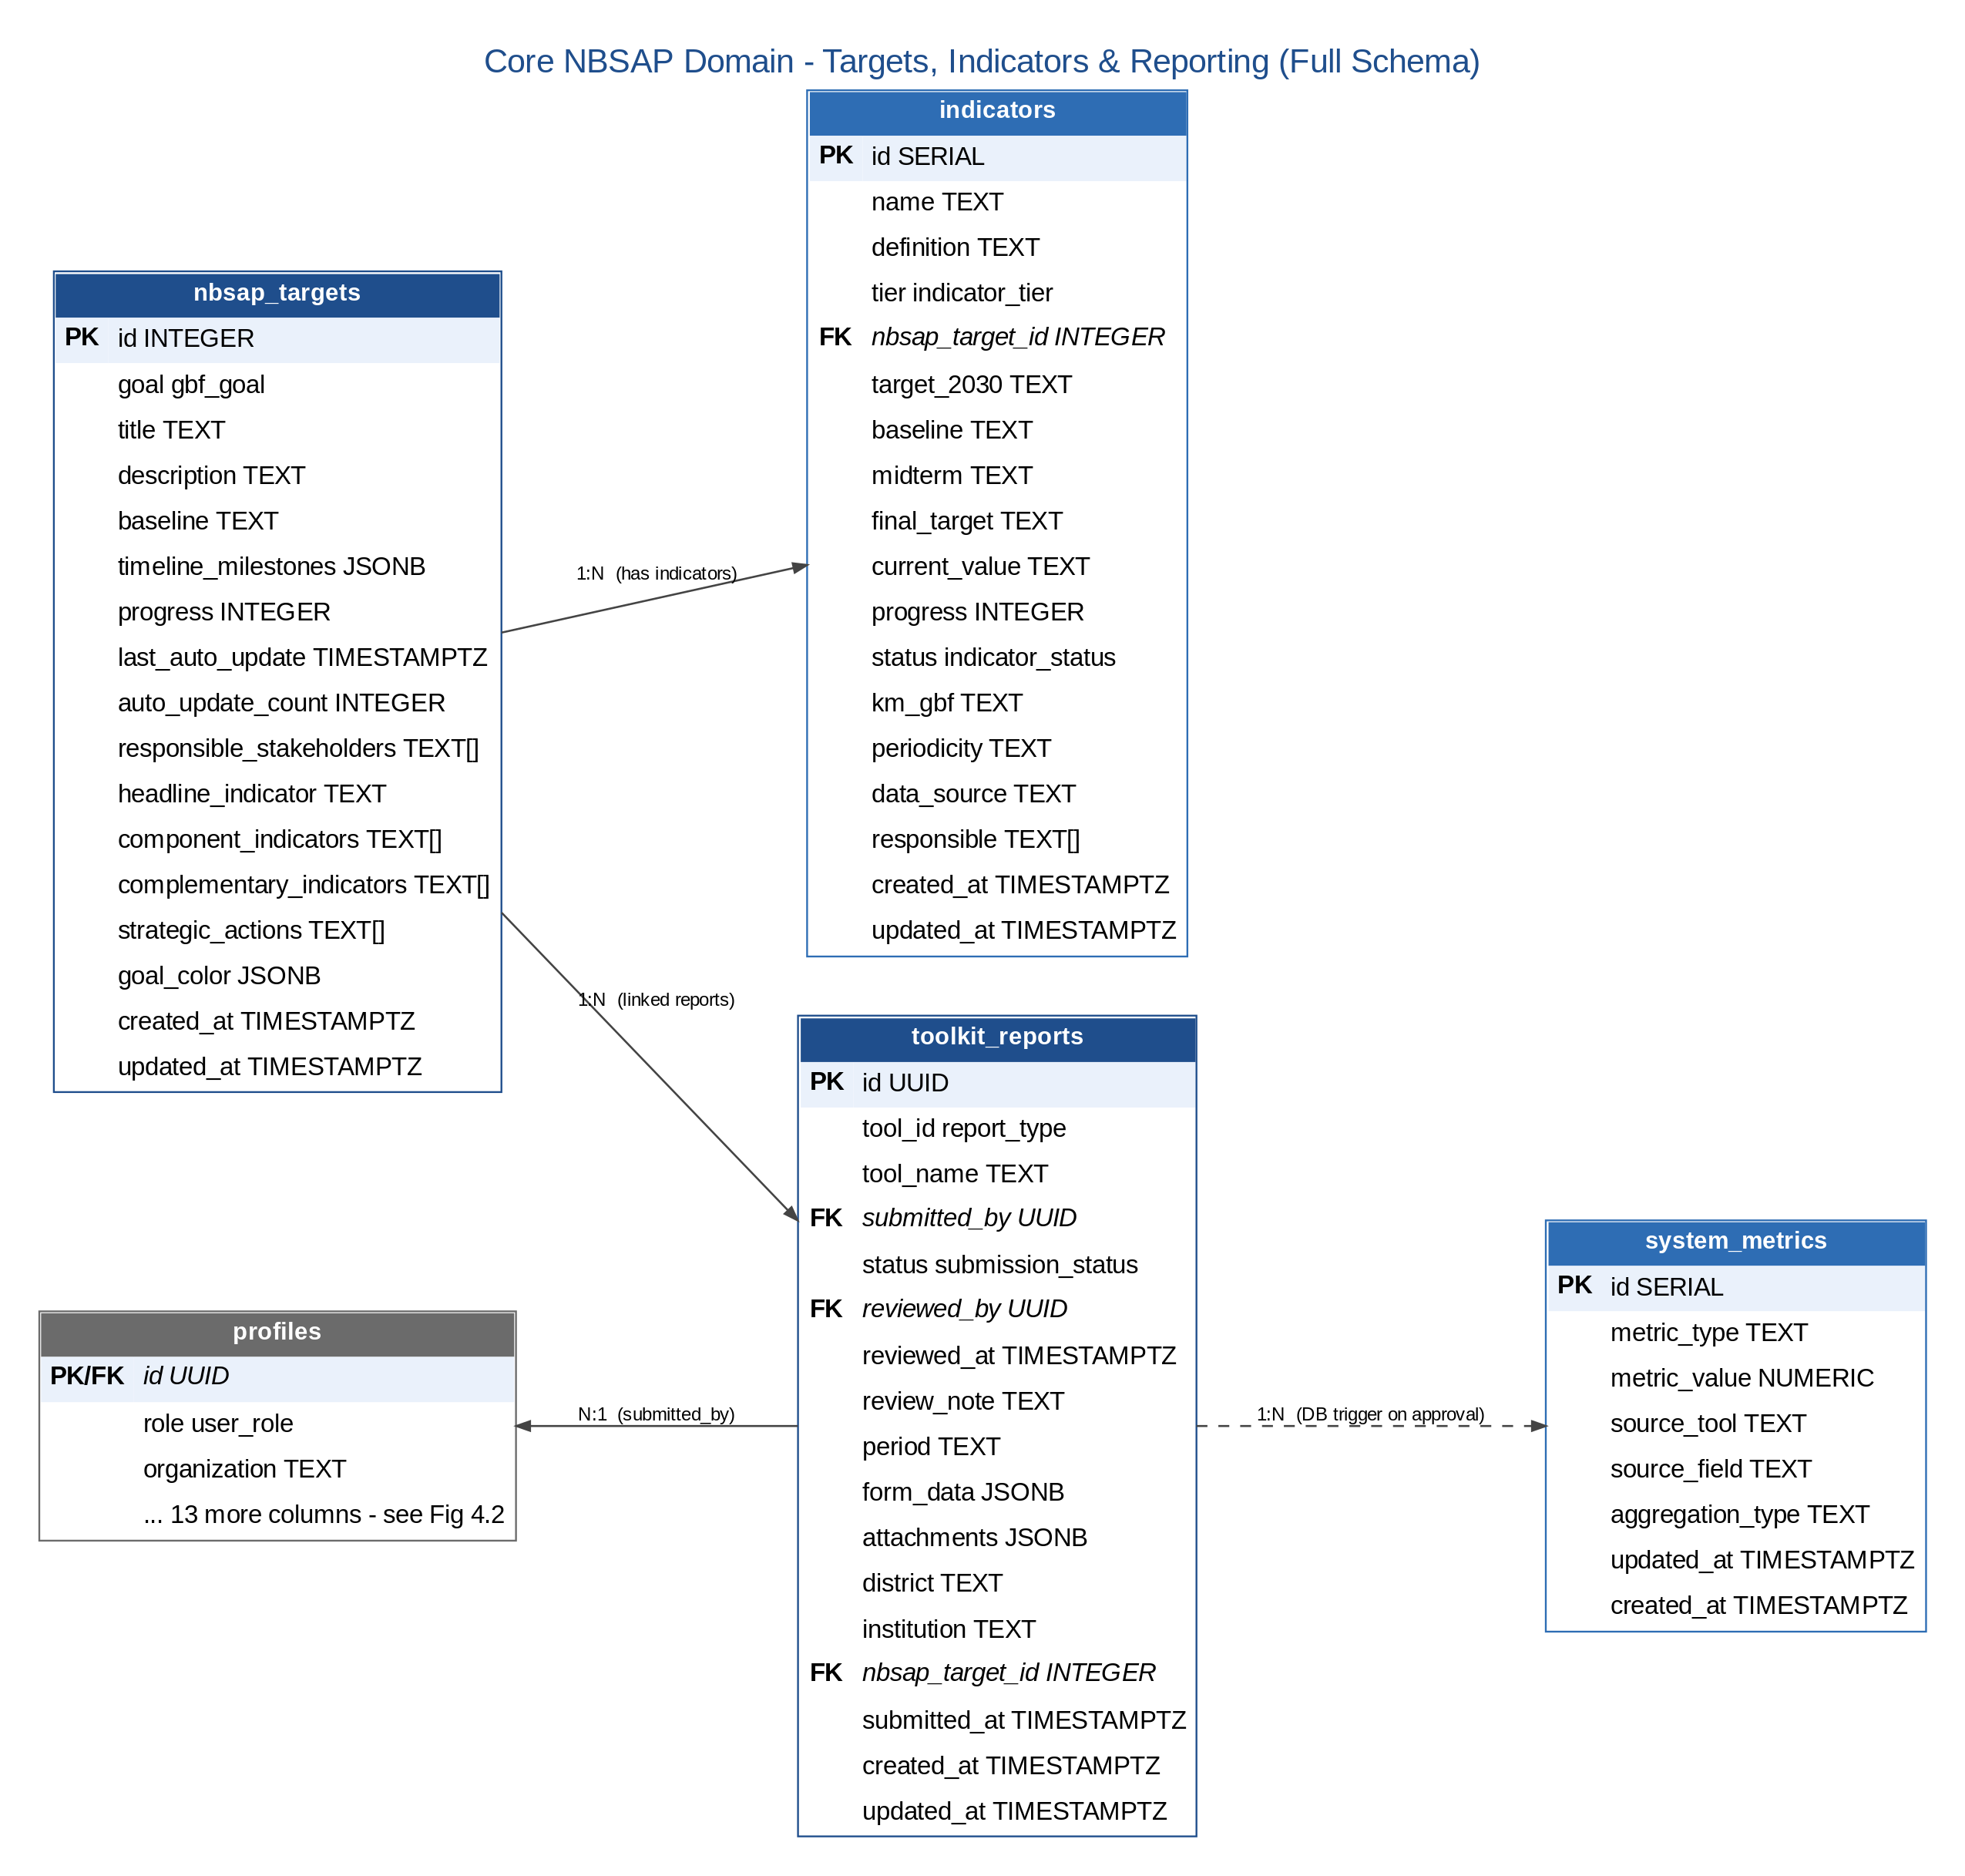
Figure 4.1 — Core NBSAP Domain: Targets, Indicators & Reporting

4.4.2 User Identity & Access Control
Every authenticated user has exactly one profile, which fans out 1:1 into personal settings and notification preferences, and 1:N into notifications, role-change requests, and the immutable audit trail.
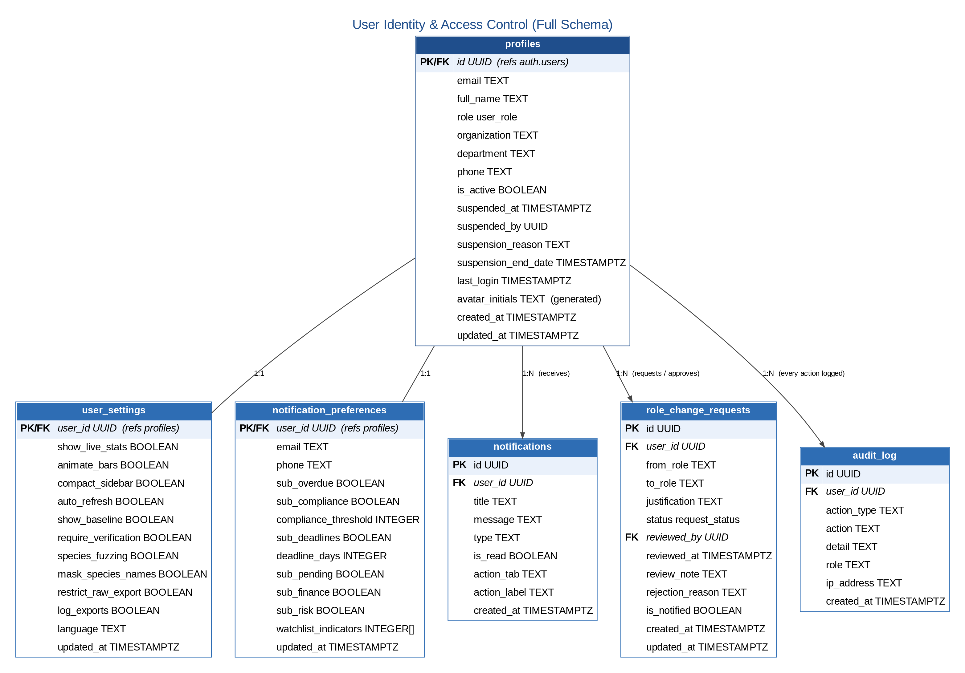
Figure 4.2 — User Identity & Access Control

4.4.3 Reporting & AI Extraction Pipeline
Each submitted toolkit report can carry multiple evidence attachments and triggers exactly one AI document-extraction job, which in turn can generate multiple proposed data updates for human review.
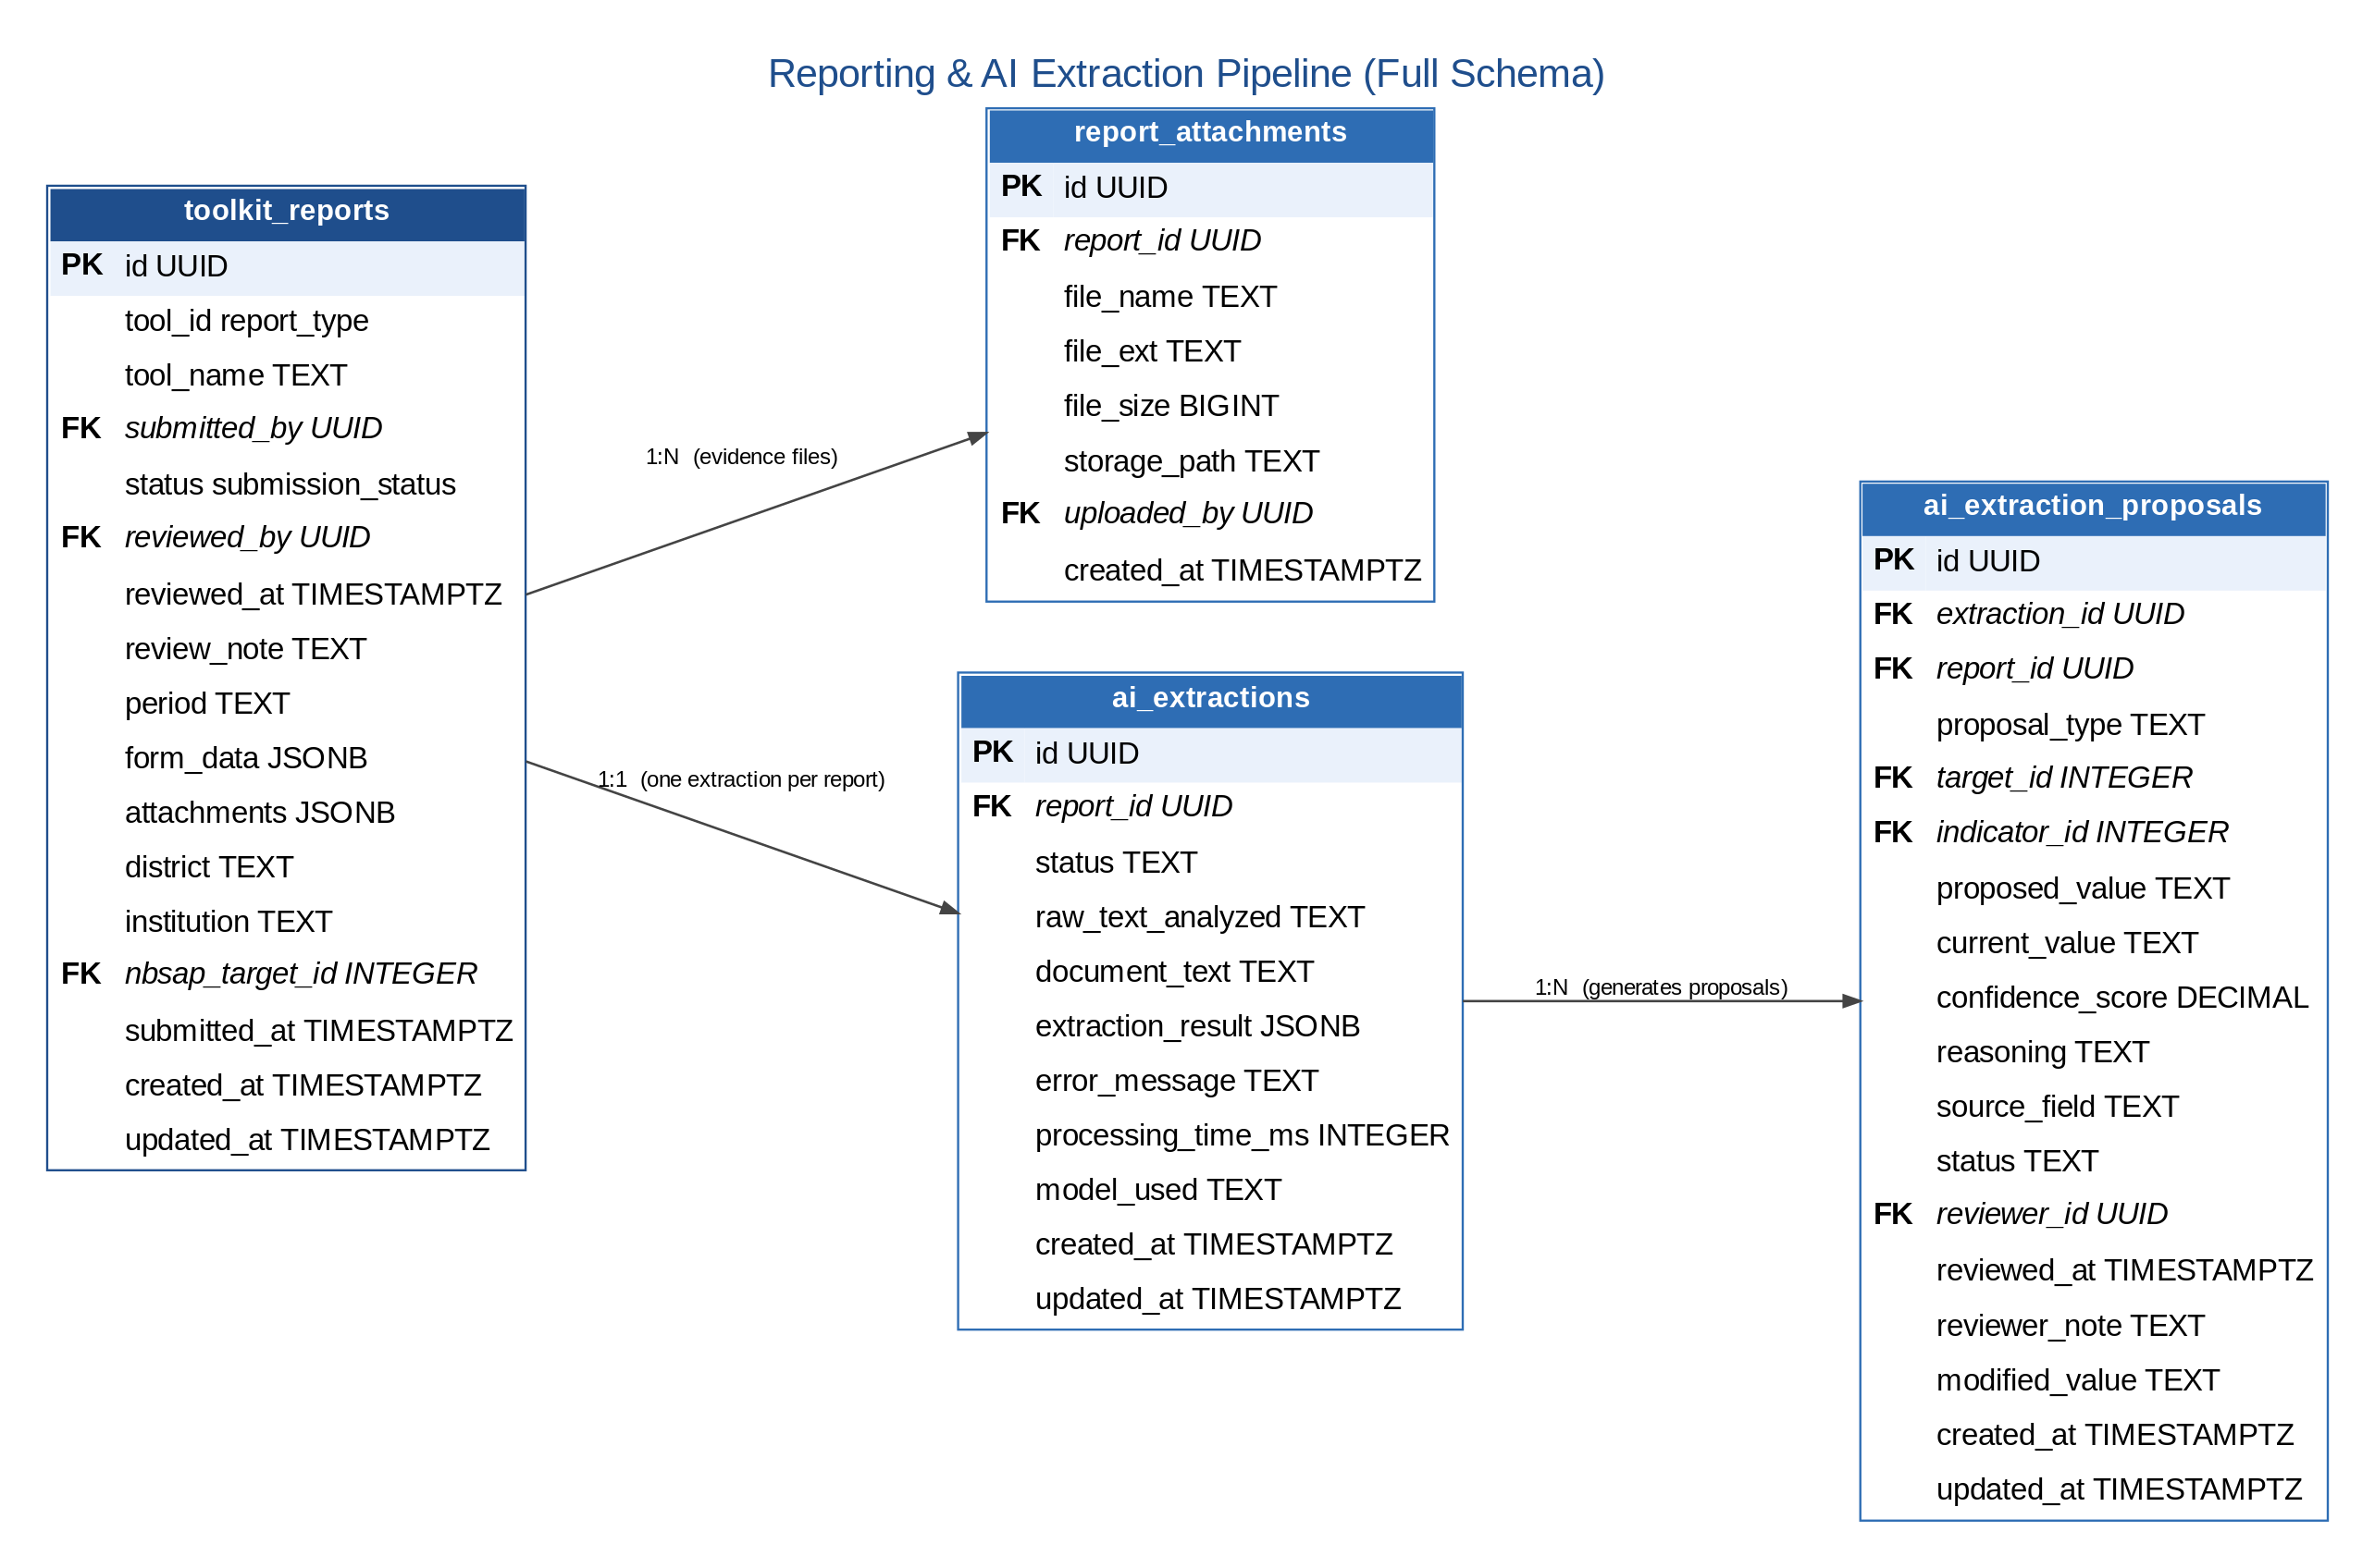
Figure 4.3 — Reporting & AI Extraction Pipeline

4.4.4 Geographic Reference Data
Rwanda's 5 provinces and 30 districts form the geographic backbone referenced (mostly by denormalised district name, for query simplicity) throughout the reporting and compliance tables.
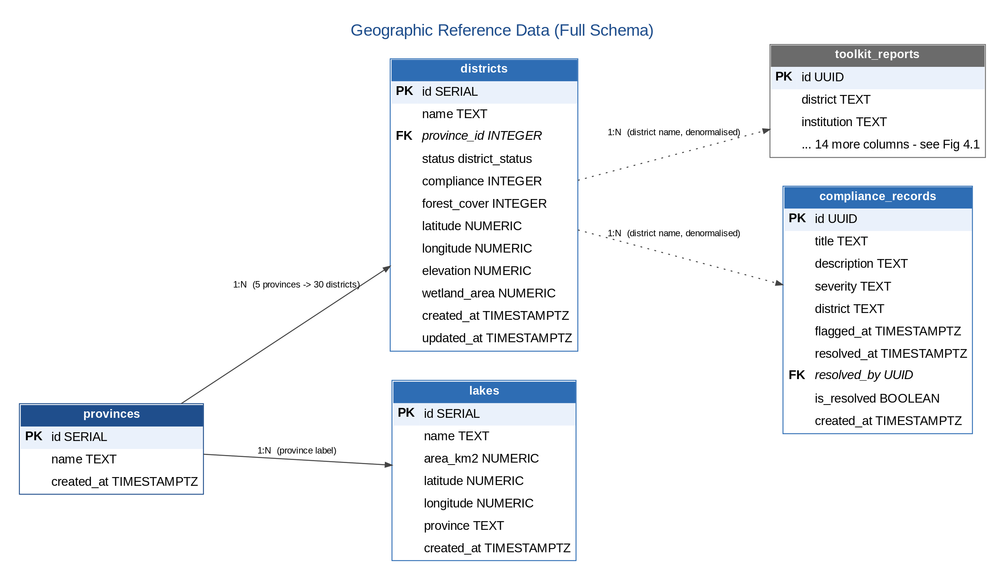
Figure 4.4 — Geographic Reference Data

4.4.5 Key Cardinalities Summary
Relationship | Cardinality | Notes
auth.users -> profiles | 1:1 | Auto-created on signup via database trigger
profiles -> user_settings | 1:1 | Auto-created on signup
profiles -> notification_preferences | 1:1 | Auto-created on signup
provinces -> districts | 1:N | 5 provinces, 30 districts
nbsap_targets -> indicators | 1:N | 1 target -> 2-4 component indicators plus 1 headline indicator
nbsap_targets -> toolkit_reports | 1:N | Each report optionally links to one target
toolkit_reports -> report_attachments | 1:N | Attachment metadata is also mirrored into a JSONB column
toolkit_reports -> ai_extractions | 1:1 | One AI extraction job per submitted report
ai_extractions -> ai_extraction_proposals | 1:N | Multiple proposed field updates per extraction
profiles -> toolkit_reports (submitted) | 1:N | A user can submit many reports over time
profiles -> toolkit_reports (reviewed) | 1:N | A reviewer can approve/reject many reports
profiles -> audit_log | 1:N | Every significant user action is logged

5. Infrastructure Architecture

5.1 Deployment Architecture
Component | Technology | Configuration
Web Server / Edge Proxy | Vercel Edge Network | Automatic SSL, global CDN, 200+ edge locations
Application Hosting | Vercel (static SPA build) | Git-push auto-deploy from main branch
Database | Supabase-managed PostgreSQL 15 | Primary instance with daily automated backup
Realtime Service | Supabase Realtime | WebSocket channel-based push, scoped by RLS
File Storage | Supabase Storage (S3-compatible) | Private buckets with access-policy-controlled URLs
Serverless Functions | Supabase Edge Functions (Deno) | GBIF proxy function, deployed alongside the database project
CDN | Vercel global CDN | Content-hashed static asset caching, 1-year cache headers
CI/CD | Vercel Build Pipeline | npm install -> vite build -> deploy on every git push
Monitoring | Vercel Analytics + Supabase Dashboard | Build/deploy status, query performance, error rates
Version Control | GitHub | Source of truth; webhook triggers the Vercel build

5.2 Security Architecture
Layer | Security Control
Network | Vercel/Supabase managed network perimeter; no self-managed servers to patch or expose
Transport | TLS 1.2+ enforced on all connections; HSTS headers; automatic certificate renewal (Vercel)
Application | JWT authentication, Role-Based Access Control, OWASP Top 10 considerations, Content-Security-Policy headers, X-Frame-Options DENY
Database | Row-Level Security on all 18 tables (25+ policies); AES-256 encryption at rest; least-privilege service roles; no public direct access
File Storage | Private storage buckets, access-policy-controlled signed URLs, file type/size restrictions on upload
Secrets | Environment-variable secrets (Supabase keys, RBIS token) never committed to source control
Audit | Immutable, append-only audit log; every significant action attributed to a user ID and timestamp

5.3 Environment Strategy
Environment | Purpose | Data | Access
Development | Local development and feature testing | Synthetic/sample seed data | Developers only
Staging / UAT | Pre-release validation and stakeholder review | Anonymised or representative test data | QA team and REMA stakeholders
Production | Live national reporting and dashboard use | Real, regulator-protected biodiversity data | REMA operations staff and authenticated end users

5.4 Network Flow Matrix
Flow | Protocol | Source | Destination | Port | Authentication
Browser -> Frontend | HTTPS | End user | Vercel CDN | 443 | None (public)
Browser -> Supabase API | HTTPS | End user | Supabase Cloud | 443 | JWT (anon key + session)
Browser -> Supabase Realtime | WSS | End user | Supabase Cloud | 443 | JWT session
Edge Function -> GBIF | HTTPS | Supabase | api.gbif.org | 443 | None
Browser -> RBIS | HTTPS | End user | rbis.ur.ac.rw | 443 | Bearer token

6. Integration, Availability & Scalability

6.1 External Integration Points
+----------------------+
| NBSAP Dashboard |
| |
| +-----------------+ | +-------------------+
| | Supabase Edge |--+---->| GBIF API |
| | Function (proxy)| | | (species data) |
| +-----------------+ | +-------------------+
| |
| +-----------------+ | +-------------------+
| | RBIS Service |--+---->| RBIS API |
| | (browser client) | | | (biodiversity |
| +-----------------+ | | data streams) |
| | +-------------------+
| +-----------------+ | +-------------------+
| | Map Components |--+---->| Static GeoJSON |
| | (Leaflet) | | | (CDN-served) |
| +-----------------+ | +-------------------+
+----------------------+

6.2 Integration Resilience
Integration | Failure Mode | System Behaviour
GBIF API down | Timeout after 30 seconds | Dashboard shows cached data; map shows last-known occurrence records
RBIS API down | Connection error | Status indicator turns red; manual data entry continues unaffected
Supabase down | Service unavailable | Full system offline; users see a graceful error page
GeoJSON CDN miss | 404 error | Map renders without the affected layer; warning logged to console

6.3 Availability & Backup Strategy
Component | Target SLA | Redundancy / Backup Approach
Vercel CDN | 99.99% | Multi-region edge network
Supabase Database | 99.9% | Managed PostgreSQL with automated daily backups (7-30 day retention)
Supabase Auth | 99.9% | Managed GoTrue service
GBIF API | Best-effort (external) | Graceful degradation; last-fetched data cached client-side
RBIS API | Best-effort (external) | Dashboard remains fully functional without RBIS
Source code | N/A | GitHub repository, every commit preserved indefinitely
Migration files | N/A | Git-versioned SQL files, indefinite retention

6.4 Recovery Procedures
Scenario | Recovery Action | Estimated Time
Frontend deployment issue | Vercel automatic rollback to the previous successful deployment | < 5 minutes
Database corruption | Restore from the most recent Supabase daily backup | 1-4 hours
Credential compromise | Rotate Supabase keys and redeploy with updated environment variables | 30 minutes
Complete infrastructure loss | Re-deploy from GitHub and re-run all 22 migrations on a new Supabase project | 2-4 hours

6.5 Scalability Considerations
Dimension | Current Design | Headroom
Concurrent users | Designed for 500 | Sufficient for the current stakeholder base (~200 active users)
Report storage | 10,000+ reports | Ample for quarterly reporting from 30 districts over a 5-year NBSAP cycle
Database size | Supabase free tier (500MB) | Current usage well under the limit
API calls | Supabase free tier (500K/month) | Current usage well under the limit
File storage | Supabase free tier (1GB) | Adequate for current evidence attachment volume

Should usage grow beyond current capacity, the recommended scaling path is to upgrade Supabase to its Pro tier (database, storage and API call ceilings all expand at a fixed monthly cost), provision an additional regional Supabase project if the system expands beyond Rwanda, and reuse the same backend for a future companion mobile application built with React Native.

6.6 Technology Lifecycle
Technology | Current Status | End-of-Support Risk | Upgrade Path
React 18 | Active (LTS) | Low (2027+) | Move to React 19 once stable
TypeScript 5.2 | Active | Very low | Incremental version upgrades
Vite 5.0 | Active | Low | Non-breaking upgrades to Vite 6+
PostgreSQL 15 | Active (LTS) | Very low (2027+) | Supabase manages database version upgrades
Node.js (build tooling) | Active (LTS) | Moderate | Track Node.js LTS releases
Leaflet.js | Stable | Very low | Actively maintained open-source project

7. Document Approval
The undersigned confirm that this System Architecture Document has been reviewed and is approved as the authoritative technical architecture reference for the Rwanda NBSAP Monitoring Dashboard.

Role | Name | Signature | Date
Prepared by | Joe Karanga
Reviewed by
Approved by (REMA)
Approved by (Ministry of Environment)

Appendix A: Complete System Entity-Relationship Diagram
This appendix consolidates all four domain-scoped diagrams from Section 4.4 into a single, authoritative entity-relationship diagram covering all 20 database tables (19 production tables plus the Supabase-managed auth.users table), each with its full column list, PostgreSQL data type, and primary/foreign key markers. Tables are grouped into five labelled domains — Core NBSAP Domain, Reporting & AI Extraction Pipeline, User Identity & Access Control, Geographic Reference Data, and Standalone Reference/Configuration Tables — matching the structure of the underlying physical schema documented in ERD.md. This page is set in landscape orientation and the source image is rendered at high resolution; reviewers may zoom in within Word (or a PDF export) to inspect any individual column without loss of clarity.
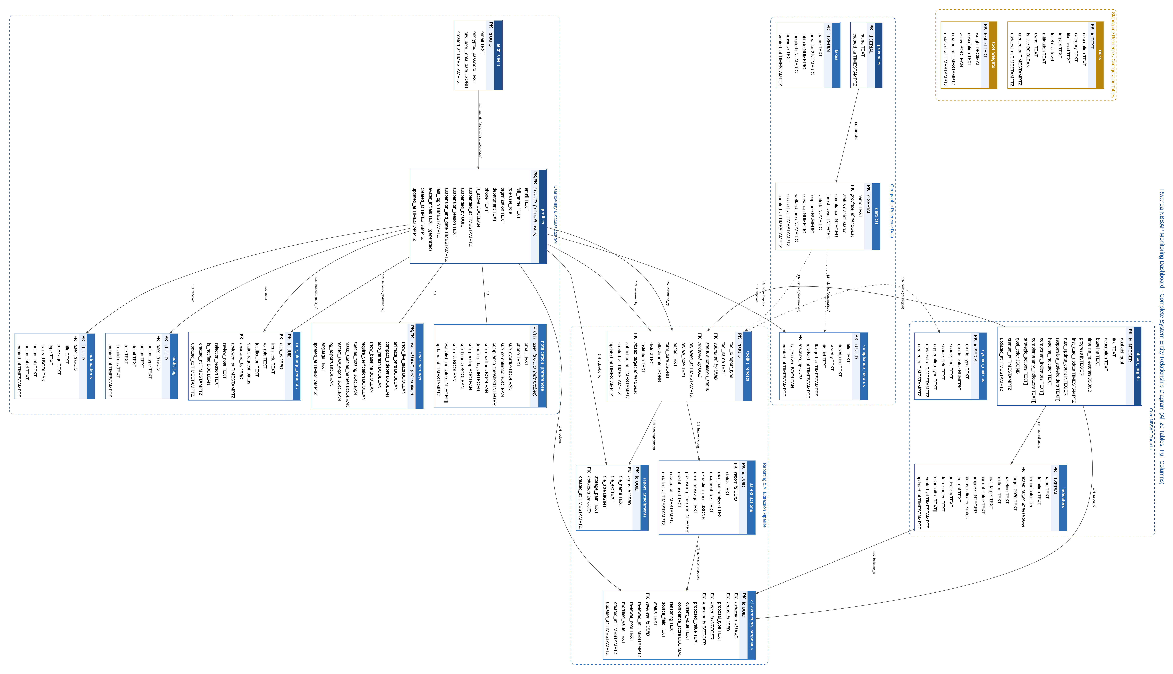
Figure A.1 — Complete System Entity-Relationship Diagram (all 20 tables, full columns, full PostgreSQL types)

A.1 PostgreSQL Enum Type Reference
The following 9 enumerated types constrain the values of specific columns referenced in Figure A.1 and throughout Section 4. Listing them here completes the schema documentation: every custom (non-primitive) type used anywhere in the database is fully defined.
Enum Type | Permitted Values | Used By (table.column)
user_role | policy_monitoring, lead_government_ministry_reporting, local_reporting, dashboard_management, programme_alignment, public_viewer | profiles.role
indicator_status | on-track, at-risk, behind | indicators.status
indicator_tier | headline, component, complementary, binary | indicators.tier
submission_status | pending, approved, rejected | toolkit_reports.status
district_status | submitted, pending, missing | districts.status
report_type | T01, T02, T03, T04, T05, T06, T07 | toolkit_reports.tool_id
risk_level | High, Medium, Low | risks.level
gbf_goal | A, B, C, D | nbsap_targets.goal
request_status | pending, approved, rejected, cancelled, stale | role_change_requests.status

A.2 Table Inventory Summary
20 tables in total: 1 Supabase-managed identity table (auth.users) and 19 application tables, none of which are abbreviated or omitted from Figure A.1 above.
Domain | Tables | Count
Core NBSAP Domain | nbsap_targets, indicators, system_metrics | 3
Reporting & AI Extraction Pipeline | toolkit_reports, report_attachments, ai_extractions, ai_extraction_proposals | 4
User Identity & Access Control | auth_users, profiles, user_settings, notification_preferences, notifications, audit_log, role_change_requests | 7
Geographic Reference Data | provinces, districts, lakes, compliance_records | 4
Standalone Reference / Configuration | risks, tool_weights | 2

