**Create a test level!**

- In GUI, Browse to “test_leveleditor1” in the workspace.

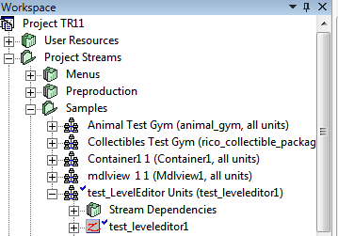

-Right click “test_leveleditor1” > File > Copy Zone

-Set a unique zone name in the New Name field.

-Change the New Folder to your user folder. Make yourself a new user folder if needed.

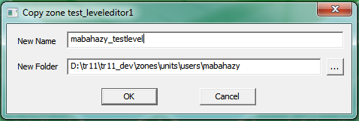

Figure 1. Sample name and location.

-Click OK. Notice that the new files are now created and checked out in P4.

-Browse to zones\units\users\username and double click the zone you just created to open the unit in Horizon.

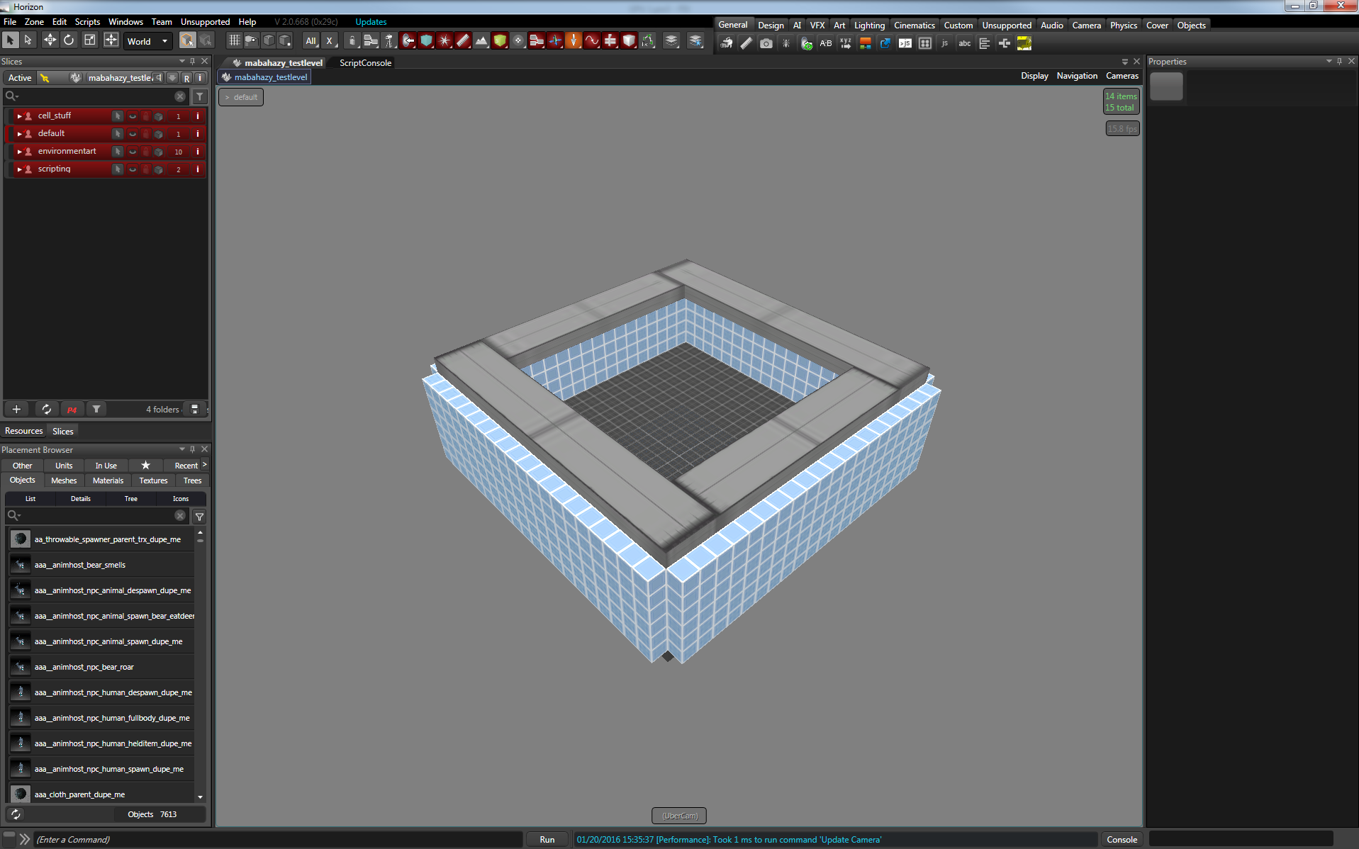

Figure 2. You should see something like this in your Horizon viewport.

In Horizon, click Zone > Run > Build and Run.

The unit should now be running on your desired platform. Most likely the Xbox.

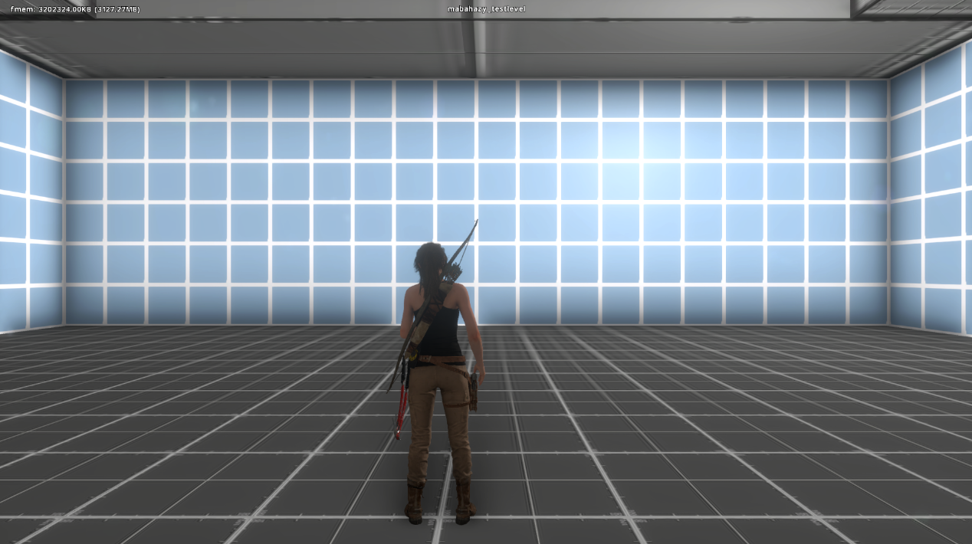

Figure 3. You should see this on your platform of choice.

You now have your own personal test unit. This simple tutorial will provide you with one of our most powerful tools to create, experiment, and test rapidly in a safe way. Feel free to make as many as you’d like, but keep them in your user folder unless you have a good reason to populate the public folders.