CSIT314 Software Development Methodologies
Lab Test – Assessment (10 marks)
Duration: 1 hour
Submit a softcopy of your work to the correct submission site on Moodle. Late submission is NOT accepted.
Important note: This lab exercise is expected to be completed independently. You must do it on your own. Plagiarism may result in a FAIL grade being recorded

Name: KOH EE HUI JOSEPH
Tutorial Group: T02
UOW ID: 1441309
Marking Sheet
Task | Total Marks | Awarded Marks
1. Develop a list of user stories | 2
2. Develop a use case diagram and use case descriptions
- Develop a use case diagram | 2.5
- Choose one major use case and develop a detailed use case description for it | 1
3. Use the b-c-e framework to develop a design

- Draw a class diagram to represent your design | 3
- Draw a sequence diagram for the selected use case in Question 2.b | 1.5
Total Marks

My Answer

1. Userstories:

- As a donor, I want to browse and search item listings so that I can find a family I want to help

- As a donor, I want to see a listing’s story and funding progress so that I can decide whether to donate

- As a donor, I want to donate towards an item so that the family can receive it

- As a donor, I want to view the public ledger so that I can see how donations were used

- As a social worker, I want to create an item listing for my client so that donors can fund it

- As a social worker, I want to edit my listing so that donors understand the need better

- As a user administrator, I want to verify a social worker’s organisation so that only trusted people can list items

- As a user administrator, I want to approve or reject submitted listings so that only vetted items go live

- As a user administrator, I want to purchase a fully funded item and order delivery so that the family receives it

- As a merchant, I want to confirm delivery so that the listing is marked as fulfilled

2. Usecase Diagram

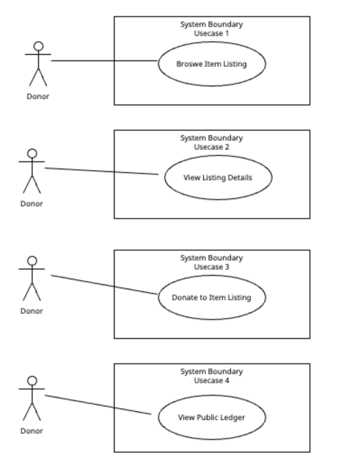

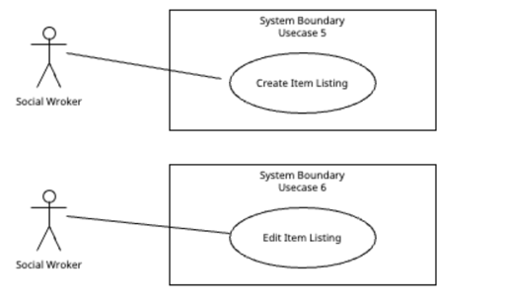

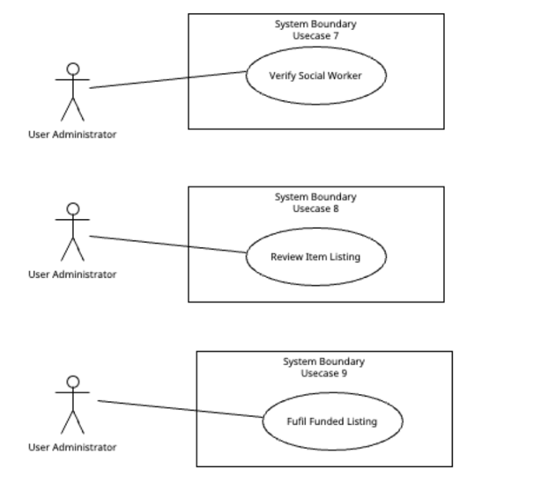
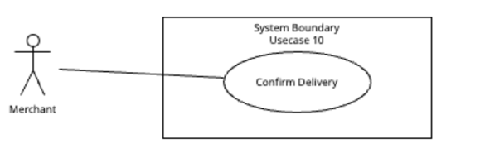

Major Usecase Description:

Field | Content
Name | Donate to Item Listing (Usecase 3)
Actor | Donor
Description | A donor donates towards a specific item listing that a social worker created, so that the item can be bought and delivered to the family
Trigger | The donor clicks “Donate” on an item listing page
Pre-existing condition | The item listing must be created by the social worker first
Normal flow | - Donor views the item listing  - Donor enters the donation amount  - Donor clicks the donate button  - System checks that the listing is still open and the amount is valid  - System records and save the donation  - System adds the amount to the listing’s funds raised  - System displays that the donation was successful
Alt flow | The listing is closed or the amount is invalid: system returns a ValueError and displays an error message, and the donor returns to step 1.

3. Class Diagram

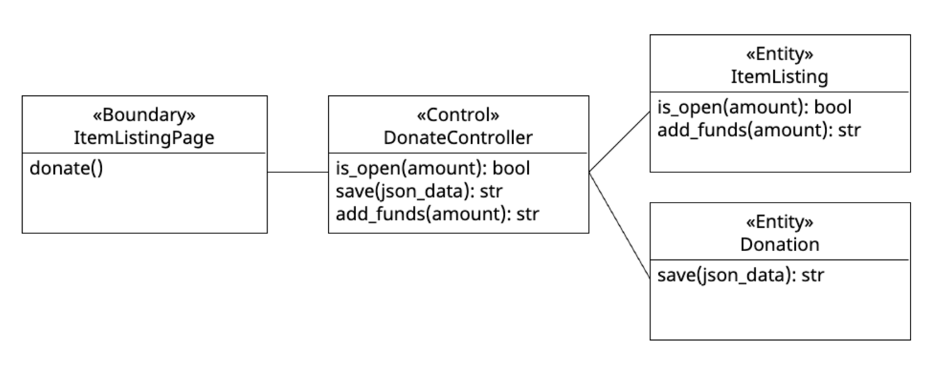

4. Sequence Diagram

