
ECON251
INDUSTRY AND TRADE IN ASIA
Data Analysis 1

- Website : The world Bank Databank – World Development indicators
https://databank.worldbank.org/source/world-development-indicators
- Time period (25 years) : year 2000 to year 2025
- Countries : Singapore, Assigned Asia Economy [ To be announced during tutorial]
- Submission of assignment comes in 2 parts on Moodle . you are strongly encouraged to complete it during the tutorial session
Part 1 : Answer all the given questions online based on your processed data for the assigned economy
Part 2: Submit the excel data file, Tutorial assignment 1 data _student” showing your raw data. Processed data , charts and regressions output tables. Use clearly labelled worksheets
Remarks : you do not need to submit this word document
Objective
General steps
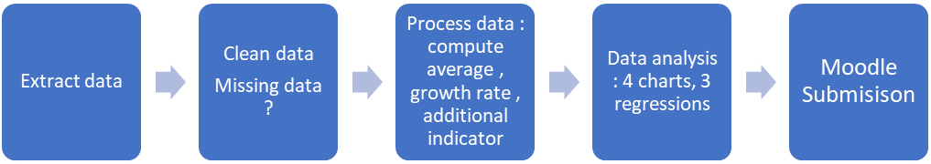
Demo data on Singapore is provided in the student excel file “Tutorial assignment 1 data _student”
Key step discussed in the demo is also presented in the PowerPoint slides ËCON251 World bank data access_pptx for your reference

Question 1 : Data Collection and comparison
Key data  Data series . | Singapore | Assigned Economy

1. Production/Output

Average real GDP (in 2015 constant USD)

Average Economic growth rates (in %)

Average Level of manufacturing output

Average Manufacturing output growth rate

Share of manufacturing output : Manufacturing , value added % of GDP

Share of primary output , Agriculture, forestry and fishing value added % of GDP

2. Inputs
2.1 Labour (L) | Singapore | Assigned Economy

Average size of labour force

Average level of Employment rate

Average number of employed

Average level of Labour productivity

Key formulas:

Employment rate = 100 – Unemployment rate

Total employed = (Employment rate /100) X labour force

Labour productivity = Real GDP/Total employed

Average labour productivity growth rate
2.2 Capital Goods (K) | Singapore | Assigned Economy

Average level of gross fixed capital formation (K) (in USD)

Average gross fixed capital accumulation growth rate

Average capital per worker

Key Formula

Capital per worker

= Total K / Total Employed
2.3 Human Capital (A)  There is no standard level of indicator used to measure H  Suggested indicators ( depending on the availability on WDI for the country and we do not expect to get yearly data  Education attainment in upper secondary school or post-secondary school (%) | Singapore | Assigned Economy
2.4 Natural resources (N) | Singapore | Assigned Economy

Total natural resources rents (% of GDP)

3. Components of spending
 | Singapore | Assigned Economy

Average % share by household consumption

Average % share by firms’ capital spending

Average % share by government total spending

Average % share by net trade

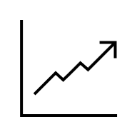Part 2: Data presentation

GENERAL INSTRUCTIONS
- Select the Correct Chart Type:
- Use Complete Raw Data: All charts must be plotted using the complete, year-by-year raw data or computed values based on the raw data for the stated periods. Do not plot averages or summarized data points.
- Format Your Axes and Labels Professionally: Every chart must include:
  - A clear Chart Title specifying the country and the variables being shown.
  - Explicit Axis Titles with units of measurement (e.g., "Year" on the X-axis, and "% of GDP" or "Annual % Growth" on the Y-axis).
- Display Trendline Equations and R²: When adding a linear trendline to your chart, ensure you check the boxes in Excel to "Display Equation on Chart" and "Display R-squared value on Chart." * The General Linear Trendline Equation: The trendline will appear in the format:
y = mx + b
(Where y is your vertical axis variable, x is your horizontal axis variable, m is the slope/rate of change per unit, and b is the Y-intercept).

Question 1: GDP Growth and the components of spending

Plot two different charts presenting the 4 components of spending (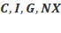) contributing to the country’s GDP over the given period.

Chart 1: A stacked bar chart.

Chart 2: A line chart with linear trendlines for each component. Observe the values of coefficient of x and the R2 values

Compare the two outputs. Which chart type is more effective if your goal is

To show the various and key spending components of Singapore's economy over time, vs

To analyse the growth velocity of individual components?

Question 2: Evidence of industrialisation

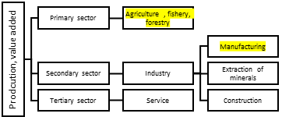

Chart 3: The Output Transformation (Line Chart)

Data to plot: Manufacturing value added (% of GDP) and Primary sector value added (% of GDP) over time (Years on the X-axis).

Part 1: Visualizing Structural Change

Plot a line chart showing the country’s manufacturing share of GDP and primary sector share of GDP with the GDP growth rate over the given time period. Include a linear trendline and equation for all lines.

If any of the values in the series are far apart or compress your chart, create a Combo Chart and plot the contrasting data series on a Secondary Axis to ensure all trends are clearly visible and legible.

Look at the linear equations displayed on your chart (y = mx + b).

a) Compare the slopes (m) of both equations. Which sector is expanding, and which is contracting? Explain what the exact value of the manufacturing slope means for the country's annual economic growth.

b) Compare the R² values for both sectors. Which sector’s trend over time was steadier and more predictable, and which one experienced more volatility?

c) In the event that the GDP shares of both the manufacturing and agriculture sectors are falling simultaneously over time, what does this trend imply about the country's structural economic transformation? What other specific data or indicators would be relevant to justify your conclusion?

Question 5: Effects of industrialisation : Structural transformation

In this discussion ,we want to consider if a country grows her manufacturing sector, there will be direct effects on her economy esp. in terms of employment (where labour will move from one sector to the other) and labour productivity

Chart 4 : Using a scatterplot diagram, study the relationship between the country’s employment share in the primary sector( effect) and the manufacturing share of GDP (cause) . Display the trendline on your chart and interpret the resulting linear equation in terms of:

The sign of the slope (What does a positive or negative relationship mean in the real world?)

The value of the slope (What does the exact number tell us about the rate of change?)

The R² value (How well does the trendline fit the actual data points?)

Part 3: Regression

Please read and follow these guidelines carefully before conducting your analysis:

1. Software Requirement

You must use the MS Excel Data Analysis Toolpak to run the multiple regressions required for the following questions.

Note: If you do not see the "Data Analysis" option under your Excel 'Data' tab, you will need to enable it via File > Options > Add-ins.

2. Data Requirements & Preparation

Use Raw Data: All regression analysis requires the use of the complete, year-by-year raw data for the stated periods. Do not use the average values calculated or discussed in Question 1.

Consistency: Ensure that all data used for running the regression uses the same unit of measurement.

Data Cleaning: Check your dataset to ensure there are no missing indicators or blank cells before running the tool.

Ensure your independent variables are in adjacent columns in Excel, as the Data Analysis Toolpak requires a single, continuous range for the "Input X Range

3. The Regression Model

You will be estimating the following general multiple regression equation:

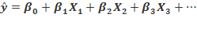

Where:

is the predicted target (dependent) variable.

is the intercept.

represents your chosen independent variables/indicators.

represents the coefficients for each independent variable.

4. Required Deliverables & Interpretation

The Data Analysis Toolpak will generate a standard Regression Summary Output table.

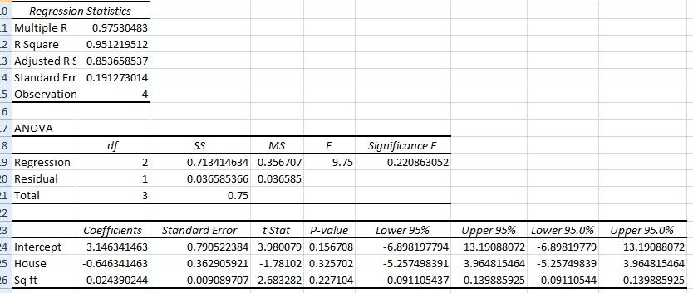

For your submission, you are required to extract, report, and thoroughly interpret the following key values:

R-Square (): To explain the model's goodness of fit.

Coefficients (): To explain the direction and magnitude of the relationships.

P-values: To determine the statistical significance of your independent variables.

Tip for students: Ensure your independent variables are in adjacent columns in Excel, as the Data Analysis Toolpak requires a single, continuous range for the "Input X Range.

Question 1 : Regression : key engines of production and growth

The economic output of our assigned country can be modelled using the aggregate production function:

Y = A f(K, L, N, H)

Where Y is total output (GDP), K is physical capital, L is labour, N is natural resources, and H is human capital.

Run a multiple linear regression using the data collected across your previous questions to determine which factor inputs are the most critical drivers of this economy.

Using raw data

Dependent Variable (Y Target): GDP (in constant USD)

Independent Variables (X):

Capital (K): Gross fixed capital formation (constant currency)

Labor (L): Total employed

Natural Resources : Total natural resource rents (% of GDP).

Human capital measured in terms of education level attained : % of population

Regression 1: Based on the raw data, we can only run a simple regression of Y = f(K,L) and discuss the results. Is capital or labour a main determinant of output growth in the country

Vs modified data : a choice of converting all to monetary value or in %
Find rate of change
= [(new – original)/original] X 100 %

Dependent Variable (Y Target): GDP growth (in %)

Independent Variables (X):

Capital (K): Gross fixed capital formation growth rate (in %)

Labor (L): Growth of employed labour (in %)

Natural Resources : Total natural resource rents (% of GDP).

Human capital measured in terms of education level attained : % of population
Already in % find change in $ point
= New % - original %

Regression 2: Based on your regression output, fill in the table below to rank the inputs from most important to least important based on their statistical significance.
Ranking | Input Factor | Coefficient | Evidence [p value]

1

2

3

4

Question 2: Regression 3: Effects of industrialisation
Run a multiple linear regression to analyse the core drivers of a country's workforce efficiency.
Because industrialization and economic development are dynamic, continuous processes, analysing them in absolute levels can obscure structural shifts due to sheer scale over time.
Using variables expressed in percentage growth rates allows us to capture the velocity and momentum of these structural changes rather than just their size
- Dependent Variable (Y Target): Growth rate of labour productivity (GDP per person employed, annual % growth)
- Independent Variables (X$:
  - Capital Deepening: Growth rate of capital per worker (Annual % growth)
  - Industrialization: Growth of manufacturing sector (Manufacturing value added, annual % growth)
  - Human Capital: Growth in education attainment ( in %)
Using your REGRESSION OUTPUT TABLE, answer the following questions:
a) Evaluating the Explanatory Power (R²): Interpret the R₂ value of your regression. What does this number tell us about how well our model explains changes in labour productivity growth?
b) Which is a more important factor in driving the change in labour productivity in the country.

