USAID Final Mission

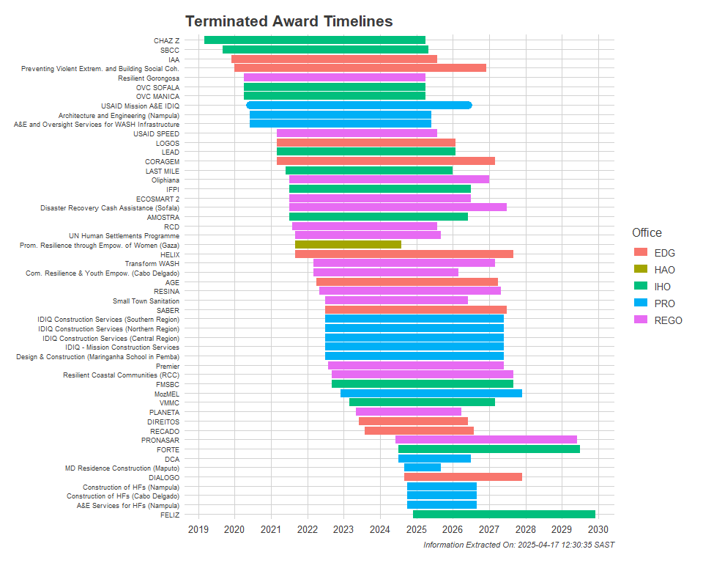

## Quarto

Quarto enables you to weave together content and executable code into a finished document. To learn more about Quarto see <https://quarto.org>.

[1] 2