**Documentation for ‘ScoreInfo’ Microservice**

With reference of CodingAssignmentJavaDeveloper_NTT.docx, I have developed a microservice, named ‘**scoreinfo**’. The package structure of the service in Eclipse can be referred below as screenshot.

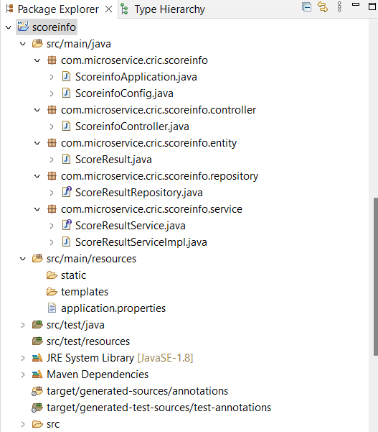

The ***application.properties*** of the service is attached below.

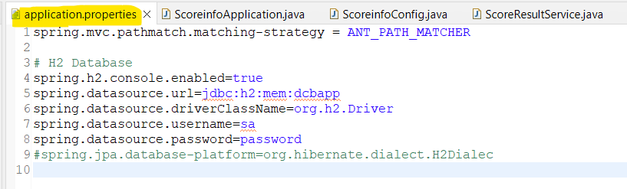

This microservice has five operations add new ScoreResult, read/get all ScoreResult(s), update a specific ScoreResult and delete a ScoreResult. Each operation’s URLs and Request & Response attached below.

1. Add New ScoreResult

URL: <http://localhost:8080/scoreinfo/addscoreresult>

RQ: {

"country1Name":"Ind",

"country1Score":"248/5",

"country2Name":"Aus",

"country2Score":"241/3",

"place":"Bangalore",

"matchDate":"2024-05-19 18:30:11",

"result":"India won the match."

}

RS: {

"matchId": 1,

"country1Name": "Ind",

"country1Score": "248/5",

"country2Name": "Aus",

"country2Score": "241/3",

"place": "Bangalore",

"matchDate": "2024-05-19 18:30:11",

"result": "India won the match."

}

Screenshot:

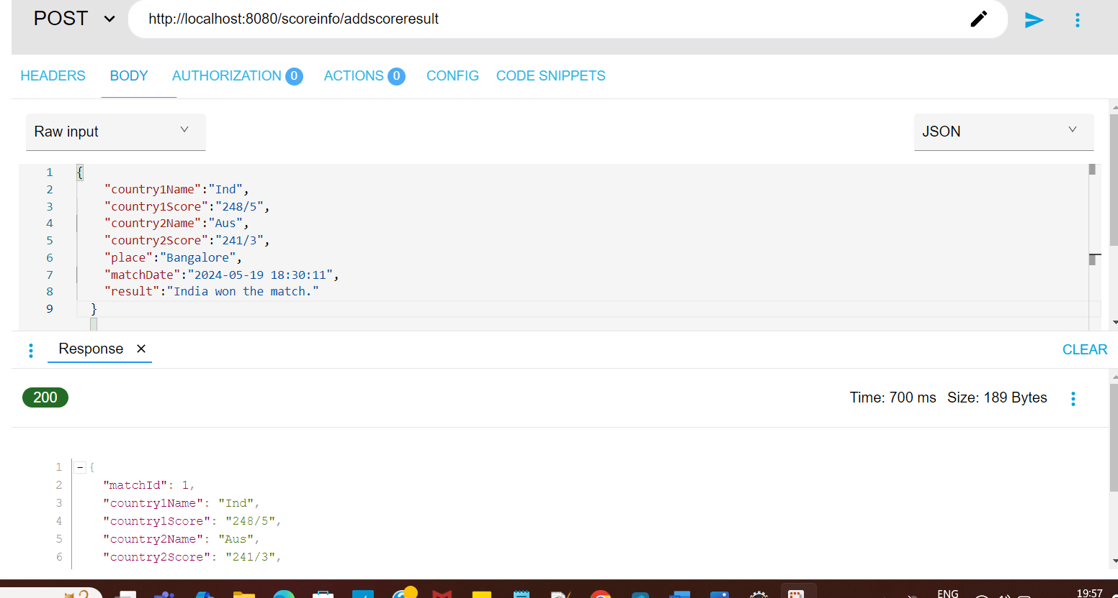

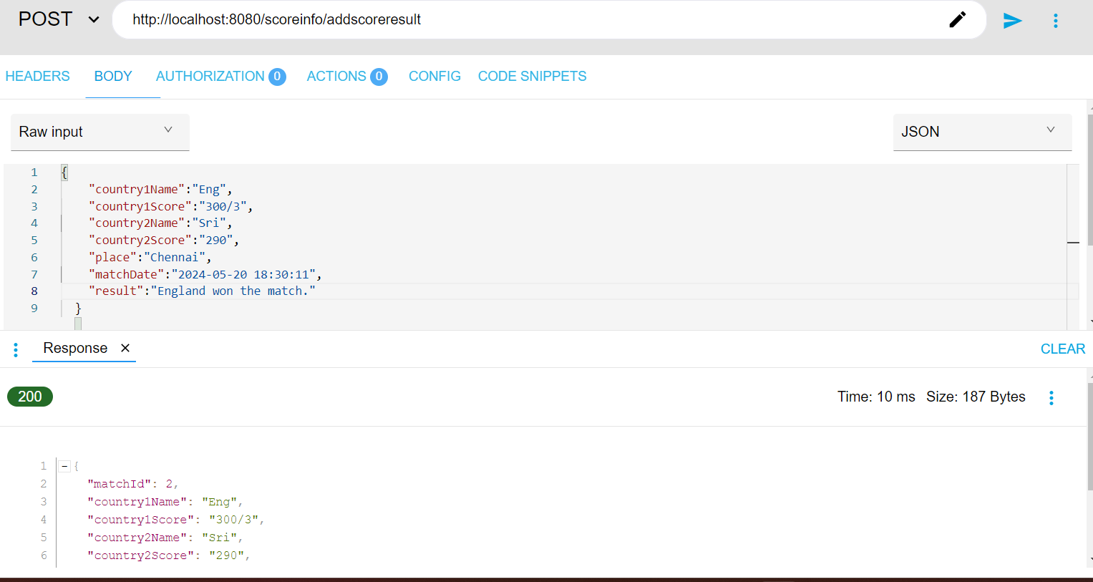

1. Get all records of ScoreResult

URL: <http://localhost:8080/scoreinfo/getscoreresults>

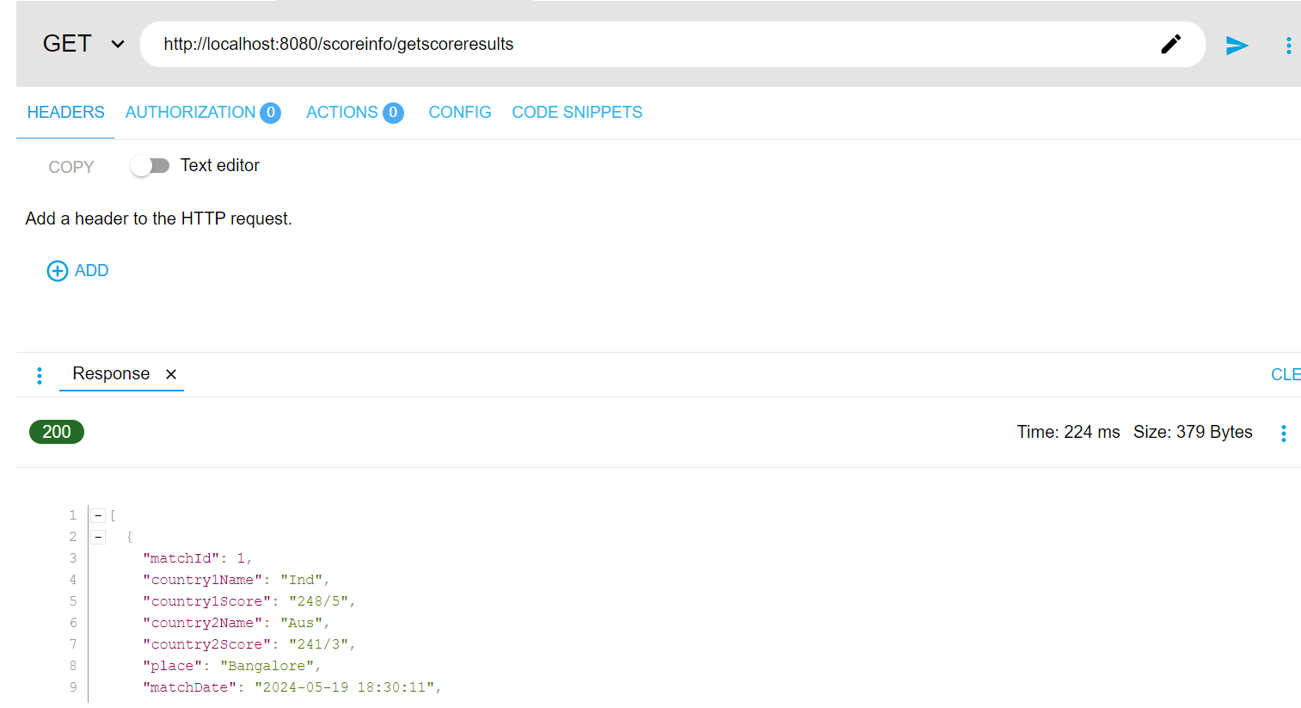

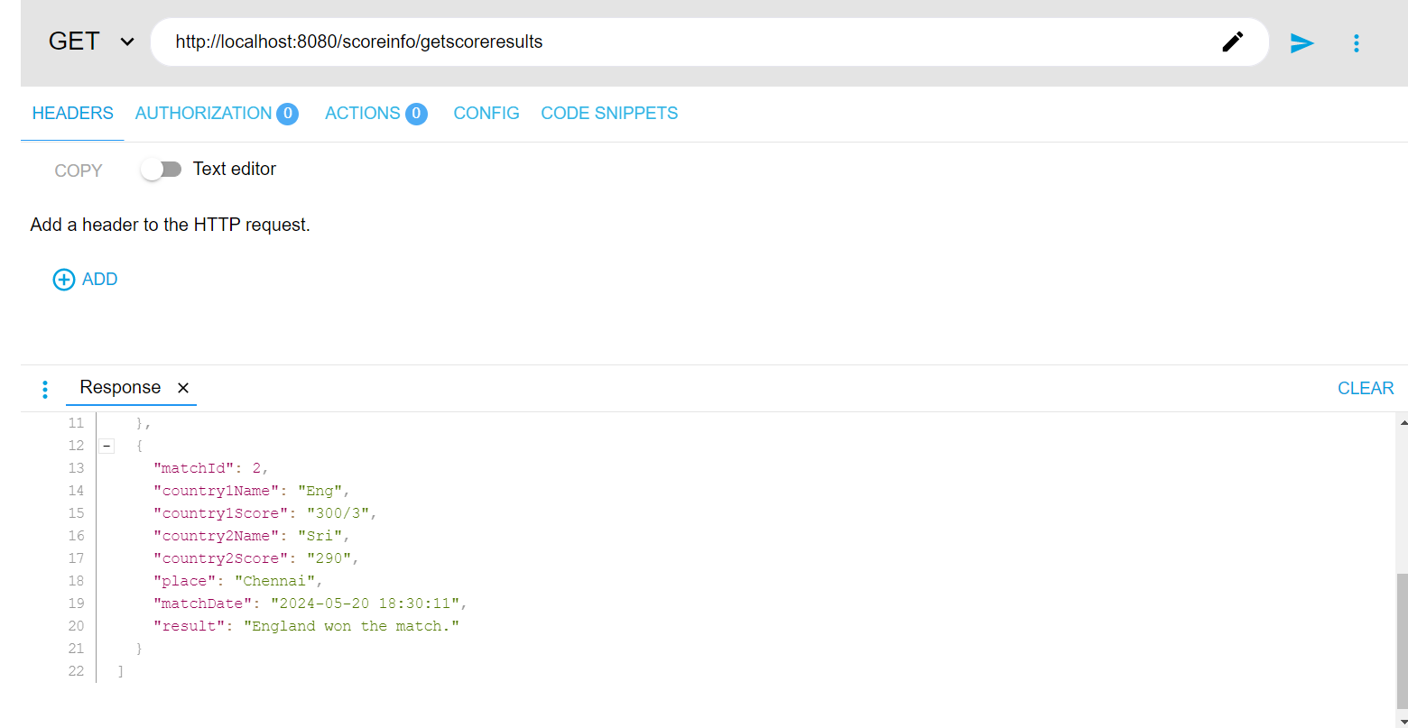

1. Get specific record of ScoreResult

URL: <http://localhost:8080/scoreinfo/getscoreresult/2>

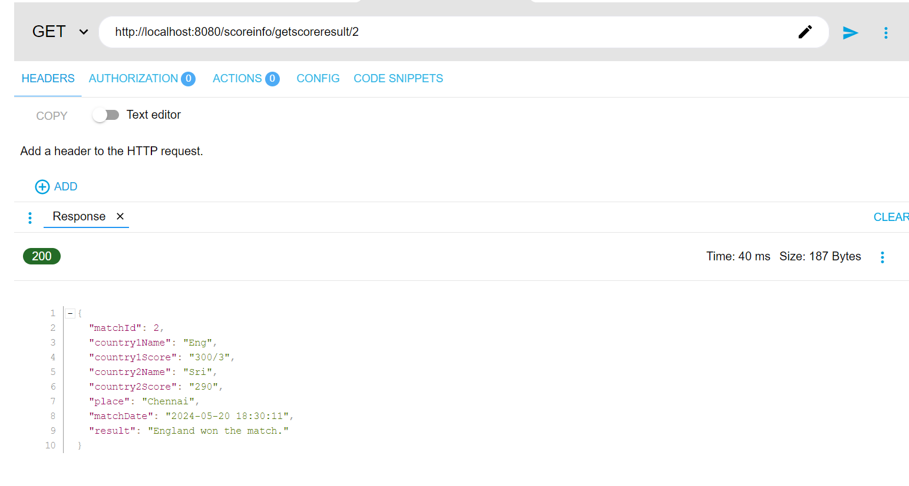

1. Update specific record of ScoreResult

URL: <http://localhost:8080/scoreinfo/updatescoreresult/1>

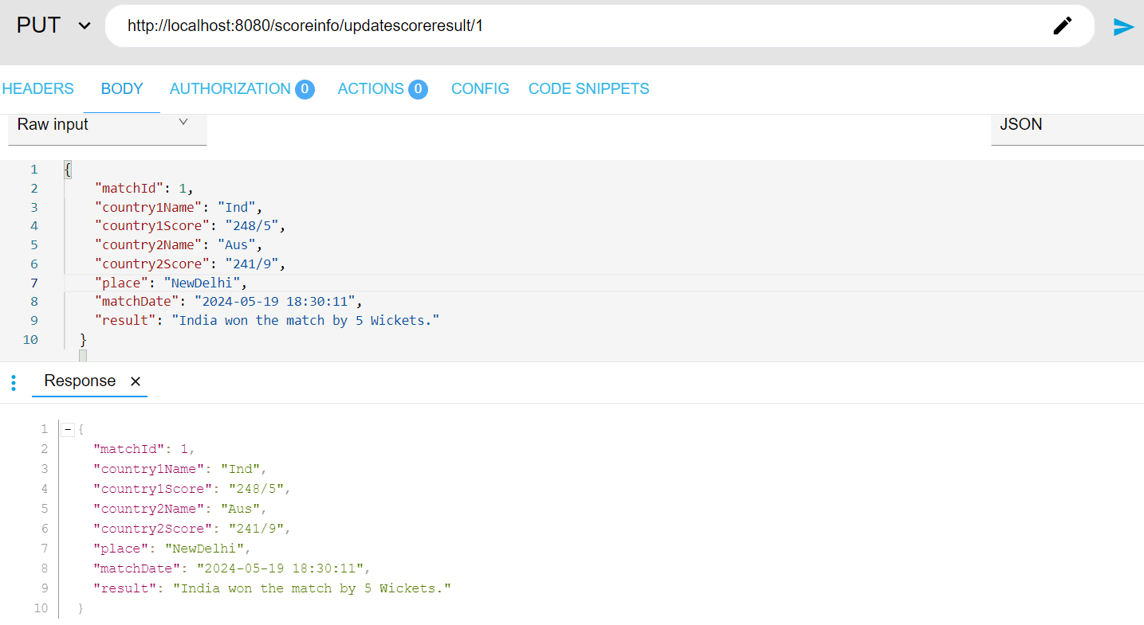

1. Update specific record of ScoreResult

URL: <http://localhost:8080/scoreinfo/deletescoreresult/1>

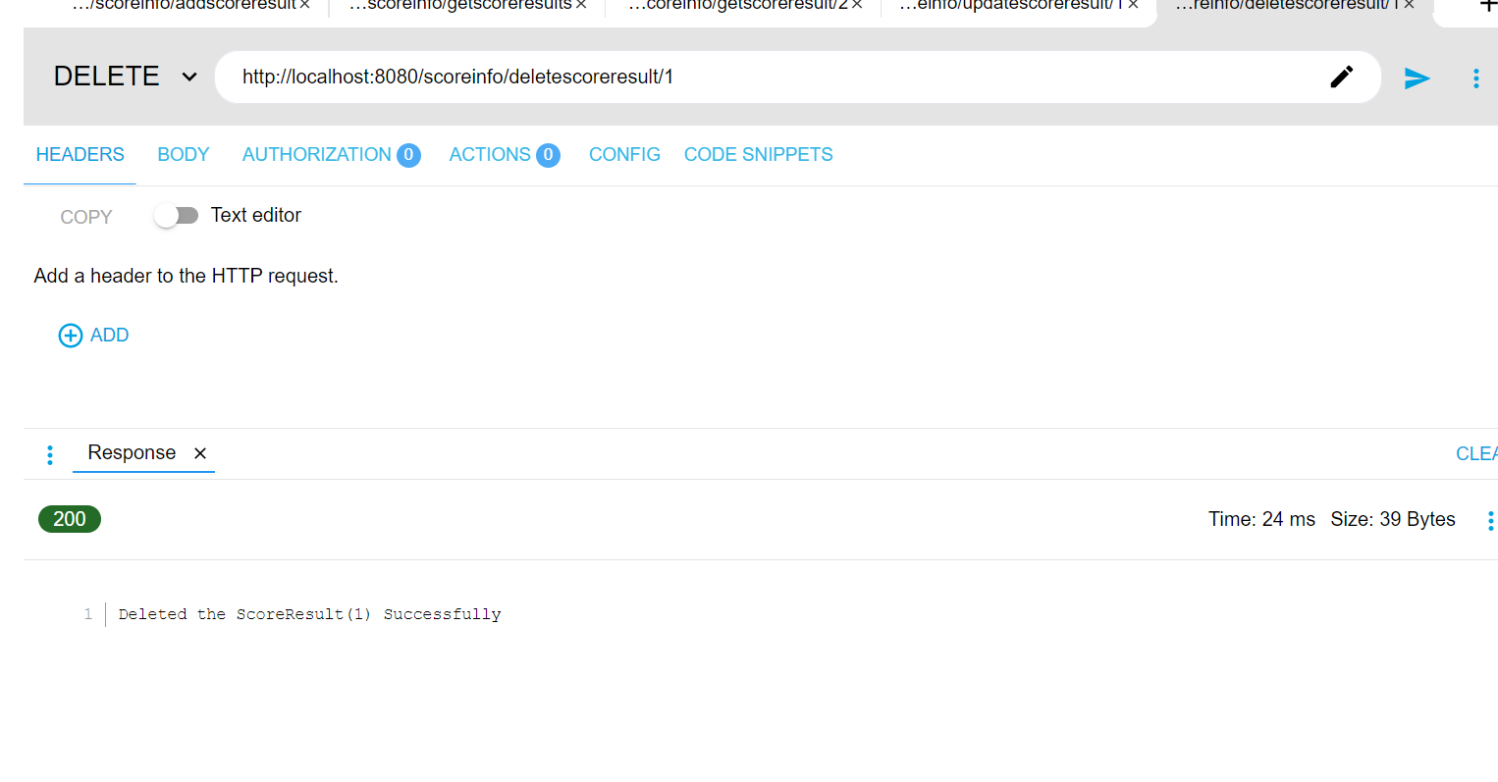

**Swagger View**

I have implemented Swagger view for all operations and model entity. Which should be view by the following URL <http://localhost:8080/swagger-ui/index.html#/>

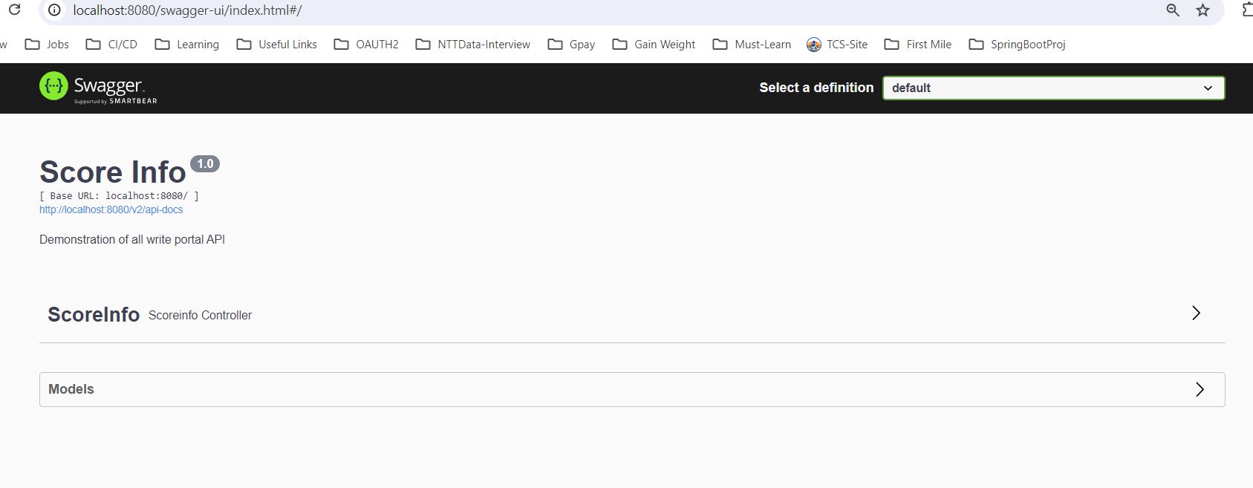

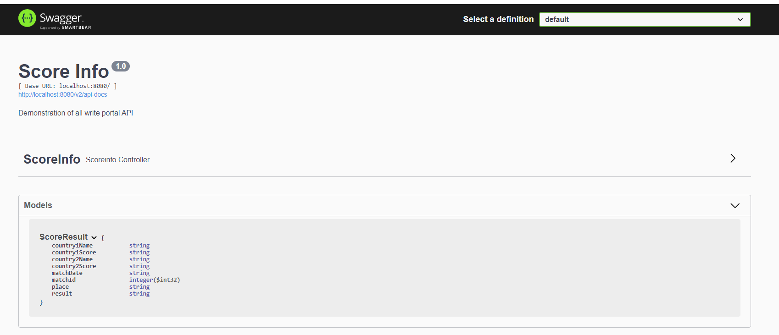

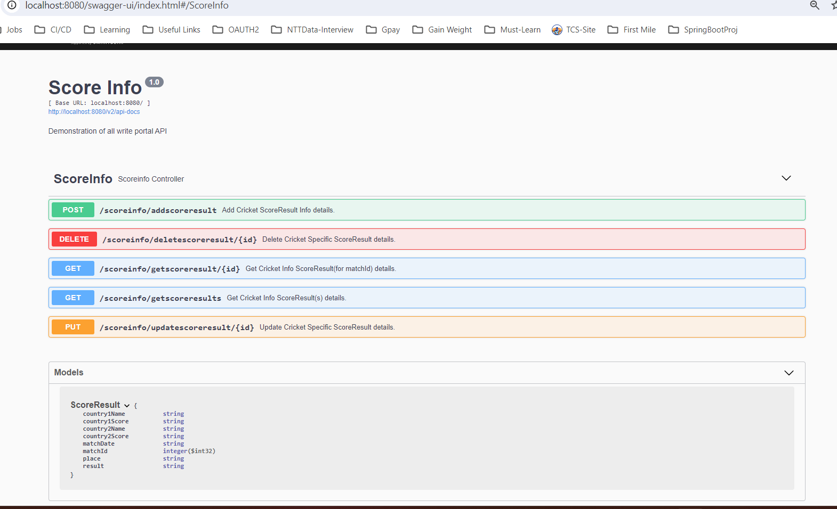

For expanded screen for all services is attached in below pdf.



**H2 In Memory Database**

Below URL to access in-memory database.

URL: <http://localhost:8080/h2-console>

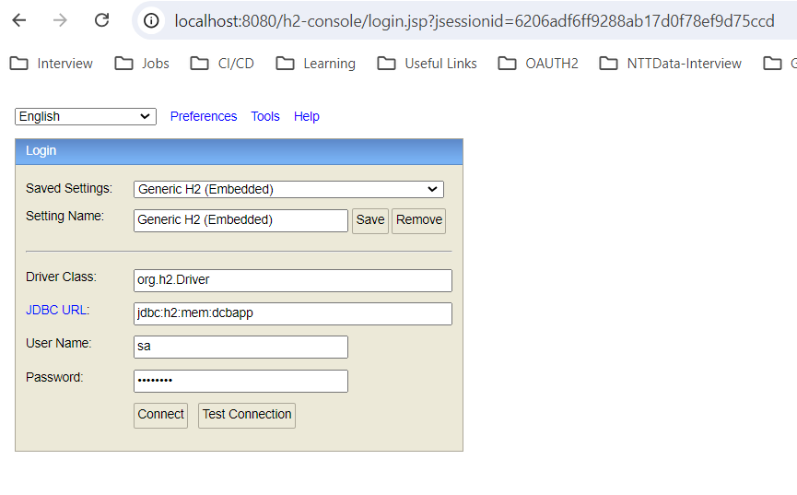

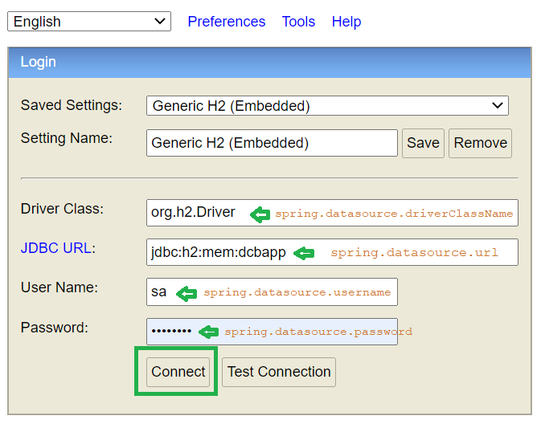

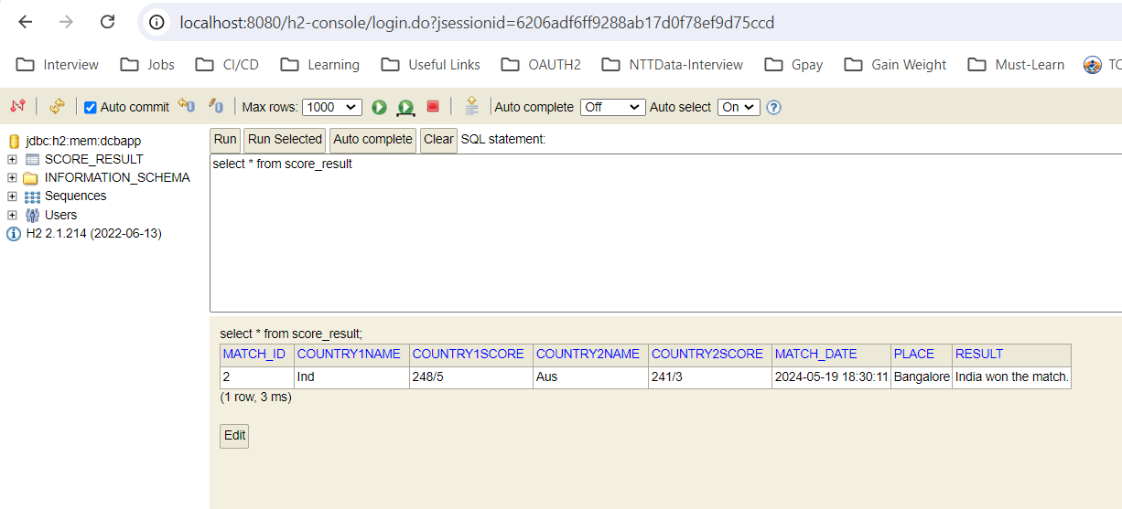

**ScoreinfoControllerTest Class**

* Junit test cases implemented for all controller methods/operations. Below i have attached screenshots for those result.

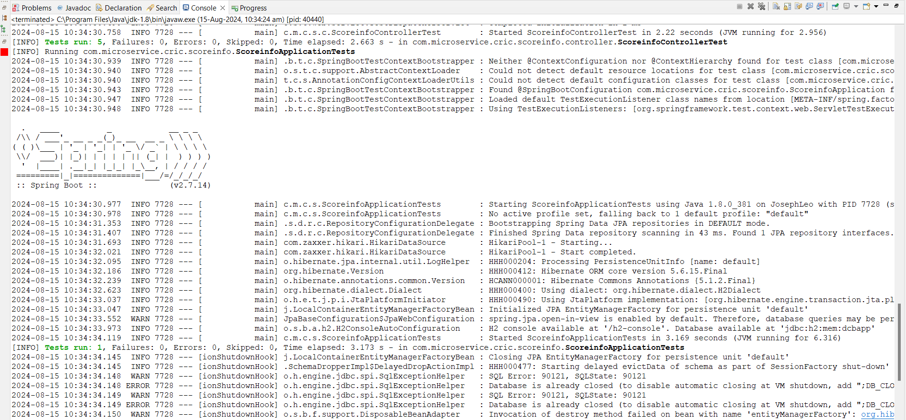

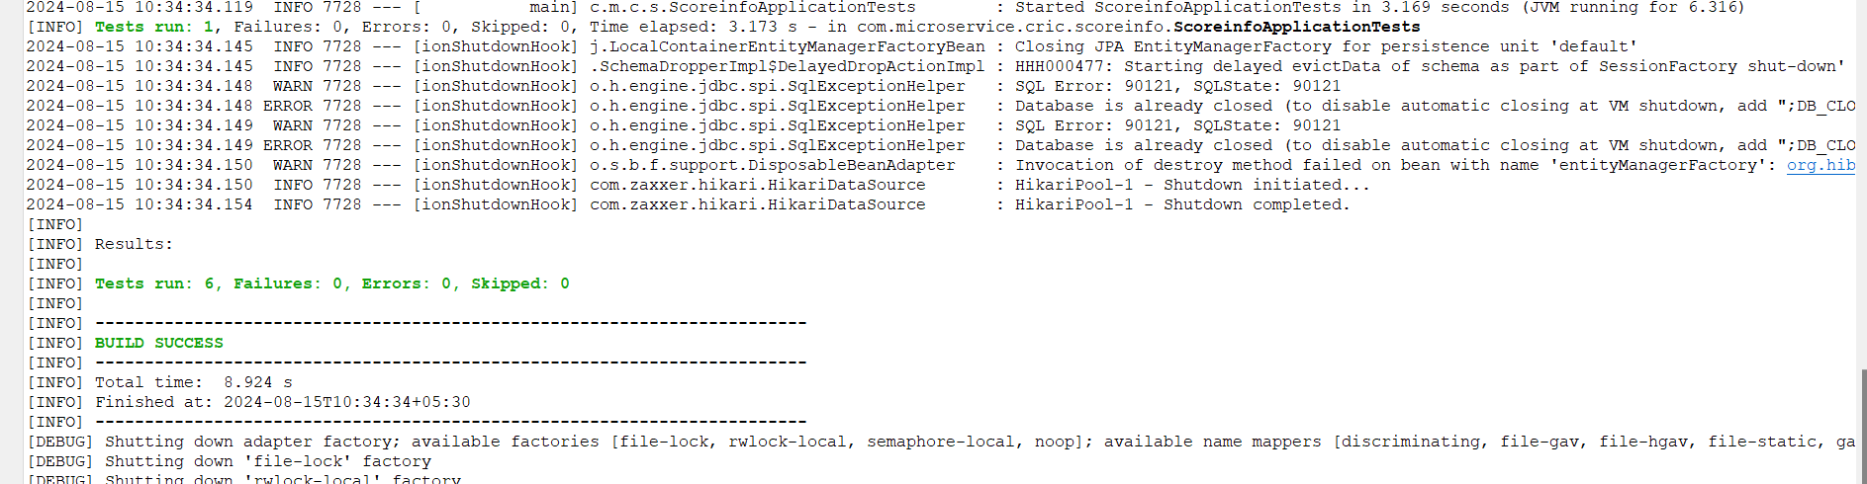

**Docker Image and YAML file for Kubernetes**

* I have created docker image for this service, tested the same and create **scoreinfo-application_image.tar** file (in below screenshot) to export.
* ***Docketfile*** marked in below screenshot in the project director.
* The **scoreinfo_kube_service.yaml** file created to create deployment and service in Kubernetes for the service. The same file marked in below screenshot.
* Due to size of **scoreinfo-application_image.tar file, we could not upload it to git.**

