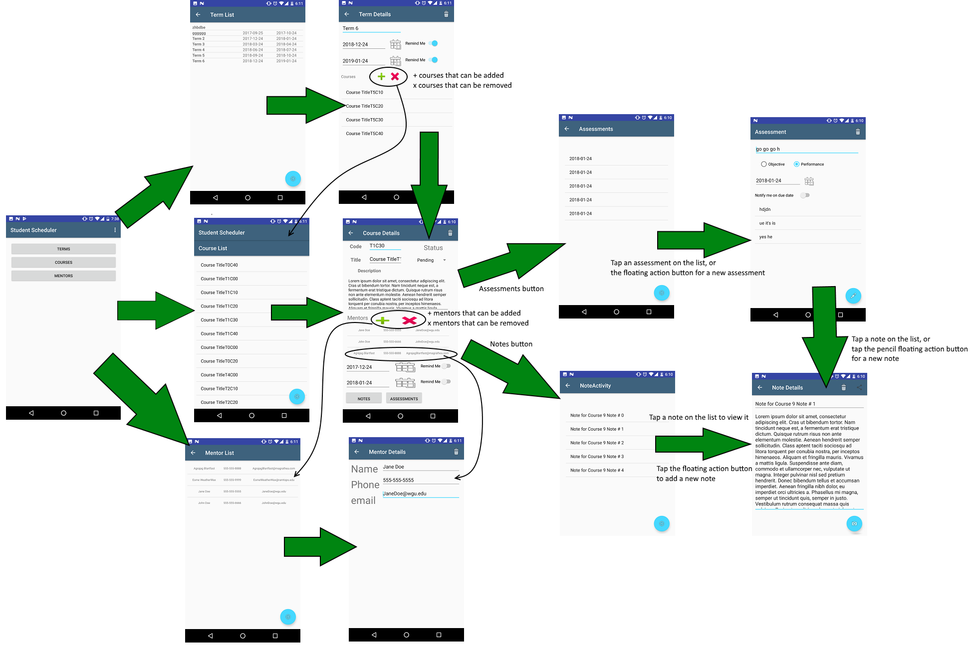
C196 Mobile Application Development Practical Assessment, Section D Joseph Losee
Storyboard

