Cpt S 411 Assignment Cover Sheet

(To be turned in along with each homework and program project submission)

Assignment 4

For team projects:

Coulter, Blake

Nassar, Adam

List of collaborative personnel (excluding team participants): None

I[1] certify that I have listed above all the sources that I consulted regarding this assignment, and that I have not received or given any assistance that is contrary to the letter or the spirit of the collaboration guidelines for this assignment. I also certify that I have not referred to online solutions that may be available on the web or sought the help of other students outside the class, in preparing my solution. I attest that the solution is my own and if evidence is found to the contrary, I understand that I will be subject to the academic dishonesty policy as outlined in the course syllabus.

Please print your names.

Adam Joseph Nassar

Blake Coulter

Assignment Project Participant(s):

Adam Joseph Nassar

Blake Coulter

Today’s Date: 11/9/2022

|  |  |  |
| --- | --- | --- |
| processes | Parallel Time | Serial Time |
| 2 | 2.44E-07 | 5.88E-08 |
| 4 | 1.67E-07 | 5.87E-08 |
| 8 | 1.09E-07 | 5.87E-08 |
| 16 | 2.31E-07 | 5.88E-08 |
| 32 | 2.72E-07 | 5.88E-08 |

Parallel vs. Serial for n=524288

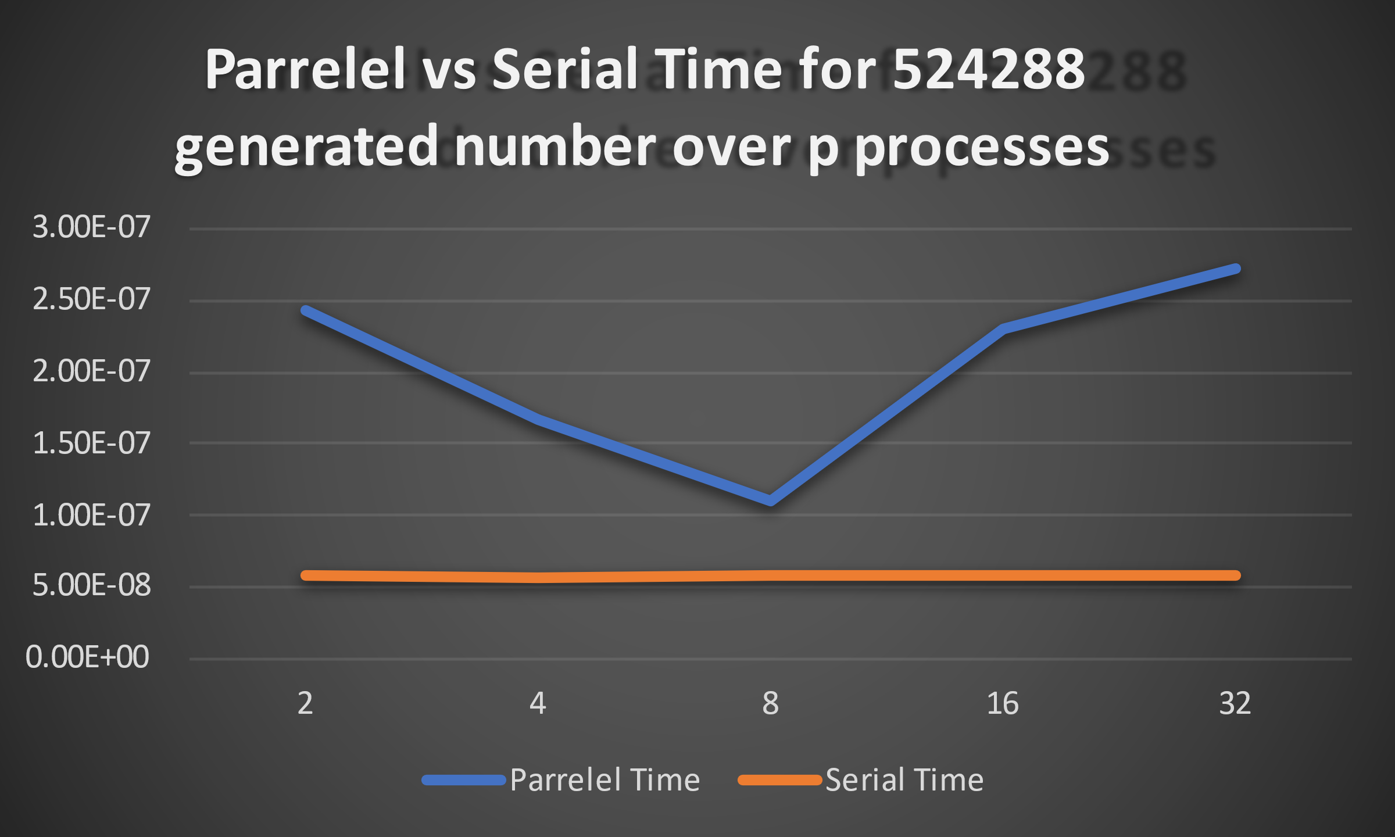

|  |  |  |
| --- | --- | --- |
| n | Parrelel Time | Serial Time |
| 1024 | 2.43E-07 | 5.88E-08 |
| 2048 | 4.36E-07 | 1.15E-07 |
| 4096 | 4.35E-07 | 1.15E-07 |
| 8192 | 1.19E-05 | 3.59E-06 |
| 16384 | 1.20E-05 | 3.60E-06 |
| 32768 | 1.19E-05 | 3.63E-06 |
| 65536 | 2.35E-05 | 7.15E-06 |
| 131072 | 2.37E-05 | 7.24E-06 |
| 262144 | 9.35E-05 | 2.90E-05 |
| 524288 | 1.89E-04 | 5.80E-05 |

Parallel vs. Serial for procs = 2,4,8,16

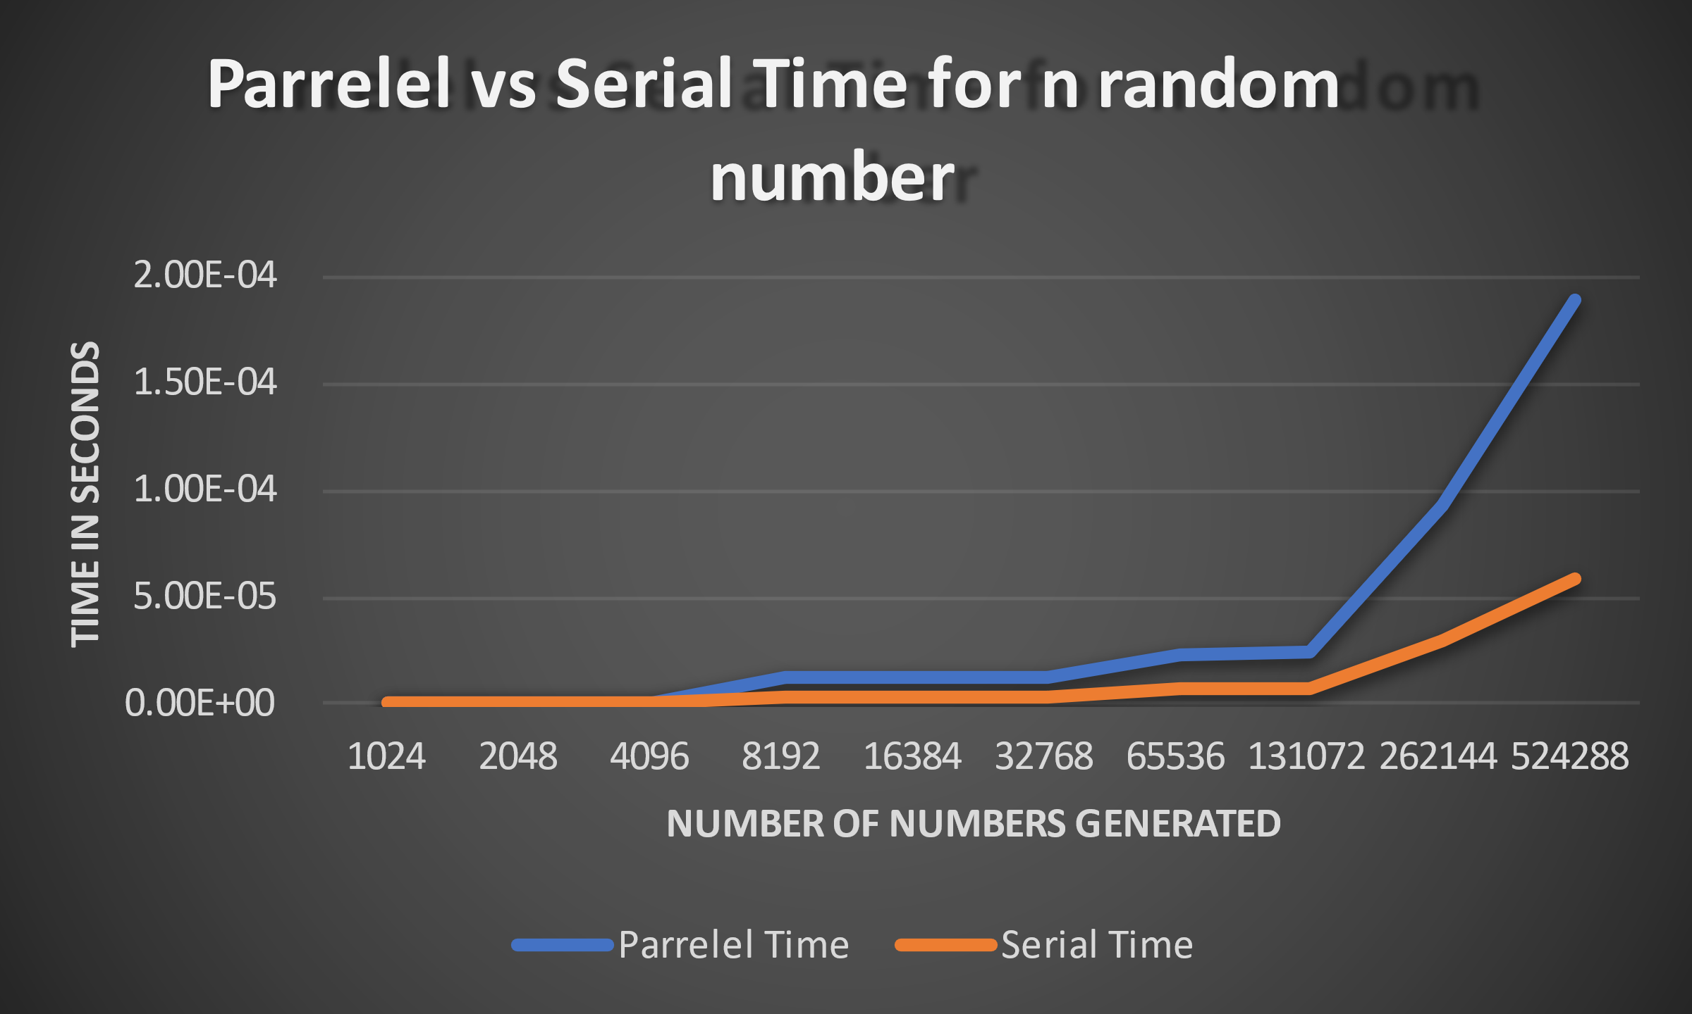

Synopsis: As we can see in the results above, the serial time measured is lower than the parallel implementation time. This goes against what we expected as there are only 10-time steps when n = 52488 which ideally would decrease time, however that does not seem to be the case. We are sure these times are accurate, as they were run 1000 times a piece. We believe the parallel implementation takes longer, due to the fact that the size difference is not substantial enough to counteract the time taken do to MPI_SendRecv. We expect if we had increase the number of processors to greater than 16, as well as the size of the random number array, we would most likely see parallel time decrease.

1. If you worked as a team, then the word “I” includes yourself and your team members.

   School of EECS, Washington State University