171805020 Yusuf AKIN

1. Source IP=192.168.0.19 Source Port=53475
2. Destination IP=128.119.245.12 Destination Port=80
3. Empty

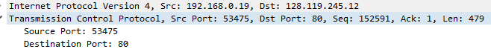

1. Sequence Number=0 and ,the Syn flag is set to 1 which indicates that this segment is a SYN segment.

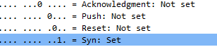

1. Sequence Number=0 ACK=1 because gaia.cs.umass.edu acknowledged requested.

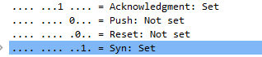

1. Sequence Number=1



1. Segment 1 sequence number is 1

Segment 2 sequence number is 752

Segment 3 sequence number is 2211

Segment 4 sequence number is 3671

Segment 5 sequence number is 5131

Segment 6 sequence number is 6591

Time=7,031249 Ack Time=7,189512 RTT=0,158263

Time=7,035159 Ack Time=7,201387 RTT=0,166228

Time=7,035159 Ack Time=7,201387 RTT=0,166228

Time=7,035159 Ack Time=7,201387 RTT=0,166228

Time=7,035159 Ack Time=7,201387 RTT=0,166228

Time=7,035159 Ack Time=7,201387 RTT=0,166228

Estimated RTT 1=0,158263

Estimated RTT 2= 0,875\*(0,158263)+0,125\*0,166228=0,159258

Estimated RTT 3=0,875\*(0,159258)+0,125\*0,166228=0,160129

Estimated RTT 4=0,875\*(0,160129)+0,125\*0,166228=0,160891

Estimated RTT 5=0,875\*(0,160891)+0,125\*0,166228=0,161558

Estimated RTT 6=0,875\*(0,161558)+0,125\*0,166228=0,162142



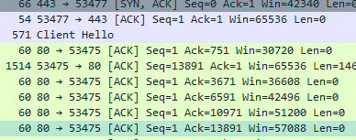

1. 1-)750 bytes

2-)1460 bytes

3-)1460 bytes

4-)1460 bytes

5-)1460 bytes

6-)1460 bytes

1. 29200. The sender is never throttled.

10-) Yes, I checked time sequenced number(steven) graphed and all sequences do not increases continuosly.

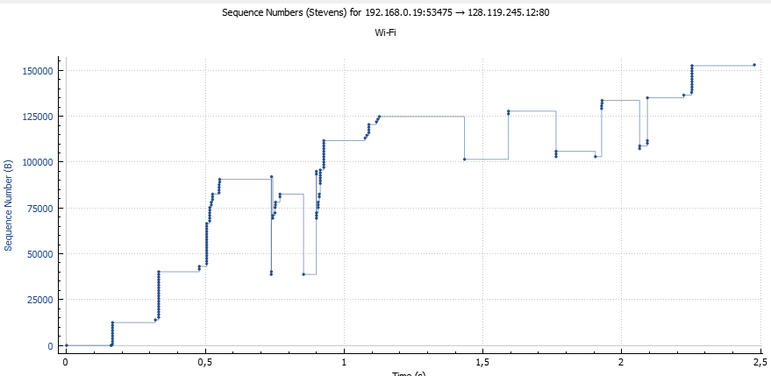

11-)The difference between the sequence number of two consecutive ACKs represents the data received by the server. For example here is 1460.



12-)9,347330s-7,031249s=2,316081s (Last ACK)-(First SYN ACK)

Download Time=(Finish Download)-(Start Download)

152136 KB/2,316081s=65686,82 bytes/sec (Data Length/Download Time) is throughput.

13-)Empty

14-) Empty