|  |  |  |  |
| --- | --- | --- | --- |
| **Group No** | **Student ID** | **Name** | **Project Topic** |
| **38** | **171805004** | **SEMİH AKIN** | **Online Banking System** |
| **171805020** | **YUSUF AKIN** |
|  |  |

|  |  |  |
| --- | --- | --- |
| **TABLE** | **PRIMARY KEY** | **FOREIGN KEY** |
| Personal | Personal_no,ID_no |  |
| Users | IBAN_no | Person_no->Personal.Person_no |
| Property |  | IBAN_no->User.IBAN_no |
| Stock | Stock_code |  |
| Checking_account |  | IBAN_no->User.IBAN_no |
| Credit card | Credit_card_no |  |
| Staff | Staff_no |  |
| Department | Department_no |  |
| Login info | login_info |  |

**Query1:** Finding the information of users whose first name is Yusuf and last name Akin.

**sql code:**

SELECT * FROM personal WHERE (Fname='Yusuf' AND Lname = 'AKIN');

**screenshot of query’s output:**



**Query2:** Print the attributes in the personnel table in order.

**sql code:**

SELECT * FROM personal ORDER BY Person_no;

**screenshot of query’s output:**

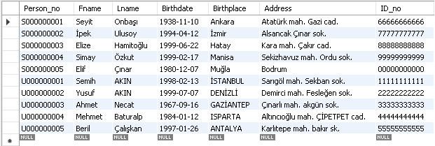

**Query3:** Print attributes for users with birthdates between 1990-01-01 and 2000-01-01.

**sql code:**

SELECT * FROM personal WHERE Birthdate BETWEEN'1990-01-01' AND '2000-01-01';

**screenshot of query’s output:**

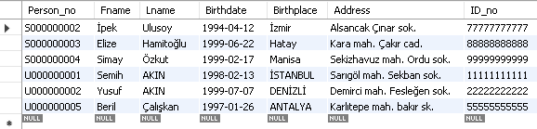

**Query4**: Print the person_no and salary information of those whose salary is specified in the staff table**.**

**sql code:**

SELECT person_no, salary FROM Staff WHERE salary is NOT NULL;

**screenshot of query’s output:**

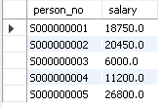

**Query5:** Finding the highest, lowest and average salary among those with account numbers in the Checking account table.

**sql code:**

SELECT MIN(BALANCE) AS 'MIN BALANCE', MAX(BALANCE) AS 'MAX BALANCE', AVG(BALANCE) AS 'AVERAGE BALANCE' FROM checking_account;

**screenshot of query’s output:**



**Query6:**

---Total salaries of employees sorting by department code in department table.

---Cartesien product with property and personal.

**sql code**:

SELECT D.Department_no AS 'Department No', COUNT(*) AS 'Piece', SUM(salary)

FROM department D, staff S

WHERE D.Department_no=S.Department_no

GROUP BY S.Department_no;

SELECT COUNT(*) AS 'number of cartesian products'

FROM property PR, personal P ;

**screenshot of query’s output:**

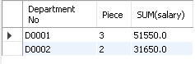



**Query7:** Total salaries of employees sorting by department code in department table.

**sql code:**

SELECT D.Department_no AS 'Department No', COUNT(*) AS 'Piece', SUM(salary)

FROM department D, staff S

WHERE D.Department_no=S.Department_no

GROUP BY S.Department_no;

**screenshot of query’s output:**

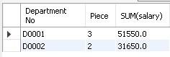

**Query8:** Finding the number of employees in the D0001 department using HAVING.

**sql code:**

SELECT S.Department_no AS 'Department No', COUNT(*) AS 'number of D0001'

FROM staff S

HAVING S.Department_no IN ('D0001');

**screenshot of query’s output:**



**Query9:** Finding people who write “Gazi” anywhere in their personal address.

**sql code**:

SELECT *

FROM personal

WHERE address LIKE "%Gazi%";

**screenshot of query’s output:**

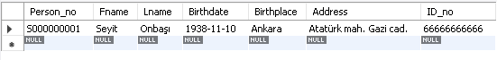

**Query10:** Update the attributes in the staff table.

**sql code:**

UPDATE staff SET department_no='D0002' WHERE staff_no='100002';

UPDATE staff SET department_no='D0002' WHERE staff_no='100004';

**screenshot of query’s output:**



**Query11:**Retrieving S.Person_no, P.Fname, P.Lname information from 2 tables connected to each other using join.

**sql code**:

SELECT S.Person_no, P.Fname, P.Lname

FROM personal P

JOIN Staff S

ON P.Person_no=S.Person_no;

**screenshot of query’s output:**

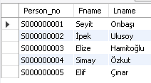

**Query12**: find the average salary in the department table, sorted by department_no.

**sql code:**

SELECT D.Department_no AS 'Department No', COUNT(*) AS 'Piece', SUM(salary)

FROM department D, staff S

WHERE D.Department_no=S.Department_no

GROUP BY S.Department_no;

**screenshot of query’s output:**

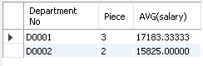

**Query13:** Finding assets in property table of person with staff number 'U000000002' with join rule.

**sql code:**

SELECT *

FROM property P

WHERE P.IBAN_no IN(SELECT IBAN_no

FROM users S

WHERE S.person_no='U000000002' AND S.IBAN_no=P.IBAN_no);

**screenshot of query’s output:**



**Query14:** Find the staff_no information of the people working in the 'D0001' department code by connecting the staff and department table with the left join rule.

sql code:

SELECT D.Department_no, S.Person_no

FROM Staff S

LEFT JOIN Department D

ON S.department_no=D.Department_no AND D.Department_no='D0001';

**screenshot of query’s output:**

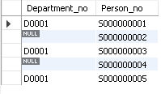

**Query15:** Find the staff_no information of the people working in the 'D0001' department code by connecting the staff and department table with the right join rule.

**sql code:**

SELECT D.Department_no, S.Person_no

FROM Staff S

RIGHT JOIN Department D

ON S.department_no=D.Department_no AND D.Department_no='D0001';

**screenshot of query’s output:**

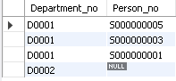

**Query16:** Linking left join and right join tables.

**sql code:**

SELECT D.Department_no, S.Person_no

FROM Staff S

LEFT JOIN Department D

ON S.department_no=D.Department_no AND D.Department_no='D0001'

UNION

SELECT D.Department_no, S.Person_no

FROM Staff S

LEFT JOIN Department D

ON S.department_no=D.Department_no AND D.Department_no='D0001';

**screenshot of query’s output:**

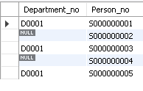

**Query17:** Create a stored procedure that retrieves Fname, Lname, Address of all personal.

**sql code:**

DELIMITER &&

CREATE PROCEDURE GetInformation()

BEGIN

SELECT p.Fname, p.Lname, p.Address

FROM personal P;

END &&

DELIMITER ;

CALL GetInformation();

**screenshot of query’s output:**

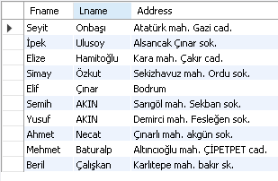

**Query18:** Create a stored procedure that retrieves “staff_no, Salary, Fname, Lname” according to given “Department_no“.

**sql code:**

DELIMITER ##

CREATE PROCEDURE GetDepartmentPerson(IN departmentNo varchar(10))

BEGIN

SELECT S.Staff_no, S.Salary, P.Fname, P.Lname

FROM Staff S, Personal P

WHERE S.Department_no=departmentNo AND P.Person_no=S.Person_no;

END ##

DELIMITER ;

CALL GetDepartmentPerson("D0001");

CALL GetDepartmentPerson("D0002");

**screenshot of query’s output:**

CALL GetDepartmentPerson("D0001");

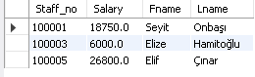

CALL GetDepartmentPerson("D0002");



**Query19:** Create View from Staff table as: Personal First name, Personal Last name, Staff Salary, Authority.

**sql code:**

CREATE VIEW vıew_staff_info AS

SELECT P.Fname, P.Lname, S.Salary, D.Authority

FROM Staff S, Personal P, Department D

WHERE P.Person_no=S.Person_no AND S.department_no=D.department_no;

SELECT *

FROM vıew_staff_info;

**screenshot of query’s output:**

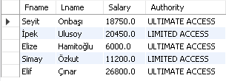

**Query20:** Create the View from the department table as: Department_id, Authority, COUNTS.department_id, SUM(S.salary) sorted by department_no.

**sql code:**

CREATE VIEW vıew_group_department(Dept_No, Dept_Authority, No_of_Staff, Salary_Sum ) AS

SELECT D.department_no, D.Authority, COUNT(S.department_no), SUM(S.salary)

FROM Staff S, Personal P, Department D

WHERE P.Person_no=S.Person_no AND S.department_no=D.department_no

GROUP BY D.department_no

ORDER BY COUNT(S.department_no);

SELECT *

FROM vıew_group_department;

**screenshot of query’s output:**

