Technical University of Kenya (TU-K)
Department of Computing and Information Technologies
FINAL PROJECT REPORT
Online Exam Registration System (OERS)
Submitted by: JOSEPH ODHIAMBO
Registration Number: SCCJ/01577/2024
Course: Software Engineering (IBL2305 – Industry Based Learning)
Course Unit: IBL2305
Supervisor / Adjunct Lecturer: Chrispinus Indumuli
Submission Date: 31st August 2026

Declaration
I, JOSEPH ODHIAMBO, Registration Number SCCJ/01577/2024, declare that this final project report titled "Online Exam Registration System (OERS)" is my own original work, prepared and submitted in fulfilment of the requirements of the IBL2305 Industry Based Learning course unit at the Technical University of Kenya. Where the work of other authors has been used, it has been duly acknowledged.
Student's Signature: ______________________ Date: ______________________

This report has been submitted for examination with my approval as the supervisor.
Supervisor: Chrispinus Indumuli, Adjunct Lecturer, Department of Computing and Information Technologies.
Supervisor's Signature: ______________________ Date: ______________________

Acknowledgement
I would like to sincerely thank the Almighty God for granting me the strength, wisdom, and resources to undertake and complete this project. I extend my heartfelt gratitude to my supervisor, Mr Chrispinus Indumuli, Adjunct Lecturer in the Department of Computing and Information Technologies, for his invaluable guidance, patience, and constructive feedback throughout every module of this project, from requirements gathering to final testing and deployment.
I also thank the Technical University of Kenya for providing the academic environment, class notes, templates, and reference materials that shaped the direction of this work. Finally, I am grateful to my family, friends, and classmates for their continuous encouragement and support during the course of this project.

Abstract
Examination registration in many higher-learning institutions remains a largely manual, paper-driven process that is time-consuming, error-prone, and difficult to scale as student populations grow. This report documents the complete design and development of the Online Exam Registration System (OERS), a web-based application built to digitise and automate the examination registration workflow at a university or college. The system allows students to create accounts, log in securely, view examinations for which they are eligible, register for units, upload proof of examination-fee payment, and track the status of their registration in real time. On the administrative side, Examination Officers and Administrators are able to manage student records, examination sessions, verify payments, approve or reject registrations, and generate reports.
The project followed a structured Software Development Life Cycle (SDLC), beginning with requirements elicitation and a formal Software Requirements Specification (SRS), followed by system analysis and design using the Unified Modelling Language (UML) — including use case, activity, class, sequence, communication, state, deployment, and component diagrams — before proceeding to implementation, testing, and deployment. The system was implemented as a role-based web application secured with session-based authentication, and was validated through a structured set of test cases executed against a running prototype, with results captured as screenshot evidence. This report presents each of these phases in turn and concludes with an evaluation of the system against its original objectives, its current limitations, and recommendations for future enhancement.

Table of Contents
Declaration
Acknowledgement
Abstract
Chapter 1: Introduction
Chapter 2: Software Requirements Specification
Chapter 3: System Analysis and Design (UML) — Static & Functional View
Chapter 4: System Design — Interaction and Behavioural Diagrams
Chapter 5: Database Design
Chapter 6: Implementation
Chapter 7: Testing, Deployment and Evaluation
Chapter 8: Conclusion and Recommendations
References
Appendix A: Test Case Summary

Chapter 1: Introduction

1.1 Background
Examination registration is one of the most critical administrative processes in any university or college calendar. In the traditional manual system, students are required to physically visit the examinations office or their respective departments, fill out paper registration forms, obtain signatures or stamps, present proof of tuition and fee payment, and wait for the completed forms to be manually recorded in ledgers or spreadsheets by administrative staff. As the number of students grows every academic year, this manual approach becomes slow, error-prone, and increasingly difficult to manage.
The Online Exam Registration System (OERS) was conceived and developed as a course project to address these inefficiencies by providing students and examinations staff with a centralised, secure, and easily accessible web-based platform for managing the entire examination registration workflow, from account creation through to the generation of an examination card.

1.2 Aim of the Project
The aim of this project is to design and develop an Online Exam Registration System that allows students to register for examinations electronically, eliminating the inefficiencies of manual registration processes. The system enables students to view available exams, register for units/courses, verify eligibility, and receive confirmation, while allowing administrators to manage exam schedules, student records, and registration data through a centralised, secure, and easily accessible platform.

1.3 Problem Statement
Examination registration in many universities remains a largely manual, paper-driven process that is inefficient, error-prone, and poorly suited to the scale of a modern student population. The core problems associated with this manual process include:
- Manual paperwork — registration relies on physical forms that must be filled, signed, filed, and later transcribed into records, consuming significant staff time and increasing the risk of lost or damaged documents.
- Long queues — because students must register in person, examination offices experience overcrowding and long waiting times, particularly as registration deadlines approach.
- Registration delays — the cumulative effect of manual processing and queuing often results in delays that leave some students unable to complete registration before the deadline.
- Duplicate registrations — without an automated check, the same student may be registered more than once for the same examination.
- Human errors — manual data entry is susceptible to typographical errors in student names, registration numbers, and course codes.
- Poor record management — paper records and disconnected spreadsheets are difficult to back up, secure, and consolidate.
- Difficulty tracking registrations — both students and staff find it difficult to verify the accurate status of a registration at any given time.
- Poor communication — there is no reliable channel through which the examinations office can promptly inform students about deadlines, eligibility issues, or schedule changes.
The Online Exam Registration System directly addresses each of these challenges by digitising the registration workflow, applying automated validation to prevent duplicate or ineligible registrations, centralising records in a secure database, and giving both students and staff real-time visibility into registration status.

1.4 Objectives
The specific objectives of the project are to:
- Eliminate manual, paper-based exam registration procedures.
- Reduce the time students spend queuing to register for examinations.
- Provide an accurate, centralised, and easily searchable database of student registrations.
- Automatically verify student eligibility before allowing registration.
- Provide administrators and examination officers with tools to manage students, courses, departments, and examination sessions efficiently.
- Improve communication between students and the examinations office through automated notifications and status tracking.
- Generate accurate and timely reports for examination planning and auditing.

1.5 Scope of the Project
The scope of this project covers the registration component of the examination process. Specifically, the system shall:
- Provide an online interface where students can register for examinations.
- Allow students to log into the system securely using role-based authentication.
- Enable students to select examination units and view an exam catalogue filtered by programme and year of study.
- Allow students to upload examination fee payment proof.
- Verify student registration details against institutional records.
- Allow Examination Officers to approve or reject examination registrations.
- Maintain examination registration history and status (Pending, Approved, Rejected, Cancelled).
- Generate administrative reports and automatically produce examination cards/slips.
- Provide secure storage of examination information and reduce manual paperwork within the Examinations Department.
The project does not extend to online examination delivery, automated marking, or results management, which are treated as out of scope for this version of the system.

1.6 Significance of the Project
Beyond satisfying the requirements of the IBL2305 Industry Based Learning course unit, this project provided practical, hands-on experience across the full software development life cycle — requirements analysis, UML-based system design, database design, implementation of a secure multi-role web application, and structured testing. It demonstrates how a real institutional problem can be translated into a working software solution using recognised software engineering practices, and it produces a reusable reference architecture that could realistically be extended for production use.

1.7 Definitions, Acronyms and Abbreviations
Term | Definition
OERS | Online Exam Registration System.
Student | A registered learner who uses OERS to register for examinations.
Examination Officer | The administrator responsible for verifying student information, approving/rejecting registrations, and generating reports.
Registration | The act of a student formally enrolling for a specific examination.
Eligibility | The condition under which a student meets academic and financial requirements to sit an examination.
Registration Slip / Exam Card | A printable document confirming successful registration for an examination.
RBAC | Role-Based Access Control.
SRS | Software Requirements Specification.
UML | Unified Modelling Language.
ERD | Entity Relationship Diagram.
HTML / CSS / JS | HyperText Markup Language / Cascading Style Sheets / JavaScript — the core front-end web technologies used in the project.
PHP / Node.js | Server-side technologies considered for implementing the system's business logic.
MySQL | The relational Database Management System used to store student, course, and registration records.

1.8 Tools and Technologies Used
The following tools and technologies were used across the design and implementation phases of the project:
- HTML5, CSS3 and JavaScript for the presentation layer.
- A server-side scripting/runtime environment (PHP or Node.js/Express) for business logic and RESTful endpoints.
- MySQL as the relational database management system.
- Visual Studio Code as the primary source-code editor.
- XAMPP (Apache + MySQL) as the local development and testing server.
- Draw.io / PlantUML for producing UML diagrams.
- Git and GitHub for version control and source-code hosting.
- Google Chrome / Mozilla Firefox for client-side testing.

1.9 Report Structure
The remainder of this report is organised as follows. Chapter 2 presents the full Software Requirements Specification, covering functional and non-functional requirements, constraints, assumptions, and dependencies. Chapter 3 presents the static and functional UML design of the system — actors, use cases, the activity diagram, and the class diagram. Chapter 4 presents the dynamic/behavioural design — sequence, communication, state, deployment, and component diagrams. Chapter 5 describes the database design, including the entity relationship diagram, table schemas, and data dictionary. Chapter 6 describes the implementation of the system. Chapter 7 presents the testing strategy, test case results with screenshot evidence, deployment procedure, and an evaluation of the completed system. Chapter 8 concludes the report and outlines recommendations for future work.

Chapter 2: Software Requirements Specification

2.1 Purpose
This Software Requirements Specification (SRS) describes the functional and non-functional requirements for the Online Exam Registration System (OERS). It provides a clear, complete, and unambiguous description of the system to be developed and serves as a common reference point guiding the analysis, design, implementation, and testing phases of the project.

2.2 Existing Manual System and Proposed Solution
In the current manual process, students physically visit the examinations office to fill out paper registration forms, obtain signatures, present proof of tuition payment, and submit the forms for manual recording. This results in long queues, inconsistent record-keeping, and delayed or lost registrations. The Online Exam Registration System is proposed as a web-based application that digitises the entire workflow: students create accounts, log in securely, view examinations for which they are eligible, register online, upload proof of payment, and print or download registration slips without visiting the examinations office physically. Administrators and examination officers manage student data, courses, departments, examination sessions, and registration approvals through a secure administrative interface backed by a centralised relational database.

2.3 Intended Users
- Student — registers for examinations and manages a personal profile.
- Examination Officer — approves or rejects registrations and manages examination sessions.
- Administrator — manages overall system data, including students, courses, departments, users, and reports.

2.4 Functional Requirements

2.4.1 Student Functional Requirements
ID | Requirement | Description
FR-01 | Student Account Creation | Allow a new student to create an account with personal details, registration number, programme and institutional email, validating uniqueness before account creation.
FR-02 | Secure Login and Logout | Allow a registered student to log in with a registration number/username and password over an encrypted connection, and to securely log out.
FR-03 | Password Recovery | Provide a password-reset mechanism via a reset link or one-time code sent to the student's registered email.
FR-04 | Student Profile Management | Allow a student to view and update permitted profile details while restricting changes to core academic data.
FR-05 | View Available Exams | Display examinations for the current session, filtered by the student's programme and year of study.
FR-06 | Check Exam Eligibility | Automatically verify academic and financial eligibility before permitting registration, and display the reason if a student is ineligible.
FR-07 | Register for Exams | Allow an eligible student to register for one or more examinations within the active window, blocking duplicate registration.
FR-08 | Edit or Cancel Registration | Allow a student to modify or cancel a registration before the published deadline.
FR-09 | Download/Print Registration Slip | Generate a registration slip / exam card containing the student's details, registered units, and a unique reference number.
FR-10 | View Registration History | Allow a student to view the history of past and current registrations and their status.
FR-11 | Receive Notifications | Send automated notifications regarding confirmation, approval, rejection, and deadlines.

2.4.2 Administrative Functional Requirements
ID | Requirement | Description
FR-12 | Administrator Login | Provide a separate, secure login interface for administrators/examination officers with role-based access control.
FR-13 | Manage Students | Add, update, deactivate, or delete student records and view registration history.
FR-14 | Manage Departments | Create, update, and remove academic departments.
FR-15 | Manage Courses | Create, update, and remove courses, including code, title, credit units and department.
FR-16 | Manage Examination Sessions | Create and configure examination sessions, dates, venues, and registration deadlines.
FR-17 | Approve or Reject Registrations | Review pending registrations and approve or reject them, optionally with a reason.
FR-18 | Generate Reports | Generate registration, statistical, and eligibility-exception reports exportable to PDF/Excel.
FR-19 | Search Students | Search student records by registration number, name, programme, or department.
FR-20 | Manage Users | Create, update, deactivate, and assign roles to system user accounts.
FR-21 | Backup Data | Support scheduled and on-demand backup of the database.

2.5 Non-Functional Requirements
Attribute | Requirement
Security | Enforces role-based access control, encrypts data in transit (HTTPS/TLS), hashes passwords with a strong one-way function, and mitigates SQL injection and cross-site scripting.
Performance | Responds to standard requests within three seconds under normal load with up to 500 concurrent users.
Reliability | Targets at least 99% uptime during active registration periods, with error detection and logging.
Availability | Accessible 24/7 except during scheduled, communicated maintenance windows.
Scalability | Supports horizontal and vertical scaling as the student population and course catalogue grow.
Maintainability | Built using modular, well-documented code following recognised design patterns.
Portability | Accessible through modern browsers on desktop and mobile without platform-specific installation.
Usability | Provides an intuitive, consistent interface allowing first-time users to register with minimal guidance.
Compatibility | Renders correctly on Chrome, Firefox, Edge, and Safari, on both desktop and mobile.
Data Integrity | Enforces validation rules and database constraints (PK/FK/unique) to keep data accurate and duplicate-free.
Backup & Recovery | Performs scheduled automated backups with a documented recovery procedure.
Privacy | Collects and processes only data necessary for registration and restricts access to authorised personnel.

2.6 System Constraints
- The system must be delivered as a web-based application accessible via standard browsers; native desktop installation is out of scope.
- The system uses a relational database management system (MySQL) for data persistence.
- Development had to be completed within the academic semester timeline allocated for the IBL2305 course unit.
- Online examination delivery, automated marking, and results processing are outside the scope of this version.
- Only authorised administrators/examination officers may approve registrations, and payment verification must be completed before approval.

2.7 Assumptions and Dependencies
- Students possess a valid registration/admission number and have access to a computer or smartphone with internet connectivity.
- Examination fees are paid, and proof of payment is available, before registration approval.
- Examination Officers and Administrators possess authorised system accounts and receive adequate training before rollout.
- The institution provides accurate, up-to-date student, course, and department data.
- A reliable internet connection and hosting infrastructure (on-premises or cloud) are available to support the system.
- An SMTP email service or notification gateway is available for automated notifications.

2.8 User Roles and Responsibilities

Student
Creates and maintains a personal account, views available examinations, verifies eligibility, registers for examinations within the stipulated deadline, uploads payment proof, downloads/prints the registration slip, and monitors registration status.

Examination Officer
Creates and manages examination sessions, reviews pending registrations, verifies payment and eligibility, approves or rejects registrations, and communicates decisions to students.

Administrator
Manages student records, departments, courses, and user accounts; generates administrative and statistical reports; performs or schedules data backups; and maintains overall system integrity.

2.9 System Features Summary
Feature | Description
Account Management | Registration, login, password recovery, and profile maintenance.
Exam Catalogue | Displays examinations relevant to a student's programme and year of study.
Eligibility Engine | Automatically evaluates academic/financial standing before allowing registration.
Online Registration | Register, edit, or cancel examination registrations within defined deadlines.
Registration Slip Generator | Produces a printable, uniquely referenced confirmation of registration.
Notification Service | Delivers alerts on registration status, deadlines, and schedule changes.
Administrative Dashboard | Tools for managing students, courses, departments, and sessions.
Approval Workflow | Lets examination officers review, approve, or reject pending registrations.
Reporting Module | Generates statistical and operational reports.
Search and Filter | Quick retrieval of student and registration records.
Backup and Recovery | Scheduled and on-demand backup of system data.

2.10 Sample Use Case Description: Register for Examination
Field | Detail
Use Case ID | UC-04
Primary Actor | Student
Secondary Actors | Examination Officer, Notification Service
Preconditions | Student has an active account, is logged in, and registration for the target exam is open.
Main Flow | Student browses available exams → selects an exam and clicks Register → system displays a pre-filled form → student submits it → system validates eligibility → system creates a registration with status PENDING → student uploads fee payment proof → Examination Officer verifies and approves → system updates status to CONFIRMED and generates the exam card → student is notified and downloads the exam card.
Alternate Flow — Not Eligible | If eligibility fails, the system displays the reason and marks the registration REJECTED.
Alternate Flow — Payment Not Verified | If payment proof cannot be verified, the registration remains PENDING and the student is prompted to resubmit proof.
Postconditions | A registration record in state CONFIRMED and an exam card linked to the student exist in the database.
Business Rules | Fee once verified is non-refundable; only one registration is permitted per exam per student.

Chapter 3: System Analysis and Design (UML) — Static & Functional View

3.1 Introduction
This chapter presents the Unified Modelling Language (UML) design of the Online Exam Registration System, serving as the blueprint for implementation. It documents the actors who interact with the system, the use case diagram capturing functional scope, the activity diagram describing the primary workflow, and the class diagram describing the static structure of the system.

3.2 Actors
Actor | Role / Responsibility
Student | Primary end user. Creates an account, logs in, browses exams, registers for examinations, uploads payment proof, downloads the exam card, and checks registration status.
Examination Officer (Administrator) | Verifies student eligibility and payment, approves or rejects registrations, manages examination sessions, and generates reports.
Administrator | Manages student records, departments, courses, examination sessions, and system users; retains full administrative privileges.
Notification Service (external) | Delivers confirmation, reminder, and status-change notifications to students.

3.3 Use Case Diagram
The use case diagram below captures the functional requirements of the system by showing the interactions between the actors and the use cases they perform. The Online Exam Registration System supports ten principal use cases: Login, Student Registration, Register for Examination, Select Examination Units, Upload Examination Fee Payment, Verify Registration, Approve Registration, Check Registration Status, Generate Reports, and Generate Examination Card.
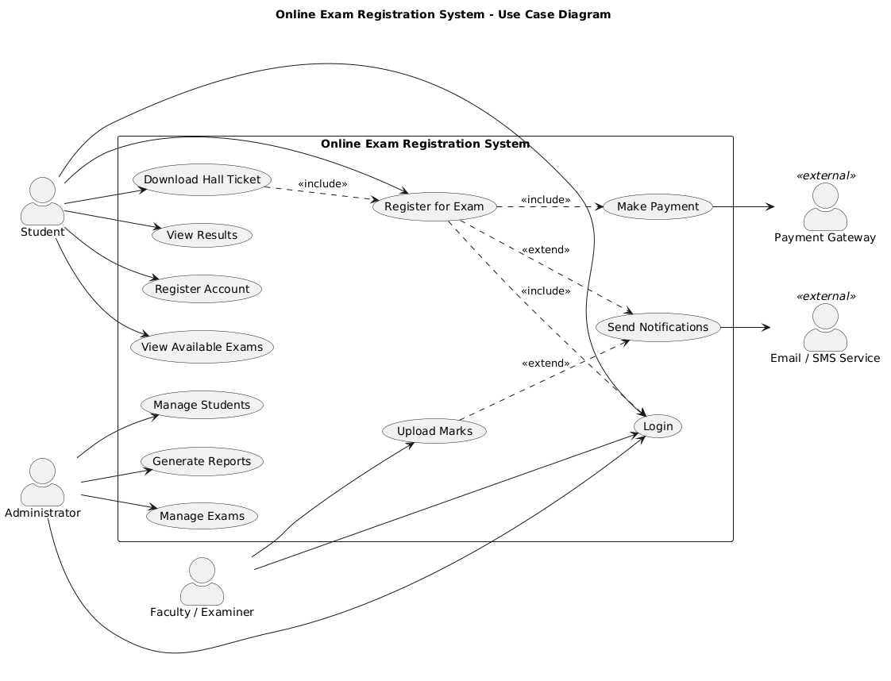
Figure 3.1 — Use Case Diagram for the Online Exam Registration System

Use Case Narratives
- Login — the student or examination officer logs in using a valid username (registration/admission number for students) and password; the system authenticates the user before granting access to the appropriate dashboard.
- Student Registration — a new student creates an account by entering personal details such as admission number, full name, programme, department, email, phone number, and password; the system validates the information before creating the account.
- Register for Examination — the student selects the examination session and completes the registration form for the intended examinations.
- Select Examination Units — the student selects units to be examined during the semester; the system checks that selected units belong to the student's programme.
- Upload Examination Fee Payment — the student uploads proof of fee payment, which is stored pending verification.
- Verify Registration — the Examination Officer verifies registration details together with payment information to determine eligibility.
- Approve Registration — after successful verification, the Examination Officer approves the registration; if discrepancies are found, the registration is rejected and the student notified.
- Check Registration Status — the student checks whether a registration is Pending, Approved, or Rejected through the online portal.
- Generate Reports — the Examination Officer/Administrator generates reports on registered students, approvals, rejections, and payment summaries.
- Generate Examination Card — once a registration is approved, the system automatically produces an examination card showing the student's details, registered units, venue, date, and timetable.

3.4 Activity Diagram — Register for Exam
The activity diagram models the workflow of the primary use case, 'Register for Exam', from the moment a student logs in until the registration process is completed. Swim lanes separate the responsibilities of the Student, the System, and the Examination Officer / Payment step.
The process begins when the student logs into the system. After successful authentication, the student selects the examination session, chooses examination units, uploads payment proof, and submits the registration form. The Examination Officer then verifies the payment and student details. If the registration satisfies all institutional requirements, it is approved and an examination card is generated; if verification fails, the registration is rejected and the student is informed to correct the identified issues before resubmitting.
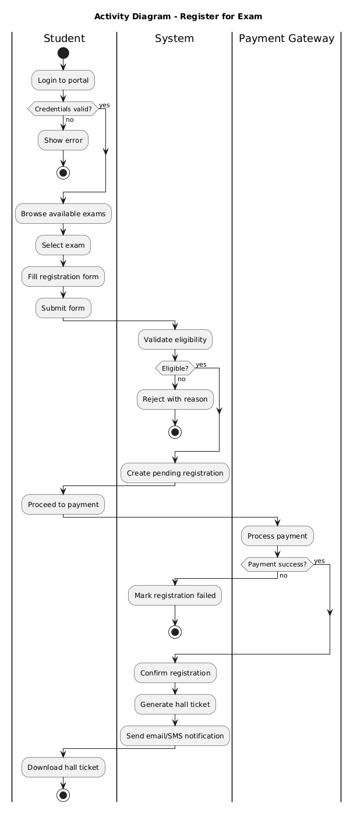
Figure 3.2 — Activity Diagram: Register for Exam

3.5 Class Diagram
The class diagram describes the static structure of the system — its entity classes, their attributes and operations, and the relationships between them. The Online Exam Registration System class diagram consists of six principal classes: Login, Student, Examination, Registration, Administrator, and Verification.
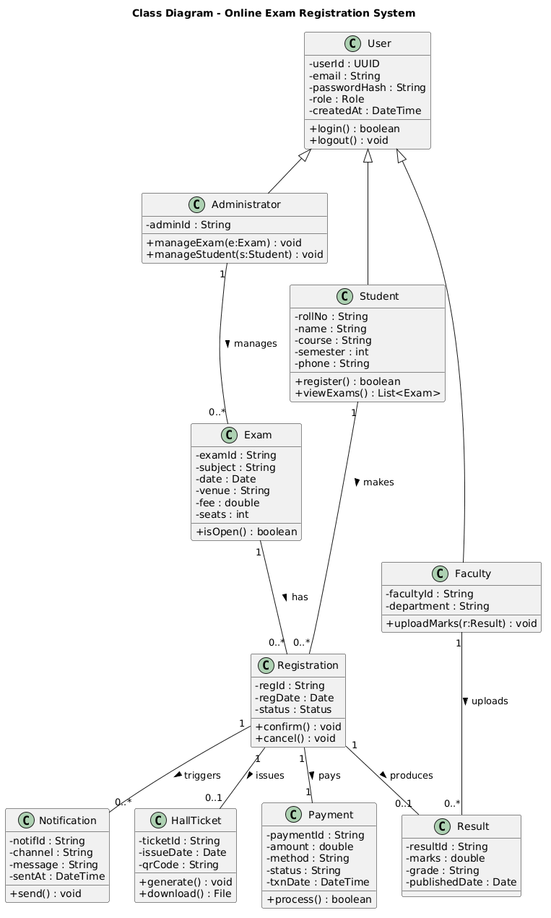
Figure 3.3 — Class Diagram of the Online Exam Registration System

3.5.1 Class Descriptions
Class | Key Attributes | Key Operations
Login | username, password | createLogin(), signIn()
Student | studentId, admissionNumber, fullName, dateOfBirth, gender, programme, department, yearOfStudy, email, phoneNumber, password | register(), updateProfile(), viewProfile(), login()
Examination | examId, semester, academicYear, unitCode, unitName, examDate, venue, examSession | viewExamSchedule(), selectUnits(), viewRegisteredUnits()
Registration | registrationId, studentId, examId, registrationDate, registrationStatus, paymentStatus, remarks | submitRegistration(), modifyRegistration(), cancelRegistration(), downloadExamCard()
Administrator | adminId, name, designation, username, password | login(), approveRegistration(), rejectRegistration(), generateReport(), manageStudents()
Verification | verificationId, registrationId, studentId, adminId, verificationStatus, verificationDate, remarks | verifyRegistration(), validatePayment(), approve(), reject()

3.5.2 Key Design Decisions
- Registration is modelled as a first-class associative entity between Student and Examination, carrying its own lifecycle state (Pending, Approved, Rejected, Cancelled).
- Verification is a dedicated class rather than an attribute of Registration, so that every approval/rejection decision is independently auditable, with its own actor (Administrator) and timestamp.
- Administrator and Student both depend on the Login class for authentication, keeping credential management centralised and consistent across roles.
- Notifications are generated by the system in response to state changes on Registration and are not directly manipulated by any actor.

Chapter 4: System Design — Interaction and Behavioural Diagrams

4.1 Overview
This chapter presents the interaction and behavioural diagrams that describe how the Online Exam Registration System behaves at runtime: six sequence diagrams covering the principal user journeys, a communication diagram, a statechart describing the registration lifecycle, a deployment diagram showing the physical architecture, and a component diagram describing the logical software architecture. Together with Chapter 3, these diagrams form a complete, implementation-ready design.

4.2 Sequence Diagram — Student Registration
This diagram models the interactions performed when a new student creates an account. The student opens the sign-up page and submits their full name, email, and password. The Registration UI forwards the credentials to the Auth Controller, which validates the input, creates the user record, and requests the Student Service to persist a profile and assign the default 'student' role. The Notification Service then dispatches a welcome message. An alternative flow short-circuits the process if validation fails, ensuring invalid data never reaches the database.
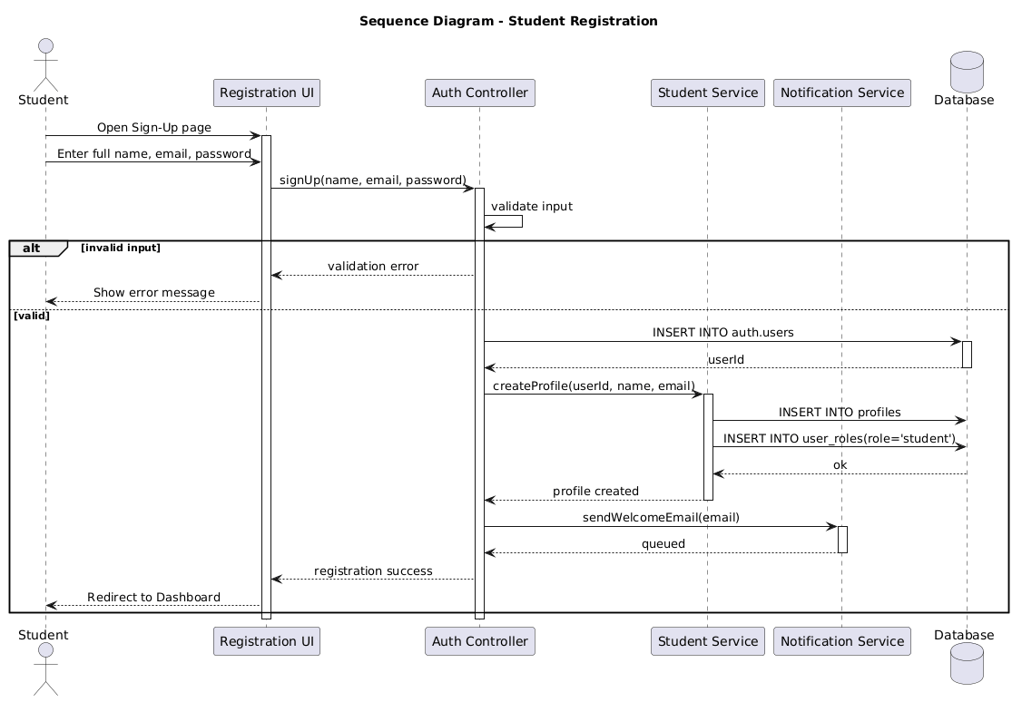
Figure 4.1 — Sequence Diagram: Student Registration

4.3 Sequence Diagram — User Login
This diagram describes the authentication sequence used by all actors (Student, Administrator, Examination Officer). The user submits credentials through the Login UI; the Auth Controller retrieves stored credentials from the database and validates them. On success, a session token is issued and the user's role is fetched to route them to the correct dashboard; invalid credentials abort the flow with an error message. A single, standardised entry point authenticates every actor and enforces role-based redirection immediately after login.
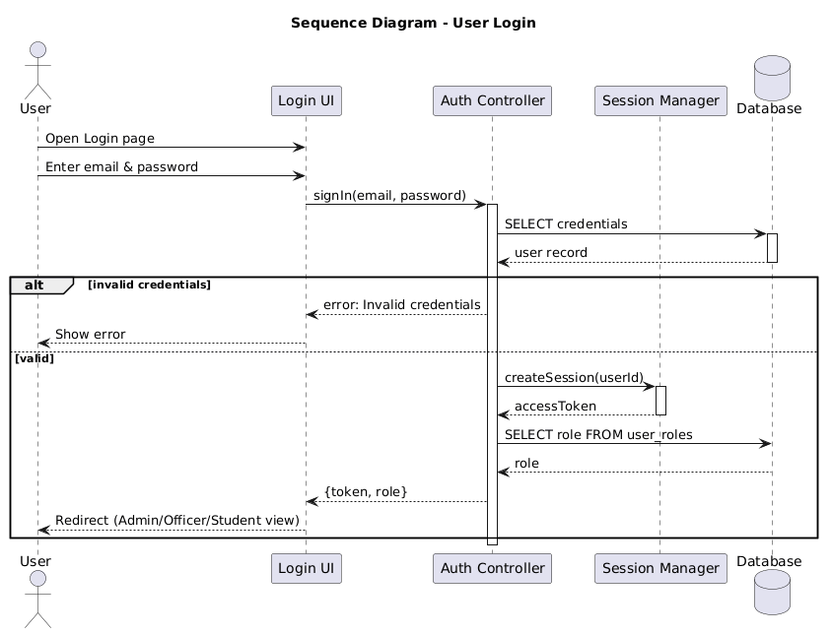
Figure 4.2 — Sequence Diagram: User Login

4.4 Sequence Diagram — Online Exam Registration
This diagram models the full sequence followed by a student when registering for examinations, including unit selection, fee-status validation, and submission. The Registration Controller invokes a Fee Service to verify that the student has no outstanding balance before storing the registration with status 'Pending'; otherwise, the student is redirected to settle fees first. The registration record is created only once academic and financial preconditions are satisfied, keeping the system's behaviour consistent with the business rules stated in Chapter 2.
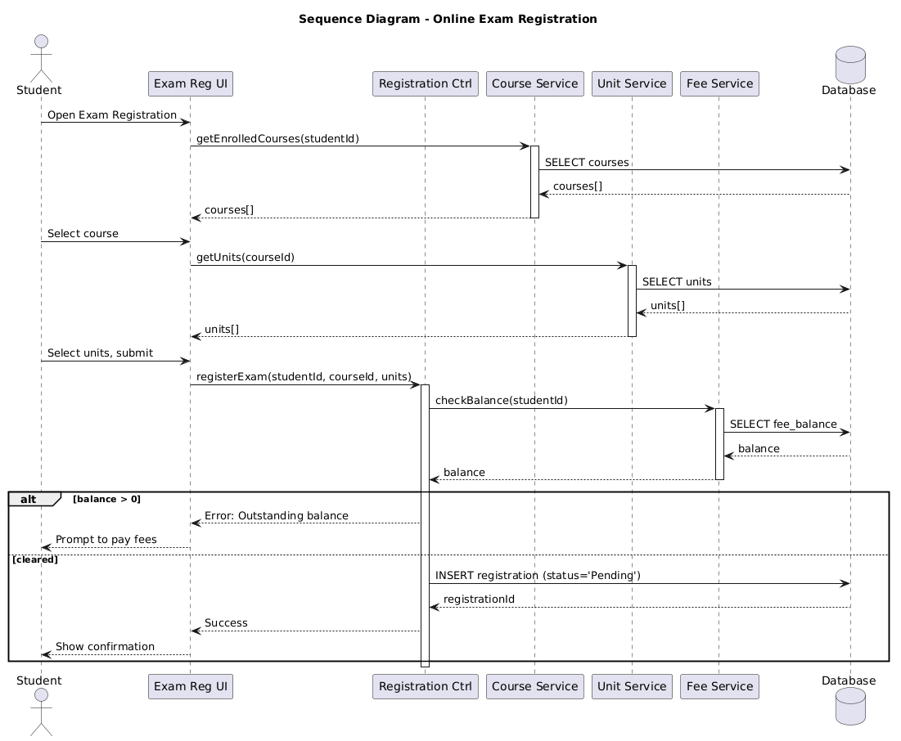
Figure 4.3 — Sequence Diagram: Online Exam Registration

4.5 Sequence Diagram — Payment Verification
This diagram specifies how the system validates fee payments submitted by students. The student submits a payment reference through the Payment UI; the Payment Controller checks the transaction against the payment record, and on a valid response the payment is recorded and the student's fee balance updated. Because only verified transactions mutate financial state, payment integrity is guaranteed before a registration can be approved.
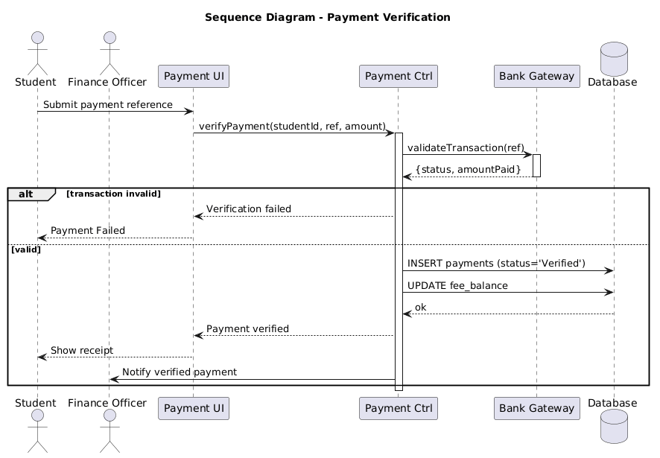
Figure 4.4 — Sequence Diagram: Payment Verification

4.6 Sequence Diagram — Registration Approval
This diagram describes how the Examination Officer reviews pending registrations and issues an approval or rejection decision. The officer lists pending registrations and opens a record for review; the Approval Controller fetches joined data (student, course, units, fee status). Depending on validity, the officer approves or rejects with a reason; in both cases the registration status is updated and the student is notified. This two-branch decision closes the loop between financial verification and academic clearance.
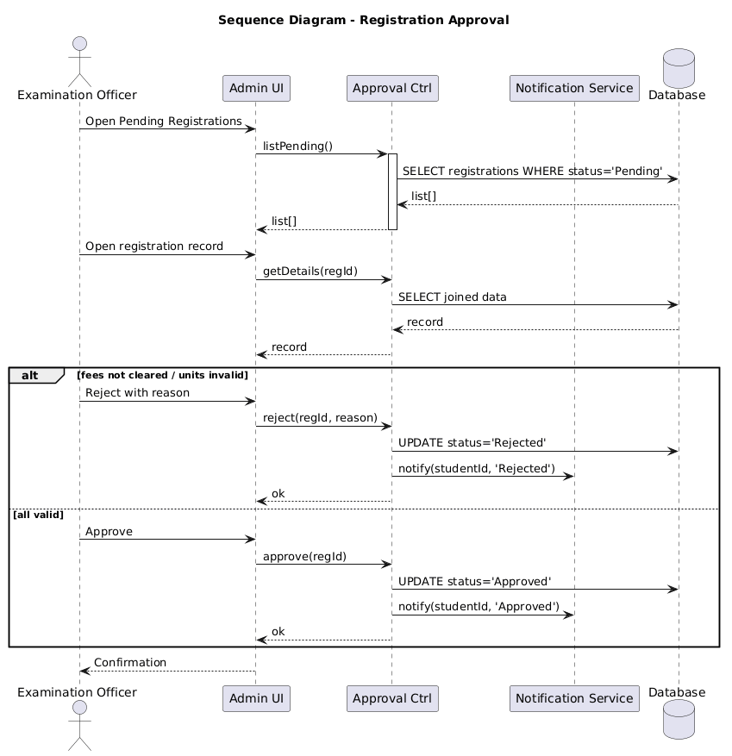
Figure 4.5 — Sequence Diagram: Registration Approval

4.7 Sequence Diagram — Download / Print Exam Card
This diagram describes how an approved student obtains a printable exam card. The ExamCard Controller validates that the registration status is 'Approved' and retrieves the associated student, course, unit, and exam data; a PDF generator then renders the exam card, which is streamed back to the browser for download or printing. Because access control is enforced on registration status, only approved students can obtain an exam card.
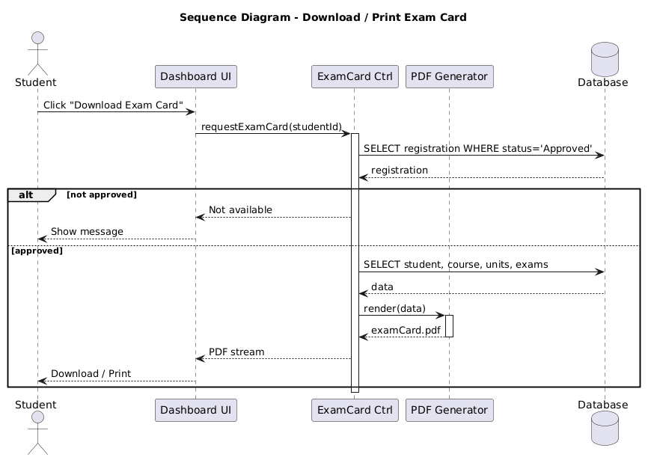
Figure 4.6 — Sequence Diagram: Download / Print Exam Card

4.8 Communication Diagram — Exam Registration Process
The communication diagram presents the exam-registration interaction as a network of collaborating objects with numbered messages, emphasising the structural links between objects rather than their temporal order. The student initiates registration through the system UI; the request is forwarded to the Registration module, which coordinates with the Payment module to verify the fee balance via the database, persists the registration, notifies the Administrator/Examination Officer for approval, and propagates the confirmation back to the student once a decision is recorded.
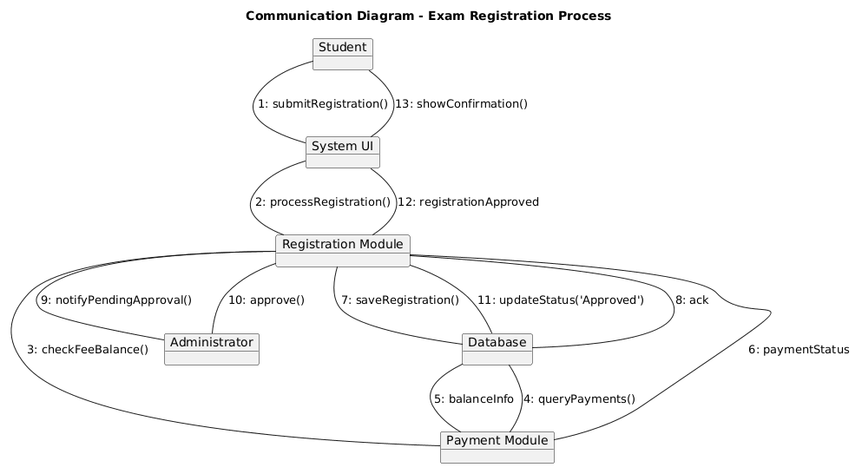
Figure 4.7 — Communication Diagram: Exam Registration Process

4.9 State (Statechart) Diagram — Registration Lifecycle
The statechart models the complete lifecycle of a single registration record, from creation to completion. The lifecycle starts at Registration Created, progresses through Profile Completed, Units Selected, Payment Pending, and Payment Verified states before entering Registration Submitted and Under Review. From there, the Examination Officer transitions the record to Approved (leading to Exam Card Generated and Completed) or to Registration Rejected. Alternative branches cover Payment Failed (with retry or cancel) and Registration Cancelled. Every transition is triggered by exactly one named event, guaranteeing a deterministic lifecycle and giving the implementation team a single authoritative reference for status values and permitted transitions.
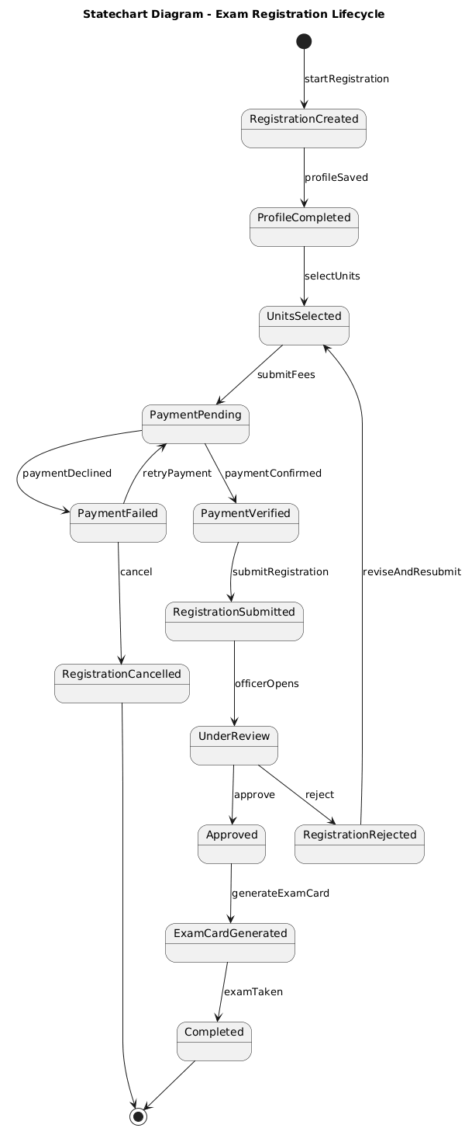
Figure 4.8 — State Diagram: Registration Lifecycle

4.10 Deployment Diagram — Physical Architecture
The deployment diagram shows the physical nodes on which the system executes and the communication protocols between them. Student and Administrator devices run a web browser that communicates over HTTPS with a web server hosting the front-end application. The web server calls an application server running the Authentication, Registration, Payment, and Notification services, which in turn communicates with the MySQL database server. This three-tier deployment cleanly separates presentation, application, and persistence layers, enabling each layer to be scaled and secured independently.
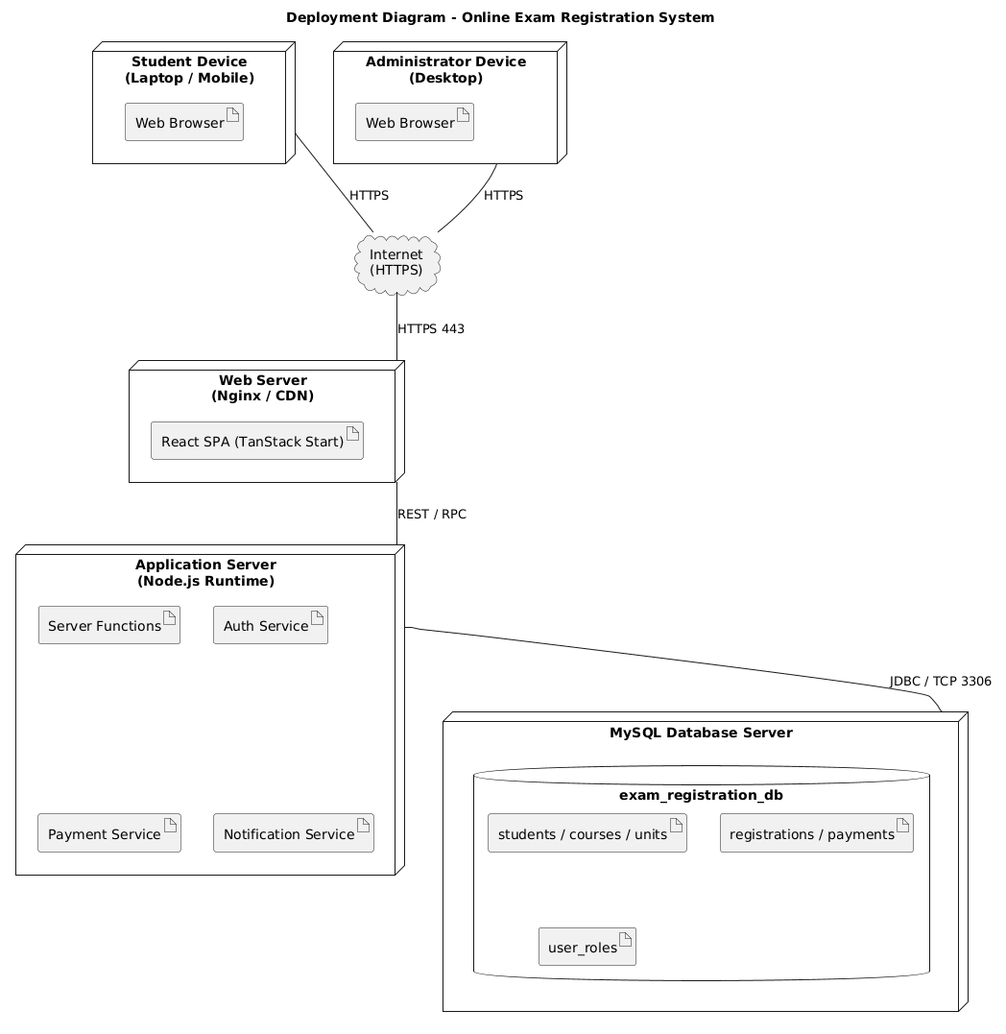
Figure 4.9 — Deployment Diagram: Physical Architecture

4.11 Component Diagram — Logical Components
The component diagram decomposes the system into cohesive software components arranged in Presentation, Application, and Data layers. The User Interface consumes provided interfaces (Authentication, Registration, Course/Unit management, Payment, and Reporting) supplied by the corresponding application-layer components. The Registration component depends on the Course, Unit, Payment, and Approval components; the Approval and Payment components use the Notification component; and all application-layer components depend on the Database component for persistence. Explicit interfaces isolate the user interface from implementation details, giving the system a stable architectural blueprint for implementation, testing, and future extension.
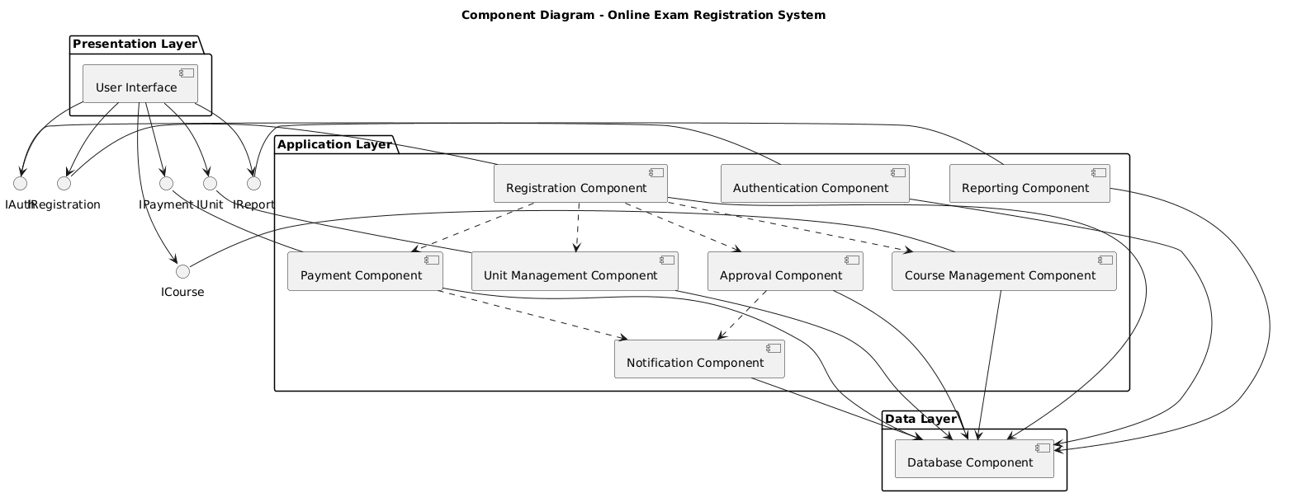
Figure 4.10 — Component Diagram: Logical Components

4.12 Summary
Together, the eight diagrams presented in this and the preceding chapter specify exactly how the Online Exam Registration System behaves at runtime, how its objects collaborate, how a registration record evolves through its lifecycle, and how the software is physically and logically deployed. All diagrams are internally consistent, aligned with the SRS in Chapter 2, and follow UML 2.x conventions, providing an implementation-ready design for the development phase discussed in Chapter 6.

Chapter 5: Database Design

5.1 Overview
The Online Exam Registration System uses a relational database consisting of eight tables. Primary keys uniquely identify each record, and foreign keys enforce referential integrity between related tables. This chapter presents the entity relationship diagram, followed by the schema for each table and a data dictionary summarising the purpose of every table.

5.2 Entity Relationship Diagram (ERD)
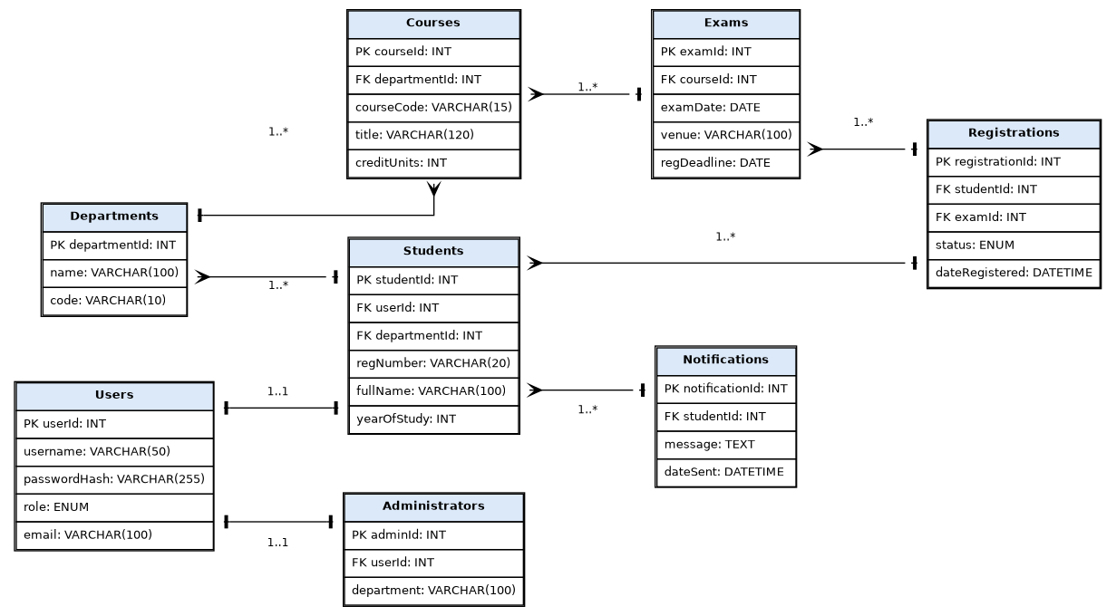
Figure 5.1 — Entity Relationship Diagram of the Online Exam Registration System

5.3 Table Schemas

5.3.1 Departments Table
Field | Data Type | Key | Description
departmentId | INT | PK | Unique identifier for the department.
name | VARCHAR(100) |  | Full name of the department.
code | VARCHAR(10) |  | Short department code.

5.3.2 Courses Table
Field | Data Type | Key | Description
courseId | INT | PK | Unique identifier for the course.
departmentId | INT | FK | References Departments.departmentId.
courseCode | VARCHAR(15) |  | Official course code.
title | VARCHAR(120) |  | Full title of the course.
creditUnits | INT |  | Number of credit units for the course.

5.3.3 Users Table
Field | Data Type | Key | Description
userId | INT | PK | Unique identifier for the system user.
username | VARCHAR(50) |  | Login username.
passwordHash | VARCHAR(255) |  | Securely hashed password.
role | ENUM |  | Role of the user: Student, Administrator, or ExaminationOfficer.
email | VARCHAR(100) |  | Registered email address.

5.3.4 Students Table
Field | Data Type | Key | Description
studentId | INT | PK | Unique identifier for the student.
userId | INT | FK | References Users.userId.
departmentId | INT | FK | References Departments.departmentId.
regNumber | VARCHAR(20) |  | Official student registration number.
fullName | VARCHAR(100) |  | Full name of the student.
yearOfStudy | INT |  | Current year of study.

5.3.5 Administrators Table
Field | Data Type | Key | Description
adminId | INT | PK | Unique identifier for the administrator.
userId | INT | FK | References Users.userId.
department | VARCHAR(100) |  | Administrative department or unit.

5.3.6 Exams Table
Field | Data Type | Key | Description
examId | INT | PK | Unique identifier for the examination.
courseId | INT | FK | References Courses.courseId.
examDate | DATE |  | Scheduled date of the examination.
venue | VARCHAR(100) |  | Examination venue.
regDeadline | DATE |  | Final date for registration.

5.3.7 Registrations Table
Field | Data Type | Key | Description
registrationId | INT | PK | Unique identifier for the registration.
studentId | INT | FK | References Students.studentId.
examId | INT | FK | References Exams.examId.
status | ENUM |  | Registration status: Pending, Approved, Rejected, or Cancelled.
dateRegistered | DATETIME |  | Date and time the registration was submitted.

5.3.8 Notifications Table
Field | Data Type | Key | Description
notificationId | INT | PK | Unique identifier for the notification.
studentId | INT | FK | References Students.studentId.
message | TEXT |  | Content of the notification.
dateSent | DATETIME |  | Date and time the notification was sent.

5.4 Data Dictionary
Table | Purpose
Departments | Stores the academic departments within the institution.
Courses | Stores course information, including the department each course belongs to.
Users | Stores login credentials and role information for all system users.
Students | Stores student-specific academic details, linked to a Users record.
Administrators | Stores administrator-specific details, linked to a Users record.
Exams | Stores examination scheduling details for each course.
Registrations | Stores the record of each student's registration for a specific examination, including its status.
Notifications | Stores messages sent to students regarding registration status and other alerts.

5.5 Database-Level Design Considerations
- Referential integrity is enforced through foreign-key constraints between Students, Courses, Exams, and Registrations, preventing orphaned or inconsistent records.
- A unique constraint on (studentId, examId) in the Registrations table prevents duplicate registration for the same examination by the same student.
- Passwords are never stored in plain text; the passwordHash column stores a one-way cryptographic hash of each user's password.
- The Users table centralises authentication for all three roles (Student, Administrator, Examination Officer), while Students and Administrators hold role-specific details, avoiding duplication of login logic.
- Scheduled database backups (see Chapter 7, Section 7.3) protect against data loss and support disaster recovery.

Chapter 6: Implementation

6.1 Overview
Building on the requirements specified in Chapter 2 and the UML design presented in Chapters 3 and 4, this chapter describes how the Online Exam Registration System was implemented. It covers the system architecture, the technology stack actually used, the project folder structure, the core modules that were built, and the security measures enforced throughout the application.

6.2 System Architecture
The Online Exam Registration System follows a three-tier architecture that separates the presentation, application logic, and data storage layers to improve maintainability, scalability, and security.

6.2.1 Presentation Tier
The front end is a responsive web interface built with HTML5, CSS3, and JavaScript. It renders registration forms, displays examination catalogues, and presents confirmation and status pages to students and administrators, communicating with the back end via standard HTTP requests.

6.2.2 Application Tier
The application tier implements the system's business logic: authentication, eligibility verification, registration processing, payment-proof handling, approval workflow, and report generation. Every page that performs a protected action independently re-checks the logged-in user's session and role before executing, rather than relying solely on hiding menu links in the interface.

6.2.3 Data Tier
The data tier is a MySQL relational database that stores all persistent data — student records, courses, departments, examinations, registrations, and notifications — structured according to the schema presented in Chapter 5.

6.3 Technology Stack
Layer | Technology | Purpose
Frontend structure | HTML5 | Defines the structure and content of web pages.
Frontend styling | CSS3 | Provides consistent, responsive visual styling.
Frontend interactivity | JavaScript | Handles client-side interactivity and form validation.
Backend / server runtime | PHP | Implements business logic and handles form submissions and session management.
Database | MySQL | Stores and manages all persistent application data.
Local development server | XAMPP (Apache + MySQL) | Provides a local runtime environment for development and testing.
Version control | Git | Tracks changes to source code throughout development.
Code hosting | GitHub | Hosts the remote repository for collaboration and backup.

6.4 Project Folder Structure
Source code, configuration, and documentation were organised into clearly named folders, following the structure below, so that any collaborator can quickly locate controllers, database configuration, and static assets:
- config/ — database connection configuration (db.php) and environment-specific settings.
- auth/ — login, logout, registration, and password-recovery scripts.
- student/ — student dashboard, exam catalogue, registration form, payment-proof upload, and 'My Registrations' status page.
- admin/ — administrator and examination-officer dashboards, student management, course/department management, and approval screens.
- includes/ — shared session-guard and role-check logic reused across protected pages.
- assets/ — CSS, JavaScript, and image assets.
- uploads/ — locally stored student documents such as fee-payment proof.
- database_backups/ — timestamped SQL dumps of the database schema and data.
- README.md — project overview, tech stack, folder structure, features by role, and setup instructions.

6.5 Core Modules Implemented
Module | Description
Authentication Module | Handles account creation, login, logout, and session management for all three roles (Student, Administrator, Examination Officer).
Student Registration Module | Allows a student to view eligible examinations, select units, and submit a registration request.
Payment Proof Module | Allows a student to upload proof of examination fee payment for verification.
Approval Module | Allows the Examination Officer to review pending registrations and approve, reject, or update their status.
Exam Card / Registration Slip Module | Generates a confirmation document once a registration reaches Approved/Confirmed status.
Admin Management Module | Allows an Administrator to manage student records, departments, courses, and examination sessions.
Reporting Module | Produces summary reports of registrations, approvals, rejections, and payment status.

6.6 Security Measures Implemented
- Session-based authentication — a session is created on successful login and destroyed on logout; every protected page independently verifies that a valid session exists before rendering content.
- Role-Based Access Control (RBAC) — each protected page checks the logged-in user's role and redirects unauthorised users (for example, a Student attempting to access the Admin dashboard directly by URL is redirected with an unauthorised error, as demonstrated in test case TC-04 in Chapter 7).
- Parameterised / prepared database statements — all database queries that incorporate user input use prepared statements rather than string concatenation, mitigating SQL injection.
- Server-side validation — registration and account-creation forms are validated on the server in addition to any client-side JavaScript validation, so that invalid or malicious input is rejected even if client-side checks are bypassed.
- Duplicate-registration prevention — the system checks for an existing registration for the same student and examination before creating a new one, as demonstrated in test case TC-03 in Chapter 7.

6.7 Implementation Notes and Known Limitations
At the point of submission, database credentials were configured directly in config/db.php rather than being externalised into environment variables; this is an accepted simplification for a local academic prototype but would need to be resolved before any public deployment. Uploaded documents (such as fee-payment proof) are stored on the local filesystem rather than in cloud object storage, which would also need to change for a production deployment. These limitations, together with recommended future enhancements, are revisited in the evaluation in Chapter 7 and the conclusion in Chapter 8.

Chapter 7: Testing, Deployment and Evaluation

7.1 Testing Strategy
The system was tested using a structured set of black-box test cases designed to verify the correctness of the core registration workflow, authentication, access control, and the approval process. Each test case was executed against a running instance of the application, and the actual outcome was compared with the expected result. Screenshot evidence was captured directly from the running prototype for every test case, in line with the requirement that testing claims be accompanied by visual proof rather than theoretical description alone.

7.2 Test Cases and Results
Test ID | Description | Expected Result | Actual Result | Status
TC-01 | User registration with valid data | New user record created; redirected to login | Record created (user_id 6, janeqa), redirected to login | PASS
TC-02 | User login with incorrect password | System displays "Invalid username or password" | Message shown as expected | PASS
TC-03 | Student registers for the same exam twice | System blocks duplicate exam registration | "You have already registered for this exam" shown | PASS
TC-04 | Logged-in Student attempts to access Admin dashboard directly by URL | Access denied; redirected to login with unauthorized error | Redirected to login.php?error=unauthorized | PASS
TC-05 | Exam Officer updates a registration's status to "Confirmed" | Status updated in DB; student sees updated status immediately | Status updated to Confirmed; reflected on student's My Registrations page | PASS

7.3 Proof of Execution
The following screenshots were captured directly from the running prototype during test execution.
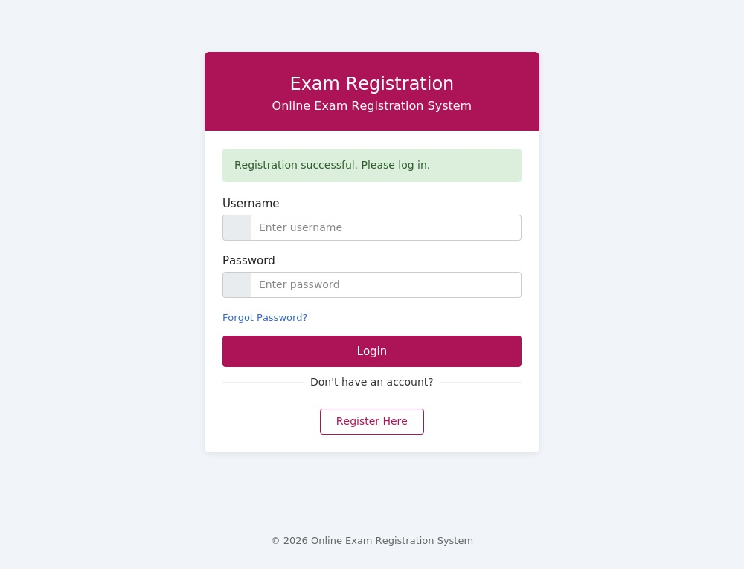
Figure 7.1 — TC-01: Registration success message after submitting valid data (new record confirmed in the users table).
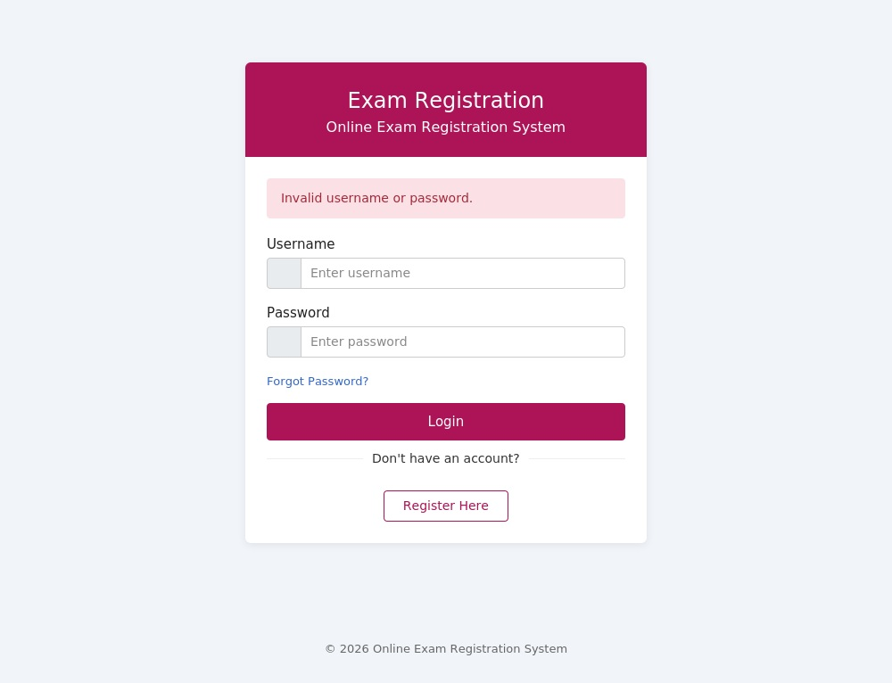
Figure 7.2 — TC-02: "Invalid username or password" shown after submitting an incorrect password.
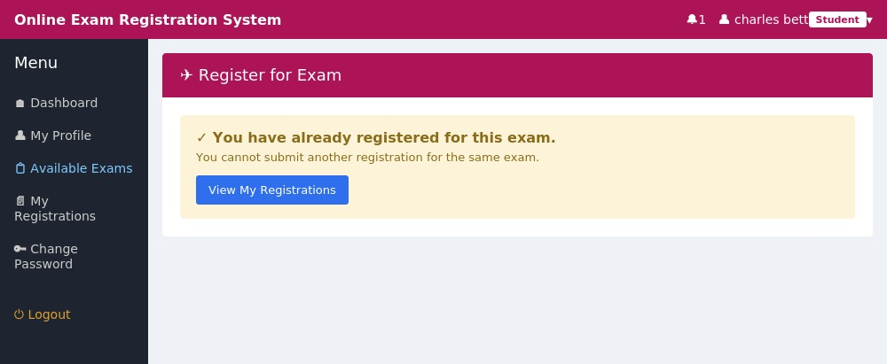
Figure 7.3 — TC-03: System blocks a second registration for the same exam by the same student.
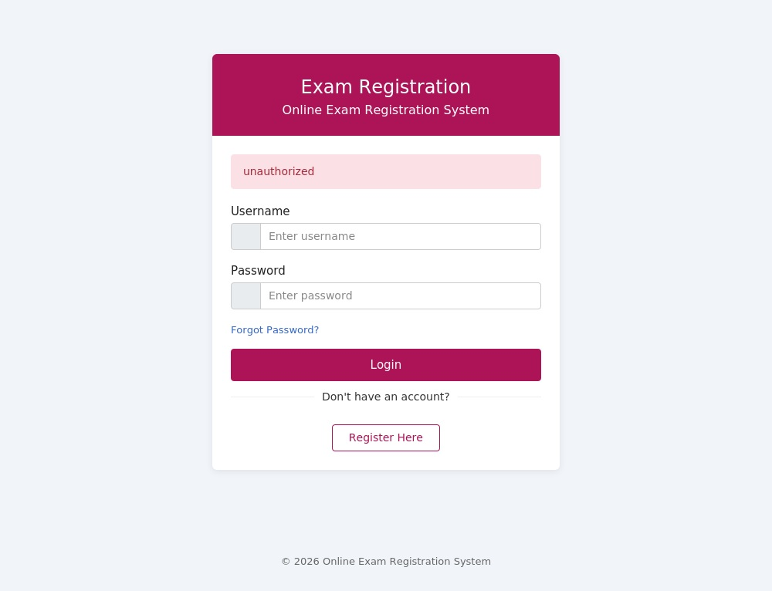
Figure 7.4 — TC-04: Direct URL access to the Admin dashboard is rejected and redirected with an "unauthorized" error.
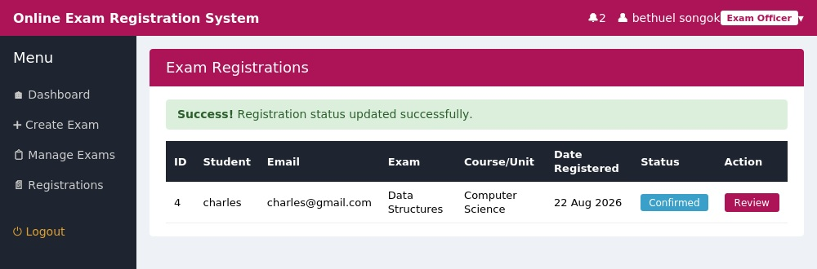
Figure 7.5a — TC-05: Exam Officer view after updating a registration's status to "Confirmed".
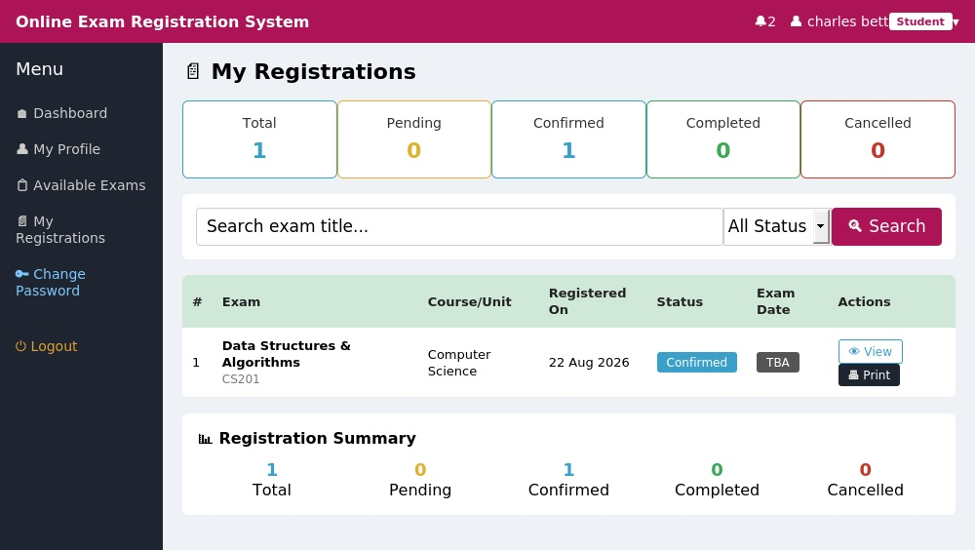
Figure 7.5b — TC-05: The same status change reflected immediately on the Student's own "My Registrations" page.

7.4 System Deployment
The system currently runs on a local XAMPP-equivalent environment (Apache/PHP built-in server together with MySQL) rather than a permanent live public URL, since the application requires a persistent PHP runtime and MySQL database that free static hosting platforms (for example, GitHub Pages or Vercel) cannot support without significant re-architecture. For this stage of the project, the system was deployed to a temporary local staging server in order to execute and screenshot the test cases documented above.

Run Instructions
- Clone the repository into the XAMPP htdocs folder.
- Start Apache and MySQL via the XAMPP control panel.
- Import database_backups/exam_registration_backup_2026-07-31_19-55-28.sql into phpMyAdmin as "exam_registration".
- Confirm config/db.php matches the local database credentials.
- Visit http://localhost/exam_registration_system/ in the browser.

7.5 README.md Documentation
The repository root contains a populated README.md file covering the technology stack, folder structure, features available to each role, and setup instructions, providing any collaborator with a clear starting point for running and understanding the project.

7.6 Discussion and System Evaluation
The Online Exam Registration System meets the core goals set out in the Software Requirements Specification: it replaces a manual, paper-based exam registration process with a trackable digital workflow across three roles. Students can register for exams and track status in real time; Examination Officers can review, approve, and update registrations without manual communication; Administrators retain full oversight and account control. Role-based access control, enforced independently on every protected page, addresses the project's primary security requirement, as demonstrated live in test case TC-04.
Some limitations remain. Database credentials are still hardcoded in config/db.php rather than externalised, which is acceptable for a local prototype but would need resolving before any public deployment. The system has not yet been deployed to a permanent live environment, so it has not been tested under real network conditions or concurrent multi-user load. Document uploads (student ID, fee receipts, passport photos) are stored on the local filesystem, which would need to move to persistent or cloud storage in a production deployment. Future enhancements could include automated email notifications (currently in-app only), fully automated eligibility checks against academic and financial records, and a proper CI/CD pipeline with automated tests.

Chapter 8: Conclusion and Recommendations

8.1 Conclusion
This report has presented the complete design and development of the Online Exam Registration System, from the initial problem statement and Software Requirements Specification, through UML-based system analysis and design, database design, implementation, and structured testing. The finished system successfully replaces a manual, paper-based examination registration process with a centralised, role-based web application: students can create accounts, view examinations relevant to their programme, register for units, upload proof of payment, and track their registration status in real time, while Examination Officers and Administrators can verify eligibility, approve or reject registrations, manage core academic data, and generate reports.
Building the system end-to-end — from requirements and wireframes through authentication, core business logic, and testing — reinforced how much of software engineering is disciplined structure rather than just features. Consistent session guards, parameterised database queries, and independent role checks on every protected page mattered more to the system's integrity than any single user-interface screen. Running actual test cases against a live instance, rather than describing them abstractly, surfaced real behaviour that a written test plan alone would not have caught. The main lesson from this software development life cycle was that security and input validation are cheapest to get right early, and considerably more costly to retrofit once modules begin to depend on one another.

8.2 Achievement of Objectives
Objective | Status
Eliminate manual, paper-based registration | Achieved — registration is performed entirely online.
Reduce queuing time for students | Achieved — students register remotely without visiting the examinations office.
Provide a centralised, searchable database of registrations | Achieved — a relational MySQL database stores all registration records.
Automatically verify student eligibility | Partially achieved — duplicate-registration checks are enforced; full automated academic/financial eligibility checks are identified as future work.
Provide administrative tools for managing data | Achieved — administrator and examination-officer dashboards support student, course, and session management.
Improve communication through notifications | Partially achieved — in-app status updates are implemented; automated email/SMS notification is future work.
Generate reports for planning and auditing | Achieved — basic registration and status reports are supported.

8.3 Recommendations for Future Work
- Externalise database credentials and other configuration into environment variables rather than hardcoding them in config/db.php, in preparation for production deployment.
- Deploy the system to a permanent hosting environment with a persistent PHP/Node.js runtime and managed MySQL database, and test it under realistic concurrent-user load.
- Migrate uploaded documents (fee-payment proof, student photographs) from local filesystem storage to persistent or cloud object storage.
- Implement automated email and SMS notifications for registration confirmation, approval, rejection, and deadline reminders.
- Extend the eligibility engine to automatically cross-check academic standing and financial clearance against institutional records rather than relying solely on manual verification of uploaded payment proof.
- Introduce a continuous integration/continuous deployment (CI/CD) pipeline with automated unit and integration tests to catch regressions earlier in the development cycle.
- Add exportable PDF/Excel reporting for administrators, and richer analytics dashboards for examination planning.

8.4 Final Remarks
Overall, the Online Exam Registration System project achieved its primary aim of demonstrating, through a working prototype, how examination registration can be digitised end-to-end using recognised software engineering practices — from requirements specification and UML design to secure implementation and evidence-based testing. The system, together with this report, provides a solid foundation that could be extended into a production-ready solution for the Technical University of Kenya or a similar institution.

References
IEEE Std 830-1998, IEEE Recommended Practice for Software Requirements Specifications.
Sommerville, I. (2016). Software Engineering (10th ed.). Pearson Education.
Pressman, R. S., & Maxim, B. R. (2019). Software Engineering: A Practitioner's Approach (9th ed.). McGraw-Hill.
Technical University of Kenya, Department of Computing and Information Technologies. IBL2305 Final Project Report — Submission and Presentation Guidelines.
Technical University of Kenya Examination Regulations and Handbook (institutional document).

Appendix A: Test Case Summary
Test ID | Focus Area | Result
TC-01 | Student account registration with valid data | PASS
TC-02 | Login rejection on incorrect password | PASS
TC-03 | Duplicate examination registration blocked | PASS
TC-04 | Role-based access control on the Admin dashboard | PASS
TC-05 | Registration status update propagation (Officer → Student view) | PASS

