August, 2008
From Green to Gold - Green Initiatives Drive Cost out of the Supply Chain
Analyst Insight
Aberdeen’s Insights provide the analyst perspective of the research as drawn from an aggregated view of the research surveys, interviews, and data analysis

The complexity in the business environment brought on by globalization and rising energy and transport costs are helping to drive a major movement in sustainability and Corporate Social Responsibility (CSR) initiatives.

Greening the Supply Chain

As companies try to mitigate rising costs while seeking opportunities to differentiate themselves, more are recognizing the growing importance of green initiatives. Plenty of opportunities for companies to become significantly greener exist in the supply chain, but first a strategy needs to be defined and the company will have to consider how to balance the tradeoffs inherent to investing in going green.
A recent Aberdeen survey found that of the 290 respondents, 44% indicate that they have plans to redesign parts of the supply chain, 25% say they have already redesigned part, and 55% say they will increase their budget for green supply chain management (SCM) initiatives over the next 12 months. Nevertheless, there is some confusion about how to go about this process. Seventy-two percent (72%) of respondents say that they either do not know enough about CSR solutions to support their initiatives or do not know where to begin.

Goals of Green Initiatives
The current trend to go green is undeniable, but it's important to find out why it's necessary for companies to bring green practices into their supply chains. Figure 1 compares the goals that companies have in mind when undertaking green initiatives. Reducing overall business cost, chosen by 58% of respondents, was most commonly cited goal, yet some of the other goals could directly affect costs. For example, due to the rising price of fuel, becoming more fuel efficient, chosen by 33% of respondents, could potentially reduce overall business cost, as could reducing waste and improving disposal methods, chosen by 36%. Other goals are linked as well: enhancing company social responsibility, chosen by 52% of respondents, would ideally result in improved profits, chosen by 42%, due to the increased business brought on by a company's green image. Companies realize that carefully planned and implemented green SCM can lead to increased profits and reduced costs.
Figure 1: Top 7 Goals of Green Initiatives
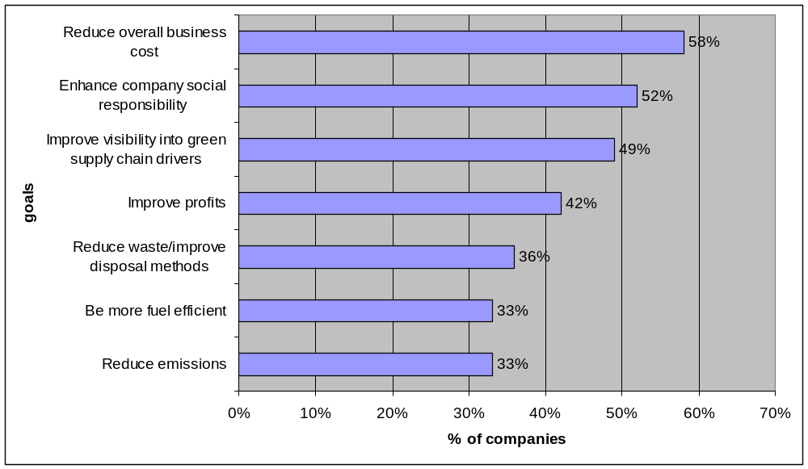
Source: Aberdeen Group, March 2008
In figure 2, which compares how companies say green initiatives will increase profits, 58% of respondents say they are seeking to increase profits through gaining a competitive edge/brand differentiation and 52% through becoming a preferred supplier, making them the top two ways companies plan to increase profits through green initiatives. Desire to be a thought leader is one of the main pressures driving green SCM, and that directly relates to the competitive edge and preferred supplier status that companies expect from going green. As more and more companies throughout a supply chain seek to enhance their status as a conscientious player, these companies demand environmental responsibility of their partners as well.

Figure 2: How will you seek to increase profits with your green initiative?

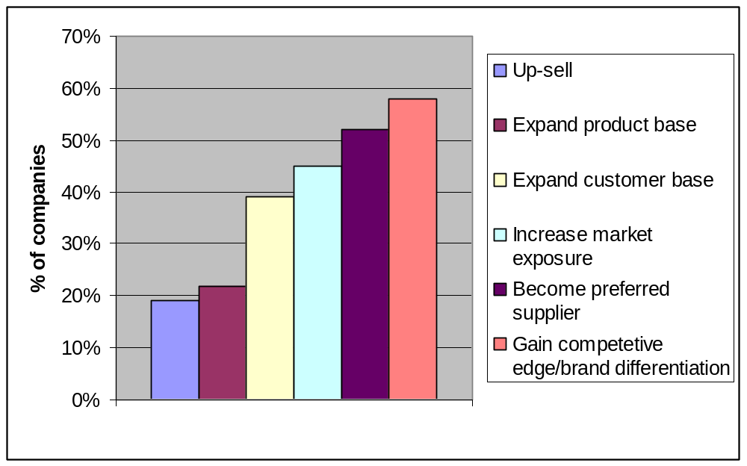

Green Supply Chain Solutions
There are ample opportunities for green initiatives at every step along the supply chain. Figure 3 shows the initiatives that companies are already investing in and which ones they plan on investing in. The top capability currently in place is training and education, with 50% of respondents investing. This is a significant number because the next most common capability, transport/logistics, is only being invested in by 27% of respondents, just over half as many. As 72% of respondents say they can't get started with their green initiatives because they simply do not know enough about green initiatives, education and training is a logical first step for most companies and can make green a part of their corporate culture as well as inform them about what steps need to be taken to get started. Green warehouse building and services are on the horizon for 64% of respondents, making it the most planned capability by a large margin.
Aside from current and planned initiatives, what else can companies do to further their green agenda? Companies should consider adopting energy efficiency and reuse and recycle initiatives internally and externally. Measurement leads to success, so metrics need to be constructed to monitor the progress of initiatives. Companies should also seek assistance in managing their initiatives by looking to the products and services that can help them.
Figure 3: What capabilities are they considering?

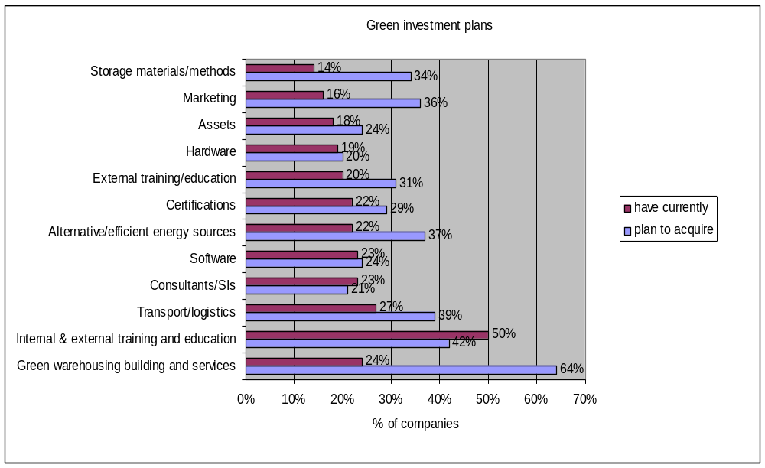

Solution Snapshot
Table 1 provides a partial list of vendors offering Green SCM solutions. While education can help lay the groundwork for transformation into a green company, taking steps to automate and bringing in seasoned professionals to oversee the initiative can help guarantee a successful endeavor.
Table 1: Vendor Landscape
Company | Solutions
Prologis | Green warehouse building and services
Gazely | Green warehouse building and services
Eaton | Alternative/efficient energy sources
PRe | Lifecycle Management
Deloitte | Consulting, Training and education
Ryder | Transport/logistics
Source: Aberdeen Group, June 2008

Key Takeaways
Green SCM is happening now, and pressures for companies to get involved, such as desire to be a thought leader, gaining competitive advantage, and mitigating rising fuel costs are mounting. There's no time to waste: many companies are already redesigning their supply chain and most are increasing their budgets for green initiatives.
When planning the first steps toward a greener supply chain, consider:
- Education and training - A lack of understanding about green initiatives can result in resistance from employees. Proper education will make green a part of everyday corporate culture.
- Metrics - Put metrics in place to measure the success of any green initiatives that are undertaken.
- Energy efficiency - Adopt energy efficiency and reuse and recycle programs.
- Green warehouse building and services - Reducing costs is one of the main goals driving companies to go green. A growing number of companies recognize green warehouse design as a way to reduce costs.
With the right strategies and solutions and careful balancing of the tradeoffs, environmental sustainability can go hand-in-hand with increased profits and reduced costs.

For more information on this or other research topics, please visit www.aberdeen.com
Related Research
Driving Green: Facing the Challenges; July 2008
Author: Joseph Hebert, Research Associate, Supply Chain Management
Since 1988, Aberdeen's research has been helping corporations worldwide become Best-in-Class. Having benchmarked the performance of more than 644,000 companies, Aberdeen is uniquely positioned to provide organizations with the facts that matter — the facts that enable companies to get ahead and drive results. That's why our research is relied on by more than 2.2 million readers in over 40 countries, 90% of the Fortune 1,000, and 93% of the Technology 500.
As a Harte-Hanks Company, Aberdeen plays a key role of putting content in context for the global direct and targeted marketing company. Aberdeen's analytical and independent view of the "customer optimization" process of Harte-Hanks (Information – Opportunity – Insight – Engagement – Interaction) extends the client value and accentuates the strategic role Harte-Hanks brings to the market. For additional information, visit Aberdeen http://www.aberdeen.com or call (617) 723-7890, or to learn more about Harte-Hanks, call (800) 456-9748 or go to http://www.harte-hanks.com
This document is the result of primary research performed by Aberdeen Group. Aberdeen Group's methodologies provide for objective fact-based research and represent the best analysis available at the time of publication. Unless otherwise noted, the entire contents of this publication are copyrighted by Aberdeen Group, Inc. and may not be reproduced, distributed, archived, or transmitted in any form or by any means without prior written consent by Aberdeen Group, Inc. 043008a

