Chapter 2: Document Set-up

Open up a new Word 2002 document. Word 2002 may not look friendly at first, but stick with it and you’ll be a pro before too long. There are just a few simple tricks you need to know before you can really get started. First, you want to set up your document by using the Formatting Toolbar (see Figure 2.1).

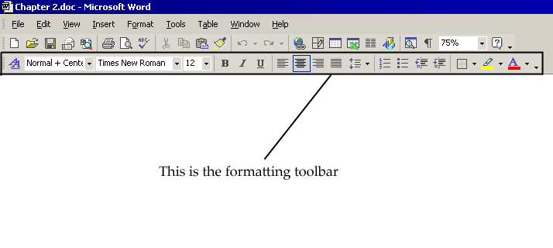

Figure 2.1: Your best pal, the formatting toolbar

2.1 Changing Fonts

Type a few words in your new document. Do you like the default font? There are plenty of other fonts already on your computer. You should check them out. Here’s how:

- Click on the arrow to the right of the font menu to pull it down. (see Figure 2.2)

- Click on the font that you want.

- Click on the pull-down menu to the right of the font menu. This is the Font Size menu.

- Click on the font size you want.

- Click the three buttons to the right of the Font Size menu to toggle bold, italics, and underline.

2.2 Spacing

How is your paper supposed to be spaced? Do you want the professional look of single spacing, or do you want to double space it for easy editing later on? If you really want fill up a lot of pages, go ahead and triple space. This is how you change the spacing:

- Click on the Spacing button in the Formatting toolbar to pull down the menu. (see Figure 2.3)

- Click on the spacing that you want.

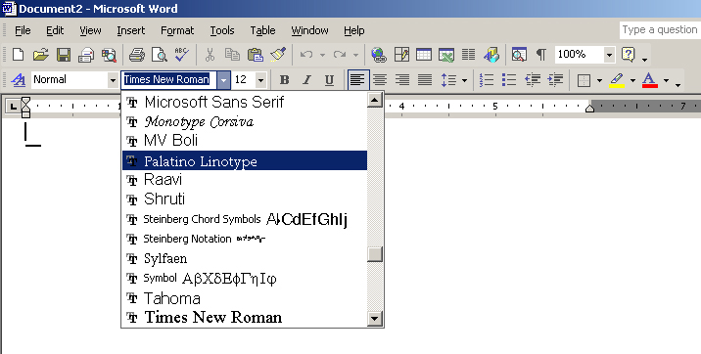

Figure 2.2: The font menu.

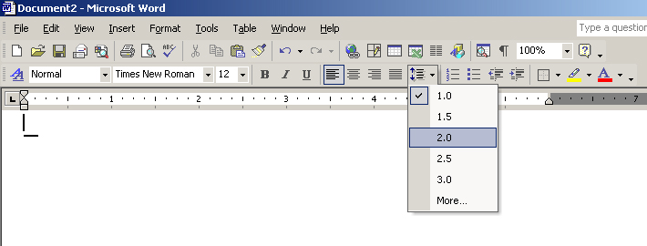

Figure 2.3: The spacing menu.

2.3 Alignment

Generally, you probably want text aligned to the left, which is the default, but maybe you want a title to be centered or your organization could demand some right alignment. If you want your document to have that novel look you might want to justify. To change alignment:

- Click on the alignment button that corresponds to the type of alignment you want (see Figure 2.4).

2.4 Setting Margins

Do you want lots of space on either side, or are you trying to not waste any paper? By setting the margins you can decide exactly how much space you leave on any side of the paper. Here’s how you do it:

- Open the File menu.

- Click on Page Setup. This opens the Page Setup window. (see Figure 2.5)

- Click on the Margins tab in the Page setup window.

- Type in the sizes that you want in the fields for bottom, top, left, and right margins.

- Click OK to apply the new margins.

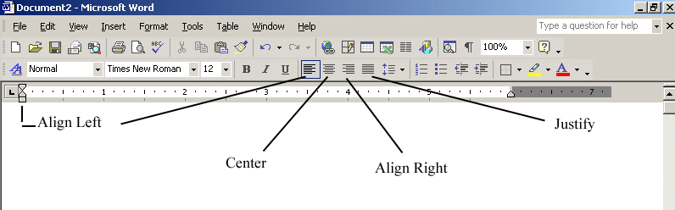

Figure 2.4: The alignment buttons.

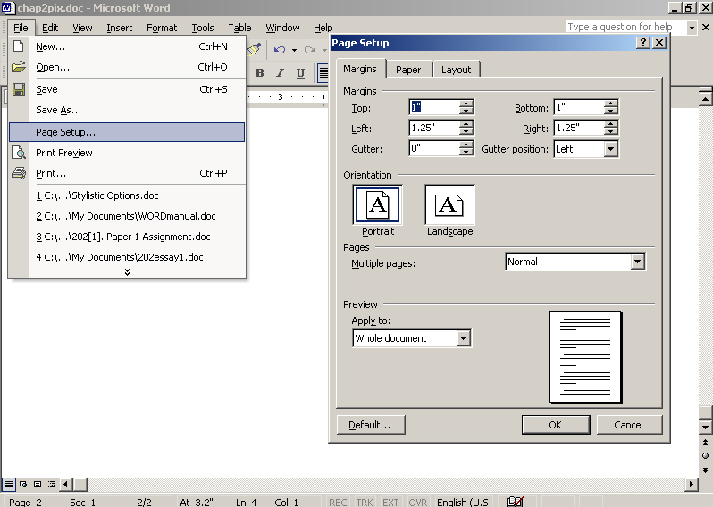

Figure 2.5: File menu pull down and Page Setup window.

