**Create A Facebook App and Add Developer Access :**

Please login your Facebook ID using which you want to give access then . One you added yourself as a successful developer there you can see one green colored “create app” button ()for ref see the below image) .

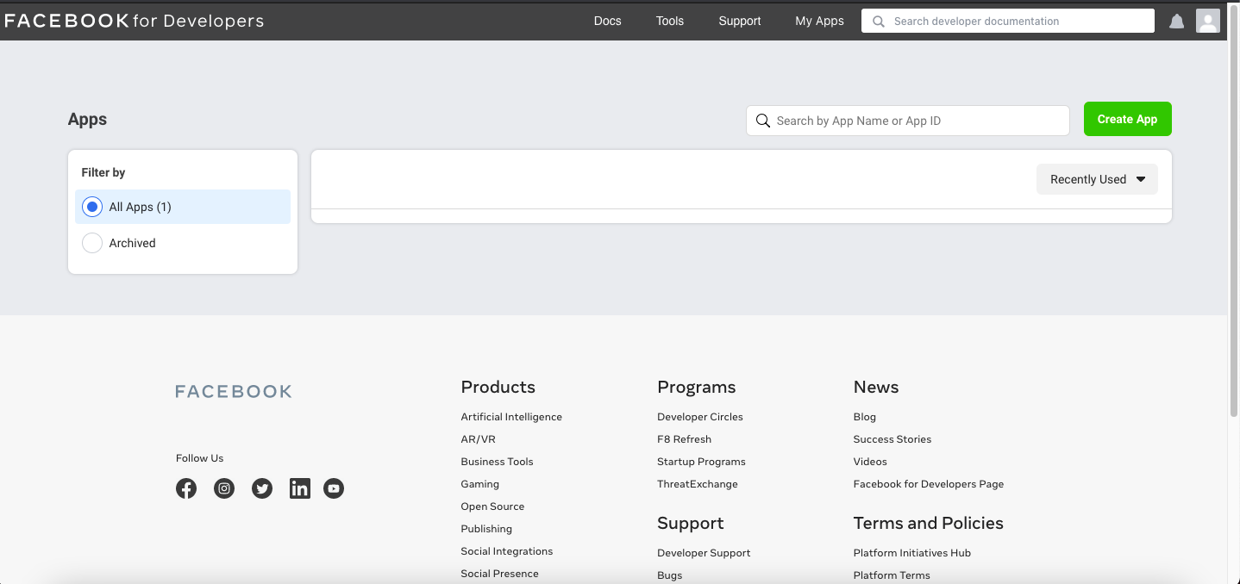

Once you click on it

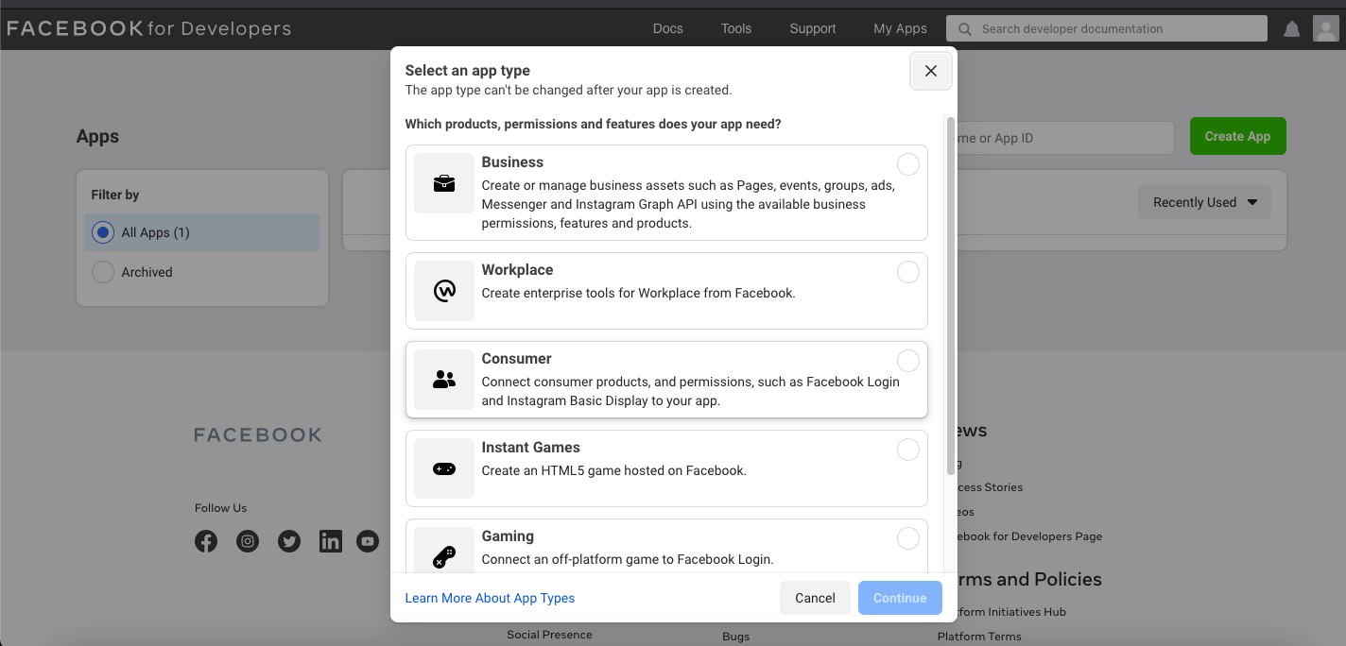

Some information you may need to give there ([click here](https://magefan.com/blog/create-facebook-application) to learn more) so suggested is please read steps properly before you move forward.

Once an app is being created you can see it like this way.

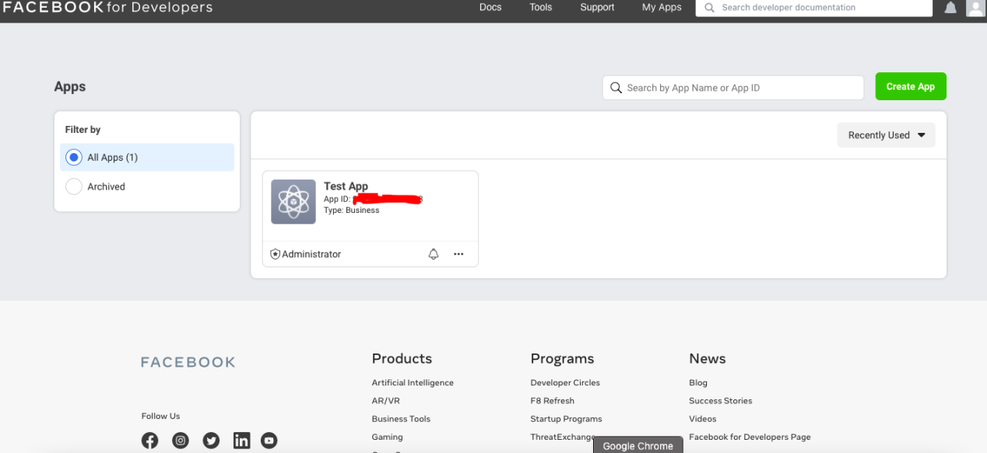

**Now Click On the APP then click on the role, once you click on roles you can see something as similar as**

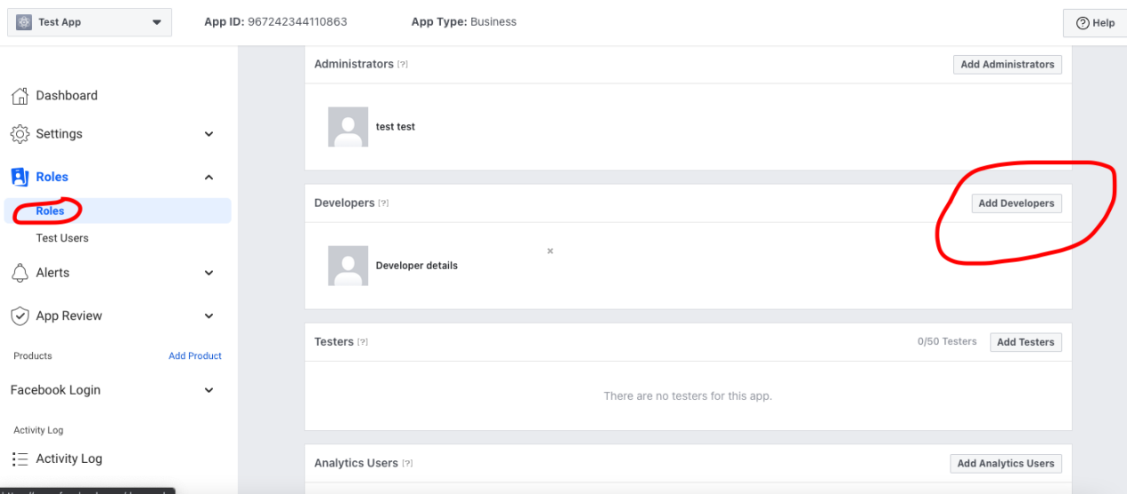

**Click on Add developer button we will share you one or multiple ids just you have to add those to give access to this app so that we can move on the API work further.**

**N.B : Facebook repetitively changing there screens/pages so may be differ form screens what I have shared. So that is a basic idea you can say I have provides.**