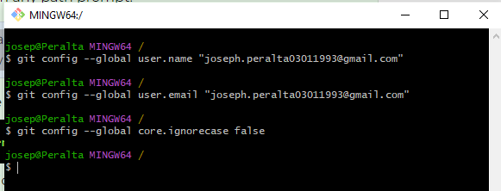

Install Git in your computer

1. Before downloading **Git**, check to make sure you don't already have Git installed on your computer.
   1. Open a **command prompt** by clicking the Start button and typing cmd in the search box. You should get the command prompt terminal to open.

Alternatively, in VS Code, you can use the terminal panel to complete any command line task. use the **Ctrl+`** keyboard shortcut to toggle the terminal panel.

* 1. Enter the following command and then press **Enter**:

git --version

* 1. If you see a version number, you already have Git installed. If you don't see a version number, you need to install Git.

1. To install Git for Windows. Go to [git-scm.com/downloads](https://git-scm.com/downloads) and select **Download for Windows**.  
   An .exe file will be downloaded.
2. Double click that .exe file to open and run the installation executable. The process of installing Git will start.
   1. Allow the installer to make changes to your computer.
   2. Select **Next** through all of the setup windows, leaving all the defaults. There will be many windows.
   3. The last window will let you select **Install** and then click **Finish**.
3. Open up a **new** Command Prompt window by closing the first Command Prompt window and start a instance by clicking the Start button and typing cmd in the search box.
4. Enter the git --version command and then press **Enter** to see if Git is installed. You should see the version number.
5. While we are still in the Command Prompt, we will type in two more commands to set up our username and email that are associated with our GitHub account. Again, it doesn't matter what the path prompt is. These are global settings so you can type them from any path prompt.

Make sure you use your own username and email between the "" quotes. Use the username and your email you used for the GitHub account. It will be different for everyone.

* 1. Type in this configuration command to set the global git username:

git config --global user.name "yourusername"

and select **Enter**. Nothing will happen if you did it right. If you get an error, you need to fix it.

* 1. Enter this configuration command to set the email:

git config --global user.email "youremail@byui.edu"

**Nothing** will happen if you did it right. If you get an error, you need to fix it.

* 1. Type in this configuration command in order to not ignore case changes in files and folder names:

git config --global core.ignorecase false

**Nothing** will happen if you did it right. If you get an error, you need to fix it.