LDS Reblock Process

Process
- Read Topo Shapefiles to temporary Database
- Reblock Layers
  - Merge features across layers
  - Generate/Associate/Persist LDS UFIDs
- Create Revision
- Insert Differences
- Complete Revision
- SourceAPI changes to LDS

Connectivity

Topo Shape Reader
Shape reader functionality to include ability to poll or periodically check content changes in reserved directory. Read changed chapefiles into PostgreSQL operating database.

Reblock Layers

Feature Reblock
Layer features first identified as reblocking candidates and joined where they have been split along a mapsheet boundary.

Criteria for reblocking

Features are considered to be reblock candidates if ST_RELATE(f1,f2,'FF2F11212') yields TRUE.
Candidate features must share a NS/EW boundary coincident with a mapsheet edge. (Mapsheet edges are identified using MOD(EXTENT(feature),1000))
Candidate features must share 'common' non-null attribute values.

A list of feature pairs is created and aggregated into a combined list containing all feature components required to reconstruct an original feature allowing PostGIS to employ the Cascaded Union algorithm when actioning the ST_UNION function.
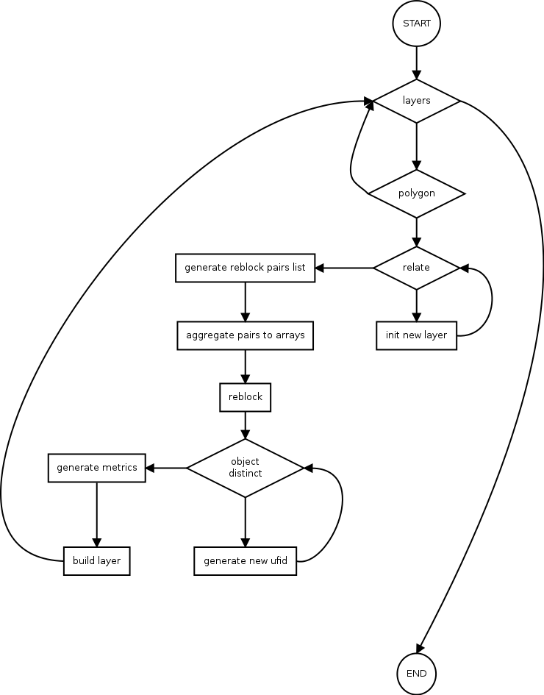

LDS UFIDS
Original features will be named according to TOPO UFID conventions but in the case of reblocked features a new composite UFID will have to be constructed and maintained.

As a rule, features shoud not be renamed as long as they are logiclly consistent. When original features are split and new UFID has to be generated and the respective UFID's of it's composite parts will have to be stored alongside. Rules governing changes to a composite UFID will be based on (provisionally 66% UFID composition) percent change to the original feature.

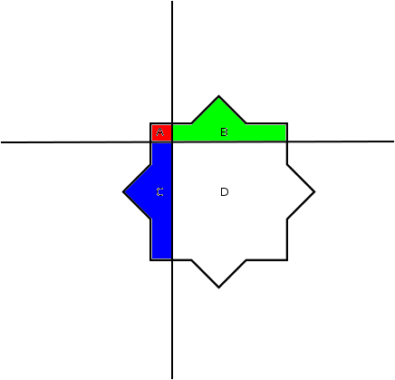  Original Composite Feature.  count-count' = 100%  area-area' = 100%  perimeter-perimeter'=100% | 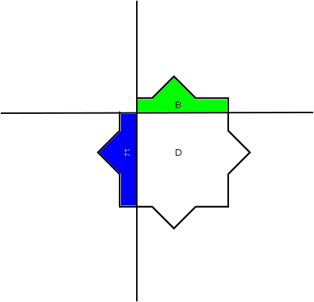  Section A Removed.  count-count' = 75%  area-area' = 95%  perimeter-perimeter'=100%
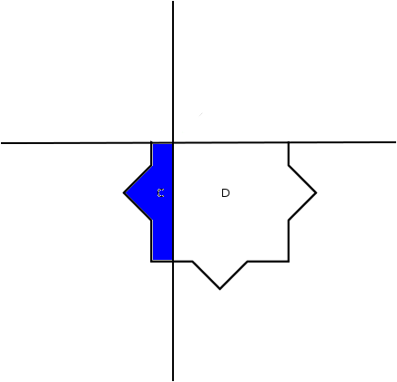  Section A,B Removed.  count-count' = 50%  area-area' = 85%  perimeter-perimeter'=90% | 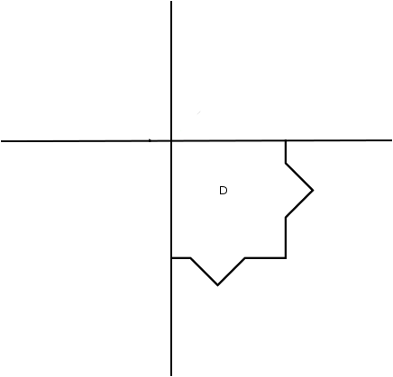  Section A,B,C Removed.  count-count' = 25%  area-area' = 75%  perimeter-perimeter'=80%

Ideally determination of effective percentage change will be made considering feature area and/or perimeter change.
The recalculation trigger for a new composite UFID will consider number of component parts, area and perimeter or some combination of these.

Part | COUNT([f1,f2,f3...]) - COUNT([f1',f2',f3'...]) > THRESHOLD
Area | AREA([f1,f2,f3...]) - AREA([f1',f2',f3'...]) > THRESHOLD
Perimeter | PERIMETER([f1,f2,f3...]) - PERIMETER([f1',f2',f3'...]) > THRESHOLD
Location | CENTROID() - CENTROID() > THRESHOLD

If a new code is required a repeatable hash will be generated from the component UFIDs. One simple proposal is to sum all component UFID's and truncate overlong results

select
ceil(sum_ufid/pow(10,greatest(0,ceil(log(sum_ufid))-exp-1)))) as new_ufid
from (
select
(select sum(s) from unnest(idarray) s) as sum_ufid,
ceil(log( (select max(s) from unnest(idarray) s) )) as exp
from (
select array[ufid1,ufid2,ufid3...] as idarray
) sample
) a

Create Revision
Comparing a reblocked layer with previous snapshots using BDE versioning tools will be used to generate changesets.

Insert Diffs
Differences resulting from comparisons can be used to create revisions

Complete Revision
Complete the revision

SourceAPI Upload
Newly minted layers are uploaded to LDS using the SourcesAPI

Connectivity

Centering around the reblocking processor, source data will be periodically dropped into lds_data_staging. Polling on a named directory will inform the reblocker of data to be processed and trigger the file conversion stage of the provisioning operation.

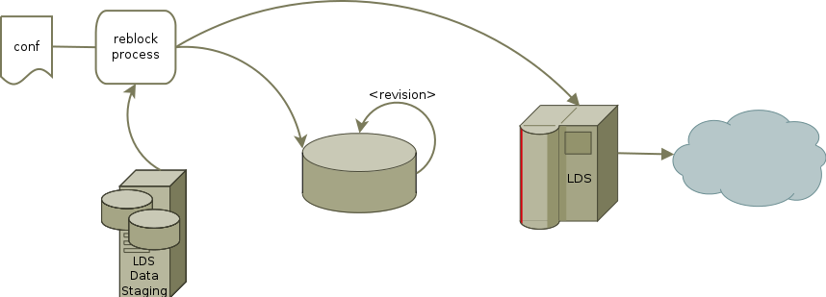
Reblocked data will be stored into temporary tables on a PostgreSQL database and revisioned in situ. Since BDE processing provides revisioning capability the reblocking functionality would be most easily located here.
Uploading to the LDS servers can occur anytime thereafter or during a predetermined upload window. Using the SourcesAPI this client side initiated process and can be built into the reblock process.

