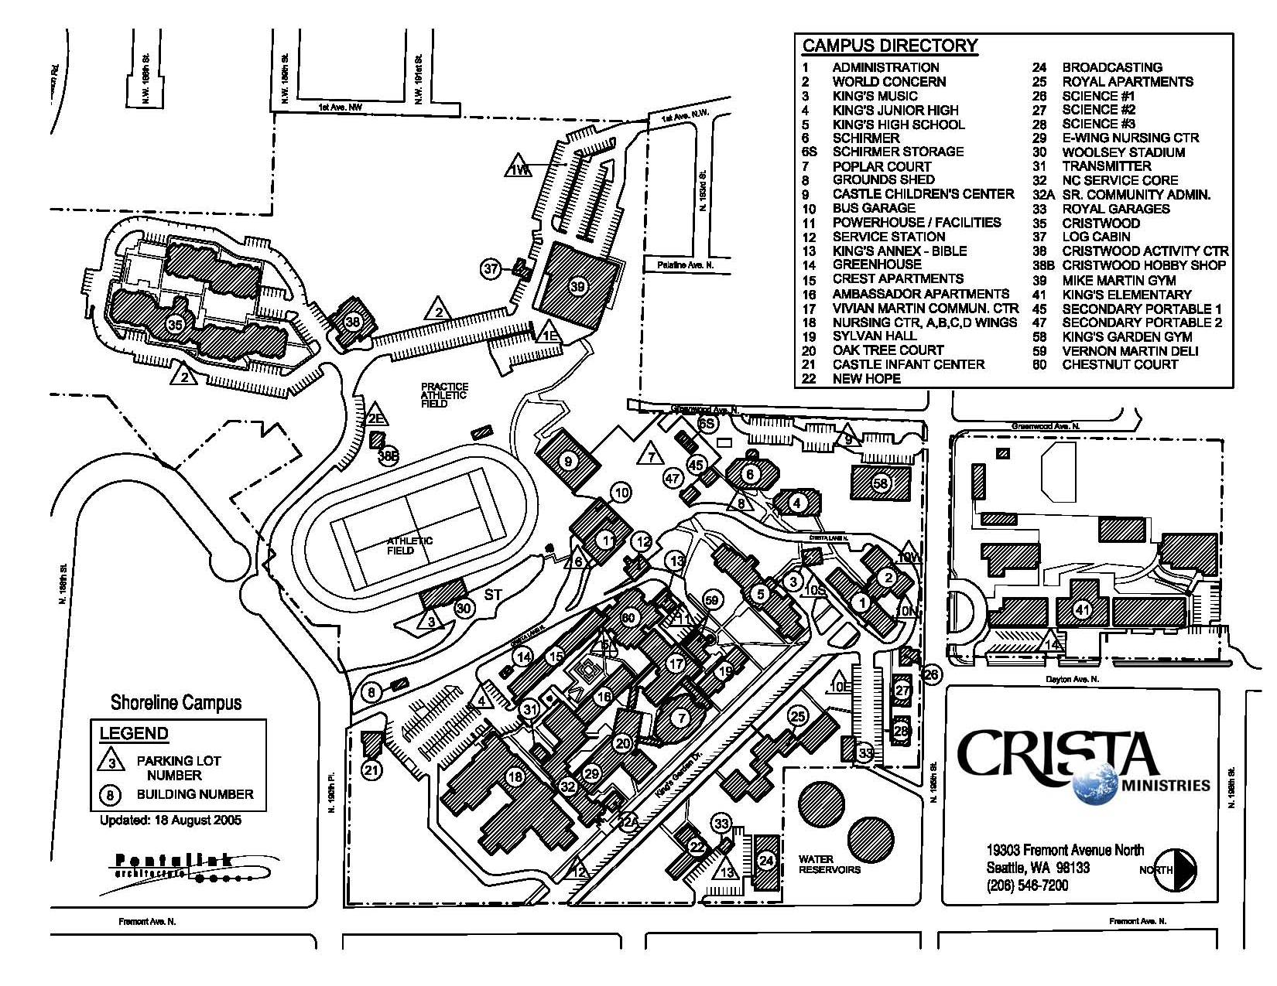
Driving Directions to CRISTA / World Concern Campus
From I-5:
- Take Exit 176 (NE 175th Street)
- Head West on N 175th Street
- Turn Right onto WA-99 (Aurora Ave N)
- Turn Left onto N 185th Street
- Turn Right onto Fremont Ave N
- Turn Left onto 195th Street
- Follow 195th West to Greenwood Ave N
- Turn Left onto Greenwood Ave N
- Turn Left into the parking lot behind Schirmer Auditorium and Kings Garden Gym
(Buildings 6 and 58 on this map)

