S. No | Name | Company | Picture
1 | Gaurav Jain | GIC | 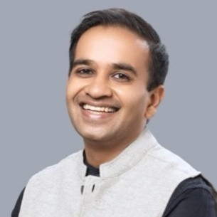
2 | Shalabh Tandon | IFC | 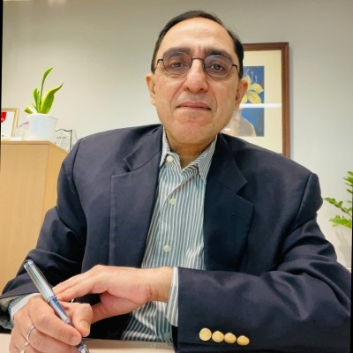
3 | Treasa Mathew | IFC | 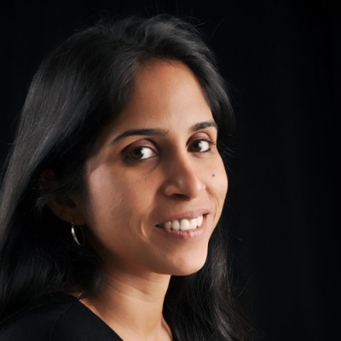
4 | Gordon Chan | IFC | 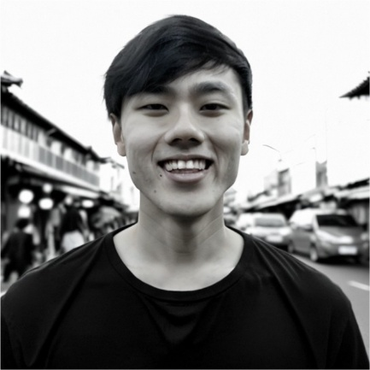
5 | Ali Abdulhussain | Oman Investment Authority | 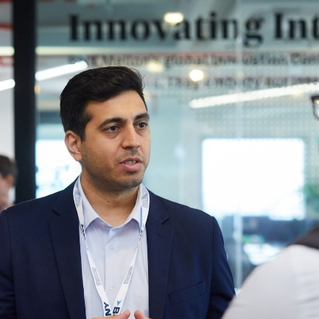
6 | Mahmoud Al Khatri | Oman Investment Authority | 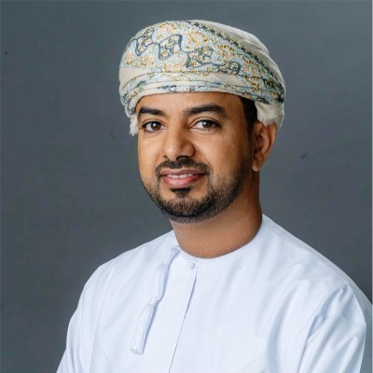
7 | Boon How Khor | Pavilion Capital | 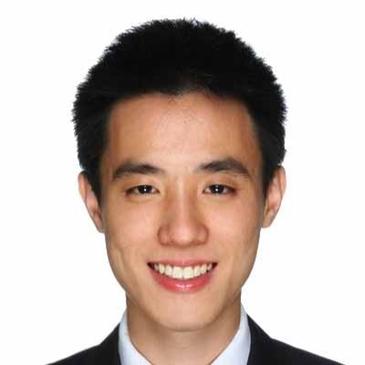
8 | Sam CHEN | Pavilion Capital | 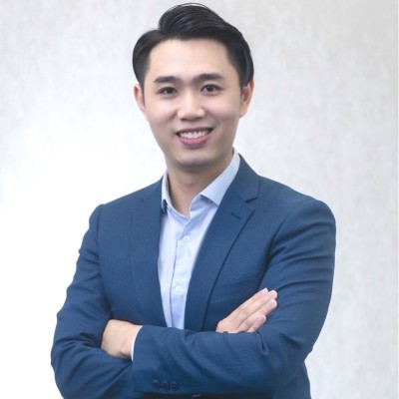
9 | Ankit Agarwal | Nippon India | 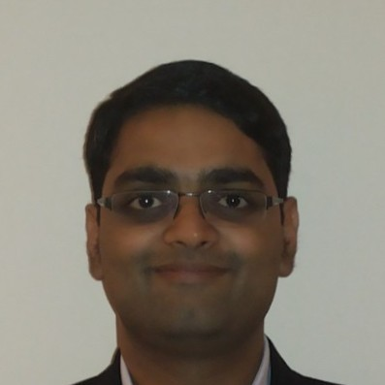
10 | George Li | Transsion | 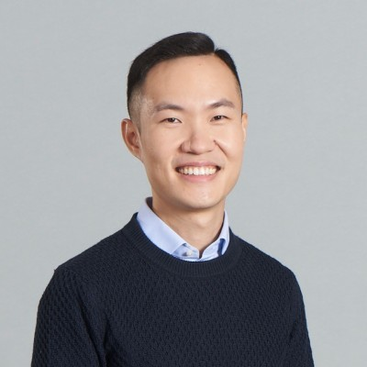
11 | Pawan Chaturvedi | Unilever Ventures | 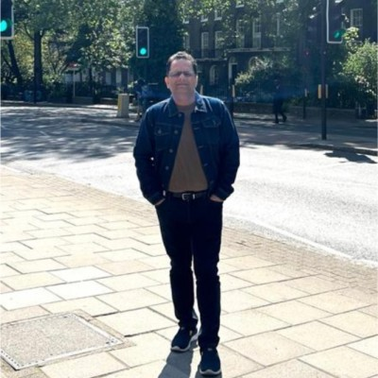
12 | Devesh Papney | Unilever Ventures | 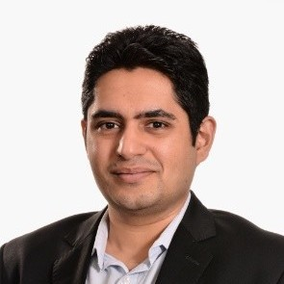
13 | Priyanka Thakkar | Unilever Ventures | 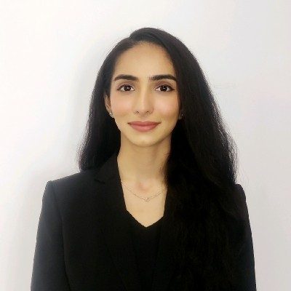
14 | Fiyin Olayisade | Transpose Platform | 
15 | Anoushka | Evolvence Equity Partners | 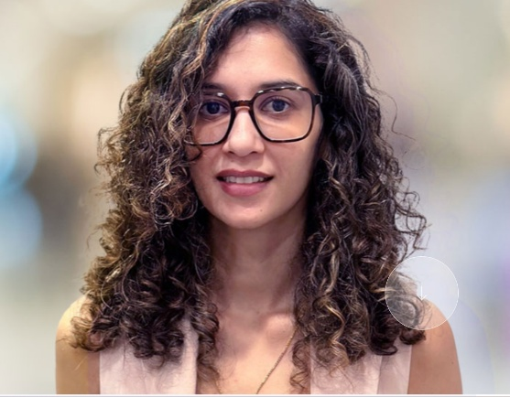
16 | Boris DSouza | Mirabilis | 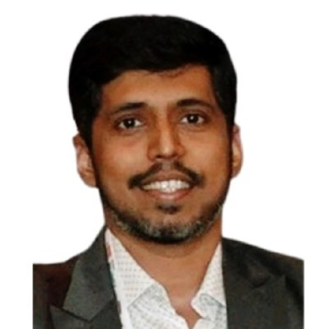
17 | Balsam Alsaif | Prosperity 7 | 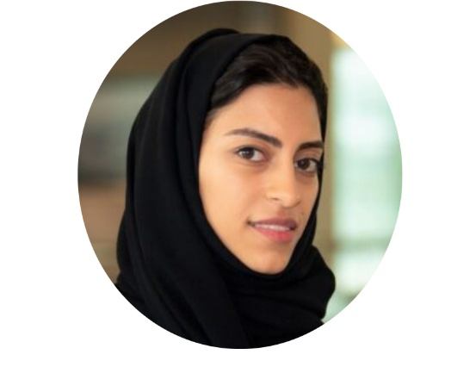
18 | Raed Twaily | Prosperity 7 | 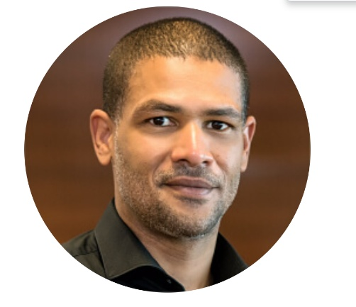
19 | Omar Alnammary | Prosperity 7 | 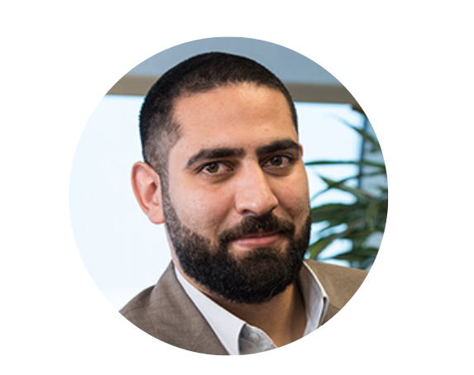
20 | Abhishek Shukla | Prosperity 7 | 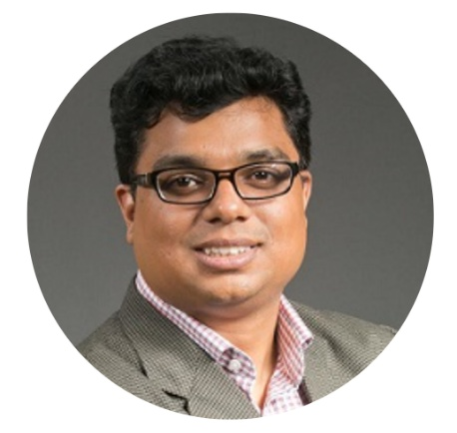
21 | Kiran | UTEC | 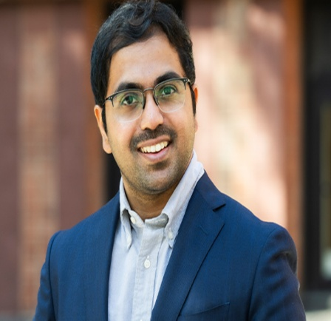
22 | Nitin Agarwal | Neo Secondaries Fund | 