Assignment 2: Developing an FAQ Chatbot Using LangChain and LLM APIs
Joseph Smith
Institution: Study.com
Computer Science 311: Artificial Intelligence
Instructor: Ryan Villard
Date: Mar 31, 2026

App Name and Purpose
The app’s name is PyBot. It provides speedy answers to questions related to the Python programming language. Allowing a user to retrieve reliable information when needed. Under the hood, the tool generates a prompt to an OpenAI LLM (gpt-4.1 Nano) using a predefined FAQ as the context. The app is allowed to go outside this context but only if the question is directly related to Python.

NLP/LLM Methods Used
This is interesting because the entire program is less than 100 lines of code. I’m loading the csv data in a function and returning the questions and answers. Obviously, this is not part of the NLP but it’s relevant because we’re doing some very light cleaning here with dropna() and strip()
Since the returned document object is just a python list of questions and answers, we don’t have to worry about chunking as much. Each item in the list is a chunk. I wrote more about improving this under Discussion and Insights.
The list is then handed to the createDB function which calls the OpenAIEmbeddings() function. My understanding is that this is a class from LangChain but just acts as a wrapper to the OpenAI embeddings API. Basically, this and FAISS.from_texts() create a vector representation of the text which captures the semantic meaning and allows the retriever (used later) to find the most relevant text even if the query words don’t match the FAQ exactly.
Finally, the database is passed to a createChain function which generates a retriever and specifies the number of similar results to return when a query is submitted. In this function we’re also creating a prompt from the ChatPromptTemplate.from_template() method which allows us to give the LLM our question, our context, and our explicit instructions. Finally, we create the chain using the prompt, LLM, and the retriever. Then, return the output back to the user

Dataset Information
I found this dataset from Google Dataset Search. It’s sourced via Kaggle, linked here, and cited below. It contains a 138 records plus the header for a total of just 139 rows. That said, each question seems to have the right level of specificity. It includes only two columns (features) and both are leveraged in the application. The first is Questions which provided the basis of our FAQ. Each question is a string of characters. The second is Answers which provide responses to the Questions. Each answer is a string of characters. The preprocessing was fairly simple. I did an initial review of the data manually. The only thing I found was 1 special character had been appended to every row. Since this data is static, I just did a massive find/replace. Once the csv was added to the project I hooked into the loadFAQ() function to drop any missing values with dropna() and trimmed up any leading or trailing spaces with strip(). This is an iterative process using a loop but I might be able to find a better method.

Libraries, Toolkits, and Frameworks
I’m using dotenv to load the .env file where the OpenAI API key is being kept separate from the mail application.
I’m using the Pandas library for its Dataframe object and to do some data manipulation such as creating the return features and basic sort on the date values
I’m using LangChain for several purposes. First, it gives us the embeddings wrapper from OpenAIEmbeddings. It also provides the ability to store vectors using the community.vectorStores library. Then, it gives us access to the prompt templates via core.prompts and also provides and parsed response object for the user via core.output.parsers

Application Design and Implementation
I described most of the design in the NLP/LLM section, but I’ll summarize here.
When the app is started it will…
- Provide a basic notification to the user via print() and listen for a query (while loop)
- Loads the predefined FAQ csv into memory. We get some natural chunking when this happens.
- Creates the vector database from the FAQ in memory using OpenAIEmbeddings() and FAISS
- Create a LangChain using the vector database, the prompt we engineered, and the LLM
- Invoke the chain passing the user’s query as an argument
- Return the response to the user and continue listening for more queries
- Exit on request

Instructions For Running
- Optionally, create a virtual machine to containerize the development. This is not required but recommended and could help smooth out future deployments.
- Install your favorite IDE. I’m using Github Codespaces. It’s great for flexibility. It’s web-based and can be accessed from any computer. The downside of that is running scripts on a server has some security implications. I have also found a few libraries don’t work (such as creating GUI’s and displaying charts), without a lot of extra configurations.
- Optionally install the python extension for your IDE. This will include enhanced features for debugging, language support, and dedicated python environments (huge)
- Install the project dependencies. Python comes native with the pip package installer so, open the terminal window in your IDE. Then, use the “pip install dependency” command to install dotenv, pandas, and LangChain.
- Create a file called Python FAQ Dataset.csv and copy the dataset provided by Kaggle. Cited below.
- Create a file called .env the first and only line should specify your OpenAI API key as OPENAI_API_KEY=ReplaceWithKey. This key must be generated from the OpenAI dashboard
- Create a file called PyBot.py and paste the code I provided in my PyBot.py file
- Finally, run the terminal command “python PyBot.py”

Screens provided for additional support
Install python-dotenv
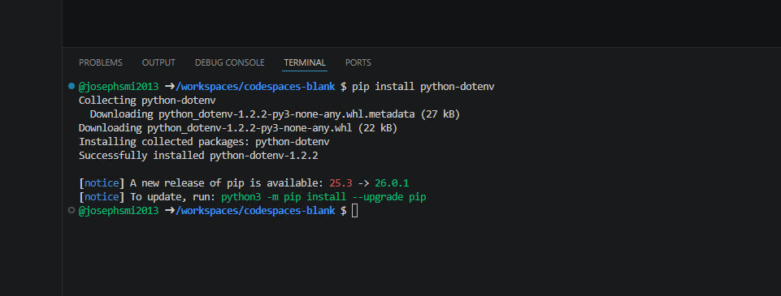
Install Pandas
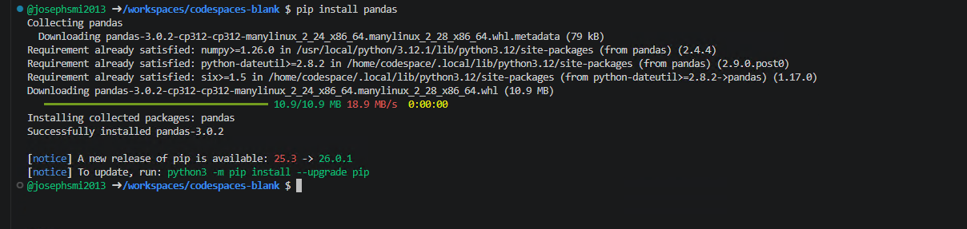
Install OpenAI
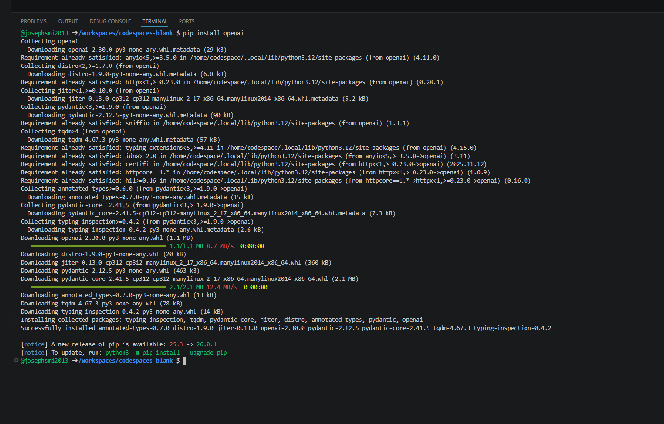
Install LangChain
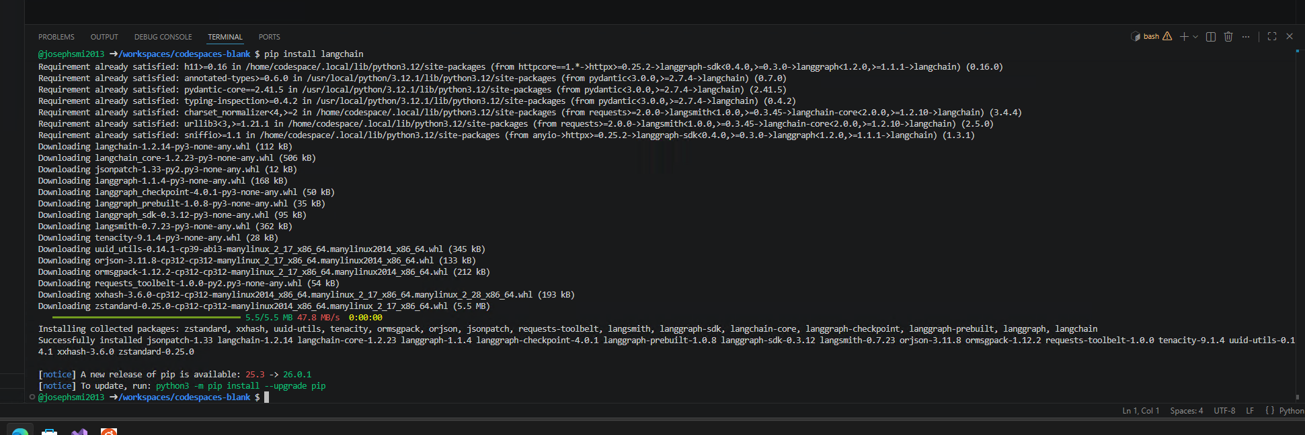
Install LangChain Splitters
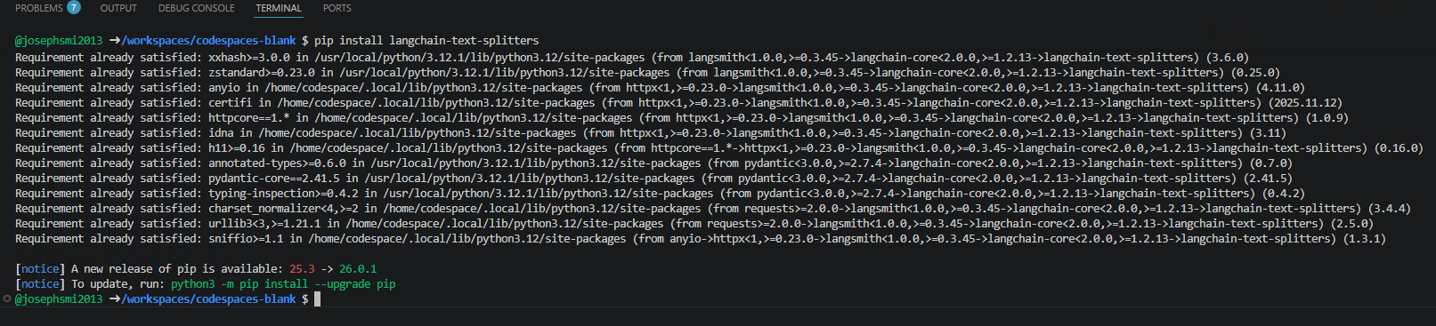
Install LangChain-OpenAI
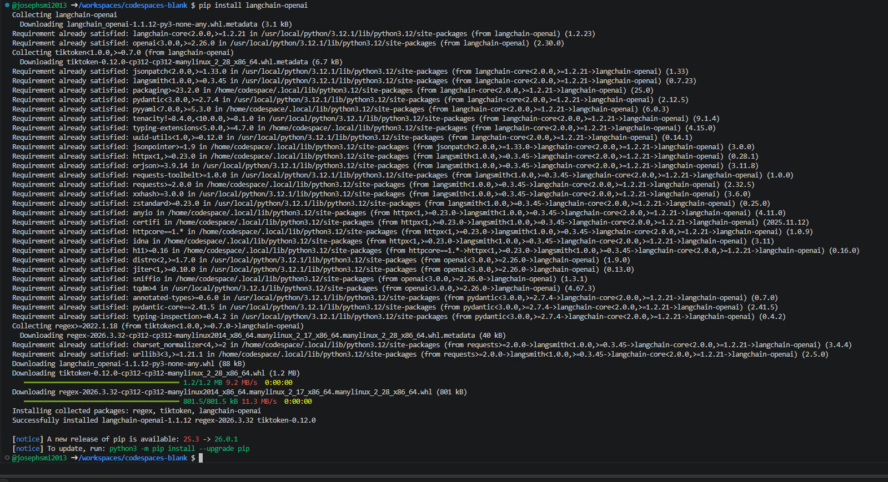
Install LangChain-Community
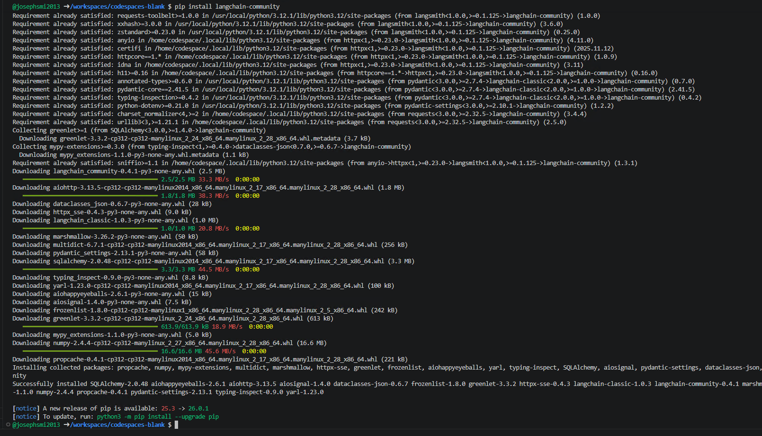
Install Faiss-cpu
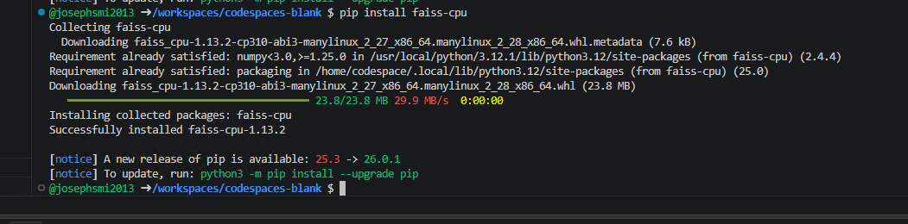

Results
Just a few sentences here. The first screenshot shows the chatbot responding successfully to a query about Python. The second screenshot shows its limitation when asked about a python question not directly in the FAQ context. This is because the original prompt I setup was very strict. It told the LLM it could not go outside the context for any reason.
Given this, I modified the original prompt to make it a little more loosely fitted. Basically I’m now telling the LLM it can go outside the context to answer the question but only if the topic is directly Python related. The third screen shows the new prompt engineering text. The fourth screen shows how the chatbot responds much better when faced with a question not specifically in the FAQ
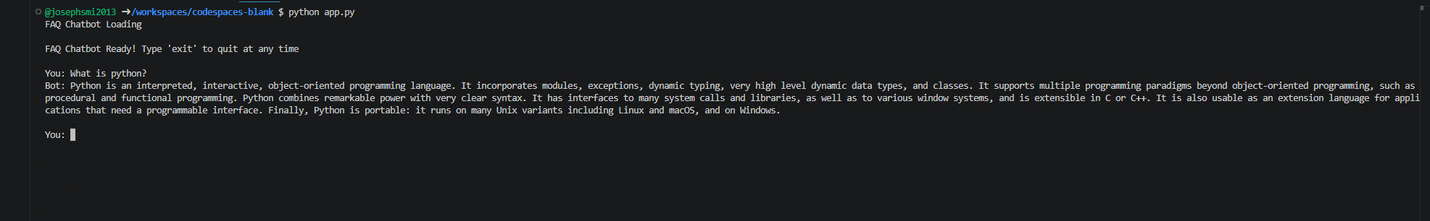
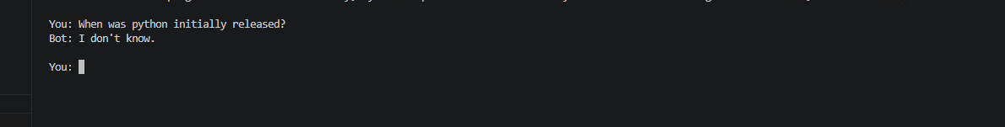
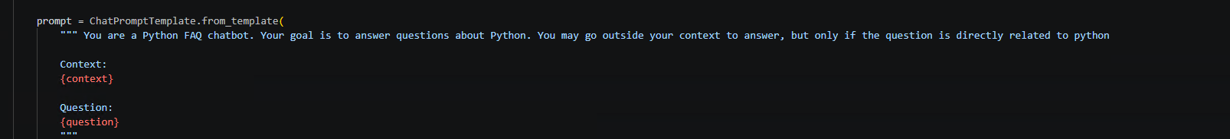
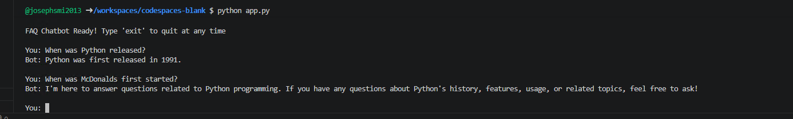

Discussion and Insights
My experience with this project was very enjoyable. I’m learning a lot about ML and AI, even though it feels like I have a long way to go. The programs performance was acceptable. It takes a few seconds to load the FAQ data and I did try it with a dataset containing 20,000 rows so, I know first hand how quickly this step impacts performance. That said, the program responds accurately when queried and that’s probably my biggest takeaway. I’m amazed by knowledge horsepower available in just 100 lines of code.
This is just a prototype and so many improvements would be needed if we wanted to continue the product. First, I probably want to persist the vector database for long-term storage. This should help get it ready for a production environment. Along this line, I could add memory chatbot itself. This would store the conversation context and mean users could ask different questions and the app would remember the conversation history. Next, we should probably switch from a CSV to JSON file for improved accuracy when searching. I think we could also get some metadata into the JSON in the process. We could add sources to the response so users can see where the answer is coming from. This is nice for users but probably also covers us so the answers don’t appear plagiarized. Finally, I’d like to build a UI to manage the interaction. It seems like Streamlit is a good candidate for this.

References
Lemelle Fernandes, P. (2022, June 10) Natural Language Processing & Deep Learning. Study.com. https://study.com/academy/lesson/natural-language-processing-deep-learning.html
Gibbs, M. (2018, March 1) Practical Application for Artificial Intelligence: Learning Chatbot. Study.com. https://study.com/academy/lesson/practical-application-for-artificial-intelligence-learning-chatbot.html
Samaroo, A. (2025, July 8) What is a Large Language Model (LLM)? Study.com. https://study.com/academy/lesson/what-is-an-large-language-model-llm.html
Samaroo, A. (2026, January 4) Large Language Models and Artificial Intelligence. Study.com. https://study.com/academy/lesson/large-language-models-and-artificial-intelligence.html
Alabi, W. (2024). Python FAQ Dataset [Data set]. Kaggle. https://www.kaggle.com/datasets/williamalabi/python-faq-datase
Author or Channel Name. (202X, Month Day). LangChain explained in 10 minutes (components breakdown) [Video]. YouTube. https://www.youtube.com/watch?v=xTmU8ZImUO8
Eteimorde, Y. (2023, August 12). Understanding LangChain’s RecursiveCharacterTextSplitter [Blog post]. DEV Community. https://dev.to/eteimz/understanding-langchains-recursivecharactertextsplitter-2846
OpenAI. (n.d.). Developer quickstart | OpenAI API [Documentation]. OpenAI. https://developers.openai.com/api/docs/quickstart?desktop-os=windows

