

Mandatory Patient Notifications
PATCH RMPR*3*125

INSTALLATION GUIDE

Version 3.0

September 2009

Department of Veterans Affairs
Office of Enterprise Development (OED)

Revision History
Date | Description | Author/Project Manager
September 2009 | Version 3.0 update | Sam Spencer/Gary Pickwoad
June 2009 | Version 3.0 update | Sam Spencer/Gary Pickwoad

Table of Contents

Overview 1
Client Installation 2
Request Security Keys and Privileges 2
Station Number Identification 2
Extract Directory Setup 2
Setting up SSH PRIVATE/PUBLIC keys 4
On the VMS system (client) 4
Testing the SSH2 private/public key authentication 6
Follow these Instructions 8
Setting up SSH Private key authentication using Reflection’s ssh client in a non-VMS windows environment. 8
TESTING THE KEY 14
SET UP FOR INSTITUTION FILE 16
ADDING IP ADDRESS/DOMAIN NAME AND OPERATING SYSTEM FILE DIRECTORY TO PROSTHETICS SITE PARAMATER 16
ADDING NEW PURCHASING AGENT DATA TO PROSTHETICS SITE PARAMATER 17
SETTING THE NIGHTLY JOB 18
ENTERING A SINGLE PATIENT/ PURCHASE TO BE ADDED TO THE NIGHTLY PULL 18
ENTERING THE RETURNED CARD INFORMATION 19
SETUP INSTRUCTION FOR THE DATA BASE RECEIVING THE TRANSMISSIONS 21

Patch RMPR*3*125 Installation Guide

Overview
The Joint Commission on the Accreditation of Healthcare Organizations (JCAHO) requires patients be notified when equipment has been ordered for them. The Mandatory Notification enhancement will add the following:
- Notify patients of all equipment ordered for them to be delivered to their home.
- Batch all Notifications and send once a day after all transactions for that day have been completed. The Option Delivery Verification Nightly Job [RMPR DVN NIGHTLY JOB] option will be scheduled to run once a day before midnight. The data will be sent to VHA Sacramento Regional Processing Center.
- Create the means to resend notifications. If a patient sends back a notification card stating the Item was not received, etc. Also, if determined by Prosthetic Clinical Management (PCM) they can send a server message to run a single date.
- Provide an option to enter data into the #660 -- RECORD OF PROS APPLIANCE/REPAIR FILE when the Notification Cards are returned from the patient.
- Satisfy JCAHO requirements.

Client Installation
Steps | Follow these Instructions
Step  1  Step 2 | Request Security Keys and Privileges  You will need the following system access or privileges:  Massachusetts General Hospital Utility Multi-Programming System (MUMPS) Programmer  Virtual Memory System (VMS) Administrator or Microsoft (MS) Windows/New Technology (NT) Administrator  Station Number Identification  NOTE: Perform this step for each instance of Cache running on your server(s) (single or multiple instances).  Start at the Programmer prompt: >  Obtain the station number from your system.  NOTE: When your system was configured, a unique number was assigned to the configuration (single station sites and multi-division facilities).  In order to obtain the station number (used to name the directory), type the following two commands at the programmer prompt:  NOTE: In this example, the site number returned is 695.  The command you entered MUST return a site number (which is set in the variable Y).  > S Y=$$GET1^DIQ(4,$$KSP^XUPARAM("INST")_",",99) [Enter]  > W Y [Enter]  > 695
Step  3 | Extract Directory Setup  NOTE: The naming convention for directories is different for each OS.  Be sure to follow the instructions for your particular OS.  a. Cache / VMS Sites  NOTE: The proposed naming convention is a recommendation. A more knowledgeable and experienced System Manager may choose to setup the extract directory using existing drives and definitions. The directory name chosen must have the appropriate READ, WRITE, EXECUTE, and DELETE privileges.  - Set up a VMS Directory named USER$:[RMPRDVNxxx] where xxx is the station number.  In our example, the name of the directory would be:  USER$:[RMPRDVN695] (station number obtained in step 2).  - The new directory MUST have READ, WRITE, EXECUTE, and DELETE privileges for the currently installed Cache instance.  You must have administrator privileges when you perform this task in order to assure the directory is setup/created with the necessary permissions.  Following is an example for you to follow to set up the extract directory.  NOTE: The owner of the directory should be CACHEMGR.  $ CREATE/DIRECTORY USER$:[RMPRDVNxxx] /own=CACHEMGR  /PROTECTION=(S:RWED,O:RWED,G:RWED,W:RWED)/LOG  NOTE: Where USER$=the disk of your choice (e.g. USER$, PQ$, etc. - SYS$ is not recommended) and xxx=the station number.  NOTE: Confirm that the extract directory has similar protections and permissions  A3$dir/security user$:[000000]RMPRDVN695.DIR;1  Directory USER$:[000000]  RMPRDVN695.DIR;1 [CACHEMGR] (RWED,RWED,RWED,RWED)  NOTE: After the extract directory set up is complete, provide the directory name to the Prosthetic Chief to be entered into the SS Enter/Edit Station Site Parameters option in the DVN FILE DIRECTORY: field.  b. Cache / MS Windows or NT Sites  NOTE: The proposed naming conventions should be followed to avoid duplication. A more knowledgeable and experienced System Manager may choose to setup the extract directory using existing drives and definitions. The directory must have the appropriate READ, WRITE, EXECUTE, and DELETE privileges.  - Set up an MS Windows directory named D:\RMPRDVNxxx where xxx is the station number.  In our example, the name of the directory would be: D:\RMPRDVN695 (station number obtained in step 2).  - The new directory MUST have READ, WRITE, EXECUTE, and DELETE privileges for the currently installed MS Windows instance.  You must have administrator privileges when you perform this task in order to assure the directory is setup/created with the necessary permissions.  SPECIAL INSTRUCTIONS FOR WINDOWS/NT STATIONS  The directory set up in the example is D:\RMPRDVN500. You MUST append a backslash ( \ ) to the MS Windows directory name when you enter a value in the Prosthetics Site Parameter file, field DVN FILE DIRECTORY for example: D:\RMPRDVNS500\
Step  4 | Setting up SSH PRIVATE/PUBLIC keys  On the VMS system (client)  1) determine the VISTA(VMS) account that will require the keys for authentication (production account)  a) The default directory of the account being used will require an .SSH2 sub-directory. If the subdirectory for the designated account does not exist, create it.  $ DIR USER$:[sitecode_vista_dir]  Directory USER$:[sitecode_vista_dir]  LOGIN.COM;1  Total of 1 file.  $ CREATE/DIRECTORY/LOG –  USER$:[sitecode_vista_dir.SSH2]/OWN=sitecode-vista –  /PROTECTION=(G:RE,W:RE)  %CREATE-I-CREATED, USER$:[sitecode_vista_dir.SSH2] created  $  2) generate private/public keys via the SSH_KEYGEN  a) Create a VMS symbol for the command:  $ SSH_KEYGEN == "$SYS$SYSTEM:TCPIP$SSH_SSH-KEYGEN2.EXE"  - Set your default directory to the vms_account’s .SSH2 sub-directory.  $ SET DEFAULT user$:[sitecode-vista_dir.SSH2]  $ DIR  %DIRECT-W-NOFILES, no files found  $ SHOW DEFAULT  user$:[sitecode_vista_dir.SSH2]  $  - Execute the SSH_KEYGEN symbol with the appropriate parameters.  If a paraphrase is entered, the SFTP server will prompt the client session for the paraphrase. The intent of this is not to be prompted at all. (In the following example, The standard format is RMPRXXX (where xxx = station number) for the private/public key pair name.  $ ssh_keygen -t dsa -"P" RMPR695  Generating 2048-bit dsa key pair  6 Ooo.oOo.oOo.  Key generated.  2048-bit dsa, vhamachillsg@R1PB07.r01.med.va.gov, Thu Jul 31 2008 19:59:20  Private key saved to RMPR695 ← note: private key  Public key saved to RMPR695.pub ← note: public key  $  3) Add the private key to the IDENTIFICATION. file in the VMS account’s .SSH2 directory (System Manager for the OS needs to be involved & perhaps a Change Control Request (CCR)).  a) Using a VMS editor, edit the IDENTIFICATION. file and add the following substituting private_key_name with the actual name of the key you created. (If the IDENTIFICATION. file does not exist, create it)  IDKEY private_key_name  $ EDIT IDENTIFICATION.  IDKEY RMPR695  [EOB]  ^Z  * EXIT  user$:[sitecode_vista_dir.SSH2]IDENTIFICATION.;1 1 line  $  - Copy the SSH.DIR to the Extract Directory named USER$:[RMPRDVNxxx] that you created and sent to the Prosthetics Chief earlier.  Example:  $ COPY/LOG *.* USER$:[RMPRDVNXXX]  %COPY-S-COPIED, USER$:[RMPRDVNXXX.SSH2]IDENTIFICATION.;1 copied to USER$:[RMPRDV  NXXX]IDENTIFICATION.;1 (1 block)  %COPY-S-COPIED, USER$:[RMPRDVNXXX.SSH2]RMPR999.;1 copied to USER$:[RMPRDVNXXX]RM  PRXXX.;1 (3 blocks)  %COPY-S-COPIED, USER$:[RMPRDVNXXX.SSH2]RMPRXXX.PUB;1 copied to USER$:[RMPRDVNXXX  ]RMPRXXX.PUB;1 (3 blocks)  %COPY-S-NEWFILES, 3 files created  $ DIR/SEC [.SSH2]  Directory SYS$USER:[RMPR499.SSH2]  HOSTKEYS.DIR;1 [sitecode_vista] (RWED,RWED,RE,RE)  (DEFAULT_PROTECTION,SYSTEM:RWED,OWNER:RWED,GROUP:RWED,WORLD:RWED)  IDENTIFICATION.;1 [sitecode_vista] (RWED,RWED,RE,RE)  RANDOM_SEED.;1 [sitecode_vista] (RWD,RWD,,)  RMPRSFTP.;1 [sitecode_vista] (RWED,RWED,,)  RMPRSFTP.PUB;1 [sitecode_vista] (RWED,RWED,RE,)  - Never share your private key with anyone. The private key will allow another system to authenticate as the originator of the keys. This means authentication has been compromised and the SFTP servers should delete the public key immediately and request a new key from the client system  The public key should be sent securely to the target recipients (Regional Reproduction Staff) via Exchange.  The System Manger should FTP the RMPRxxx.pub file to their PC, and then sent it through Outlook.  Send the public key to the RRC/OI&T support staff  *As of 01JUL09 the email address that you would send the public key to would be: VA IT Region 1 RDP RRC  Testing the SSH2 private/public key authentication  4) Once the RRC/OI&T has received your public key they will send you a reply to your message that it was received and stored in the necessary directory. Then you can test SFTP to see if everything is set up correctly. To test authentication, using the VMS account you created the keys for, sign on as that account and issue the SFTP command to connect to the remoter server.  You should not be prompted for a password or paraphrase. If you are prompted, the keys, identification or authorization file, or the SSH2 directory/folder may not have been implemented correctly.  Authentication setup correctly:  $ sftp rmprftp@10.173.116.60  sftp> exit  $  Authentication not setup correctly:  $ sftp rmprftp@10.173.116.60  rmprftp's password: (Had to enter a password)  Authentication successful.  Terminal access is denied for user 'xeroxfhm'.  Connection to 10.173.116.60 closed.  $

Steps | Follow these Instructions
Step  4b | Setting up SSH Private key authentication using Reflection’s ssh client in a non-VMS windows environment.  1) Start the reflection Key Agent application  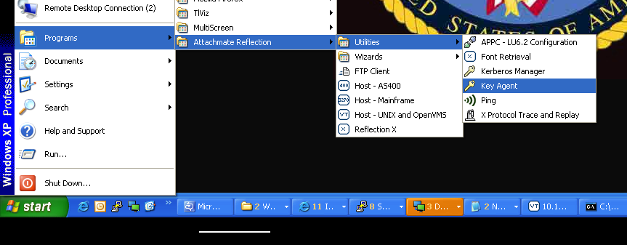  - If the Key Agent control file (rAgent ) does not exist for the user, you will be prompted for a passphrase to control access to the Key Agent (normally on the first time setting up the keys)  (just press return for now)  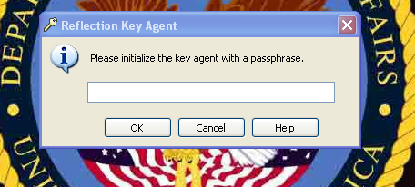  3) When the Key Agent is started, a key will appear in the SYSTRAY. This icon must be in the tray when using Reflection’s SFTP executable.  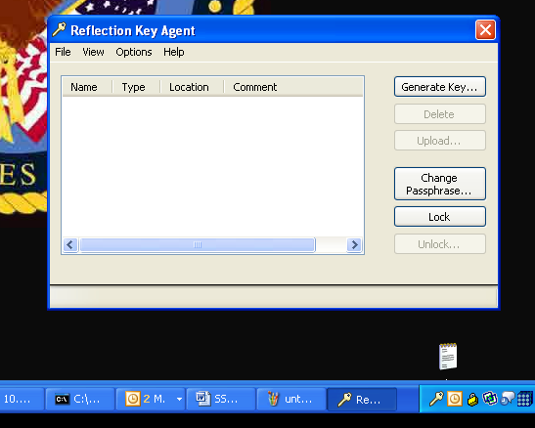  4) To create a private/public key pair, click on the Generate Key button  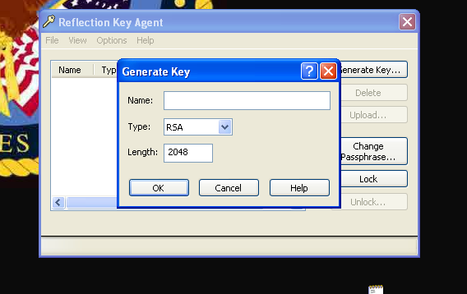  5) Enter key information  Enter a name for the key, no spaces, no special characters  Change type to DSA (when selecting DSA Length field defaults to 1024)  Change Length to 2048  Press OK to generate the private & public keys  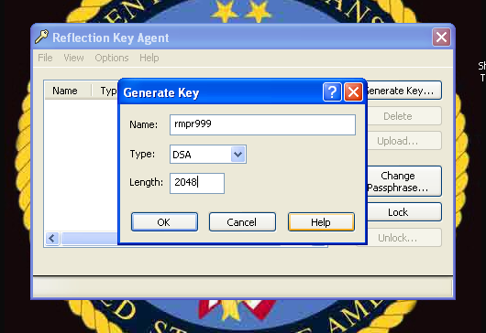  6) Once the private key has been generated and saved, you can export the key from the reflection database.  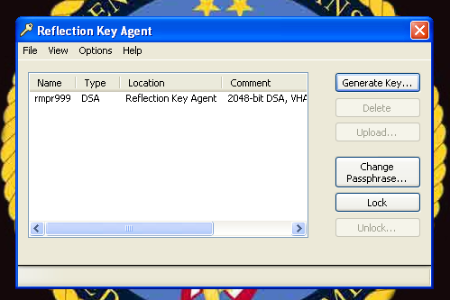  7) The public key must be exported and sent to the RRC or OI&T staff that will install the public key on the sftp server.  To export the public key:  Select the key  From the File menu option, select EXPORT PUBLIC KEY.  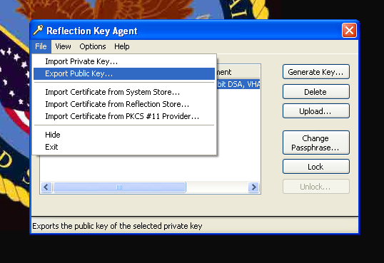  8) The exported public key should have a format of OPENSSH.  Place a check mark in the box  Press OK  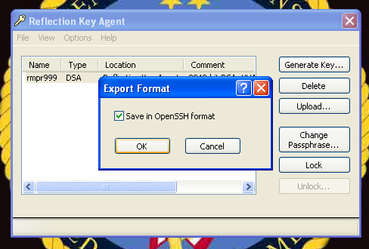  9) Save the public key:  During the export, you are prompted for a location to save the file. The default location is:  C:\Documents and Settings\domain_accout\My Documents\Attachmate\Reflection\.ssh  Please name the file as RMPRnnn (where nnn is your station number)  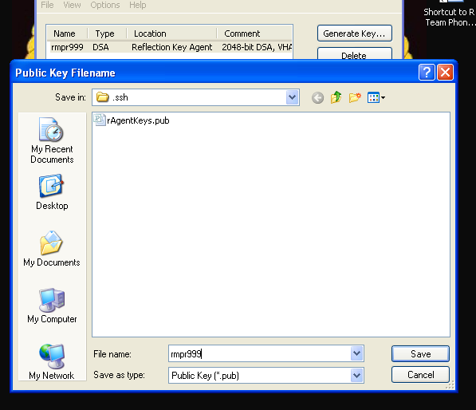  10) After selecting SAVE, you can check the save location for the exported public key.  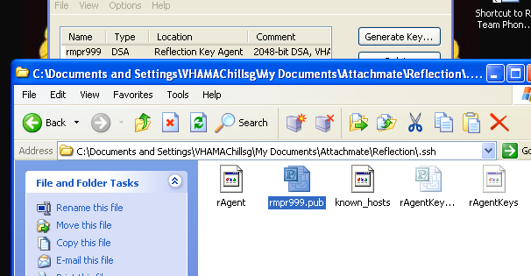  11) Send the public key to the RRC/OI&T support staff  (As of 01JUL09 the address that you would send the public key to would be: VA IT Region 1 RDP RRC  The save key should be sent securely to the target recipients (Regional Reproduction Staff) via Exchange (secure message if possible).  TESTING THE KEY  Once the public key has been put in place on the SFTP server, you can test Reflection’s sftp client. From a DOS prompt on the client that has exported the public key, execute the following command:  C:\Documents and Settings\VHAMAChillsg>sftp -i "C:\Documents and Settings\AD_domain_account\My Documents\Attachmate\Reflection\.ssh\rAgentKeys" rmprftp@vhamacappt.v21.med.va.gov  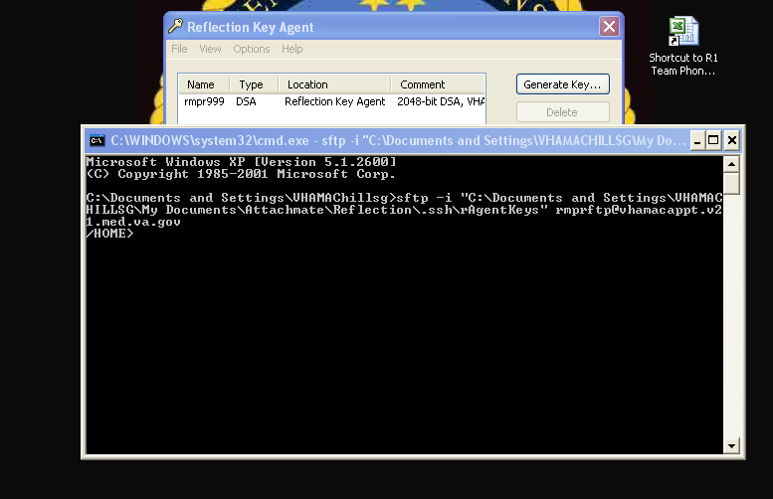  The above is a successful connection. Type “exit” to exit the sftp session and return to DOS.  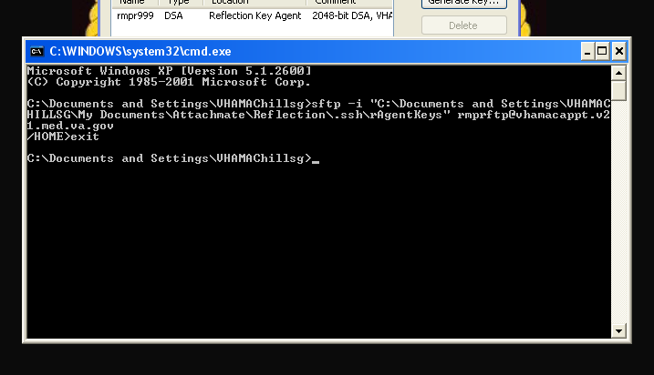  If you receive a prompt for a passphrase or password, the authentication is not setup correctly.
Step  5 | SET UP FOR INSTITUTION FILE  IRM also needs to check the entry in the INSTITUTION file #4 and make sure the mailing address fields for your site are populated.  Select OPTION: ENTER OR EDIT FILE ENTRIES  INPUT TO WHAT FILE: INSTITUTION//  EDIT WHICH FIELD: ALL// 4.01 ST. ADDR. 1 (MAILING)  THEN EDIT FIELD: 4.02 ST. ADDR. 2 (MAILING)  THEN EDIT FIELD: 4.03 CITY (MAILING)  THEN EDIT FIELD: 4.04 STATE (MAILING)  THEN EDIT FIELD: 4.05 ZIP (MAILING)  THEN EDIT FIELD: 100 OFFICIAL VA NAME  THEN EDIT FIELD:  STORE THESE FIELDS IN TEMPLATE:  Select INSTITUTION NAME: SUPPORT ISC IL 499  ST. ADDR. 1 (MAILING): ST ADD 1 M//  ST. ADDR. 2 (MAILING): ST ADD 1 M//  CITY (MAILING): HINES//  STATE (MAILING): ILLINOIS//  ZIP (MAILING): 60142//  OFFICIAL VA NAME: SUPPORT ISC HINES DEV Replace
Step  6 | ADDING IP ADDRESS/DOMAIN NAME AND OPERATING SYSTEM FILE DIRECTORY TO PROSTHETICS SITE PARAMATER  Select Prosthetic Official's Menu Option: UT Utilities  AP Add/Edit Patient to Prosthetics  DIS Enter Prosthetic Disability Code to 2319  REM Delete Prosthetic Disability Code from 2319  PGE Purge Obsolete Data ...  RC Flag Item as Returned/Condemned  RE Edit Returned/Condemned Item  FCLN RMPR file cleansing for field lengths  MS Manual Send Delivery Notification  RD Returned Delivery Verification Card  SP Enter/Edit Site Parameters ...  WD Display Prosthetic PO Information  Select Utilities Option: SP Enter/Edit Site Parameters  SS Enter/Edit Station Site Parameters  RF Set CPT Modifier Rental Flag  Select Enter/Edit Site Parameters Option: SS Enter/Edit Station Site Parameters  Select PROSTHETICS SITE PARAMETER SITE NAME: ?  ALBANY VAMC 500  ATLANTA VAMC 508  HINESTEST 578  Hines Development System 499  Answer with INSTITUTION NAME, or STATUS, or STATION NUMBER, or  OFFICIAL VA NAME, or CURRENT LOCATION, or CODING SYSTEM/ID PAIR, or  NPI, or STATUS, or NAME (CHANGED FROM), or CODING SYSTEM  Do you want the entire INSTITUTION List? N (No)  Select PROSTHETICS SITE PARAMETER SITE NAME: ALBANY VAMC <<< ONLY PICK THE FIRST SITE FROM THE LIST ABOVE  SITE NAME: ALBANY VAMC//  VISN:  PHONE NUMBER:  STREET ADD1: //  CITY: ALBANY//  STATE: NEW YORK//  ZIP CODE: 32136//  MANAGER COMMENT:  DVN IP ADDRESS: vhamacappt.v21.med.va.gov// IP or DOMAIN NAME in SACRAMENTO <<<THIS IS THE ADDRESS TO SEND THE DATA. THIS ENTRY MUST BE DONE IN THE FIRST SITE IN THE LIST. YOU ONLY HAVE TO ENTER THIS IN THE FIRST SITE IN THE SITE PARAMATER FILE LIST.  DVN FILE DIRECTORY: FILE DIRECTORY FROM IRM// <<<THIS IS THE ADDRESS TO SEND THE DATA. THIS ENTRY MUST BE DONE IN THE FIRST SITE IN THE LIST. YOU ONLY HAVE TO ENTER THIS ONCE.  DVN SFTP USERNAME: rmprftp//
Step  7 | ADDING NEW PURCHASING AGENT DATA TO PROSTHETICS SITE PARAMATER  MUST BE COMPLETED FOR EACH SITE IN YOUR SITE PARAMETERS THAT YOU DO PURCHASING FROM  Select PROSTHETICS SITE PARAMETER SITE NAME: HINESTEST  SITE NAME: HINESTEST//  VISN: 7//  PHONE NUMBER:  STREET ADD1: STREET AD1//  CITY: CHICAGO//  STATE: ILLINOIS//  ZIP CODE: 44444//  MANAGER COMMENT:  DVN IP ADDRESS: <<<ADDED IN STEP 5 ABOVE FOR THE FIRST SITE. LEAVE BLANK.  DVN FILE DIRECTORY: <<< ADDED IN STEP 5 ABOVE FOR THE FIRST SITE. LEAVE BLANK.  CHIEF SIG BLOCK: TEST USER//  Select PURCHASING AGENT: NELSON,KEN// SPENCER,SAMUEL P SPS IRM COM  PUTER SPECIALIST  ...OK? Yes// (Yes)  PURCHASING AGENT: SPENCER,SAMUEL P//  START RANGE: 0//  STOP RANGE: 99//  PHONE: (NNN) NNN-NNNN ex NNNNN <<< WILL HANDLE 18 CHARACTERS. REPEAT FOR EACH PURCHASING AGENT.  PRINT NAME: PURCHASING AGENT NAME <<< WILL HANDLE 60 CHARACTERS. REPEAT FOR EACH PURCHASING AGENT. May want to just use the Purchasing Agents first name to protect their privacy.
Step  8 | SETTING THE NIGHTLY JOB  Select Systems Manager Menu Option: TASKman Management  Schedule/Unschedule Options  One-time Option Queue  Taskman Management Utilities …  List Tasks  Dequeue Tasks  Requeue Tasks  Delete Tasks  Print Options that are Scheduled to run  Cleanup Task List  Print Options Recommended for Queuing  You have PENDING ALERTS  Enter “VA to jump to VIEW ALERTS option  Select Taskman Management Option: Schedule/Unschedule Options  Select OPTION to schedule or reschedule: RMPR DVN NIGHTLY JOB DELIVERY VERIFICATION NIGHTLY JOB  Are you adding ‘RMPR DVN NIGHTLY JOB’ as  a new OPTION SCHEDULING (the 108TH)? No// Y (Yes)  Edit Option Schedule  Option Name: RMPR DVN NIGHTLY JOB  Menu Text: DELIVERY VERIFICATION NIGHTLY JO TASK ID:  _______________________________________________________  QUEUED TO RUN AT WHAT TIME: FEB 29,2008@23:00  DEVICE FOR QUEUED JOB OUTPUT:  QUEUED TO RUN ON VOLUME SET:  RESCHEDULING FREQUENCY: 1D  TASK PARAMETERS:  SPECIAL QUEUEING:
Step  9 | ENTERING A SINGLE PATIENT/ PURCHASE TO BE ADDED TO THE NIGHTLY PULL  Select Prosthetic Official's Menu Option: Utilities  AP Add/Edit Patient to Prosthetics  DIS Enter Prosthetic Disability Code to 2319  REM Delete Prosthetic Disability Code from 2319  PGE Purge Obsolete Data ...  RC Flag Item as Returned/Condemned  RE Edit Returned/Condemned Item  FCLN RMPR file cleansing for field lengths  MS Manual Send Delivery Notification <<<< NEW OPTION  RD Returned Delivery Verification Card  SP Enter/Edit Site Parameters ...  WD Display Prosthetic PO Information  Select Utilities Option: ms Manual Send Delivery Notification  Please Enter the 2319 Date or Patient's Name: 1829 12-4-2007 DANGER,DAN ...OK? Yes// (Yes)  At this prompt, you can manually enter the Internal entry Number of the Record, Record Date, or Patient Name.  Please Enter the 2319 Date or Patient's Name: ENTER ANOTHER RECORD OR RETURN TO QUIT
Step  10 | ENTERING THE RETURNED CARD INFORMATION  Select Prosthetic Official's Menu Option: U Utilities  AP Add/Edit Patient to Prosthetics  DIS Enter Prosthetic Disability Code to 2319  REM Delete Prosthetic Disability Code from 2319  PGE Purge Obsolete Data ...  RC Flag Item as Returned/Condemned  RE Edit Returned/Condemned Item  FCLN RMPR file cleansing for field lengths  MS Manual Send Delivery Notification  RD Returned Delivery Verification Card <<<<NEW OPTION  SP Enter/Edit Site Parameters ...  WD Display Prosthetic PO Information  Select Utilities Option: RD Returned Delivery Verification Card  Select RECORD OF PROS APPLIANCE/REPAIR ENTRY DATE: 1829 12-4-2007 DANGER,D  AN ...OK? Yes// (Yes)  At this prompt, you will scan the bar code label found on the card. The patient name and transaction will appear. Alternatively, you can manually enter the Internal entry Number of the Record, Record Date, or Patient Name.  Select DELIVERY VERIFICATION DATE: T FEB 29, 2008  This is the action date. Every time the action blow changes for this particular record a new date is entered. Only the last entry date and action are saved. This is not a multiple field.  DELIVERY VERIFICATION STATUS: ?  Choose from:  1 RECEIVED  2 NOT RECEIVED  3 DAMAGED or INCOMPLETE  4 RECEIVED not as ORDERED  5 RECEIVED IN ERROR  DELIVERY VERIFICATION STATUS: 1 RECIEVED  Select RECORD OF PROS APPLIANCE/REPAIR ENTRY DATE: ENTER ANOTHER RECORD OR RETURN TO END THE OPTION.
Step  11 | If determined by Prosthetic Clinical Management (PCM) they  can send a server message to run a single date  Subj: RETRANS NOTIFICATION INFO  RETRANS NOTIFICATION INFO <<line 1 of message  *3090616* <<line 2 of message date you want to transmit (must be in this format).  Addressed to:  "S.RMPR AMISSERVER"@whatever VA.MED.VA.GOV

SETUP INSTRUCTION FOR THE DATA BASE RECEIVING THE TRANSMISSIONS

(At this time the above data base/server is in the Regional Reproduction Center at the Sacramento VA)
1) A copy of the public key (xxxx.PUB) sent from each VA around the country needs to be placed in the user’s .SSH2 folder on the SFTP server. Attachemate’s Reflection Suite is being used by Region 1 (This was a national purchase for all VHA sites).
a) To retain the correct file structure, it is best to FTP the file to your PC and send to the SFTP server manager via Exchange

b) The Reflection SFTP server requires a .SSH2 folder in the user’s Documents and Settings folder for the account being used to authenticate.
(C:\DocumentsandSetttings\some_account\.ssh2)

c) Within this .SSH2 folder, a file called AUTORIZATION needs to be created that will contain a pointer to the public key copied to the SFTP server. This is a text file that can be modified using NOTEPAD and add the follow line
(substituting public_key_name as appropriate):

key public_key_name

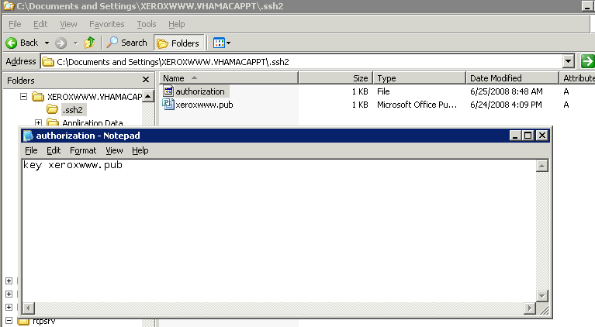

d) A copy of the client’s public key should exist in the .SSH2 folder as well as the AUTHORIZATION. file.

