Architect Interview Materials

Architect Interview Preparation: Multi-Agent AI Platform

This guide breaks down your project from high-level strategic decisions (Level 5000) to low-level code and debugging (Level 1). This structured approach demonstrates your ability to operate at all levels of the stack—a critical trait for a senior architect.

---

Level 5000: Executive & Business Impact (The "Why")

Q1: What business problem were you solving with this multi-agent platform, and why couldn't it be solved with traditional automation (e.g., RPA or basic scripting)?
- Answer: We were facing high manual overhead in delivery coordination, project tracking, and knowledge retrieval. Traditional automation (RPA) is rigid and rule-based; it fails when inputs are unstructured (like emails or scattered documentation) or when workflows require decision-making. By leveraging a multi-agent LLM system, we could process unstructured data, reason over context, and dynamically adapt workflows—resulting in a 30% reduction in manual coordination.
- Architect Rationale: Shows you understand the limitations of deterministic systems and the specific value-add of non-deterministic (LLM) systems.

Q2: How did you measure the "30% improvement in delivery productivity"? What were your KPIs?
- Answer: We measured the time spent by project managers on routine tasks: parsing emails for action items, retrieving historical project data, and generating reports. By automating the ingestion of data (like pulling emails via Gmail API) and allowing agents to classify and log RAID (Risks, Assumptions, Issues, Dependencies) items directly into our tracking systems, we reduced task completion time from hours to minutes.
- Architect Rationale: Proves you design for measurable outcomes, not just "cool tech."

---

Level 1000: System Architecture & Component Interaction (The "What")

Q3: Walk me through the high-level architecture of your multi-agent system. Why did you choose LangGraph over other orchestration frameworks like AutoGen or standard LangChain?
- Answer: The system is built on a Python backend orchestrated by LangGraph. It features several specialized agents: a RAG Agent for unstructured knowledge, a SQL Agent for structured project data, and a Workflow Agent (e.g., Email Poller) for taking action. I chose LangGraph because it models agent workflows as state machines (graphs), which provides granular control over cyclical execution, state persistence, and human-in-the-loop checkpoints, which is much harder to reliably achieve in standard linear LangChain or the highly autonomous but unpredictable AutoGen.
- Architect Rationale: Demonstrates your ability to evaluate trade-offs in modern AI orchestration tools.

Q4: How do you handle the orchestration between different agents? Does one central router control everything, or is it decentralized?
- Answer: We use a hierarchical / supervisor pattern in LangGraph. A supervisor node interprets the user intent or the trigger event (like a new email) and routes the execution to the appropriate worker agent (RAG, SQL, or Classifier). The workers execute their specialized tasks, update the shared graph state, and return control to the supervisor, which decides if the overall workflow is complete.

---

Level 500: Detailed Design & The RAG System (The "How - Conceptual")

Q5: RAG is notoriously prone to hallucinations, especially with quantitative data. How did you design your knowledge retrieval to ensure accuracy?
- Answer: I implemented a hybrid approach. For unstructured text (policies, past project summaries), we use standard vector search RAG. However, for deterministic, quantitative data (e.g., project hours, costs), RAG often hallucinates. To solve this, I designed a specialized SQL Agent. When a query involves time-phased data or aggregations, the supervisor routes it to the SQL Agent, which queries normalized tables (like `ProjectMonthlyHours`) directly. This completely eliminated quantitative hallucinations.
- Architect Rationale: Highlights a critical architectural lesson: LLMs are bad at math and aggregations. Using a SQL agent for structured data is a highly mature architectural decision.

Q6: How do you manage the "State" of a long-running multi-agent workflow?
- Answer: LangGraph natively supports state management via its `StateGraph`. We define a TypedDict that holds the context (e.g., current emails, retrieved documents, intermediate SQL results). For persistent, long-running processes (like polling for RAID items), we back this state with a database (SQLite/PostgreSQL) using LangGraph's checkpointer mechanism. This allows the system to pause, wait for external triggers, and resume without losing context.

---

Level 100: Implementation & Tooling (The "How - Technical")

Q7: Explain the workflow for your autonomous email classification and execution system.
- Answer: We implemented a Python script that polls via the Gmail API (using MCP-Gmail integration) every 5 minutes. The script passes new emails to an LLM Classifier Agent. The agent extracts entities: Project Name, RAID Type, Description, Owner, and Due Date. We enforce structured output from the LLM using JSON schemas (via Groq/OpenAI tool calling). Once parsed, a separate tool execution node validates the data and executes a SQL `INSERT` into our `RAIDitems` database table.

Q8: How do you ensure the LLM outputs exactly what your database expects?
- Answer: We rely on Function Calling / Tool Calling APIs with strict JSON schemas (Pydantic models). If the LLM misses a required field (e.g., Due Date), the system enters a self-correction loop in LangGraph: an error message is appended to the state, and the LLM is prompted to retry or extract the missing information, bounded by a maximum retry limit to prevent infinite loops.

---

Level 1: Operations, Monitoring & Debugging (The "Nitty-Gritty")

Q9: LLM calls are non-deterministic and can fail silently or become expensive. How do you monitor this platform in production?
- Answer: I integrated Langfuse SDK into our Python application. Every interaction—from the supervisor routing to the Groq/LLM API calls—is instrumented. Langfuse gives us full observability into traces, prompt inputs/outputs, latency, and token usage/costs. If an agent starts failing or taking too long, we can drill down into the specific trace to see exactly which prompt or context retrieval caused the issue.

Q10: What happens if the Gmail API goes down or rate-limits you during the workflow? How is your system resilient?
- Answer: The system uses standard distributed system resilience patterns. The polling mechanism implements exponential backoff for API rate limits. Because our agent workflow state is persisted (via LangGraph checkpoints), if a tool execution fails halfway through processing an email, the state is saved. We can resume the graph execution exactly from the failed node once the external API recovers, ensuring no data loss.

---

Tips for the Interview:
1. Drive the Narrative: When asked about the project, start at Level 5000 (We saved 30% time) and only drill down to Level 100 (Pydantic, SQL Agents) when asked or to prove deep technical competence.
2. Acknowledge Trade-offs: Be ready to talk about what *didn't* work (e.g., "Initially we tried to use RAG for everything, but it hallucinated numbers, so we architected a SQL agent..."). Architects love hearing about mistakes and course corrections.
3. Emphasize Structure: Emphasize that LLMs are chaotic, and your architecture (LangGraph, Function Calling, Langfuse) is designed to put "guardrails" around that chaos.

Platform Architecture Diagram

This artifact provides a visual architecture diagram of the multi-agent AI platform, illustrating the interplay between the orchestration layer, various specialized agents, inference engines, and data stores.

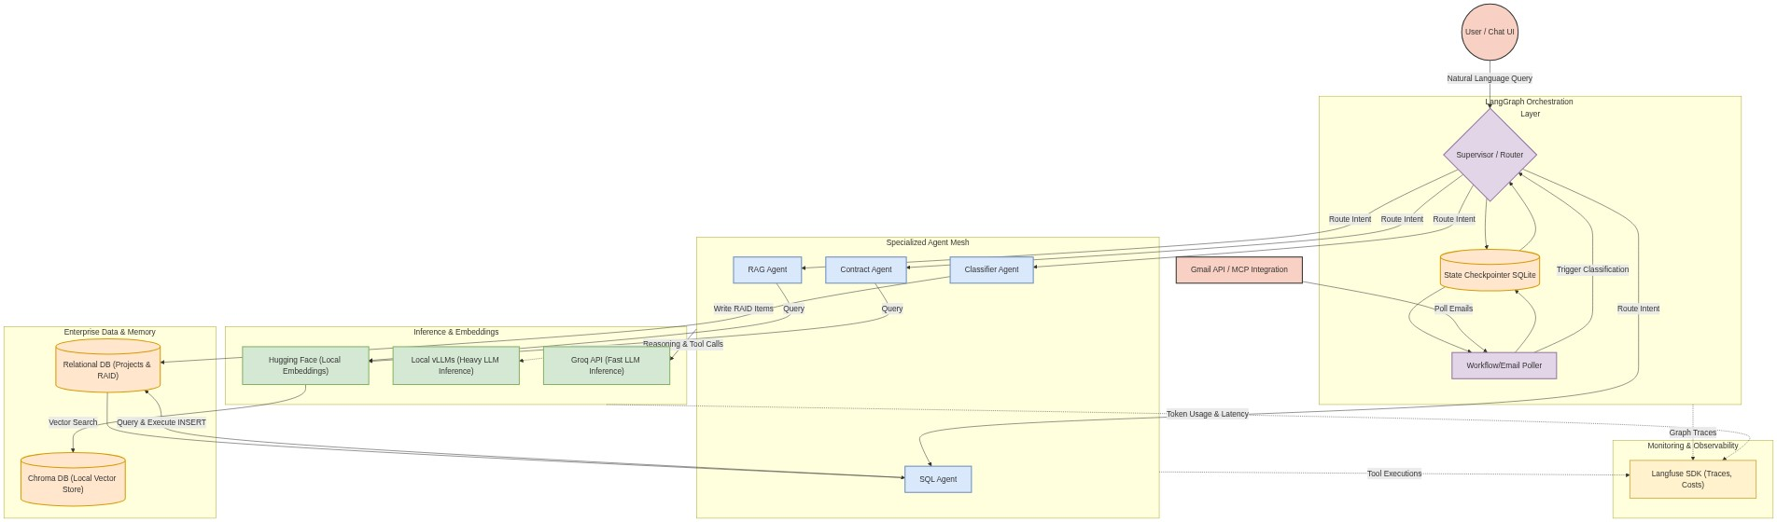

Component Breakdown

1. External Triggers: The system responds to direct user queries (chat UI) or asynchronous background events (e.g., polling Gmail for new project emails).
2. Orchestration (LangGraph): The `Supervisor` node directs traffic to the appropriate agent. The `State Checkpointer` ensures long-running tasks can pause and resume, maintaining a resilient graph state.
3. Agent Mesh: Specialized workers. For instance, the `SQL Agent` handles deterministic time-phased data to prevent hallucinations, while the `Contract Agent` focuses on unstructured terms and conditions.
4. Inference & Embeddings:
- Groq: Used for rapid reasoning, routing, and function/tool calling.
- vLLMs: Used for heavier, locally-hosted LLM generation if needed.
- Hugging Face: Runs locally to generate embeddings for enterprise documents without sending sensitive data to external APIs.
5. Data Stores:
- SQLite/Relational DB: Houses structured deterministic data (e.g., `ProjectMonthlyHours`, `RAIDitems`).
- Chroma DB: Locally hosted vector store that holds embedded chunks of unstructured data (policies, SOWs).
6. Observability (Langfuse): Instruments every layer to track prompt iterations, tool failures, latency, and operational token costs.

