Azure Monitor

Two types: metrics and logs

Metrics: time sampled numeric data (cpu usage, data ingress or egress)

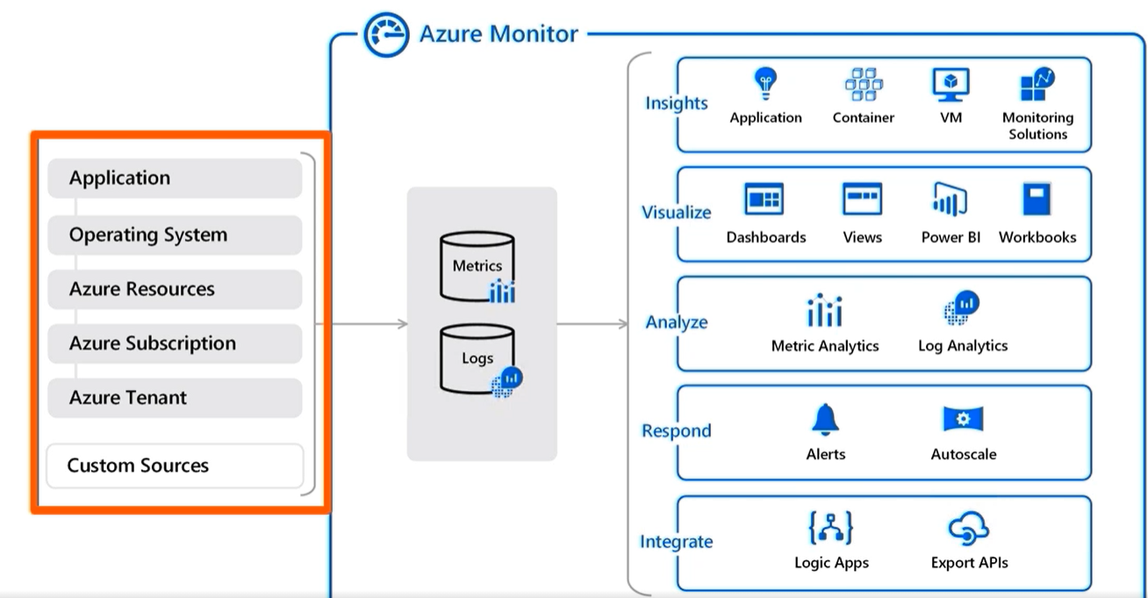

Log analytics for diagnostic data, event hubs and storage account (for long term)

For vms you can diagnostic extension. Captures sys logs, events, etc.. (only works for azure vms)

Alternatively, can use log analytics agent for any vm

Azure log analytics == Azure monitor logs

Use KQL (their log search language) to retrieve data from azure log analytics

