1/27/2021

**Microsoft Azure Cloud Concepts**

**Intro to Cloud Computing**

Many consumers use the same physical resources. Cloud virtualization splits hardware between clients.

CAPEX – Capital expenditures are depreciated over the useful life of the asset. Cannot deduct expense from fiscal year

OPEX – Operating expenses are deducted from current year

Plans allow you to save if you plan to have server up for 3, 5 years. VMs can expand resources as needed.

Cloud providers take care of High Availability and Disaster Recovery. HA refers to server outages, failures. DR refers to recovery from natural disasters. Also has fault tolerance. These do increase costs. Split servers between multiple regions can increase availability (like if Florida goes under water, you could have a backup in Kansas…).

**Types of Cloud Computing Services** 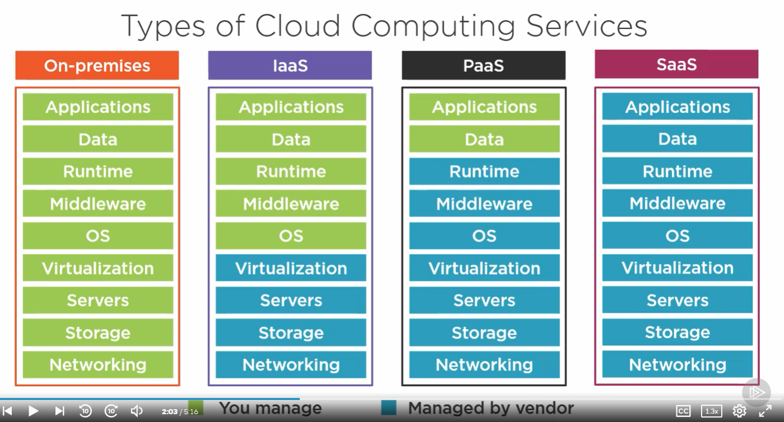

IaaS: Great for development – turn on services with ease, turn them off when you don’t need them. Pay for the resources/time you use.

PaaS: For development, build components using built in tools/templates

SaaS: Access to tools without any overhead (think using Gmail).

**Cloud Deployments**

Public cloud (Azure) – Cloud service provided to multiple clients, sharing the same hardware on the backend/

Private cloud – Hardware is used only by a single client, often owned by same company.

Hybrid Cloud – Combination of public and private with orchestration between the two

Community Cloud – Infrastructure shared with several orgs with shared concerns.

Azure is a Public Cloud generally but has options to run Azure on a Private Cloud. Allowing easy transfer of on-premise resources to Azure cloud.

It has a cloud offering for Governments, Azure Government, that handles specific Government requirements. Exists in separate data centers than the plebian resources.