**SET 1**

SQL> CREATE TABLE EMP(Empno NUMBER(10) PRIMARY KEY,Ename VARCHAR2(25),Job VARCHAR2(12),Salary NUMBER(10,2),Commission NUMBER(7,2),Deptno NUMBER(2));

Table created.

SQL> DESC Emp;

Name Null? Type

----------------------------------------- -------- ----------------------------

EMPNO NOT NULL NUMBER(10)

ENAME VARCHAR2(25)

JOB VARCHAR2(12)

SALARY NUMBER(10,2)

COMMISSION NUMBER(7,2)

DEPTNO NUMBER(2)

SQL> INSERT INTO Emp ValUES(&Empno,'&Ename','&Job',&Salary,&Commission,&deptno);

Enter value for empno: 101

Enter value for ename: Keerthana

Enter value for job: clerk

Enter value for salary: 5900

Enter value for commission: 500

Enter value for deptno: 4

old 1: INSERT INTO Emp ValUES(&Empno,'&Ename','&Job',&Salary,&Commission,&deptno)

new 1: INSERT INTO Emp ValUES(101,'Keerthana','clerk',5900,500,4)

1 row created.

SQL> /

Enter value for empno: Lakshmi

Enter value for ename: 790

Enter value for job: 76

Enter value for salary: 876

Enter value for commission: 445

Enter value for deptno: 334

old 1: INSERT INTO Emp ValUES(&Empno,'&Ename','&Job',&Salary,&Commission,&deptno)

new 1: INSERT INTO Emp ValUES(Lakshmi,'790','76',876,445,334)

INSERT INTO Emp ValUES(Lakshmi,'790','76',876,445,334)

*

ERROR at line 1:

ORA-00984: column not allowed here

SQL> /

Enter value for empno: 102

Enter value for ename: Lakshmi

Enter value for job: Manager

Enter value for salary: 6000

Enter value for commission: 700

Enter value for deptno: 3

old 1: INSERT INTO Emp ValUES(&Empno,'&Ename','&Job',&Salary,&Commission,&deptno)

new 1: INSERT INTO Emp ValUES(102,'Lakshmi','Manager',6000,700,3)

1 row created.

SQL> /

Enter value for empno: 103

Enter value for ename: Kavya

Enter value for job: Teacher

Enter value for salary: 5600

Enter value for commission: 400

Enter value for deptno: 5

old 1: INSERT INTO Emp ValUES(&Empno,'&Ename','&Job',&Salary,&Commission,&deptno)

new 1: INSERT INTO Emp ValUES(103,'Kavya','Teacher',5600,400,5)

1 row created.

SQL> SET LINESIZE 1000

SQL> SELECT * FROM Emp;

EMPNO ENAME JOB SALARY COMMISSION DEPTNO

---------- ------------------------- ------------ ---------- ---------- ----------

101 Keerthana clerk 5900 500 4

102 Lakshmi Manager 6000 700 3

103 Kavya Teacher 5600 400 5

SQL> INSERT INTO Emp ValUES(&Empno,'&Ename','&Job',&Salary,&Commission,&deptno);

Enter value for empno: 105

Enter value for ename: Rani

Enter value for job: NULL

Enter value for salary: 6700

Enter value for commission: 600

Enter value for deptno: 4

old 1: INSERT INTO Emp ValUES(&Empno,'&Ename','&Job',&Salary,&Commission,&deptno)

new 1: INSERT INTO Emp ValUES(105,'Rani','NULL',6700,600,4)

1 row created.

SQL> SELECT * FROM Emp;

EMPNO ENAME JOB SALARY COMMISSION DEPTNO

---------- ------------------------- ------------ ---------- ---------- ----------

101 Keerthana clerk 5900 500 4

102 Lakshmi Manager 6000 700 3

103 Kavya Teacher 5600 400 5

105 Rani NULL 6700 600 4

SQL> INSERT INTO Emp ValUES(&Empno,'&Ename','&Job',&Salary,&Commission,&deptno);

Enter value for empno: 106

Enter value for ename: Raji

Enter value for job: analyst

Enter value for salary: 7000

Enter value for commission: 560

Enter value for deptno: 6

old 1: INSERT INTO Emp ValUES(&Empno,'&Ename','&Job',&Salary,&Commission,&deptno)

new 1: INSERT INTO Emp ValUES(106,'Raji','analyst',7000,560,6)

1 row created.

SQL> SELECT * FROM Emp;

EMPNO ENAME JOB SALARY COMMISSION DEPTNO

---------- ------------------------- ------------ ---------- ---------- ----------

101 Keerthana clerk 5900 500 4

102 Lakshmi Manager 6000 700 3

103 Kavya Teacher 5600 400 5

105 Rani NULL 6700 600 4

106 Raji analyst 7000 560 6

SQL> UPDATE Emp SET Job='CLERK' WHERE Job='NULL';

1 row updated.

SQL> SELECT * FROM Emp;

EMPNO ENAME JOB SALARY COMMISSION DEPTNO

---------- ------------------------- ------------ ---------- ---------- ----------

101 Keerthana clerk 5900 500 4

102 Lakshmi Manager 6000 700 3

103 Kavya Teacher 5600 400 5

105 Rani CLERK 6700 600 4

106 Raji analyst 7000 560 6

SQL> UPDATE Emp SET Job='data analyst' WHERE Job='analyst';

1 row updated.

SQL> SELECT * FROM Emp;

EMPNO ENAME JOB SALARY COMMISSION DEPTNO

---------- ------------------------- ------------ ---------- ---------- ----------

101 Keerthana clerk 5900 500 4

102 Lakshmi Manager 6000 700 3

103 Kavya Teacher 5600 400 5

105 Rani CLERK 6700 600 4

106 Raji data analyst 7000 560 6

SQL> ALTER TABLE Emp ADD(doj DATE);

Table altered.

SQL> UPDATE Emp SET doj='17-DEC-80' WHERE doj IS NULL;

5 rows updated.

SQL> SELECT * FROM Emp;

EMPNO ENAME JOB SALARY COMMISSION DEPTNO DOJ

---------- ------------------------- ------------ ---------- ---------- ---------- ---------

101 Keerthana clerk 5900 500 4 17-DEC-80

102 Lakshmi Manager 6000 700 3 17-DEC-80

103 Kavya Teacher 5600 400 5 17-DEC-80

105 Rani CLERK 6700 600 4 17-DEC-80

106 Raji data analyst 7000 560 6 17-DEC-80

SQL> SELECT DISTINCT Job FROM Emp;

JOB

------------

Manager

data analyst

CLERK

clerk

Teacher

SQL> SELECT Empno,Ename,Job FROM Emp;

EMPNO ENAME JOB

---------- ------------------------- ------------

101 Keerthana clerk

102 Lakshmi Manager

103 Kavya Teacher

105 Rani CLERK

106 Raji data analyst

SQL> SELECT Ename FROM Emp WHERE deptno=3 OR deptno=5;

ENAME

-------------------------

Lakshmi

Kavya

SQL> SELECT SUM(Salary) FROM Emp;

SUM(SALARY)

-----------

31200

SQL> SELECT Ename,SUM(Salary+Commission) FROM Emp GROUP BY Ename;

ENAME SUM(SALARY+COMMISSION)

------------------------- ----------------------

Keerthana 6400

Lakshmi 6700

Kavya 6000

Raji 7560

Rani 7300

SQL> SELECT Job,SUM(Salary) FROM Emp GROUP BY JOB;

JOB SUM(SALARY)

------------ -----------

Manager 6000

data analyst 7000

CLERK 6700

clerk 5900

Teacher 5600

**Aggregate Functions**

**Create table called EMP1**

SQL> CREATE TABLE EMP1(Eid NUMBER PRIMARY KEY,Ename VARCHAR(20),Age NUMBER,Salary NUMBER);

Table created.

SQL> INSERT INTO EMP1 VALUES(&Eid,'&Ename',&Age,&Salary);

Enter value for eid: 101

Enter value for ename: Kuttuz

Enter value for age: 34

Enter value for salary: 6700

old 1: INSERT INTO EMP1 VALUES(&Eid,'&Ename',&Age,&Salary)

new 1: INSERT INTO EMP1 VALUES(101,'Kuttuz',34,6700)

1 row created.

SQL> /

Enter value for eid: 102

Enter value for ename: Lakshmi

Enter value for age: 25

Enter value for salary: 7000

old 1: INSERT INTO EMP1 VALUES(&Eid,'&Ename',&Age,&Salary)

new 1: INSERT INTO EMP1 VALUES(102,'Lakshmi',25,7000)

1 row created.

SQL> /

Enter value for eid: 103

Enter value for ename: Merin

Enter value for age: 45

Enter value for salary: 7800

old 1: INSERT INTO EMP1 VALUES(&Eid,'&Ename',&Age,&Salary)

new 1: INSERT INTO EMP1 VALUES(103,'Merin',45,7800)

1 row created.

SQL> SELECT * FROM EMP1;

EID ENAME AGE SALARY

---------- -------------------- ---------- ----------

101 Kuttuz 34 6700

102 Lakshmi 25 7000

103 Merin 45 7800

SQL> SELECT COUNT(Eid) FROM EMP1;

COUNT(EID)

----------

3

SQL> SELECT MAX(Age) FROM EMP1;

MAX(AGE)

----------

45

SQL> SELECT MIN(Age) FROM EMP1;

MIN(AGE)

----------

25

SQL> SELECT SUM(Salary) FROM EMP1;

SUM(SALARY)

-----------

21500

SQL> SELECT AVG(Salary) FROM EMP1;

AVG(SALARY)

-----------

7166.66667

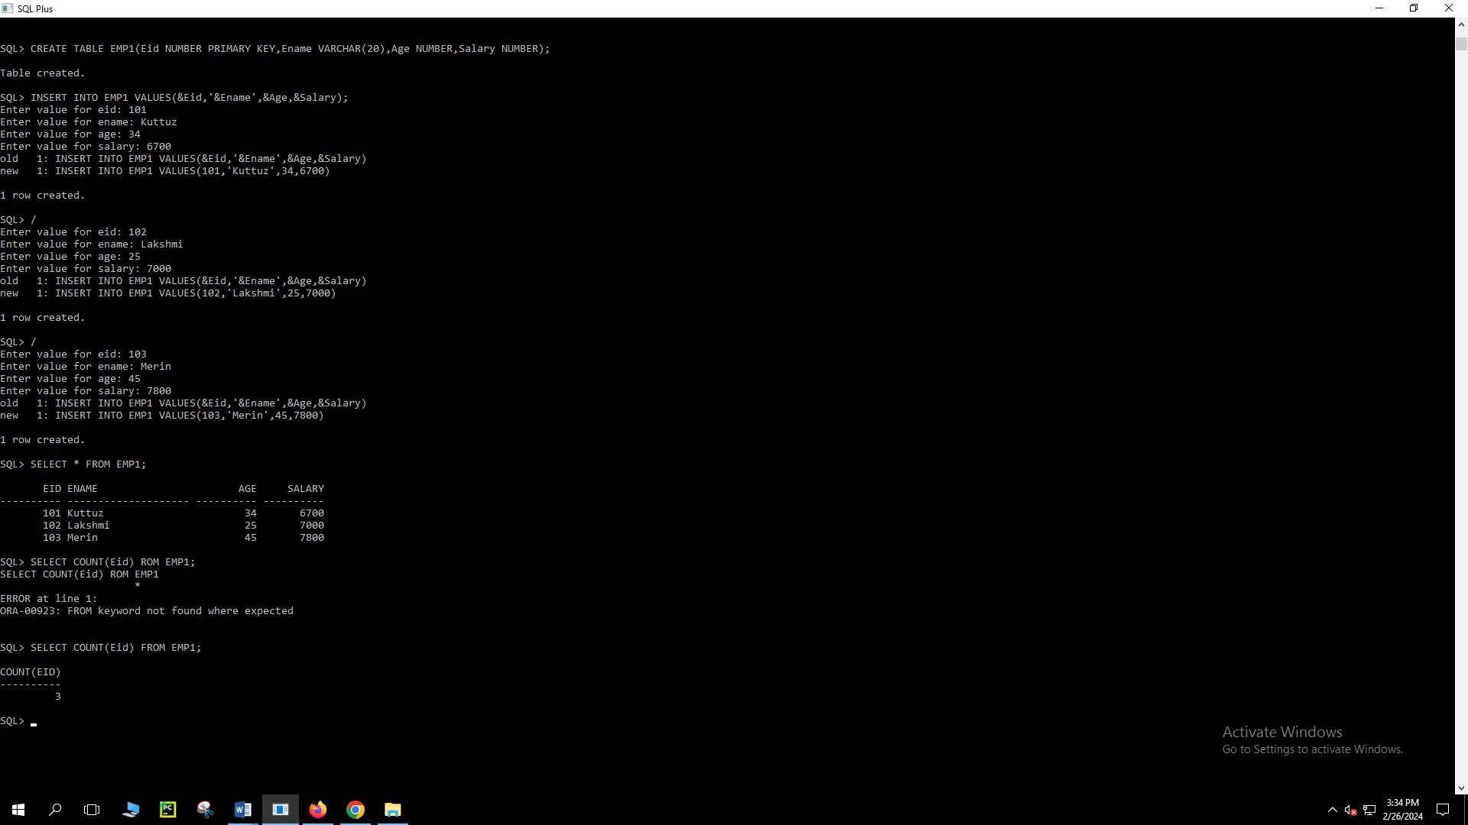

**VIEW**

SQL> CREATE OR REPLACE VIEW EMP1View AS SELECT Ename,Age FROM EMP1;

View created.

SQL> CREATE OR REPLACE VIEW EView AS SELECT Eid,Ename,Salary FROM EMP1;

View created.

SQL> SELECT Ename,Salary FROM EMP1 ORDER BY Salary DESC;

ENAME SALARY

-------------------- ----------

Merin 7800

Lakshmi 7000

Kuttuz 6700

SQL> SELECT Ename FROM EMP1 ORDER BY Age;

ENAME

--------------------

Lakshmi

Kuttuz

Merin

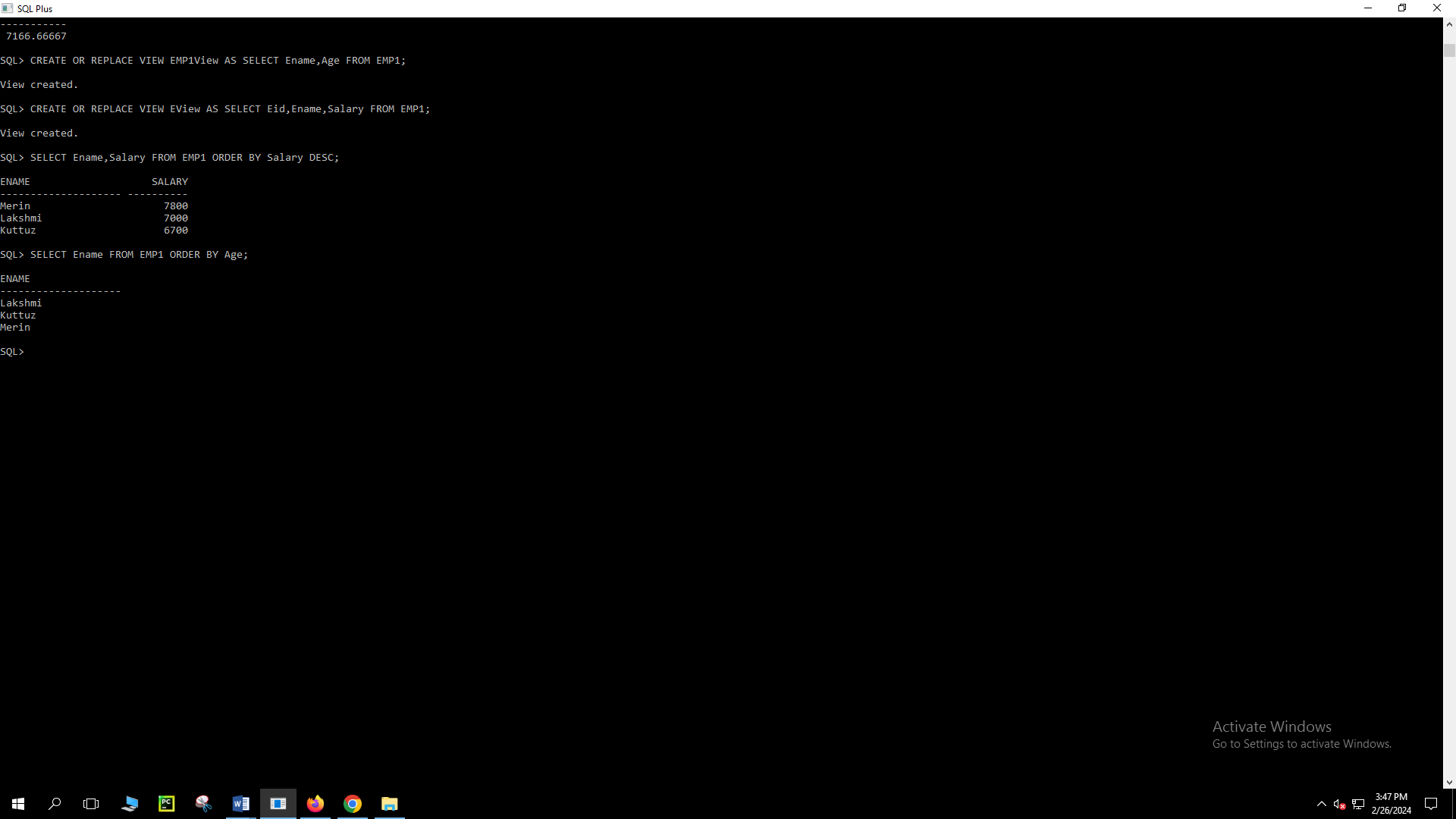

**Create table called Sailors,Boats,Reservers:**

SQL> CREATE TABLE Sailors(Sid NUMBER PRIMARY KEY,Sname VARCHAR(20),Rating NUMBER,Age NUMBER);

Table created.

SQL> CREATE TABLE BOATS(Bid NUMBER PRIMARY KEY,Bname VARCHAR(20),Color VARCHAR(20));

Table created.

SQL> CREATE TABLE Reservers(Sid NUMBER REFERENCES Sailors(Sid),Bid NUMBER REFERENCES Boats(Bid),Day DATE);

Table created.

SQL> INSERT INTO Sailors VALUES(&Sid,'&Sname',&Rating,&Age);

Enter value for sid: 22

Enter value for sname: Dustin

Enter value for rating: 7

Enter value for age: 45

old 1: INSERT INTO Sailors VALUES(&Sid,'&Sname',&Rating,&Age)

new 1: INSERT INTO Sailors VALUES(22,'Dustin',7,45)

1 row created.

SQL> /

Enter value for sid: 29

Enter value for sname: Brutas

Enter value for rating: 1

Enter value for age: 33

old 1: INSERT INTO Sailors VALUES(&Sid,'&Sname',&Rating,&Age)

new 1: INSERT INTO Sailors VALUES(29,'Brutas',1,33)

1 row created.

SQL> /

Enter value for sid: 31

Enter value for sname: Lubber

Enter value for rating: 8

Enter value for age: 55

old 1: INSERT INTO Sailors VALUES(&Sid,'&Sname',&Rating,&Age)

new 1: INSERT INTO Sailors VALUES(31,'Lubber',8,55)

1 row created.

SQL> /

Enter value for sid: 32

Enter value for sname: Andy

Enter value for rating: 8

Enter value for age: 25

old 1: INSERT INTO Sailors VALUES(&Sid,'&Sname',&Rating,&Age)

new 1: INSERT INTO Sailors VALUES(32,'Andy',8,25)

1 row created.

SQL> /

Enter value for sid: 58

Enter value for sname: Rusty

Enter value for rating: 10

Enter value for age: 35

old 1: INSERT INTO Sailors VALUES(&Sid,'&Sname',&Rating,&Age)

new 1: INSERT INTO Sailors VALUES(58,'Rusty',10,35)

1 row created.

SQL> /

Enter value for sid: 64

Enter value for sname: Horatio

Enter value for rating: 7

Enter value for age: 35

old 1: INSERT INTO Sailors VALUES(&Sid,'&Sname',&Rating,&Age)

new 1: INSERT INTO Sailors VALUES(64,'Horatio',7,35)

1 row created.

SQL> /

Enter value for sid: 71

Enter value for sname: Zorba

Enter value for rating: 10

Enter value for age: 16

old 1: INSERT INTO Sailors VALUES(&Sid,'&Sname',&Rating,&Age)

new 1: INSERT INTO Sailors VALUES(71,'Zorba',10,16)

1 row created.

SQL> /

Enter value for sid: 74

Enter value for sname: Horatio

Enter value for rating: 9

Enter value for age: 35

old 1: INSERT INTO Sailors VALUES(&Sid,'&Sname',&Rating,&Age)

new 1: INSERT INTO Sailors VALUES(74,'Horatio',9,35)

1 row created.

SQL> /

Enter value for sid: 85

Enter value for sname: Art

Enter value for rating: 3

Enter value for age: 26

old 1: INSERT INTO Sailors VALUES(&Sid,'&Sname',&Rating,&Age)

new 1: INSERT INTO Sailors VALUES(85,'Art',3,26)

1 row created.

SQL> /

Enter value for sid: 95

Enter value for sname: Bob

Enter value for rating: 64

Enter value for age: 64

old 1: INSERT INTO Sailors VALUES(&Sid,'&Sname',&Rating,&Age)

new 1: INSERT INTO Sailors VALUES(95,'Bob',64,64)

1 row created.

SQL> SELECT * FROM Sailors;

SID SNAME RATING AGE

---------- -------------------- ---------- ----------

22 Dustin 7 45

29 Brutas 1 33

31 Lubber 8 55

32 Andy 8 25

58 Rusty 10 35

64 Horatio 7 35

71 Zorba 10 16

74 Horatio 9 35

85 Art 3 26

95 Bob 64 64

10 rows selected.

SQL> INSERT INTO Boats VALUES(&Bid,'&Bname','&Color');

Enter value for bid: 101

Enter value for bname: Interlake

Enter value for color: Blue

old 1: INSERT INTO Boats VALUES(&Bid,'&Bname','&Color')

new 1: INSERT INTO Boats VALUES(101,'Interlake','Blue')

1 row created.

SQL> /

Enter value for bid: 102

Enter value for bname: Interlake

Enter value for color: Red

old 1: INSERT INTO Boats VALUES(&Bid,'&Bname','&Color')

new 1: INSERT INTO Boats VALUES(102,'Interlake','Red')

1 row created.

SQL> /

Enter value for bid: 103

Enter value for bname: Clipper

Enter value for color: Green

old 1: INSERT INTO Boats VALUES(&Bid,'&Bname','&Color')

new 1: INSERT INTO Boats VALUES(103,'Clipper','Green')

1 row created.

SQL> /

Enter value for bid: 104

Enter value for bname: Marine

Enter value for color: Red

old 1: INSERT INTO Boats VALUES(&Bid,'&Bname','&Color')

new 1: INSERT INTO Boats VALUES(104,'Marine','Red')

1 row created.

SQL> SELECT * FROM Boats;

BID BNAME COLOR

---------- -------------------- --------------------

101 Interlake Blue

102 Interlake Red

103 Clipper Green

104 Marine Red

SQL> INSERT INTO Reservers VALUES(&Sid,&Bid,'&Day');

Enter value for sid: 22

Enter value for bid: 101

Enter value for day: 10-OCT-98

old 1: INSERT INTO Reservers VALUES(&Sid,&Bid,'&Day')

new 1: INSERT INTO Reservers VALUES(22,101,'10-OCT-98')

1 row created.

SQL> /

Enter value for sid: 22

Enter value for bid: 102

Enter value for day: 10-OCT-98

old 1: INSERT INTO Reservers VALUES(&Sid,&Bid,'&Day')

new 1: INSERT INTO Reservers VALUES(22,102,'10-OCT-98')

1 row created.

SQL> /

Enter value for sid: 22

Enter value for bid: 103

Enter value for day: 10-AUG-98

old 1: INSERT INTO Reservers VALUES(&Sid,&Bid,'&Day')

new 1: INSERT INTO Reservers VALUES(22,103,'10-AUG-98')

1 row created.

SQL> /

Enter value for sid: 22

Enter value for bid: 104

Enter value for day: 10-JUL-98

old 1: INSERT INTO Reservers VALUES(&Sid,&Bid,'&Day')

new 1: INSERT INTO Reservers VALUES(22,104,'10-JUL-98')

1 row created.

SQL> /

Enter value for sid: 31

Enter value for bid: 102

Enter value for day: 11-OCT-98

old 1: INSERT INTO Reservers VALUES(&Sid,&Bid,'&Day')

new 1: INSERT INTO Reservers VALUES(31,102,'11-OCT-98')

1 row created.

SQL> /

Enter value for sid: 31

Enter value for bid: 103

Enter value for day: 11-JUN-98

old 1: INSERT INTO Reservers VALUES(&Sid,&Bid,'&Day')

new 1: INSERT INTO Reservers VALUES(31,103,'11-JUN-98')

1 row created.

SQL> /

Enter value for sid: 31

Enter value for bid: 104

Enter value for day: 11-DEC-98

old 1: INSERT INTO Reservers VALUES(&Sid,&Bid,'&Day')

new 1: INSERT INTO Reservers VALUES(31,104,'11-DEC-98')

1 row created.

SQL> /

Enter value for sid: 64

Enter value for bid: 101

Enter value for day: 9-MAY-98

old 1: INSERT INTO Reservers VALUES(&Sid,&Bid,'&Day')

new 1: INSERT INTO Reservers VALUES(64,101,'9-MAY-98')

1 row created.

SQL> /

Enter value for sid: 64

Enter value for bid: 102

Enter value for day: 9-AUG-98

old 1: INSERT INTO Reservers VALUES(&Sid,&Bid,'&Day')

new 1: INSERT INTO Reservers VALUES(64,102,'9-AUG-98')

1 row created.

SQL> /

Enter value for sid: 74

Enter value for bid: 103

Enter value for day: 9-AUG-98

old 1: INSERT INTO Reservers VALUES(&Sid,&Bid,'&Day')

new 1: INSERT INTO Reservers VALUES(74,103,'9-AUG-98')

1 row created.

SQL> SELECT * FROM Reservers;

SID BID DAY

---------- ---------- ---------

22 101 10-OCT-98

22 102 10-OCT-98

22 103 10-AUG-98

22 104 10-JUL-98

31 102 11-OCT-98

31 103 11-JUN-98

31 104 11-DEC-98

64 101 09-MAY-98

64 102 09-AUG-98

74 103 09-AUG-98

10 rows selected.

**1. Find the names and ages of all sailors**

SQL> SELECT Sname,Age FROM Sailors;

SNAME AGE

-------------------- ----------

Dustin 45

Brutas 33

Lubber 55

Andy 25

Rusty 35

Horatio 35

Zorba 16

Horatio 35

Art 26

Bob 64

10 rows selected.

**2. Find all information of sailors who have reserved boat number 101.**

SQL> SELECT * FROM Sailors WHERE Sid IN(SELECT Sid FROM Reservers WHERE bid=101);

SID SNAME RATING AGE

---------- -------------------- ---------- ----------

22 Dustin 7 45

64 Horatio 7 35

**3. Find all sailors with rating above 7**

SQL> SELECT * FROM Sailors WHERE Rating>7;

SID SNAME RATING AGE

---------- -------------------- ---------- ----------

31 Lubber 8 55

32 Andy 8 25

58 Rusty 10 35

71 Zorba 10 16

74 Horatio 9 35

95 Bob 64 64

6 rows selected.

**4. Find the names of sailors who have reserved boat no 103**

SQL> SELECT Sname FROM Sailors WHERE Sid IN(SELECT Sid FROM Reservers WHERE bid=103);

SNAME

--------------------

Dustin

Lubber

Horatio

**5. Find the names of sailors who have reserved a red boat, and list in the order of age.**

SQL> SELECT Sname FROM Sailors WHERE Sid IN(SELECT Sid FROM Reservers WHERE Bid IN(SELECT Bid FROM Boats WHERE Color='Red'))ORDER BY age;

SNAME

--------------------

Horatio

Dustin

Lubber

**6. Find the names of sailors who have reserved either a red or green boat**

**7. Find the colors of boats reserved by “Lubber”.**

**8. Find the names of sailors who have reserved both red and green boats**

**9. Find the names of sailors who have reserved at least one boat**

**10. Find the ids and names of sailors who have reserved two different boats on the same day.**

**11. Find the name and the age of the youngest sailor.**

**12. Find the names and ratings of a sailor whose rating is better than some sailor called**

**Horatio.**

**13. Find the names of sailors who have reserved all boats.**

**14. Count the number of different sailor names.**

**15. Calculate the average age of all sailors.**

**16. Find the average age of sailors for each rating level.**

**17. Find the average age of sailors for each rating level that has at least two sailors.**

