**Create table customer**

CREATE TABLE CUSTOMER(Cust_name VARCHAR2(20),Cust_street VARCHAR2(20),Cust_city VARCHAR2(20));

INSERT INTO CUSTOMER VALUES('&Cust_name','&Cust_street','&Cust_city');

ALTER TABLE CUSTOMER ADD(Salary NUMBER(10));

SELECT FROM CUSTOMER;

ALTER TABLE CUSTOMER ADD(Salary NUMBER(10));

ALTER TABLE CUSTOMER DROP COLUMN Salary;

DELETE CUSTOMER WHERE Cust_city='Hyd';





**SET 1**

1. CREATE TABLE Emp(Empno NUMBER(10) PRIMARY KEY,Ename VARCHAR2(25),Job VARCHAR2(12),Salary NUMBER(10,2),Commission NUMBER(7,2),Deptno NUMBER(2));

DESC Emp;

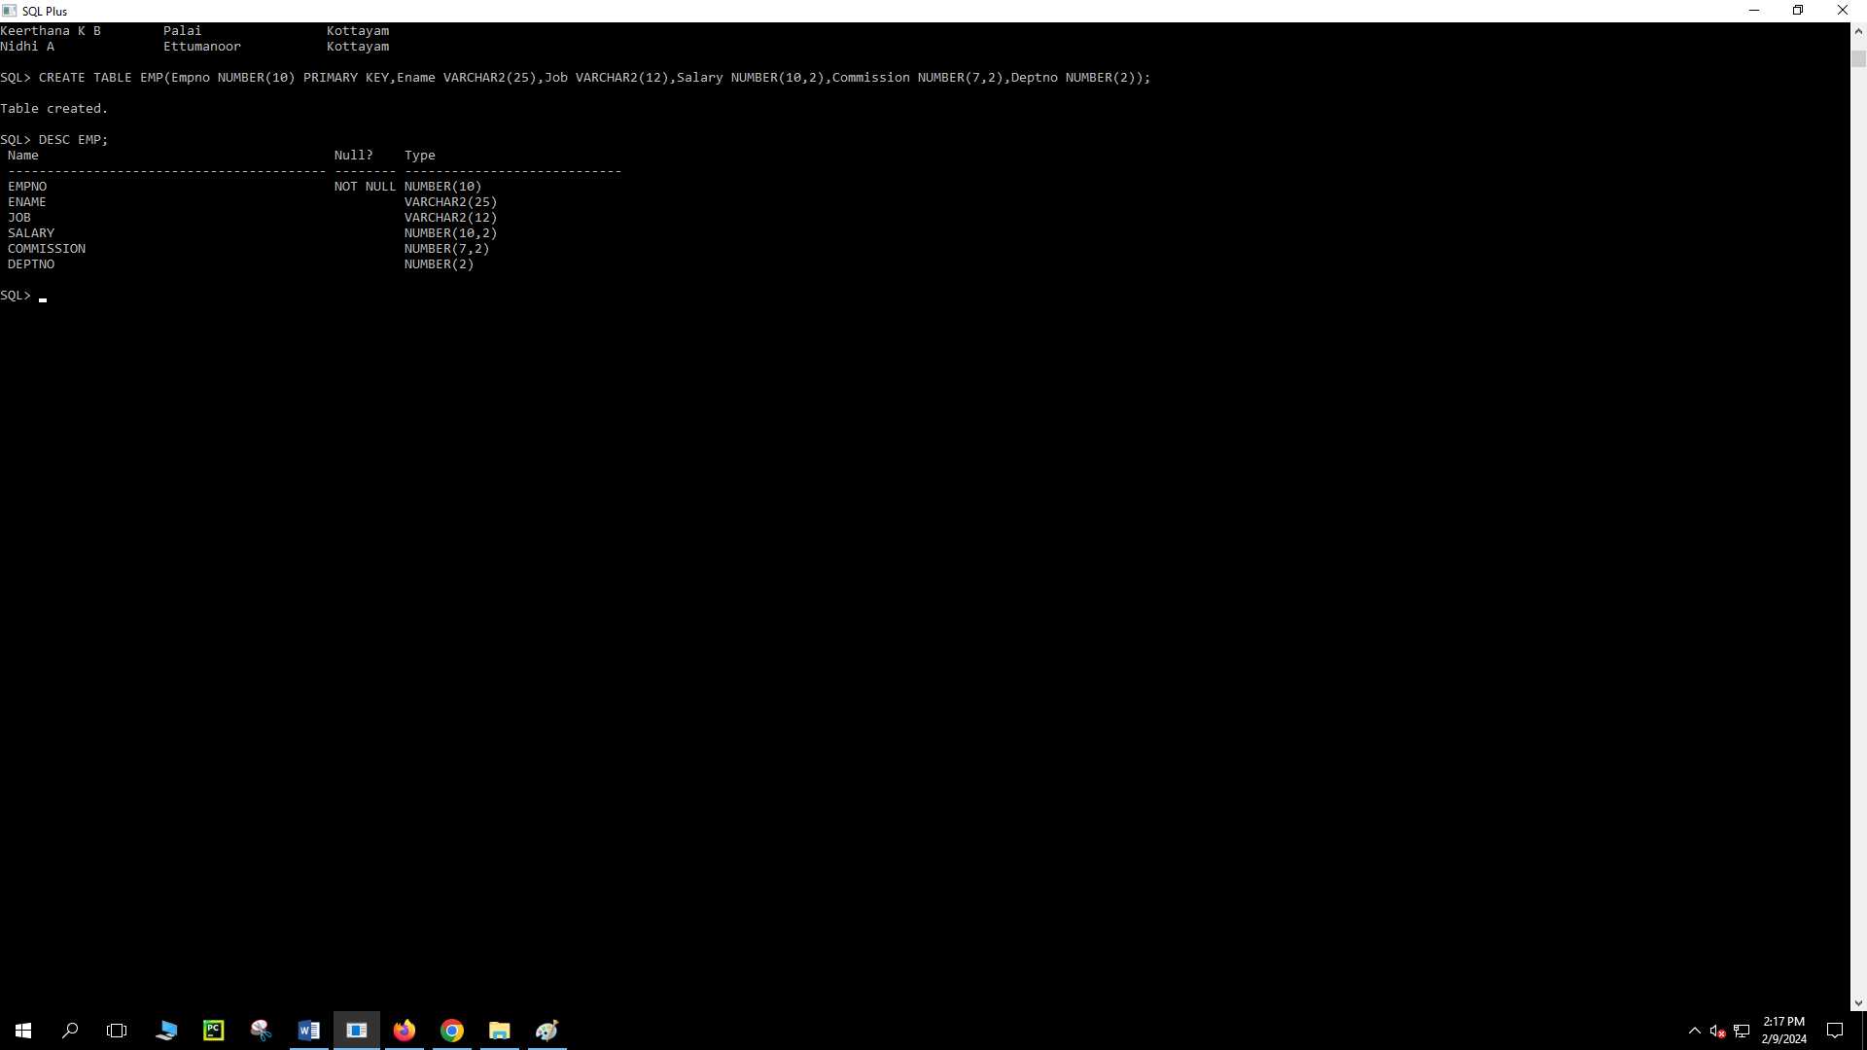

INSERT INTO Emp ValUES(&Empno,'&Ename','&Job',&Salary,&Commission,&deptno);

SELECT * FROM Emp;



UPDATE Emp SET Job='CLERK' WHERE Job='NULL';

UPDATE Emp SET Job='data analyst' WHERE Job='analyst';

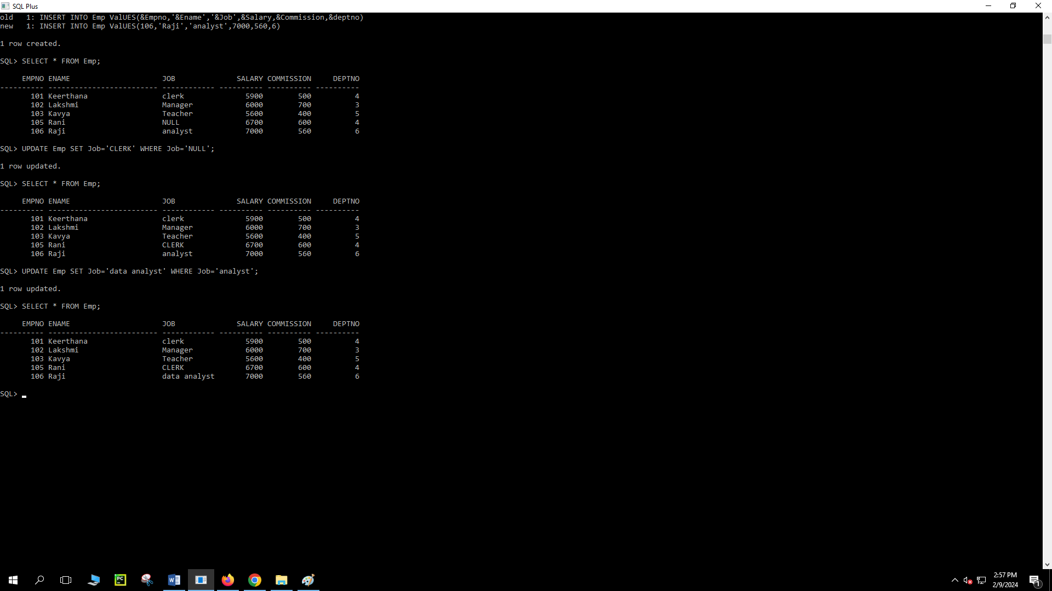

ALTER TABLE Emp ADD(doj DATE);

UPDATE Emp SET doj='17-DEC-80' WHERE doj IS NULL;

SELECT DISTINCT Job FROM Emp;

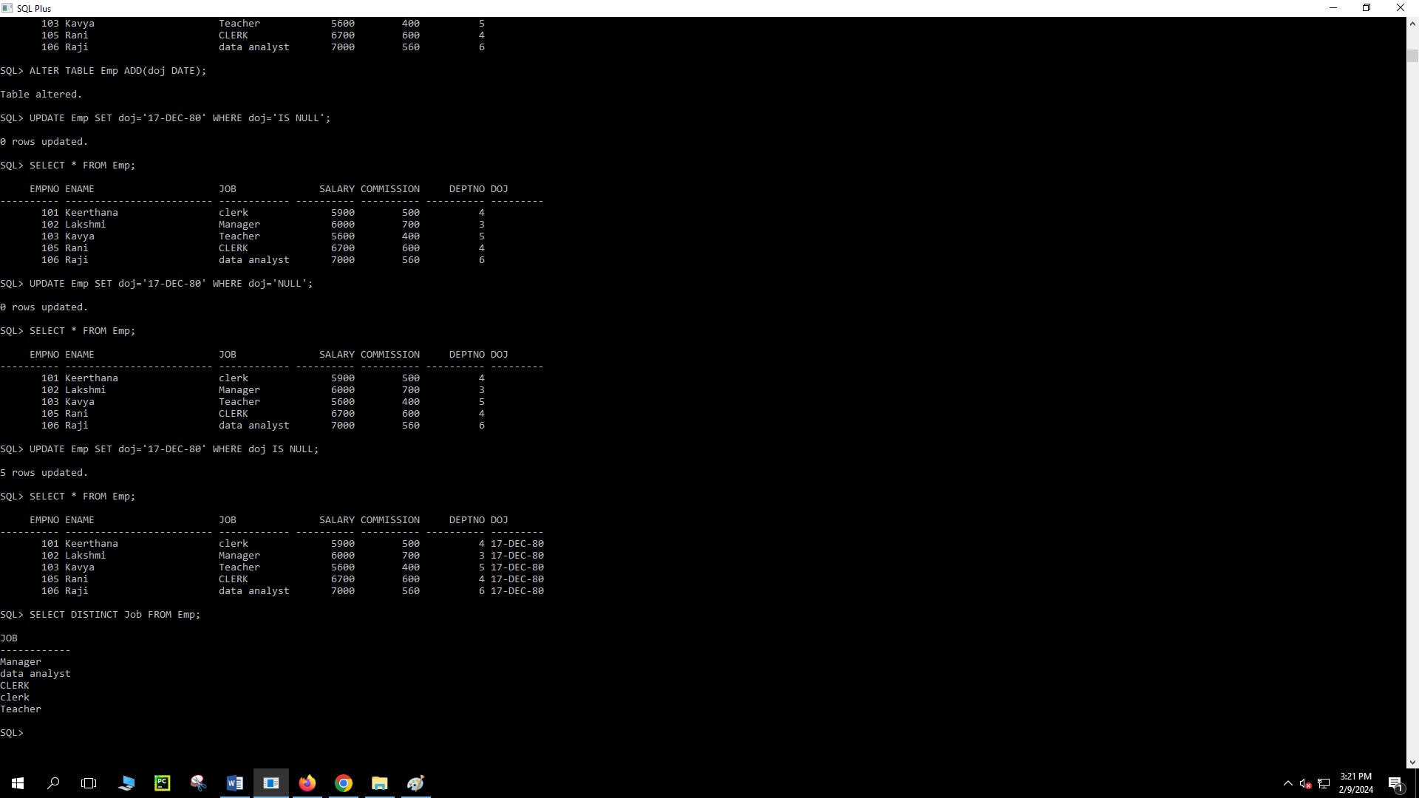

SELECT Empno,Ename,Job FROM Emp;

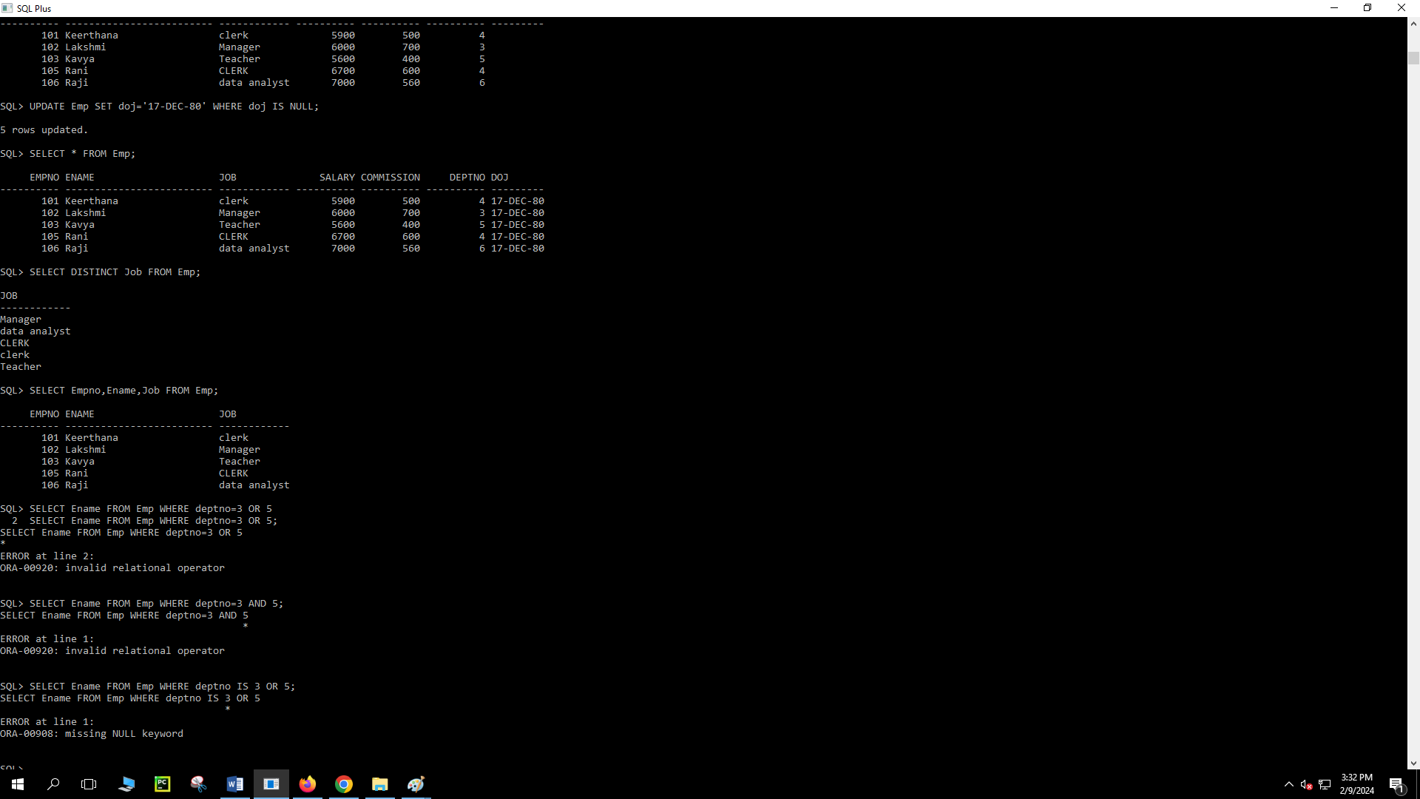

SELECT Ename FROM Emp WHERE deptno=3 OR deptno=5;



SQL> SELECT Ename FROM Emp WHERE deptno=3 OR deptno=5;

ENAME

-------------------------

Lakshmi

Kavya

SQL> SELECT SUM(Salary) FROM Emp;

SUM(SALARY)

-----------

31200

SQL> SELECT Ename,SUM(Salary+Commission) FROM Emp GROUP BY Ename;

ENAME SUM(SALARY+COMMISSION)

------------------------- ----------------------

Keerthana 6400

Lakshmi 6700

Kavya 6000

Raji 7560

Rani 7300

SQL> CREATE TABLE MPP(Empno NUMBER(10) PRIMARY KEY,Ename VARCHAR2(25),Job VARCHAR2(12),Salary NUMBER(10,2),Commission NUMBER(7,2),Deptno NUMBER(2));

Table created.

SQL> DESC Emp;

Name Null? Type

----------------------------------------- -------- ----------------------------

EMPNO NOT NULL NUMBER(10)

ENAME VARCHAR2(25)

JOB VARCHAR2(12)

SALARY NUMBER(10,2)

COMMISSION NUMBER(7,2)

DEPTNO NUMBER(2)

SQL> INSERT INTO Emp ValUES(&Empno,'&Ename','&Job',&Salary,&Commission,&deptno);

Enter value for empno: 101

Enter value for ename: Keerthana

Enter value for job: clerk

Enter value for salary: 5900

Enter value for commission: 500

Enter value for deptno: 4

old 1: INSERT INTO Emp ValUES(&Empno,'&Ename','&Job',&Salary,&Commission,&deptno)

new 1: INSERT INTO Emp ValUES(101,'Keerthana','clerk',5900,500,4)

1 row created.

SQL> /

Enter value for empno: Lakshmi

Enter value for ename: 790

Enter value for job: 76

Enter value for salary: 876

Enter value for commission: 445

Enter value for deptno: 334

old 1: INSERT INTO Emp ValUES(&Empno,'&Ename','&Job',&Salary,&Commission,&deptno)

new 1: INSERT INTO Emp ValUES(Lakshmi,'790','76',876,445,334)

INSERT INTO Emp ValUES(Lakshmi,'790','76',876,445,334)

*

ERROR at line 1:

ORA-00984: column not allowed here

SQL> /

Enter value for empno: 102

Enter value for ename: Lakshmi

Enter value for job: Manager

Enter value for salary: 6000

Enter value for commission: 700

Enter value for deptno: 3

old 1: INSERT INTO Emp ValUES(&Empno,'&Ename','&Job',&Salary,&Commission,&deptno)

new 1: INSERT INTO Emp ValUES(102,'Lakshmi','Manager',6000,700,3)

1 row created.

SQL> /

Enter value for empno: 103

Enter value for ename: Kavya

Enter value for job: Teacher

Enter value for salary: 5600

Enter value for commission: 400

Enter value for deptno: 5

old 1: INSERT INTO Emp ValUES(&Empno,'&Ename','&Job',&Salary,&Commission,&deptno)

new 1: INSERT INTO Emp ValUES(103,'Kavya','Teacher',5600,400,5)

1 row created.

SQL> SET LINESIZE 1000

SQL> SELECT * FROM Emp;

EMPNO ENAME JOB SALARY COMMISSION DEPTNO

---------- ------------------------- ------------ ---------- ---------- ----------

101 Keerthana clerk 5900 500 4

102 Lakshmi Manager 6000 700 3

103 Kavya Teacher 5600 400 5

SQL> INSERT INTO Emp ValUES(&Empno,'&Ename','&Job',&Salary,&Commission,&deptno);

Enter value for empno: 105

Enter value for ename: Rani

Enter value for job: NULL

Enter value for salary: 6700

Enter value for commission: 600

Enter value for deptno: 4

old 1: INSERT INTO Emp ValUES(&Empno,'&Ename','&Job',&Salary,&Commission,&deptno)

new 1: INSERT INTO Emp ValUES(105,'Rani','NULL',6700,600,4)

1 row created.

SQL> SELECT * FROM Emp;

EMPNO ENAME JOB SALARY COMMISSION DEPTNO

---------- ------------------------- ------------ ---------- ---------- ----------

101 Keerthana clerk 5900 500 4

102 Lakshmi Manager 6000 700 3

103 Kavya Teacher 5600 400 5

105 Rani NULL 6700 600 4

SQL> INSERT INTO Emp ValUES(&Empno,'&Ename','&Job',&Salary,&Commission,&deptno);

Enter value for empno: 106

Enter value for ename: Raji

Enter value for job: analyst

Enter value for salary: 7000

Enter value for commission: 560

Enter value for deptno: 6

old 1: INSERT INTO Emp ValUES(&Empno,'&Ename','&Job',&Salary,&Commission,&deptno)

new 1: INSERT INTO Emp ValUES(106,'Raji','analyst',7000,560,6)

1 row created.

SQL> SELECT * FROM Emp;

EMPNO ENAME JOB SALARY COMMISSION DEPTNO

---------- ------------------------- ------------ ---------- ---------- ----------

101 Keerthana clerk 5900 500 4

102 Lakshmi Manager 6000 700 3

103 Kavya Teacher 5600 400 5

105 Rani NULL 6700 600 4

106 Raji analyst 7000 560 6

SQL> UPDATE Emp SET Job='CLERK' WHERE Job='NULL';

1 row updated.

SQL> SELECT * FROM Emp;

EMPNO ENAME JOB SALARY COMMISSION DEPTNO

---------- ------------------------- ------------ ---------- ---------- ----------

101 Keerthana clerk 5900 500 4

102 Lakshmi Manager 6000 700 3

103 Kavya Teacher 5600 400 5

105 Rani CLERK 6700 600 4

106 Raji analyst 7000 560 6

SQL> UPDATE Emp SET Job='data analyst' WHERE Job='analyst';

1 row updated.

SQL> SELECT * FROM Emp;

EMPNO ENAME JOB SALARY COMMISSION DEPTNO

---------- ------------------------- ------------ ---------- ---------- ----------

101 Keerthana clerk 5900 500 4

102 Lakshmi Manager 6000 700 3

103 Kavya Teacher 5600 400 5

105 Rani CLERK 6700 600 4

106 Raji data analyst 7000 560 6

SQL> ALTER TABLE Emp ADD(doj DATE);

Table altered.

SQL> UPDATE Emp SET doj='17-DEC-80' WHERE doj IS NULL;

5 rows updated.

SQL> SELECT * FROM Emp;

EMPNO ENAME JOB SALARY COMMISSION DEPTNO DOJ

---------- ------------------------- ------------ ---------- ---------- ---------- ---------

101 Keerthana clerk 5900 500 4 17-DEC-80

102 Lakshmi Manager 6000 700 3 17-DEC-80

103 Kavya Teacher 5600 400 5 17-DEC-80

105 Rani CLERK 6700 600 4 17-DEC-80

106 Raji data analyst 7000 560 6 17-DEC-80

SQL> SELECT DISTINCT Job FROM Emp;

JOB

------------

Manager

data analyst

CLERK

clerk

Teacher

SQL> SELECT Empno,Ename,Job FROM Emp;

EMPNO ENAME JOB

---------- ------------------------- ------------

101 Keerthana clerk

102 Lakshmi Manager

103 Kavya Teacher

105 Rani CLERK

106 Raji data analyst

SQL> SELECT Ename FROM Emp WHERE deptno=3 OR deptno=5;

ENAME

-------------------------

Lakshmi

Kavya

SQL> SELECT SUM(Salary) FROM Emp;

SUM(SALARY)

-----------

31200

SQL> SELECT Ename,SUM(Salary+Commission) FROM Emp GROUP BY Ename;

ENAME SUM(SALARY+COMMISSION)

------------------------- ----------------------

Keerthana 6400

Lakshmi 6700

Kavya 6000

Raji 7560

Rani 7300

SQL> SELECT Job,SUM(Salary) FROM Emp GROUP BY JOB;

JOB SUM(SALARY)

------------ -----------

Manager 6000

data analyst 7000

CLERK 6700

clerk 5900

Teacher 5600

**Create table called Employee with following data structure.**

SQL> CREATE TABLE Employee(Empno NUMBER(10),Ename VARCHAR(20),Job VARCHAR(20),Sal NUMBER(10),PRIMARY KEY(Empno));

Table created.

SQL> ALTER TABLE Employee ADD(Commission NUMBER(10));

Table altered.

SQL> INSERT INTO Employee VALUES(&Empno,'&Ename','&Job',&Sal,&Commission);

Enter value for empno: 101

Enter value for ename: Kavya

Enter value for job: Manager

Enter value for sal: 7000

Enter value for commission: 670

old 1: INSERT INTO Employee VALUES(&Empno,'&Ename','&Job',&Sal,&Commission)

new 1: INSERT INTO Employee VALUES(101,'Kavya','Manager',7000,670)

1 row created.

SQL> /

Enter value for empno: 102

Enter value for ename: Merin

Enter value for job: Clerk

Enter value for sal: 5000

Enter value for commission: 500

old 1: INSERT INTO Employee VALUES(&Empno,'&Ename','&Job',&Sal,&Commission)

new 1: INSERT INTO Employee VALUES(102,'Merin','Clerk',5000,500)

1 row created.

SQL> /

Enter value for empno: 103

Enter value for ename: Lakshmi

Enter value for job: Teacher

Enter value for sal: 6500

Enter value for commission: 700

old 1: INSERT INTO Employee VALUES(&Empno,'&Ename','&Job',&Sal,&Commission)

new 1: INSERT INTO Employee VALUES(103,'Lakshmi','Teacher',6500,700)

1 row created.

SQL> /

Enter value for empno: 104

Enter value for ename: Keerthu

Enter value for job: Analyst

Enter value for sal: 7900

Enter value for commission: 780

old 1: INSERT INTO Employee VALUES(&Empno,'&Ename','&Job',&Sal,&Commission)

new 1: INSERT INTO Employee VALUES(104,'Keerthu','Analyst',7900,780)

1 row created.

SQL> SELECT * FROM Employee;

EMPNO ENAME JOB SAL COMMISSION

---------- -------------------- -------------------- ---------- ----------

101 Kavya Manager 7000 670

102 Merin Clerk 5000 500

103 Lakshmi Teacher 6500 700

104 Keerthu Analyst 7900 780

SQL> UPDATE Employee SET Job='Trainee' WHERE Empno=103;

1 row updated.

SQL> SELECT * FROM Employee;

EMPNO ENAME JOB SAL COMMISSION

---------- -------------------- -------------------- ---------- ----------

101 Kavya Manager 7000 670

102 Merin Clerk 5000 500

103 Lakshmi Trainee 6500 700

104 Keerthu Analyst 7900 780

SQL> ALTER TABLE Employee RENAME COLUMN Sal TO Salary;

Table altered.

SQL> SELECT * FROM Employee;

EMPNO ENAME JOB SALARY COMMISSION

---------- -------------------- -------------------- ---------- ----------

101 Kavya Manager 7000 670

102 Merin Clerk 5000 500

103 Lakshmi Trainee 6500 700

104 Keerthu Analyst 7900 780

SQL> DELETE Employee WHERE Empno=104;

1 row deleted.

SQL> SELECT * FROM Employee;

EMPNO ENAME JOB SALARY COMMISSION

---------- -------------------- -------------------- ---------- ----------

101 Kavya Manager 7000 670

102 Merin Clerk 5000 500

103 Lakshmi Trainee 6500 700

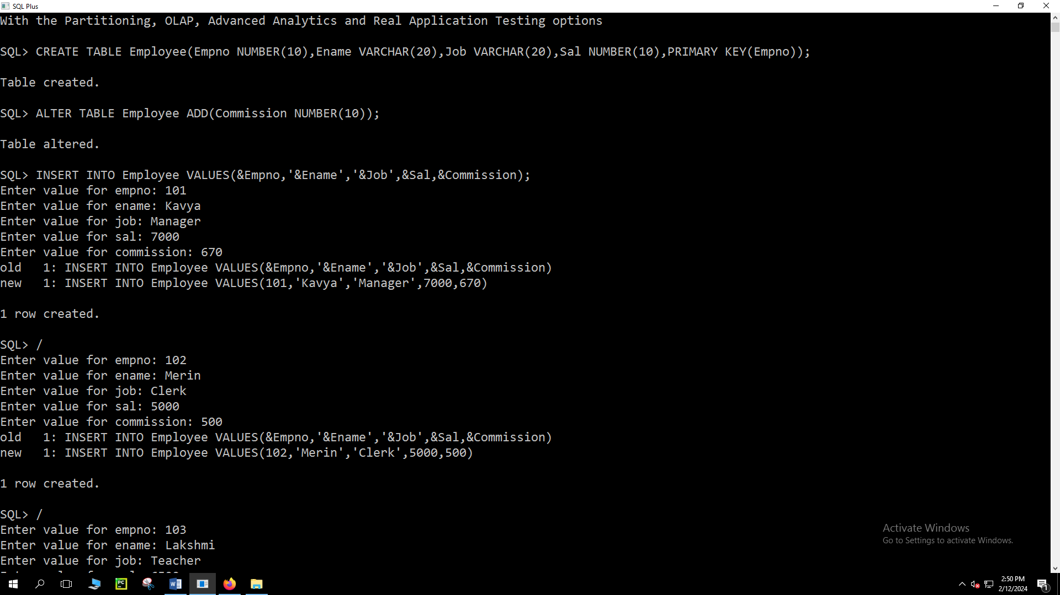

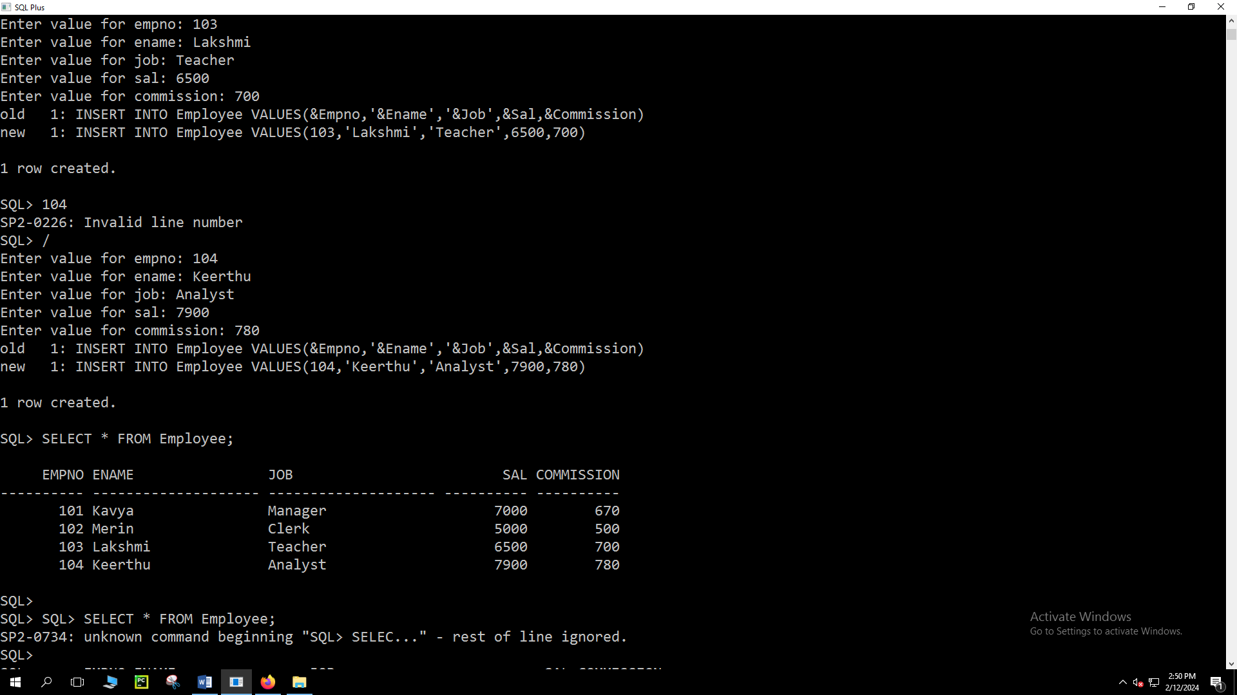

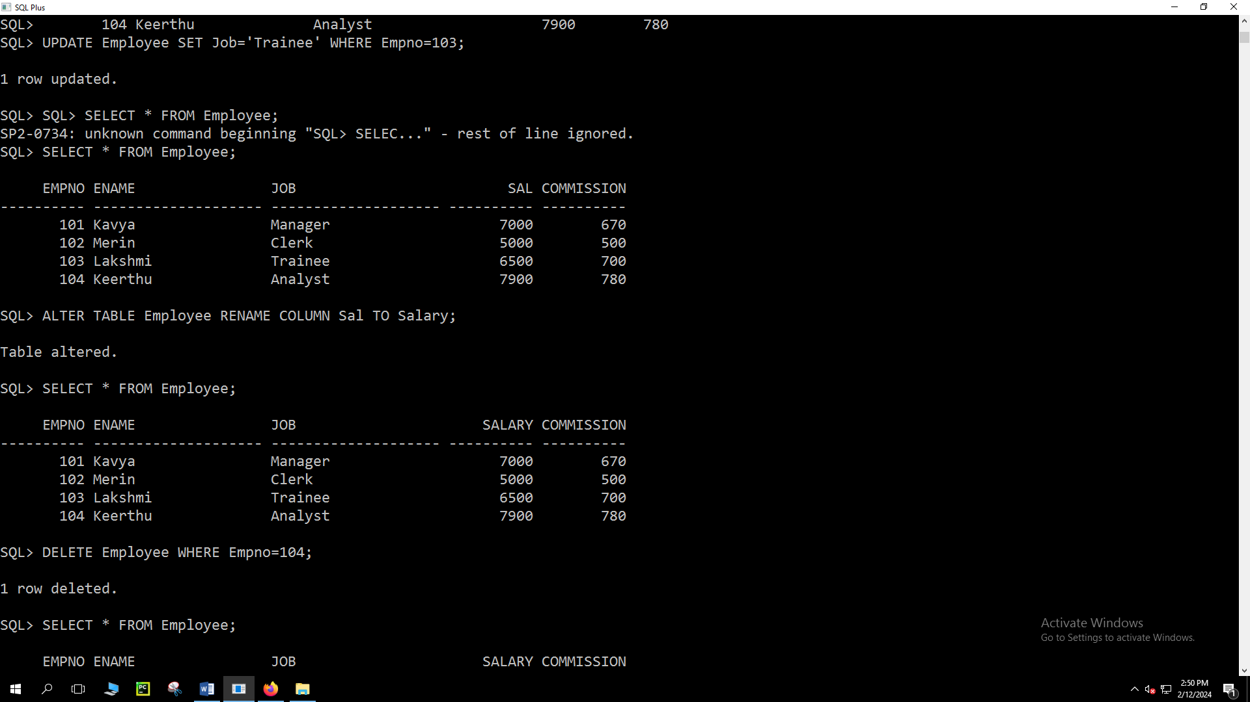

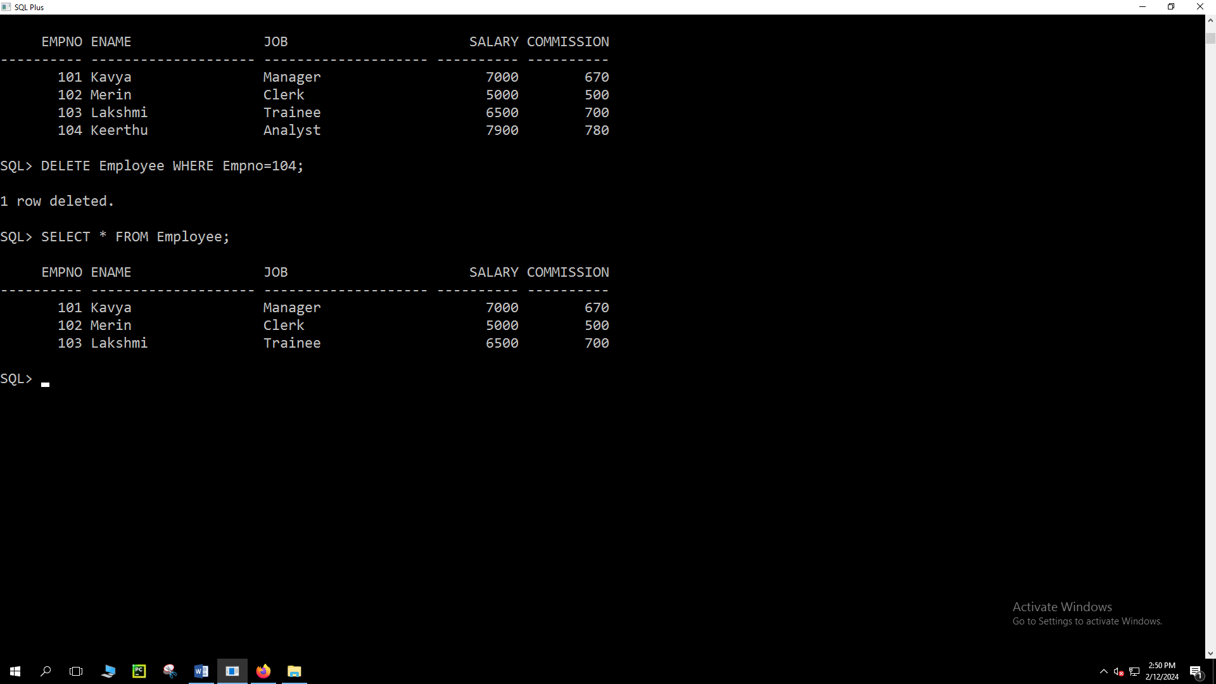

**Create table called Department with following data structure.**

SQL> CREATE TABLE Department(Deptno NUMBER(10),Deptname VARCHAR2(10),Location VARCHAR2(10));

Table created.

SQL> ALTER TABLE Department ADD(Designation VARCHAR2(10));

Table altered.

SQL> INSERT INTO Department VALUES(&Deptno,'&Deptname','&Location','&Designation');

Enter value for deptno: 111

Enter value for deptname: CS

Enter value for location: Pala

Enter value for designation: Student

old 1: INSERT INTO Department VALUES(&Deptno,'&Deptname','&Location','&Designation')

new 1: INSERT INTO Department VALUES(111,'CS','Pala','Student')

1 row created.

SQL> /

Enter value for deptno: 112

Enter value for deptname: ME

Enter value for location: Kottayam

Enter value for designation: Teacher

old 1: INSERT INTO Department VALUES(&Deptno,'&Deptname','&Location','&Designation')

new 1: INSERT INTO Department VALUES(112,'ME','Kottayam','Teacher')

1 row created.

SQL> /

Enter value for deptno: 113

Enter value for deptname: MCA

Enter value for location: Pala

Enter value for designation: Student

old 1: INSERT INTO Department VALUES(&Deptno,'&Deptname','&Location','&Designation')

new 1: INSERT INTO Department VALUES(113,'MCA','Pala','Student')

1 row created.

SQL> SELECT * FROM Department;

DEPTNO DEPTNAME LOCATION DESIGNATIO

---------- ---------- ---------- ----------

111 CS Pala Student

112 ME Kottayam Teacher

113 MCA Pala Student

SQL> SELECT Deptno,Deptname FROM Department GROUP BY Deptno,Deptname;

DEPTNO DEPTNAME

---------- ----------

113 MCA

111 CS

112 ME

SQL> UPDATE Department SET Deptname='MCA' WHERE Deptno=111;

1 row updated.

SQL> SELECT * FROM Department;

DEPTNO DEPTNAME LOCATION DESIGNATIO

---------- ---------- ---------- ----------

111 MCA Pala Student

112 ME Kottayam Teacher

113 MCA Pala Student

SQL> ALTER TABLE Department DROP COLUMN Location;

Table altered.

SQL> SELECT * FROM Department;

DEPTNO DEPTNAME DESIGNATIO

---------- ---------- ----------

111 MCA Student

112 ME Teacher

113 MCA Student

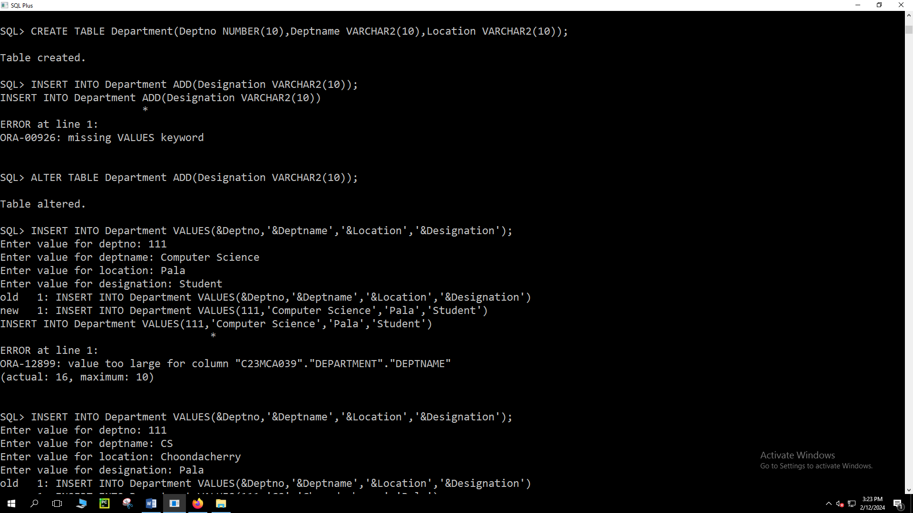

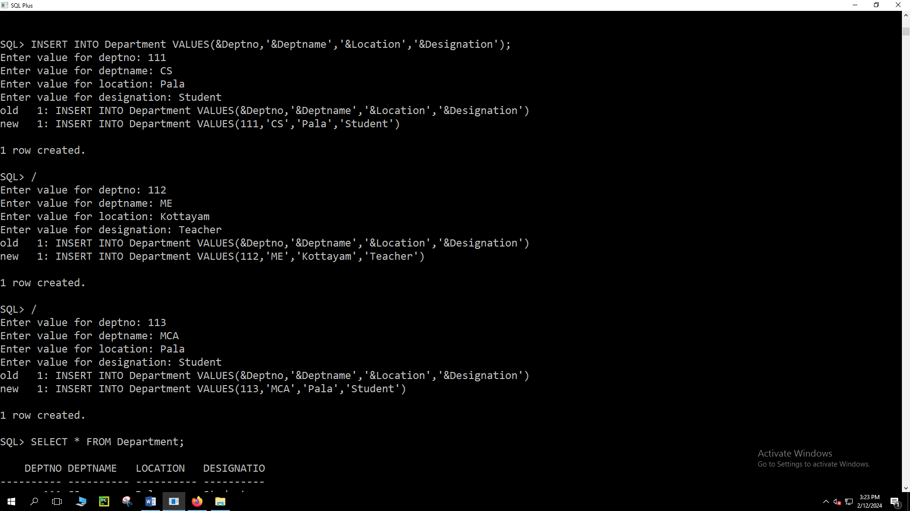

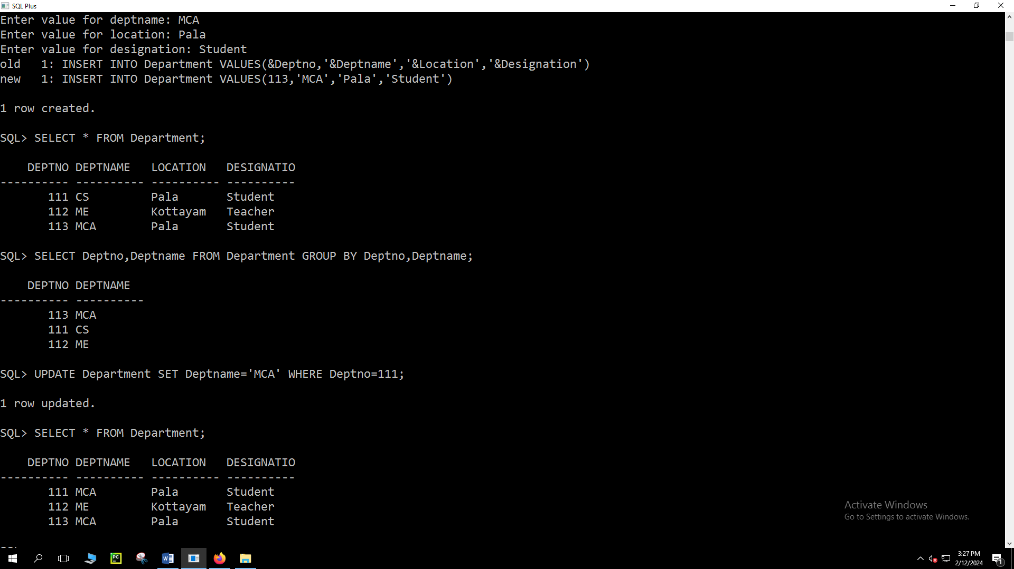

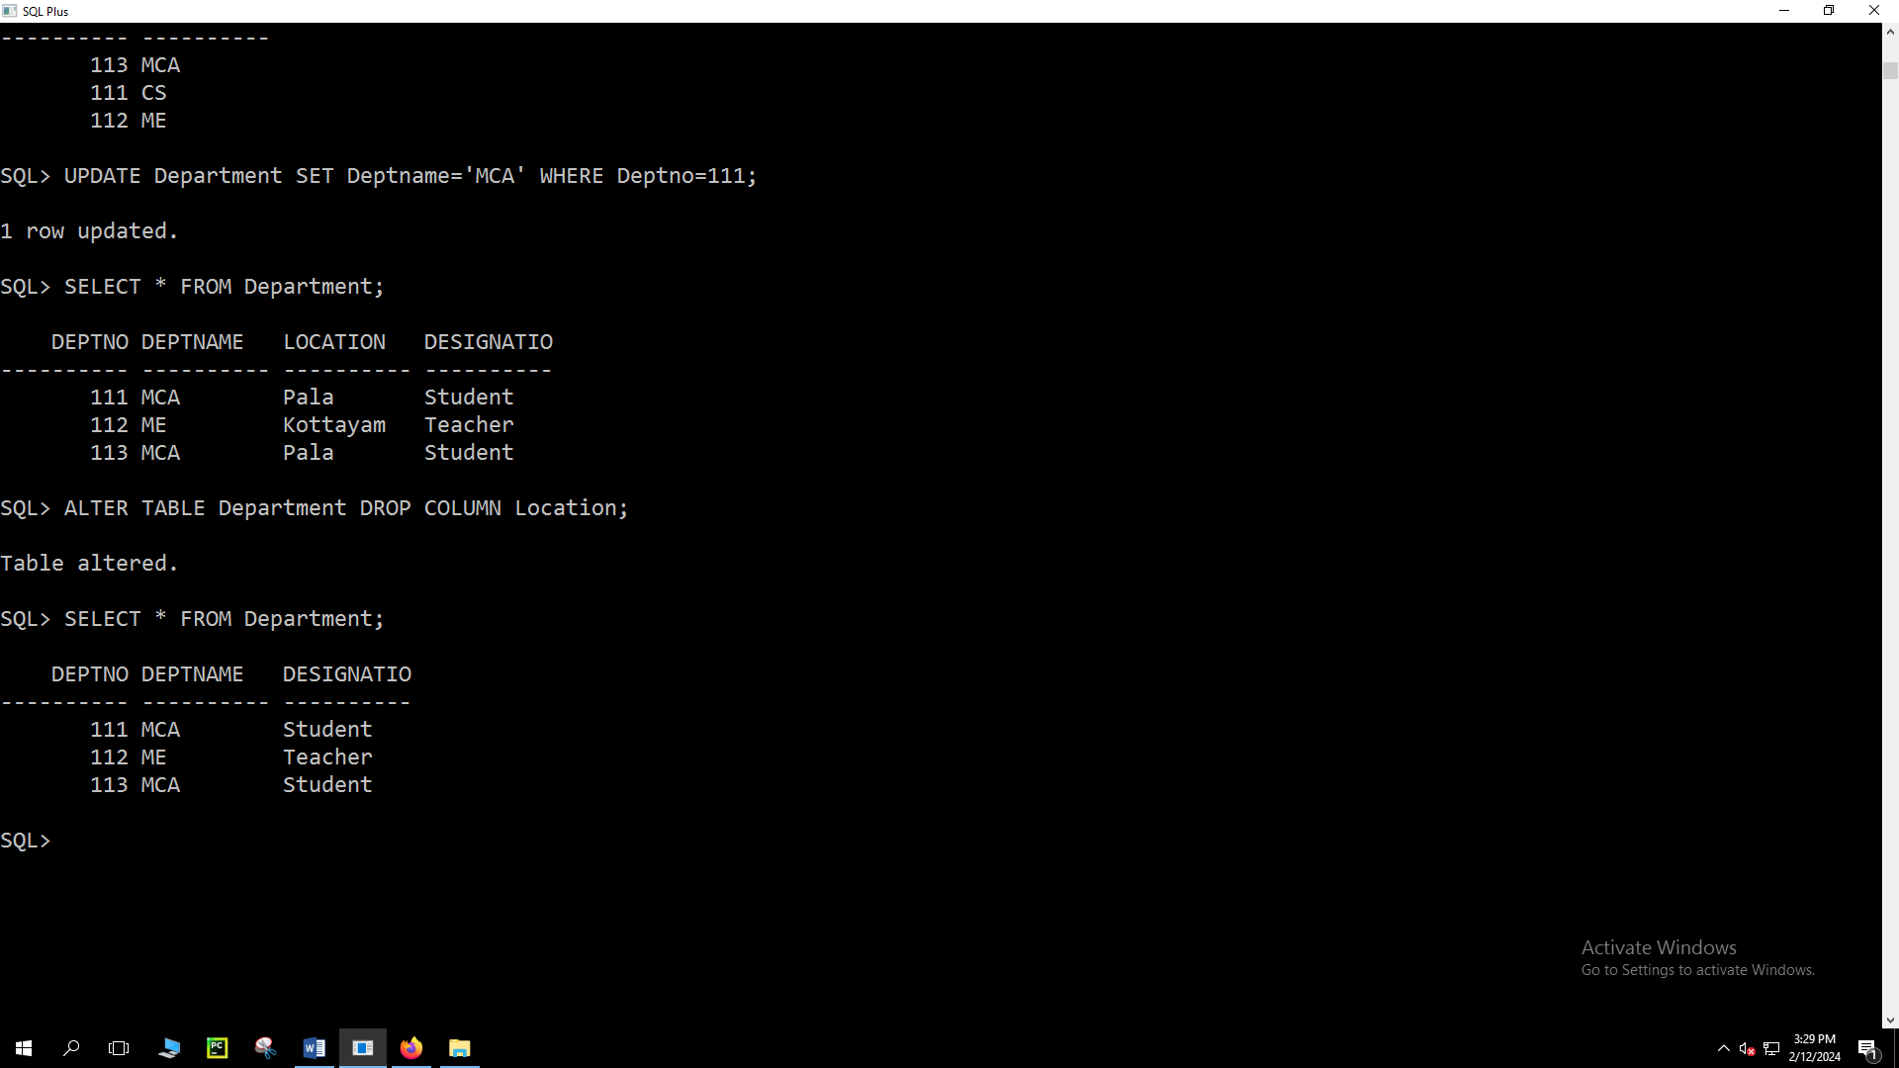

**Create table called Branch with following data structure.**

SQL> CREATE TABLE Branch(Branch_name VARCHAR2(10),Branch_city VARCHAR2(10),Asserts NUMBER(10));

Table created.

SQL> DESC Branch

Name Null? Type

----------------------------------------- -------- ----------------------------

BRANCH_NAME VARCHAR2(10)

BRANCH_CITY VARCHAR2(10)

ASSERTS NUMBER(10)

SQL> ALTER TABLE Branch MODIFY Asserts NUMBER(35);

Table altered.

SQL> DESC Branch

Name Null? Type

----------------------------------------- -------- ----------------------------

BRANCH_NAME VARCHAR2(10)

BRANCH_CITY VARCHAR2(10)

ASSERTS NUMBER(35)

SQL> ALTER TABLE Branch ADD(Branch_address VARCHAR2(20));

Table altered.

SQL> DESC Branch

Name Null? Type

----------------------------------------- -------- ----------------------------

BRANCH_NAME VARCHAR2(10)

BRANCH_CITY VARCHAR2(10)

ASSERTS NUMBER(35)

BRANCH_ADDRESS VARCHAR2(20)

