**Introduction**

This white paper will address the need for chaos prevention and resource distribution in a post-apocalyptic world.

**Background / Problems**

It is the year 2277. Megaton is a city located in the mountainous region, just east of Vault 101 in the capital wasteland. It has low rainfall, is mostly sunny, and generally cold. There is very little vegetation, and there are no nearby water features. Megaton is populated by survivals of a recent nuclear apocalypse. The leader of Megaton was determined by an arm wrestling contest; the peoples believed this was the least-violent way to assert dominance.

Zak Zot won the contest. He has an Associate’s Degree in Physical Therapy. Before the apocalypse started, he was working on a Bachelor’s in Inventory Mismanagement at University of Arizona. Zot has a large build, and is revered because he appears strong. If he fails in his leadership position, he will be exiled. Zot has no prior leadership experience, and sees software as his primary tool/solution.

**Solution**

The only way an entire community can benefit from technologies [water filtration and irrigation, power systems, personalized medicines, etc.] is if they cooperate with one another. Our service helps leaders determine which resources should be used to develop such technologies and sustain the population. Community members use the service to connect to their leader, providing feedback and contributing to the effort of rebuilding society. Without an inventory service, resources might be hoarded amongst members, and people miss the opportunity to innovate together.

The Very Advanced Technological System (VATS) records inventory, calculates the estimated time range of supply, and serves as a bridge of communication between the leader and the community members. In simple terms, VATS is an inventory service, with a target market of community leader. It is important to note that the feedback feature engages community members in constant communication with their leader; the product benefits them as well.

Hardware components include:

* Raspberry Pi
* Small display
* MicroSD card
* High-discharge Li-Po battery
* Keyboard
* HDMI cable, micro USB cable , pin headers

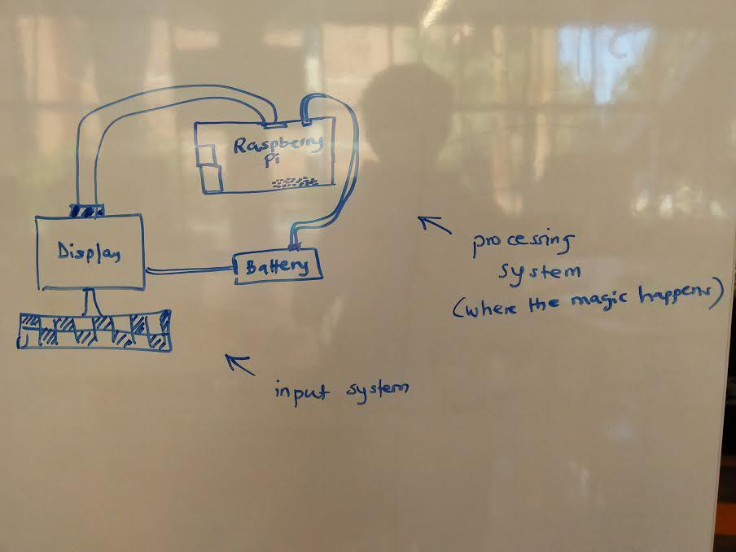

The schematic above demonstrates VATS working on a single, independent power source. The software operates on the Raspberry Pi, and outputs the information to the small monitor. Users can input data with a keyboard attached to the Pi’s USB port.

To use VATS, users need only plug in the microusb to the Raspberry Pi, log into the main user profile, and type ‘vats’ into the command line. A menu will display from there to guide users through their specific tasks.

**Conclusion**

We have identified the need to improve resource management techniques and here present a fully integrated software system to help community leaders organize their resources.