Joseph Tong

CIS565

9/20/13

**Joseph Tong Project 1: Ray Tracer ReadMe**

This project is a CUDA based ray tracer that utilizes the GPU to generate ray traced images very quickly. The project reads in a text file that specifies the materials, objects, and camera for the scene. So far, I’ve implemented ray casting from a camera into a scene through a pixel grid, phong lighting for one point light source, Diffuse lambertian surfaces, ray traced shadows, cube intersection testing, and random sphere surface point sampling1. Additionally, of the extra features, my ray tracer also supports specular reflection, soft shadows and multiple area lights, depth of field, super sampled anti-aliasing, and an interactive camera. Here’s a sample render from my ray tracer.

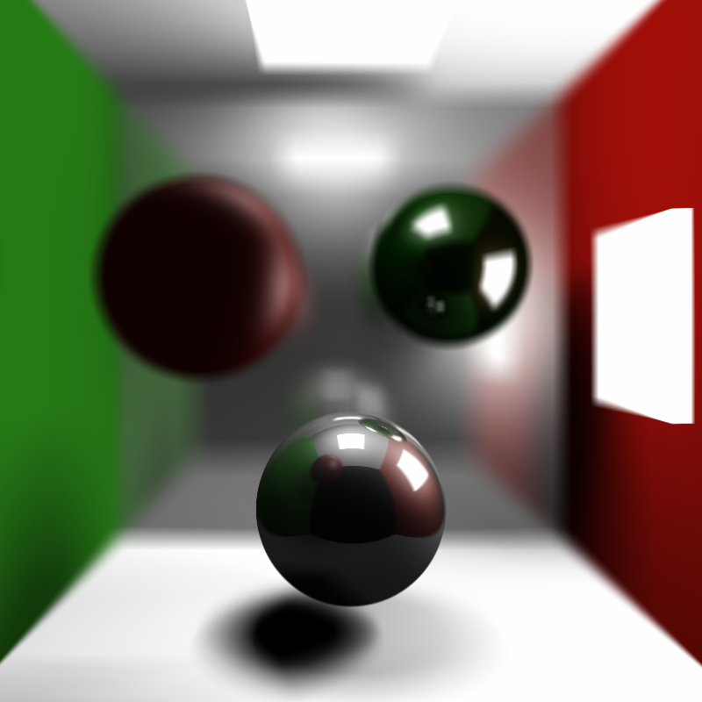

Link to video of my Ray tracer running: <https://vimeo.com/75070266>

**Performance Analysis**

As we learned in class, when programming on the GPU, conditionals really slow down the speed of the program. For my performance evaluation experiment, I set an invariant that all the cubes in the scene would be loaded first proceeded by all the spheres. That way, when I check for intersection testing, I don’t have to go through a conditional on each loop to check if the object is a sphere or cube. My optimization would just first loop through all the cubes and then all the spheres with no conditionals necessary.

|  |  |  |
| --- | --- | --- |
| **Scene Setup** | **With Conditionals** | **Without Conditionals** |
| 2 cubes | 0.015 secs/iteration | 0.013 secs/iteration |
| 4 cubes | 0.021 secs/iteration | 0.017 secs/iteration |
| 8 cubes | 0.034 secs/iteration | 0.024 secs/iteration |
| 16 cubes | 0.057 secs/iteration | 0.039 secs/iteration |
| 2 spheres | 0.014 secs/iteration | 0.012 secs/iteration |
| 4 spheres | 0.018 secs/iteration | 0.015 secs/iteration |
| 8 spheres | 0.027 secs/iteration | 0.021 secs/iteration |
| 16 spheres | 0.043 secs/iteration | 0.033 secs/iteration |
| 1 cube 1 sphere | 0.014 secs/iteration | 0.013 secs/iteration |
| 2 cubes 2 spheres | 0.019 secs/iteration | 0.015 secs/iteration |
| 4 cubes 4 spheres | 0.032 secs/iteration | 0.021 secs/iteration |
| 8 cubes 8 spheres | 0.052 secs/iteration | 0.032 secs/iteration |

As you can see, the removal of conditionals with this tweak did produce a slight performance boost. It even sped up the seconds/iteration when the scene was just cubes or just spheres. However, where it had the most effect was when the scene was both cubes and spheres. Note that when the scene is 8 cubes and 8 spheres, it almost cut the secs/iteration in half (0.052 to 0.032).