Question 5.1
Using crime data from the file uscrime.txt (http://www.statsci.org/data/general/uscrime.txt, description at http://www.statsci.org/data/general/uscrime.html), test to see whether there are any outliers in the last column (number of crimes per 100,000 people). Use the grubbs.test function in the outliers package in R.

Methodology

My first step was to import my libraries. The libraries that I imported were outliers and ggplot2. I imported the data, “uscrime.txt”, and filtered the dataset to only the crime rates since that is what we are analyzing for outliers.

Next, I plotted a density curve and histogram of the distribution of the crime rates. I also ran the Shapiro test to test for normality.

I created a boxplot of the crime rates and used the IQR method to identify potential outliers.

Another method I used was the grubbs.test() function. I used the Shapiro test to test the normality of the distribution. Then, I used grubbs.test() with type = 10 since we are only testing on one tail. If it was considered an outlier, then I would remove it and then rerun the whole process until the distribution became normal, using repeat().

Results

The outliers that I removed were the crime rates valued at 1969 and 1994. I know these are outliers because the p-value dropped below 0.05 after removing the second outlier, 1969. After removing those two outliers, the distribution passed the normality test.

Discussion of Results

Looking at this histogram of the number of crimes, the distribution is not normal, but instead, is right skewed. According to the Shapiro test, the p-value is less than 0.05, so we can reject the null hypothesis and conclude that the distribution is not normal. Additionally, in the density curve, you can see the right skew. The right skew may mean that there are potential outliers in the higher values. The grubbs.test() is performed under the assumption that the distribution is normal. Since it is not normal, we may have to include different methods to identify the outliers. However, we can still use a for loop to run a grubbs.test() to identify one outlier, remove it, and then run the grubbs.test() until the distribution becomes normal.
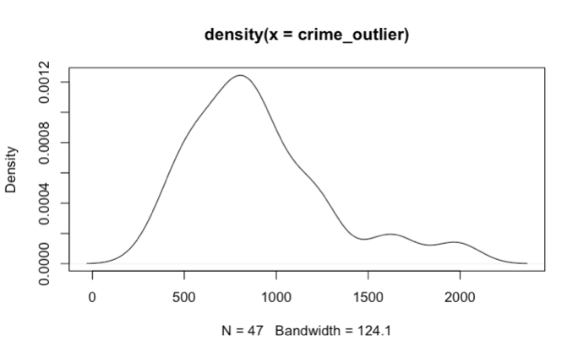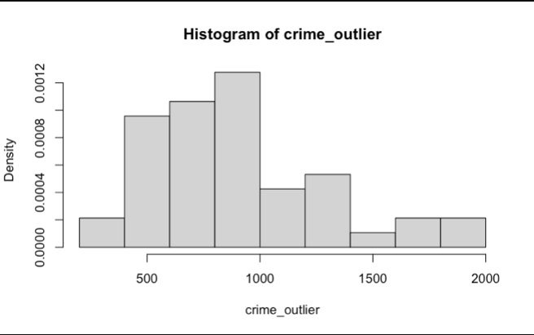

According to the boxplot, the maximum value is 1,635. However, there are three values higher than the maximum that are potential outliers: 1674, 1969, and 1993. We can use the boxplot outlier formula to see if these points are considered outliers or not. Since Q3 = 1057.5 and Q1 = 658, the IQR = Q3 - Q1 = 399.5. Then, we use the equation Q3 + 1.5 * IQR = 1057.5 + 1.5 * 399.5 = 1656.75. Since 1675, 1969, and 1993 are all greater than 1635, we can consider these three points potential outliers. Based on the boxplot, there does not seem to be an outlier that is lower than the minimum. Next, I will be performing the grubbs.test() with type = 10 since we are only focusing on one tail (the higher side).

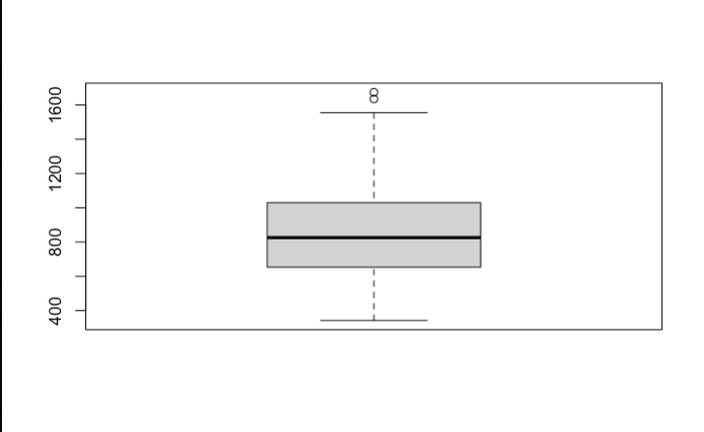

For my first grubbs.test() the null hypothesis is that the highest value, 1993, is an outlier. The alternative hypothesis is that 1993 is not an outlier. The p-value was 0.07887, which is greater than 0.05. However, I still chose to reject the null hypothesis because the difference in p-value was very small, and the distribution was still not normal. I considered 1993 an outlier and removed it. Next, I ran the grubbs.test() a second time, but the null hypothesis was that the next highest value, 1969, was an outlier. The alternative hypothesis was that 1969 was not an outlier. The p-value was 0.02848, which is less than 0.05. Therefore, I rejected the null hypothesis and concluded that 1969 is an outlier. I removed the point 1969, and my code ran the Shapiro test again. The distribution became normal after removing these two points.

Question 6.1
Describe a situation or problem from your job, everyday life, current events, etc., for which a Change Detection model would be appropriate. Applying the CUSUM technique, how would you choose the critical value and the threshold?

In my past internship, I worked for a Korean company that imported and exported special metals such as copper and nickel. My job was to work with time series data of the fluctuations in the Korean Won to USD exchange rate.I applied change detection to identify significant shifts in the exchange rate. I think a good way to choose the critical value would be to choose any fluctuation difference that exceeds 0.5 USD. The reason for this is that if there is a currency fluctuation that is over $0.50, that can be seen as a significant change. Anything below that can be considered “not too impactful” since there are lots of cases where the daily currency fluctuations go up and down by a couple cents.

Based on the annual graph of the currency fluctuations between KRW and USD, I would choose my threshold value based on the average year to year change in rate. The reason for this is that the currency exchange rate continuously increases as time goes on. Therefore, if we see a steady increase in the CUSUM plot, then that is a sign that the currency exchange rate is rising over time. Once the exchange reaches a certain threshold in a change point plot, for example, then we can conclude that there is a clear rise for exchange rate.

Question 6.2
- Using July through October daily-high-temperature data for Atlanta for 1996 through 2015, use a CUSUM approach to identify when unofficial summer ends (i.e., when the weather starts cooling off) each year. You can get the data that you need from the file temps.txt or online, for example at http://www.iweathernet.com/atlanta-weather-records or https://www.wunderground.com/history/airport/KFTY/2015/7/1/CustomHistory.html . You can use R if you’d like, but it’s straightforward enough that an Excel spreadsheet can easily do the job too.

Methodology

The first step was to import the dataset, “temps.txt”. Looking at the first question, it wanted us to find out when “unofficial summer” ends using the CUSUM approach based on the daily high temperature data for Atlanta from 1996-2015. To do this, I created a function called cusum. I stored a vector of zeros for my C-Positives and C-Negatives.

I created a for loop that went from 2 to the length of the data. Inside the for loop, I used the mathematical equations that we learned from Dr. Sokol’s lectures and re-created them in code.

Then, I created a variable called years which took the column names of the years only (1996-2015). I created a for loop that ran through each day of the year and calculated the temperature change between each day and added them all up so that it gave us the accumulated change.

I took the average of the peak values of all the years combined and use the 15% quantile of that average as my threshold.

Finally, I created a line plot that displayed the accumulated number of above-average temperatures over time. I showed the lines C+ and C-, and I also created a dashed line for my threshold and where the peak was at. It displayed a plot for every year.

Results

“Unofficial summer” ends roughly around the range of September 18th to October 8th.

Discussion of Results

I set my k-value to 0.3. The reason for this is that I did not want to include meaningless deviations that may cause C+ to increase. At the same time, since a couple graphs were barely above the threshold, I wanted to keep k at a balanced value so that it showed the clear result of when "unofficial summer" ended. I only wanted to consider the temperature of the days where it was meaningfully above the average. For my threshold, I took the average of the peak values of each year. However, the threshold was still strict, so I took the 15% quantile of that average, and ended up using 262 as my threshold. The x-axis, Days, is a time series that goes through each day of the data. The y-axis, C+, represents the accumulated number of above-average temperatures over time. Since I perform the calculation in my for loop (temp - mean - k), it created the deviation for me, and then I would add up those deviations to represent the C+ accumulation. Once the decrease reached the threshold, that would be the day I would consider the end of "unofficial summer". Almost every plot dropped below the threshold from Days 80-100. This means that the end of unofficial summer is roughly between September 18th to October 8th. Additionally, the solid blue line shows the increase of the cooling temperatures. In almost every plot, the blue line increases when the red line hits the threshold. This proves that "unofficial summer" is ending. However, there were a couple plots whose max accumulated temperature didn't reach my threshold. However, I still looked at the plots and noticed the same pattern in the drop of accumulated temperatures and an increase in the C- blue line from September 18th to October 8th.

- Use a CUSUM approach to make a judgment of whether Atlanta’s summer climate has gotten warmer in that time (and if so, when).

Methodology

The first thing I did was calculate the average temperature of each year. In the previous question, we were focusing on the days. For this question, we want to focus on the years.

Next, I created a function that calculated the difference in the average temperatures between each year.

Then, I created a line plot where the x-axis was year, and the y-axis was the cumulative sum of the summer average temperature. I created a dash line at 0 as well.

Finally, I wanted to find the change point of the graph. To do this, I had to identify the largest average difference between two years. I used which.max() to identify at which index the max difference was, and I found out which year that index was. I created a line plot that showed the difference in average temperatures as well as a dashed blue line that showed where the change point was.

Results

Based on my results, I concluded that Atlanta’s summer climate has gotten warmer, especially from the years 2009 to 2012. In the plot, there is a sharp increase in those years, so that would mean that the climate has gotten warmer. Additionally, the plot started at a sharp decrease, and then suddenly increased. I found the change point where the direction of the slope changed. The change point is at year 2009.

Discussion of Results

I set k = 0 because I want to take all deviations into account. Since we are focusing on the years, small shifts in those annual averages are also meaningful. Therefore, I want to capture all changes. Looking at the graph, the slope suddenly increases starting from 2009. Therefore, the change point is at year 2009. From there on, it strictly increases and peaks at year 2012. The dashed line at h = 0 means that there was no cumulative deviation from the mean. When the line is below the dashed line, that means that there is still a cooling trend since the CUSUM is in the negatives. When it is above the dashed line, that means that there is a warming trend. The CUSUM is above h = 0 around year 2012. Therefore, there is a clear warming trend that year.

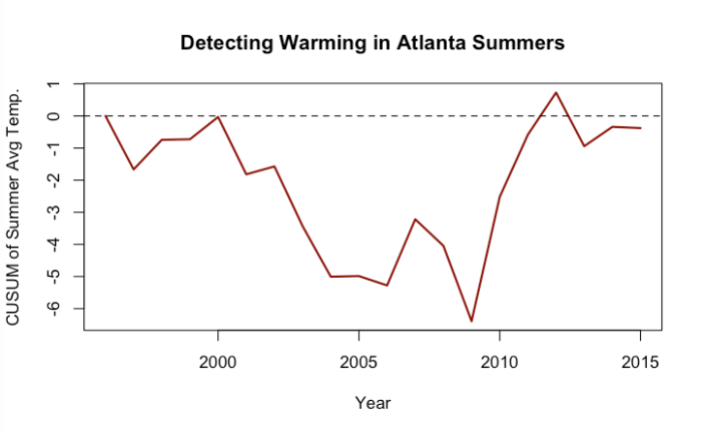

The graph with the orange line shows the difference in average temperature for each year. I used this plot to show the change point. The blue line clearly shows that the change point starts at year 2009. There is a huge average difference between 2009 and 2010. It is about a six degree difference. After that, the average difference is on a decline. Therefore, we can see that the climate has gotten warmer significantly from 2009-2010, and although it is at a decline after 2010, the average temperature values are still higher than the earlier years (1996-2006).

