Question 7.1

Describe a situation or problem from your job, everyday life, current events, etc., for which exponential smoothing would be appropriate. What data would you need? Would you expect the value of α (the first smoothing parameter) to be closer to 0 or 1, and why?

One situation where exponential smoothing would be appropriate is when you are focusing on the pattern of stocks in the past 5 years. You can check the highest stock price of each month (so in total 60 months) and look at the overall trend and seasonality of the plot. The type of data I would need is a time series data where the y-axis is the stock market price value (maybe closing market price). I would expect the value of alpha to be closer to zero because stock prices have lots of randomness since many unexpected things happen.

Question 7.2

Using the 20 years of daily high temperature data for Atlanta (July through October) from Question 6.2 (file temps.txt), build and use an exponential smoothing model to help make a judgment of whether the unofficial end of summer has gotten later over the 20 years. (Part of the point of this assignment is for you to think about how you might use exponential smoothing to answer this question. Feel free to combine it with other models if you’d like to. There’s certainly more than one reasonable approach.)

Note: in R, you can use either HoltWinters (simpler to use) or the smooth package’s es function (harder to use, but more general). If you use es, the Holt-Winters model uses model=”AAM” in the function call (the first and second constants are used “A”dditively, and the third (seasonality) is used “M”ultiplicatively; the documentation doesn’t make that clear).

Methodology

The first thing I did was read the dataset and convert it into a time series. Then, I plotted the time series.

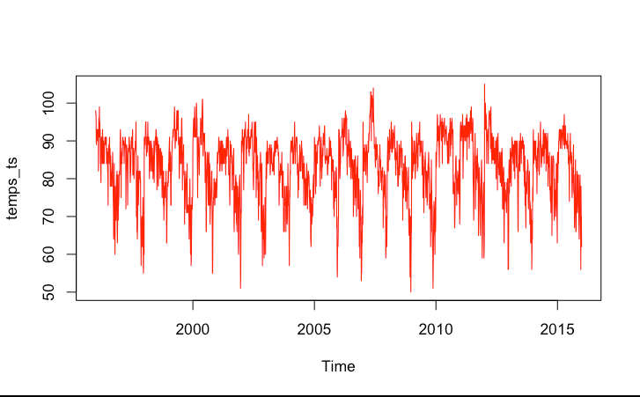

I used the HoltWinters() function using the time series that I created, alpha, beta, and gamma all valued to ‘NULL’, and multiplicative seasonality.

Then, I plotted the decomposition of the time series with type equal to multiplicative. The decomposed plots show the plots for the observed, trend, seasonal, and random factors.

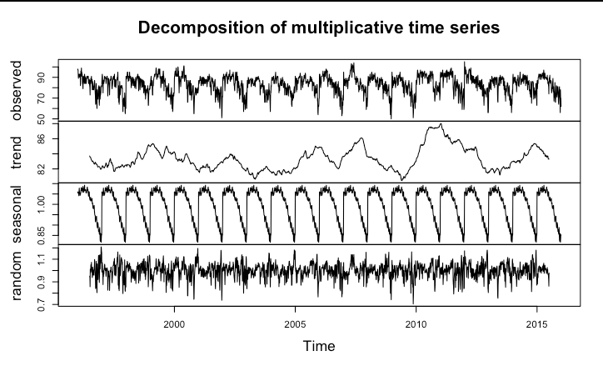
Looking at the graph above, it seems like the seasonal graph shows the least amount of noise. Therefore, I think gamma is important to look at, and it should be NULL.

I plotted the Holt-Winters model. Additionally, I created three new models. One triple exponential smoothing model is without trend and seasonality, one double exponential smoothing model is without trend, and one double exponential smoothing model is without seasonality. Then, I plotted all these models. I decided to focus on the triple exponential smoothing model.

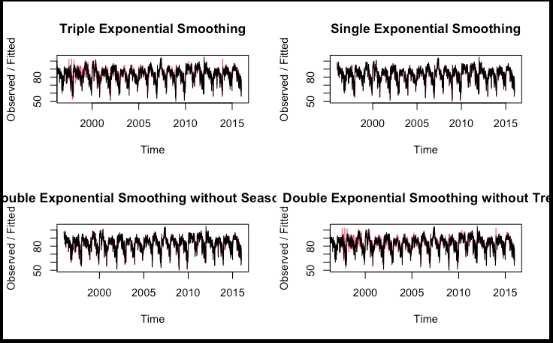

I think the first graph has the least noise involved. Additionally, the first graph has gamma set to NULL. These two reasons are why I decided to use triple exponential smoothing.

Using the triple exponential smoothing model, I created a data frame where the smoothed data takes the exponential smoothing model for the entire time and includes the date column and row names.

For Year 1997, I plotted the points of the actual values and then created a line of the exponential smoothing to compare it to those points. The smoothed line is pretty accurate for the first 60 days of the data, but then slowly becomes inaccurate later. For Year 2015, I plotted the points of the actual values and then created a line of the exponential smoothing to compare it those points. The smoothed line is less accurate in terms of matching the data points, but it captures the general trend well.

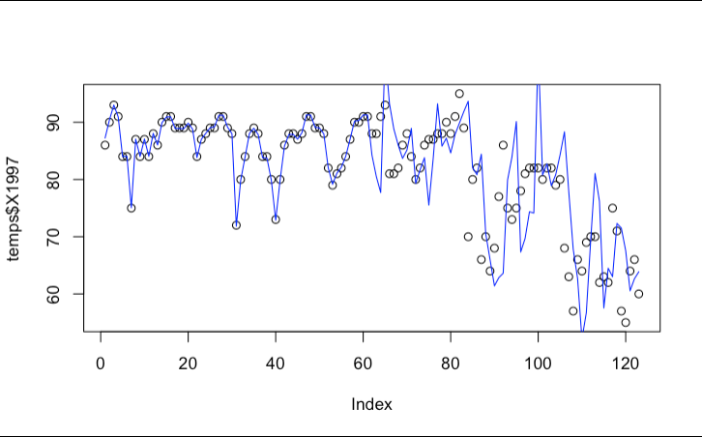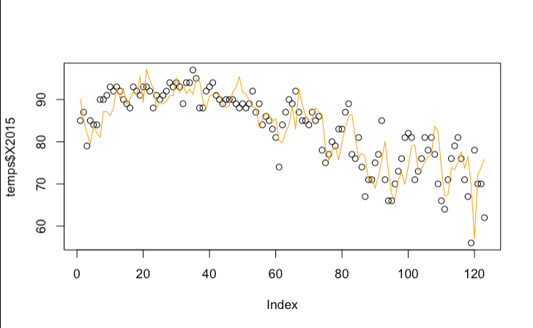

I decided to use CUSUM analysis to determine whether the summer in Atlanta is ending later over the years.

I created a for loop, and inside the for loop, I used the equation max(0, s[i-1] + (mean – x_t – C) to detect the change.

Then, I created a plot where the standard deviation was set to the default value, 0.5, and I set the threshold to five times the standard deviation, so 50. I also plotted the line of the cumulative sum. According to the plot, the minimum value of where the cumulative sum reaches the threshold is at day 91. This means that September 29th, is the unofficial end of the summer in 1997, according to the CUSUM model.

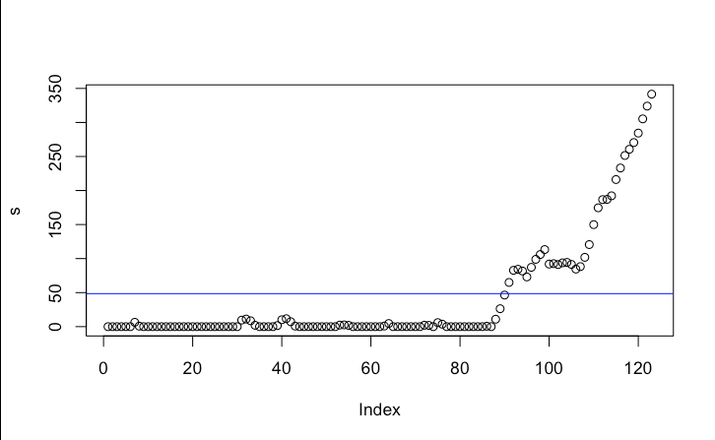

I repeated this process for all the other years. As a result, it returned the result of the unofficial ending summer days for each year. Then, I combined the chronological order of years to the order of the values to put them side by side.

I used ggplot() to plot the results I got. According to the graph, the latest unofficial end of summer was in 2005 on October 8. As the years go by, it looks like the unofficial end of summer gets a little bit earlier compared to the earlier years. However, this is from the unsmoothed data.

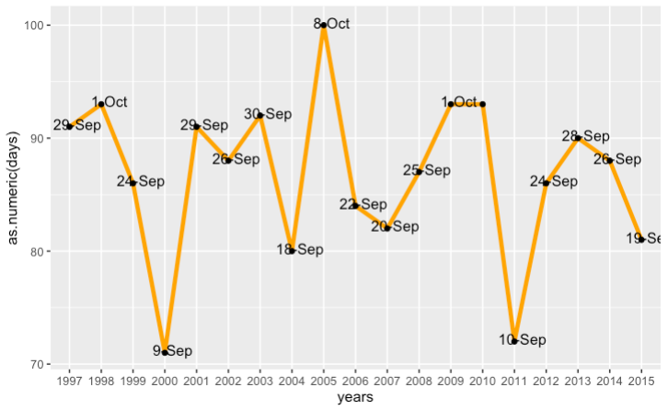

From the smoothed data, we can see one significant change. In year 2013, the unsmoothed data tells us that unofficial summer ends on August 17th. The smoothed data tells us that unofficial summer ends on September 28th.
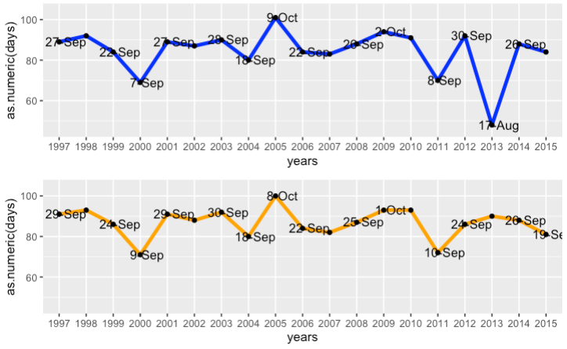

Finally, I used scatter.smooth() where the x-axis was the years, and the y-axis was the days of when unofficial summer ends. According to the graph, the line slightly goes down, which means that summer is ending earlier.

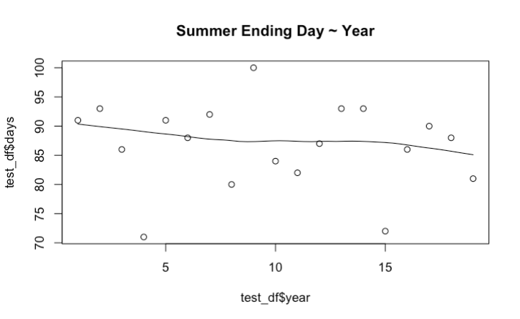

Results

According to the graph from my scatter.smooth() function, the line goes down slightly, which means that summer is ending earlier. Therefore, we cannot say that the unofficial end of summer has gotten later over the 20 years.

Discussion of Results

Like I mentioned before, I chose to focus on the triple exponential smoothing method. Based on the graph I created, the last day of summer was at day 91 for 1997. I repeated this graph for every year from 1997-2015. Here are the results of the last days.

The days go up and down a lot, peaks at the middle (which is October 8), and then goes back to fluctuating again. It seems like there is not much change happening. Now, if we look at the smoothed data, it looks like the unsmoothed data, with some minimal differences by a day or two. However, there is a significant change in 2013, and the smoothing fixed the extremely early date. From the start, the first year was at 91 days, and the last year was at 81 days; based on the smoothed line, the first value is around 90 days, and the last value is around 85 days. Since we see a downward trend, this means that the summer in Atlanta ends earlier rather than later. Therefore, we cannot conclude that the unofficial end of summer has gotten later over the 20 years.

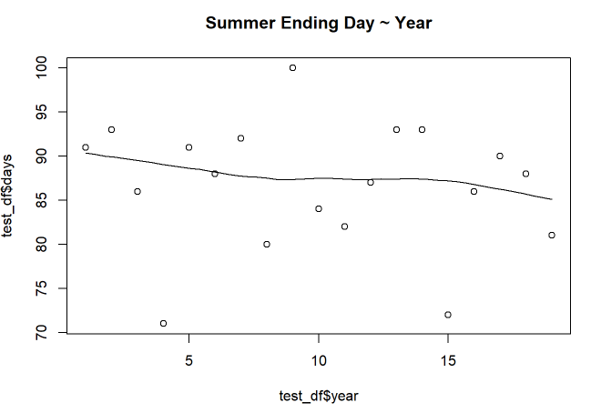

References:
https://www.rdocumentation.org/packages/stats/versions/3.6.2/topics/HoltWinters

